Adapting EMCAD to 2D Multi-class Brain Tumor Segmentation
MSD BrainTumour (Task01) · PVT-EMCAD-B2 · Technical task report

1. Data and preprocessing
I used the Medical Segmentation Decathlon Task01 BrainTumour data (via Kaggle uploads). Each case is a 4-channel MRI volume, with channels in the MSD order FLAIR, T1w, T1gd (T1ce), T2w. Labels are 1 = edema, 2 = non-enhancing tumor, 3 = enhancing tumor. Because of the time limit, I used a subset: 80 training patients (of the 250 in the training set) and 20 validation patients (from the labeled 100-patient validation set). No patient appears in both.
Each volume was z-score normalized per modality over brain voxels, split into axial slices, and resized to 128×128 (bilinear for images, nearest-neighbor for labels). Slices with almost no brain (under 2% non-zero pixels) were dropped. For training, all tumor slices were kept plus a random 20% of tumor-free slices; for validation, all brain slices were kept. Training augmentation was random horizontal and vertical flips. This gave 6,540 training slices and 2,621 validation slices.

2. Model
I used PVT-EMCAD-B2: an ImageNet-pretrained PVTv2-b2 encoder with the EMCAD decoder (MSCAMs, LGAGs, EUCBs and four segmentation heads), unchanged. Two changes were needed:
- Input: the first patch-embedding convolution was widened from 3 to 4 channels. The first three channels keep the pretrained weights, and the fourth is initialized to their mean. All 332 backbone tensors loaded from the pretrained file.
- Output: each of the four segmentation heads outputs 4 classes (background plus three tumor labels), with softmax, as in the paper’s multi-class setup. The nested regions are derived from the predicted labels: WT = labels 1, 2, 3; TC = labels 2, 3; ET = label 3. I chose softmax over three independent sigmoid outputs because it follows the paper and the repository’s multi-class (Synapse) setup.
The skip connections and MSCAM blocks needed no changes, because they depend on the encoder’s feature-map channels and not on the number of input channels or classes.

3. Loss and training
The loss was 0.7 × Dice + 0.3 × cross-entropy (the weights used for multi-class tasks in the paper), applied to each of the four heads’ outputs plus an additional term on their summed logits. This is a simplified version of the paper’s multi-head combination loss, which sums the loss over all 15 head combinations. Training used AdamW (learning rate 1e-4, weight decay 1e-4), cosine learning-rate decay, batch size 16, mixed precision, random seed 0 and 15 epochs (about 13 minutes on one Kaggle GPU). The best epoch (epoch 14) was selected by mean slice-level Dice on the validation set; the training loss fell from 1.83 to 0.80 over the 15 epochs. Predictions use the argmax of the sum of the four heads’ logits; the paper uses only the last head (p4) as the final output, so this is a deviation.

4. Evaluation
For each validation patient, I predicted every slice, stacked the slices into a 3D volume, and computed Dice and HD95 per patient for WT, TC and ET, then averaged over the 20 patients. HD95 is in mm, using an approximate voxel spacing of 1 mm between slices and 240/128 mm in-plane (to account for the resize). HD95 was defined for all patients (no empty prediction or ground truth).
Region | Dice | HD95 (mm)
Whole tumor (WT) | 0.891 | 8.28
Tumor core (TC) | 0.855 | 7.90
Enhancing tumor (ET) | 0.780 | 5.94
Mean | 0.842 | 7.37
Table 1. Per-patient 3D metrics on 20 validation patients (mean over patients).
For reference, the pooled slice-level Dice on the validation set at the selected epoch was WT 0.894, TC 0.880, ET 0.785 (mean 0.853). The per-patient 3D numbers above are the primary results.
Two other runs of the same pipeline gave a mean Dice of 0.841 and mean HD95 of 7.46 mm (an earlier notebook run without a fixed seed) and 0.843 and 7.20 mm (a seeded notebook run), compared with 0.842 and 7.37 mm here, so the result is stable across runs. The numbers in this document come from the repository’s command-line scripts (train.py, evaluate.py, visualize.py), run with seed 0.

5. Qualitative results
Figure 1 shows the best, median and worst patients (ranked by mean 3D Dice) at their largest-tumor slice, plus the worst-performing slice overall. Predictions closely match the ground truth for most patients, and the enhancing region is the hardest class.
- Best (patient 14, mean Dice 0.913): a large tumor with a ring-shaped enhancing rim around a non-enhancing core. The prediction reproduces the rim, core and surrounding edema; its boundaries are smoother than the ground truth, which has a more irregular, patchy enhancing region.
- Median (patient 6, 0.879): tumor location and extent match closely. The split between enhancing and non-enhancing tissue inside the core differs from the ground truth: the ground truth is mostly enhancing with small non-enhancing spots, while the prediction assigns a larger non-enhancing region in the lower part.
- Worst (patient 0, 0.682): whole-tumor Dice is high (0.940), but tumor-core Dice is only 0.337. The ground truth in this slice is mostly edema with a small, scattered enhancing region, while the model predicts a large non-enhancing core and a solid enhancing blob, so the whole-tumor extent is right but the sub-regions are misjudged.
- Failure slice (patient 19, slice 36, WT Dice 0.29): a small lesion at the edge of a fragmented brain cross-section; the model marks only part of the edema. This is a single slice, not a poor patient: the 3D whole-tumor Dice for patient 19 is 0.831.
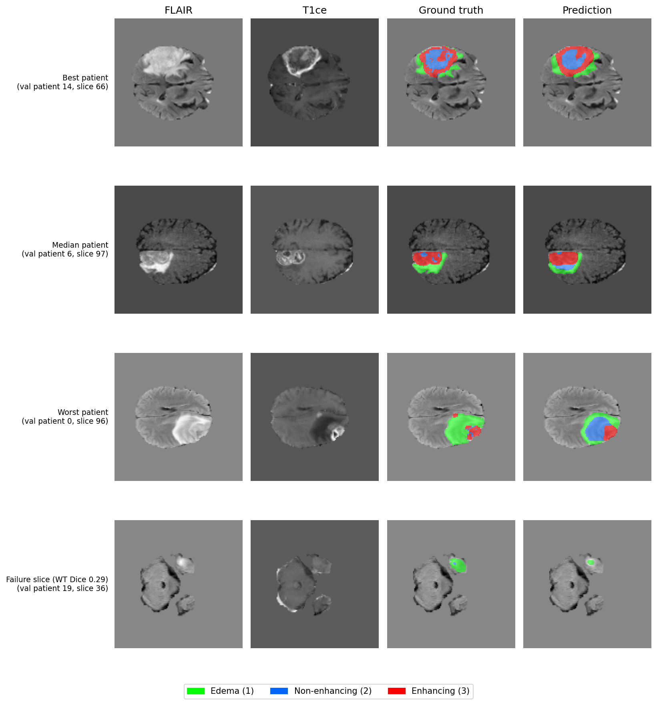
Figure 1. FLAIR, T1ce, ground truth and prediction for the best, median and worst patients and the worst slice. Green = edema, blue = non-enhancing tumor, red = enhancing tumor.

6. Limitations and notes
- Only 80 of 250 training patients, 15 epochs and 128×128 resolution, and results come from three runs, so differences of about a point are not meaningful.
- The best epoch was chosen on the same validation set that is reported, so the numbers may be slightly optimistic. There is no separate test set.
- HD95 spacing is approximate and was measured on the resized grid.
- Mean HD95 is pulled up by a few patients: patient 15 has HD95 of 49.0 mm (WT) and 63.4 mm (TC), patient 17 has 31.9 mm (WT), and patient 0 has 23.1 mm (TC) and 24.6 mm (ET). The per-patient median HD95 is lower (WT 4.00, TC 3.54, ET 3.82 mm). I did not investigate the cause of these outliers.
- No 3D post-processing (such as removing small isolated blobs) was applied.
- Simplified loss and head-summed prediction, as described in Section 3.
- Next steps: full training set, higher resolution, longer training, the full multi-head loss, and a held-out test set.

