23IT11E – WEBFRAMEWORKS USING PYTHON
Micro Project
Report On
Farmers Consultation Portal
Submitted by
MAYAVATHI.E 24205044
In partial fulfillment for the award of the degree
of
BACHELOR OF ENGINEERING
in
INFORMATION TECHNOLOGY

NATIONAL ENGINEERING COLLEGE
(An Autonomous Institution affiliated to Anna University, Chennai)
K.R.NAGAR, KOVILPATTI - 628503
OCTOBER – 2026
NATIONAL ENGINEERING COLLEGE
K.R.NAGAR, KOVILPATTI – 628503
BONAFIDE CERTIFICATE
This is to certify that this project report is a Bonafide record of MAYAVATHI.E (24205044) work done for the course 23IT11E – WEBFRAMEWORKS USING PYTHON at the NATIONAL ENGINEERING COLLEGE, K.R. NAGAR, during the academic year 2026 who carried out the project work under my supervision.

Course Instructor/Guide
TABLE OF CONTENTS
CHAPTER NO | TITLE | PAGE NO
 | ABSTRACT | 4
1 | INTRODUCTION | 5
2 | IMPLEMENTATION | 7
3 | IMPLEMENTATION RESULTS | 51
4 | CONCLUSION | 54

ABSTRACT
The GATE CSE Preparation Portal is a web application that organizes core study resources for students preparing for the Graduate Aptitude Test in Engineering (Computer Science and Information Technology). The portal brings course-wise learning materials and administrator-managed links into one simple interface.
The application provides student registration and login, a separate administrator account choice on the shared login page, eight GATE CSE course groups, and an administrator dashboard for creating, editing and deleting website or video resources. Students can open a course and browse its available materials. Account and resource data are stored in MongoDB; passwords are stored as Werkzeug password hashes.
The project is implemented with Python and Flask, Jinja templates, HTML and CSS, and the PyMongo driver. Its purpose is to demonstrate a clear CRUD-based web application with authentication, role checks, MongoDB persistence and a responsive course-oriented user experience. It provides a foundation for future additions such as progress tracking, mock tests and study planning.

CHAPTER 1
INTRODUCTION

1.1 INTRODUCTION
The GATE examination requires sustained preparation across several computer science subjects. Students commonly collect notes, videos and reference websites from different sources. When these resources are scattered across browser bookmarks and files, it becomes harder to find a useful item again or keep materials organized by subject.
The GATE CSE Preparation Portal addresses this problem with a web-based catalog of eight course groups. A student signs in, selects a course and opens its listed resources. An administrator maintains the shared catalog through create, read, update and delete operations. The application uses Flask routes to handle requests, Jinja templates to render pages and MongoDB collections to persist users and materials.

1.2 PROBLEM STATEMENT
Students need a simple way to locate preparation resources by GATE CSE subject. A manually maintained collection can become inconsistent, difficult to update and unavailable to other students. A web portal with course grouping and an administrator-managed resource list provides a central place to discover and maintain those learning links.

1.3 OBJECTIVES
• Provide one portal for eight core GATE CSE course groups.
• Allow students to register, log in and browse course materials.
• Provide an administrator role that can manage study resources.
• Store user and resource records in MongoDB.
• Demonstrate CRUD operations, sessions, password hashing, form validation and role-based route protection using Flask.

1.4 SCOPE
The current project covers student accounts, administrator access, course browsing and CRUD management of website and video links. It does not currently implement mock examinations, automatic online question collection, PDF upload, study-plan scheduling or analytics. These are possible extensions and are not represented as existing features in this report.

1.5 EIGHT GATE CSE COURSE GROUPS
• Engineering Mathematics
• Digital Logic
• Computer Organization and Architecture
• Programming and Data Structures
• Algorithms
• Theory of Computation and Compiler Design
• Operating Systems
• Databases and Computer Networks

CHAPTER 2
IMPLEMENTATION

2.1 TECHNOLOGIES USED
• Python 3 and Flask: application routes, sessions, request processing and template rendering.
• MongoDB and PyMongo: persistent storage and database queries.
• Werkzeug security utilities: password hashing and password verification.
• HTML, CSS and Jinja: page structure, styling and dynamic rendering.
• Microsoft Edge: local browser used to run and capture the portal screens.

2.2 SYSTEM REQUIREMENTS
The project requires Python, the packages listed in requirements.txt, a running MongoDB service and a modern web browser. MongoDB connection and database names can be configured with MONGO_URI and MONGO_DB. The default local database name in the application is gate_prep.

2.3 PROJECT STRUCTURE
• app.py — Flask application, database connection, route handlers and CRUD logic.
• templates/ — Jinja HTML pages for the landing page, login, registration, courses, course resources, administrator dashboard and resource form.
• static/ — shared CSS and other static assets.
• requirements.txt — Python package dependencies.

2.4 DATABASE DESIGN
The application uses the MongoDB database named gate_prep by default. The users collection stores a name, normalized email, password_hash and role. A unique index on email prevents duplicate accounts. The materials collection stores title, subject, description, URL and resource_type. The resource type is Website or Video. MongoDB ObjectId values identify resource records and are used by edit and delete routes.

2.5 APPLICATION WORKFLOW
• A visitor opens the landing page and chooses to log in or register as a student.
• A student account is created with a hashed password and a user role; successful login creates a Flask session.
• The student opens the course list and selects one of the eight course groups.
• The course page retrieves matching materials from MongoDB and displays their links.
• An administrator selects Admin on the login form and signs in with an administrator account.
• The administrator dashboard lists resources and provides actions to add, edit or delete a material.
• Protected routes check the session role before returning student or administrator pages.

2.6 CRUD OPERATIONS
Create: the administrator submits a resource form; validated values are inserted into MongoDB. Read: the dashboard lists stored resources and each course page retrieves resources for its subject. Update: the administrator opens an existing resource, changes its fields and saves the updated values. Delete: the administrator submits the delete action for a selected ObjectId. This set of operations demonstrates persistent CRUD functionality through Flask routes and PyMongo.

2.7 AUTHENTICATION AND ACCESS CONTROL
Student and administrator accounts use a shared login page with an account-type selector. Passwords are hashed with Werkzeug before storage and checked during login. Flask session values hold the signed-in user identifier, display name and role. A route decorator requires a valid session and, where specified, the required role. Registration is limited to student accounts.

2.8 VALIDATION AND ERROR HANDLING
The registration flow checks a minimum password length and handles duplicate email addresses. The resource form checks that title, description and URL are present, that the course belongs to the supported list and that the resource type is valid. Invalid identifiers and unknown course slugs return a not-found response; unauthorized roles are rejected.

CHAPTER 3
IMPLEMENTATION RESULTS
The following screenshots were captured from the project running locally with its MongoDB connection. They show the pages available in the current implementation.

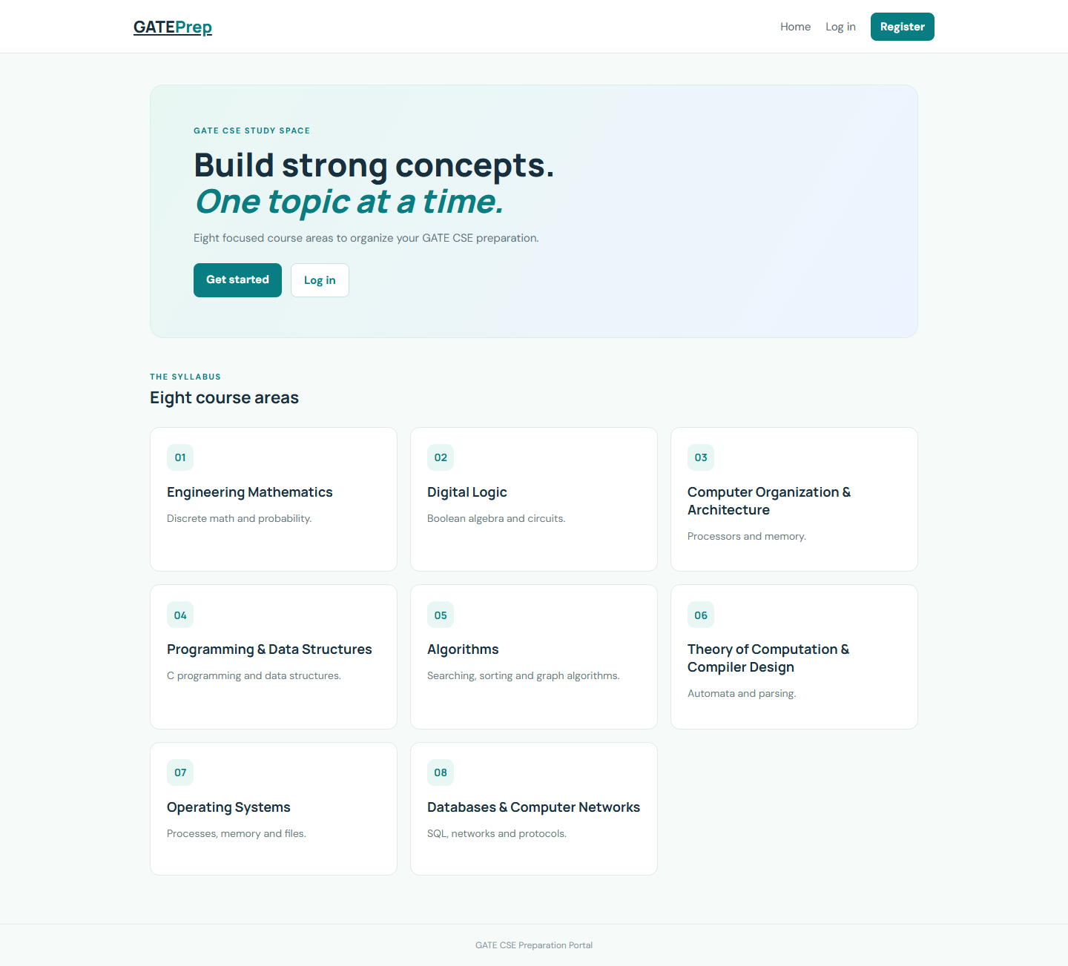
Figure 3.1: Portal landing page

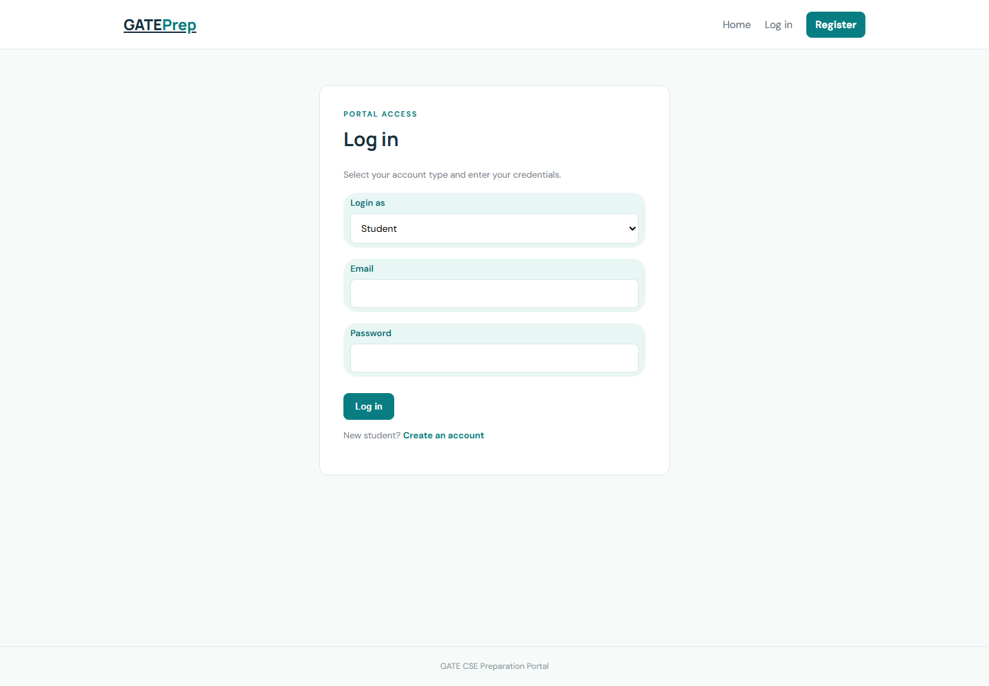
Figure 3.2: Shared login page with student and administrator selection

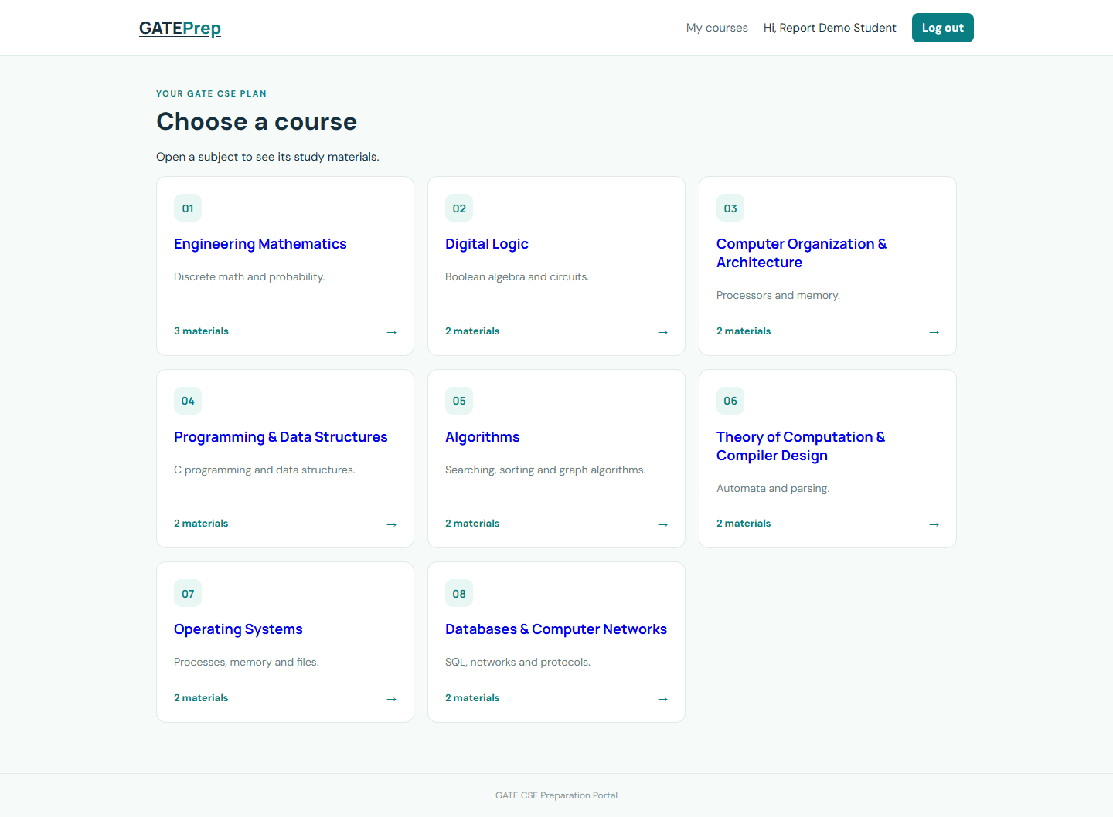
Figure 3.3: Student view of the eight GATE CSE course groups

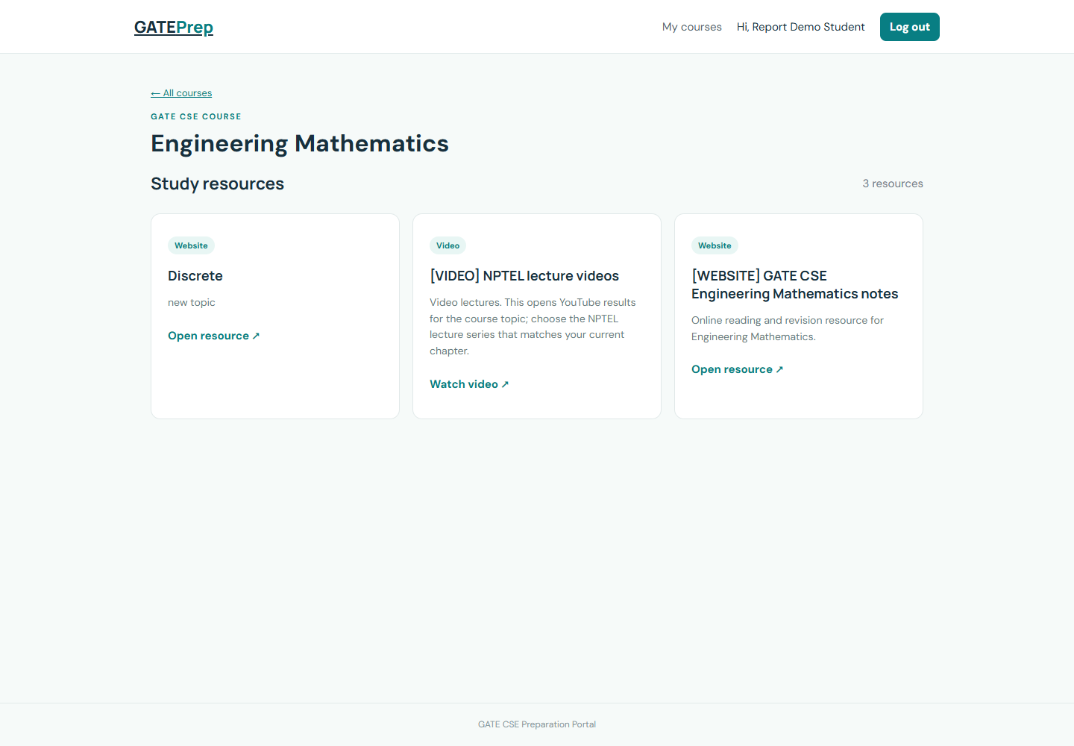
Figure 3.4: Course resource listing

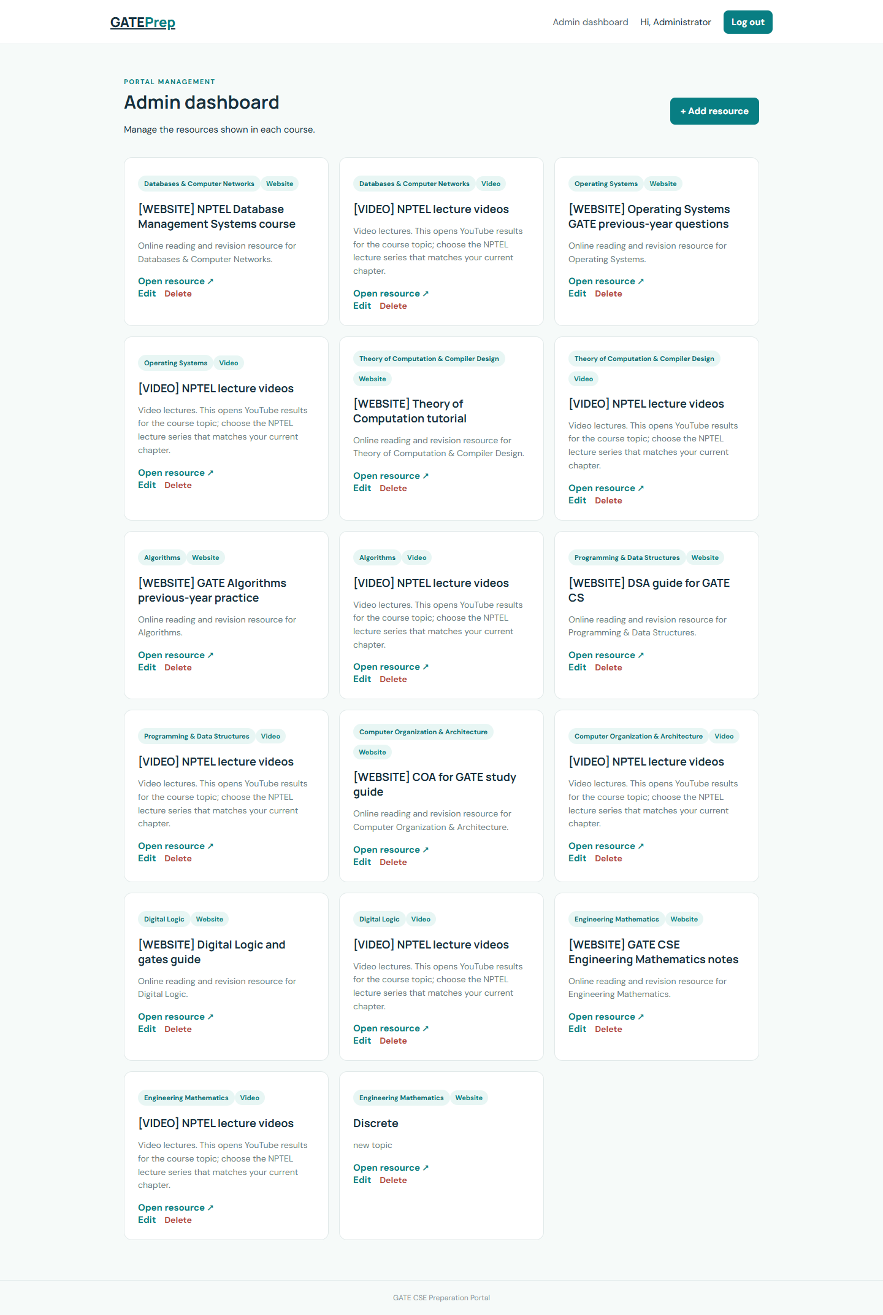
Figure 3.5: Administrator dashboard for resource management

3.1 RESULT SUMMARY
The portal starts locally, connects to MongoDB and serves the landing page. Student registration and login lead to the course area, where the eight subject groups are available. Administrator login opens the resource dashboard. Resources can be created, listed, edited and deleted, and course pages show matching resource records. The screenshots document these visible interfaces.

CHAPTER 4
CONCLUSION

4.1 SUMMARY OF THE PROJECT
The GATE CSE Preparation Portal was developed to provide students with a single place to find learning links arranged by subject. The portal brings together eight course groups: Engineering Mathematics, Digital Logic, Computer Organization and Architecture, Programming and Data Structures, Algorithms, Theory of Computation and Compiler Design, Operating Systems, and Databases and Computer Networks. This organization makes it easier for students to identify the materials relevant to the topic they are studying.

4.2 FEATURES COMPLETED
The student workflow supports account registration, login, course browsing and viewing course-specific resources. The administrator workflow supports adding, viewing, editing and deleting website or video resources. These are the four basic CRUD operations. A resource added by an administrator is stored in MongoDB and can then be displayed to students under its selected course. Updates and deletions are reflected in later database reads, keeping the course pages aligned with the maintained resource list.

4.3 CONCEPTS DEMONSTRATED
The project demonstrates how a Flask application connects URL routes to Python functions and uses templates to render dynamic HTML pages. Forms pass user input to the server, where the application validates values before saving them. PyMongo connects the application to MongoDB collections and performs inserts, queries, updates and deletes. Password hashing avoids storing plain-text passwords, while Flask sessions remember a signed-in user. Role checks protect administrator functions from student accounts. Together, these concepts show how a small web application can be divided into clear request, validation, storage and presentation steps.

4.4 CURRENT SCOPE AND LIMITATIONS
The current implementation focuses on account access, course-wise study links and administrator-managed resource records. The resource types currently supported are website and video links. It does not automatically collect questions or materials from the internet, conduct mock examinations, upload PDF files, generate personalized study schedules, or calculate student performance analytics. Stating this scope clearly distinguishes working features from proposed extensions and provides a practical baseline for future development.

4.5 FUTURE ENHANCEMENTS
The portal can be extended with structured notes and administrator-uploaded PDF materials, provided file type and size are validated and storage is handled safely. A study planner could let students set subject goals and mark planned topics as complete. Progress tracking could record completed resources and revision status. Mock tests could use a curated and reviewed question bank, store attempts, and show scores by subject or topic. Revision reminders and performance summaries could then help students decide which topics to revisit. Each enhancement should have its own data model, validation rules and user interface so that it integrates cleanly with the existing CRUD workflows.

4.6 FINAL REMARKS
The completed project provides a useful foundation for a GATE CSE preparation portal and a clear demonstration of Flask and MongoDB in a student-level web application. Its central resource catalog addresses the basic need to organize study links, while separate student and administrator roles give each user an appropriate set of actions. The application can be run and extended incrementally: first by adding verified learning content, and later by introducing planning, revision and assessment features. The project therefore meets its present CRUD-focused objective and leaves a structured path for further improvement.

REFERENCES
Flask Documentation, https://flask.palletsprojects.com/
MongoDB Manual, https://www.mongodb.com/docs/manual/
PyMongo Documentation, https://www.mongodb.com/docs/languages/python/pymongo-driver/current/
Werkzeug Security Helpers, https://werkzeug.palletsprojects.com/en/stable/utils/

APPENDIX A — FLASK APPLICATION SOURCE (app.py)
Source file: app.py
import os
from functools import wraps
from flask import Flask, session, request, redirect, url_for, render_template, flash, abort
from werkzeug.security import generate_password_hash, check_password_hash
from pymongo import MongoClient, ASCENDING
from pymongo.errors import DuplicateKeyError
from bson import ObjectId
app = Flask(__name__); app.secret_key = os.environ.get("SECRET_KEY", "change-this-secret")
client = MongoClient(os.environ.get("MONGO_URI", "mongodb://127.0.0.1:27017"), serverSelectionTimeoutMS=3000); client.admin.command("ping")
mongo = client[os.environ.get("MONGO_DB", "gate_prep")]
# Eight GATE CSE course groups
COURSES = [
("engineering-mathematics","Engineering Mathematics","Discrete math and probability."), ("digital-logic","Digital Logic","Boolean algebra and circuits."),
("computer-organization","Computer Organization & Architecture","Processors and memory."), ("programming-data-structures","Programming & Data Structures","C programming and data structures."),
("algorithms","Algorithms","Searching, sorting and graph algorithms."), ("toc-compiler-design","Theory of Computation & Compiler Design","Automata and parsing."),
("operating-systems","Operating Systems","Processes, memory and files."), ("dbms-networks","Databases & Computer Networks","SQL, networks and protocols.")]
TYPES = {"website":"Website", "video":"Video"}
mongo.users.create_index("email", unique=True)
admin_email = os.environ.get("ADMIN_EMAIL", "admin@gate.local").lower()
if not mongo.users.find_one({"email": admin_email}):
mongo.users.insert_one({"name":"Administrator","email":admin_email,"password_hash":generate_password_hash(os.environ.get("ADMIN_PASSWORD","admin123")),"role":"admin"})
def records(items): return [dict(item, id=str(item["_id"])) for item in items]
def need(role=None):
def decorate(view):
@wraps(view)
def check(*args, **kwargs):
if not session.get("user_id"): return redirect(url_for("login"))
if role and session.get("role") != role: abort(403)
return view(*args, **kwargs)
return check
return decorate
@app.route("/")
def index():
if session.get("role"): return redirect(url_for("admin" if session["role"]=="admin" else "courses"))
return render_template("index.html", courses=COURSES)
@app.route("/register", methods=["GET","POST"])
def register():
if request.method == "POST":
name=request.form["name"].strip(); email=request.form["email"].strip().lower(); pw=request.form["password"]
if len(pw)<6: flash("Password needs at least 6 characters.","error")
else:
try:
user={"name":name,"email":email,"password_hash":generate_password_hash(pw),"role":"user"}
user_id=mongo.users.insert_one(user).inserted_id
session.update(user_id=str(user_id),name=name,role="user")
return redirect(url_for("courses"))
except DuplicateKeyError: flash("Email already registered.","error")
return render_template("register.html")
@app.route("/login", methods=["GET","POST"])
def login():
if request.method == "POST":
role={"admin":"admin","student":"user"}.get(request.form["account_type"])
user=mongo.users.find_one({"email":request.form["email"].strip().lower()})
if role and user and user["role"]==role and check_password_hash(user["password_hash"],request.form["password"]):
session.clear(); session.update(user_id=str(user["_id"]),name=user["name"],role=role)
return redirect(url_for("admin" if role=="admin" else "courses"))
flash("Check account type, email, and password.","error")
return render_template("login.html")
@app.route("/logout")
def logout(): session.clear(); return redirect(url_for("index"))
@app.route("/courses")
@need("user")
def courses():
counts={c[1]:mongo.materials.count_documents({"subject":c[1]}) for c in COURSES}
return render_template("courses.html",courses=COURSES,counts=counts)
@app.route("/courses/<slug>")
@need("user")
def course(slug):
selected=next((c for c in COURSES if c[0]==slug),None)
if not selected: abort(404)
items=records(mongo.materials.find({"subject":selected[1]}).sort("title",1))
return render_template("course.html",course=selected,materials=items,resource_types=TYPES)
@app.route("/admin")
@need("admin")
def admin(): return render_template("admin.html",materials=records(mongo.materials.find().sort("_id",-1)),resource_types=TYPES)
@app.route("/admin/material/new",methods=["GET","POST"])
@app.route("/admin/material/<item_id>/edit",methods=["GET","POST"])
@need("admin")
def resource_form(item_id=None):
item=mongo.materials.find_one({"_id":ObjectId(item_id)}) if item_id and ObjectId.is_valid(item_id) else None
item_id and not item and abort(404)
if request.method=="POST":
title=request.form["title"].strip(); subject=request.form["subject"]
desc=request.form["description"].strip(); url=request.form["url"].strip(); kind=request.form["resource_type"]
if not title or not desc or not url or subject not in [c[1] for c in COURSES] or kind not in TYPES:
flash("Complete all fields and choose a valid course and type.","error")
else:
values={"title":title,"subject":subject,"description":desc,"url":url,"resource_type":kind}
mongo.materials.update_one({"_id":item["_id"]},{"$set":values}) if item else mongo.materials.insert_one(values)
return redirect(url_for("admin"))
item=records([item])[0] if item else None
return render_template("material_form.html",material=item,courses=COURSES,resource_types=TYPES)
@app.post("/admin/material/<item_id>/delete")
@need("admin")
def delete_resource(item_id):
if not ObjectId.is_valid(item_id): abort(404)
mongo.materials.delete_one({"_id":ObjectId(item_id)})
return redirect(url_for("admin"))
if __name__=="__main__":
app.run(debug=True)

APPENDIX B — HTML TEMPLATE: admin.html
Source file: templates/admin.html
{% extends "base.html" %}{% block title %}Admin dashboard{% endblock %}{% block content %}<div class="row"><div><div class="kicker">PORTAL MANAGEMENT</div><h1>Admin dashboard</h1><p>Manage the resources shown in each course.</p></div><a class="btn" href="/admin/material/new">+ Add resource</a></div><section class="grid">{% for m in materials %}<article class="card"><label>{{m.subject}}</label><span class="resource-badge">{{resource_types.get(m.resource_type,'Website')}}</span><h3>{{m.title}}</h3><p>{{m.description}}</p><a href="{{m.url}}" target="_blank" rel="noopener">Open resource ↗</a><div class="actions"><a href="/admin/material/{{m.id}}/edit">Edit</a><form method="post" action="/admin/material/{{m.id}}/delete" onsubmit="return confirm('Delete this resource?')"><button class="link danger">Delete</button></form></div></article>{% else %}<div class="empty">No resources yet. Add a website or video link.</div>{% endfor %}</section>{% endblock %}

APPENDIX C — HTML TEMPLATE: base.html
Source file: templates/base.html
<!doctype html><html lang="en"><head><meta charset="utf-8"><meta name="viewport" content="width=device-width,initial-scale=1"><title>{% block title %}GATE Prep{% endblock %} | GATE CSE</title><link rel="stylesheet" href="{{url_for('static',filename='style.css')}}"></head><body><header><a class="brand" href="/">GATE<span>Prep</span></a><nav>{% if session.get('role')=='user' %}<a href="/courses">My courses</a>{% elif session.get('role')=='admin' %}<a href="/admin">Admin dashboard</a>{% else %}<a href="/">Home</a><a href="/login">Log in</a>{% endif %}{% if session.get('user_id') %}<span>Hi, {{session.get('name')}}</span><a class="btn small" href="/logout">Log out</a>{% else %}<a class="btn small" href="/register">Register</a>{% endif %}</nav></header><main>{% with ms=get_flashed_messages(with_categories=true) %}{% for c,m in ms %}<div class="flash {{c}}">{{m}}</div>{% endfor %}{% endwith %}{% block content %}{% endblock %}</main><footer>GATE CSE Preparation Portal</footer></body></html>

APPENDIX D — HTML TEMPLATE: course.html
Source file: templates/course.html
{% extends "base.html" %}{% block title %}{{course[1]}}{% endblock %}{% block content %}<a class="back-link" href="/courses">← All courses</a><div class="kicker">GATE CSE COURSE</div><h1 class="page-title">{{course[1]}}</h1><div class="row"><h2>Study resources</h2><span>{{materials|length}} resources</span></div><section class="grid">{% for m in materials %}<article class="card"><span class="resource-badge">{{resource_types.get(m.resource_type,'Website')}}</span><h3>{{m.title}}</h3><p>{{m.description}}</p><a class="resource-action" href="{{m.url}}" target="_blank" rel="noopener noreferrer">{% if m.resource_type=='video' %}Watch video ↗{% else %}Open resource ↗{% endif %}</a></article>{% else %}<div class="empty">No resources for this course yet.</div>{% endfor %}</section>{% endblock %}

APPENDIX E — HTML TEMPLATE: courses.html
Source file: templates/courses.html
{% extends "base.html" %}{% block title %}Your courses{% endblock %}{% block content %}<div class="kicker">YOUR GATE CSE PLAN</div><h1 class="page-title">Choose a course</h1><p class="muted">Open a subject to see its study materials.</p><section class="grid">{% for c in courses %}<a class="card course-card course-link" href="{{url_for('course',slug=c[0])}}"><span class="number">{{"%02d"|format(loop.index)}}</span><h3>{{c[1]}}</h3><p>{{c[2]}}</p><span class="course-count">{{counts.get(c[1],0)}} materials <b>→</b></span></a>{% endfor %}</section>{% endblock %}

APPENDIX F — HTML TEMPLATE: index.html
Source file: templates/index.html
{% extends "base.html" %}{% block title %}GATE CSE Prep{% endblock %}{% block content %}<section class="hero"><div class="kicker">GATE CSE STUDY SPACE</div><h1>Build strong concepts.<br><em>One topic at a time.</em></h1><p>Eight focused course areas to organize your GATE CSE preparation.</p><div class="hero-actions"><a class="btn" href="/register">Get started</a><a class="btn secondary" href="/login">Log in</a></div></section><div class="row"><div><div class="kicker">THE SYLLABUS</div><h2>Eight course areas</h2></div></div><section class="grid">{% for c in courses %}<article class="card course-card"><span class="number">{{"%02d"|format(loop.index)}}</span><h3>{{c[1]}}</h3><p>{{c[2]}}</p></article>{% endfor %}</section>{% endblock %}

APPENDIX G — HTML TEMPLATE: login.html
Source file: templates/login.html
{% extends "base.html" %}
{% block title %}Login{% endblock %}
{% block content %}
<form class="form card" method="post">
<div class="kicker">PORTAL ACCESS</div>
<h1>Log in</h1>
<p class="muted">Select your account type and enter your credentials.</p>

<label>Login as
<select name="account_type" required>
<option value="student">Student</option>
<option value="admin">Admin</option>
</select>
</label>
<label>Email<input name="email" type="email" required autocomplete="username"></label>
<label>Password<input name="password" type="password" required autocomplete="current-password"></label>
<button class="btn">Log in</button>
<p>New student? <a href="/register">Create an account</a></p>
</form>
{% endblock %}

APPENDIX H — HTML TEMPLATE: material_form.html
Source file: templates/material_form.html
{% extends "base.html" %}{% block title %}Resource{% endblock %}{% block content %}<form class="form card" method="post"><a class="back-link" href="/admin">← Admin dashboard</a><h1>{{'Edit' if material else 'Add'}} resource</h1><label>Title<input name="title" required value="{{material.title if material else ''}}"></label><label>Course<select name="subject" required><option value="">Choose a course</option>{% for c in courses %}<option value="{{c[1]}}" {% if material and material.subject==c[1] %}selected{% endif %}>{{c[1]}}</option>{% endfor %}</select></label><label>Description<textarea name="description" rows="4" required>{{material.description if material else ''}}</textarea></label><label>Resource type<select name="resource_type" required>{% for key,label in resource_types.items() %}<option value="{{key}}" {% if material and material.resource_type==key %}selected{% endif %}>{{label}}</option>{% endfor %}</select></label><label>Resource URL<input name="url" type="url" required value="{{material.url if material else ''}}" placeholder="https://..."></label><button class="btn">Save resource</button></form>{% endblock %}

APPENDIX I — HTML TEMPLATE: register.html
Source file: templates/register.html
{% extends "base.html" %}{% block title %}Student registration{% endblock %}{% block content %}<form class="form card" method="post"><div class="kicker">STUDENT ACCOUNT</div><h1>Create account</h1><label>Name<input name="name" required></label><label>Email<input name="email" type="email" required></label><label>Password (6+ characters)<input name="password" type="password" minlength="6" required></label><button class="btn">Register and start</button><p>Already registered? <a href="/login/student">Student login</a></p></form>{% endblock %}

