IBM NORC Simulator User’s Guide
24-Jul-2021

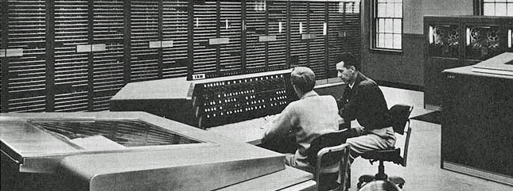

COPYRIGHT NOTICE

The following copyright notice applies to the SIMH source, binary, and documentation:
Original code published 1993-2012, written by Robert M Supnik
Copyright © 1993-2012, Robert M Supnik
Copyright © 2020-2021, Roberto Sancho
Permission is hereby granted, free of charge, to any person obtaining a copy of this software and associated documentation files (the "Software"), to deal in the Software without restriction, including without limitation the rights to use, copy, modify, merge, publish, distribute, sublicense, and/or sell copies of the Software, and to permit persons to whom the Software is furnished to do so, subject to the following conditions:
The above copyright notice and this permission notice shall be included in all copies or substantial portions of the Software.
THE SOFTWARE IS PROVIDED "AS IS", WITHOUT WARRANTY OF ANY KIND, EXPRESS OR IMPLIED, INCLUDING BUT NOT LIMITED TO THE WARRANTIES OF MERCHANTABILITY, FITNESS FOR A PARTICULAR PURPOSE AND NONINFRINGEMENT. IN NO EVENT SHALL THE AUTHORS BE LIABLE FOR ANY CLAIM, DAMAGES OR OTHER LIABILITY, WHETHER IN AN ACTION OF CONTRACT, TORT OR OTHERWISE, ARISING FROM, OUT OF OR IN CONNECTION WITH THE SOFTWARE OR THE USE OR OTHER DEALINGS IN THE SOFTWARE.
Except as contained in this notice, the names of the authors shall not be used in advertising or otherwise to promote the sale, use, or other dealings in this Software without prior written authorization from the authors.

1 Introduction 3
1.1 The IBM NORC Naval Ordnance Research Computer 3
1.2 Simulator Files 4
2 Simulator Features 5
2.1 Hardware-Equivalent Actions 5
2.2 Simulator Specific Commands 6
2.2.1 Word Display and Entry 6
2.2.2 RUN and GO 7
2.2.3 STEP and SubOperations 7
2.2.4 Device Configuration 9
2.2.5 Enabling and Disabling Devices 9
2.3 Tracing Simulator Operations 10
3 Processor Device Simulations 11
3.1 Central Processing Unit 11
3.1.1 Speed 11
3.1.2 Simulation Stops 13
3.1.3 Mnemonics 13
3.1.4 Tracing 13
3.1.5 Registers 13
3.1.6 Additional instructions 14
3.1.7 LOAD a program 15
3.1.8 Symbolic Information 16
3.1.9 Symbolic trace 17
3.1.10 Console Switches and Buttons 19
3.1.11 Other Console Switches and Buttons 22
3.2 Magnetic Tape (MT) 24
3.3 On Line Printers (LP) 25
3.4 Card-to-Tape-to-Card (CTC) 26
3.4.1 Punching Cards 26
3.4.2 Punched cards character set 28
3.4.3 Creating a Tape from Cards / Dumping Tape to Cards 29
3.4.4 Printing Cards offline 30
4 Software Support 31
5 Simulator Usage 32
5.1 Assemble and Run a Program 32
5.2 Available Software 33
5.2.1 Sample Programs 33
5.2.2 PERT 33
5.3 Running demo script 35
5.4 File extensions 35
6 Control Panel 36
6.1 Introduction 36
6.2 Available Control Panels 36
6.1 Control Panel areas 37
6.2 Control Panel size and position 38
6.3 Control Panel HotKeys 38
6.3.1 Control T – Toggle Marks 39
6.3.2 Control I – Show Information Panel 39
6.3.3 Control F – Fast Mode 40
6.4 Control Panel usage 41
6.5 Interactive Mode 42
6.6 Tape Options 44
6.7 Console Keyboard 45
6.8 Additional comments 45
6.8.1 Speed Measurement 45
6.9 Control Panel usage example 46
6.10 Demo scripts 48
7 Version History 49

Introduction
This manual documents the features and operation of the IBM NORC simulator. It is intended for use in conjunction with the SIMH Users' Guide manual, which describes how to compile and run the simulator, as well as the general commands that may be entered at the Simulation Control Program (SCP) prompt.

The IBM NORC Naval Ordnance Research Computer
The IBM Naval Ordnance Research Calculator (NORC) was a one-of-a-kind first-generation (vacuum tube) computer built by IBM for the United States Navy's Bureau of Ordnance. It went into service in December 1954[1] and was likely the most powerful computer at the time.[2] The Naval Ordnance Research Calculator (NORC), was built at the Watson Scientific Computing Laboratory under the direction of Wallace Eckert

IBM made several enhancements during the life of the computer

- 1954:
  - 2000 words of memory, based on Williams CRT

- 1955:
  - 3600 words of memory, based on Williams CRT
  - Additional instructions?

- 1957:
  - High Speed Printer based on the Charactron cathode ray tube

- 1960:
  - 20.000 words of core memory

Reading or writing a word in memory takes 8 microseconds (called the access time in NORC programming manual). The basic machine cycle is one microsecond (clock is 1 MHz).

Simulator Files
The simulator sources are divided into a set of files for the Simulator Control Program and its support libraries, and a set of files for the IBM NORC CPU and device simulations; the latter reside in a subdirectory of the directory that contains the SCP files. The former set is common to all SIMH simulators, whereas the latter set is specific to the virtual machine being simulated. The files that make up this simulator are:

Subdirectory | File | Contains
NORC | NORC_defs.h | System architectural declarations
 | NORC_sys.c | SCP interface
 | NORC_cpu.c | Main CPU simulator
 | NORC_ctc.c | IBM Card-Tape-Card simulator
 | NORC_lp.c | On Line printers
 | NORC_mt.c | IBM NORC tape simulator
 | NORC_cpanel.c | IBM NORC Control Panel
 | cpanel.c | Control Panel interface
 | cpanel.h | Control Panel declarations
 | cpanel_vid.c | Control Panel video interface
 | cpanel_vid.c | Control Panel video declarations
 | NORC_doc.doc | Documentation (this file)
 | NORC_test.ini | Executes all the sw rest-run scripts
NORC / cpanel |  | Contains the control panel image bitmaps
NORC / test |  | Contains the simulator test suite
NORC / sw |  | Contains the included software and test run script files (See usage section)

PDF files for IBM NORC programming manual is available in Bitsavers repository: http://www.bitsavers.org/

The NORC hardware is described in the book “Faster, faster” (Eckert, W. J, 1955) available Hathitrust in repository: https://babel.hathitrust.org/

Simulator Features
The IBM NORC simulator contains the following device simulations:

Device Name(s) | Simulates
CPU | IBM NORC Calculator  2K word or 3,6K drum
CTC | Card-Tape-Card Machine
LP1 and LP2 | On Line printers attached to NORC
MT1 to MT8 | IBM NORC Magnetic Tape

The simulator has been tested with and supports the following software:
- Samples from programming manual and faster, faster book
- Special Project Office PERT

The simulator also provides extensive facilities for tracing CPU and I/O device operations.

Hardware-Equivalent Actions
To use simulated IBM NORC two interfaces are available

- Commands that can be entered through the simulation console at sim> prompt

- Pressing buttons and moving switches on simulation control panel GUI

The following table describes the SCP commands and their equivalent action on real hardware. For control panel actions, see the Control Panel section on this manual.

Hardware Console Action | Equivalent Simulation Command
Set V register contents | DEPOSIT V <address>
Set Console Option 74 to 79 | SWITCH SW74 .. 79 OFF | STOP | TRANSFER
Display Register1 | EXAMINE REG1
Set register1 | DEPOSIT REG1 <value>
Display CRT Storage contents | EXAMINE <address>
Set a contents of CRT Storage | DEPOSIT <address> <value>
Set Tape address to unit 2 | SWITCH "Tape address 01" TO MT2
Set Program Check switch | SWITCH "Program Check" TO PROCEED | STOP
Press START Key | GO
Press STOP Key | ^E on console
Clear CRT storage | SET CPU CRTMEMCLEAR

Mounting media on a peripheral device is simulated by the ATTACH command. For example, entering the ATTACH MT1 <tape-image-filename> command is equivalent to mounting and loading a tape reel on the physical tape Unit 1.

Simulator Specific Commands
In general, all of the commands documented in the SIMH Users' Guide manual are available for use with the IBM NORC simulator. Commands whose execution or parameters are implementation-defined are specified below.

Word Display and Entry
When examining or depositing into memory, command line switches specifying the format may be used to override the default numeric mode, as follows:

Switch | Mode Interpretation
–W | 4 groups of 4 digits
–F | Float number format
–M | Machine instruction format

Note that IBM NORC supports no mnemonics, no character and no sign in memory words. Just 16 decimal digits 0 to 9

If neither switch is used, the normal 16-digit decimal form is assumed. Digits can be separated by spaces for ease of reading. If number has less than 16 digits, it is assumed to have leading zeroes. Values are displayed as 16 adjacent digits.

Memory addresses are entered as 4 decimal digits without intervening spaces.

Examples

examine 0100
100: 9988777766665555

examine –w 0100
100: 9988 7777 6666 5555

examine –f 0100
100: 99 8 8777766665555

examine –m 0100
100: 99 8 8777766665555

deposit 0100 00 40 1223 0000 5544
examine 0100
100: 0040122300005544

The DEPOSIT and EXAMINE SCP command accepts addresses from 0 to 1999, or to 3599 depending on the size of memory.

RUN and GO
The RUN and GO commands do not accept any parameter addresses. Execution will start at the address specified by the V register.

On real NORC hardware, each instruction is broken up into a sequence of steps called SubOperations. SimH simulation is done at SubOperation level.

The IBM NORC does not have a Program Counter/Instruction Counter register.

Register V indicates the address of the instruction to be loaded in the Instruction Register (IREG) for decoding and execution. V is thus acting as the Program Counter on the Read Instruction SubOperations.

However, V register is also the selection address for any CRT memory access, so V changed if instruction does a memory read or write. As the simulator reproduces this behavior, V cannot be used as a Program Counter.

SimH relies on an Instruction Counter for command display of user information. For example, when the CPU stops, the simulator uses the program counter to display the current instruction address and mnemonic on the simulation console.

To permit this, a fictional IC register (Instruction Counter) has been added to the simulation even though it has no equivalent on real hardware. This register keeps track of the address of the current instruction for display purposes.

As this IC register has no use in the simulated CPU, altering its value has no effect. This is why it is necessary to deposit the address in the V register to set the address of the next instruction to execute.

The RUN command does an implied RESET. All register except V are set to zero. Memory is NOT zeroed.

When RUN command is used, execution starts at first SubOperation of the instruction addressed by the V register value.

When GO command is used, execution continues with next SubOperation of current instruction. If current instruction has finished, GO proceeds with first SubOperation of the instruction addressed by the V register value.

The GO command is equivalent to pressing the START key on the console and is the way to start or resume execution after a programmed stop or a program check stop.

STEP and SubOperations
The STEP command is used to execute program step by step

By default, STEP will execute one complete instruction at once. if SET CPU STEPSUBOP command has been previously issued, STEP will execute only one SubOperation at once. The SubOperation counter NSUBOP will be displayed automatically if it is in the middle of an instruction

sim> dep v 1
sim> set cpu StepSubOp
sim> step

Step expired, IC: 00001 (00 22 2030 1000 0395 - NSUBOP 2)
sim> step

Step expired, IC: 00001 (00 22 2030 1000 0395 - NSUBOP 3)
sim> step

Step expired, IC: 00001 (00 22 2030 1000 0395)
sim> ex v
V: 00002

The SET CPU STEPINSTR command allows the STEP to execute back instructions at once.

The command DEPOSIT V will also reset the current SubOperation counter (NSUBOP) so STEP/GO will proceed with next instruction from its first SubOperation

The following are the SCP commands that resets the SubOperation counter:
- DEPOSIT V
- RESET
- PRESS “SubOp Reset”
- SET CPU CRTMEMCLEAR or the equivalent PRESS “CRT Reset”

The SCP command EXAMINE NSUBOP will show the SubOperation counter and the already executed ones:

sim> dep v 1
sim> step

Step expired, IC: 00001 (00 22 2030 1000 0395)
sim> ex nsubop
NSUBOP: 0
- Read Instruction
- Decode
- Read Operand 1
- Read Operand 2
- Float Operands
- Sub
- Shift Result
- Terminate
- Operation Completed

Also this can be done on a SubOperation basis:

sim> set cpu stepsubop
sim> dep v 1
sim> st

Step expired, IC: 00001 (00 22 2030 1000 0395 - NSUBOP 2)
sim> ex nsubop
NSUBOP: 2
- Read Instruction
sim> st

Step expired, IC: 00001 (00 22 2030 1000 0395 - NSUBOP 3)
sim> ex nsubop
NSUBOP: 3
- Read Instruction
- Decode
sim> st

Step expired, IC: 00001 (00 22 2030 1000 0395 - NSUBOP 4)
sim> ex nsubop
NSUBOP: 4
- Read Instruction
- Decode
- Read Operand 1
sim> st

Step expired, IC: 00001 (00 22 2030 1000 0395 - NSUBOP 5)
sim> ex nsubop
NSUBOP: 5
- Read Instruction
- Decode
- Read Operand 1
- Read Operand 2
sim>

During the execution of an instruction, a given SubOperation can be skipped if not needed (say Read Operand 1 if instruction field R is blank). NSUBOP is the number of next subop to execute, but not the number of executed SubOperations:

Step expired, IC: 00001 (00 22 0000 1000 0395 - NSUBOP 5)
sim> ex nsubop
NSUBOP: 5
- Read Instruction
- Decode
- Read Operand 2
sim>

If the SubOperation counter is manually reset, no SubOperation will be displayed:

Step expired, IC: 00001 (00 22 0000 1000 0395 - NSUBOP 5)
Sim> dep v 1 <- This resets the SubOperation counter
sim> ex nsubop
NSUBOP: 0
sim>

Device Configuration
Most devices support user configuration. The general forms of the configuration commands are:
SET [<switch> ...} <device> <option> [,<option> ..]
SET [<switch> ...] <unit> <option> [,<option> ...]
The options available and applicable switches are described in the individual device descriptions below.

Enabling and Disabling Devices
All devices other than the CPU and CTC may be disabled or enabled. Disabling a device simulates putting offline the associated equipment from the main CPU console. To disable or enable a device, use:

Command | Action
SET <device> DISABLED | Disable the device
SET <device> ENABLED | Enable the device

MTn (magnetic tape) and LPn (printer units) are enabled by default

Tracing Simulator Operations
The simulator provides options for extensive tracing of the internal operations of selected devices. This is useful as an aid to hardware and software debugging as well as to gain an understanding of the internal operations of the simulated devices. Devices offer multiple trace reporting levels, from command overviews to detailed operation. Tracing for each device and its separate reporting levels may be enabled independently.

To obtain a trace, two SCP commands must be given.

First, a debug log must be established with the SET DEBUG <target> command. This command is described in detail in the “Controlling Debugging” section of the SIMH Users' Guide manual. The target can be a text file, so that the trace may be reviewed after capture, or stdout to display the trace data on the console as it is generated.

Second, tracing must be enabled for the desired devices with SET <device> DEBUG=<option> commands. The formats of the trace outputs are specific to the devices being traced. All traces for a device can be enabled at once with a SET <device> DEBUG command.

Tracing does impose some overhead on the simulator, with more detailed tracing slowing the simulator more than higher-level tracing. No overhead is incurred when tracing is suspended with the SET NODEBUG command, even if individual device tracing options remain in effect.

When all the debug traces are set, a sensible overhead is produced, and a very big debug file is generated (as much as 20 MB per minute)

Processor Device Simulations

Central Processing Unit
The CPU is configured with commands of the form:

SET CPU <option>

Device options that may be specified are:

Option | Action
2K | Set the CRT memory size to 2000 words
3K | Set the CRT memory size to 3600 words (default)
CRTMEMCLEAR | Clear CRT memory, set V=0
DEBUG=<option> | Enable tracing
NODEBUG | Disable tracing (default)
STEPINSTR | Enable STEP to step on each instruction
STEPSUBOP | Enable STEP to step on each SubOperation
FAST | Execute all SubOperations in one cycle
REALTIME | Simulate real number of cycles (default)
SPEED | Set simulated CPU speed

The command

RESET CPU

Will do the following actions:
- Clear REG1, REG1, IREG, M4, M6, M8 registers
- DO NOT clear V register, Do NOT clear CRT memory
- reset SubOp counter to zero
- Clear all indicator lights, flag lights
- Set all tapes as ready (terminate any pending/in progress operation), set printer as ready (terminate any pending /in progress printing cycle)

Speed
Main computer clock operates at 1 MHz, 1 microsecond each cycle. This defines the basic timing interval of the CPU.

On average, instructions need 70 cycles to execute. This means that on real hardware, the average execution speed is around 14000 instructions per second (IPS).

Nevertheless, on real applications, achieved IPS can be lower, mainly because I/O is SYNCHRONOUS with CPU: while Tape is operating (read or write), the CPU is not executing instructions.

The tape I/O instructions terminate its execution when all data has been transfer from/to tape. This means that the instruction can last as much as several minutes of execution time.

The user can disable the simulation of execution time, so all instructions will need only one cycle to execute.

SET CPU FAST each instruction needs only one cycle to execute
SET CPU REALTIME simulate real number of cycles times needed by instruction
to execute (default)

To allow setting the simulated CPU speed a new SCP command is defined;

SET CPU SPEED=n.n Set the simulated CPU speed to n.n times the speed of real hardware (i.e speed is relative to original IBM NORC speed)

Depending on n.n value, it is possible to set the simulated speed. If n.n is …

- Set simulated speed to be the same as in real hardware(1 microsecond cycle time)

2.0 Set to double of real hardware speed

0.5 Set to half of real hardware speed

Up to two decimal digits are permitted. Value 0.0 is not allowed. Range goes from as low as 0.01 (one hundred times slower) to 100.0 (100 times faster).

Maximum speed is set using the form

SET CPU SPEED=MAX Simulated CPU runs al maximum speed allowed by host

The current value of speed setting can be show using the command

SHOW CPU SPEED Display Speed relative to original hardware, the current speed in MHz, the number of IPS executed per second. All of these figures are wall clock time

Example output:

Measured speed: Clock at 1.00 MHz
Speed is x1.0 relative to original hardware
14525 Instructions per second (IPS) achieved
run elapsed 6.7 sec (6734 msec)

The measurements are done taking into account the total number of instructions executed in the last run. On this context last run is time elapsing between cpu started (either by a GO or RUN SCP command), until cpu is stopped and control returned to SCP (either to continue a script execution or to command prompt)

If no data measured (not run yet, executing step by step) the SCP command SHOW CPU SPEED will only display first output line indicating the speed setting.

On startup, the simulator defaults to MAX speed.

Simulation Stops
The IBM NORC simulator implements several unique stop conditions:

Programed STOP
Operation code check
Invalid Address
Float number index is invalid
Float number sign is invalid
Division by zero
Tape operative check error
End of tape check error
Host os i/o error
Printer operative check

Mnemonics
IBM NORC has no defined mnemonics for its instructions. The documentation refers to them by a long name, and a 2-digit operation code.

This simulation as well does not define any mnemonic. As a tool, a simple assembler has been written, that support mnemonics for some most common instructions.

Tracing
When a debug log has been established, tracing may be configured by specifying one or more of the reporting level options:

Option | Reporting Level
CMD | Opcode instructions executed
DATA | Memory data accesses
DETAIL | Register values or processing information

Registers
The CPU state contains the registers visible to the programmer:

Name | Size | Description
V | 4 | V register
U | 4 | U register
M4 | 4 | Address Modifier M4
M6 | 4 | Address Modifier M6
M8 | 4 | Address Modifier M8
IREG | 16 | Instruction Register
REG1 | 16 | Storage Register 1
REG2 | 16 | Storage Register 2

Size is given in digits, not in bits. If size is 1, only 0 and 1 values are allowed. There is no sign bit.

The CPU state has a number of flags that are can be checked on a program with the appropriate instruction. There are defined to be available to SCP to allow scripting on its state:

Name | Size | Description
OV | 1 | Overflow flag
ZR | 1 | Zero result flag
IA | 1 | Index Adjust
TEOF | 1 | Tape End of file flag
TCHK | 1 | Tape check flag

In addition, these pseudo register are implemented in simulator for convenience

Name | Size | Description
IC | 4 | Current Instruction address (read/only)
NSUBOP | 2 | Current SubOperation (read/only)
CPANELGUI | 1 | Returns 0 if simulator is compiled without Control Panel GUI. Returns 1 if simulator supports Control Panel

These pseudo registers does not exists in real hardware, but are useful for SCP scripting.

Additional instructions
During the life of NORC its instruction set has been upgraded several times. Sadly no documentation at all (at dec 2020) is available on that.

Nevertheless, the PERT absolute listing includes some opcodes not described in programming manual. By carefully analyzing the program it is possible to deduct the opcode operation.
- New Opcode 42. Proposed name: META MASK
Apply to C(R) the mask on C(S), then shift result on P
Digits in operand 2 are scanned. If digit is zero, the corresponding digit in result is zeroed. If digit in operand 2 is NOT zero (any value), the digit in result is taken unchanged from operand 1. Shifting of result is allowed
- Enhanced Opcodes 40 and 41. META ADD / META SUB

Shifting result is allowed on META operations
- New Opcode 59. Proposed name: Transfer Address Modifiers to REG1

Transfer Current value of Address Modifiers Registers to REG1 as
0000 M4 M6 M8 → REG1
- Enhanced Opcode 58: LOOP

P field in instruction word allows to indicate the Address Modifier used in instruction 58. If P=00 or P=04 then M4 Address Modifier is used, if P=06 then M6 is used, if P=08 then M8 is used. Any other value of P triggers an Operation Code Check and CPU stops

LOAD a program
SCP command LOAD has been implemented. LOAD has no equivalent on real hardware as the input device for loading programs is the magnetic tape.

LOAD is very convenient for loading programs on CPU using text files and a single SCP command. The syntax is

LOAD <file>

The file is a text file, with a simple fixed format as show in this example:

Sample program at page 47 in Programming Manual

NNNN PP QQ RRRR SSSS TTTT Text

0008 08 94 0060 0073 0001 Read in X's and Y's
67 0034 If end of file sensed transfer to 0034
68 0008 0046 0045 If tape check failure, transfer to 0045
55 Clear M4 and M8
0012 50 24 4060 4060 0049 Multiply Xi.Xi=Xi^2 into 0049
50 24 4061 4061 Yi^2
50 20 0049 0049 Xi^2 + Yi^2 into 0049
50 22 4060 0054 Xi-1 into register storage only
...

NNNN indicates the address where the instruction will be stored. If blank, last address + 1 will be used. Addresses can be in file in any order, o be non-consecutive.

PP QQ RRRR SSSS TTTT indicates the instruction. Spaces are interpreted as zeroes.

Note that NNNN and PP to TTTT are fixed fields. Text is a free form text to hold comments on instructions.

When load finishes, the simulator displays the following:

loaded sample2_prog.txt from 0008 to 0054 address

Showing the lowest and highest address loaded.

Symbolic Information
The simulator supports loading symbolic information. If the program is loaded via SPC LOAD command, then the symbolic information will be associated with the address where the instruction is stored.

The symbolic information loaded remains associated with the address until a SET CPU CRTMEMCLEAR command is issued. When this happens, all symbolic information for all addresses is removed. LOAD also clears symbolic information before loading the program.

The symbolic information loaded is the field Text for LOADed file.

The simulator generates the following debug information in the debug.txt file as result of execution:

DBG()> CPU CMD: Exec 0009: 00 67 0000 0000 0034 If end of file sensed transfer to 0034
DBG()> CPU DETAIL: Condition not present
Address
Instruction Symbolic Information
DBG()> CPU CMD: Exec 0010: 00 68 0008 0046 0045 If tape check failure, transfer to 0045
DBG()> CPU DETAIL: Condition not present
DBG()> CPU CMD: Exec 0011: 00 55 0000 0000 0000 Clear M4 and M8
DBG()> CPU DETAIL: Clear M4
DBG()> CPU DETAIL: M4: 0000
DBG()> CPU DETAIL: M6: 3000
DBG()> CPU DETAIL: Clear M8
DBG()> CPU DETAIL: M8: 0000
DBG()> CPU CMD: Exec 0012: 50 24 4060 4060 0049 Multiply Xi.Xi=Xi^2 into 0049
DBG()> CPU DETAIL: M4 Address Modifier: 0000
DBG()> CPU DETAIL: Read R 0060: 0001100000000000
DBG()> CPU DETAIL: M4 Address Modifier: 0000
DBG()> CPU DETAIL: Read S 0060: 0001100000000000
DBG()> CPU DETAIL: Float: REG1: 00 0 1 1000 0000 0000 (1.100000)
DBG()> CPU DETAIL: REG2: 00 0 1 1000 0000 0000 (1.100000)
DBG()> CPU DETAIL: Result: 00 0 1 2100 0000 0000 00024414 06250000 (1.210000)
DBG()> CPU DETAIL: Shift : 00 0 1 2100 0000 0001 00024414 06250000 (1.210000)
DBG()> CPU DETAIL: Write 0049: 0001210000000001
...

Symbolic trace
SimH has a native set of debugging tools: breakpoints, examine/deposit, etc. The IBM NORC simulator provides an additional tool for symbolic trace

It is possible to have symbolic information on debug output (see above). It is possible to place trace commands on this symbolic information field. It will not harm at all the load or execution. But will be produce trace output when its instruction is executed.

Symbolic trace commands begins with ** (two consecutive asterisks).
The output information is shown in console, and included on debug file if any

Available commands

**trace
Shows the current execution time (elapsed from last go/run SCP command) and the symbolic information for this instruction. Time is shown in hours, minutes, seconds and milliseconds.

LOADed program Example:

0056 00 60 1708 1681 0000 **trace

Produce the output (hh:mm:ss:msec addr)

00:00:00:003 0056:

**time
Resets the time count for trace. This is very useful to measure the time elapsed
LOADed program Example:

0056 00 60 1708 1681 0000 **time

Produce the output

00:00:00:000 0056:

**regs
Shows the contents of Storage register 1 and Address Modifiers BEFORE instruction execution.

LOADed program Example:

0056 00 60 1708 1681 0000 **regs

Produce the output

00:00:03:005 0056: REG1: 0000000000000000, M4: 0000, M6: 0000, M8: 0000

**flags
Shows the contents of CPU flags BEFORE instruction execution

LOADed program Example:

0056 00 60 1708 1681 0000 **flags

Produce the output

00:00:02:116 0056: OV: 1, IA: 1, ZR: 0, TCHK: 0, TEOF: 0, PRT: 1

**m
Shows the contents of memory block BEFORE instruction execution. The syntax is
**mNNNN-LL

Where NNNN is the address, and LL is the number of words to show (1 to 99).
if NNNN >= 4000, then use M4: if NNN >= 6000 use M6; if NNNN >= 8000 use M8

Example: shows 5 words, starting at address 0200.

00:00:03:663 0056:
0200: 0060000000000000
0201: 0057000000000001
0202: 0860020200001801
0203: 0057000000000001
0204: 0860020400001729

**echo
Shows a literal string (no spaces allowed). If literal end with “:” (double colon) then current value or REG1 BEFORE instruction execution is show.

LOADed program Example:

0056 00 60 1708 1681 0000 **echo Hola_Adios LoQue

Produce the output

00:00:02:311 0056: Hola_Adios

LOADed program Example:

0056 00 60 1708 1681 0000 **echo Var123:

Produce the output

00:00:02:311 0056: Var123: 0012033344445555

Console Switches and Buttons
On real hardware, operator’s console provides a number of switches and buttons to set some internal state of CPU. These settings are not registers, not are accessible to been read/set by program.

To simulate these settings, a number of SCP commands are available:

SWITCH <switch name> TO <label name>
SWITCH <switch name> TO <decimal value>

DEPRESS <button name>
PRESS <button name>

If button/switch name/label name contains spaces, it should be enclosed with quotes. All names are case insensitive.

This command simulates rotating switch setting or button pressing on Operator’s Console.

switch "Tape address NN" to MTn | none

Set tape address NN (01 to 12) with physical tape unit n (MT1 to MT8).
If a tape instruction P field (tape address) references a tape address set to none, the cpu stops. Tape address NN and physical unit N can or may not be same number.

On simulator startup, all tape addresses are set to none by default. It is necessary to set the tape address before using it:

On SCP script:

att MT1 tapeimagefile.tap Attach tape file
...
switch "tape address 02" to MT1 Set tape address
dep V 0008 Set V to start prog addr
go execute prog

On executed prog
…
02 94 0500 0000 0000 Read from tape addr 02
means reading from MT1

switch "Program Check" to proceed | stop

Specifies what the CPU does if program check is raised by an instruction
- Divide By zero: if set to proceed, result of dividing by zero is set to zero
- Float number sign is not 0 nor 1: if set to proceed, a nonzero sign is interpreted as 1 (a negative number)
- Float number exponent (number index in doc) out of 0..30 or 70..99 range: if set to proceed, the given value is kept on calculation
The following program checks will ALLWAYS stop the CPU even if Program Check switch is set to proceed
- Operation Code Check (undefined instruction code, or Instruction 58 (LOOP) with P field not 00, 04, 06 or 08)
- Fetching an opcode from an invalid addr (from V or U address)
- Host I/O Error
The following program check is not under control of Program Check switch. It will stop the CPU if Printer Check switch is set to stop (or will continue if set to proceed, see Printer Check description)
- Printer Operation check
The following program checks are not under control of Program Check switch. They will stop the CPU if Tape Check switch is set to stop (or will continue if set to proceed, see Tape Check description)
- End of tape check
- Tape Operation Check

switch "Printer Check" to proceed | stop

The instructions 81 to 84 start a printing cycle of 400 milliseconds. During this time, address 0001 to 0007 cannot be modified (because there are being read by printer device). If they are modified, a printer check is raised.

Printing on a disabled LP unit will raise a printer check

Depending on this switch, the CPU will stop or proceed

switch "CRT Check" to proceed | stop

If switch CRT Check is set to proceed, the CPU will:
- Ignore writing to invalid address, and will read zero if referencing an invalid address (maybe after applying address modifiers)
- Terminate without error tape transfer if reading/writing to invalid CRT address

The following situations will also stop the CPU even in if CRTCheck switch is set to proceed
- If a tape instruction (code 90 to 98) references on P field a tape address set to none, the CPU will stop with address check set.
- If a tape instruction (code 90 to 98) has its P field as zero
- If reading (fetching) an instruction to be executed from an invalid address

switch "Floated Index" to on | off

If set to on, any arithmetic instruction will float the index of its operands as if the instruction has the filed P set to 50, regardless of the P actual value

switch "Write Output" to on | off

If set to on, instructions 90 (Write tape) will be executed as it was instruction 91 (write output leaving space each 100 words, to allow using the tape on CTC device)

switch Overflow to proceed | stop
switch "Adjust Index" to proceed | stop
switch "Zero Result" to proceed | stop

Specifies if CPU is stopped if the condition is raised during float arithmetic operations

switch "Tape end of file" to proceed | stop

Specifies if CPU is stopped if found an end of file mark when reading

switch "Tape Check" to proceed | stop

Specifies if CPU is stopped if any of the following situations are met:
- Found end of tape when reading/writing forward, begin of tape when reading backward.
- Trying to operate a disabled physical tape unit
- Found beginning of tape when reading backwards
- Write on a Write-protected tape
- Found (simulated) error in tape record
- No tape medium mounted on tape (tape file not attached to simulated MT unit)

switch sw74 to transfer | off | stop
switch sw75 to transfer | off | stop
switch sw76 to transfer | off | stop
switch sw77 to transfer | off | stop
switch sw78 to transfer | off | stop
switch sw79 to transfer | off | stop

Specifies the behavior of instructions of 74 to 79 (transfer on condition switch)

press “SubOp Reset”

Resets the SubOperation counter, so next GO / STEP SCP command will execute current instruction from its start

press “Carriage A”
press “Carriage B”

Generates a carriage return (i.e. a blank line is printed) either on Printer 1 or Printer 2. On real NORC, the printer plugboard allows to specify which one of A and B physical printer is the program addressable printer 1 and printer 2. As long a printer plugboard is not simulated, A is set to match printer 1, and B matches 2.

press “CRT Reset”

Reset the CRT memory, set V to zero. This is the same as SET CPU CRTMEMCLEAR command, so the SubOperation counter is also reset so the instruction starts at its beginning.

press “Indicator Reset”

Reset all the indicators lights and flags (OV; IA, ZR, TCHK, TEF)

press “Read Forward” MTn
press “Read Backward” MTn

These are the manual read operations. Advance forward or backward one block (without storing in CRT memory) from tape MTn (MT1 to MT8)

press “rewind” MTn

Rewinds then tape MTn (MT1 to MT8). This is the same as SET MTn REWIND command

Other Console Switches and Buttons
On real hardware, operator’s console provides also a number of switches and buttons to set CPU registers and start program execution. These switches and buttons are not needed because SCP provides (better) means to do the same operations

Nevertheless, IBM NORC simulation aim is to allow the same CPU usage that is described in Programming and Coding manual. So some of these switches and buttons are simulated

switch "Source of Instruction" to V | U | IREG

Indicates the source of instruction to be executed on next GO / RUN / STEP SCP command.

If set to V, IREG is loaded with instruction at contents of V register address.
If set to U, V is loaded with U register value, then IREG is loaded as above.
If set to IREG, then no instruction is fetched from memory. The current instruction into IREG register is executed

press "Register 1 reset"

Will reset register 1 to zero.

switch “Keyboard entry” to Reg1 | Reg2 | off

This switch indicates the destination of value typed on NORC console keyboard: to Reg1 storage register, or to Reg2 storage register. Set switch to off to disable entry of console keyboard

press keyboard N..N

Simulates typing the value N..N (one to 16 decimal digits 0-9) in the NORC console keyboard. Spaces are allowed between digits.

Digits are inserted on right side of the destination register, shifting left the actual contents of register. This means that is less than 16 digits are to be typed, it may be necessary to clear (reset) the register

switch "Register 1 CRT Address" to NNNN
press "Register 1 TO CRT"

Will store the contents of Storage Register REG1 into NNNN address (four 0-9 digits). When storing data into memory, the register V is automatically set to value NNNN (as it is the address selection register for CRT Memory)

press "V to U"
press "U to V"

Copy the contents of V (or U) register to U (or V) register

As an example, this is the equivalence of directions stated in programing manual, page 40

Directions for real hardware:

The operator […] resets the entire CRT memory to zero and reset all program and condition lights […] in order to start any problem

- Key into register 1 the following instruction 09 94 0002 0007 0000, and load it into CRT location 0001
- With the source of instruction switch set to V, press start

Equivalence using plain SCP

reset cpu
set cpu crtmemclear
dep 0001 09 94 0002 0007 0000
dep V 0001
go

Equivalence using console SCP commands

press "CRT Reset"
press "Indicator Reset"
switch "Keyboard Entry" to Reg1
press keyboard 09 94 0002 0007 0000
switch "Register 1 CRT Address" to 0001
press "Register 1 TO CRT"
switch "Source of instruction" to V
go

Magnetic Tape (MT)

The Magnetic Tape (MT) reads and writes reels of magnetic medium. Tape reels are simulated as files in standard SimH tape format.

Eight tapes are allowed, ranging from MT1 to MT8.

The ATTACH command simulates mounting and loading a tape reel in tape unit:

ATTACH MTn <file>

Each individual tape drive support several options:

SET MTn REWIND Sets the mag tape to the load point.
SET MTn LOCKED Sets the mag tape to be read only.
SET MTn WRITEENABLE Sets the mag tape to be writeable.
SET MTn LENGHT Set tape medium length (50 to 10000 feet).

SET MTn FORMAT=SIMH Sets SIMH tape format
SET MTn FORMAT=E11 Sets E11 format.
SET MTn FORMAT=TPC Sets TPC format.
SET MTn FORMAT=P7B Sets P7B format.

NORC Tape reels have a length of 1400 feet.

On Line Printers (LP)

NORC has two high speed on line printers. Attaching a text file to the unit simulates loading paper into the printer:

ATTACH [-N] LPn <printoutfilename>

n is the printer number, can be 1 or 2

Adding the –N (new file) switch clears the contents of the image file if present. Without the –N switch, printer output will be appended to any preexisting image file content.

Printer output written to the printout file is buffered by the host operating systems. Stopping the simulation flushes the file.

The printout will be always seven 16 digits words. If a word is zero (all its 16 digits are zero), spaces are printed instead. The wiring panels of printers are not simulated.

Each individual printer support several options:

SET LPn ECHO Echo printed lines to console
SET LPn NOECHO Do not echo printed lines to console
SET LPn PRINT Add printed line to printout file
SET LPn NOPRINT Do not add printed line to printout file

Printers defaults to ECHO and PRINT

Printing with no output file attached does not produce an error, but printing on a disabled unit will raise a printer check.

Each printed line char la length of 7 words x (16 digits +1 separation space) = 119 characters. This fits well on real hardware printer (120 chars per line), and in the output text file. But does not fit in the 80 columns console. On console, only 75 first characters will be shown. If non-zero digits follows column 75, they will not printed, but replaced by “…”

Card-to-Tape-to-Card (CTC)
The IBM CTC is an auxiliary device that combines a modified IBM 519 card read and punch, 100 memory words, and a Magnetic tape

To operate the CTC, several SCP commands are available

PUNCH <format> <textfile> TO <deckfile> punch a deck of cards
CTC CARD <deckfile> TO TAPE <tapefile> load card deck to tape
CTC TAPE <tapefile> TO CARD <deckfile> [DATAONLY] dump tape to card deck
PRINT <format> <deckfile> TO <textfile> [CONSOLE] print offline card deck.

Punching Cards
The first step on loading data to NORC is to punch (normally with an IBM 026) data into perforated cards

Data is supplied in a plan ascii text file. The format parameter describes how each line maps to 80 positions card

PUNCH 1WORD <inputfile.txt> TO <deckfile.dck>

Read input file in readable text format. Generates a deck ready to be loaded in CTC.

Input text format is 1 word per line:

; comment
[-]NN NN NNNN NNNN NNNN[-] comment

Words are 16 digits or less, can be separated by any number of spaces.
if less than 16 digits, a zero is assumed on the non-indicated ones.
Comment allowed on column 30 and beyond.
Punched card format:
Column number

1 2 3 4 5 6 7 8
12345678901234567890123456789012345678901234567890123456789012345678901234567890
[ word 1 ][ word 2 ][ word 3 ][ word 4 ]

Each card will hold four 16-digits words starting on column 12. Last card can have 4, 3, 2 or only one word (missing words will be left with space to simulate not punched)

PUNCH 4WORDS <inputfile.txt> TO <deckfile.dck>

Input text format is 4 words per line:

; comment
[-]NNNNNNNNNNNNNNNN[-] [-]NNNNNNNNNNNNNNNN[-] [-]NNNNNNNNNNNNNNNN[-] [-]NNNNNNNNNNNNNNNN[-] comment

Words must be exactly 16 digits each. Spaces into words are NOT allowed. If minus, must be placed next to digit without spaces. The minus character is interpreted as a Minus Punch X(11) on adjacent digit.

Spaces before/after words are allowed. A line can have less than 4 words (missing words assumed to be zero). Comments are allowed following last word.

The punched card format is same as for 1word (above)

PUNCH PERT <inputfile.txt> TO <deckfile.dck>

Input text format is describe in Book PERT summary report Phase 2 (https://babel.hathitrust.org/cgi/pt?id=umn.31951002472361l&view=1up&seq=3) page 54.

The simulator allows having a header in input text file to help user to place the data at correct columns. This header is skipped on processing the file. Also blank lines are permitted (and ignored)

; comment
For office | Activity Identification | Time Interval Estimates | |
use only +-------+-------------+-----+---------+---------+---------+ Schedulled |
| Beggining | Ending | Opti- | Most | Pessi- | Completition | Remarks
Report| Event No. | Event No. | mistic | Likely | mistic | Date |
code| | | (weeks) | (weeks) | (weeks) | |
(1) (2) (3) | (4) | (B) | (C) | (D) | (E) | (F) | (G) | (H)
------------+-----+-------------+-------------+---------+---------+---------+-----------------+-----------
12 13-16 | 43 | 18 - 26 | 34 - 42 | 44 - 47 | 48 - 51 | 52 - 55 | 60 - 65 |
------------+-----+-------------+-------------+---------+---------+---------+-----+-----+-----+-----------
x xx xx | x | xxx-xxx-xxx | xxx-xxx-xxx | xxx.x | xxx.x | xxx.x | Mo. | Day | Yr. |
------------+-----+-------------+-------------+---------+---------+---------+-----------------+-----------
1 022-106-000 022-106-745 038.0 041.0 044.6 03 18 60 New data

The punched card format is described in Summary report. Let’s see how the previous input line will be punched

Column number
1 2 3 4 5 6 7 8
12345678901234567890123456789012345678901234567890123456789012345678901234567890
1 022106000 022106745 038004100446 031860

PUNCH SCP command read input file (can have hundreds of lines) and will automatically add a start of block word and an end of block word. There will be a max of 98 cards per block.

Punched cards character set
The standard IBM 026 KeyPunch has two available character sets for creating punched cards:

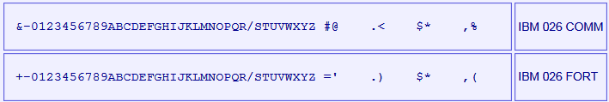

The IBM NORC is a pure numerical machine, so all input it recognizes is digits 0 to 9, maybe with a Minus Punch.

Each card contains 80 columns; each column has 12 lines that can be punched.

- The upper line on the card: called High Punch, Hi Punch, 12, Y or Y(12)
- The line bellow: called 11, X, X(11) or Minus Punch
- The lines identified as 0 to 9

The following card image shows the punches corresponding to each available character:

X(11)
Punch
X(12)
Hi Punch
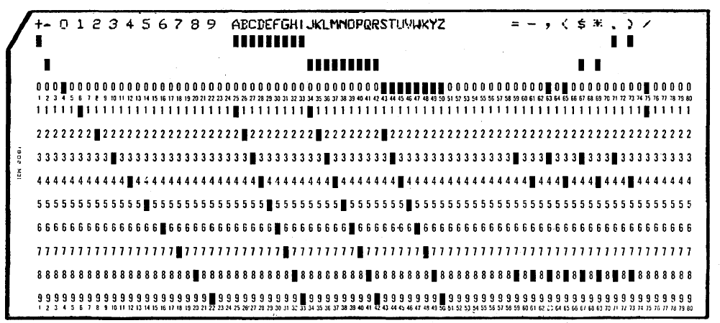

When simulating these cards as text files, each column can be mapped to an ASCII character as follows:

0 1 2 3 4 5 6 7 8 9 numeric digit 0 to 9
? A B C D E F G H I 0 to 9 with Y(12) High Punch set
! J K L M N O P Q R 0 to 9 with X(11) Minus Punch set

Creating a Tape from Cards / Dumping Tape to Cards
Once a card deck is prepared, it is possible to load it on a magnetic tape

SCP commands:

CTC CARD <deckfile> TO TAPE <tapefile>

Read input deck file previously prepared with PUNCH command, and write it on tape file (created as new file).

The deck loaded this way to tape must include start of block and end of block words. If this condition is not met, the CTC will create a tape record, but NORC will not be able to read it.

CTC TAPE <tapefile> TO CARD <deckfile> [DATAONLY]

Read input tape file and create a new card deck file. Will include all words from all blocks in tape until an end of file mark is found.

Will include in card the start of block word, end of block word, and end of file word.
- Start of block word is identified with a Minus Punch on first digit
- End of block word is identified by a Minus punch on last digit.
- End of file word got a Minus punch on both first and last digit
Example of cards generated this way:

Column number
1 2 3 4 5 6 7 8
12345678901234567890123456789012345678901234567890123456789012345678901234567890
!290000200073951099400080000000000680000000000060060000000000008
000000000000000000610000000000010000000000003951029000020007395J

(Note the ! and J characters that maps the Minus punch on digit)

If optional DATAONLY clause is present, then the Start of Block/End of word/end of file words will not be punched. This is useful when card deck is not a tape program dump (as above) but a data dump made to be printed offline on an IBM 407

Printing Cards offline
The regular way to get computation results in NORC is storing the output to a tape. Then this tape is dumped to cards on CTC, so these cards could be printed offline on an IBM 407, maybe on a paper with some form preprinted on it.

To simulate this following command is available

PRINT <format> <deckfile> TO <textfile> [CONSOLE]

Will read the card deck file and generate a plain ascii text file according to specified format. If CONSOLE clause is present, each line will be also echoed to console

The formats available are the following:

PRINT 4WORDS <deckfile> TO <textfile> [CONSOLE]

Output is 4 words per line. A minus character is printed next to first or last word digit if it has the Minus punch set)

Example: for these 2 cards:

Column number
1 2 3 4 5 6 7 8
12345678901234567890123456789012345678901234567890123456789012345678901234567890
!290000200073951099400080000000000680000000000060060000000000008
000000000000000000610000000000010000000000003951029000020007395J

This is the printout:

-0290000200073951 0994000800000000 0068000000000006 0060000000000008
0000000000000000 0061000000000001 0000000000003951 0290000200073951-

PRINT 1WORD <deckfile> TO <textfile> [CONSOLE]

Same as above, but one word on each line

PRINT PERT <deckfile> TO <textfile> [CONSOLE]

Simulates printing PERT output cards on BiWeekly report pre-printed forms:

+-------------+-------+-------+-------+-------+----+----------------------
| EVENT | TE | TL | TL-TE | TS | PR | Sched date (MM/DD/YY)
+-------------+-------+-------+-------+-------+----+----------------------
022-100-001 31.5- 31.5- 0

Software Support
This IBM NORC release supports the following software:

Software | Notes
PERT System  Date: Sep/1958 | Description: PERT Program Evaluation Research Task  Hardware needed: IBM NORC, 2K CRT memory  Documentation: PERT Summary report phase 2  Documentation URL:  https://babel.hathitrust.org/cgi/pt?id=umn.31951002472361l&view=1up&seq=3  Comments: This is the only available original program for NORC  It’s the original impelementation of PERT system, used to track the Fleet ballistic Missile (FBM) program

Simulator Usage

Assemble and Run a Program
The assembler for NORC is described in Kozarsky, K. "Naval Ordnance Research Calculator (NORC) compiler" Naval Proving Ground, 1955, AD62333. Unfortunately, this document is not yet available anywhere.

A very simple cross assembler (for Windows) has been written to produce the general sorting programs missing in PERT System. The assembler usage can be seen in Build.ini script. The resulting assembled program is generated with prog.txt filename, and a format ready to be loaded with SCP LOAD command.

As a convention, assembled program starts at address 0008. The following steps loads and executed the program:

SCP Commands | Comment | Real Hardware equivalent
set cpu crtmemclear  load prog.txt | Clear CRT memory  Load program into memory | Press CRT RESET button.  No equivalent in real hardware. NORC programs are loaded from tape (see later)
att lp1 -n printer1.txt  set lp1 echo  att mt1 data1.tap  att mt2 data2.tap  …  switch "Tape address 01" to MT1  switch "Tape address 02" to MT2  … | Set printer 1 to output to printer.txt file, and also echo to console  Attach tape file images  Set tape address for each needed tape | Put printer 1 online, make sure paper available  Mount tape needed for program run on physical units 1 and 2.  This is done in NORC console with Tape Address Selector switches
switch sw74 to off  switch sw75 to transfer  switch sw76 to stop  … | Set the options switches as needed for program | This is done in NORC console with Option Selector switches
switch "Program Check" to stop  switch  " Tape end of file" to proceed  switch " Tape Check" to proceed | Set check stops on default position: stop if common program errors, do not stop on tape conditions (handled by program) | This is done in NORC console with check Stops and Condition stops Selector switches
dep V 0008  go | Set register V on first address of program to run and start program execution | Press Reset SubOp button. Load V using V Entry switches. Set Source Of Instructions switch to V, press Start button

The build.ini script shows how to load assembled programs on a program tape. PERT_Run.ini script shows how load and start a program from tape.

Available Software
The available software files are in NORC/sw directory. These files have been typed from listings information from documents available.

Sample Programs

Files | Description
Sample1.ini | SimH script to load and run sample program
Sample1/ | Folder contents:
Sample1_prog.txt | Sample program at page 156 in book "Faster, Faster"
Opcodes_Diag.ini | Opcode diagnostics

Files | Description
Sample2.ini | SimH script to load and run sample program
Sample2/ | Folder contents:
Sample2_prog.txt | Sample program at page 47 in Programming Manual
Sample2_data.txt | 1word format input data for sample
Sample2_mt_out.tap | Expected binary image of output tape
Sample2_deck_out.dck | Expected output deck

How to run:
sim> cd Sample1
sim> do Sample1.ini
sim> cd ..
sim> cd Sample2
sim> do Sample2.ini

PERT
IBM NORC is the computer on which the Program Evaluation Research Task (PERT) project management system was developed and implemented first, as part of Polaris Fleet Ballistic Missile (FBM) program.

Fortunately, a printout of PERT programs listing in absolute binary form is included in Book Program Evaluation Research Task (PERT) summary report Phase 2, September 1958, (https://babel.hathitrust.org/cgi/pt?id=umn.31951002472361l&view=1up&seq=3). This software has been scanned, OCRs, restored and made operational with a set of ready-to-run SCP scripts

Files | Description
PERT_Build.ini | SimH script to call build.ini script
Build/ | Folder contents:
Build.ini | SimH script to build pert system program tape
empty_events_mt3.tap | Generates blank empty event tape for Run06
PERT_program.tap | Generates PERT System program tape
PERT_program.dck | Program tape dump to card deck
PERT_program.txt | Card deck listing

The PERT Systems programs for Run06 (update), Run07 (sequence) and Run08 8compute) comes from absolute listing in PERT) summary report Phase 2 document. These programs have been put in LOADable format and have been annotated.

Programs for data housekeeping in Run02 (convert), Run 03/04/05 (sort transactions), and Run09 (sort events) has been recreated with functionality described in the document

Build.ini script will perform the following action
- Assemble programs in source form
- Load programs into tape, adding a loader for each one
- Create empty active event tape
- Dump program tape to card and creates a printout of deck
- Execute Run01, Run06, Run07, Run08 with sample data and check the result is the expected

Files | Description
PERT_Run_Tape.ini | SimH script to call PERT_Run.ini script
PERT_Run/ | Folder contents:
PERT_Run.ini | SimH script to execute pert system from program tape
card_activity_input.txt | Transaction file input of PERT Runs
printer1.txt | PERT Runs printer 1 output
Printer2.txt | PERT Runs printer 2 output
events.txt | BiWeekly event PERT report output text file

There is a folder for each PERT Run: from Run01 up to Run10. Each folder contains

- The relevant _src.txt program (if any), the annotated PERT program _prog.txt
- The relevant _prog.txt programs with annotated PERT program
- RunNN.ini (NN is 01 to 10) script to execute each Run
- The printer output files
- The tape output files.

How to run:

To build PERT System program tape

sim> cd pert
sim> do PERT_Build.ini

To run PERT System on a sample input file and a given date (01 (month) 13 (day) 58 (year)

sim> do PERT_Run_Tape.ini card_activity_input.txt 01 13 58

To run PERT System on a card input set file and a week now. Each Run is executed in sequence, but loading program with symbolic information to be used in debug.txt file

sim> do PERT_RunNN.ini ..\PERT_Run\card_activity_input.txt 01 13 58

Running demo script
The file NORC_demo_all.ini executes all the scripts in sequence.
This script can be used as an example of other scripts usage.

File extensions
The simulator does not enforce any extension for any file. Nevertheless, some extension are used as a convention on the script files
Extension Meaning
*.dck Ascii text format card deck
*.crd Binary format card deck
*.tap Magnetic tape image file
*.ini SimH NORC simulator script
*.txt Text file
*_src.txt editable source code (text format) file for the assembler tool
*_prog.txt absolute binary LOADable file with symbolic information and comments

Control Panel

Introduction
Control panel provides simulation of IBM NORC console panel on a GUI window. It is possible to interact with the computer thru the Control Panel, in the same manner as it was done with the original hardware

But also it’s nice just to see the Blinkenlights during program run, the tape fast jerky motion, the CRT blended and always changing digits, or the beautiful near-aligned printing.

Control Panel files are stored in cpanel directory. There are .png bitmap images and an .ini file. This .ini file is called Definition File, and has all the info to instruct the simulator on how to display the control panel on the GUI window.

To show the control panel, these are the commands to issue on SCP:

sim> att cpanel ../cpanel/NORC.ini
sim> set cpanel on

(if needed, use the adequate path for .ini file in your installation). The Control Panel GUI window is displayed:

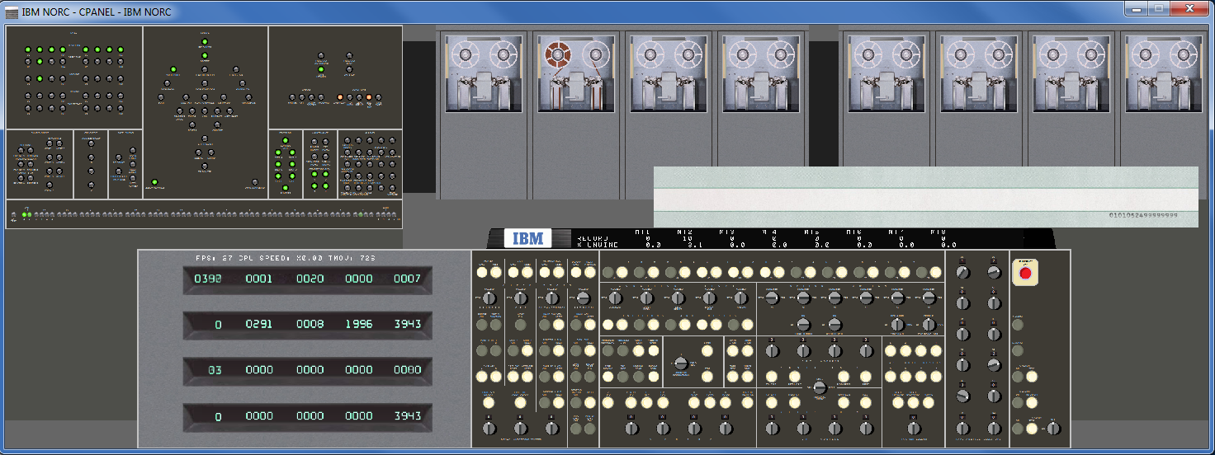

To close the control panel, use the command

sim> set cpanel off

Available Control Panels
Several Control panels are selectable, Default one shows all the main CPU console.

Before issuing SET CPANEL ON, it is possible to use SET CPANEL OPTION command to select the one to display

sim> att cpanel ../cpanel/NORC.ini
sim> set cpanel option=console
sim> set cpanel on

The SET CPANEL OPTION=console will select only the console and crt register display

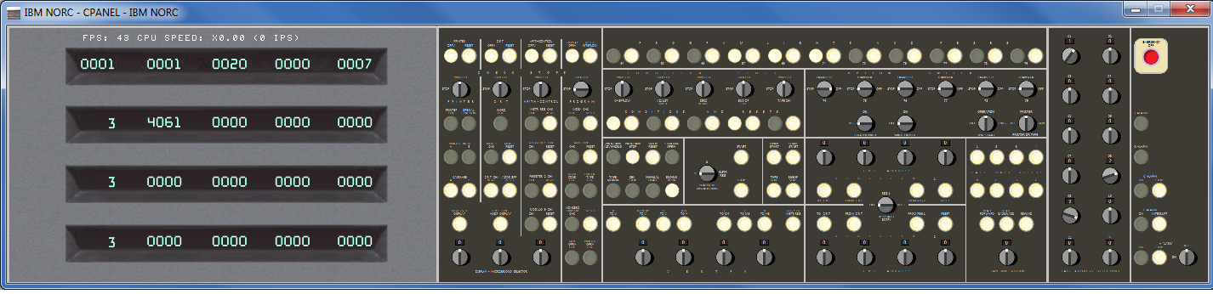

SET CPANEL OPTION=AllPanels will select the full control panel GUI. This is the default

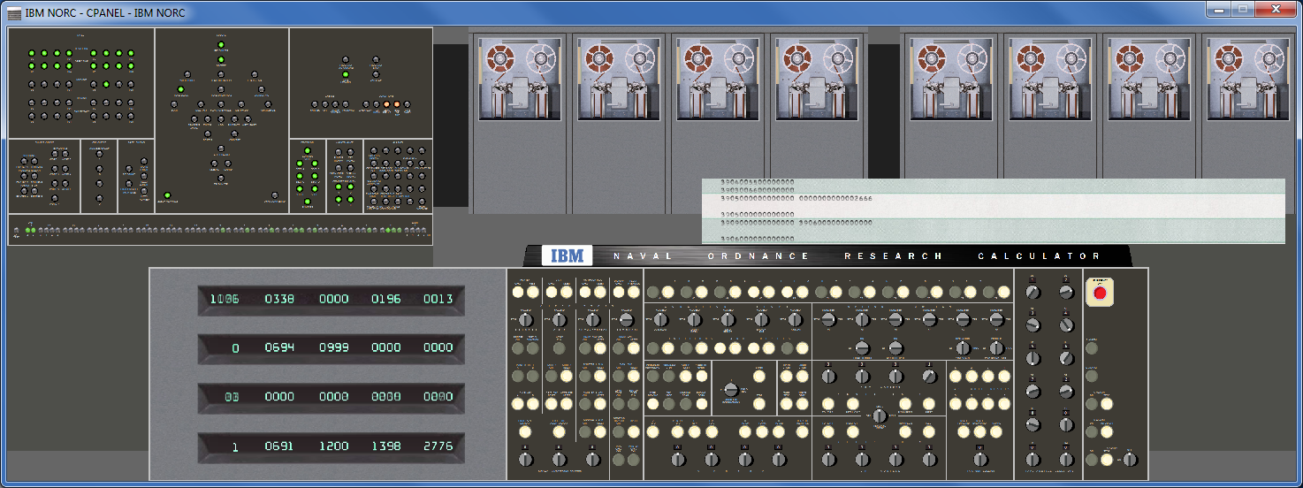

Control Panel areas

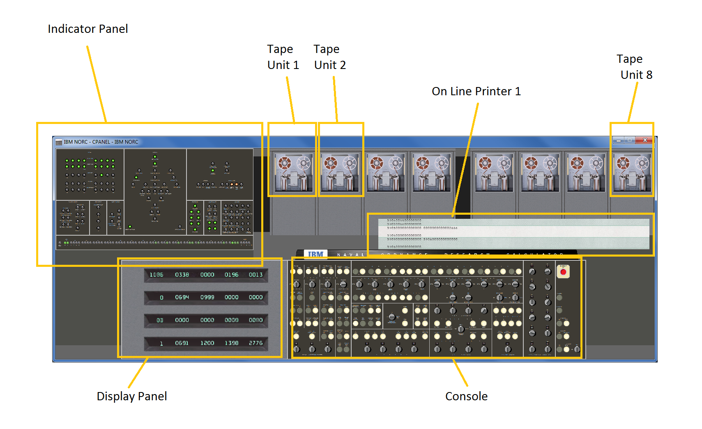

Control Panel size and position
As Control Panel includes more hardware, its size gets bigger. Allpanels option is 3645 pixels wide.

To allow a comfortable display it is possible to set the scale on which the Control Panel GUI window will show the Control Panel.

sim> att cpanel ../cpanel/NORC.ini
sim> set cpanel option=AllPanels
sim> set cpanel scale=50
sim> set cpanel on

Will display the control panel at 50% of its original size. Allowed scales ranges from 10 (10% of original size) up to 200 (double of original size)

SCP command ATTACH CPANEL resets the scale to 100 (i.e the original size). SET CPANEL SCALE can be issued at any moment, before or after SET CPANEL ON, one time or several times.

At any moment it is possible to move the Control Panel window with the mouse, as any regular window. But also it is possible to set the position of window with a command. This is handy to assure the position of Control panel is a good one given its scale when preparing a SCP script.

sim> att cpanel ../cpanel/NORC.ini
sim> set cpanel option=AllPanels
sim> set cpanel scale=50
sim> set cpanel pos=50/100
sim> set cpanel on

Will set the Control Panel on screen coordinates x=50, y=100. Coordinates can be negative.

Important: To be effective, SET CPANEL POS command should be issued after CPANEL ON.

Control Panel HotKeys
There are several HotKeys, that can be pressed while the Control Panel Window has the focus.

HotKey | Description
Control E | Halts the simulation (same as Control E issued on SimH console)
Control Y | Toggles size of window between 100% and 50% (full size/half size)
+  Control + | Increases size of window a 10% (maximum 200%)  Increases size of window a 1%
-  Control - | Decreases size of window a 10% (minimum 10%)  Decreases size of window a 1%
Control T | Toggles mark on clickable areas of control panel
Control I | Toggles show Info
Control F | Fast Mode: while pressed, simulated CPU runs at maximum speed. When releases, CPU returns to its selected speed.

Control T – Toggle Marks
Control T will show an alternate green-red-flashing box on clickable control in the control panel. This eases to identify what can be used, and what cannot.
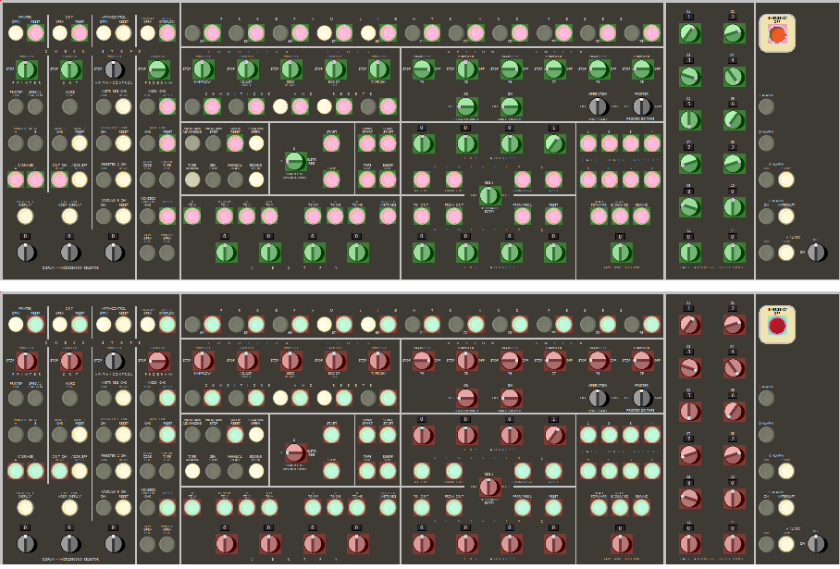

Control I – Show Information Panel
Control I will show an information panel with some internal simulator state on real time. Pressing again Control I will hide the info

There are two panels. One on main CPU:

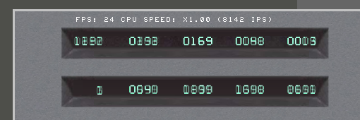

This information panel display:

- The current Frames Per Second (FPS) refresh rate
- The current measured CPU speed as a multiplier. x1.0 means original hardware speed.
- Afterwards there will be information depending on the internal state of CPU
- If CPU is executing instructions, shows
(nnnn IPS): Instructions Per Second executed
- If tape operation in progress
TMOV nnnn: is simulated time (in milliseconds) remaining for Tape Moving operation to finish
- If there is a printing cycle in progress (cpu still running, but if a tape or printer instr is executed, it will be stalled)
PRT nnnn: simulated time (milliseconds) remaining for printing cycle to finish
- If cpu is stalled (cpu not running)
FPS nnnn STALL aaaaa: CPU is stalled waiting for something. nnn is the number of simulated milliseconds remaining to resume exec,
If =0 will never resume aaa is the reason. It can be:
- WAIT PRT READY: Print instr stalled because current printer cycle not finished
- TAPE WAIT PRT READY: Tape instr stalled because current printer cycle not finished
- TAPE UNIT NOT RDY: Tape instr stalled because tape unit not ready

The other panel is on tape:

This information panel display, for each tape:

- The current record the tape r/w head is positioned on (not the total number of records on tape). On NORC Simulator, each tape block is implemented as a SimH tape record
- The current % of tape unwind on right reel. 0% mans all the medium is on left reel, 100% means all the medium is on right reel. An R means there is a rewind operation in progress

If scp command SET CPANEL OPTION=ShowInfo is issued before SET CPANEL ON, the Control Panel window will display the information panels when opened.

The information panel is designed to be show at 100% and 50% scale.

Control F – Fast Mode
Control F will accelerate the CPU speed while pressed.

This is very handy to speed slow operations on the fly.

X1.0 speed | Control F
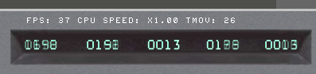 | 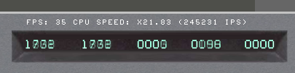

Control F also allows to speed-up High Speed rewind operation. Turn off debugging (SET NODEBUG) to get the maximum performance in fast mode.

The CPU acceleration will continue until

- The user releases Control F keys

- Simulator executes SET CPU SPEED command (e.g. on the script being run). In this case, the new CPU speed figures are recalculated and CPU resumes at new speed setting. To accelerate the CPU it is necessary to press again Control F

Control Panel usage
The clickable controls can be spotted with Control T hotkey. Buttons and switches works as stated on programming manual (www.bitsavers.org/pdf/ibm/norc/NORC_Programming_Manual.pdf)

Clickable controls:
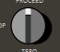
Switch Button

As a convention, the power buttons and the close top right box quits the simulation

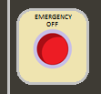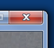

When CPU is running (thus the control panel is refreshed and responsive), the mouse pointer will be an arrow. If the pointer is placed on a clickable control, it will be changed to a hand

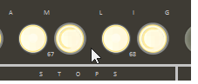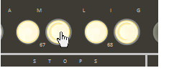

If the user clicks on control panel and moves the mouse without releasing the mouse button, then the control panel window will be moved on screen.

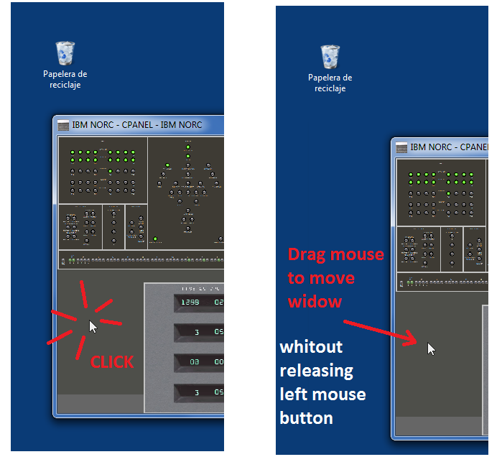

This is very handy when control panel window is zoomed and does not fit on screen.

When moving the Control Panel window by dragging the title bar (the standard move procedure), the GUI image stop being updated but the simulation still running. When moving the window by clicking in the image and dragging the mouse, the GUI image will not freeze and will be updated as the windows moves.

Control Panels can be big. With + and – hotkeys it is easy to resize the window at will. But when size is small, it can be difficult to read keys/switches labels.

On clicking on right mouse button, a tooltip will popup with showing the control panel image under the mouse at 100% scale.

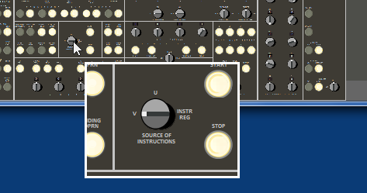

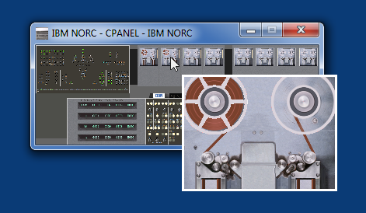

Dragging the mouse over the window while right button is kept pressed will show the contents on tooltip as mouse moves.

The tooltip window is closed automatically moving the mouse over it.

Interactive Mode
When simulated CPU is running, control panel is operating (shows info and reacts to mouse clicks).

Nevertheless, when simulated CPU is stopped, SimH can be either executing scp commands in a script, or be waiting for scp commands from user on console prompt.

But during user console input at prompt, SimH is blocked waiting user to type a command and press enter. Thus the whole control panel is not responsive to mouse clicks, not responsive to window close box, nor is updated. This situation is signaled to the user by the slashed red circle mouse cursor shape
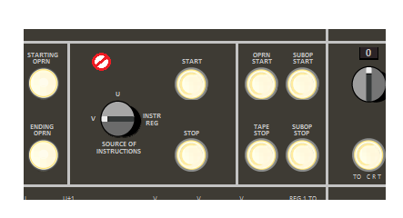

Note that when simulated CPU is running, Control Panel window close box is active, and quits the simulation. When SimH is waiting on sim> command prompt, simulated CPU is stopped and thus close box of control panel window is not responsive. In this case, to quit the simulation it is necessary to close the console window (or issue the scp command QUIT or BYE)

When user press enter on sim> console, the GUI is updates once. This means you can click on GUI, that appears to not respond. Just press Enter on sim> prompt to see the updates on GUI

If scp command SET CPANEL INTERACTIVE is issued, SimH transfer the control of simulation from scp command line to control panel. SimH then refreshes control panel and responds to mouse in the same way as when CPU is running. This allows to control the simulation from control panel as in the real computer. CPU can be started and stopped while into interactive mode.

When in interactive mode, no scp command can be typed on console, as SET CPANEL INTERACTIVE command still in execution. To terminate interactive mode and regain control on console, the user can either

- press Control E on console or on Control Panel window (or any other defined as WRU character)
- Press Enter on console

While CPU is running, the button “STOP” will also activate interactive mode. This button is placed near the center of console, next to SOURCE OF INSTRCTIONS switch.



Tape Options

It is possible to setup the state of tape cabinet door. It is done via the SET CPANEL OPTION, issued after ATTACH CPANEL but before ATTACH MTn command

SET CPANEL OPTION=MTn/s

- n ranges from 1 to 8
- s can be
V for door open, visible vacuum columns
C for door closed
Example:

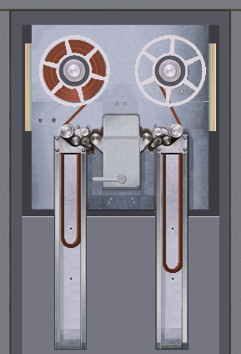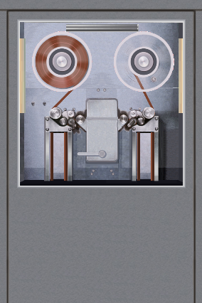

sim> set cpanel option=mt1/v set cpanel option=mt2/c

At any moment, it is possible to open/close the door to see the tape loops going up and down into the vacuum columns just by clicking under the tape widow:

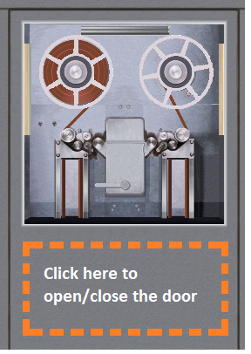

Console Keyboard
The NORC console has a keyboard to allow to key-in digits into the CPU registers

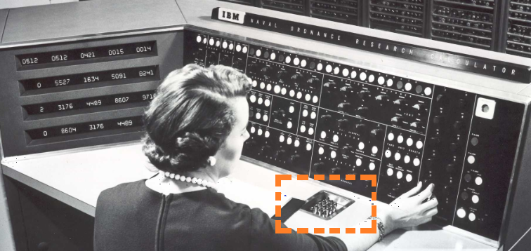

The keyboard is not visually represented in the control panel GUI window. Nevertheless, it is simulated. To used it:

- Stop CPU by pressing the STOP button: the simulated keyboard is operative only with CPU stopped

- Set the KEYBOARD ENTRY switch to REG1 or REG2, the storage register that will receive the typed digits

The keys 0-9 typed on host computer will be inserted by the right on selected storage register

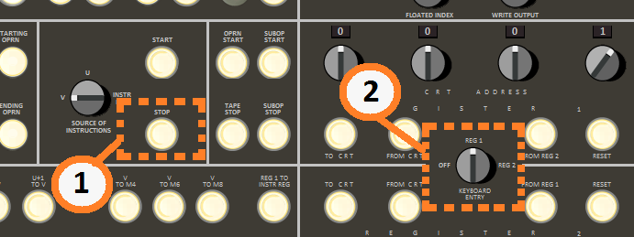

Additional comments

Speed Measurement
The speed measurement show on info panel (Control-I) is not the same as the one obtained with SHOW CPU SPEED.

Show CPU speed command measures the speed along all the run, that is, from the moment that simulated has been started until the moment the simulated CPU is stopped

On information panel, the speed is measured on the fly. Control F boosts the measured speed, rewind opcode can make the IPS value zero if CPU waits until rewind terminates.

Control Panel usage example
This is the sequence to start a program stored on tape as stated in programing manual, page 40:

 | SCP Commands | Comment | Real Hardware equivalent | Equivalent GUI control to use
0 | att mt1 tape_image_file.tap | Mount program tape  CPU is stopped | Mount tape reel on tape unit 1 (TU1) | No equivalent. Must be done with SCP command
1 | switch "Tape address 01" to MT1 | Set tape address for needed tape | This is done in NORC console with Tape Address Selector switches | 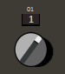
2 | switch "Program Check" to stop | Set check stops on default position: stop if common program errors, do not stop on tape conditions (handled by program) | This is done in NORC console with check Stops and Condition stops Selector switches | 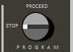
3 | switch  " Tape end of file" to proceed |  |  | 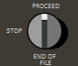
4 | switch " Tape Check" to proceed |  |  | 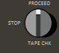
5 | set cpu crtmemclear | Clear CRT memory | Press CRT RESET button. | 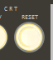
6 | press "Indicator Reset" | Reset the indicator lights | Press RESET button on CHECK STOPS – PROGRAM section of console (at the lower end) | 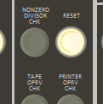
7 | switch "Keyboard Entry" to Reg1 | Enable console keyboard to feed digits to REG1 | Set KEYBOARD ENTRY switch to REG1 | 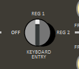
8 | press keyboard 01 94 0002 0007 0000 | Store in REG1 the instruction to load from tape | Type in digits in console keyboard | Focus on Control Panel GUI window, type in keyboard
9 | switch "Register 1 CRT Address" to 0001 | Address in CRT memory to store instruction hold into REG1 | Set 0001 in Register 1 address switches | 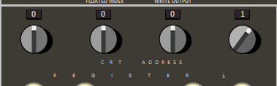
10 | press "Register 1 TO CRT" | Store REG1 in CRT memory. Also will set V register to 0001 | Press Register 1 TO CRT button | 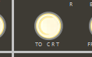
11 | switch "Source of instruction" to V | Program will start execution at address in V register (now set to 0001) | Set switch SOURVE OF INSTRUCTIONS to V | 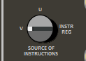
12 | go | Start program execution | Press START button | 

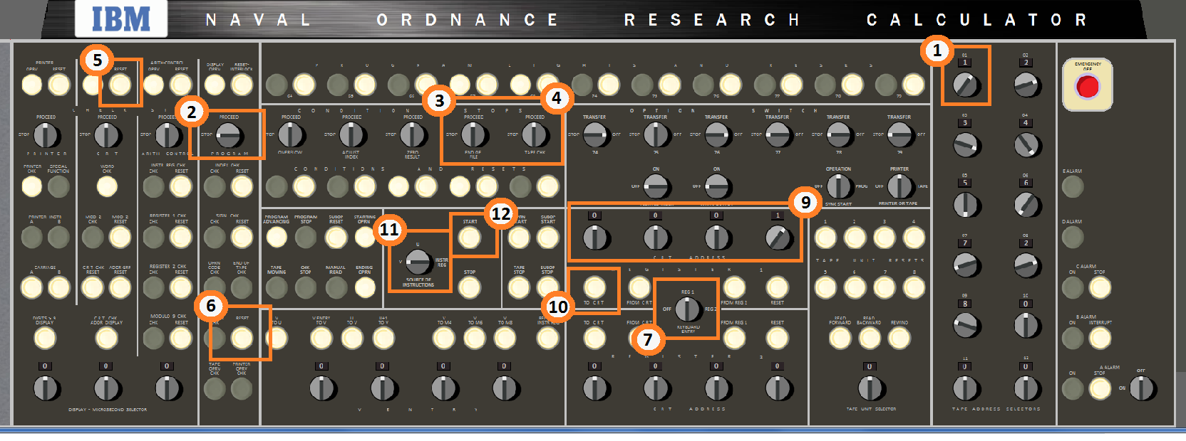

Demo scripts

Several demo ready to run scripts are provided in the sw/ directory

Files | Description
run_PERT_cpanel.ini | Run PERT system (with a se of1000+ activities)
run_tape_demo_cpanel.ini | Wind/rewind tapes demo. Nice to see

How to run:
sim> cd sw
sim> do run_PERT_cpanel.ini

Version History
- Release 1: Jan/2021
- Hardware support:
  - 2000 and 3600 words memory size.
  - IBM NORC CPU with enhanced instructions
  - 8 IBM NORC magnetic tapes, CTC device, 2 IBM High Speed on line printers
  - Control Panel GUI
- Software included:
  - Sample programs from Programming Manual, and Faster Faster bool
  - Special Proyect Ofice (SPO) PERT System for Polaris Ballistic Missile (FBM)

- Release 2: Jul/2021
- New Hardware support:
  - (none)
- New Software included:
  - (none)
- New Features:
  - Reduced CPU usage when Control Panel visible
  - Anti-Aliased control panel image on GUI on scale less than 50%
- Bugs Corrected:
  - Fixed typos and small errors in this document (never-ending task)

