IBM 650 Simulator User’s Guide
28-Dec-2021

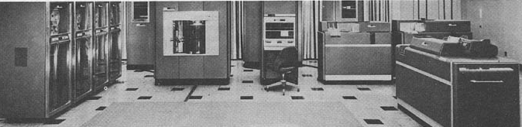

COPYRIGHT NOTICE

The following copyright notice applies to the SIMH source, binary, and documentation:
Original code published 1993-2012, written by Robert M Supnik
Copyright © 1993-2012, Robert M Supnik
Copyright © 2018-2020, Roberto Sancho
Permission is hereby granted, free of charge, to any person obtaining a copy of this software and associated documentation files (the "Software"), to deal in the Software without restriction, including without limitation the rights to use, copy, modify, merge, publish, distribute, sublicense, and/or sell copies of the Software, and to permit persons to whom the Software is furnished to do so, subject to the following conditions:
The above copyright notice and this permission notice shall be included in all copies or substantial portions of the Software.
THE SOFTWARE IS PROVIDED "AS IS", WITHOUT WARRANTY OF ANY KIND, EXPRESS OR IMPLIED, INCLUDING BUT NOT LIMITED TO THE WARRANTIES OF MERCHANTABILITY, FITNESS FOR A PARTICULAR PURPOSE AND NONINFRINGEMENT. IN NO EVENT SHALL THE AUTHORS BE LIABLE FOR ANY CLAIM, DAMAGES OR OTHER LIABILITY, WHETHER IN AN ACTION OF CONTRACT, TORT OR OTHERWISE, ARISING FROM, OUT OF OR IN CONNECTION WITH THE SOFTWARE OR THE USE OR OTHER DEALINGS IN THE SOFTWARE.
Except as contained in this notice, the names of the authors shall not be used in advertising or otherwise to promote the sale, use, or other dealings in this Software without prior written authorization from the authors.

1 Introduction 4
1.1 The IBM 650 Magnetic Drum Data-Processing Machine 4
1.2 Simulator Files 5
2 Simulator Features 6
2.1 Hardware-Equivalent Actions 6
2.2 Simulator Specific Commands 7
2.2.1 Symbolic Display and Entry 7
2.2.2 RESET 8
2.2.3 RUN and GO 8
2.2.4 STEP 9
2.2.5 CARDDECK 10
2.2.6 Device Configuration 13
2.2.7 Enabling and Disabling Devices 13
2.3 Tracing Simulator Operations 13
3 Processor Device Simulations 14
3.1 Central Processing Unit 14
3.1.1 Speed 14
3.1.2 Mnemonics 17
3.1.3 Storage unit 17
3.1.4 Simulation Stops 17
3.1.5 Tracing 18
3.1.6 Registers 18
3.2 IBM 533 Card Reader/Puncher (CDR) 19
3.2.1 Symbolic Information Load 19
3.2.2 Punched cards character set 20
3.3 IBM 533 Card Punch (CDP) 22
3.4 IBM 727 Magnetic Tape (MT) 22
3.5 IBM 355 RAMAC Storage (DSK) 23
3.6 Panel Wiring 24
3.7 Printing 25
3.8 Symbolic trace 25
4 Software Support 27
5 Simulator Usage 30
5.1 Assemble a SOAP Program 30
5.2 Available Software 31
5.2.1 Interpretive Floating Decimal System 31
5.2.2 Regional Assembler 31
5.2.3 Floating Point Interpretive System 32
5.2.4 SOAP Assembler 32
5.2.5 Internal Translator (IT Compiler) 33
5.2.6 FORTRANSIT 34
5.2.7 SuperSoap 35
5.3 Running demo script 35
5.4 File extensions 36
6 Control Panel 37
6.1 Introduction 37
6.2 Available Control Panels 38
6.3 Control Panel size and position 40
6.4 Control Panel HotKeys 41
6.4.1 Control T – Toggle Marks 41
6.4.2 Control I – Show Information Panel 42
6.4.3 Control F – Fast Mode 43
6.5 Control Panel usage 44
6.6 Interactive Mode 46
6.7 Drag and Drop files 47
6.8 Detach tape file 48
6.9 Tape Options 49
6.10 Additional comments 49
6.10.1 Speed Measurement 49
6.10.2 Speed settings and rewind animation 49
6.11 Scripting 50
6.12 Control Panel usage example 52
6.13 Demo scripts 53
7 Version History 54

Introduction
This manual documents the features and operation of the IBM 650 simulator. It is intended for use in conjunction with the SIMH Users' Guide manual, which describes how to compile and run the simulator, as well as the general commands that may be entered at the Simulation Control Program (SCP) prompt.

The IBM 650 Magnetic Drum Data-Processing Machine
IBM sold the IBM 650 Magnetic Drum Data-Processing Machine from 1953 through 1962. The first unit was installed in December 1954.

IBM made several enhancements during the life of the computer (source: Wikipedia)

- 1954: Initial model
  - 1K or 2K word drum memory (IBM 650)
  - Connection of one device Card Read Punch (IBM 533 or 537)
  - IBM 407 for off line printing of punched cards

- 1955: Storage Unit
  - 60 words of core memory
  - 3 index registers
  - Floating Point
  - Magnetic Tape support
  - Connection of up to 3 devices: card read punch or modified IBM 407 for on-line printing

- 1956: RAMAC Disc support
  - Enhancements in Storage Unit to support disc
  - IBM 838 inquiry stations support

- 1959: Model 4
  - 4K word drum memory

All of these were vacuum tube machines. Each machine word is composed of 10 decimal digits plus sign. It is a decimal machine.

Reading or writing a word takes 96 microseconds (called the word time in IBM Operation manual and described as having a duration of 0.096 milliseconds). This is the basic machine cycle. As main memory is implemented by a drum, the CPU waits while drum is seeking to the word to read or write. This can take from zero to 49 cycles. An average on optimized code is about 5 cycles per instruction. The execution speed for optimized code is range of 2K instructions per second.

Simulator Files
The simulator sources are divided into a set of files for the Simulator Control Program and its support libraries, and a set of files for the IBM 650 CPU and device simulations; the latter reside in a subdirectory of the directory that contains the SCP files. The former set is common to all SIMH simulators, whereas the latter set is specific to the virtual machine being simulated. The files that make up this simulator are:

Subdirectory | File | Contains
i650 | i650_defs.h | System architectural declarations
 | i650_sys.c | SCP interface
 | i650_cpu.c | Main CPU simulator
 | i650_cdr.c | IBM 533 (card reader part) simulator
 | i650_cdp.c | IBM 533 (card punch part) and IBM 407 printing simulator
 | i650_mt.c | IBM 727 tape simulator
 | i650_dsk.c | IBM 355 RAMAC Disk Storage
 | i650_cpanel.c | IBM 650 Control Panel
 | cpanel.c | Control Panel interface
 | cpanel.h | Control Panel declarations
 | cpanel_vid.c | Control Panel video interface
 | cpanel_vid.c | Control Panel video declarations
 | i650_doc.doc | Documentation (this file)
 | I650_test.ini | Executes all the sw rest-run scripts
i650 / cpanel |  | Contains the control panel image bitmaps
i650 / test |  | Contains the simulator test suite
i650 / sw |  | Contains the included software and test run script files (See usage section)

PDF files of the original IBM 650 hardware and software manuals are available in Bitsavers repository: http://www.bitsavers.org/

The computer programming and its operation are described in IBM 650 magnetic drum data-processing machine manual of operation, Form 22-6060-2 (1956)

Simulator Features
The IBM 650 simulator contains the following device simulations:

Device Name(s) | Simulates
CPU | IBM 650 Drum Data Processing Machine  IBM 652 Control Unit  IBM 653 Storage Unit  1K word, 2K word or 4K drum
CDR1 to CDR3 | IBM 533 Card Reader
CDP1 to CDP3 | IBM 533 Card Punch
CDP0 | IBM 407 Printing
MT0 to MT5 | IBM 727 Magnetic Tape
DSK0 to DSK3 | IBM 355 RAMAC Disk Storage

The simulator has been tested with and supports the following software:
- IBM SOAP II as stated on 24-4000-0 manual on Bitsavers
- IBM SOAP IIA-4000
- IBM Interpretive Floating Decimal Interpretive System
- Bell Interpretive System
- Lockheed Regional Assembler
- Carnegie Internal translator
- IBM Fortransit (version II (S))
- Case Institute SuperSoap

The simulator also provides extensive facilities for tracing CPU and I/O device operations.

Hardware-Equivalent Actions
To use simulated IBM 650 two interfaces are available

- Commands that can be entered through the simulation console at sim> prompt

- Pressing buttons and moving switches on simulation control panel GUI

The following table describes the SCP commands and their equivalent action on real hardware. For control panel actions, see the Control Panel section on this manual.

Hardware Console Action | Equivalent Simulation Command
Set PROGRAMMED switch to RUN | STOP | DEPOSIT CSWPS 0 | 1
Set OVERFLOW switch to SENSE | STOP | DEPOSIT CSWOS 0 | 1
Set HALF CYCLE switch to RUN | HALF | DEPOSIT HALF 0 | 1
Set ERROR switch | Not simulated
Set CONTROL to ADDRESS STOP | BREAK <address>
Setting the Console Switches | DEPOSIT CSW <value>
Display Lower Accumulator | EXAMINE ACCLO
Display Upper Accumulator | EXAMINE ACCUP
Display Distributor | EXAMINE DIST
Display Program Register | EXAMINE PR
Display Read-Out Storage | EXAMINE <address>
Display Read-In Storage | DEPOSIT <address> <value>
Press TRANSFER Key | DEPOSIT AR <address>
Press PROGRAM START Key | GO
Press PROGRAM STOP Key | ^E on console
Press COMPUTER RESET Key | RESET

Mounting media on a peripheral device is simulated by the ATTACH command. For example, entering the ATTACH CDR1 <card-deck-image-filename> command is equivalent to loading the card deck into the read hopper of the IBM 533. .

Simulator Specific Commands
In general, all of the commands documented in the SIMH Users' Guide manual are available for use with the IBM 650 simulator. Commands whose execution or parameters are implementation-defined are specified below.

Symbolic Display and Entry
When examining or depositing into memory, command line switches specifying the symbolic mode and format may be used to override the default numeric mode, as follows:

Switch | Mode Interpretation
–C | String of up to five character
–M | A CPU instruction opcode

If the –C switch is specified, the value is displayed as five characters delimited by single quotes.

Depositing with –C accepts up to five displayable characters. They can optionally be enclosed by quotes (single or double). If less than five are supplied, the command pads on right side with spaces up to five characters. If more than five are supplied, the sixth and following characters are ignored. If a character not belonging to the IBM 650 character set is supplied, it is interpreted as space. If a character not belonging to the IBM 650 character set is displayed, it is shown as ~. Lowercase letters are converted to uppercase.

If the –M switch is specified, the value is displayed or accepted as a CPU machine instruction opcode mnemonic, as described in the Operation Manual. Note that the names of opcodes can range from two letters such as RD up to five letters such as BRMIN. The names used are not the SOAP assembler ones (all of them have three letters).

If neither switch is used, the normal 10-digit decimal form is assumed. Digits can be separated by spaces for ease of reading. A sign can be included before of just after the last digit (no space separator). If number has less than 10 digits, it is assumed to have leading zeroes. Values are displayed as 10 adjacent digits followed by a trailing sign. A negative zero (minus zero) value is allowed.

Memory addresses are entered as 4 decimal digits without intervening spaces.

Examples

examine 0100
100: 9011112222-

examine –c 0100
100: 9011112222- '0~~~~'

examine –m 0100
BRD10 1111 2222

deposit –c 0100 hola
examine –c 0100
100: 6876736100+ 'HOLA '

deposit –c 0100 ' HOLA'
examine –c 0100
100: 0068767361+ ' HOLA'

The DEPOSIT and EXAMINE SCP command accepts addresses in the drum range, from 0 to 999, or to 1999 depending on the size of drum memory. EXAMINE accept addresses of 8000 and beyond for the console, distributor, and lower and upper accumulators; and (if Storage Unit enabled) index registers and IAS storage contents.

RESET
The RESET command is equivalent in hardware to pressing the COMPUTER RESET console button.

RUN and GO
The RUN and GO commands do not accept any parameter addresses. Execution will start at the address specified by the AR register.

The IBM 650 does not have a Program Counter/Instruction Counter register. Architecturally, it is not necessary, as each instruction word contains the address of the next instruction to execute.

Register AR indicates the address of the instruction to be loaded in the PR register, thus acting as the Program Counter on the first half of instruction execution (I-Cycle). However, is overwritten by the address of the data read or written during instruction execution (D-Cycle). If an error occurs during a D-Cycle, e.g. the data address to be read from the drum is invalid, the CPU stops without updating the AR register with address of the next instruction. As the simulator reproduces this behavior, AR cannot be used as a Program Counter. Also note that as AR is overwritten during instruction execution, there is no trace at all of where the current instruction in the PR register came from the drum.

SimH relies on an Instruction Counter for command display of user information. For example, when the CPU stops, the simulator uses the program counter to display the current instruction address and mnemonic on the simulation console.

To permit this, a fictional IC register (Instruction Counter) has been added to the simulation even though it has no equivalent on real hardware. This register keeps track of the address of the current instruction for display purposes.

As this IC register has no use in the simulated CPU, altering its value has no effect. This is why it is necessary to deposit the address in the AR register to set the address of the next instruction to execute.

The RUN command does an implied RESET, so it is equivalent in hardware to pressing the console panel RESET COMPUTER key, then the TRANSFER key, and finally the PROGRAM START key. As reset clears all of the registers, AR will be zero, so execution starts at drum address zero.

The GO command is equivalent to pressing the TRANSFER key on the console and is the way to start or resume execution after a programmed halt. Execution starts at the instruction addressed by the AR register value.

There is a special case when program halts on a STOP opcode instruction.

STOP instruction is the normal way to end a program or to stop execution because there is an error to notify to the computer operator. Normally the error code is the contents of DA part of STOP instruction, shown on computer console as AR register value.

When cpu halted on STOP instruction, if the user enters a GO command on SCP console, then the program execution will resume using STOP’s instruction IA address, instead of current AR contents.

This allows using the GO command to resume the execution after a programmed stop.

STEP
The STEP command is used to execute program instructions on a one by one basis.

By default, when the simulator steps, it executes a full instruction cycle (an I-Cycle and a D-Cycle) and then stops.

On real hardware, stepping is done only by cycle halves. This is simulated with:

DEPOSIT HALF 1

In this case, STEP will only execute an I-Cycle or a D-Cycle alternatively. Examining the HALF CPU register will show which cycle will be done on next step: an I-Cycle, a D-Cycle. If CPU has just stopped because a programmed stop or because a stop on overflow condition, the HALF CPU register will show d-Cycle. In this case, GO command will continue the program execution using the current IA part or PR register

To return to normal full instruction cycle execution on stepping, set the value to zero:

DEPOSIT HALF 0

During stepping, the IC register will show the next instruction to be executed. If the CPU stopped because of an error, IC points to the current offending instruction, not to the next one.

If half cycle stepping is set, the same instruction will be displayed twice (first on the I-Cycle step, and then on the D-Cycle step)

Note that the command DEPOSIT AR will also set the next Half cycle to be executed to I-Cycle.

CARDDECK
This command allows handling card deck files.

The general syntax is:

CARDDECK [-Q] <operation> <parameters ... >

Allowed operations are
- SPLIT: to split source deck in two decks based on a criteria
- JOIN: to join two or more decks in one destination deck
- PRINT: to print the given deck

Default format for card files is AUTO, this allow mix source decks with different formats. To set the format for carddeck operations use.

SET CDR0 FORMAT=<format>

See section IBM 533 Card Reader/Puncher (CDR) for details on formats.

Switches:

-Q quiet operation. Suppress messages.

CARDDECK SPLIT

Split either the source deck file or the deck being punched in IBM 533 device in two separate destination decks.

CARDDECK SPLIT <count> < dev | file0 > <file1> <file2>

Parameters:

<count> Split the source deck based on number of cards.

<count> is the number of cards in the first destination deck, remaining cards goes to second destination deck.

If <count> is negative, it indicates the number of cards to be kept in second destination deck, remaining cards goes to first destination deck.

If <count> is 5CD, the command assumes that the source deck contains 5-word-per-load-card. The command will put 5-word-per-load-cards in second destination deck, and the rest of cards in first destination deck.

If <count> is PAT, the command assumes that the source deck contains SOAP availability cards (as result of a PAT pseudoop execution during assembly). The command will put availability cards in second destination deck, and the rest of cards in first destination deck.

< dev | file0 > If this parameter is CDP1, CDP2 or CDP3, the source deck will be taken from attached file to the device (a file must be attached, and it is automatically detached).

If not a device, this parameter indicates the filename for source deck.

<file1> First destination deck file

<file2> Second destination deck file

Files are overwritten if already exists

Both <file1> or <file2> can have same name as source deck (either the given <file0> or the attached file to cdp device)

If 5CD or PAT is used, the selected cards will go to second deck. If no card is found in source deck, the second deck will contain no cards and in consequence, <file2> will have a size of zero bytes. In this case, the command deletes <file2> to avoid generating an empty file.

SimH reads the whole source deck file at once in an internal buffer, then writes the destination files. Therefore, there is no problem on using same file name as source and destination.

Examples:

carddeck split -10 cdp1 deck1.dck deck2.dck

Put punched cards on deck1.dck, except the last 10 cards that goes to desc2.dck

carddeck split 20 deck1.dck nul deck1.dck

Removes firsts 20 cards from deck1.dck

carddeck split pat deck1.dck deck1.dck nul

Discard availability cards from deck1.dck

carddeck split 5cd deck1.dck deck1.dck condensed.dck

Generates a condensed deck file only if deck1.dck contains 5-word-per-card-load cards.

CARDDECK JOIN

Join several source deck files in one destination deck file.

CARDDECK JOIN <file1> <file2> … <file N> AS <file>

Parameters:

<file1> First source deck file

<file2> Second source deck file

…

<file N> Nth source deck file

<file> Destination deck file

Destination file is overwritten if already exists

Any source file can have same name as destination deck.

SimH reads all the source deck files one by one in an internal buffer (room for 10K cards), then writes the destination file. Therefore, there is no problem on using same file name as source and destination,

Examples:

carddeck join deck1.dck deck2.dck as deck2.dck

Add deck1 at the beginning of deck2.

carddeck join deck1.dck as deck2.dck

Created deck2 as duplicate of deck1

If cdr0 format is AUTO (default), duplicating a deck (carddeck join deck1.dck as deck2.dck) allow to convert source deck (in any format) to TEXT

CARDDECK PRINT

Print deck on console and on simulated IBM 407 is any file is attached to cpd0

CARDDECK PRINT <file>

Parameters:

<file> Deck to print

CARDDECK ECHOLAST

Display on console (but do not print on simulated IBM 407) the lasts cards that has being processed and are in the card reader take stacker of IBM 533 Card Read-Punch

CARDDECK ECHOLAST <count> <dev>

Parameters:

<count> The command will display <count> last cards arrived to take hopper

< dev > This parameter should be CDR1, CDR2 or CDR3. Is the device unit to use when looking for cards in take hopper.

Examples:

carddeck echolast 3 cdr1

Displays last 3 cards read by cdr1 unit.

Device Configuration
Most devices support user configuration. The general forms of the configuration commands are:
SET [<switch> ...} <device> <option> [,<option> ..]
SET [<switch> ...] <unit> <option> [,<option> ...]
The options available and applicable switches are described in the individual device descriptions below.

Enabling and Disabling Devices
All devices other than the CPU, CDR and CDP may be disabled or enabled. Disabling a device simulates removing the associated equipment from the main CPU console. To disable or enable a device, use:

Command | Action
SET <device> DISABLED | Disable the device
SET <device> ENABLED | Enable the device

MTn (magnetic tape) and DSKn (disk units) are enabled by default

Tracing Simulator Operations
The simulator provides options for extensive tracing of the internal operations of selected devices. This is useful as an aid to hardware and software debugging as well as to gain an understanding of the internal operations of the simulated devices. Devices offer multiple trace reporting levels, from command overviews to detailed operation. Tracing for each device and its separate reporting levels may be enabled independently.

To obtain a trace, two SCP commands must be given.

First, a debug log must be established with the SET DEBUG <target> command. This command is described in detail in the “Controlling Debugging” section of the SIMH Users' Guide manual. The target can be a text file, so that the trace may be reviewed after capture, or stdout to display the trace data on the console as it is generated.

Second, tracing must be enabled for the desired devices with SET <device> DEBUG=<option> commands. The formats of the trace outputs are specific to the devices being traced. All traces for a device can be enabled at once with a SET <device> DEBUG command.

Tracing does impose some overhead on the simulator, with more detailed tracing slowing the simulator more than higher-level tracing. No overhead is incurred when tracing is suspended with the SET NODEBUG command, even if individual device tracing options remain in effect.

When all the debug traces are set, a sensible overhead is produced, and a very big debug file is generated (as much as 20 MB per minute)

Processor Device Simulations

Central Processing Unit
The IBM 650 computer console contains the machine-instruction execution unit and the main drum memory. The CPU is configured with commands of the form:

SET CPU <option>

Device options that may be specified are:

Option | Action
1K | Set the drum memory size to 1000 words
2K | Set the drum memory size to 2000 words (default)
4K | Set the drum memory size to 4000 words
DEBUG=<option> | Enable tracing
NODEBUG | Disable tracing (default)
SOAPMNE | Use SOAP opcode mnemonics
DEFAULTMNE | Use regular IBM opcode mnemonics (default)
FAST | Execute all instructions in one cycle
REALTIME | Simulate real number of cycles (default)
SPEED | Set simulated CPU speed
STORAGEUNIT | Enable IBM 653 Storage Unit
NOSTORAGEUNIT | Disable IBM 653 Storage Unit (default)
CNTRLUNIT | Enable IBM 652 Control Unit
NOCNTRLUNIT | Disable IBM 652 Control Unit (default)
TLE | Enable Table LookUp on equal feature
NOTLE | Disable Table LookUp on equal feature (default)

Speed
Main computer memory is drum based. Drum rotates at 12500 rpm (revolutions per minute), this defines the basic timing interval of the CPU.

12.500 rpm -> 208.3 rotation per second
There are 50 words in drum band, so each drum rotation there are 50 words times
This means 50x208,3=10416 word times per second, 10,3 word times per millisecond
This means each word time stands for 1/10416=96 microsec

The word time which is 96 microseconds (stated as 0.096 milliseconds in manual)
Word time is also the basic timing unit on simulator. So we can say that “clock” on IBM 650 is set at 10.4 KHz.

On average, instructions needs 5-6 words times to execute. This means that on real hardware, the theoretical maximum average execution speed of fully optimized code is around 1800 instructions per second (IPS).

Nevertheless, on real applications, achieved IPS is much lower, mainly because
- the wait introduced by I/O interlocks,
- the delays waiting for the instruction/data to be available due to drum rotation.

These are some figures:
- Fortransit compiling (very low card read/punch activity): 220 IPS
- SOAP assembly (1 card read/punched each 1-2 sec): 190 IPS
- Computations (very low card punch activity): 230 IPS.

By issuing the SCP command:

SET THROTTLE 11K

… it is possible to simulate the speed of real hardware. Note that throllelling needs some seconds to calibrate, during this time CPU will execute at faster speed. As an alternative, to simulate real hardware speed starting at the first simulated instruction, use the already calibrated form of command:

SET THROTTLE 55/5

This will pause host computer 5 msec each 55 simulated word times.

The above commands sets how much word times per second will be executed by simulator. Another element to consider is the number of word times an instruction needs to execute.

IBM 650 simulator reproduces the number of word times each instruction needs depending on instruction type, Data Address used, and angular position of drum. AL (Add Lowe) instruction needs from 5 (best case) up to 103 word times.

The user can disable the simulation of execution time, so all instructions will need only one word time to execute.

SET CPU FAST each instruction needs only one word time to execute
SET CPU REALTIME simulate real number of word times needed by instruction
to execute (default)

Nevertheless, using throttle has some limitations. The command SET THROTTLE 11K needs 3 secs aprox to calibrate. During this time, the simulated CPU will be running at maximum speed (in 3 sec at max speed, the processing can be finished!).

The command SET THROTTLE 55/5 does not works well when Control Panel GUI is active. The way to slow down the simulated CPU is fixed. The time needed to draw and refresh the GUI is added to the total execution time, effectively slowing the simulated CPU beyond the real hardware speed.

To allow to set the simulated CPU speed with accuracy when Control Panel GUI is active, a new scp command is defined;

SET CPU SPEED=n.n Set the simulated CPU speed to n.n times the speed of real hardware (i.e speed is relative to original IBM 650 speed)

Depending on n.n value, it is possible to set the simulated CPM speed. If n.n is …

- Set simulated speed to be the same as in real hardware(10416 word times
per second)

2.0 Set to double of real hardware speed

0.5 Set to half of real hardware speed

Up to two decimal digits are permitted. Value 0.0 is not allowed. Range goes from as low as 0.01 (one hundred times slower) to 100.0 (100 times faster).

When setting simulated CPU speeds < 1.0 (slower than real hardware), the opcodes are executed slower. But I/O hardware is not slowed down. The following table describes how speed affects timing

For IBM 533 Card Read/Punch | At real speed  (set cpu speed=1.0) | At double speed  (speed=2.0) | At half speed  (speed=0.5)
Card read/punch opcodes | 30 msec opcode execution | 15 msec | 60 msec
Interlock | Set during 300 msec while simulated IBM 533 reads card (600 msec for punch) | 150 msec | 300 msec
Control Panel Animation on GUI | Card out to take hopper animation takes 150 msec | 150 msec | 150 msec

Time measured with wall clock. Interlock time reflects the maximum card punch/read rate of device. 300 msec per card means 3,3 cards per second, 200 cards read per minute. At double speed, cards are read at 400 cards per minute rate. At half speed, cards are still read at normal 200 cards per minute rate. This allows to not slowing down card deck loading even if cpu is slowed down.

At the minimum speed allowed (Speed=0.01, 100 times slower), the simulated cpu executes 100 word times per second, aprox 20 opcodes per second.

Maximum speed is set using the form

SET CPU SPEED=MAX Simulated CPU runs al maximum speed allowed by host

The current value of speed setting can be show using the command

SHOW CPU SPEED Display Speed relative to original hardware, the number of WordTimes / IPS executed per second. Remember that real hw speed is 10416 wordtimes per second. Will also show the elapsed time cpu has been running. All of these figures are wall clock time

Example output:

Speed set to 1.00 (10400 WordTimes per sec), relative to original hardware
Measured speed: 10543 WordTimes per second
Speed is x1.0 relative to original hardware
138 Instructions per second (IPS) achieved
run elapsed 3 min 57 sec (237 sec)

The measurements are done taking into account the total number of wordtimes and instructions executed in the last run. On this context last run is time elapsing between cpu started (either by a GO or RUN SCP command), until cpu is stopped and control returned to scp (either to continue a script execution or to command prompt)

If no data measured (not run yet, executing step by step) the SCP command SHOW CPU SPEED will only display first output line indicating the speed setting.

On startup, the simulator defaults to MAX speed.

Mnemonics
IBM defines the regular instruction opcode mnemonics in Operation Manual. These mnemonics range from 2 letter (e.g. AL – Add Lower) to 5 letter (BRNZU. Branch if Non-Zero Upper). Simulator will use this mnemonics by default.

SOAP provides a new set of instruction opcode mnemonics, all of them with 3 letters (AL becomes ALO, BRNZU becomes NZU)

With the generalization of SOAP usage, IBM changed the mnemonics in its manuals revisions. For example, IBM 650 magnetic drum data-processing machine manual of operation, Form 22-6060-2 (1956) and IBM 650 MDDPM Additional Features, Form 22-6258-0 (1955) uses regular mnemonics, while IBM 650 Data Processing System Bulletins, Forms 24-5000-0 up to 24-5004-0 (1958) uses SOAP mnemonics.

Simulator allows to choose the mnemonics to be used with the following options

SET CPU SOAPMNE to use SOAP mnemonics
SET CPU DEFAULTMNE to use regular mnemonics (default)

Simulator will accept both mnemonic types on DEPOSIT SCP command whatever this setting is. EXAMINE –M command will take the setting in consideration when displaying the opcode mnemonic.

Storage unit
In 1955 IBM releases the IBM 653 Storage Unit that provides IBM 650 with additional features:

- Immediate Access Storage (IAS)
- Index registers
- Floating Point support
- Synchronizers 2 & 3

Storage unit can be enabled using the following options

SET CPU STORAGEUNIT enable IBM 653
SET CPU NOSTORAGEUNIT disable (default)

When Storage unit is enabled, the simulator

- recognizes and executes the additional instruction opcodes for IAS, Index, etc.
- displays the new opcodes with EXAMINE –M command
- allows to enter the new opcodes with DEPOSIT –C command
- allows the command EXANIME to display the contents of Index registers at address 8005, 8006 and 8006, and IAS storage at address 9000-9059

Simulation Stops
The IBM 650 simulator implements several unique stop conditions:

Unknown Opcode
IO Error (no card in hopper, read/punch failure, disk error)
Programmed Stop
Overflow
Opcode Execution Error
Address Error (Store attempt to address 800X, address out of drum memory)

Tracing
When a debug log has been established, tracing may be configured by specifying one or more of the reporting level options:

Option | Reporting Level
CMD | Opcode instructions executed
DATA | Memory data accesses
DETAIL | Register values or processing information

Registers
The CPU state contains the registers visible to the programmer (either on code or thru the IBM 650 console):

Name | Size | Description
DIST | 10 | Distributor
ACCLO | 10 | Lower Accumulator
ACCUP | 10 | Upper Accumulator
PR | 10 | Program Register
AR | 4 | Address Register
OV | 1 | Overflow
CSW | 10 | Console Switches
CSWPS | 1 | Console Switch Programed Stop
CSWOS | 1 | Console Switch Overflow Stop

Size is given in digits, not in bits. If size is 1, only 0 and 1 values are allowed.
If size is 10, sign is also included.

In addition, these pseudo register are implemented in simulator for convenience

Name | Size | Description
IC | 4 | Current Instruction address (read/only)
HALF | 1 | Deposit: enable (1) /disable (0) half cycle stepping  Examine: show also I-Cycle or D-Cycle (or d-Cycle)
PROP | 2 | Last executed Instruction Operation Code (read/only)
CPANELGUI | 1 | Returns 0 if simulator is compiled without Control Panel GUI. Returns 1 if simulator supports Control Panel
CDR1RDHOPPER | 4 | Number of cards into read hopper at Card Reader CDR1 pending to be read (read/only)

These pseudo registers does not exists in real hardware, but are useful for SCP scripting. E.g. PROP allows SCP script to test for example if cpu has stopped because last instruction was HLT.

IBM 533 Card Reader/Puncher (CDR)
The card reader (CDR) reads simulated punched card decks into the computer. Card decks are simulated as file with ASCII lines with terminating newlines.

Card reader files can be either text (one character per column) or column binary (two characters per column). The file type can be specified with a SET command:

SET CDR1 FORMAT=TEXT sets ASCII text mode
SET CDR1 FORMAT=BINARY sets for binary card images.
SET CDR1 FORMAT=BCD sets for BCD records.
SET CDR1 FORMAT=CBN sets for column binary BCD records.
SET CDR1 FORMAT=AUTO automatically determines format.

The ATTACH command simulates putting a card deck in the reader hopper:

ATTACH CDR1 <file>

Symbolic Information Load
The simulator supports loading symbolic information. If the file is attached with the –L switch, and it is a standard 1-word load card at address 1951, then the symbolic information will be associated with the machine address where the load card deposit the word.

ATTACH CDR1 –L <file>

The symbolic information loaded remains associated with the machine address until a SET CPU <size> command is issued. When this happens, all symbolic information for all addresses is removed.

For example, given the card deck text file (deck.dck) in one-word load format:

6I1954195C 0015241000800?000000000D startnop 0000 setx
6I1954195C 0016240004800?600007001A setx rauone stx set x
6I1954195C 0017240011800?210027003? stx stup0001 to 1
6I1954195C 0018240030800?190033000C mpya calculate
6I1954195C 0019240003800?150006006A alob f
6I1954195C 0020240061800?608002001I rau 8002
…
Load Address
Symbolic Information

Word (Instruction)

The deck is load and run:

set cpu 2k set 2k memory drum, clears symb info
set debug -n debug.txt create new file debug.txt for …
set cpu debug=cmd;data;detail … CPU debug info
att cdr1 –l deck.dck attach program deck w/ symbolic info
d csw 7019519999 setup load card instruction …
d ar 8000
go … load program into drum
d ar 1000 setup program start address
go run the program

The simulator generates the following debug information in the debug.txt file as result of execution:

DBG()> CPU CMD: Exec 1000: 00 NOOP 0000 0004 symb: start nop 0000 setx
Instruction Symbolic Information
DBG()> CPU CMD: Exec 0004: 60 RAU 0007 0011 symb: setx rau one stx set x
DBG()> CPU DATA: ... Read 0007: 0000000001+
DBG()> CPU DETAIL: ... ACC: 0000000001 0000000000+, OV: 0
DBG()> CPU CMD: Exec 0011: 21 STU 0027 0030 symb: stx stu p0001 to 1
DBG()> CPU DATA: ... Write 0027: 0000000001+
DBG()> CPU CMD: Exec 0030: 19 MULT 0033 0003 symb: mpy a calculate
DBG()> CPU DATA: ... Read 0033: 0000000002+
DBG()> CPU DETAIL: ... Mult ACC: 0000000001 0000000000+, OV: 0
DBG()> CPU DETAIL: ... by DIST: 0000000002+
DBG()> CPU DETAIL: ... ACC: 0000000000 0000000002+, OV: 0
DBG()> CPU CMD: Exec 0003: 15 AL 0006 0061 symb: alo b f
DBG()> CPU DATA: ... Read 0006: 0000000003+
DBG()> CPU DETAIL: ... ACC: 0000000000 0000000005+, OV: 0
DBG()> CPU CMD: Exec 0061: 60 RAU 8002 0019 symb: rau 8002
...

Address

Punched cards character set
The standard IBM 026 KeyPunch has two available character sets for creating punched cards:

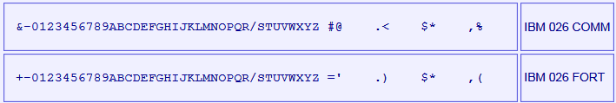

The IBM 650 simulator always uses the FORT character set.

Each card contains 80 columns; each column has 12 lines that can be punched.

- The upper line on the card: called High Punch, Hi Punch, 12, Y or Y(12)
- The line bellow: called 11, X, X(11) or Minus Punch
- The lines identified as 0 to 9

The following card image shows the punches corresponding to each available character:

X(11)
Punch
X(12)
Hi Punch
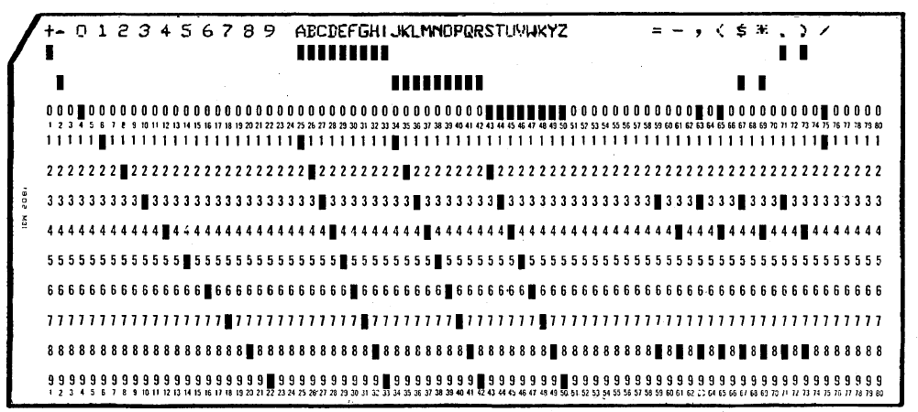

When simulating these cards as text files, each column can be mapped to an ASCII character as follows:

0 1 2 3 4 5 6 7 8 9 numeric digit 0 to 9
? A B C D E F G H I 0 to 9 with Y(12) High Punch set
! J K L M N O P Q R 0 to 9 with X(11) Minus Punch set

a b c x y z regular alphabetic characters
( ) $ . , = + - / * allowed symbols

A load card is identified by a Y(12) punch set on any of the 80 columns.

Note that the character set is tied to IBM 026/IBM 407 and not to the IBM 650 itself.
When preparing source program cards to be read by a program, some characters are forbidden:
- uppercase letters A to I
- the question mark (?)
- plus sign (+) on column 1
If these characters are used, they will be interpreted as numbers with Y(12) set, the whole line (i.e. the punched card corresponding to this line) will be interpreted as a load card, and the program will crash when trying to execute it.

Note that the dot (.) and left parenthesis ()) characters, even if they are coded with Y(12) punches, are not tested by the simulator when checking if the current card is a load card.

IBM 650 stores alphabetic characters using two digits. The following table describes the 650 code for each character, and it card punch equivalent code

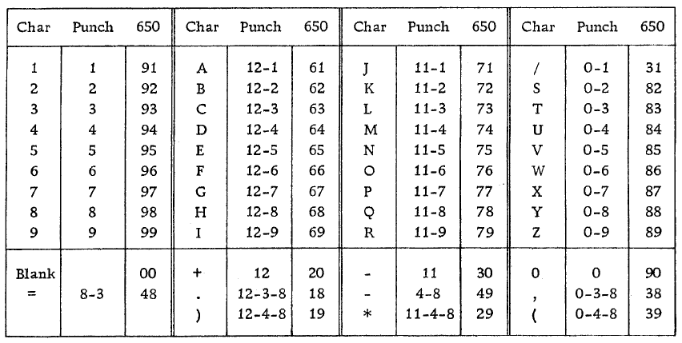
(table taken from http://bitsavers.org/pdf/ibm/650/29-4047_FORTRAN.pdf page 36)

IBM 533 Card Punch (CDP)

The card punch (CDP) punches card decks with data sent from computer. Card decks are simulated as files.

Card punch files can be either text (one character per column) or column binary (two characters per column). The file type can be specified with a SET command:

SET CDP1 FORMAT=TEXT sets ASCII text mode
SET CDP1 FORMAT=BINARY sets for binary card images.
SET CDP1 FORMAT=BCD sets for BCD records.
SET CDP1 FORMAT=CBN sets for column binary BCD records.
SET CDP1 FORMAT=AUTO automatically determines format.

The ATTACH command simulates putting a blank card deck into the card punch feed hopper:

ATTACH CDP1 <file>

IBM 727 Magnetic Tape (MT)

The Magnetic Tape (MT) reads and writes reels of magnetic medium. Tape reels are simulated as files in standard SimH tape format.

To use tapes, both IBM 652 Control Unit and IBM 653 Storage Unit must be enabled. If not, tape opcodes will be not available, and cpu will halt on trying to execute them with undefined opcode error.

Six tapes are allowed, ranging from MT0 to MT5. MT0 maps to 8010 address, MT5 to 8015 address.

The ATTACH command simulates mounting and loading a tape reel in tape unit:

ATTACH MTn <file>

Each individual tape drive support several options:

SET MTn REWIND Sets the mag tape to the load point.
SET MTn LOCKED Sets the mag tape to be read only.
SET MTn WRITEENABLE Sets the mag tape to be writeable.
SET MTn LENGHT Set tape medium length (50 to 10000 feet).

SET MTn FORMAT=SIMH Sets SIMH tape format
SET MTn FORMAT=E11 Sets E11 format.
SET MTn FORMAT=TPC Sets TPC format.
SET MTn FORMAT=P7B Sets P7B format.

By default, tapes have a length of 2400 feet).

IBM 355 RAMAC Storage (DSK)

The RAMAC Disk Storage (DSK) reads and writes to one up to four hard disk units. Hard disk units are simulated as files.

To use RAMAC, both IBM 652 Control Unit and IBM 653 Storage Unit must be enabled. If not, disk opcodes will be not available, and cpu will halt on trying to execute them with undefined opcode error.

Four disk units are allowed, ranging from DSK0 to DSK3.

The ATTACH command simulates powering on disk unit:

ATTACH DSKn <file>

Each disk unit has 3 read/write arm, that can operate at the same time. On Control Panel GIO, only one arm is visible. To get a nice picture of arm movement, it is possible to instruct the simulator to redirect all the disk commands to the first arm of each disk unit. This redirection is transparent to the program, which will works as the 3 arms where active. The only difference is that the arm 0 will have to move to each disk/track, thus introducing some delay in program execution.

SET CPU 1DSKARM to use only first arm for all disk operations
SET CPU 3DSKARM to enable all the disk arms for regular operation

Panel Wiring

The IBM 650 has no I/O formatting facilities. It only can read and punch cards using the IBM 533 device.

Formatting is done by wiring the IBM 533 control panel. This maps how the words sent by the computer are to be punched. In addition, the wiring maps how the punch marks read from cards are to be set up as word values.

In each program’s documentation it is usual to have a section describing the needed IBM 533 control panel wiring, the column format for input card, and maybe the panel wiring for the IBM 407 to printout the results.

This wiring is outside the scope of the current simulation. In order to use the IBM 533, several predefined wirings have been defined. These can be selected using

SET CDR1 WIRING=<option>

or

SET CDP1 WIRING=<option>

Where <option> can be one of the following:

<Option> | Description
SOAP | Simulates SOAP II assembler wiring
SOAPA | Simulates SOAP IIA multipass assembler wiring
SUPERSOAP | Simulates SuperSoap assembler
IS | Simulates Bell Floating Point Interpretive System wiring
IT | Simulates IT Compiler wiring
8WORD | Simulates an 8 word per card wiring, with no translation (default)
RA | Simulates wiring for Lockheed Regional Assembler cars
FDS | Simulates wiring for Interpretive Floating Decimal System
FORTRANSIT | Simulates FORTRANSIT Compiler wiring

The 8WORD wiring just punches/reads cards with the word value from the first eight words of the I/O buffer. No character translation is done.

Printing

The IBM 650 has no special I/O for printing. On real hw, printing is done by the following procedure

- Collect punched cards from IBM 533
- Feed them into the card input hopper of an IBM 407
- Set up the IBM 407 control panel wiring to obtain the desired print formatting
- Print the cards from the input hopper

On real hardware this is a manual offline procedure, done outside of computer’s control.

To simulate printing, it is possible to attach a file to device CDP0 that will act as the printer part of the IBM 407. For example:

attach cdp1 deck.dck
set cdp1 wiring=soap
set cdp1 echo
set cdp1 print
attach cdp0 printout.txt

The SCP command attach cdp1 deck.dck saves the cards punched by simulated IBM 533 to the file deck.dck. Then the required wiring is selected with set cdp1 wiring=soap. This defines the formatting to be used for words sent by the computer to be punched or printed.

The SCP command set cdp1 echo instructs the simulator to echo the printed format of each punched card to the console.

The SCP command set cdp1 print instructs the simulator to send the printed format of each punched card to the file attached to device CDP0.

Symbolic trace

SimH has a native set of debugging tools: breakpoints, examine/deposit, etc. The IBM 650 simulation provides an additional tool for symbolic trace

It is possible to have symbolic information on debug output (see “Symbolic Information Load” section of this document). On this symbolic information is included the SOAP comments field (up to 10 characters) on each machine instruction

It is possible to place commands on this comment field. It will not harm at all the SOAP assembly, not the program execution. But will be produce trace output when its instruction is executed.

Symbolic trace commands begins with ** (two consecutive asterisks).
The output information is shown in console, and included on debug file if any

Available commands

**trace
Shows the current execution time (elapsed from last go/run scp command)
and the symbolic information for this instruction. Time is shown in hours, minutes, seconds and milliseconds. Example:

00:04:12:547 TRACE: std ntot1 **trace

**time
resets the time count for trace. This is very useful to measure the time elapsed

00:00:00:000 TRACE: raa 0004 s1a **time
00:02:37:985 TRACE: std ntot1 **trace

Example on debug file:

DBG(4402121)> CPU CMD: Exec 1311: 80 RAA 0004 0917 symb: raa 0004 s1a **time
00:00:00:000 TRACE: raa 0004 s1a **time
DBG(4402121)> CPU DETAIL: ... IRA: 0004+

**regs
Shows the contents of registers (upper and lower Accumulator, distributor) BEFORE opcode execution

00:00:07:163 TRACE: raa 0004 s1a **regs
ACC: 0000000000 2790001854+, DIST: 0000000000+

**index
Shows the contents of index registers (IRA, IRB and IRC) BEFORE opcode execution

00:00:07:176 TRACE: raa 0004 s1a **index
IRA: 8010, IRB: 0001, IRC: 0001

Example on debug file:

DBG(4825780)> CPU CMD: Exec 1311: 80 RAA 0004 0917 symb: raa 0004 s1a **index
00:00:07:176 TRACE: raa 0004 s1a **index
IRA: 8010, IRB: 0001, IRC: 0001
DBG(4825780)> CPU DETAIL: ... IRA: 0004+

On this example, it is shown the value or IRA before execution (IRA: 8010, because **index command) and the value after RAA opcode execution (IRA: 0004)

**m
Shows the contents of memory block BEFORE opcode execution. The syntax is
**mNNNN-LL

Where NNNN is a drum address or ias address, and LL is the number of words to show (1 to 99). Example: shows 5 words, starting at address 1000.

00:00:07:167 TRACE: raa 0004 s1a **m1000-5
1000: 7019621962+
1001: 5580100856+
1002: 6507680773+
1003: 6507590963+
1004: 6507680823+

Software Support
This IBM 650 release supports the following software:

Software | Notes
Interpretive Floating Decimal System  Date: Sep/1954 | Description: Interpreter for floating point calculation.  Hardware needed: basic IBM 650, 2k drum, IBM 533 card read-punch  Documentation: Appl Sci Tech Newletter 08 Sep54.pdf (pages 18-37)  Documentation URL: http://www.bitsavers.org/pdf/ibm/periodicals/Applied_Sci_Tech_Newsletter/  CDR/CDP Wiring: FDS  Card deck: fds.dck  Source: (no source)  Comments: This is an Interpreter for floating point calculation, developed by IBM. Available on IBM 650 launch. Allows mixing interpretive instructions with native 650 instructions.
Regional Assembly Routine  Date: Jun/1955 | Description: Regional assembler.  Hardware needed: basic IBM 650, 2k drum, IBM 533 card read-punch  Documentation: Appl Sci Tech Newletter 10 Oct55.pdf (pages 32-49)  Documentation URL: http://www.bitsavers.org/pdf/ibm/periodicals/Applied_Sci_Tech_Newsletter/  CDR/CDP Wiring: RA  Card deck: ra.dck (five-field per card)  Source: (no source)  Comments: This is regional Assembler developed at Missile Systems Division Lockheed Aircraft Corporation. It is a regional assembler (as IBM 701 Regional Assemble) but not symbolic: that is, no mnemonics allowed.
Floating Point Interpretive System  (BELL interpreter)  Date: Mar/1956 | Description: Interpreter for floating point calculation  Hardware needed: basic IBM 650, 2k drum, IBM 533 card read-punch  Documentation: 28-4024_FltDecIntrpSys.pdf  Documentation URL: http://www.bitsavers.org/pdf/ibm/650/  CDR/CDP Wiring: IS  Card deck: is.dck (1-word per card load cards)  Source: is_main_src.txt  Comments: This is also known as the BELL interpreter, and it is a descendent of the IBM 701 SpeedCoding system. It predates SOAP, so source is given as list of words to be loaded in drum. Optional decks are available: is_trace_src.txt to enable tracing, and is_set_loopbox.txt to allow calculated indexing (needed by is_example_1_src.txt).
Internal Translator  (IT Compiler)  Date: 1956 | Description: Algebraic Compiler  Hardware needed: basic IBM 650, 2k drum, IBM 533 card read-punch  Documentation: CarnegieInternalTranslator.pdf  Documentation URL: http://www.bitsavers.org/pdf/ibm/650/  CDR/CDP Wiring: IT  Card deck: it_compiler.dck (1-word per card load cards),  Source: it_compiler_listing.txt  Comments: IT source listing requires SOAP I. As it is not available, it has been slightly modified to be assembled with SOAP II. Also, the SOAP patches stated in listing are to be applied on SOAP I deck. They have been modified to be applied to SOAP II instead.
SOAP II  Date: 1957 | Description: Assembler  Hardware needed: basic IBM 650, 2k drum, IBM 533 card read-punch  Documentation: 24-4000-0_SOAPII.pdf  Documentation URL: http://www.bitsavers.org/pdf/ibm/650/  CDR/CDP Wiring: SOAP  Card deck: soapII.dck (1-word per card load cards), soapII_condensed_card.dck (7 words per card load cards)  Source: soap_src.txt  Comments: Many versions were produced. SOAP (first version 1956), SOAP II (mid-1957), SOAP IIA (end-1957). Versions also exists for specific hardware configurations: SOAP IIA 4000 (for 4k drum machines) and Tape SOAP II (for tape machines)
FOR TRANSIT  Date: Aug/1957 | Description: Fortran Compiler  Hardware needed: IBM 650 with IBM 653 Storage Unit, 2k drum, IBM 533 card read-punch  Documentation: 28-4028_FOR_TRANSIT.pdf (the program listing is in CarnegieInternalTranslator.pdf file)  Documentation URL: http://www.bitsavers.org/pdf/ibm/650/  CDR/CDP Wiring: FORTRANSIT  Card deck: fortransit_translator.dck and fortransit_it_compiler.dck (1-word per card load cards),  Source: fortransit_translator_compiler_listing.txt  Comments: There were 4 versions: Fortransit I, II, I (S), II (S). “I” and “II” indicates the it compiler to be used. “I” is for basic IBM 650, and “II” is for IBM 650 + IBM 653. “S” indicates the version of fortransit translator to be used. “S” is to be used when IBM 533 included the special character option. The available version is Fortransit II (S).
SOAP IIA-4000  Date: 1959 | Description: Assembler  Hardware needed: basic IBM 650, 4k drum, IBM 533 card read-punch  Documentation: SOAPIIA-4000_listing.pdf (24-5013-0_SOAP2L.pdf contains al complete description of assembler)  Documentation URL: http://www.bitsavers.org/pdf/ibm/650/  CDR/CDP Wiring: SOAPA  Card deck: soap4.dck  Source: soa4p_src.txt  Comments: Supports tape library and multipass assembling
SuperSoap  Date; 1959 | Description: Assembler  Hardware needed: basic IBM 650, 2k drum, IBM 533 card read-punch, RAMAC disk unit, TLE feature enabled  Documentation: 102784983-05-01-acc.pdf  Documentation URL: https://archive.computerhistory.org/resources/access/text/2018/07/  CDR/CDP Wiring: SUPERSOAP  Card deck: ssoap_main.dck  Source: ssoap_main_core_src.txt  Comments: This assembler resides in RAMAC. Supports tape/disk or card output

Simulator Usage

Assemble a SOAP Program
Files | Description | Hardware equivalent
soapII.dck | SOAP II assembler deck | Punched card deck
source.dck | Source program to be assembled | Punched card deck
deck_out.dck | Assembled program output | Blank cards deck
print.txt | SOAP assembly listing printout | Paper listing

The following steps are described on page 15 of the SOAP II manual (24-4000-0) in the "Machine Operator's Guide" section:

SCP Commands | Comment | Real Hardware equivalent
set cpu 2k  set cdr1 wiring=soap  att cdr1 soapII.dck  set cdp1 wiring=soap  att cdp1 deck_out.dck | Use a 2k machine  Set SOAP wiring  Attach soap assembler  Attach file for assembled program output | SOAP II needs a 2k machine.  In IBM 533 Read-Punch unit:  Insert SOAP II control panel  Place SOAP deck in read hopper  Ready punch feed with blank cards
dep cswps 1  dep half 0  dep cswos 0 | These are the defaults and can be omitted | Set programmed switch to STOP  Set half cycle switch to RUN  Set control switch to RUN  Set display switch to DISTRIBUTOR  Set overflow switch to SENSE  Set error switch to STOP
dep csw 7019519999  dep ar 8000  go | Load a read card (RD) opcode at address 8000 (the storage entry switches address), and execute it. | SOAP is being loaded, set (70, 1951, 9999) in storage entry switches  Press computer-reset key  Press program-start key (Computer stops when finished loading SOAP deck into drum)
att cdr1 source.dck  set cdp1 echo, print  att cdp0 print.txt | Set up the simulated IBM 407 for printing the punched cards that will be generated. Set up to print and display cards punched as they are generated | Put source deck in read hopper
dep csw 0000001000  dep ar 8000  go | Start SOAP at address 1000 | Set (00, 0000, 1000) in storage entry switches  Press computer-reset key  Press program-start key
det cdp1  det cdp0 | The deck_out.dck file has the assembled program punched cards, and the Print.txt file has the assembly listing in a readable format | Get cards punched from the IBM 533 output stacker. Move them to the IBM 407 input feed to print the assembly listing

Note: all these steps are automated in run_soap.ini script

Available Software
The available software files are in i650/sw directory. These files have been typed from listings information from documents available on BitSavers.

xxx_run.ini script will allow to load and run source program given as parameter.
build_xxx.ini will allow to build the main program deck.

All ini files an in i650/sw directory. The language files in its own folder

Interpretive Floating Decimal System

Files | Description
run_fds.ini | SimH script to load and run fds programs
fds/ | Folder contents:
load_ card.dck | Loader for FDS deck in five-word format (load card)
5440.2009_INTERPRETIVE_FDS.crd | FDS main deck (five-word format), binary format
ra_starter_card.dck | Regional assembler starter card (see doc) (load card)
example.txt | Sample program

How to run:
sim> do run_ra.ini print_drum_ctrl_cards.txt print_drum_src.txt 0900 deck_in.dck

Regional Assembler

Files | Description
run_ra.ini | SimH script to load and run source programs
regional/ | Folder contents:
load_id_card.dck | Loader for any deck in five-field format (load card)
ra.dck | Regional assembler main deck (five-field format)
ra_starter_card.dck | Regional assembler starter card (see doc) (load card)
punch_drum_a_to_b.dck | Sample assembled prog (five-field format)
punch_eighths_drum.dck | Sample assembled prog (five-field format)
print_five_field_ctrl_cards.txt | Sample Reg.Ass. source program (control cards)
print_five_field_src.txt | Sample Reg.Ass. source program

How to run:
sim> do run_ra.ini print_drum_ctrl_cards.txt print_drum_src.txt 0900 deck_in.dck

Floating Point Interpretive System

Files | Description
build_is_from_decks.ini | SimH script to build IS main deck from source using SOAP II
run_is.ini | SimH script to load and run source programs
bell/ | Folder contents:
00_readme.txt | Restoration comments
is_sys_load_src.txt | Source for program build (system loader)
is.dck | Main program deck (1-word load format)
is_main_src.txt | Main program source
is_trace_src.txt | Main program source for trace
is_set_loopbox.txt | Main program source extension
is_example_1_src.txt | Sample IS source. Prints prime numbers < 50

How to run:
sim> do Build_is_from_decks.ini ntr lbox
sim> do run_is.ini bell/is_example_1_src.txt

SOAP Assembler

Files | Description
build_soap_from_source.ini | SimH script to build SOAP from source using condensed SOAP II card deck
run_soap.ini | SimH script to assemble and run source programs using SOAP II
run_soap4.ini | SimH script to assemble and run using SOAP IIA-4000
soap/ | Folder contents:
00_readme.txt | Restoration comments
soap_listing.txt | Main program assembly listing (SOAP II)
soap_src.txt | Main program source
soapII.dck | Main program deck (1-word load format)
soapII_condensed_card.dck | Main program deck (7-word per card load format)
soap_example_1_src.txt | Sample 1 SOAP source (as in manual)
soap4_listing.txt | Main program assembly listing (SOAP IIA-4000)
soap4_src.txt | Main program source
soap4.dck | Main program deck (1-word load format)
soap4_lib.txt | SOPA IIA-4000 Tape Librarian
soap4_example_lib_routines.txt | Sample routines for library tape
soap4_example_tap.txt | Sample usage of library routines with TAP pseudo-op

How to run:
sim> do build_soap_from_source.ini
sim> do run_soap.ini soap/soap_example_1_src.txt 1000

; build SOAP-4000 from source
sim> do run_soap4.ini soap/soap4_src.txt

; create SOAP-4000 library tape
sim>del soaplib.tap
; assemble librarian program (soap4_lib.txt) and run it (starts at addr 1000)
; as data gets the routines to be loaded in library tape (soap4_lib_routines.txt)
; must use SOAPA wiring on card read and punch
sim> do run_soap4.ini soap/soap4_lib.txt 1000
soap/soap4_example_lib_routines.txt SOAPA SOAPA
; now test library tape usage
sim> do run_soap4.ini soap/soap4_example_tap.txt 1000

Internal Translator (IT Compiler)

Files | Description
run_it.ini | SimH script to compile and run source programs
it/ | Folder contents:
00_readme.txt | Restoration comments
it_compiler_listing.txt | Compiler assembly listing
it_compiler.dck | Main program deck (1-word load format)
soap_patch_listing.txt | Patches on SOAP listing (as on manual)
soapII_patch.txt | Text file that describe patches on SOAP II
soapII_patch.dck | Patches to SOAP II (1-word load format)
soapII.dck | SOAP II to be patched (1-word load format)
it_reservation_p1.dck | Reservation for Runtime Package P1 source
it_reservation_p1.dck | Reservation for Runtime Package P2 source
it_reservation_p2.dck | Reservation for Runtime Package P3 source
it_reservation_p4.dck | Reservation for Runtime Package P4 source
it_reservation_p1_listing.txt | Reservation for Runtime Package P1 assembly listing
it_reservation_p2_listing.txt | Reservation for Runtime Package P2 assembly listing
it_reservation_p3_listing.txt | Reservation for Runtime Package P3 assembly listing
it_reservation_p4_listing.txt | Reservation for Runtime Package P4 assembly listing
it_package_p1.dck | Runtime Package P1 (1-word load format)
it_package_p2.dck | Runtime Package P2 (1-word load format)
it_package_p3.dck | Runtime Package P3 (1-word load format)
it_package_p4.dck | Runtime Package P4 (1-word load format)
it_package_p1_listing.txt | Runtime Package P1 assembly listing
it_package_p2_listing.txt | Runtime Package P2 assembly listing
it_package_p3_listing.txt | Runtime Package P3 assembly listing
it_package_p4_listing.txt | Runtime Package P4 assembly listing
it_subr_cos_listing.txt | Cosine subroutine assembly listing
it_subr_sqrt_listing.txt | Square root subroutine assembly listing
it_example_1_src.txt | Sample 1 source (as in manual)
it_example_1_data.txt | Sample 1 input data
it_example_1_out.txt | Sample 1 output data
it_example_2_src.txt | Sample 2 IT source. Prints prime numbers < 50

How to run:
sim> do run_it.ini it/it_example_1_src.txt it/it_example_1_data.txt
sim> do run_it.ini it/it_example_2_src.txt nul deck_out.dck

FORTRANSIT

Files | Description
build_fortransit_pack.ini | SimH script to build PACKAGE from source using regular SOAP II card deck
run_fortransit.ini | SimH script to compile and run source programs
fortransit/ | Folder contents:
00_readme.txt | Restoration comments
fortransit_translator_listing.txt | Fortransit Translator assembly listing
it_compiler_listing.txt | Fortransit IT compiler assembly listing
fortransit_addfn_listing.txt | Fortransit Add Function title card
pack_listing.txt | Fortransit run time PACKAGE assembly listing
fortransit_translator_src.txt | Translator source
fortransit_addfn_src.txt | Add Function title card
pack_entry_src.txt | PACKAGE entry points source
pack_res1.txt | Reservation for PACKAGE build source
pack_res2.txt | Reservation for PACKAGE usage source
fortransit_translator.dck | Main program deck (1-word load format)
fortransit_addfn.dck | Main program deck (1-word load format)
it_compiler.dck | Main program deck (1-word load format)
pack.dck | Runtime PACKAGE (1-word load format)
soapII.dck | Regular SOAP II assembler (1-word load format)
fortransit_example_1_src.txt | Sample Fortransit source. Prints prime numbers < 50
fortransit_example_2_src.txt | Sample Fortransit source as in manual (rectangular
fortransit_example_2_data.txt | matrix multiplication) and input data
fortransit_example_3_src.txt | Sample Fortransit source as in manual
fortransit_example_4_src.txt | Sample Fortransit source. Package functions test
fortransit_example_5_src.txt | Sample Fortransit source. Card punch graphics

How to run:
sim> do run_fortransit.ini fortransit/fortransit_example_1_src.txt
sim> do run_fortransit.ini fortransit/fortransit_example_2_src.txt
fortransit/fortransit_example_2_data.txt

SuperSoap

Files | Description
build_ssoap_ramac_from_decks.ini | SimH script to build SuperSoap into RAMAC for later use
run_supersoap.ini  run_supersoap_ramac.ini | SimH script to assemble and run a supersoap source program using supersoap main deck/using already built supersoap into RAMAC
supersoap/ | Folder contents:
00_readme.txt | Restoration comments
ssoap.txt | SuperSoap assembled listing recovered from doc
ssoap_main_core_src.txt | SuperSoap source code
ssoap_main.dck | SuperSoap assembled main deck (resides on drum)
ssoap_core.dck | SuperSoap assembled core deck (resides on core)
ssoap_loader_src.txt | SuperSoap loader source code
build_ssoap_ramac_src.txt | Build loader+main+core into RAMAC
ssoap_calling_card.txt | SuperSoap calling card listing from doc
ssoap_calling_card.dck | SuperSoap calling card deck
ssoap_example.txt | SuperSoap example listing from doc
ssoap_example_src.txt | Example source code
ssoap_example_src.txt | Example source code

How to run:
sim> do build_ssoap_ramac_from_decks.ini

This generates the ramac0.dsk disk image file that contains SuperSoap loaded in it, ready to use with the following scripts:

sim> do run_supersoap_ramac.ini supersoap/ssoap_example_src.txt
sim> do run_supersoap_ramac.ini supersoap/ssoap_main_core_src.txt

Running demo script
The file i650_demo_all.ini executes all the scripts in sequence. Between each script, SimH asks
Press Enter to continue . . .
All the console output is available in console.txt file.
This script can be used as an example of other scripts usage.

File extensions
The simulator does not enforce any extension for any file. Nevertheless, some extension are used as a convention on the script files
Extension Meaning
*.dck Ascii text format card deck
*.crd Binary format card deck
*.tap Magnetic tape image file
*.dsk RAMAC disk unit image file
*.ini SimH i650 simulator script
*.txt Text file
*_src.txt editable source code (text format) card deck
*_listing.txt original listing as found in original doc

Control Panel

Introduction
Control panel provides simulation of IBM 650 front panel on a GUI window. It is possible to interact with the computer thru the Control Panel, in the same manner as it was done with the original hardware

But also it’s nice just to see the Blinkenlights during program run, the tape fast jerky motion, the RAMAC hurried arm movements, the punched cards regular flow, or the beautiful near-aligned printing.

Control Panel files are stored in cpanel directory. There are .png bitmap images and an .ini file. This .ini file is called Definition File, and has all the info to instruct the simulator on how to display the control panel on the GUI window.

To show the control panel, these are the commands to issue on SCP:

sim> att cpanel ../cpanel/ibm650_photo.ini
sim> set cpanel on

(if needed, use the adequate path for .ini file in your installation). The Control Panel GUI window is displayed:

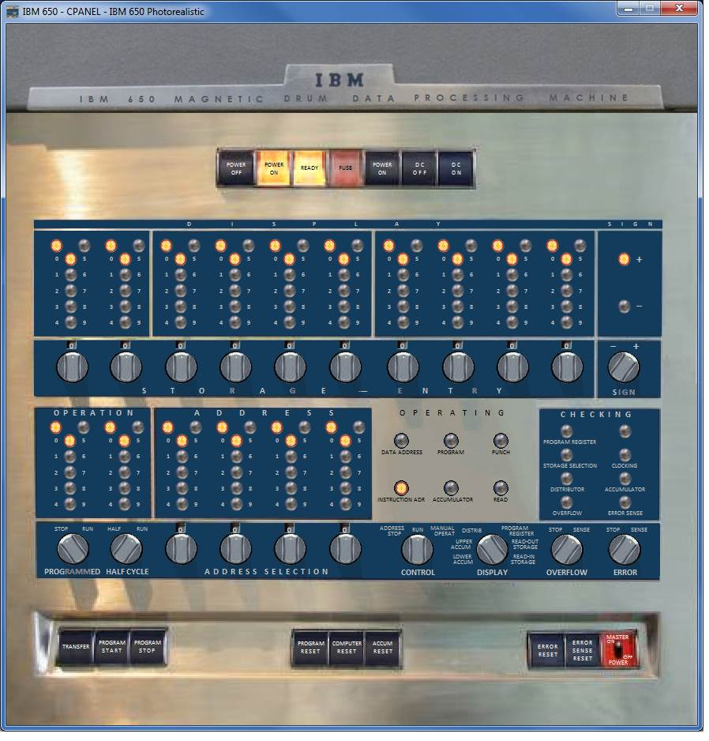

To close the control panel, use the command

sim> set cpanel off

Available Control Panels
Several Control panels are selectable, Default one shows only the main CPU console (as it was in 1954).

Before issuing SET CPANEL ON, it is possible to use SET CPANEL OPTION command to select the one to display

sim> att cpanel ../cpanel/ibm650_photo.ini
sim> set cpanel option=cpu1955
sim> set cpanel on

The SET CPANEL OPTION=cpu1955 will select the console as it was on 1955 (there is a new central row on operating lights, that supports the 1955 new hardware: tapes and RAMAC)

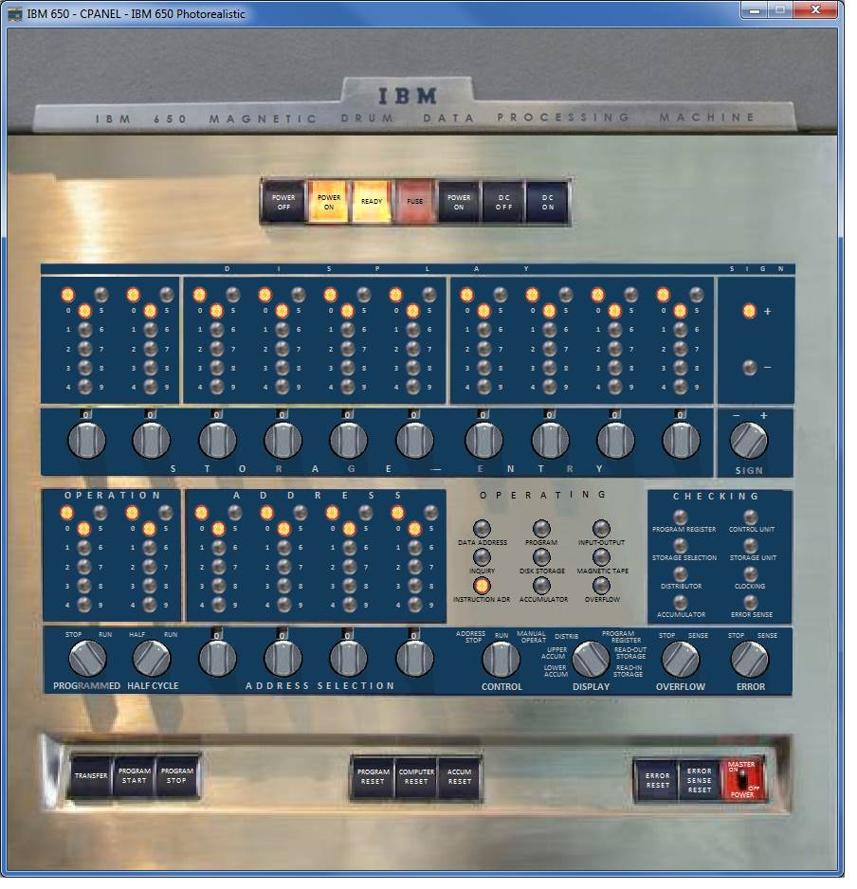

Other options available are (note: option command is case insensitive):

SET CPANEL OPTION=CardReadPunch will select the 1954 cpu console, the IBM 533 Card Read-Punch, and will show printout from IBM 407 Accounting machine connected as printer. This hardware combination is usually called “Basic IBM 650”

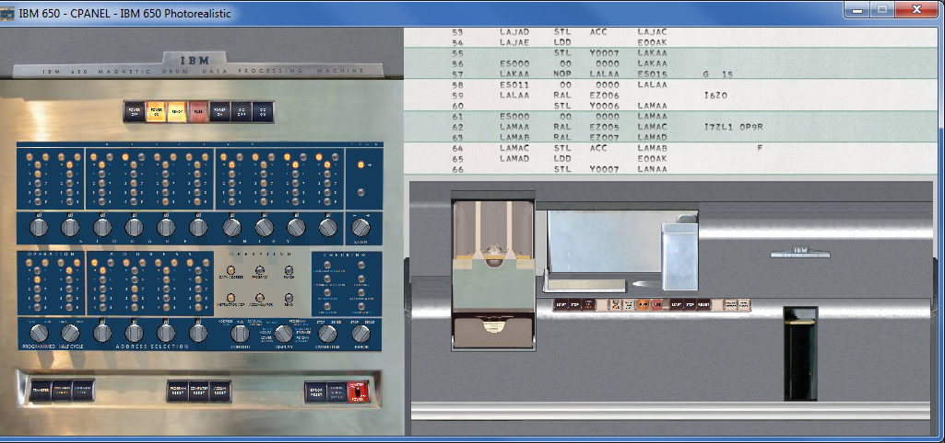

SET CPANEL OPTION=cpupanels will select the 1955 cpu console, the IBM 653 Storage Unit console, and the IBM 652 Control Unit console. This hardware combination is usually called “Enhanced” or ”Augmented IBM 650”

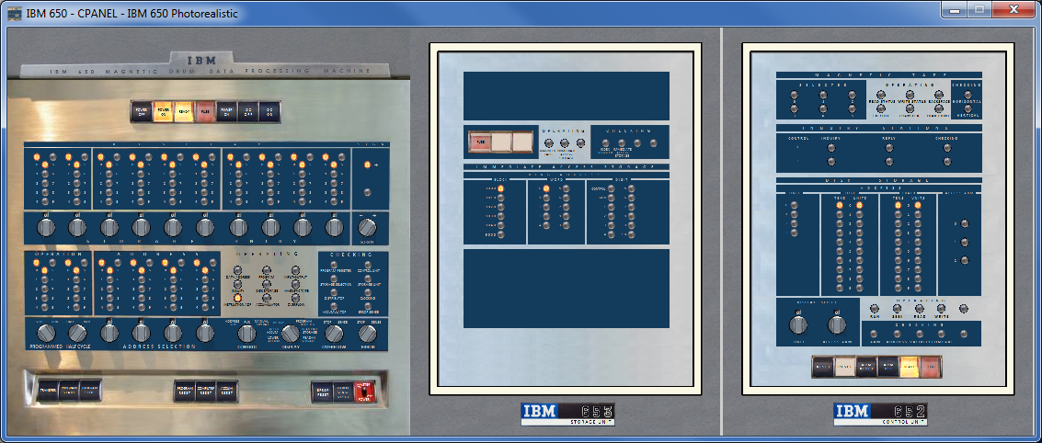

SET CPANEL OPTION=IAS will select cpu console (1955), Card Punch, printer, and Storage Unit

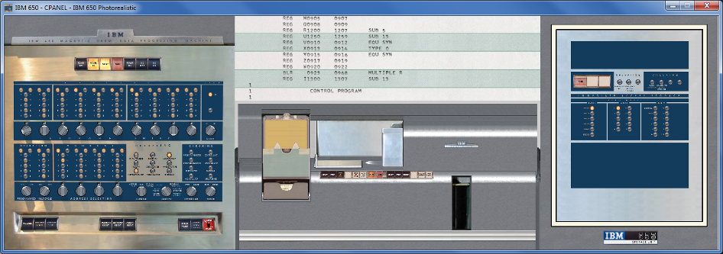

SET CPANEL OPTION=Tape will show also 6 tape units

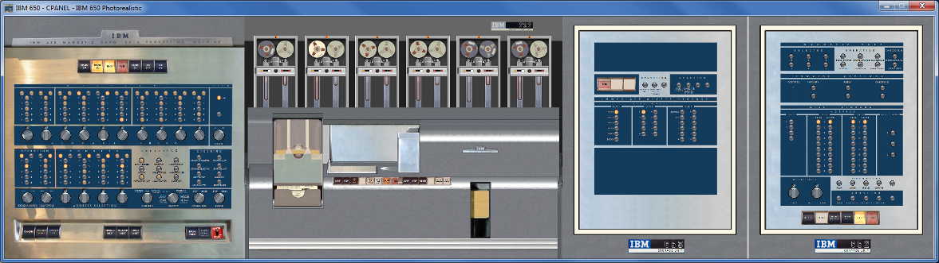

SET CPANEL OPTION=RAMAC will show a full equipped IBM 650 with tapes and RAMAC Storage Disk.

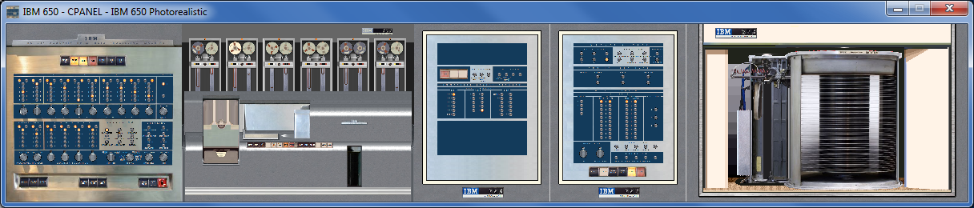

You can explicitly select the default panel with SET CPANEL OPTION=cpu1954

Important: To be effective, the SCP command SET CPANEL OPTION must be set after ATTACH CPANEL command, but before SET CPANEL ON.

Control Panel size and position
As Control Panel includes more hardware, its size gets bigger. CPU console is 875x890 pixels and fits on any screen. But RAMAC option is 4800 pixels wide.

To allow a comfortable display it is possible to set the scale on which the Control Panel GUI window will show the Control Panel.

sim> att cpanel ../cpanel/ibm650_photo.ini
sim> set cpanel option=ramac
sim> set cpanel scale=50
sim> set cpanel on

Will display the RAMAC control panel at 50% of its original size. Allowed scales ranges from 10 (10% of original size) up to 200 (double of original size)

SCP command ATTACH CPANEL resets the scale to 100 (i.e the original size). SET CPANEL SCALE can be issued at any moment, before or after SET CPANEL ON, one time or several times.

At any moment it is possible to move the Control Panel window with the mouse, as any regular window. But also it is possible to set the position of window with a command. This is handy to assure the position of Control panel is a good one given its scale when preparing a SCP script.

sim> att cpanel ../cpanel/ibm650_photo.ini
sim> set cpanel option=ramac
sim> set cpanel scale=50
sim> set cpanel pos=50/100
sim> set cpanel on

Will set the Control Panel on screen coordinates x=50, y=100. Coordinates can be negative.

Important: To be effective, SET CPANEL POS command should be issued after CPANEL ON.

Control Panel HotKeys
There are several HotKeys, that can be pressed while the Control Panel Window has the focus.

HotKey | Description
Control E | Halts the simulation (same as Control E issued on SimH console)
Control Y | Toggles size of window between 100% and 50% (full size/half size)
+  Control + | Increases size of window a 10% (maximum 200%)  Increases size of window a 1%
-  Control - | Decreases size of window a 10% (minimum 10%)  Decreases size of window a 1%
Control T | Toggles mark on clickable areas of control panel
Control I | Toggles show Info
Control F | Fast Mode: while pressed, simulated CPU runs at maximum speed. When releases, CPU returns to its selected speed.

Control T – Toggle Marks
Control T will show an alternate green-red-flashing box on clickable control in the control panel. This eases to identify what can be used, and what cannot .
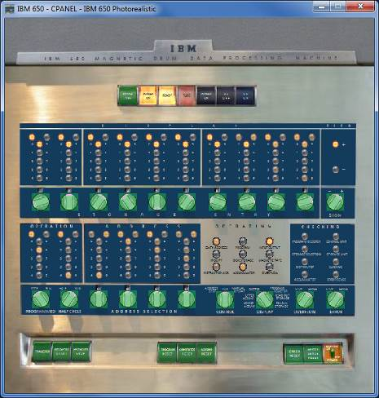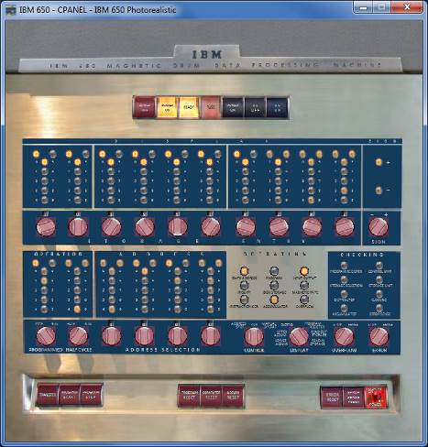

Also the areas where a file can be dropped are marked (See section “Drag and Drop files” bellow):

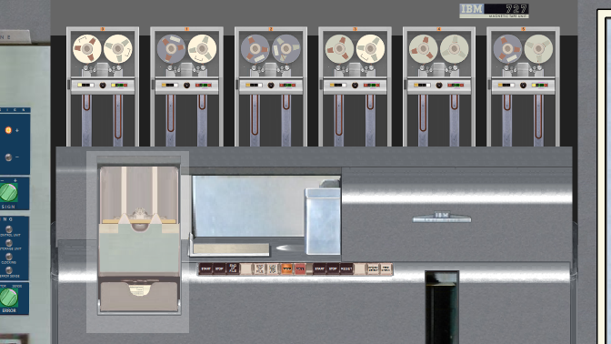
Drop tape file here to attach it
Drop card deck file in reader to attach it

Control I – Show Information Panel
Control I will show an information panel with some internal simulator state on real time. Pressing again Control I will hide the info

There are two panels. One on main CPU:

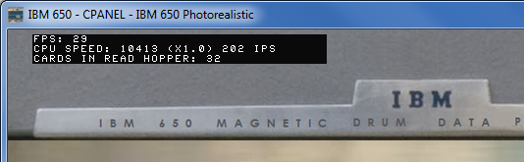

This information panel display:

- The current Frames Per Second (FPS) refresh rate
- The current measured CPU speed: in the example, 10413 are the wordtimes per second that means x1.0 speed relative to original hardware. 202 are the Instructions per Second (IPS) being executed.
- The number of cards in the read hopper waiting to be processed.

The other panel is on tape:

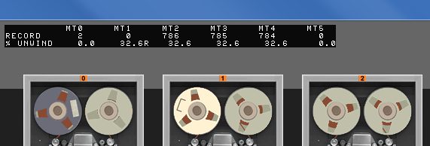

This information panel display, for each tape:

- The current record the tape r/w head is positioned on (not the total number of records on tape)
- The current % of tape unwind on right reel. 0% mans all the medium is on left reel, 100% means all the medium is on right reel. An R means there is a rewind operation in progress

If scp command SET CPANEL OPTION=ShowInfo is issued before SET CPANEL ON, the Control Panel window will display the information panels when opened.

The information panel is designed to be show at 100% and 50% scale.

Control F – Fast Mode
Control F will accelerate the CPU speed while pressed.

This is very handy to speed slow operations on the fly, for example the card loading operation which read rate is 200 cards per minute at x1.0 CPU speed.

X1.0 speed | Control F
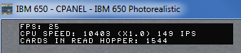 | 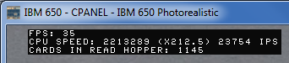

Control F also allows to speed-up High Speed rewind operation. To show the rewind progress, left reel is made transparent while Control F is pressed.

x1.0 speed | Control F
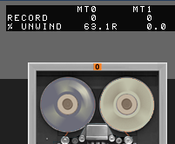 | 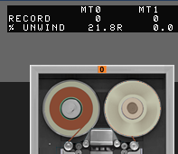

The CPU acceleration will continue until

- The user releases Control F keys

- Simulator executes SET CPU SPEED command (e.g. on the script being run). In this case, the new CPU speed figures are recalculated and CPU resumes at new speed setting. To accelerate the CPU it is necessary to press again Control F

Control Panel usage
The clickable controls can be spotted with Control T hotkey. Buttons and switches works as stated on operation manual 24-5000-0 General Information Console Operation (http://www.bitsavers.org/pdf/ibm/650/24-5000-0_GeneralInfo.pdf)

Clickable controls:
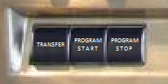
Switch Buttons

As a convention, the power buttons and the close top right box quits the simulation

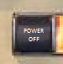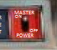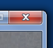

When CPU is running (thus the control panel is refreshed and responsive), the mouse pointer will be an arrow. If the pointer is placed on a clickable control, it will be changed to a hand

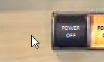

If the user clicks on control panel and moves the mouse without releasing the mouse button, then the control panel window will be moved on screen.

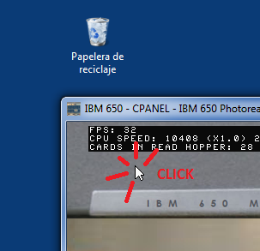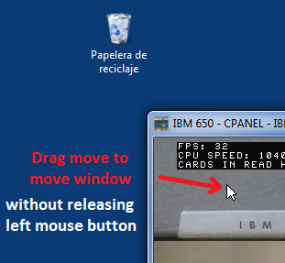

This is very handy when control panel window is zoomed and does not fit on screen.

When moving the Control Panel window by dragging the title bar (the standard move procedure), the GUI image stop being updated but the simulation still running. When moving the window by clicking in the image and dragging the mouse, the GUI image will not freeze and will be updated as the windows moves.

Control Panels can be big. With + and – hotkeys it is easy to resize the window at will. But when size is small, it can be difficult to read keys/switches labels.

On clicking on right mouse button, a tooltip will popup with showing the control panel image under the mouse at 100% scale.

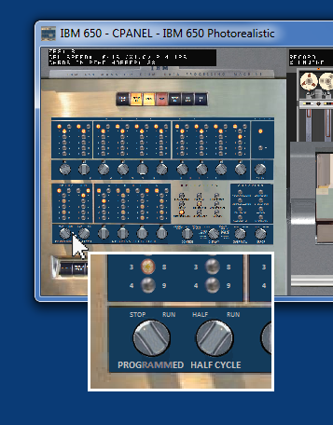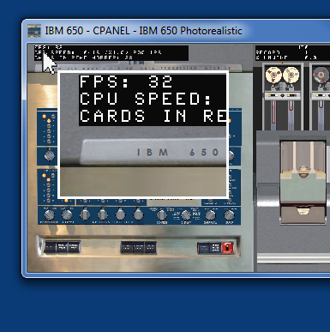

Dragging the mouse over the window while right button is kept pressed will show the contents on tooltip as mouse moves.

The tooltip window is closed automatically moving the mouse over it.

Interactive Mode
When simulated CPU is running, control panel is operating (shows info and reacts to mouse clicks).

Nevertheless, when simulated CPU is stopped, SimH can be either executing scp commands in a script, or be waiting for scp commands from user on console prompt.

But during user console input at prompt, SimH is blocked waiting user to type a command and press enter. Thus the whole control panel is not responsive to mouse clicks, not responsive to window close box, nor is updated. This situation is signaled to the user by the slashed red circle mouse cursor shape


Note that when simulated CPU is running, Control Panel window close box is active, and quits the simulation. When SimH is waiting on sim> command prompt, simulated CPU is stopped and thus close box of control panel window is not responsive. In this case, to quit the simulation it is necessary to close the console window (or issue the scp command QUIT or BYE)

When user press enter on sim> console, the GUI is updates once. This means you can click on GUI, that appears to not respond. Just press Enter on sim> prompt to see the updates on GUI

If scp command SET CPANEL INTERACTIVE is issued, SimH transfer the control of simulation from scp command line to control panel. SimH then refreshes control panel and responds to mouse in the same way as when CPU is running. This allows to control the simulation from control panel as in the real computer. CPU can be started and stopped while into interactive mode.

When in interactive mode, no scp command can be typed on console, as SET CPANEL INTERACTIVE command still in execution. To terminate interactive mode and regain control on console, the user can either

- press Control E on console or on Control Panel window (or any other defined as WRU character)
- Press Enter on console

While CPU is running, the button “PROGRAM STOP” will also activate interactive mode

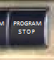

Drag and Drop files
It is possible to attach (mount) magnetic tape files, or to attach input card deck files by using drag and drop feature of GUI.

To attach a tape file

- Select the magnetic tape image file
- Drag it to the tape unit where desired
- Drop the file in the drop file area
- The load animation starts to signal the file is attached. The left reel will show all the tape medium on it.

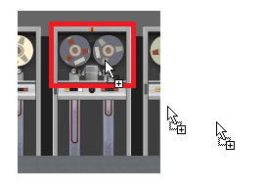
File being dragged
Drop file area

To attach a card deck file

- Select the card deck image file
- Drag it to the card reader unit
- Drop the file in the drop file area
- New cards will be shown stacked as pending to be read in the input hopper

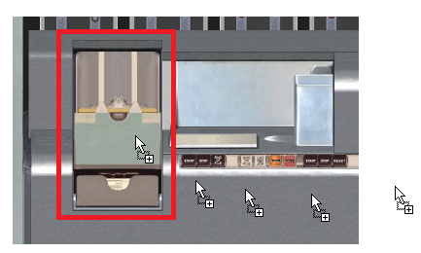
File being dragged
Drop file area

Detach tape file
To detach the current attached tape file (i.e unmount the tape reel currently mounted), just proceed as in real hardware:

- Click on the unload button on tape cabinet
- The unload animation starts to signal the file is being detached. The reel will show no medium on it.

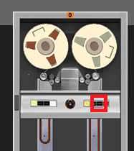

Tape Options

It is possible to setup the color of tape reels. It is done via the SET CPANEL OPTION, issued after ATTACH CPANEL but before ATTACH MTn command

SET CPANEL OPTION=MTn/LR

Defines the tape unit n will use color L for left reel, and color for right reel.

- n ranges from 0 to 5
- L and R can be
W for while colored reel
G for grey colored reel
D for dark grey colored reel

if L/R part is not given or is invalid, gray reels are used as default. Reel color options are processed each time a tape file is attached to MT device, so reel color options must be set before the attach scp command

Example:

sim> set cpanel option=mt1/wg

will set the reels on tape unit 1 as follow: Left Reel is white, Right reel is gray.

Additional comments

Speed Measurement
The speed measurement show on info panel (Control-I) is not the same as the one obtained with SHOW CPU SPEED.

Show CPU speed command measures the speed along all the run, that is, from the moment that simulated has been started until the moment the simulated CPU is stopped

On information panel, the speed is measured on the fly. Control F boosts the measured speed, rewind opcode can make the IPS value zero if CPU waits until rewind terminates.

Speed settings and rewind animation
Control F or SET CPU SPEED=MAX will allow the rewind animation to be show on Control Panel. On the contrary, if SET FAST command has been issued, rewind will be done instantly and no animation will be visible.

Scripting
The actions of pressing control panel’s buttons and acting on switches can be scripted via SCP commands

The general syntax is:

DEPRESS <button name>
PRESS <button name>

If button name contains spaces, it should be enclosed with quotes. Button name is case insensitive. This command simulates the button pressing on Control Panel, thus the Control Panel should be visible while executing this command.

Available button names:

DEPRESS Transfer
DEPRESS "Program start" or DEPRESS Start
DEPRESS "Program stop" or DEPRESS Stop
DEPRESS "Program reset"
DEPRESS "Computer reset"
DEPRESS "Accumulator reset"
DEPRESS "Error reset"
It is also possible to script the rotating switches
The general syntax is:

SWITCH <switch name> TO <label name>
SWITCH <switch name> TO <decimal value>

If switch name or label name contains spaces, it should be enclosed with quotes. Switch and label names are case insensitive. Control Panel should be visible while executing this command.

Some switches selects a value of 10 digits + sign (storage entry switches) or 4 digits without sign (address selection). In this case, a decimal value must be provided

Available switches names and labels:

SWITCH programmed TO run
stop

SWITCH "half cycle" TO half
run

SWITCH control TO run
"manual operation" or manual
"address stop"

SWITCH display TO "program register" or pr
"read-out storage" or read-out
"read-in storage" or read-in
"lower accumulator" or lower or acclo
"upper accumulator" or upper or accup
Distributor or dist

SWITCH overflow TO sense
stop

Available switches names and decimal values:

SWITCH “access arm” TO N N is 0 to 2

SWITCH “ramac unit” TO N N is 0 to 3

SWITCH “address selection” TO NNNN 4 digits (0-9) number,
SWITCH “address” TO NNNN (same as above)

SWITCH “storage entry” TO NNNNNNNNN up to 10 digits (0-9),
SWITCH storage TO NNNNNNNNN can have spaces. + or -
SWITCH entry TO NNNNNNNNN sign allowed if needed
SWITCH console TO NNNNNNNNN before first or after last
digit.
Examples:

SWITCH console TO 12 3456 7890 -

The syntax of number is the same as the one used on DEPOSIT command.

Control Panel usage example
The control panel scripting commands allow to closely matching the directions found on original manuals.

For example, this is the sequence to start a program already in the drum (taken from page 14 from 24-5000-0 General Information Console Operation (http://www.bitsavers.org/pdf/ibm/650/24-5000-0_GeneralInfo.pdf).

Starting the program, Method I |  | Equivalent SCP command in script | Equivalent GUI control to use
1 | Set 00 0000 xxxx in storage entry switches | switch console to 00 0000 xxxx | 
2 | Set control switch to RUN | switch control to run | 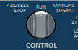
3 | Press program reset key | depress “program reset” | 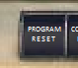
4 | Press program start key | depress start | 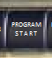

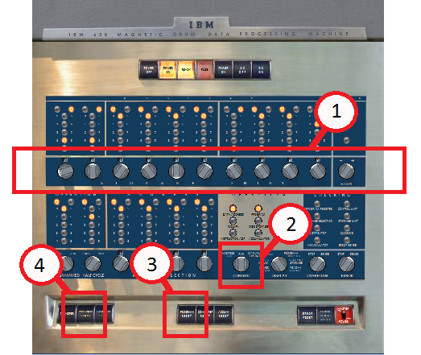

Demo scripts

Several demo ready to run scripts are provided in the sw/ directory

Files | Description
run_fortransit_cpanel.ini | Basic IBM 650 running fortransit on basic IBM 650
run_sort_1_cpanel.ini | IBM 650 performs a sort of 5000 records using only tapes (performed at x100 CPU speed). Uses depress/switch scp commands
run_sort_2_cpanel.ini | IBM 650 performs a sort of 500 records using tapes and RAMAC
run_ssoap_from_ramac_cpanel.ini | Assemble supersoap, shows only 1955 CPU.
i650_demo_all_cpanel.ini | Demo many scripts (long run)

These scripts accelerates the slow loading of from card, but keeps execution at x1.0 speed

How to run:
sim> cd sw
sim> do run_fortransit_cpanel.ini

Version History
- Release 1: Mar/2018
- Hardware support:
  - 1k and 2k drum machine.
  - IBM 533 card read-punch
  - Drum timing simulation
- Software included:
  - SOAP II One pass assembler
  - Floating Point Interpretive System

- Release 2: Apr/2018
- New Hardware support:
  - Half cycle simulation
  - Halt CPU simulation (^E on SimH console)
- New Software included:
  - Carnegie Internal Translator (IT) algebraic compiler
- New Features:
  - Support for displaying SOAP symbolic instructions in debug information
  - CardDeck internal command to split/join/print decks of cards
- Bugs Corrected:
  - Fixed card format handling. Release 1 can only read TEXT format punched cards. Release 2 can read any SimH supported formats BIN, TEXT, BCD, CBN, EBCDIC and OCTAL
  - Removed superfluous line ends from debug strings. Release 1 adds a redundant \r to debug output. Release 2 removes the extra unneeded \r
  - Better minus zero support
  - Fixed unneeded prompt Really truncate memory [N] when setting memory size

- Release 3: May/2018
- New Hardware support:
  - IBM 653 Storage Unit: provides machine opcodes for Floating Point, Immediate Access Storage (IAS), Three Index registers, Cards Punch-read synchronizers 2 and 3.
- New Software included:
  - FORTRANSIT: version II (S), plus run time PACKAGE with standard Fortran functions. Is a 704 Fortran I port.
  - Reorganized sw directory, separating each language in its own folder. Each one includes a 00_readme.txt file with restoration notes and comments.
- New Features:
  - Support for SOAP opcode mnemonics in addition to regular IBM mnemonics
  - FAST / REALTIME CPU options
  - PROP pseudo register
  - CARDDECK ECHOLAST command to display on console last n read cards that are in the simulated take stacker.
- Bugs Corrected:
  - Fixed a bug in combined usage of –C and –M flags with examine: EXAMINE –C –M <addr> was showing always opcode NOP. Now shows the correct opcode
  - Fixed a bug that prevented EXAMINE to work with addresses 8000 and beyond. Now EXAMINE can display register contents at address 8000 and beyond.
  - Fixed a bug in DIV opcode: divide was ignoring higher digit of accumulator (assuming always as zero). Now DIV takes in considerations all digits.
  - Fixed a bug in HLT opcode: on programmed stop, AR was displaying IA part of HLT opcode instead or DA part. Now HLP sets AR with DA contents when stopped, but allows SCP GO command to continue execution.
  - Fixed a bug in SCT opcode: accumulator negative sign was reset if upper accumulator is not zero and lower accumulator is zero on instruction execution entry. Now SCT keeps unchanged accumulator sign.
  - Fixed a bug in SRD opcode: a shift of 0 was performing no shifts. Now SRD performs 10 shifts when asked for zero as defined in manual.

- Release 4: May/2020
- New Hardware support:
  - IBM 650 Model 4 with 4000 words drum memory.
  - IBM 652 Control Unit: provides up to 6 tape units IBM 727
  - Table LookUp on equal feature (provides TLE opcode)
  - IBM 355 RAMAC Disk Storage
- New Software included:
  - SOAP IIA-4000 multipass assembler
  - SOAP IIA-4000 Tape Librarian
  - Regional Assembler
  - SuperSoap
- New Features:
  - CARDDECK SPLIT command now allows to split availability table deck and condensed 5-word-per-load-card deck.

- Bugs Corrected:
  - Removed query “really truncate memory” when reducing drum size
  - Fixed bug on reading cards in binary mode. Bits 16-13 where expected to be zero. Now are ignored and can have any value.
  - Fixed bug in IAS to DRUM transfers (was not stopping on end of IAS)
  - Fixed Overflow (OV) handling. All arithmetic opcodes were resetting OV flag. Now only BOV opcode resets OV flag.
  - Opcodes for card read-punch on Synchronizer 2 and 3 were missing. They has been added (RD2 RC2,WR2, RD3, RC3, WR3)
  - Fixed a bug in PCH opcode. When punching from IAS memory, Timing ring was set incorrectly. Now sets the correct value on instruction execution termination.
  - Fixed a bug in BDn opcode. If value in distributor is negative machine halts. Now sign is ignored on digit comparing against 8 or 9 value.
  - Fixed bug in NZA/B/C opcodes. Was branching to DA address on index=0. Now branch to DA address when index<>0
  - Fixed bug in LDI/LIB opcode. Was loading DIST with first word transferred. Now LDI/LIB does not modifies the distributor
  - Fixed bug in STC opcode. Was not handling the case AccUp=zero in the same way as stated in manual.
  - Fixed Index register arithmetic (opcodes RAA/B/C, RSA/B/C, AXA/B/C, SXA/B/C). Was not allowing negative values. Now it allows values from -9999 to +9999
  - Fixed Index register arithmetic (opcodes RAA/B/C, RSA/B/C, AXA/B/C, SXA/B/C). Was not updating distributor when reading operand value. Now sets the distributor with operand value when performing arithmetic on address 8000-8003, 8005-8007, 9000-9059. This behavior was not stated in docs, but expected by SuperSoap program.

- Release 5: Oct/2020
- New Hardware support:
  - Control Panel GUI !!!
- New Software included:
  - Sort program (not IBM original)
- New Features:
  - SET CPU 1DSKARM command to redirect all disk operations of each unit to arm zero
  - SET CPU SPEED / SHOW CPU SPEED command to control the cpu speed
  - Now Drum memory size defaults to 2k when starting simulation
  - SHOW HALF shows current I-Cycle or D-Cycle (or d-Cycle if program execution can continue with GO on current instruction IA address)
  - Allow trace commands on symbolic information (Symbolic trace)
  - New pseudo register CDR1RDHOPPER that holds number of cards in CDR1 hopper pending to be read
  - New pseudo register CPANELGUI allows to test if Control Panel is available

- Bugs Corrected:
  - PCH opcode was incorrectly examining RCD interlock. Fixed, now PCH examines its own interlock.
  - Tape/Disk opcodes on unattached units can result on a CPU infinite loop. Fixed, now opcode process as expected
  - Console Break (defaults Control-E) was not very responsive when real cpu speed was set with throttle. Now the way ^E is checked has changed to be more responsive at any cpu speed.
  - Build requires 10MB for stack space. Now fixed so default 1 MB is enough.
  - When reading disk 99-track 99 after disk 00-track 00 simulator can crash. Fixed.
  - Excessive stack usage on CARDECK commands fixed
  - Uninitialized variable usage on Tape service routine fixed

- Release 6: Feb/2021
- New Hardware support:
  - (none)
- New Software included:
  - (none)
- New Features:
  - Allow to click on background and drag mouse to move the window. Added right click mouse button support to show a tooltip with control panel image at 100% scale.
  - Improved Creating Control Panel doc
  - Improved IBM 355 disk spin moiré effect, added shadows under disk moving head, added vertical acceleration on ramac access arm motion, improved arm visuals
  - Improved frame rate (and reduce CPU usage). Avoid GUI window going completely off-screen if reduced when left part of window was already off-screen
- Bugs Corrected:
  - Fixed bug in speed measurement so now SHOW CPU SPEED command returns the correct value
  - Fixed typos and small errors in this document (never-ending task)

- Release 7: Jul/2021
- New Hardware support:
  - (none)
- New Software included:
  - (none)
- New Features:
  - Reduced CPU usage when Control Panel visible
  - Anti-Aliased control panel image on GUI on scale less than 50%
- Bugs Corrected:
  - Fixed typos and small errors in this document (never-ending task)

- Release 8:
- New Hardware support:
  - (none)
- New Software included:
  - (none)
- New Features:
  - Allow dropping files to tape and card reader to attach them. Control T (^T) shows the drop area
  - Allow unload tapes with tape cabinet buttons
  - Reduced CPU and memory usage when Control Panel visible
  - Bilinear scaling for a great nice cool lovely antialiased image
  - Shows IPS (instructions per second) count with IPS, KIPS and MIPS labels
- Bugs Corrected:
  - Removed nasty “ding” system sound if pressing plus/minus key to scale control panel window without ever having explicitly focused it (eg by clicking on it or moving it)
  - Corrected potential problem when closing simulator with tooltip window visible
  - Removed small pixel slew while clicking on window al low scales
  - Fixed occasional ^F key release event being lost.
  - Fixed tape medium hops in tape vacuum columns when fps is low or when moving the window by dragging the title bar (which freezes window client area updates until move finishes)

