IBM 701 Simulator User’s Guide
22-Jun-2025

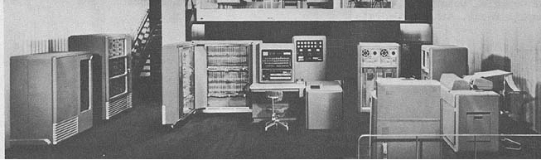

COPYRIGHT NOTICE

The following copyright notice applies to the SIMH source, binary, and documentation:
Original code published 1993-2012, written by Robert M Supnik
Copyright © 1993-2012, Robert M Supnik
Copyright © 2018-2021, Roberto Sancho
Permission is hereby granted, free of charge, to any person obtaining a copy of this software and associated documentation files (the "Software"), to deal in the Software without restriction, including without limitation the rights to use, copy, modify, merge, publish, distribute, sublicense, and/or sell copies of the Software, and to permit persons to whom the Software is furnished to do so, subject to the following conditions:
The above copyright notice and this permission notice shall be included in all copies or substantial portions of the Software.
THE SOFTWARE IS PROVIDED "AS IS", WITHOUT WARRANTY OF ANY KIND, EXPRESS OR IMPLIED, INCLUDING BUT NOT LIMITED TO THE WARRANTIES OF MERCHANTABILITY, FITNESS FOR A PARTICULAR PURPOSE AND NONINFRINGEMENT. IN NO EVENT SHALL THE AUTHORS BE LIABLE FOR ANY CLAIM, DAMAGES OR OTHER LIABILITY, WHETHER IN AN ACTION OF CONTRACT, TORT OR OTHERWISE, ARISING FROM, OUT OF OR IN CONNECTION WITH THE SOFTWARE OR THE USE OR OTHER DEALINGS IN THE SOFTWARE.
Except as contained in this notice, the names of the authors shall not be used in advertising or otherwise to promote the sale, use, or other dealings in this Software without prior written authorization from the authors.

1 Introduction 4
1.1 The IBM 701 Electronic Data Processing Machine 4
1.2 Simulator Files 5
2 Simulator Features 6
2.1 Hardware-Equivalent Actions 6
2.2 Simulator Specific Commands 7
2.2.1 Symbolic Display and Entry 7
2.2.2 RESET 8
2.2.3 RUN and GO 8
2.2.4 STEP 9
2.2.5 CARDDECK 10
2.2.6 Device Configuration 16
2.2.7 Enabling and Disabling Devices 16
2.3 Tracing Simulator Operations 16
3 Processor Device Simulations 18
3.1 Central Processing Unit 18
3.1.1 Speed 18
3.1.2 Simulation Stops 20
3.1.3 Tracing 20
3.1.4 Registers 20
3.1.5 LOAD a program 21
3.1.6 LOAD/DUMP drum contents 22
3.1.7 Symbolic Information 23
3.1.8 Symbolic trace 24
3.1.9 Console Switches and Buttons 26
3.1.10 Environment variables 28
3.2 IBM 711 Card Reader (CDR) 28
3.3 IBM 721 Card Punch (CDP) 29
3.3.1 Punched cards character set 30
3.4 IBM 726 Magnetic Tape (MT) 31
3.5 IBM 716 Printer 31
3.6 Panel Wiring 32
3.7 Software Support 33
4 Simulator Usage 35
4.1 Cross Assembler 35
4.2 Assemble a Program using NR9003 36
4.3 Available Software 37
4.3.1 Octionary Programming System 37
4.3.2 Binary Input and Output System 38
4.3.3 North American Aviation SpeedEx assembler 39
4.3.4 PACT I Compiler 40
4.3.5 HelloWorld 41
4.4 Running demo script 42
4.5 File extensions 42
5 Control Panel 43
5.1 Introduction 43
5.2 Available Control Panels 44
5.3 Control Panel size and position 47
5.4 Control Panel HotKeys 47
5.4.1 Control T – Toggle Marks 48
5.4.2 Control I – Show Information Panel 48
5.4.3 Control F – Fast Mode 49
5.5 Control Panel usage 50
5.6 Interactive Mode 51
5.7 Drag and Drop files 52
5.8 Detach tape file 53
5.9 Punched Card Viewer Panel 54
5.10 Additional comments 57
5.10.1 Speed Measurement 57
5.10.2 Speed settings and rewind animation 57
5.11 Control Panel usage example 58
6 Version History 60

Introduction
This manual documents the features and operation of the IBM 701 simulator. It is intended for use in conjunction with the SIMH Users' Guide manual, which describes how to compile and run the simulator, as well as the general commands that may be entered at the Simulation Control Program (SCP) prompt.

The IBM 701 Electronic Data Processing Machine
IBM sold the IBM 701 Magnetic Drum Data-Processing Machine from 1952 through 1955. The first unit was installed in December 1952.

IBM 701 is a vacuum tube machine. Each machine word is composed of 35 bits plus sign bit. It is a binary machine. Memory was implemented using Williams tube CRT, and references in doc as High Speed Electrostatic Memory (abbreviated as E.M). The basic machine cycle is 12 microseconds.

IBM made several enhancements during the life of the computer

- 1952 Early:
  - 2048 36bits words of memory, 4 input sense switches

- 1952 July:
  - 6 input sense switches

- 1953:
  - Addition of EXTRACT instruction

- 1953 Late:
  - Support to address a second bank of 2048 36bit words
  - Support for IBM 727 tapes
  - Support for IBM 740 CRT recorder

Reading or writing a word in memory takes 12 microseconds (called the fundamental machine cycle in IBM principles manual). This is a clock of 83.3 KHz).

This simulator covers up to 1953 computer status. 1953 Late version is no simulated

Simulator Files
The simulator sources are divided into a set of files for the Simulator Control Program and its support libraries, and a set of files for the IBM 701 CPU and device simulations; the latter reside in a subdirectory of the directory that contains the SCP files. The former set is common to all SIMH simulators, whereas the latter set is specific to the virtual machine being simulated. The files that make up this simulator are:

Subdirectory | File | Contains
i701 | i701_defs.h | System architectural declarations
 | i701_sys.c | SCP interface
 | i701_cpu.c | Main CPU simulator
 | i701_cdr.c | IBM 711 card reader simulator
 | i701_cdp.c | IBM 721 card punch simulator
 | i701_lp.c | IBM 716 printer simulator
 | i701_mt.c | IBM 726 tape simulator
 | i701_cpanel.c | IBM 701 Control Panel
 | cpanel.c | Control Panel interface
 | cpanel.h | Control Panel declarations
 | cpanel_vid.c | Control Panel video interface
 | cpanel_vid.c | Control Panel video declarations
 | i701_doc.doc | Documentation (this file)
 | i701_test.ini | Executes all the sw rest-run scripts
i701 / cpanel |  | Contains the control panel image bitmaps
i701 / test |  | Contains the simulator test suite
i701 / sw |  | Contains the included software and test run script files (See usage section)

PDF files of the original IBM 701 hardware and software manuals are available in Bitsavers repository: http://www.bitsavers.org/

The computer programming and its operation are described in IBM 701 principles of operation, Form 24-6042-1 (1953)

Simulator Features
The IBM 701 simulator contains the following device simulations:

Device Name(s) | Simulates
CPU | IBM 701 Electronic Data Processing Machine  2K word high speed electrostatic memory  4x 2K word drum storage
CDR | IBM 711 Card Reader
CDP | IBM 721 Card Punch
LP | IBM 716 Printer
MT0 to MT3 | IBM 726 Magnetic Tape

The simulator has been tested with and supports the following original software:
- IBM Octionary Programming System
- IBM Binary I/O routines
- North American Aviation (NAA) SpeedEx Assembler

The simulator also provides extensive facilities for tracing CPU and I/O device operations.

Hardware-Equivalent Actions
To use simulated IBM 701 two interfaces are available

- Commands that can be entered through the simulation console at sim> prompt

- Pressing buttons and moving switches on simulation control panel GUI

The following table describes the SCP commands and their equivalent action on real hardware. For control panel actions, see the Control Panel section on this manual.

Hardware Console Action | Equivalent Simulation Command
Set SENSE input switches | DEPOSIT SENSE_IN <value>
Display SENSE output lights | EXAMINE SENSE_OUT
Display Accumulator register | EXAMINE ACC
Display MQ register | EXAMINE MQ
Display IC register | EXAMINE IC
Display IR register | EXAMINE IR
Display CRT Memory data | EXAMINE <address>
Set CRT Memory value | DEPOSIT <address> <value>
Clear CRT Memory | SET CRT CRTMEMCLEAR
Set Load Selector | SWITCH “LOAD SELECTOR” …
Set Address switches | SWITCH “ADDRESS” …
Press START Key | GO
Set AUTOMATIC/MANUAL switch to MAN | ^E on console
Press RESET Key | RESET

Mounting media on a peripheral device is simulated by the ATTACH command. For example, entering the ATTACH CDR <card-deck-image-filename> command is equivalent to loading the card deck into the read hopper of the IBM 711. .

Simulator Specific Commands
In general, all of the commands documented in the SIMH Users' Guide manual are available for use with the IBM 701 simulator. Commands whose execution or parameters are implementation-defined are specified below.

Symbolic Display and Entry
When examining or depositing into memory, command line switches specifying the symbolic mode and format may be used to override the default mode, as follows:

Switch | Mode Interpretation
–F | Handle fullwords (default halfwords)
–O | Use octal values (default decimal)
–M | A CPU instruction opcode

If the –M switch is specified, the value is displayed or accepted as a CPU machine instruction opcode mnemonic, as described in the Operation Manual. Note that the names of opcodes can range from two letters such as TR up to seven letters with space such as STORE MQ.

IBM 701 allows to handle 18bits halfwords, and 36bits fullwords. This is simulated using the –F switch. By default, 18bit decimal quantities are assumed. The –F switch allows to use 36bits decimal values. Note that when using fullwords, only even address can be referenced.

The address is always displayed and entered as unsigned decimal number ranging from 0 to 4095. The value can be displayed/entered as decimal value (default) or as octal value if –O switch is used.

Octal values are unsigned. Decimal values can be positive or negative. Note that minus zero is a possible value to be displayed. To enter a minus zero halfword, a positive value must be entered. Note that all numbers are one-complement (see examples)

Examples

examine 0002
2: +036864

examine –o 0002
2: 11000

examine –f 0002
2: +09663934556

examine –f –o 0002
2: 110000770134

deposit –f 0002 -1 Fullword at addr 0002 maps to
examine –f 0002 halfword at addr 0002 and 0003
2: -00000000001 -1 bit pattern is all zeros except
examine 0002 sign bit (leftmost one) and rightmost one
2: -000000
examine –o 0002
2: 400000
examine 0003
3: +000001

deposit 0004 131072 Leftmost bit 18 set (sign bit)
examine 0004
4: -000000
examine –o 0004
4: 400000

deposit 0004 131074 Number 131074 and -2 generates
examine 0004 the same 18bit pattern
4: -000002
examine –o 0004
4: 400002
deposit 0004 -2
examine 0004
4: -000002

deposit –o 0003 777777
examine 0003
3: -131071
examine –o 0003
3: 777777

examine –m 0002-0003
2: -000000 – STOP 00 0000
3: -131071 – COPY 31 4095

examine –m –o 0002-0003
2: 400000 – STOP 00 0000
3: 777777 – COPY 37 7777

RESET
The RESET command is equivalent in hardware to pressing the COMPUTER RESET console button.

RUN and GO
The RUN and GO commands do not accept any parameter addresses. Execution will start at the address specified by the IC register.

The RUN command does an implied RESET, so it is equivalent in hardware to pressing the console panel RESET key, then the START key. As reset clears all of the registers, IC will be zero, so execution starts at address zero.

The GO command is equivalent to pressing the START key on the console and is the way to start or resume execution after a programmed halt.

STEP
The STEP command is used to execute program instructions on a one by one basis.

By default, when the simulator steps, it executes a full instruction cycle (an Instruction Time Cycle and an Execution Time Cycle) and then stops.

On real hardware, stepping is done only by Instruction and Execution cycles. This is simulated with:

SET CPU STEPHALF

In this case, STEP will only perform an Instruction Time Cycle or an Execution Time Cycle alternatively. On console, this will be shown with the appropriate text: when step is expired, the NEXT instruction and cycle to be done is stated

Step expired, IC: 0015 ( +053281 + STORE A 13 0033 - INSTR TIME)
sim> s

Step expired, IC: 0015 ( +053281 + STORE A 13 0033 - EXEC TIME)
sim> s

Step expired, IC: 0016 ( +036868 + ADD 09 0004 - INSTR TIME)

It is possible to display the next cycle to be performed by CPU with the command

EXAMINE HALFCYCLE

sim> ex halfcycle
HALFCYCLE: Interpretation
sim>

To return to normal full instruction cycle execution on stepping, use the following command

SET CPU STEPINSTR

Note that this CPU options only applies to the way STEP command works. CPU simulation is always done taking into consideration the cycles.

When the user issues a DEPOSIT IC command to set the Instruction Counter register, the current Cycle is reset to Instruction Time. So the next GO/STEP command will read the IC register value and the fetch its instruction into IR (Instruction register) and the execute it

When the user issues a DEPOSIT IR command to set the Instruction Register, the current Cycle is reset to Execution Time. So the next GO/STEP command will read the IR register value just set and execute it.

CARDDECK
This command allows handling card deck files.

The general syntax is:

CARDDECK [-Q] <operation> <parameters ... >

Allowed operations are
- JOIN: to join two or more decks in one destination deck
- LIST: to display a card deck on console
- PRINT: to print the given deck in line printer
- ECHOLAST: to display in console last card(s) already read in card reader unit
- IDENT: to punch an identification on each card of the given deck
- SORT: to sort given deck
- PUNCH: create (punch) a new deck with one (or more) cards

Default format for card files is AUTO, this allow mix source decks with different formats. To set the format for carddeck operations use:

SET CDP FORMAT=<format>

See section IBM 721 Card Punch (CDP) for details on formats.

Switches:

-Q quiet operation. Suppress messages.

Note: this command uses for its processing CDP device. It executes an implicit DET CDP command.

CARDDECK JOIN

Join several source deck files in one destination deck file.

CARDDECK JOIN <file1> <file2> … <file N> AS <file>

Parameters:

<file1> First source deck file

<file2> Second source deck file

…

<file N> Nth source deck file

<file> Destination deck file

Destination file is overwritten if already exists

Any source file can have same name as destination deck.

SimH reads all the source deck files one by one in an internal buffer, then writes the destination file. Therefore, there is no problem on using same file name as source and destination,

Examples:

carddeck join deck1.dck deck2.dck as deck2.dck

Add deck1 at the beginning of deck2.

carddeck join deck1.dck as deck2.dck

Created deck2 as duplicate of deck1

If cdr format is AUTO (default), duplicating a deck (carddeck join deck1.dck as deck2.dck) allow to convert source deck (in any format) to TEXT

CARDDECK LIST

Display card deck in console

CARDDECK LIST [ OCT | BIN ] <file>

Parameters:

<file> Deck to print
OCT shows also octal representation of card.
BIN shows also binary representation.

Always shows text representation of card. If the card column has punches that does not have an printable char equivalent, no char is shown.

If OCT specified, print also octal representation of card.
If BIN indicated, print also binary representation.

As an example, this is the output of the well-known Self Loading SL05 card described in page 82 of Principles of Operation Manual

sim> carddeck list bin sl05.dck

SL05 - (M T " 7 8 3 J 2 0 (
Row Y: 040006 000002 000000 000000 / ...O...........OO. ................O.
Row X: 240044 510002 540002 020041 | .O.O........O..O.. O.O..O..........O.
Row 0: 110011 150041 050001 570056 | ..O..O........O..O ..OO.O......O....O
Row 1: 010034 120000 140057 120041 | .....O.......OOO.. ..O.O.............
Row 2: 770000 030030 010041 304000 | OOOOOO............ ....OO.......OO...
Row 3: 120034 050055 150034 050000 | ..O.O........OOO.. ...O.O......O.OO.O
Row 4: 270021 510002 540000 540002 | .O.OOO.......O...O O.O..O..........O.
Row 5: 110004 150001 050055 150000 | ..O..O.........O.. ..OO.O...........O
Row 6: 150026 150034 110055 150041 | ..OO.O.......O.OO. ..OO.O.......OOO..
Row 7: 010012 000001 770004 120005 | .....O........O.O. .................O
Row 8: 150003 010001 304000 770002 | ..OO.O..........OO .....O...........O
Row 9: 770002 120003 110000 770004 | OOOOOO..........O. ..O.O...........OO

Printed Deck with 1 cards (ibm_binary_io/sl05.dck)
sim>

The contents of each card in deck (here deck has only one card) is displayed, showing 24 halfwords in octal formal (4 halfwords per row); the binary representation of two leftmost halfwords of each row, and the text equivalent of each column

sim> carddeck list oct sl05.dck

SL05 - (M T " 7 8 3 J 2 0 (
Row Y octal / 040006 000002 000000 000000
Row X | 240044 510002 540002 020041
Row 0 | 110011 150041 050001 570056
Row 1 | 010034 120000 140057 120041
Row 2 | 770000 030030 010041 304000
Row 3 | 120034 050055 150034 050000
Row 4 | 270021 510002 540000 540002
Row 5 | 110004 150001 050055 150000
Row 6 | 150026 150034 110055 150041
Row 7 | 010012 000001 770004 120005
Row 8 | 150003 010001 304000 770002
Row 9 | 770002 120003 110000 770004

Printed Deck with 1 cards (ibm_binary_io/sl05.dck)
sim>

Only the octal and text contents is shown

sim> carddeck list sl05.dck

SL05 - (M T " 7 8 3 J 2 0 (
Printed Deck with 1 cards (ibm_binary_io/sl05.dck)
sim>

Only the text contents is shown.

The card text is the full 80 columns in card. But the octal/binary contents shown is the one seen by CPU, that is: only 72 columns (4 halfword per row). 8 columns are ignored: the first 8 columns or the last 8 columns, depending on CDR setting SET CDR IGNORE_COL_72-80 or
SET CDR SKIP_COL_1-8 (see later)

CARDDECK PRINT

Print deck on console and on simulated IBM 716 printer (lp device)

CARDDECK PRINT <file>

Parameters:

<file> Deck to print

If the card column has punches that does not have a printable char equivalent, no char is printed

CARDDECK ECHOLAST

Display on console (but do not print on simulated IBM 716) the lasts cards that has being processed (read) and are in the card reader take stacker of IBM 711 Card Read

CARDDECK ECHOLAST [ OCT | BIN ] <count>

Parameters:

<count> The command will display <count> last cards arrived to take hopper

OCT shows also octal representation of card.

BIN shows also binary representation.

Examples:

carddeck echolast bin 3

Displays last 3 cards read by cdr unit.

CARDDECK IDENT

Punch identification on each card of deck. This command is useful to add an identification to binary decks in order to identify them with CARDDECK LIST/PRINT.

CARDDECK IDENT <file> AS “text” AT <col>
[ COUNT AT <col1> <col2> [ START AT <num> ] ]

Parameters:

<file> Deck to modify by adding an identification to each card in it

“text” <col> punch the identification text “text” in column <col>. Text can contain
Spaces. Column is a number ranging 1 to 80

<col1> <col2> If COUNT AT is present, a card count starting at one will be punched
from col1 up to column col2. Number will be padded with zeroes on left

<num> If START AT is present, the card count will start at this value

As a convention for IBM 701 programming, an identification of card is punched on ignored 8 columns of each card

Examples:

carddeck ident <file> as "hola" at 72

Punch as identification on each card the text "hola" starting at col 72

carddeck ident <file> as "01 112 01" at 1 count at 8 9

Punch text "01 112 00" starting at col 1 on each card of deck in give file. Set card count starting at 1 (pad left with zero) from columns 8 to 9 (2 digits)

CARDDECK SORT

Sort cards in deck ascending or descending on contents of column interval.

CARDDECK SORT <file> ASC | DESC <col1> <col2> [ TO <file2> ]

Parameters:

<file> Deck to sort

ASC | DESC Indicates if should sort in ASCending or DESCending order

<col1> <col2> Columns interval that indicate the value to sort (both columns included)

<file2> If present, use this as destination file (<file1> will remain unchanged).
If not present, the <file1> file will be modified

Examples:

carddeck sort <file> asc 8 11

sort ascending on value given by columns 8 to 11

This command is needed to prepare sorted source code deck for NAA SpeedEx assembler

CARDDECK PUNCH

Create (punch) a new deck file with one or more cards.

CARDDECK PUNCH <file> TEXT “text” [ AT <col> ]
CARDDECK PUNCH <file> OCT <data>
CARDDECK PUNCH <file> DEC <data>
CARDDECK PUNCH <file> BINCARDS <n>

Parameters:

<file> Deck to create

TEXT “text” Deck will have one card contain text.
AT <col> to be used only with TEXT form. Indicated the column where
Text is to be placed in range 1..80 (default column 1)

OCT <data> Deck will have one card contain binary data, as octal halfwords
DEC <data> Card will contain binary data, as signed decimal halfwords

BINCARDS Deck will have n binary cards with memory contents starting at location zero. Each char will hold 24 fullwords (48 Halfwords)

When punching binary data, up to 48 half words can be given on command.

These halfwords are punched starting at row 9 (bottom of card) and filling it up left to right, upside direction, 4 halfwords per row up to a max of 48 halfwords. If less than 48 are provided, a zero (no punch) is assumed.

When punching OCT, DEC or BINCARDS, 8 unused columns will be skipped either at left of card (columns 1-8) or al right side of card (columns 72-80). This is selected by the SET CDR command (see later).

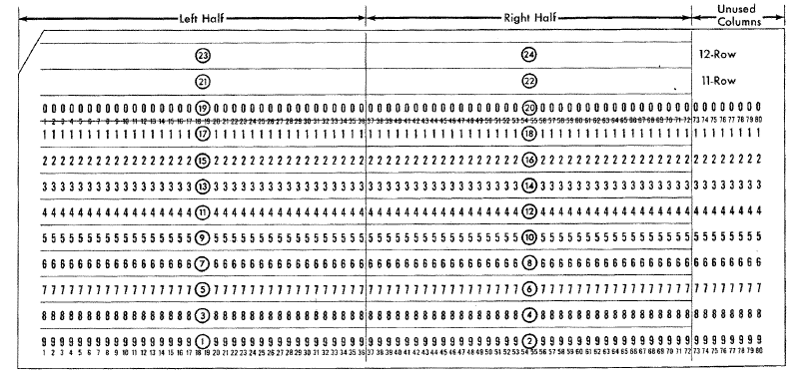

Examples:

carddeck punch <file> text "Hola adios" at 2

punch text starting at col 2. Format of card file created is TEXT.

carddeck punch <file> oct 777777 000222

punch two halfwords on row 9 on a BINARY card

carddeck punch <file> dec 123 +456 -789

will punch two halfwords on row 9, and a third halfword on row 8

carddeck punch <file> bincards 1

will punch a binary card with contents of memory location 0 to 47

This command is useful to create control cards required by Octionary Programming System programs. It is also useful to dump memory to binary cards to create self loading cards with ease.

CARDDECK ADD

Add one or more cards to existing deck file

CARDDECK ADD <file> TEXT “text” [ AT <col> ]
CARDDECK ADD <file> OCT <data>
CARDDECK ADD <file> DEC <data>
CARDDECK ADD <file> BINCARDS <n>
CARDDECK ADD <file> DECK <source file>

This command works as CARDDECK PUNCH. The difference is the fact that new generated cards are added to existing ones in <file>, instead of creating a new deck file.

There is an additional form that can be used:

CARDDECK ADD <file> DECK <source file>

Here, <source file> deck is stacked (added) at end of <file> deck. In fact, this command is a shortest way to get same resultas as

CARDDECK JOIN <file> <source file> AS <file>

Device Configuration
Most devices support user configuration. The general forms of the configuration commands are:
SET [<switch> ...} <device> <option> [,<option> ..]
SET [<switch> ...] <unit> <option> [,<option> ...]
The options available and applicable switches are described in the individual device descriptions below.

Enabling and Disabling Devices
All devices other than the CPU, may be disabled or enabled. Disabling a device simulates removing the associated equipment from the main CPU console. To disable or enable a device, use:

Command | Action
SET <device> DISABLED | Disable the device
SET <device> ENABLED | Enable the device

CDR (Card reader), CDP (Card Punch) and MTn (magnetic tape) are enabled by default

Tracing Simulator Operations
The simulator provides options for extensive tracing of the internal operations of selected devices. This is useful as an aid to hardware and software debugging as well as to gain an understanding of the internal operations of the simulated devices. Devices offer multiple trace reporting levels, from command overviews to detailed operation. Tracing for each device and its separate reporting levels may be enabled independently.

To obtain a trace, two SCP commands must be given.

First, a debug log must be established with the SET DEBUG <target> command. This command is described in detail in the “Controlling Debugging” section of the SIMH Users' Guide manual. The target can be a text file, so that the trace may be reviewed after capture, or stdout to display the trace data on the console as it is generated.

Second, tracing must be enabled for the desired devices with SET <device> DEBUG=<option> commands. The formats of the trace outputs are specific to the devices being traced. All traces for a device can be enabled at once with a SET <device> DEBUG command.

Tracing does impose some overhead on the simulator, with more detailed tracing slowing the simulator more than higher-level tracing. No overhead is incurred when tracing is suspended with the SET NODEBUG command, even if individual device tracing options remain in effect.

When all the debug traces are set, a sensible overhead is produced, and a very big debug file is generated (as much as 20 MB per minute)

Processor Device Simulations

Central Processing Unit
The IBM 701 computer console contains the machine-instruction execution unit. The CPU is configured with commands of the form:

SET CPU <option>

Device options that may be specified are:

Option | Action
CRTMEMCLEAR | Clear CRT memory, reset overflow flag
DEBUG=<option> | Enable tracing
NODEBUG | Disable tracing (default)
STEPINSTR | Enable STEP to step on each instruction
STEPHALF | Enable STEP to step on Instruction/Execution time
FAST | Execute all instructions in one machine cycle
REALTIME | Simulate real number of cycles (default)
SPEED | Set simulated CPU speed

The command

RESET CPU

Will do the following actions:
- Clear IC, IR, MR, ACC, MQ registers
- Clear OV flag, Clear Sense Out lights, Clear Check lights
- Reset machine cycle to Instruction Time
- Set all tapes as ready (terminate any pending/in progress operation). Clear any tape check condition

Speed
The basic machine cycle is 12 microseconds (usec). So we can say that clock on IBM 701 is set at 83.3 KHz.

On average, instructions needs 4-5 machine cycles to execute. Multiplication and Division takes 38 cycles. On real hardware, the average execution speed is around 10000 instructions per second (IPS).

Nevertheless, achieved IPS can be lower, mainly because the wait introduced by I/O, when an IO instruction is waiting for the device

The user can disable the simulation of execution time, so all instructions will need only one cycle to execute.

SET CPU FAST each instruction needs only one cycle time to execute
SET CPU REALTIME simulate real number of cycles times needed by instruction
to execute (default)

To allow to set the simulated CPU speed with accuracy when Control Panel GUI is active, a new scp command is defined;

SET CPU SPEED=n.n Set the simulated CPU speed to n.n times the speed of real hardware (i.e speed is relative to original IBM 701 speed)

Depending on n.n value, it is possible to set the simulated speed. If n.n is …

- Set simulated speed to be the same as in real hardware (83.333 machine cycles per second)

2.0 Set to double of real hardware speed

0.5 Set to half of real hardware speed

Up to two decimal digits are permitted. Value 0.0 is not allowed. Range goes from as low as 0.01 (one hundred times slower) to 100.0 (100 times faster).

At the minimum speed allowed (Speed=0.01, 100 times slower), the simulated cpu executes 833 cycles per second, approx. 100 instructions per second.

Maximum speed is set using the form

SET CPU SPEED=MAX Simulated CPU runs al maximum speed allowed by host

The current value of speed setting can be show using the command

SHOW CPU SPEED Display Speed relative to original hardware, the number of Instructions executed per second. Will also show the elapsed time cpu has been running. All of these figures are wall clock time

Example output:

Measured speed: Speed is x1.0 relative to original hardware
9785 Instructions per second (IPS) achieved
run elapsed 23.5 sec (23546 msec)

The measurements are done taking into account the total number of cycles and instructions executed in the last run. On this context last run is time elapsing between cpu started (either by a GO or RUN SCP command), until cpu is stopped and control returned to scp (either to continue a script execution or to command prompt)

If no data measured (not run yet, executing step by step) the SCP command SHOW CPU SPEED will only display first output line indicating the speed setting.

On startup, the simulator defaults to MAX speed.

Simulation Stops
The IBM 701 simulator implements several unique stop conditions:

Program Stop
Host I/O Error
Unknown Opcode
Division by Zero
Division Check
Copy Check
Tape Check

Tracing
When a debug log has been established, tracing may be configured by specifying one or more of the reporting level options:

Option | Reporting Level
CMD | Opcode instructions executed
DATA | Memory data accesses
DETAIL | Register values or processing information

Registers
The CPU state contains the registers visible to the programmer (either on code or thru the IBM 701 console):

Name | Size | Description
IC | 12 | Instruction Counter
IR | 18 | Instruction Register
ACC | 38 | Accumulator
MQ | 36 | Multiplier-Quotient Register
MR | 36 | Memory Register
OV | 1 | Overflow flag
SENSE_IN | 6 | Console Sense in option Switches
SENSE_OUT | 6 | Sense out lights

Size is given in bits. Format is one complement

In addition, these pseudo register are implemented in simulator for convenience

Name | Size | Description
HALFCYCLE | 1 | Examine: show Instruction Time or Execution Time
CPANELGUI | 1 | Returns 0 if simulator is compiled without Control Panel GUI. Returns 1 if simulator supports Control Panel
CDR1RDHOPPER | 4 | Number of cards into read hopper at Card Reader CDR pending to be read (read/only)

These pseudo registers does not exists in real hardware, but are useful for SCP scripting.

LOAD a program
SCP command LOAD has been implemented. LOAD has no direct equivalent on real hardware. Real hardware LOAD button loads a word from device at a given address, and the executes it. LOAD SCP command reads a text file, decodes it as location-instruction and store these instructions in memory.

LOAD is very convenient for loading programs on CPU using text files and a single SCP command. The syntax is

LOAD <file>

The file is a text file, with a simple fixed format as show in this example:

Sample program

NNNN S OPNAME OP ADDR Remarks...(max 79 chars)
OCT
0050 +12 0044 START + R ADD 0036 PROGRAM LOCATION
0051 +05 0047 + SUB 0039 X 0052 +11 0533 + ADD D4096 ADD 4096
0053 +11 0523 + ADD ONE ADD ONE TO CARRY IF ODD
END

As a convention, programs to be loaded with SCP LOAD command has a filename like *_prog.txt

The format is as follows:

NNNN S OPNAME OP ADDR Remarks...(max 79 chars)
OCT or DEC for decimal numbers
7777 + store mq 10 7777 instruction
7777 + store mq 7777 instruction
7777 + store mq 10 [ ] instruction
7777 + store mq [ ] instruction
7777 + 10 7777 instruction
7777 10 [ ] instruction
7777 - 123456 half word
7777 123456789012 full word

NNNN indicates the location where the instruction will be stored. If blank, last address + 1 will be used. Addresses can be in file in any order, o be non-consecutive.

END is optinal.

Opcode and/or opname must be present. Addr can be stated as [ ]. This is stored as zero address.

If using more than 6 digits, a fullword is assumed. Numbers are decimal (default) or can be octal. Indicate OCT or DEC at beginning of line to specify the base to use

An alternate format is available. First 8 columns are blank. Only half words are supported

DEC or OCT for octal numbers
NNNN OP ADDR COMMENTS
62-10 4086
63+ 9 88
4063+ 65599
4064- 0
4064+ 990
4065-102110
…
END

When load finishes, the simulator displays the following:

loaded sample2_prog.txt from 0008 to 0054 address

Showing the lowest and highest address loaded.

The command

LOAD –S <file>

Will load only symbolic information from file, 1) without clearing any previous symbolic info in any non loaded address, and 2) without altering the contents of memory

LOAD/DUMP drum contents
SCP command LOAD and DUMP can be used to load and dump contents of drum from/to a given file.

The file extension needs to be .drm

Symbolic Information
The simulator supports loading symbolic information. If the program is loaded via SPC LOAD command, then the symbolic information will be associated with the address where the instruction is stored.

The symbolic information loaded remains associated with the address until a SET CPU CRTMEMCLEAR command is issued. When this happens, all symbolic information for all addresses is removed. LOAD also clears symbolic information before loading the program.

The symbolic information loaded is the field Remarks for LOADed file.

The simulator generates the following debug information in the debug.txt file as result of execution:

DBG()> CPU DATA: ... Read 0237: +1 (octal 0355: 000001)
DBG()> CPU DATA: ... ACC: -12987924480 (-49545|+0 octal 1 00 140611|000000), OV: 1
DBG()> CPU CMD: Exec 0120: + STORE A 13 0113 (octal 0170 15 0161) 08260 + STORE A SA S1 08190 X
DBG()> CPU DATA: ... Read 0113: +37255 (octal 0161: 110607)
DBG()> CPU DATA: ... Write 0113: +37257 (octal 0161: 110611)
DBG()> CPU CMD: Exec 0121: + STORE A 13 0114 (octal 0171 15 0162) 08270 + STORE A SA S1 08200 X
DBG()> CPU DATA: ... Read 0114: +49543 (octal 0162: 140607)
DBG()> CPU DATA: ... Write 0114: +49545 (octal 0162: 140611)
DBG()> CPU DATA: ... ACC: -0262144 (-1|+0 octal 1 00 000001|000000), OV: 1
DBG()> CPU CMD: Exec 0123: - TR + 03 0098 (octal 0173 43 0142) 08290 - TR + PT S2 08040 CONVERT NEXT GROUP
DBG()> CPU DATA: ... Check ACC sign bit: 1
DBG()> CPU CMD: Exec 0124: + R SUB 06 0340 (octal 0174 06 0524) 10010 + R SUB RS A1 / / MINUS LFFT
Instruction Symbolic Information
DBG()> CPU DATA: ... Read 0340: +0 (octal 0524: 000000)
Address
DBG()> CPU DATA: ... ACC: -0000000 (-0|+0 octal 1 00 000000|000000), OV: 1
DBG()> CPU DATA: ... Read 0341: +0 (octal 0525: 000000)
DBG()> CPU DATA: ... ACC: -0000000 (-0|+0 octal 1 00 000000|000000), OV: 1
DBG()> CPU CMD: Exec 0126: + A RIGHT 23 0018 (octal 0176 27 0022) 10030 + A RIGHT AR A1 00018
DBG()> CPU DATA: ... ACC: -0000000 (-0|+0 octal 1 00 000000|000000), OV: 1
DBG()> CPU DATA: ... Read 0392: -00000000000 (octal 0610: 400000 000000)
DBG()> CPU DATA: ... ACC: -0000000 (-0|+0 octal 1 00 000000|000000), OV: 1
DBG()> CPU DATA: ... Write 0392: -00000000000 (octal 0610: 400000000000)
DBG()> CPU CMD: Exec 0129: + R SUB 06 0124 (octal 0201 06 0174) 10060 + R SUB RS S1 10010 TEST FOR END OF CARD
DBG()> CPU DATA: ... Read 0124: +24916 (octal 0174: 060524)
DBG()> CPU DATA: ... ACC: -6531579904 (-24916|+0 octal 1 00 060524|000000), OV: 1
DBG()> CPU CMD: Exec 0130: + ADD 09 0225 (octal 0202 11 0341) 10070 + ADD AD S1 19006 X
DBG()> CPU DATA: ... Read 0225: +24956 (octal 0341: 060574)
...

Symbolic trace
SimH has a native set of debugging tools: breakpoints, examine/deposit, etc. The IBM 701 simulator provides an additional tool for symbolic trace

It is possible to have symbolic information on debug output (see above). It is possible to place trace commands on this symbolic information field. It will not harm at all the load or execution. But will be produce trace output when its instruction is executed.

Symbolic trace commands begins with ** (two consecutive asterisks).
The output information is shown in console, and included on debug file if any

Available commands

**trace
Shows the current execution time (elapsed from last go/run SCP command) and the symbolic information for this instruction. Time is shown in hours, minutes, seconds and milliseconds.

LOADed program Example:

0061 +11 0072 + ADD ONE **trace

Produce the output (hh:mm:ss:msec addr)

00:00:00:003 0056:

**time
Resets the time count for trace. This is very useful to measure the time elapsed
LOADed program Example:

0061 +11 0072 + ADD ONE **time

Produce the output

00:00:00:000 0056:

**regs
Shows the contents of Storage register 1 and Address Modifiers BEFORE instruction execution.

LOADed program Example:

0061 +11 0072 + ADD ONE **regs

Produce the output

00:00:03:270 0049: ACC: +0000000 (+0|+0 octal 0 00 000000|000000),
OV: 1, MQ: +20743764033 (octal 232433 134101)
**m
Shows the contents of memory block BEFORE instruction execution. The syntax is
**m[o]NNNN[-LL][f][:xxxx]"

Where NNNN is the address, and LL is the number of halfwords to show (defaults to 1). If “f” is present, print fullwords instead of halfwords.
if "o" is present, NNNN and NN are interpreted as octal numbers
if ":" is present, prints on console xxxx (cannot have leading spaces, nor embebbed spaces, max 20 chars)

Example: shows 5 halfwords, starting at address 0200 octal.

**mo0200-05:Hola

Produce the output

0:00:00:283 0049: Hola
0128: +98560 (octal 0200: 300400)
0129: +4191 (octal 0201: 010137)
0130: +41287 (octal 0202: 120507)
0131: +94223 (octal 0203: 270017)
0132: -37210 (octal 0204: 510532)

**echo
Shows a literal string (no spaces allowed). Optionally print the current value or ACC or MQ register BEFORE instruction execution. The syntax is:

**echo xxx[:[f|q|o]]

if ":" is present, append contents of ACC (left halfword decimal)
if "f" is present, print ACC as fullword (both octal and decimal)
if "o" is present print ACC left halfword in octal numbers
if "q" is present print MQ fullword instead of ACC (both octal and decimal)

LOADed program Example:

**echo Hola_Adios LoQue

Produce the output

00:00:02:311 0056: Hola_Adios

LOADed program Example:

**echo Var123:fo

Produce the output

00:00:00:287 0049: Var123:fo +33301725184 (+127036|+0 octal 0 00 370074|000000)

Where:
+3301725184 is the value (decimal) of accumulator as fullword
+1270036 is the decimal value of left half of accumulator
+0 is the decimal value of right half of accumulator
0 00 370075 is the sign bit of accumulator, the overflow bits QP and the
Remaining 17 bits of left accum, in octal
000000 is the Remaining 18 bits of right accum, in octal

Console Switches and Buttons
On real hardware, operator’s console provides a number of switches and buttons to drive the computer.

These buttons and switches can be operated on control panel GUI, but can also be set by an SCP script, using the following commands:

SWITCH <switch name> TO <label name>
SWITCH <switch name> TO < value>

DEPRESS <button name>
PRESS <button name>

If button/switch name/label name contains spaces, it should be enclosed with quotes. All names are case insensitive.

This command simulates rotating switch or up/down switch on Operator’s Console.

switch "AutomaticManual” to Automatic | Manual

Set Automatic-manual switch to Automatic or manual position

On simulator startup, it is at automatic position. You can press the switch to manual while CPU is running a program to stop it.

switch "Load selector" to Card | Tape | Drum

Set the rotating Load selector switch to the indicated position

switch "instruction" to [oct] [-] NN nnnn

Set instruction entry switches. If minus sign is set, leftmost switch is
Set down. Value to set should be 6 digits. A space must be present between two leftmost digits (NN) and 4 rightmost digits (nnnnn)

If OCT is present in command, value is interpreted as octal. If OCT not present, value NN and nnnn are handled each one as decimal number

Examples:

switch “Instruction” to oct – 37 0010
switch “Instruction” to oct 77 0010
switch “Instruction” to – 31 0008
switch “Instruction” to 63 0008

gives all this result:

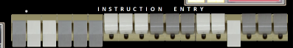

switch "Address" to [oct] nnnn

Set address part only in instruction entry switches.
Value to set should be 4 digits.

If OCT is present in command, value is interpreted as octal. If OCT not present, value nnnn is handled as decimal number

switch "MQ" to [oct] n

Set M-Q entry switches. Value can be 1 to 6 digits.

If OCT is present in command, value is interpreted as octal. If OCT not present, value n is handled as decimal number.

switch “Option 1” to Up | Down | Off | On | 0 | 1
switch “Option 2” to Up | Down | Off | On | 0 | 1
switch “Option 3” to Up | Down | Off | On | 0 | 1
switch “Option 4” to Up | Down | Off | On | 0 | 1
switch “Option 5” to Up | Down | Off | On | 0 | 1
switch “Option 6” to Up | Down | Off | On | 0 | 1

Set the Option Switches.
Up/Off/0 group and Down/On/1 group reset/set the bit sensed by program

press “printer Carriage”

Simulates the generation of a carriage return (i.e. a blank line is printed) on IBM 716 Printer.

press “Load”

Simulates pressing Load button to load a word from device set in load selector and start execution.

press “Enter MQ”

Simulates pressing “ENTER M-Q” button to load into MQ register the value set on MQ switches

Other control panel buttons has regular SCP commands that performs its function

Button | Equivalent SCP command
START | GO
Enter Instruction | DEP IR value
Memory display | EX addr
RESET | RESET CPU
RESET AND CLEAR MEMORY | SET CPU CRTMEMCLEAR
POWER OFF | QUIT
HALF STEP | STEP
MULTIPLE STEP | STEP

Environment variables
The following environment variables are defined as read-only and can be displayed or tested at any moment with ECHO or IF scp command

CPANEL Will return 1. This is used to identify IBM360 with cpanels simulator(this one) from the Richard Cornwell original simulator (without cpanels)

CPANEL_ON Will return 1 if a CPANEL is currently visible

IBM 711 Card Reader (CDR)
The card reader (CDR) reads simulated punched card decks into the computer. Card decks are simulated as file with ASCII lines with terminating newlines.

Card reader files can be either text (one character per column) or column binary (two characters per column). The file type can be specified with a SET command:

SET CDR FORMAT=TEXT sets ASCII text mode
SET CDR FORMAT=BIN sets for binary card images.
SET CDR FORMAT=BCD sets for BCD records.
SET CDR FORMAT=CBN sets for column binary BCD records.
SET CDR FORMAT=AUTO automatically determines format.

The ATTACH command simulates putting a card deck in the reader hopper:

ATTACH CDR1 <file>

The card reading gets info from in the attached file, without any visible notice. Nevertheless it is possible to set an ECHOLEVEL to display on console what is being read from card reader

SET CDR ECHOLEVEL=0 Nothing show on console about card being read
SET CDR ECHOLEVEL=1 Echo card text on console
SET CDR ECHOLEVEL=2 Echo card text + octal + binary image on console

These options are useful to allow to display on console the card reading progress of a running program

IBM 701 process by design only 72 columns from punched cards. There are 8 columns that are ignored on reading: the first 8 columns in cards or the last 8 columns in card. The following command allows to select the columns ignored

SET CDR IGNORE_COL_72-80
SET CDR SKIP_COL_1-8

The ignored columns are usually used for card identification (see SCP command CARDDECK IDENT). By default, cdr skips columns 1-8.

It is handily to have the opportunity to add explanatory comments in text file acting as card deck. As a convention, such cards starts with “;” as first character of line on text file.

The simulator will ignore (skip) such comment cards, as they were not present. Useful to add comment in a transparent way

IBM 721 Card Punch (CDP)
The card punch (CDP) punches card decks with data sent from computer. Card decks are simulated as files.

Card punch files can be either text (one character per column) or column binary (two characters per column). The file type can be specified with a SET command:

SET CDP0 FORMAT=TEXT sets ASCII text mode
SET CDP0 FORMAT=BIN sets for binary card images.
SET CDP0 FORMAT=BCD sets for BCD records.
SET CDP0 FORMAT=CBN sets for column binary BCD records.
SET CDP0 FORMAT=AUTO automatically determines format.

The ATTACH command simulates putting a blank card deck into the card punch feed hopper:

ATTACH CDP <file>

Note that the SCP commands

SET CDR IGNORE_COL_72-80
SET CDR SKIP_COL_1-8

Also applies to CDP

The card punching generates data in the attached file, without any visible notice. It is possible to set an ECHOLEVEL to display what is being punched on console

SET CDP ECHOLEVEL=0 Nothing show on console about card being punched
SET CDP ECHOLEVEL=1 Echo card text on console
SET CDP ECHOLEVEL=2 Echo card text + octal + binary image on console

These options are useful to allow to display the punching progress of a running program on console

Punched cards character set
The IBM 701 simulator uses the following character set (as printed by IBM 716 Printer).

Each card contains 80 columns; each column has 12 lines that can be punched.

- The upper line on the card: called High Punch, Hi Punch, 12, Y or Y(12)
- The line bellow: called 11, X, X(11) or Minus Punch
- The lines identified as 0 to 9

The following card image shows the punches corresponding to each available character:

X(11)
Punch
Y(12)
Hi Punch
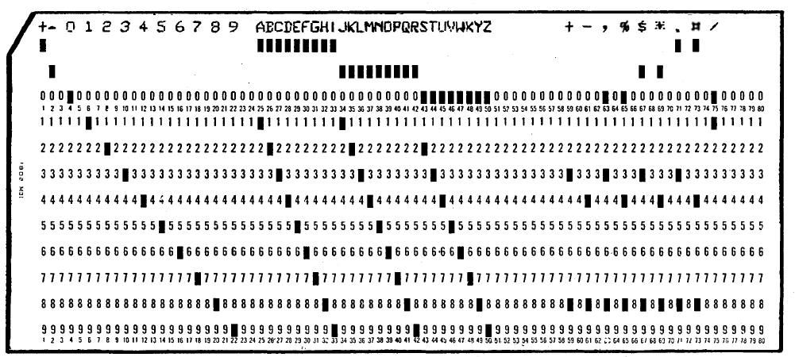

When simulating these cards as text files, each column can be mapped to an ASCII character as follows:

0 1 2 3 4 5 6 7 8 9 numeric digit 0 to 9
? A B C D E F G H I 0 to 9 with Y(12) High over punch set
! J K L M N O P Q R 0 to 9 with X(11) Minus over punch set

a b c … x y z regular alphabetic characters
# $ % . , + - / * allowed symbols

Characters “?” and “!” are recognized when read on a card, but cannot be printed (missing from IBM 716 Printer Character set)

Note that the character set is tied to IBM 026 KeyPunch and IBM 716 printer and not to the IBM 701 itself.

IBM 726 Magnetic Tape (MT)

The Magnetic Tape (MT) reads and writes reels of magnetic medium. Tape reels are simulated as files in standard SimH tape format.

Four tapes are allowed, ranging from MT0 to MT3. MT0 maps to 0256 (decimal) address, MT3 to 0259 address.

The ATTACH command simulates mounting and loading a tape reel in tape unit:

ATTACH MTn <file>

Each individual tape drive support several options:

SET MTn REWIND Sets the mag tape to the load point.
SET MTn LOCKED Sets the mag tape to be read only.
SET MTn WRITEENABLE Sets the mag tape to be writeable.
SET MTn LENGHT Set tape medium length (50 to 10000 feet).

SET MTn FORMAT=SIMH Sets SIMH tape format
SET MTn FORMAT=E11 Sets E11 format.
SET MTn FORMAT=TPC Sets TPC format.
SET MTn FORMAT=P7B Sets P7B format.

By default, tapes have a length of 1200 feet.

IBM 716 Printer

IBM 716 is the high speed on line printer for the IBM 701. Attaching a text file to the unit simulates loading paper into the printer:

ATTACH [-N] LP <printoutfilename>

Adding the –N (new file) switch clears the contents of the image file if present. Without the –N switch, printer output will be appended to any preexisting image file content.

Printer output written to the printout file is buffered by the host operating systems. Stopping the simulation flushes the file.

Printer support several options:

SET LP ECHO Echo printed lines to console
SET LP NOECHO Do not echo printed lines to console
SET LP PRINT Add printed line to printout file
SET LP NOPRINT Do not add printed line to printout file

Printers defaults to ECHO and PRINT

Printing with no output file attached does not produce an error, but printing on a disabled unit will raise an error.

Panel Wiring

Formatting the card reading/carp punching/printing is done by wiring the control panels on IBM 711, IBM 721 and IBM 716. This maps how the words sent by the computer are to be punched. In addition,

In each program’s documentation it is usual to have a section describing the needed control panel wiring, the column format for input card, and maybe the panel wiring for the IBM 716 to printout the results.

This wiring is outside the scope of the current simulation. Nevertheless several predefined wirings have been defined. These can be selected using

SET LP WIRING=<option>

Where <option> can be one of the following:

<Option> | Description
NONE | No wiring
SPEEDEX | Simulates NAA SpeedEx assembler wiring
NR9003 | Simulates IBM NR9003 Assembly
SO2 | Simulates IBM SO2 Regional Assembler
PACT | Simulates PACT compiler runtime panel

Software Support
This IBM 701 release supports the following software:

Software | Notes
Octionary Programming System  Date: Mar/1952 | Octionary Programming System  From IBM Poughkeepsie laboratory  listing and documentation at 102663096-05-01-acc.pdf  from Computer History Museum (CHM) collection  Programs with original source code  FEJ015 - Binary loading  FEJ019 - Binary Punch  MMA000 - Decimal loading  MMA011 - Octionary Loading  NR9007 - Binary Transition  WHT016 - Octionary Printing  NR9008 - Octionary Transition  NR9010 - Decimal Transition  RW01B - Read Write Subprogram  Programs rewritten based on original doc and specs  NR9003 - Assembly (Nathaniel Rochester Symbolic Assembler)  WHT014 - Print Tape  Programs described in doc but no source code nor reconstructed  FEJ020 - Binary Punch and print  WHT015 - Print Drum  JHH015 - Octionary Tracing  KYS003 - Relocation  WHT011 - Clear Memory  Comments: NR9003 is one of the firsts IBM assemblers (the other is SO2). Supports Symbolic addresses (numerical, not alphabetic). No mnemonics. It’s a 3 passes assembler, requires two tapes
Binary Input and Output  Date: Aug/1952 | Binary Input and Output for IBM EDPM Type 701  IBM Applied Science Department - Aug 1952  listing and documentation at 102663096-05-01-acc.pdf  from Computer History Museum (CHM) collection  Programs with original source code  SL05 - Seft Loading Card Program  BP05 - Binary Punching  BP06 - Binary Punching Subprogram  RW02 - Read Write Subprogram  Programs rewritten based on original doc and specs  S02 - W.F.McClelland Regional Assembler  Comments: SO2 is one of the firsts IBM assemblers (the other is NR9003). Do not support symbolic address, but region (increment + base address). No mnemonics. It’s a 1 pass assembler, requires only card reader and punch
SpeedEx Assembler  Date: Jul/1953 | SpeedEx  Single Address Assembly Program  North American Aviation  listing and documentation at 102663105-05-01-acc.pdf  from Computer History Museum (CHM) collection  Programs with original source code  SpeedEx part1 and Part2 Assembler  Programs written to support assembler  SelfLoading – Loads cards with programs assembled with SpeedEx  PunchDataCards – Punch data cards to be loaded with SelfLoader  Comments: This is the only original code surviving for an IBM 701 assembler. Supports regional and symbolic address. Supports mnemonics. It’s a 2 passes assembler, requires one tape and drum
PACT Compiler  Date: Aug/1955 | Hi level compiler for non-algebraic language.  Recreated from available doc https://dl.acm.org/doi/10.1145/320843.320844 among others  Loader, LIST routine, READ routine are original code retrieved from octal binary dump in Class notes for experienced programmers, 1955, Florence R. Anderson papers (CBI 101), The Charles Babbage Institute Archives  .

Simulator Usage

Cross Assembler
A very simple cross assembler (for Windows) has been written to produce missing in Octionary and Binary I/O Systems. The assembler usage can be seen in build_*_from_listing.ini scripts. The resulting assembled program is generated with prog.txt filename, and a format ready to be loaded with SCP LOAD command.

Using this cross assembler, several programs have been rewritten. Let’s examine the NR9003 case:
- NR9003 Assembly.
- Usage doc is available at 102663096-05-01-acc.pdf from Computer History Museum (CHM) collection, page 167
- General internal working description doc at 102663096-05-01-acc.pdf from Computer History Museum (CHM) collection, page 84
- Using this information, an NR9003_asm.txt file has been rewritten. This is the source code for Assembly, the Nathaniel Rochester Symbolic Assembler
- Using cross assembler Ibm701Assembler.exe at asm folder, a prog.txt file is generated. This prog.txt file can be run using scp LOAD command
- NR9003 Assembly is the main assembler in Octionary Programming System. Will assemble the source code programs available (*_assembly.txt).
- From original Octionary programming system handwritten listings at 102663096-05-01-acc.pdf from Computer History Museum (CHM) collection, page 182 and following, several *_prog.txt are typed in. The *_prog.txt closes matches the handwritten listing format. Also *_prog.txt files can be directly loaded & run in simulated CPU with LOAD scp command because each file line contains the absolute location-opcode program data in addition of source code
- Each *_prog.txt source file is edited to match the input card layout described in usage doc at 102663096-05-01-acc.pdf, page 167, and then saved as *_assembly.txt
- These source programs are then assembled with NR9003 to produce the binary card deck *.dck ready to be loaded in IBM 711 card Reader.
- An SimH script run_NR9003_Assembly.ini is provided to ease the assembling (and eventually running) a *_assembly.txt program. See the script file for details on operation
- A SimH script build_Octionary_from_listing.ini automates the creation of all binary deck starting only from *_prog.txt files and using cross assembler. This allows to build the initial system. The output are the *.dck binary card decks. See the script file for details on operation of cross assembler
- A second SimH script build_Octionary.ini automates the creation of all binary deck starting only from *_assembly.txt files. This allows to build the system using itself, so it needs FEJ015.dck, FEJ018.dck, NR9003.dck etc already build. The output are the *.dck binary card decks

Assemble a Program using NR9003
Files | Description | Hardware equivalent
NR9003.dck | assembler deck | Punched card deck
source.txt | Source program to be assembled | Punched card deck
deck_out.dck | Assembled program output | Blank cards deck
print.txt | SOAP assembly listing printout | Paper listing

SCP Commands | Comment | Real Hardware equivalent
set cdr skip_col_1-8  set lp0 wiring=NR9003  reset cpu  set cpu crtmemclear | Set card reader to skip columns 1 8 from input cards  Set printing formatting  Reset Cpu  Clear all memory | Usual setup un IBM 711 card reader  Insert NR9003 control panel wiring into printer  Press Reset, and Reset and Clear memory Button
carddeck join NR9003.dck  source.txt AS deck_in.dck | Create an input deck stacking together NR9003 and source code deck. | Stack both card decks
att -q cdr deck_in.dck  att -q -n cdp deck_out.dck  att -q -n mt0 mt0.tap  att -q -n mt1 mt1.tap | Set up input file, out file, and temporary tape file | Feed card reader with input deck, put empty deck in card punch, load empty tape reels
switch "Load selector" to Card  switch "Address" to 0000  press "load" | Start the assembler | Set Load Selector to card, set address part switches to zero, press Load button on console
det all | Detach all files from devices | Remove read and punched deck, unload tapes

Note1: all these steps are automated in run_NR9003_Assembly.ini script

Note2: step “Start the assembler” can be replaced with

load NR9003_prog.txt
dep ic 200
go

Instead of using the NR9003.dck binary deck, the _prog.txt file is used. The advantage is the fact that each line from _prog file will be loaded as symbolic information, so it is possible lo se on debug log the execution of assembler.

Available Software
The available software files are in i701/sw directory.

Octionary Programming System
Files | Description
build_Octionary_from_listing.ini | SimH script to build SW using typed-from-doc source programs
build_Octionary.ini | SimH script to build SW using itself
run_NR9003_Assembly.ini | SimH script to assemble and run a program
Octionary/ | Folder contents:
FEJ015.dck | Binary loader (binary card)
FEJ019.dck | Binary punch (binary card deck)
MMA000.dck | Decimal loader (binary card deck)
MMA011.dck | Octionary loader (binary card deck)
NR9003.dck | Assembly (Nathaniel Rochester Symbolic Assembler)  Binary card deck
NR9007.dck | Binary Transition (binary card deck)
WHT014.dck | Print tape (binary card deck)
WHT016.dck | Octionary Printing (binary card deck)
NR9008_oct.dck | Octionary transition (Octionary card deck)
NR9010_dec.dck | Decimal transition (Decimal card deck)
FEJ015_prog.txt | Typed-in original absolute program data + source code (ready for SCP load)
FEJ015_assembly.txt | Same as above but using Assembly format source code and syntax
FEJ019_prog.txt | Typed-in original source (ready for SCP load)
FEJ019_assembly.txt | Assembly format source code for FEJ019
MMA000_prog.txt | Typed-in original source (ready for SCP load)
MMA000_assembly.txt | Assembly format source code for MAA000
MMA011_prog.txt | Typed-in original source (ready for SCP load)
MMA011_assembly.txt | Assembly format source code for MAA011
WHT016_prog.txt | Typed-in original source (ready for SCP load)
WHT016_assembly.txt | Assembly format source code for WHT016
WHT014_asm.txt | Cross assembler source for WHT014 (rewritten)
WHT014_assembly.txt | Same as above, in Assembly format and syntax
WHT014_prog.txt | Same as above, as source code with absolute data
NR9003_asm.txt | Cross assembler source for NR9003 (rewritten)
NR9003_assembly.txt | Same as above, in Assembly format and syntax
NR9003_prog.txt | Same as above, as source code with absolute data
RW00_asm.txt | Read Write Subprogram preliminary version from IBM Early Computers book page 324 chapter 9.2
RW01A_prog.txt | Read Write Subprogram from binary card image in page 81 of Logical Organization of the new IBM Scentific Calculator
RW01B_prog.txt | Read Write Subprogram from Symbolic Programming doc at 102663096-05-01-acc.pdf, page 84 from CHM
How to run:
sim> do run_NR9003_Assembly.ini Octionary/WHT016_assembly.txt

Binary Input and Output System

Files | Description
build_IBM_Binary_IO_from_listing.ini | SimH script to build SW using typed-from-doc source programs
build_IBM_Binary_IO.ini | SimH script to build SW using itself
run_SO2_Regional_Assembler.ini | SimH script to assemble and run a program
IBM_Binary_IO/ | Folder contents:
SL05.dck | Seft Loading Card Program (binary card)
BP05.dck | Binary punch (binary card deck)
SO2.dck | W.F.McClelland Regional Assembler (binary card deck)
SL05_prog.txt | Typed-in original source (ready for SCP load)
SL05_regional.txt | Same as above but using Regional Assembler source code format and syntax
BP05_prog.txt | Typed-in original source (ready for SCP load)
BP05_regional.txt | Regional Assembler format source code for BP05
BP06_prog.txt | Typed-in original source for BP06 Binary Punch Routine
BP06_asm.txt | Same as above, but using cross assembler source code syntax
SO2_asm.txt | Cross assembler source for SO2 (rewritten)
SO2_regional.txt | Same as above, in SO2 regional format and syntax
SO2_prog.txt | Same as above, as source code with absolute data (ready for SCP load)
RW02_prog.txt | Read Write Subprogram 02

North American Aviation SpeedEx assembler

Files | Description
build_NAA_Assembler_from_listing.ini | SimH script to build SW using typed-from-doc source programs
build_NAA_Assembler.ini | SimH script to build SW using itself
run_NAA_Assembler.ini | SimH script to assemble and run a program
NAA_Assembler/ | Folder contents:
SelfLoading.dck | Seft Loading Card Program (binary card)
SpeedEx_part1.dck | North American Aviation SpeedEx assembler, Part 1 (binary card deck)
SpeedEx_part2.dck | Part 2 (binary card deck)
PunchDataCards.dck | Punch data cards (binary card deck)
SpeedEx_part1_prog.txt | Typed-in original source (ready for SCP load)
SpeedEx_part1_naa.txt | Same as above, but using SpeedEx source code format and syntax
SpeedEx_part1_asm.txt | Same as above, but using cross assembler source code format and syntax
SpeedEx_part1_naa_data.txt | Run time data needed by part1
SpeedEx_part2_prog.txt | Typed-in original source (ready for SCP load)
SpeedEx_part2_naa.txt | Same as above, but using SpeedEx syntax
SpeedEx_part2_naa_data.txt | Run time data needed by part2
SelfLoading_asm.txt | Cross assembler source for Self Loading card (rewritten)
SelfLoading_naa.txt | Same as above, using SpeedEx syntax
SelfLoading_prog.txt | Source code + absolute data
PunchSelfLoadingCards_asm.txt | Cross assembler source to generate a self loading card from a regular SpeedEx generated binary card (rewritten)
PunchSelfLoadingCards_naa.txt | Same as above, using SpeedEx syntax
PunchSelfLoadingCards_prog.txt | Same as above, Source code + absolute data
PunchDataCards_asm.txt | Cross assembler source to punch data cards
PunchDataCards_naa.txt | Same as above, using SpeedEx syntax
PunchDataCards_prog.txt | Same as above, Source code + absolute data
PunchDataCards_naa_data.txt | Run time data needed by above program

PACT I Compiler

Files | Description
PACT/ | Folder contents:
build_PACT_compiler.ini | SimH script to build compiler from scratch
run_PACT_debug.ini | SimH script to compile and run a PACT program
run_PACT_production.ini | SimH script to compile and run a PACT program
PACT_prog_Src.txt | Sample PACT source code program
*.bat | Windows batch to start execution of .ini scripts
Src/ | Compiler source code
Prod/ | Production compiler. Folder contents:
pact_load_card.crd | Compiler load card
mtpact.tap | Compiler tape
Build_log.txt | Log of build_PACT_compiler.ini script execution
Validation/ | PACT Programs to validate compiler :
comp_zRun_PACT_validation.bat | Windows batch to run all validation tests in sequence
Pact_Test_*.txt | PACT source code for validation tests
Pact_Test_*_print_ok.txt | Expected test execution printout
Decks/ | Decks generated during compiler build process
lib_asm_NN.txt | Assembled Libraries generated and used by build_PACT_debug_tapes.ini script
NN.txt | Compiler stages absolute program generated by build_PACT_debug_tapes.ini and needed by run_PACT_debug.ini script
Tmp/ | Temporal files

HelloWorld

Files | Description
run_HelloWorld.ini | SimH script to assemble and run all Hello World programs with all the available assemblers
HelloWorld/ | Folder contents:
HelloWorld_naa.txt | Print Hello Word on printer program source code, using SpeedEx format and syntax
HelloWorld_assembly.txt | Same as above, using NR9003 Assembly format and syntax
HelloWorld_regional.txt | Same as above, using SO2 Regional Assembler format and syntax
HelloWorld_asm.txt | Same as above, using cross assembler format and syntax
Hello_prog.txt | Same as above, Same as above, as source code with absolute data

Running demo script
The file i701_demo_all.ini executes all the scripts in sequence.
All the console output is available in console.txt file.
This script can be used as an example of other scripts usage.

File extensions
The simulator does not enforce any extension for any file. Nevertheless, some extension are used as a convention on the script files
Extension Meaning
*.dck binary format card deck
*.crd binary or text or mixed formats card deck
*.tap Magnetic tape image file
*.ini SimH i701 simulator script
*.txt Text file
*_prog.txt Program assembled with absolute data + source code text ready to be loaded with sim_load SCP command
*_asm.txt Source program (text format) to be assembled with Win32 cross assembler (Generates a *_prog.txt file)
*_naa.txt Source code (text format) card deck to be assembled with NAA SpeedEx assembler
*_naa_data.txt Run time data for NAA SpeedEx program
*_assembly.txt Source code (text format) card deck to be assembled with NR9003 Assembly
*_oct.txt Octionary source card (part of Octionary Programming System)
*_dec.txt Decimal source card (part of Octionary Programming System)
*_regional.txt Source code (text format) card deck to be assembled with SO2 Regional Assembler

Control Panel

Introduction
Control panel provides simulation of IBM 701 front panel on a GUI window. It is possible to interact with the computer thru the Control Panel, in the same manner as it was done with the original hardware

But also it’s nice just to see the Blinkenlights during program run, the tape fast jerky motion, the punched cards regular flow, or the beautiful near-aligned printing.

Control Panel files are stored in cpanel directory. There are .png bitmap images and an .ini file. This .ini file is called Definition File, and has all the info to instruct the simulator on how to display the control panel on the GUI window.

To show the control panel, these are the commands to issue on SCP:

sim> att cpanel ../cpanel/ibm701.ini
sim> set cpanel on

(if needed, use the adequate path for .ini file in your installation). The Control Panel GUI window is displayed:

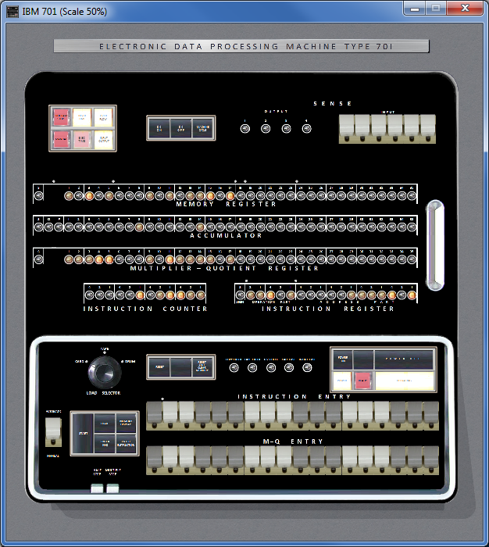

To close the control panel, use the command

sim> set cpanel off

Available Control Panels
Several Control panels are selectable, Default one shows only the main CPU console (as it was in 1952).

Before issuing SET CPANEL ON, it is possible to use SET CPANEL OPTION command to select the one to display

sim> att cpanel ../cpanel/ibm701.ini
sim> set cpanel option=EarlyConsole
sim> set cpanel on

The SET CPANEL OPTION=EarlyConsole will select the console as it was on 1952 (see Buchholz_IBM_701_System_Design_Oct53.pdf from Bitsavers)

The main difference is there are only 4 input option switches. There are also minor differences in the location of buttons

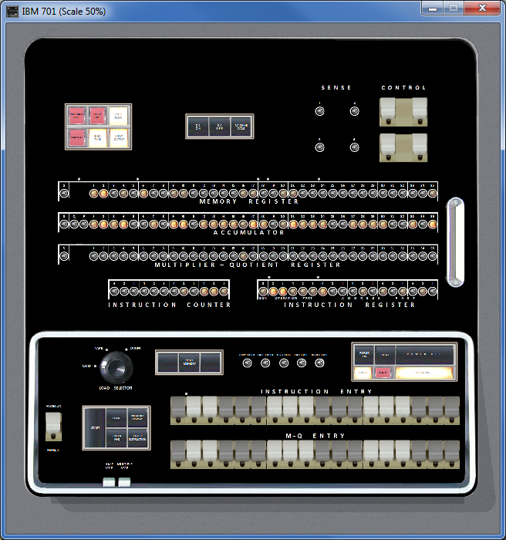

If no option is set, the full panel will be displayed

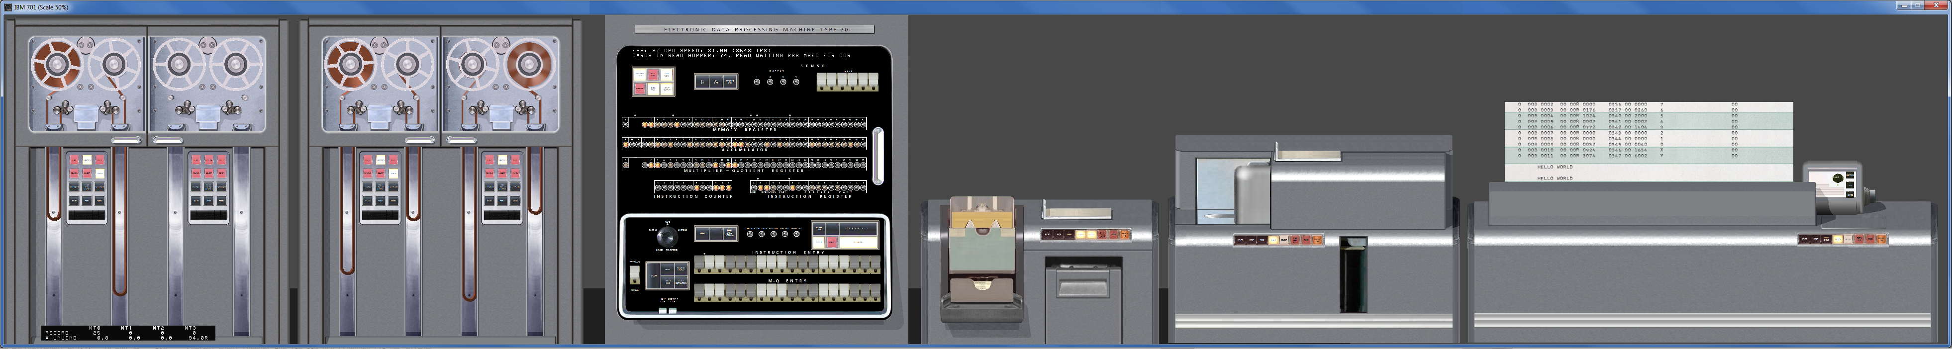

This panel includes images for 4 IBM 726 magnetic Tapes, the IBM 701 console, IBM 711 Card reader, IBM 721 Card Punch, IBM 716 Printer

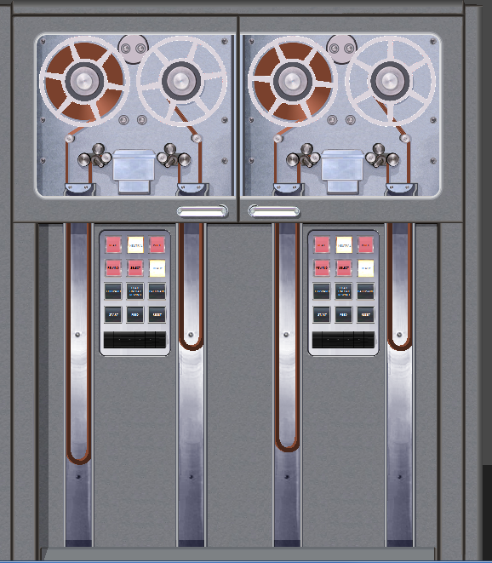

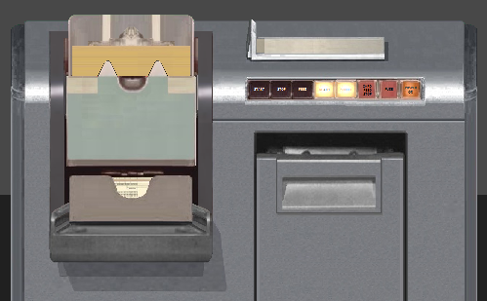
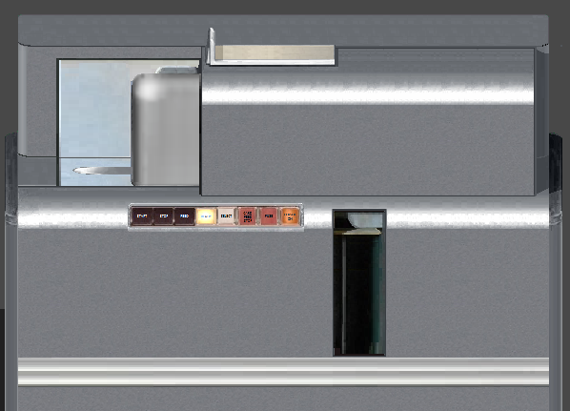

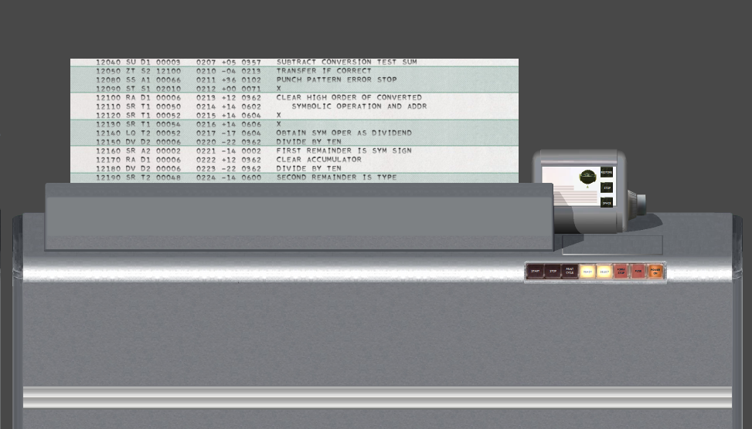

You can explicitly select the default panel with SET CPANEL OPTION=AllPanels,

Important: To be effective, the SCP command SET CPANEL OPTION must be set after ATTACH CPANEL command, but before SET CPANEL ON.

Control Panel size and position
As Control Panel includes more hardware, its size gets bigger. CPU console is 1220x1325 pixels and fits on any screen. But AllPanels option is 7800 pixels wide.

To allow a comfortable display it is possible to set the scale on which the Control Panel GUI window will show the Control Panel.

sim> att cpanel ../cpanel/ibm701.ini
sim> set cpanel option=AllPanels
sim> set cpanel scale=50
sim> set cpanel on

This will display the control panel at 50% of its original size.
Allowed scales ranges from 10 (10% of original size) up to 200 (double of original size)

At any moment it is possible to move the Control Panel window with the mouse, as any regular window. But also it is possible to set the position of window with a command. This is handy to assure the position of Control panel is a good one given its scale when preparing a SCP script.

sim> att cpanel ../cpanel/ibm701.ini
sim> set cpanel option=AllPanels
sim> set cpanel scale=50
sim> set cpanel pos=50/100
sim> set cpanel on

Will set the Control Panel on screen coordinates x=50, y=100. Coordinates can be negative.

SET CPANEL SCALE and SET CPANEL POS should be issued after ATTACH CPANEL.

If they are issued before first SET CPANEL ON, they determine the initial position and scale that will be used on panel first appearance.

If they are issued when panel is already visible (after first SET CPANEL ON), they will change the current position and scale.

SCP command ATTACH CPANEL sets initial scale to 100 (i.e the original size) and initial position to 90/50.

Control Panel HotKeys
There are several HotKeys, that can be pressed while the Control Panel Window has the focus.

HotKey | Description
Control E | Halts the simulation (same as Control E issued on SimH console)
Control Y | Toggles size of window between 100% and 50% (full size/half size)
+  Control + | Increases size of window a 10% (maximum 200%)  Increases size of window a 1%
-  Control - | Decreases size of window a 10% (minimum 10%)  Decreases size of window a 1%
Control T | Toggles mark on clickable areas of control panel
Control I | Toggles show Info
Control F | Fast Mode: while pressed, simulated CPU runs at maximum speed. When releases, CPU returns to its selected speed.

Control T – Toggle Marks
Control T will show an alternate green-red-flashing box on clickable control in the control panel. This eases to identify what can be used, and what cannot .
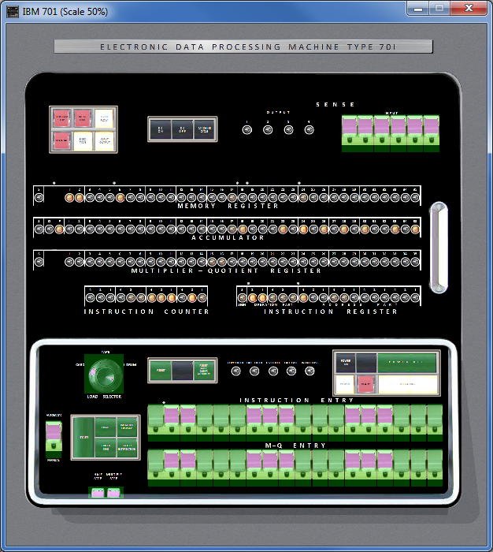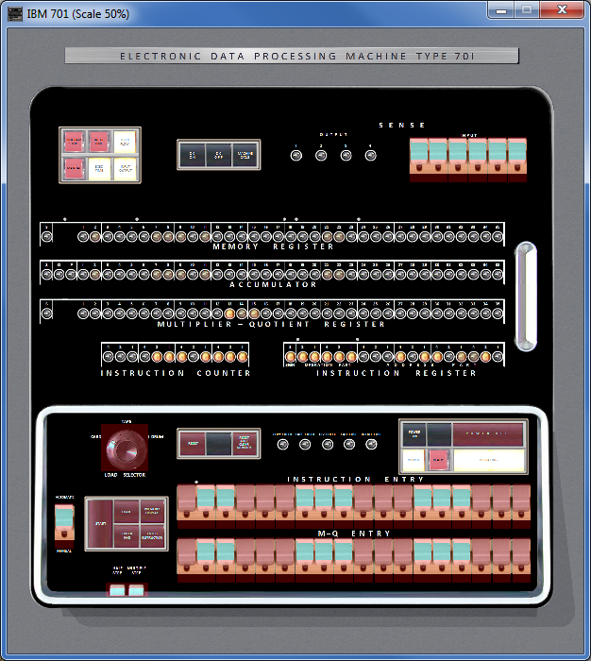

Also the areas where a file can be dropped are marked (See section “Drag and Drop files” bellow):

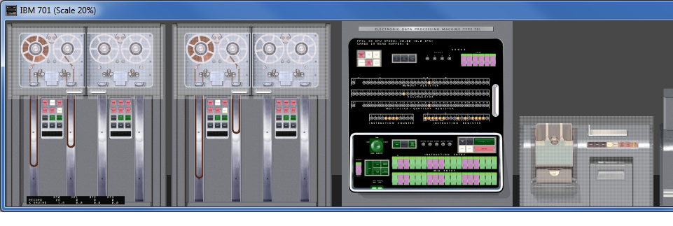
Drop tape file here to attach it
Drop card deck file in reader to attach it

Control I – Show Information Panel
Control I will show an information panel with some internal simulator state on real time. Pressing again Control I will hide the info

There are two panels. One on main CPU:

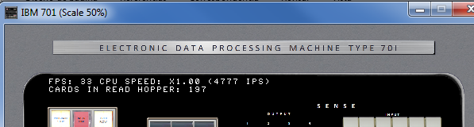

This information panel display:

- The current Frames Per Second (FPS) refresh rate
- The current measured CPU speed: in the example, x1.0 speed relative to original hardware. 4777 are the Instructions per Second (IPS) being executed.
- The number of cards in the read hopper waiting to be processed.

The other panel is on tape:

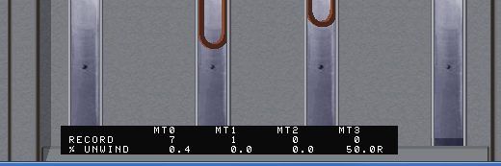

This information panel display, for each tape:

- The current record the tape r/w head is positioned on (not the total number of records on tape)
- The current % of tape unwind on right reel. 0% mans all the medium is on left reel, 100% means all the medium is on right reel. An R means there is a rewind operation in progress

If scp command SET CPANEL OPTION=ShowInfo is issued before SET CPANEL ON, the Control Panel window will display the information panels when opened.

The information panel is designed to be show at 100% and 50% scale.

Control F – Fast Mode
Control F will accelerate the CPU speed while pressed.

This is very handy to speed slow operations on the fly, for example the card loading operation which read rate is 150 cards per minute at x1.0 CPU speed.

X1.0 speed | Control F
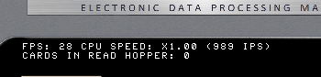 | 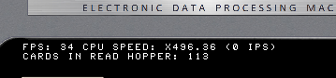

Control F also allows to speed-up High Speed rewind operation.

The CPU acceleration will continue until

- The user releases Control F keys

- Simulator executes SET CPU SPEED command (e.g. on the script being run). In this case, the new CPU speed figures are recalculated and CPU resumes at new speed setting. To accelerate the CPU it is necessary to press again Control F

Control Panel usage
The clickable controls can be spotted with Control T hotkey. Buttons and switches works as stated on Principles of operation manual (http://bitsavers.org/pdf/ibm/701/24-6042-1_701_PrincOps.pdf)

Clickable controls:

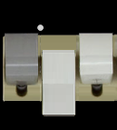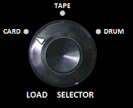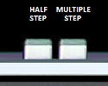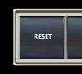
Switches Rotating Selector Buttons Buttons

As a convention, the power button and the close top right box quits the simulation

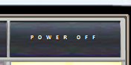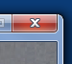

When CPU is running (thus the control panel is refreshed and responsive), the mouse pointer will be an arrow. If the pointer is placed on a clickable control, it will be changed to a hand

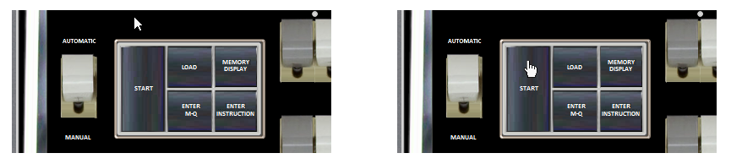

If the user clicks on control panel and moves the mouse without releasing the mouse button, then the control panel window will be moved on screen.

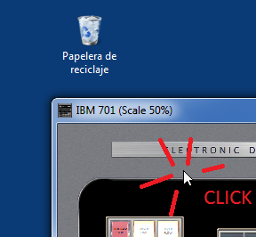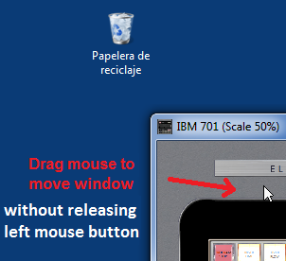

This is very handy when control panel window is zoomed and does not fit on screen.

When moving the Control Panel window by dragging the title bar (the standard move procedure), the GUI image stop being updated but the simulation still running. When moving the window by clicking in the image and dragging the mouse, the GUI image will not freeze and will be updated as the windows moves.

Control Panels can be big. With + and – hotkeys it is easy to resize the window at will. But when size is small, it can be difficult to read keys/switches labels.

On clicking on right mouse button, a tooltip will popup with showing the control panel image under the mouse at 100% scale.

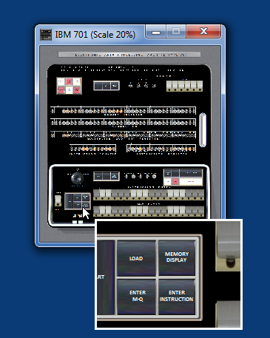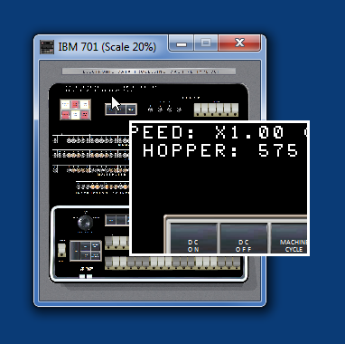

Dragging the mouse over the window while right button is kept pressed will show the contents on tooltip as mouse moves.

The tooltip window is closed automatically moving the mouse over it.

Interactive Mode
When simulated CPU is running, control panel is active: shows info and reacts to mouse clicks.

During user console input at sim> prompt, two cases are possible:

- On non-windows platforms: during user console input at prompt, SimH is blocked waiting user to type a command and press enter. Thus the whole control panel is not responsive to mouse clicks, not responsive to window close button, nor is updated. This situation is signaled to the user by the slashed red circle mouse cursor shape.

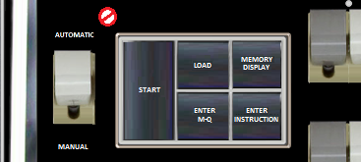

- On Windows: during user console input at prompt SimH is waiting user to type a command and press enter, but control panel is refreshed and active. Buttons/Switches/keys are sensed and works. Clicking on the close button of GUI windows exits SimH. Any SCP command issued as result of button/switch/key press on cpanel will be printed on console and executed as if it was typed by user

If scp command SET CPANEL INTERACTIVE is issued, SimH transfer the control of simulation from scp command line to control panel. SimH then refreshes control panel and responds to mouse in the same way as when CPU is running. This allows to control the simulation from control panel as in the real computer. CPU can be started and stopped while into interactive mode.

When in interactive mode, no scp command can be typed on console, as SET CPANEL INTERACTIVE command still in execution. To terminate interactive mode and regain control on console, the user can either

- press Control E on console or on Control Panel window (or any other defined as WRU character)
- Press Enter on console

While CPU is running, the Switch AUTOMATIC/MANUAL will also activate interactive mode

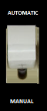

Drag and Drop files
It is possible to attach (mount) magnetic tape files, or to attach input card deck files by using drag and drop feature of GUI.

To attach a tape file

- Select the magnetic tape image file
- Drag it to the tape unit where desired
- Drop the file in the drop file area
- The load animation starts to signal the file is attached. The left reel will show all the tape medium on it.

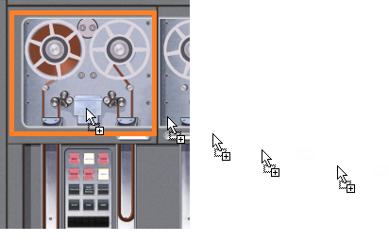
File being dragged
Drop file area

To attach a card deck file

- Select the card deck image file
- Drag it to the card reader unit
- Drop the file in the drop file area
- New cards will be shown stacked as pending to be read in the input hopper

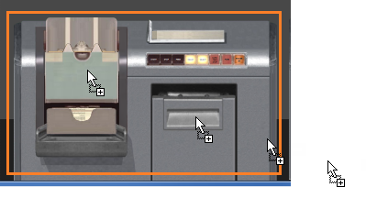
File being dragged
Drop file area

Detach tape file
To detach the current attached tape file (i.e unmount the tape reel currently mounted), just proceed as in real hardware:

- Click on the rewind button on tape cabinet (1)
- Inmediatelly after, Click the UnLoad button on same cabinet (2)
- The unload animation starts to signal the file is being detached. The reel will show no medium on it.

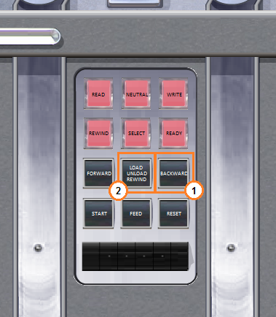

Punched Card Viewer Panel

It is possible to open a cpanel window to view the puncheds cards in use. This is equivalent to take in your hands the card deck from device and examine it.

It is possible to examine cards from

- Read Card Hopper: Inputs cards not yet read in Card Reader Device
- Read Card Stacker: Inputs cards already read by Card Reader Device
- Punched Cards Stacker: Output cards punched by Card Punch Device

Just Click in the appropiate zone main IBM 701 cpanel to open then 5.9 Punched Card Viewer Panel:
Click here to remove input card deck
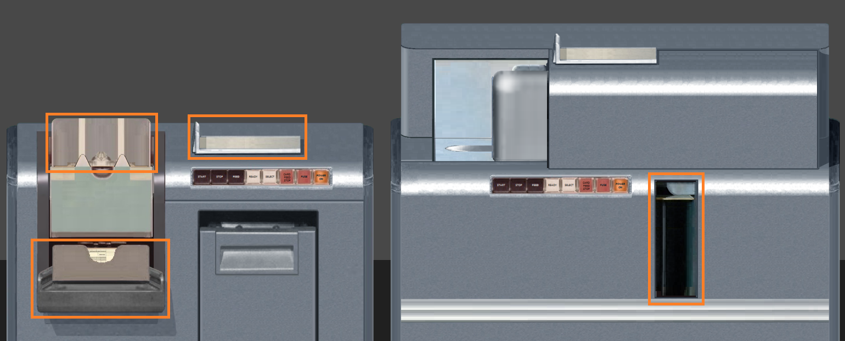
Click here to view output punched cards
Click here to view already read input cards
Click here to view input cards not yet read

Note that decks dropped on Card reader are stacked. Click on the top area to detach (i.e. to remove) input card deck from Crad Reader CDR device.

The Punched Card Viewer Panel appears showing:

- For Read Card Hopper: First card of deck: the next card to be read
- For Read Card Stacker: Last Card of deck: the last card read by computer
- For Punched Cards Stacker: Last Card of deck: the last card punched

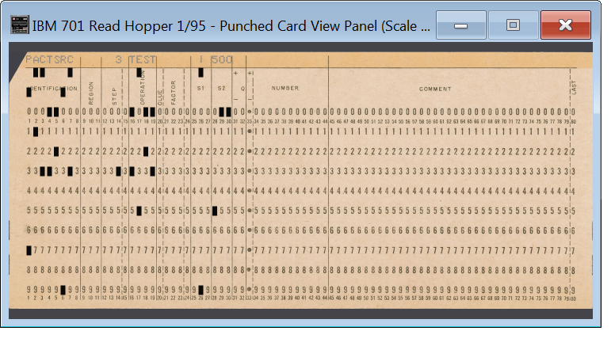

On card panel, the following zones can be clicked. These zones are made visible/hidden with Control T hotkey on keyboard:

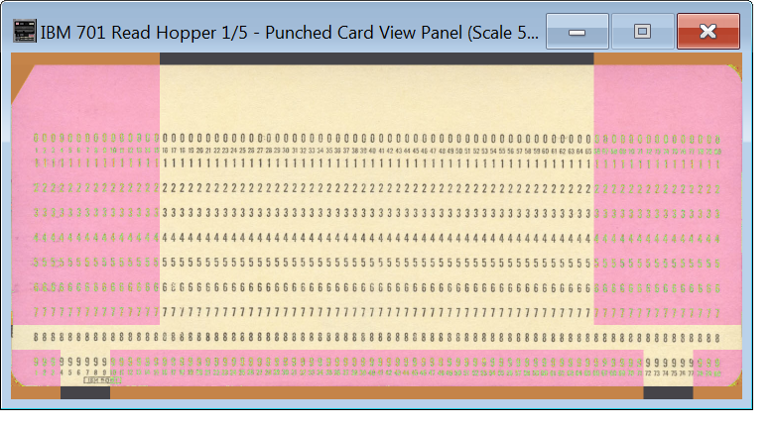
Click here to view next card on deck
Click here to view previous card on deck
Click here to view first card on deck
Click here to view last card on deck
Click here to select an arbitrary card.

If viewing last card of deck either in read/punch stacker, and a new card is added to the deck (a new card has been read or punched), the new card will de showed as last one. This is handly to allow displaying cards on real time as they are read or punched.

If viewing first cars of read hopper, and a card is read by computer, then the next card to be read is shown as first card. This is handly to allow displaying cards on real time as they are read.

If clicking on left size of selection arbtrary card zone, a card on the begging of deck will be shown. If clicking on right size of selection arbtrary card zone, a card on the ending of deck will be shown.

The Punched Card Viewer Panel can be closed and reopened at will without disturbing the program in execution. Also, browsing cards does not interfere with program execution.

The window title bar will display the deck being browsed, the card number / total cards in deck values.

There are several additional HotKeys that can be pressed while the Control Panel Window has the focus.

HotKey | Description
Cursor Left (← key) | Shows previous card
Cursor Right (→ key) | Shows next card
Home | Shows first card
End | Shows last card

Of course, all the default HotKeys are available also for Punched Card View Panel

- +, -, Control +, Control - To zoom in/out
- Control Y Toggle zoom 100% <-> 50%
- Control T Toggle coloring clickable areas of panels
- Control I Toggle info panel
- Control F Fast mode

If no cards to display, a dark card image will be shown:

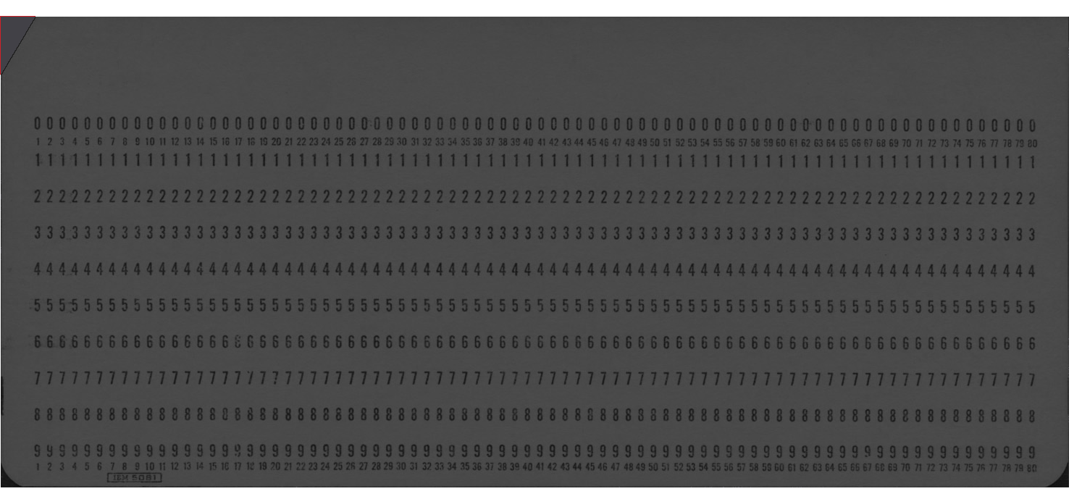

The simulator support several pre-printed cards images:

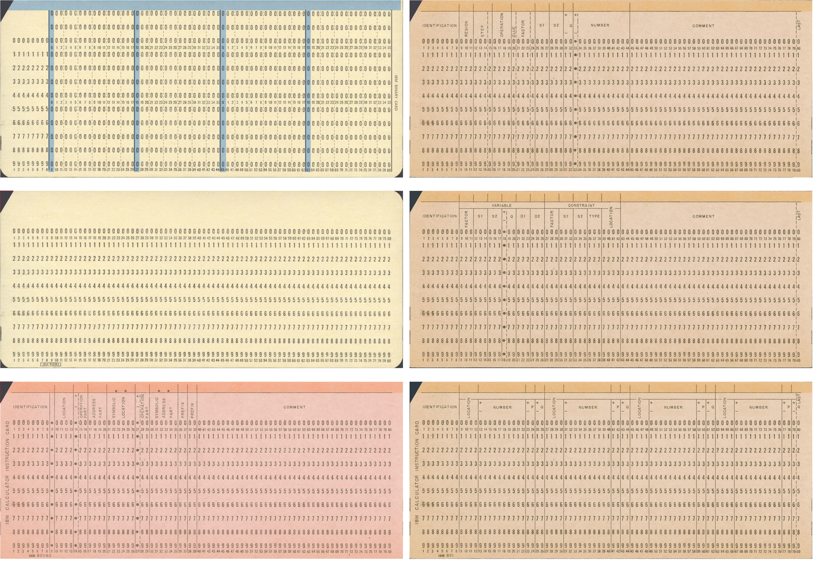
Binary card
PACT source code card
PACT variable definition card
PACT decimal data card
Default standard card
NR9003 assembly card

Additional comments

Speed Measurement
The speed measurement show on info panel (Control-I) is not the same as the one obtained with SHOW CPU SPEED.

Show CPU speed command measures the speed along all the run, that is, from the moment that simulated has been started until the moment the simulated CPU is stopped

On information panel, the speed is measured on the fly. Control F boosts the measured speed, rewind opcode can make the IPS value zero if CPU waits until rewind terminates.

Speed settings and rewind animation
Control F or SET CPU SPEED=MAX will allow the rewind animation to be show on Control Panel. On the contrary, if SET FAST command has been issued, rewind will be done instantly and no animation will be visible.

Control Panel usage example
The control panel scripting commands allow to closely matching the directions found on original manuals.

For example, this is the sequence to start a program:

Action to do in real hardware |  | Equivalent SCP command in script | Equivalent GUI control to use
0 | Put program deck on card read input hopper | attach –q cdr deck_in.dck | Drag and drop deck_in.dck file into card reader  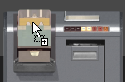
1 | Reset computer | reset cpu | 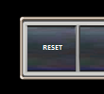
2 | Clear Electrostatic Memory | set cpu crtmemclear | 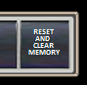
3 | Set automatic-manual switch to automatic | switch "AutomaticManual" to automatic
4 | Set load selector to CARD | switch "Load selector" to Card | 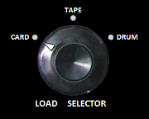
5 | Set address part of instruction entry switches | switch "Address" to nnnn  if nnnn is an octal number (instead of decima), use:  switch "Address" to oct nnnn | 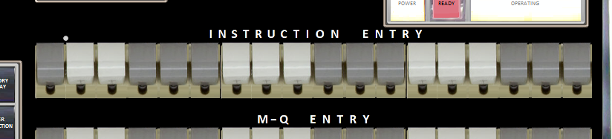
6 | Press load button | press “load” | 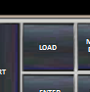

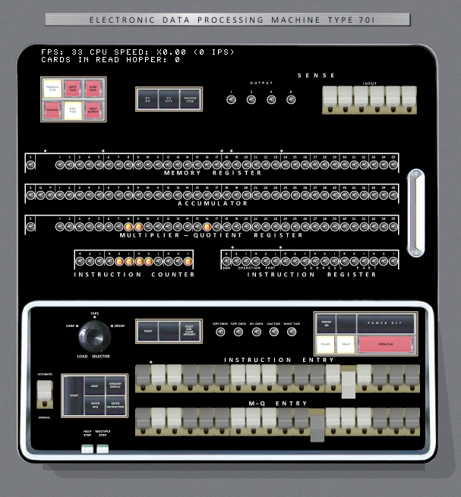
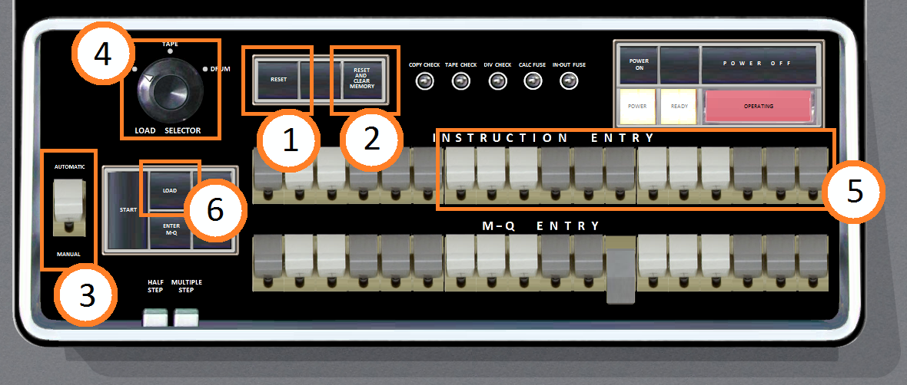

Version History
- Release 1: Jul/2021
- Hardware support:
  - IBM 701 with 2K 36-bits words and 4 drums
  - IBM 711 card read, IBM 721 card punch, IBM 716 printer
  - 4 IBM 726 magnetic tapes
  - Control Panel GUI
- Software included:
  - IBM Octionary Programming System, with NR9003 Assembly
  - IBM Binary IO, with SO2 Regional Assembler
  - NAA SpeedEx Assembler

- Release 2: Jan/2022
- New Hardware support:
  - (none)
- New Software included:
  - (none)
- New Features:
  - Allow dropping files to tape and card reader to attach them. Control T (^T) shows the drop area
  - Allow unload tapes with tape cabinet buttons
  - Reduced CPU and memory usage when Control Panel visible
  - Bilinear scaling for a great nice cool lovely antialiased image
  - Shows IPS (instructions per second) count with IPS, KIPS and MIPS labels
- Bugs Corrected:
  - Removed nasty “ding” system sound if pressing plus/minus key to scale control panel window without ever having explicitly focused it (eg by clicking on it or moving it)
  - Corrected potential problem when closing simulator with tooltip window visible
  - Removed small pixel slew while clicking on window al low scales
  - Fixed occasional the tape door image remains open when tape is operating. Fixed occasional ^F key release event being lost.
  - Fixed tape medium hops in tape vacuum columns when fps is low or when moving the window by dragging the title bar (which freezes window client area updates until move finishes)

- Release 3: May/2025
- New Hardware support:
  - (none)
- New Software included:
  - PACT I compiler
- New Features:
  - Punched Cards View control panel Added. Open it clicking on Card Reader Input hopper/Output stacker, on Card Punch Output stacker
  - Click on top of Card Reader to remove (detach) current deck (clears both input hopper and output stacker)
  - Animated tape head actuator located on top of cabinet, between reels. As seen in https://www.youtube.com/watch?v=X_OLAV1GwQ0
  - "; comment" lines in text input deck file are ignored (thus no card is read starting with ';'). Useful to comment input files in a transparent way
  - DUMP <file> dumps the simulated IBM 701 drum contents to a given file. LOAD <file> loads the previously saved drum contents. The file must have the extension .drm (any case allowed)
  - LOAD support a new text file format, new “-S” option.
  - Press “Enter MQ” SCP command added. CARDFILE ADD SCP command added
- Bugs Corrected:
  - Fixed tape check generating an incorrect stop code on SimH. Fixed to ignore sign on READ/WRITE instructions
  - Fixed a bug in sim_card.c that prevents cards with “F”, “M” in column 1 to be identified as binary cards when attached to card reader.
  - Minus zero (-0) was not properly handled by LOAD command. Now it keeps its sign
  - Attach/detach file to printer no longer resets selected wiring. Fixed bug on “dep –m opcode …” (was generating a spurious error message). Fixed timing calculation for detach devices if no COPY instr is executed on time.
  - Fixed Control Panel Program Stop light (incorrectly remained lit on next run after a stop). Fixed ^T hotkey not properly showing the drop area on tapes. Fixed Card reader stacker image not being reset to empty when no deck attached.
  - Slightly changed printed/card read/card punch charset to match the one described in “Principles of Operation type 701” IBM documentation, 1953 (the character set erroneously matched IBM 026 FORT, witch obviously not available in 1952)
  - Slightly changed IBM 701 frame image bitmap colors from neutral grey to more realistic blue-gray

