3D

**2048**

USER

MANUAL

By Sandeep Raghunandhan and Yash Sinha

**Table of Contents**

Introduction 3

How to Play 4

**Introduction**

3D 2048 is a game based on Gabriele Cirulli’s 2048. Like 2048, the objective of 3D 2048 is to move the tiles, merging like tiles as you go along in order to create the 2048 tile.

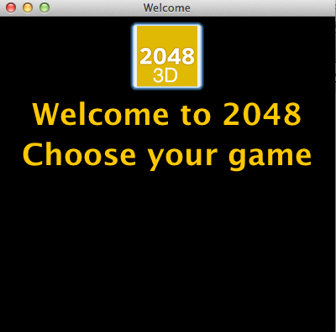

**How to Play**

Use the **Arrow Keys** (↑, ↓, ←,→) to move the tiles up, down, left and right. Use keys **Q** and **E** to move tiles in and out, respectively. There are 64 tiles in total and they are divided up into 4 planes which can each hold a maximum of 16 tiles. When two tiles collide, they become one and the number on the tile doubles The game ends once a 2048 tile has been made. The game begins at a welcome screen; click the 2048-3D tile to begin game play. In the beginning, there are two tiles. One tile is definitely a 2, the other may be a four. Move or combine these tiles to begin the game. The game will end when you may no longer make a move or you have reached the 2048 tile. 