Software Design Specification
AllJoyn Linux Application
Version 0.001
- UI Design
  - Main screen/Onboarding tab
Main screen with “Onboarding” as default tab
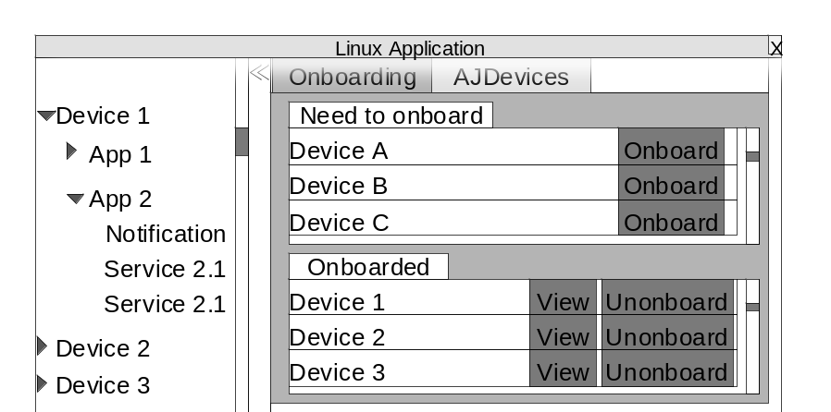
  - AJDevices screen
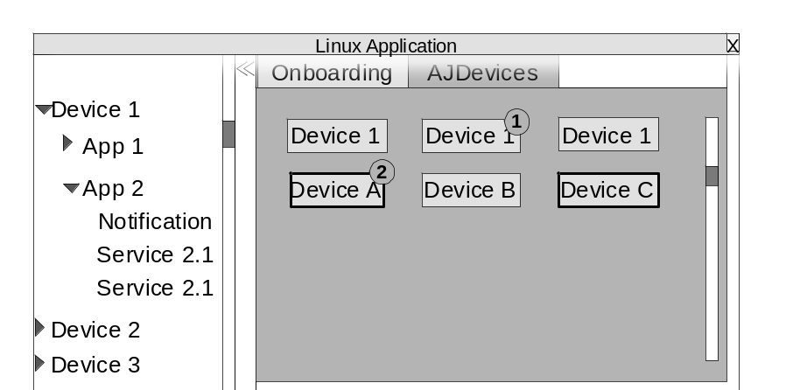

  - Device Screen
Device screen with “About” tab as default
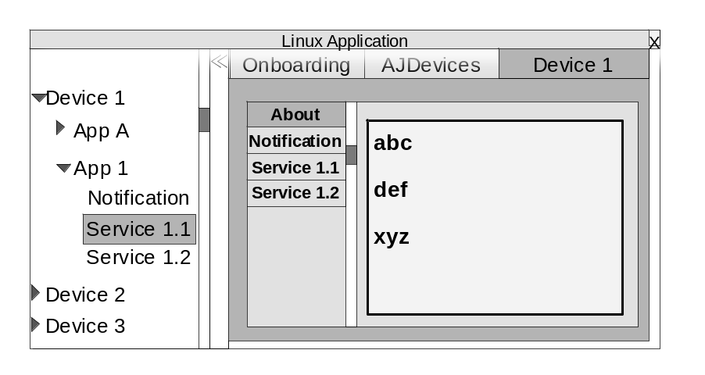
  - Notification panel
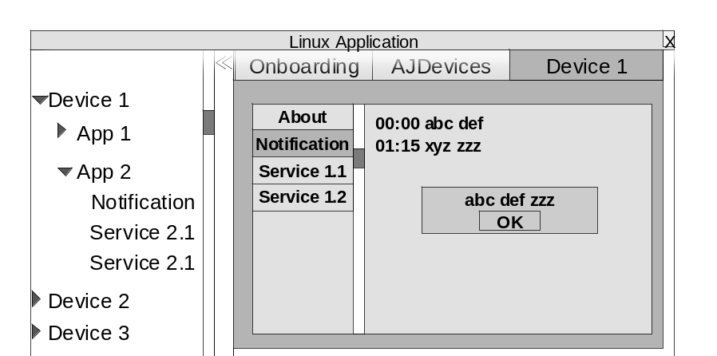
  - Service control panel
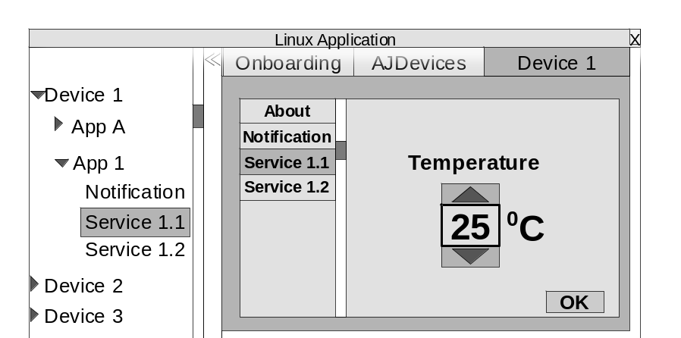
  - Hide Devices Tree
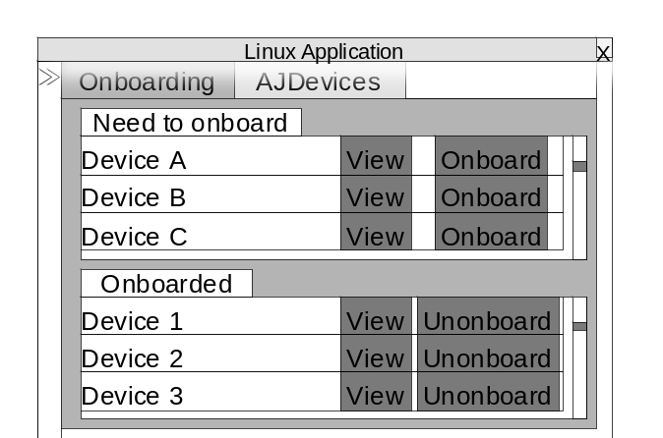
- UI API
  - API Common
    - GetAJDevices (include all devices connected to)
    - GetOnboaredDevices
    - GetNonOnboardDevices
    - invokeAction
    - notifyUpdatedDevice
    - notifyNewDevice
  - Onboarding tab
    - onboardDevice
    - getDeviceInfo
    - unonboardDevice
    - buildPanel (UI)
    - updatePanel (UI)
  - AJDevices tab
    - getDeviceStatus
    - notifyStatusChange
    - handleAction (UI)
    - buildPanel (UI)
    - updatePanel (UI)
  - About panel
    - getAboutInfo
    - buildPanel (UI)
    - updatePanel (UI)
  - Notification panel
    - loadDialog (UI)
    - showOsd (UI)
    - notifyNewMessage
    - buildPanel (UI)
    - updatePanel (UI)
  - Service control panel
    - getAJService
    - getControlPanel
    - handleAction (UI)
    - buildPanel (UI)
    - updatePanel (UI)
  - Devices Tree
    - showList (UI)
    - handleAction (UI)
- MW function
  - Common function
  - About service
  - Notification service
  - Onboarding service
  - ControlPanel service
  - Application service

