# README

This is a brief guide for running the components that are required on the document “Back-end Developers – Test”

## Database scripts

Run the scripts following these order>

1. Create Database.sql : It contains the instructions for creating the tables and stored procedures.
2. Insert 5000.sql: this script loads the Animal table with rando data. It lasts 2.5 minutes approximately.
3. Queries.sql: It contains the queries that are described on the numerals 5 and 6 of the cuestionary.
4. Insert Update Delete Animal.sql : this script build some stored procedures for inserting , updating and deleting registers on the table Animal

## API Generalities:

1. Edit the appSettings.json file of the asp net core project. Define the following parameters if were necessary:
   1. DefaultConnection : Define the database connection string.
   2. UserEmail and UserPassword: they are the credentials that are required for accessing to the API controllers
   3. KeyJwt: This is a key for creating authentication tokens.

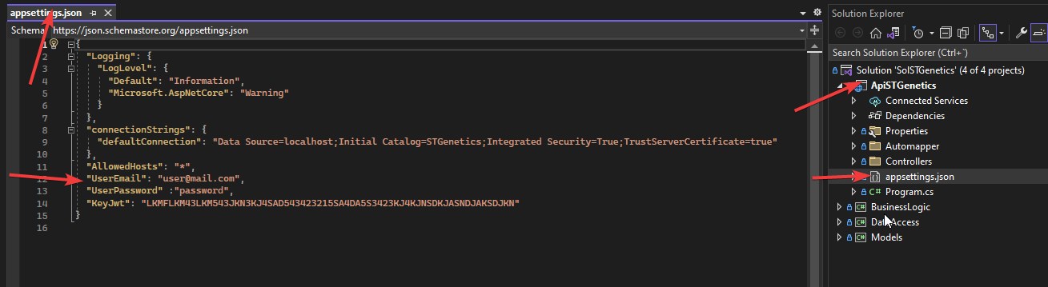

## POSTMAN COLLECTION

STGenetics.postman_collection.json

1. Edit the service domain of the API if were necessary:

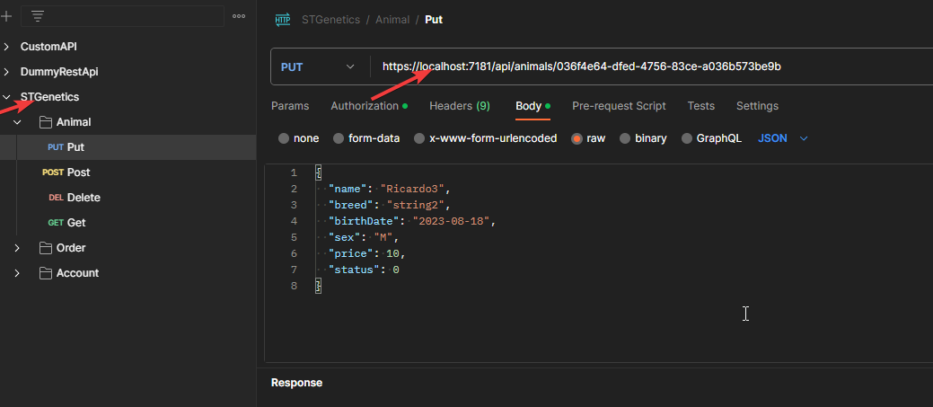

1. First of all, run the account/PostLogin request for getting a Token. Edit the body parameters if were necessary :

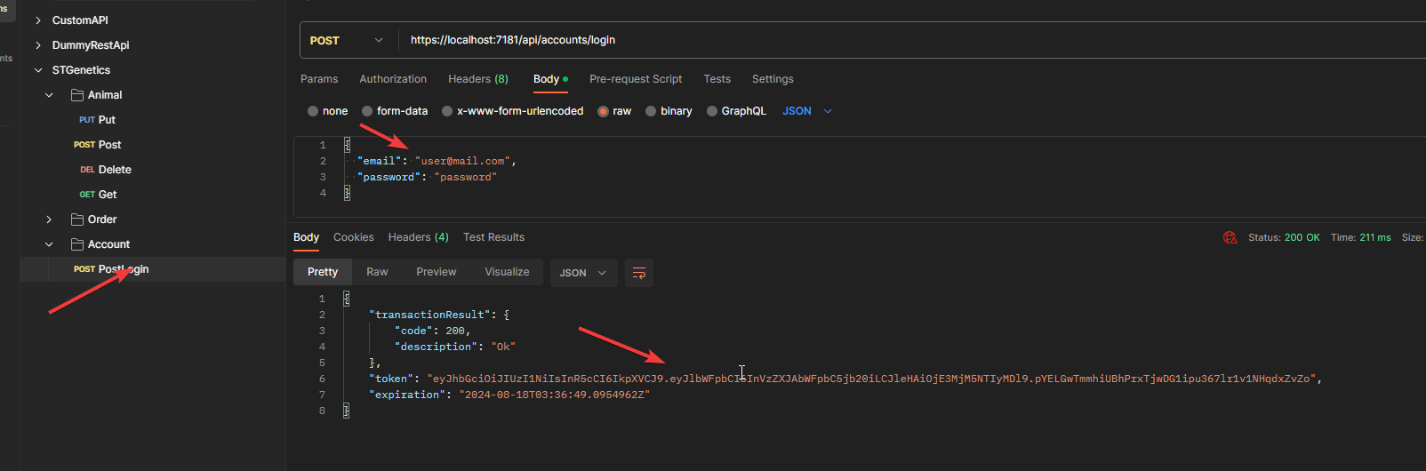

1. Run the desired requests. Set up the bearer Token on each request:

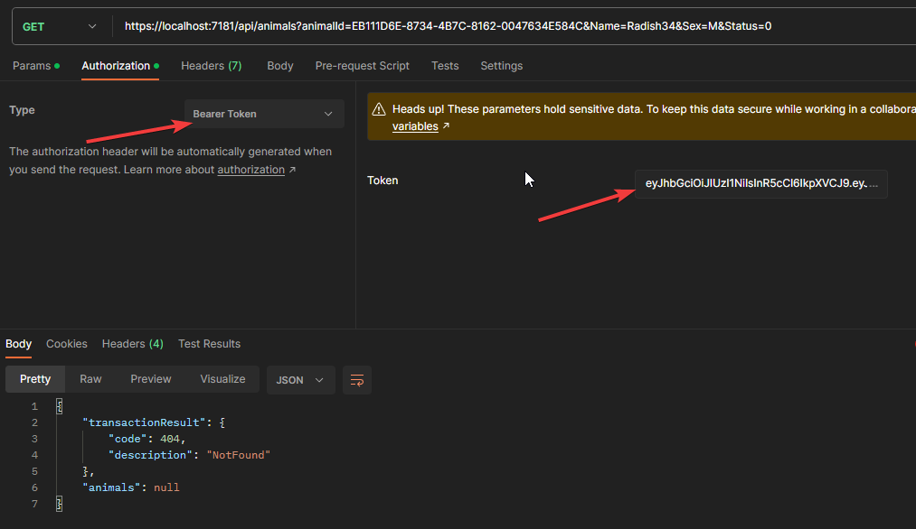

1. The Animal/Get request can process a query string that allow us define a filter for querying the Animal table. See the following example:

?animalId=EB111D6E-8734-4B7C-8162-0047634E584C&Name=Radish34&Sex=M&Status=0

Remarks:

* All the filter’parameters are not mandatory but at least one of them must be defined.
* If the animalId filter is defined the other filters will be ignorated.
* If there are more than 1 filter the api builds a query with “And” operators. For instance:

?Name=Radish34&Sex=M&Status=0

The api method, returns all the animal with Name Radish34 And Sex M (Male) And Status 0 (Inactive)

* The status filter can contain:
  + 0 : Inactive
  + 1: Active
  + -1: Both