All the projects are in ChangeFeedDemo Folder

IoTDataPump has the project which pumps the data in Collection.

AVLS – project is the UI project

AzureFuncition project has the Azure function code.

After opening the project

update the all the Git packages

Install typescript globally

npm install -g typescript

Install BingMap

Install-Package Microsoft.BingMaps.V8.TypeScript

Compile

On the portal make sure the in scmrstorage storage account has trafficqueue

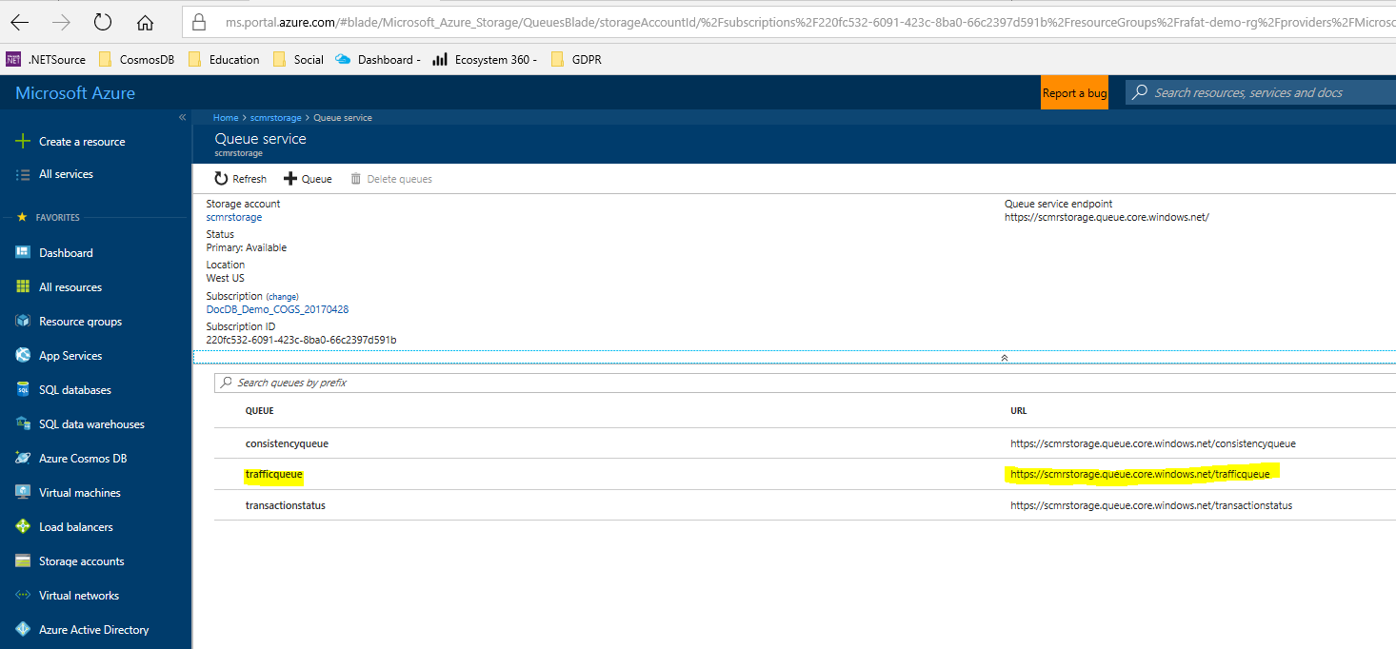

Make sure the following function exist on top of

