Rimon Sawa

**CPE301 – SPRING 2018**

Design Assignment 2

**DO NOT REMOVE THIS PAGE DURING SUBMISSION:**

The student understands that all required components should be submitted in complete for grading of this assignment.

|  |  |  |  |
| --- | --- | --- | --- |
| **NO** | **SUBMISSION ITEM** | **COMPLETED (Y/N)** | **MARKS**  **(/MAX)** |
| 1 | COMPONENTS LIST AND CONNECTION BLOCK DIAGRAM w/ PINS |  |  |
| 2. | INITIAL CODE OF TASK 1/A |  |  |
| 3. | INCREMENTAL / DIFFERENTIAL CODE OF TASK 2/B |  |  |
| 3. | INCREMENTAL / DIFFERENTIAL CODE OF TASK 3/C |  |  |
| 3. | INCREMENTAL / DIFFERENTIAL CODE OF TASK 4/D |  |  |
| 3. | INCREMENTAL / DIFFERENTIAL CODE OF TASK 5/E |  |  |
| 4. | SCHEMATICS |  |  |
| 5. | SCREENSHOTS OF EACH TASK OUTPUT |  |  |
| 5. | SCREENSHOT OF EACH DEMO |  |  |
| 6. | VIDEO LINKS OF EACH DEMO |  |  |
| 7. | GOOGLECODE LINK OF THE DA |  |  |
|  |  |  |  |
|  |  |  |  |

1. **COMPONENTS & BLOCK DIAGRAM**

Components: ATmega328p chip, Atmel studio, yellow LED, push button, and 10K resistors.

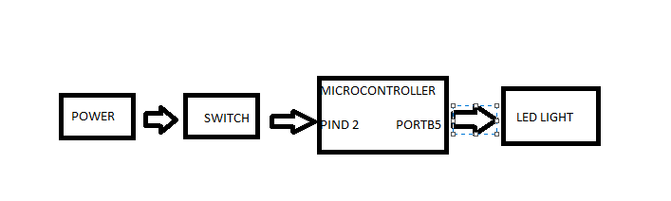

1. **CODE TASK 1/A & 1/C**

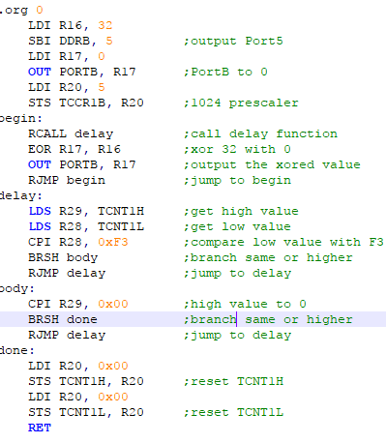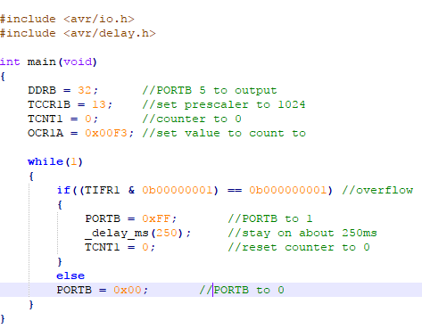

**CODE TASK 2/A & 2/C**

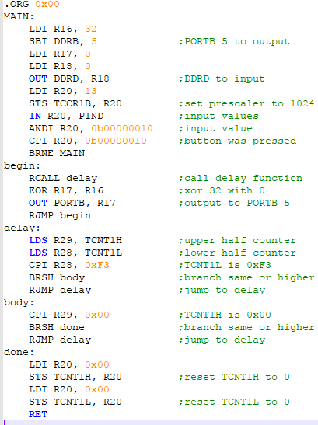

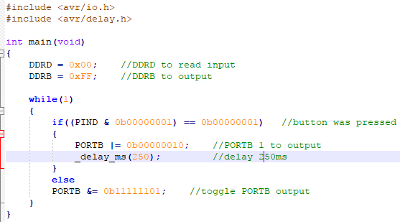

**CODE TASK 3/A & 3/C**

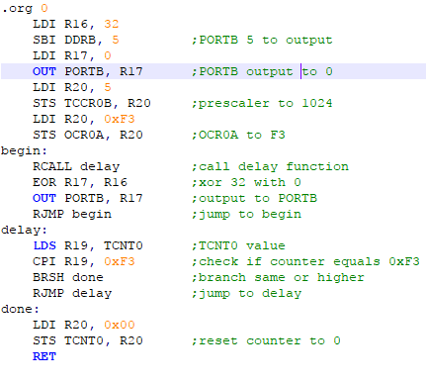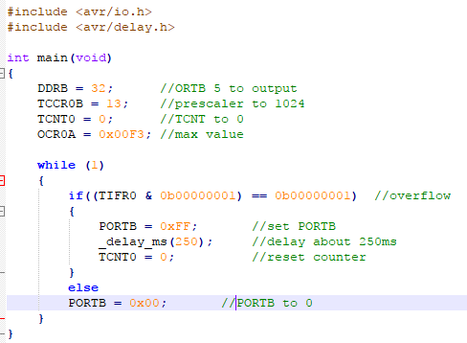

**CODE TASK 4/A & 4/C**

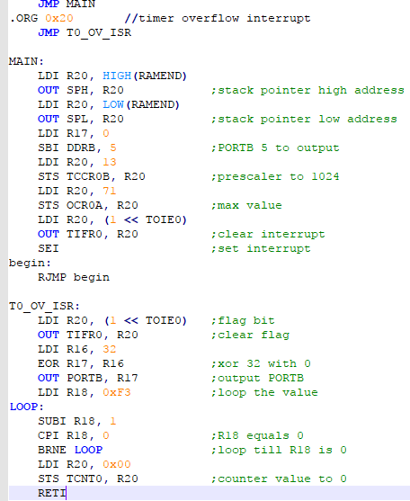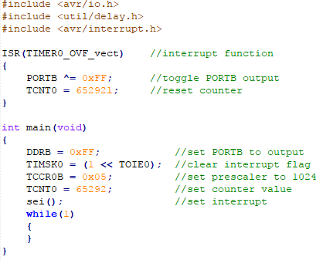

**CODE TASK 5/A & 5/C**

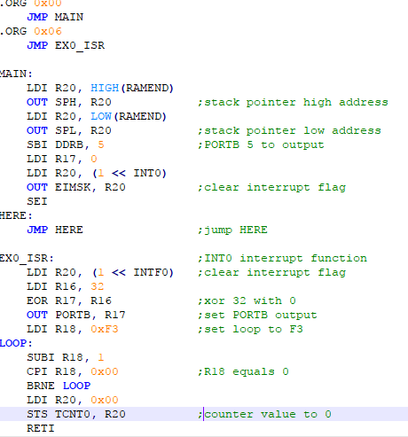

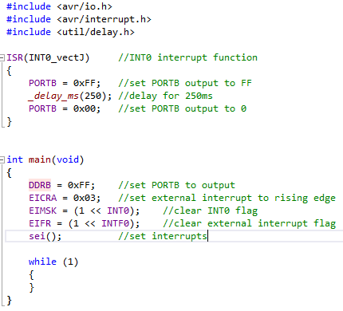

1. **SCHEMATICS**

1, 3, & 4 schematic:

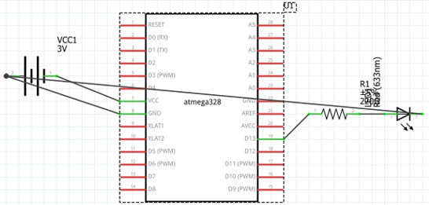

2 & 5 schematic:

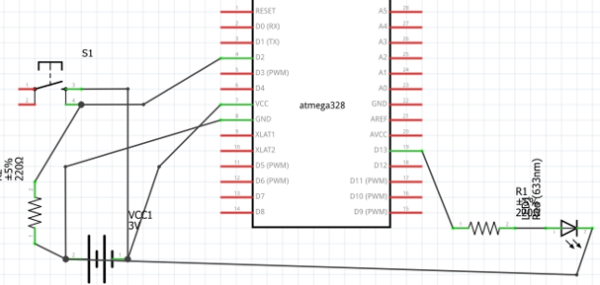

1. **PICTURES OF CIRCUIT**

**TASK 1:**

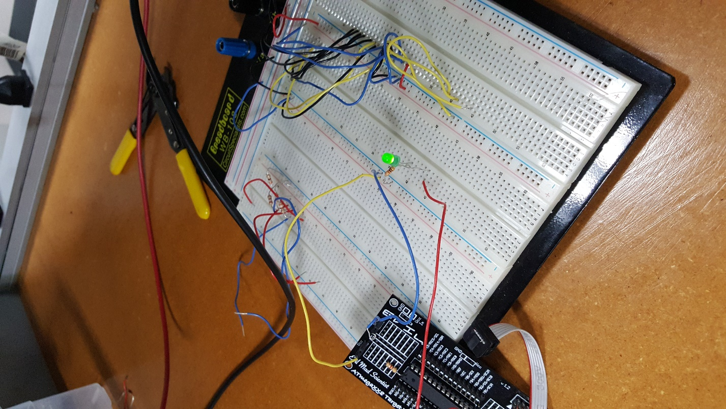

**TASK 2:**

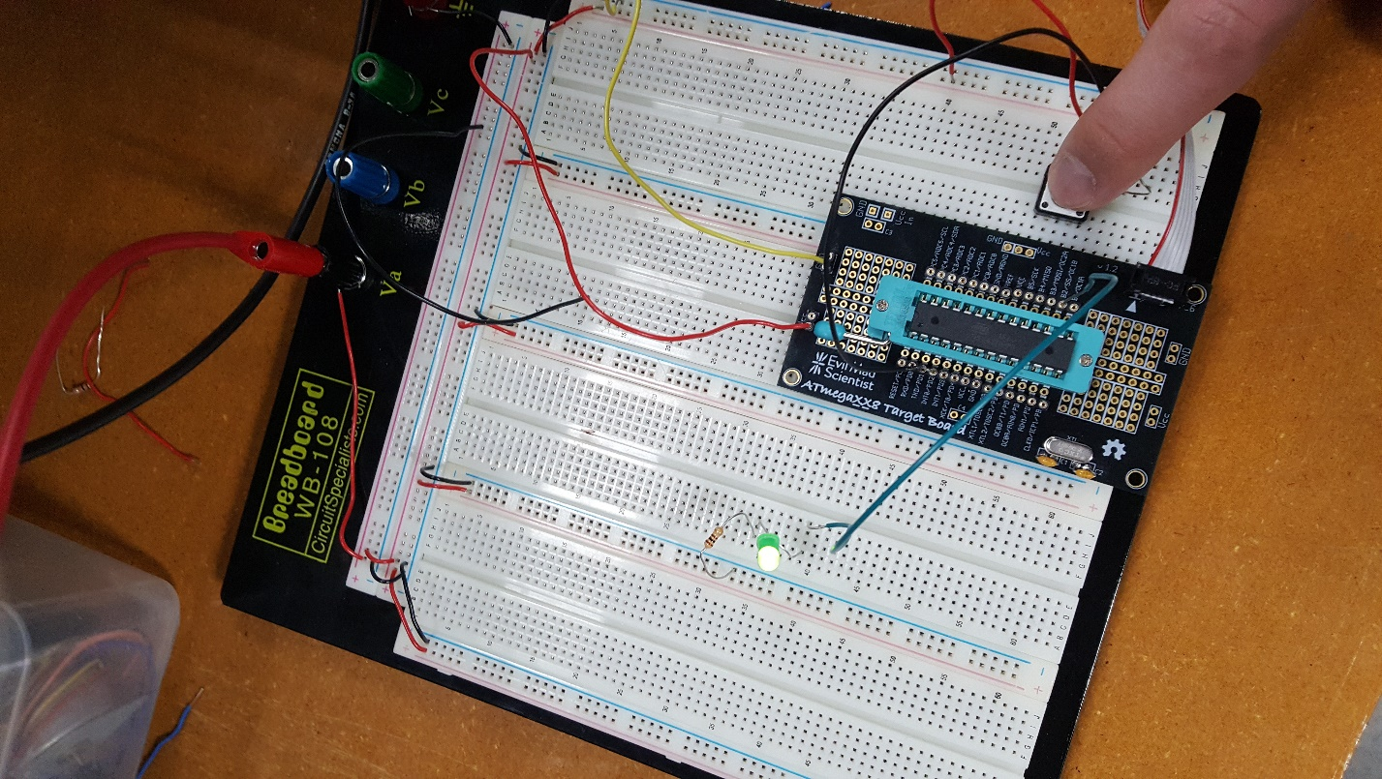

**TASK 3:**

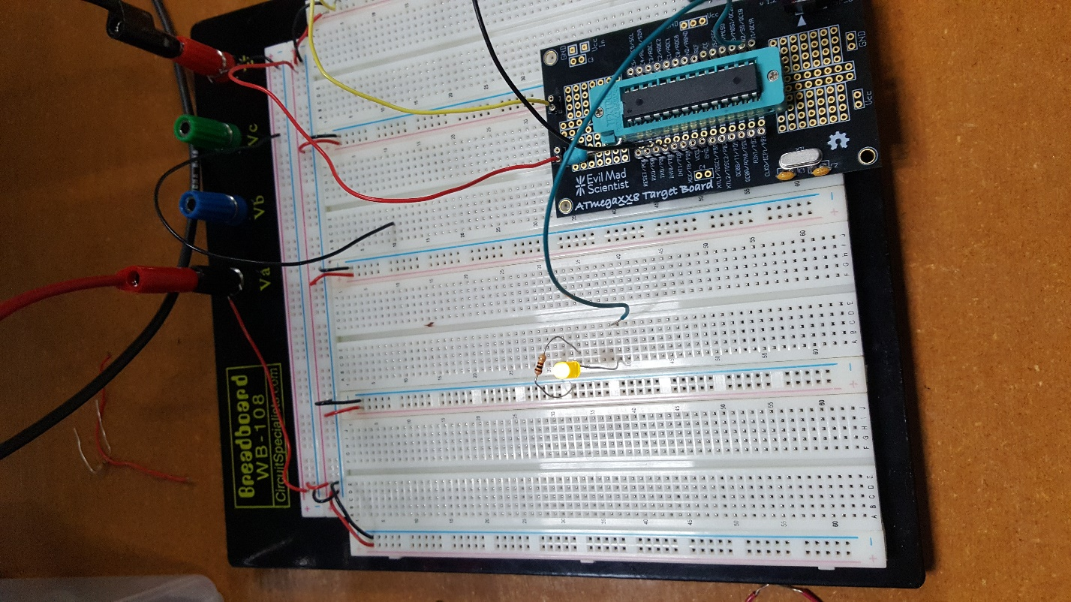

**TASK 4:**

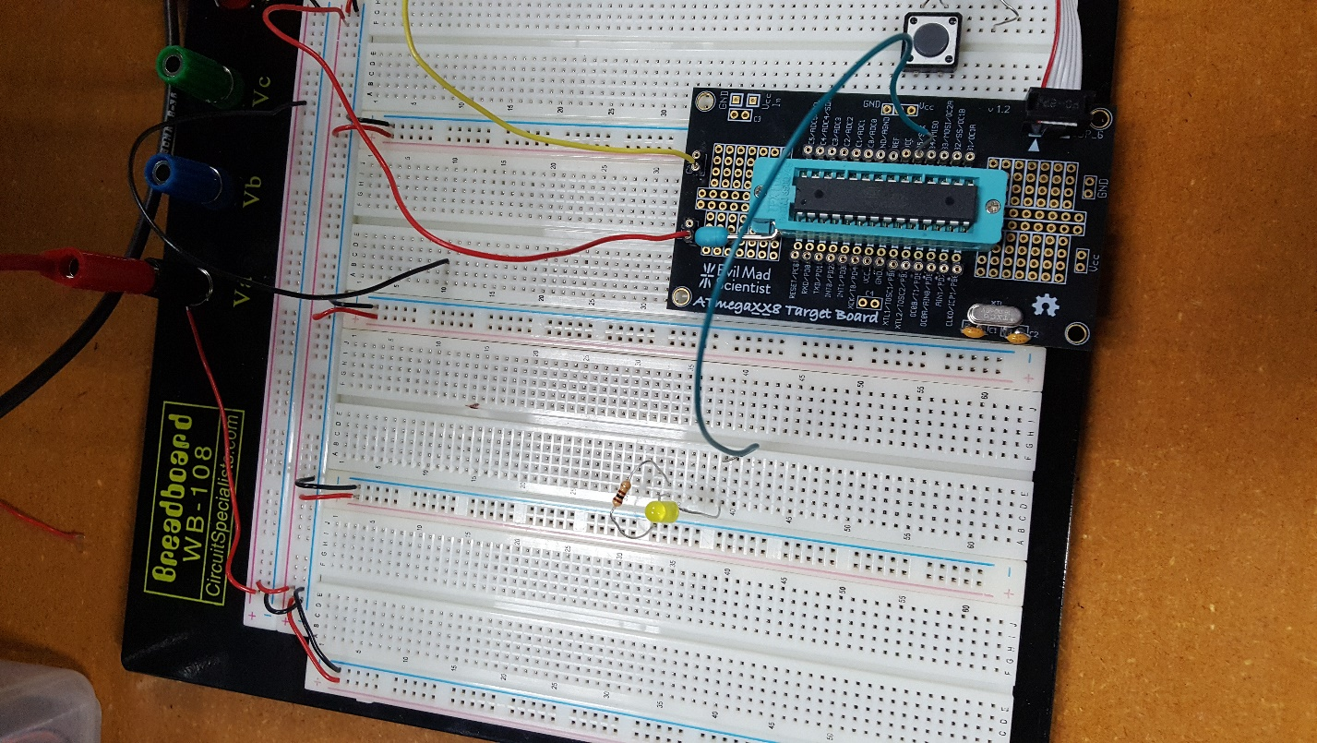

**TASK 5:**



1. **VIDEO LINKS OF EACH DEMO**

<https://youtu.be/D5utjyF5JT0>

1. **GITHUB LINK OF THIS DA**

<https://github.com/rsawa91>