Rimon Sawa

# CPE301 – SPRING 2018

# Midterm 1

**DO NOT REMOVE THIS PAGE DURING SUBMISSION:**

The student understands that all required components should be submitted in complete for grading of this assignment.

|  |  |  |  |
| --- | --- | --- | --- |
| **NO** | **SUBMISSION ITEM** | **COMPLETED**  **(Y/N)** | **MARKS (/MAX)** |
| 1 | COMPONENTS LIST AND CONNECTION BLOCK DIAGRAM w/ PINS |  |  |
| 2. | INITIAL CODE OF TASK 1/A |  |  |
| 3. | INCREMENTAL / DIFFERENTIAL CODE OF TASK 2/B |  |  |
| 3. | INCREMENTAL / DIFFERENTIAL CODE OF TASK 3/C |  |  |
| 3. | INCREMENTAL / DIFFERENTIAL CODE OF TASK 4/D |  |  |
| 3. | INCREMENTAL / DIFFERENTIAL CODE OF TASK 5/E |  |  |
| 4. | SCHEMATICS |  |  |
| 5. | SCREENSHOTS OF EACH TASK OUTPUT |  |  |
| 5. | SCREENSHOT OF EACH DEMO |  |  |
| 6. | VIDEO LINKS OF EACH DEMO |  |  |
| 7. | GOOGLECODE LINK OF THE DA |  |  |
|  |  |  |  |
|  |  |  |  |

# 1. COMPONENTS LIST AND CONNECTION BLOCK DIAGRAM w/ PINS

**Atmega328p Mini**

**FTDI**

**LM34**

**ESP8266-01.**

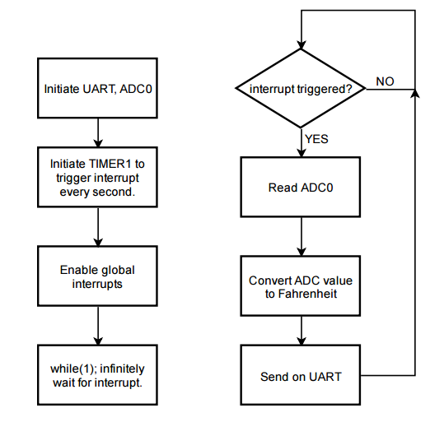

# 2. INITIAL/DEVELOPED CODE OF TASK 1/A

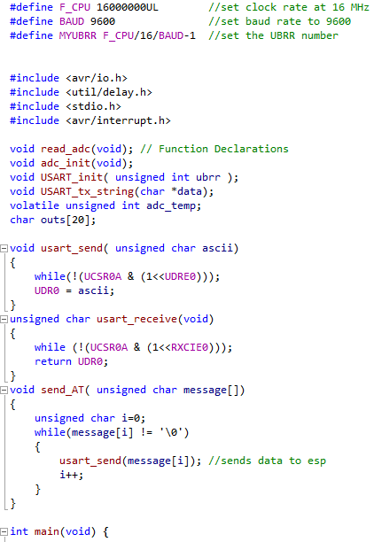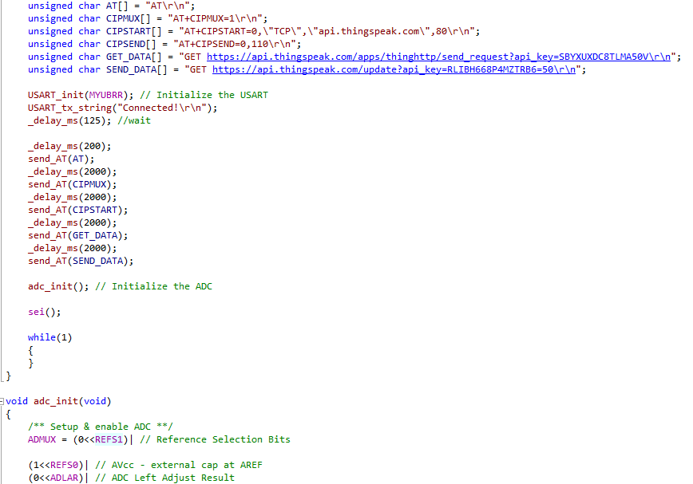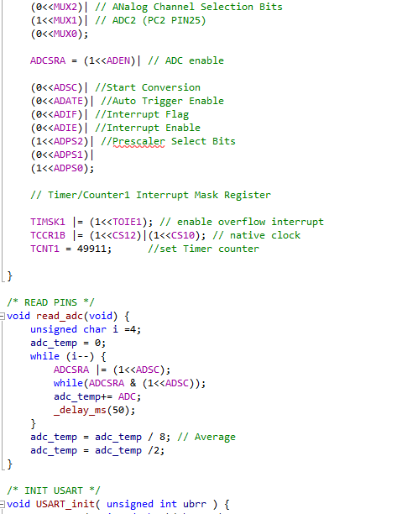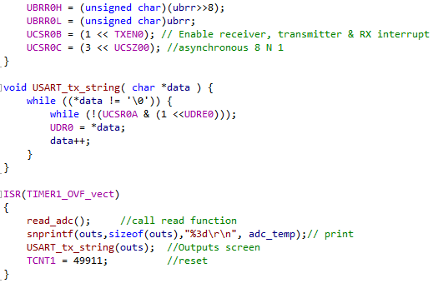

# 3. SCHEMATICS

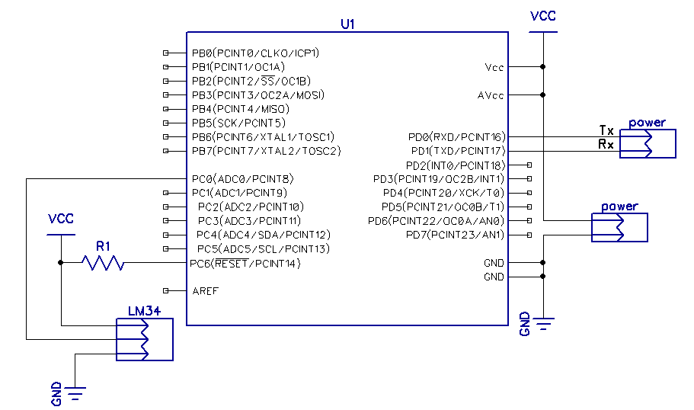

# 4. SCREENSHOTS OF EACH TASK OUTPUT (PUTTY OUTPUT)

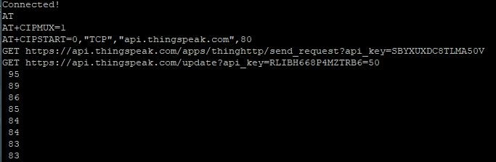

# 5. SCREENSHOT OF EACH DEMO (BOARD SETUP)

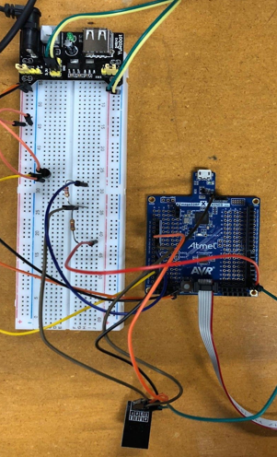

**6. VIDEO LINKS OF EACH DEMO**

**N/A**

# 7. GITHUB LINK OF THIS DA

https://github.com/rsawa91/CPE301

**Student Academic Misconduct Policy** http://studentconduct.unlv.edu/misconduct/policy.html

“*This is my work*​​”.

Rimon Sawa