Description of the Problem

The goal of Adventure is to mimic an adventure game genre which started in the 1970s. The player explores an area and interacts with items and characters.

Included on the following pages are the original programming assignment documentation.

http://www.cacs.louisiana.edu/~mgr/273/oostandards.html
Design

The divide and conquer approach was used to work though the development of Adventure. First the interface was put together and then the focus was on reading the data file (typically known as castle.dat). The interface was initially copied from DSA2 program 3, “Floor Plan.” Part of its interface prompts the user for a file name before continuing with program execution. The interface was changed to meet the needs of the Adventure program. Later, a check to see if castle.dat exists in the execution direction was added. If it exists, the user is taken immediately into game play. Otherwise, they’re presented with the necessary GUI elements to select a file.

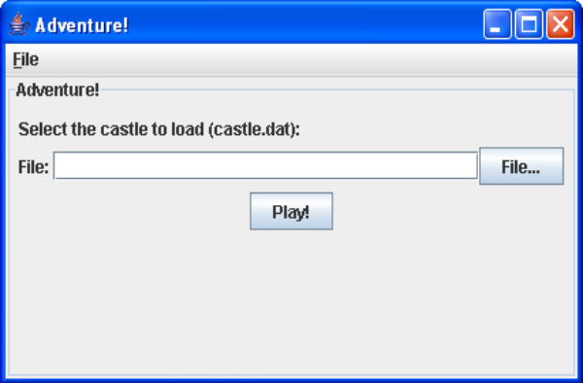
Figure 1

The interface is a Java Swing Editor which has its editable attribute set to false so the user can not type directly into it. The colors were set to match a console window, to mimic the older BBS days of online game play.

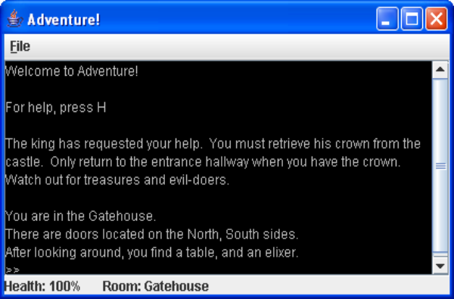
Figure 2

The File menu provides three menu options: New Game, about, and exit. When the user selects New Game, the file select window appears (see Figure 1). About presents a dialog window showing the copyright notice. Exit will end the game and close the program. For a possible future version 2, providing the path to the currently used castle.dat file in the file prompt seen in Figure 1 would be more user-friendly. Also prompting the user if they really want to exit would be nice too.

Adventure Class

There are 10 classes to Adventure. The Adventure class contains the main() method. It also defines the game’s window size and several other parameters. It then calls on the NavFrame class.

NavFrame Class

The NavFrame class defines the window as well as the menu bar. It also defines the necessary event listeners for the navigation menu (new game, about, and exit). It then loads the InputFrame class.

InputFrame Class

The InputFrame class is only to get the file name. It first checks if castle.dat is in the current path and is readable. If so, it passes along the file path to the startGame() method which starts the game. Otherwise, InputFrame builds the file pane as seen in Figure 1. It also sets up the necessary event listeners to handle the file dialog as well as the “Play!” button being pressed. Once the user selects a file and presses “Play!” the startGame() method is called and the game starts. The startGame() method creates a new AdventureGame and loads the data file in and then starts the game play.

AdventureGame Class

AdventureGame is responsible for building the game display as well as managing the game play. It calls upon various objects throughout the game. It manages the player and the castle. Before game play can begin, the data file needs to be read in. This process was broken down into three tasks, for each section of the file. The first section of the file defines the rooms in the castle. So the first task is to read in this section until number 99 is encountered. A new Castle object is created and for each room read in, a new Room object is created, as well as added to the castle’s array list of rooms. As the rooms are read in, the entrance room is identified and marked as the entrance room in the Castle object. A string constant in AdventureGame defines which room will be the entrance room. Section two of the file defines the connections between rooms. This is considered task two. Each line defines an Arc object, which is then added to the castle’s arc array list. At this point, a graph of the castle layout is now available. Although there is still a third section of the data file to read in. This section contains the items and characters found in each room. Originally, a character and item were classified as the same thing, but it was later discovered to be easier to separate the two into their own array lists. Each room object has two array lists to define the items and the characters. As each line is read from the third section of the file, the item is determined to be an actual item, or a character and added to the associated room and the associated array list. Each item and character is specified in an enumerated list called RoomItems. This enumerated list provides a means of associating attributes to each item or character. A lowercase match is made from the file to this list and if an item or character exists, then its added to the associated array. If the item is not matched, a status message is displayed to System.out. An error is not displayed to the user because game play is still possible.

Once the data file has been read in, game play may start. An introduction message is displayed to the user and the key listening begins (AdventureGame implements KeyListener). The available commands are:

N, E, S, W – Move north, east, south, or west
C – list contents of the player’s backpack
T – take an item and put it in the player’s backpack
U – use an item
R – remove an item from the player’s backpack
F – flee
D – debug (list all the rooms and their connections)
H – help
Q – quit

A switch statement is used to check for the character code. This code is always the ASCII uppercase value of the letter pressed (even if the user enters a lowercase character). For each key pressed, a method is called.

For every status update, a check is made to determine if the player is back at the entrance and if they have the crown. If they have the crown, they win the game. If they don’t have the crown, the player is considered dead and the game is over.

Making a Move

Regardless if the user selected N, E, S, or W, the makeMove() method is called. It lets the Castle object’s testMove() method to determine if the move can be made or not. If it can, the characters in the current room get played out (for example, if there’s a werewolf in the room, let it bite the player). If the player is still alive, it gets moved to the new room. The special case is if there’s a hag in the room. The hag prompts the user for an item to remove before the player can move to the new room. Regardless of what the player gives (or doesn’t give) the hag, the player will move to the new room. Once the move is complete, the player’s status is updated in the text display as well as the status bar.

Taking an Item

The player can take an item if there’s any in the room. The take() method is called (from within AdventureGame) and it checks if there’s any moveable items in the room. If there is, then it prompts the user to make a selection to pick one of the items to take. If no items can be taken, a message is displayed to let the player know. Once the player has selected an item, takeRoomItem() method is called. It checks to see if the player aborted the selection. If it hasn’t, then it checks to see if the player’s backpack has room or not. If it doesn’t have room, a message is displayed letting the player know they can remove items from their backpack if they wish. Otherwise, the item is removed from the room and played in the player’s backpack. The player’s backpack is an array list of RoomItems. The backpack array list is maintained in the Player object.

Listing Items in the Backpack

A displayList() method in AdventureGame handles displaying selection lists and its used again to display the list of items in the player’s backpack. It simply traverses the array of items and displays each one on its own line with line numbers.

Removing an Item

To remove an item, the list of items in the backpack is displayed to the player and the player makes a selection. The player doesn’t have to select an item to remove (in case they accidentally pressed R to remove an item). If they select a valid item, the item is removed from their backpack (its removed from the array list) and then added back to the room (an add() method call is made to the Room object with the item to add back).

Using an Item

The player is prompted to select an item from their backpack to use in the room. Depending on the item’s attributes, the item may then be removed from their backpack (such as a spell or a silver bullet). The item used is then added to an array list of items belong to the AdventureGame object. This list keeps track of the items the player used in a room and only is referred to when its time to act on the characters in the room. For example, if there’s a vampire on the room, the player uses their garlic (which in this case, would stay in their backpack). Then when its time to play the vampire, a check is made to the list of items that were used in the room. It will see garlic was used and let the player pass safely along. Otherwise, action is taken on the player.

Fleeing

The flee requirement specifies the player is to run as fast as possible back to the castle’s entrance. The characters in each of the rooms the player travels through do not interact with the player. The flee algorithm must be implemented using Dijkstra’s Shortest Path algorithm. The AdventureGame object calls the flee() method which then requests the Castle object to produce the shortest path from the player’s current room to the entrance room. The Castle object description will provide additional information on this algorithm’s implementation. An array list flee path of connections (defined by DSPRoomSet object) will be created and from that a text string will be generated providing output to the player.

Debug

Debug calls the Castle object’s debug method.

Quit

Immediately exits the game. Future versions should prompt the user if they wish to exit or not.

Castle Class

The Castle object models a graph-like structure. Each room is a node of the graph. The Castle object defines an adjacency matrix to be used to determine if a room connects to another room. The entrance is also identified here. The Castle object has the necessary methods to add room and arc objects. The Castle object also handles the debug output and the fleeing.

Debug

The debug output is produced by looping through all the rooms in the room array list. For each room, get the room name and its ID. The ID is used to identify the room in the adjacency matrix. A second loop is created to loop through all the rows in the adjacency matrix. For each index which is not 0, retrieve the arc object. From the arc object, the direction and the destination room can be identified. Use this information to build an output string. When done looping through the adjacency matrix, continue to the next room. When done, return the output string.

Flee

The shortest path algorithm used is Dijkstra’s. An adjacency matrix is used to locate a room’s neighbors. This was chosen over the adjacency list because there was only going to be a fixed number of rooms and the lookups would be a little easier to implement.

Before finding neighbors, the starting room is identified with the lowest connection cost. Each connection is defined with a DSPRoomSet object. This object keeps track of the room, the connecting room, and the cost to get to the connecting room, as well as a label identifying the direction to get to this room. The algorithm then finds the lowest cost connection available which turns out to be the starting room. Its removed from the search list and placed into a found list. With the new found node, find its neighbors and update their cost. Set all other rooms to a cost of infinity (which in this program is a constant value of 99999 defined by the variable INFINITY – this was a bit easier to implement than using -1 which was originally tried, but also created some interesting bugs). Find the next lowest cost connection, remove it from the search list and place it in the found list. Then find its neighbors and update their cost, if and only if their connection cost is lower. Otherwise, leave the connection cost as is. Repeat this process until either out of rooms in the search list, or the entrance room is found. Return a list of DSPRoomSet objects.

Room Class

The Room object defines a room and the characters and items in the room. The room object does not have any information regarding the rooms it connects to (this is the responsibility of the Castle object). The Room object is to behave much like a node in a graph. The necessary setter and getter methods are available as well as some helper methods to identify if a particular object or character is in a room or not.

DSPRoomSet Class

The DSPRoomSet object is used in the Dijkstra’s Shortest Path algorithm implementation. It is to keep track of the room, the room it connects to, as well as its direction. This provides enough information to be able to reproduce the shortest path taken. This object provides the necessary setter and getter methods to cater to the shortest path algorithm.

Arc Class

The arc object defines a connection between two rooms. It resembles an edge in a graph. The arc object keeps track of a source and destination room, and a label describing how the connection is made (typically “north” or a similar direction). The weight has also been implemented and is defaulted to a value of one.

Player Class

The Player object defines the game’s player. It keeps track of the current room the player is in, the previous room the player was in, the player’s backpack, and the player’s health. The necessary setter and getter methods have been implemented to update the player’s information. The player’s backpack is an array list of RoomItems. The hunchback steals something from the player’s backpack. A check is made to make sure there are items in the backpack. If there are no items, then nothing is stolen. If there are items, then a random number from 0 to the number of items in the pack is chosen. The item corresponding to the random number is then removed and the player is notified.

RoomItem Class

The RoomItem object is an enumerated type. Each possible item or character which can be in a room is defined here. Each item (or character) has attributes. These are: full name, health adder, moveable, is character, and is re-useable. Each item is setup as a constant and its attributes become constants to the item. A room object and the player object refer back to items which belong to this class.

UML Class Diagram

On the following page, the UML class diagram as generated by JGrasp has been provided. It defines the classes and how they’re connected between each other.

