Name: ________________________

- In general, what is the minimum height possible for a binary tree with 17 nodes?

- In general, what is the minimum number of leaves possible in a binary tree with 17 nodes?

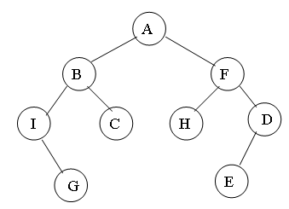
- List the nodes in the binary tree in

  - inorder traversal
  - preorder traversal
  - postorder traversal

4. Build the binary expression tree for the following input.
(((5 + 2) * (2 – 1)) / ((2 + 9) + ((7 – 2) – 1)) * 8)

5. Give the Big-O run time for an algorithm with running time

f(n) = 4n³ + 8n² + n + 3

and prove it. Minimize k and n_{o} (with respect to k, both an integer).

6. Draw the binary tree that gives the following traversals.

Inorder traversal: A I H K J L F G D E B C

Postorder traversal: I K L J H G F E D C B A

7. Write a recursive function to determine the number of leaves in a given binary tree. Define your node class to have two references, one to a left subtree (node) and one to a right subtree (node) and a private integer variable.

8. Approximately how many jelly bellies (the small jelly beans) does it take to fill a two-liter pop bottle (presumably empty to start with)? Show, in detail, your thought process in how you arrive at your estimation.

