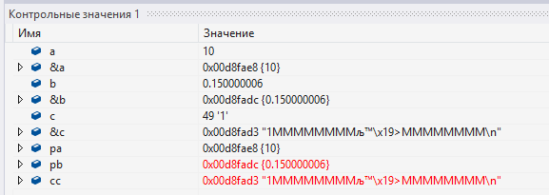

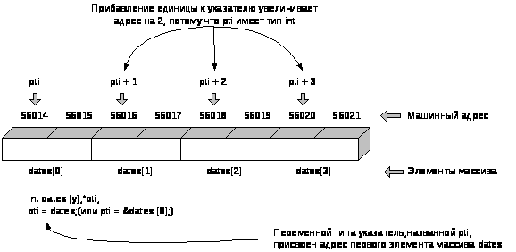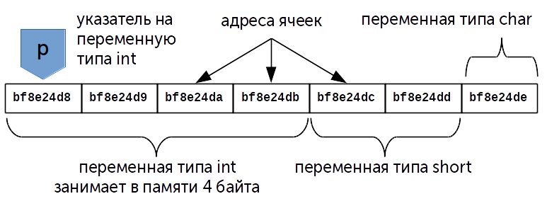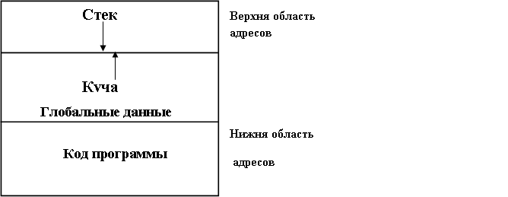

|  |  |  |  |  |  |  |  |  |  |  |  |  |  |  |  |  |  |  |  |  |  |  |  |  |  |  |  |
| --- | --- | --- | --- | --- | --- | --- | --- | --- | --- | --- | --- | --- | --- | --- | --- | --- | --- | --- | --- | --- | --- | --- | --- | --- | --- | --- | --- |
|  |  |  |  |  |  |  |  |  |  |  |  |  |  |  |  |  |  |  |  |  |  |  |  |  |  |  |  |
| Верхняя область адресов  Стек данных | | | | | | | | Heap – куча  Динамическая память | | | | | | | | | | | | Нижняя область адресов  Код программы | | | | | | | |

