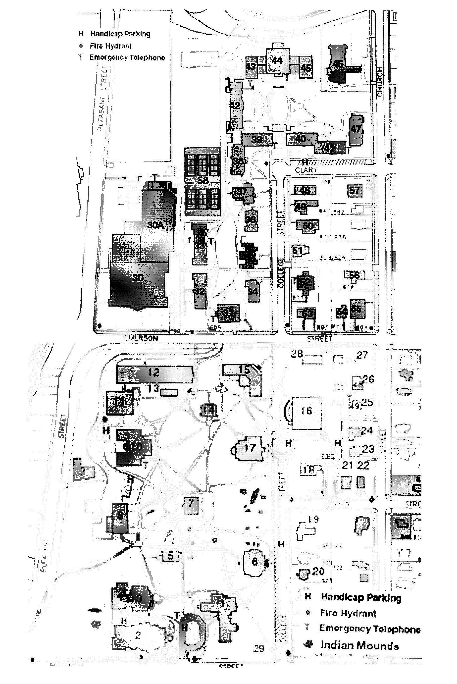
Woodward
Aldrich Hall
Parking Lot
Maurer Hall
Chapin - Dining
Flood Arena/Sports Center
Wright Museum of Art
Pearsons Hall
Whitney Hall
Blaisdell Hall
Maurer Link – Check-in
Logan Museum of Anthropology

Beloit College Campus Map

(DRIVING INSTRUCTIONS ON BACK)

