Richard Schack

10/30/21

HW4

[itec225_rschack/ITEC225_HW4 at main · rschackedu/itec225_rschack (github.com)](https://github.com/rschackedu/itec225_rschack/tree/main/ITEC225_HW4)

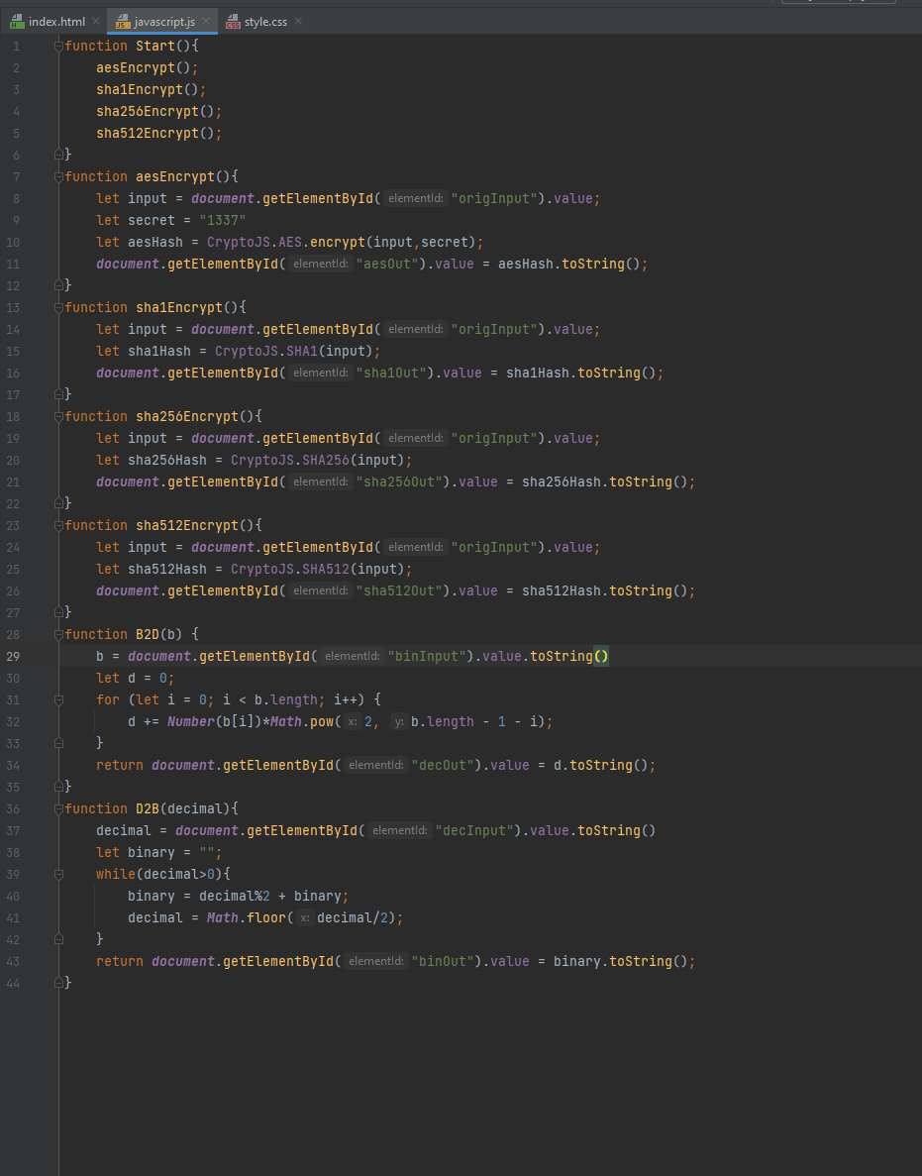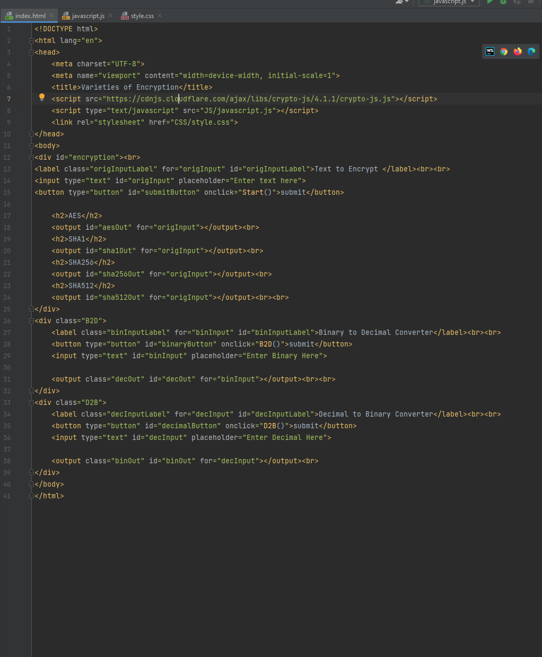

[itec225_rschack/ITEC225_HW4 at main · rschackedu/itec225_rschack (github.com)](https://github.com/rschackedu/itec225_rschack/tree/main/ITEC225_HW4)