Tomato nutrient study correlations

Rachel Schattman and Becky Maden

November 7, 2018

## Load library

library(dplyr)

##   
## Attaching package: 'dplyr'

## The following objects are masked from 'package:stats':  
##   
## filter, lag

## The following objects are masked from 'package:base':  
##   
## intersect, setdiff, setequal, union

## Start script

script_path <- "C:/Users/rschattman/Documents/Research/Greenhouse_tomatoes_2018"  
in_dir <- "C:/Users/rschattman/Documents/Research/Greenhouse_tomatoes_2018"  
out_dir <- "C:/Users/rschattman/Documents/Research/Greenhouse_tomatoes_2018/output"  
data <- data.frame(read.csv("C:/Users/rschattman/Documents/Research/Greenhouse_tomatoes_2018/Nutrient_levels_NH_VT_MA_11_14_18.csv"))

# Nitrate

## Create dataframe w/variables of interest for Nitrate only, omit rows with NA

tomatofun_nitrate <- subset(data, select = c("Nitrate.N..ppm..SME", "Nitrate.N..ppm..MM", "TN.....Leaf.Analysis"))  
tomatofun_nitrateNONA <- na.omit(tomatofun_nitrate)

## Check distribution - all are non normal

shapiro.test(tomatofun_nitrateNONA$Nitrate.N..ppm..SME)

##   
## Shapiro-Wilk normality test  
##   
## data: tomatofun_nitrateNONA$Nitrate.N..ppm..SME  
## W = 0.86211, p-value = 9.017e-05

shapiro.test(tomatofun_nitrateNONA$Nitrate.N..ppm..MM)

##   
## Shapiro-Wilk normality test  
##   
## data: tomatofun_nitrateNONA$Nitrate.N..ppm..MM  
## W = 0.88707, p-value = 0.0004461

shapiro.test(tomatofun_nitrateNONA$TN.....Leaf.Analysis)

##   
## Shapiro-Wilk normality test  
##   
## data: tomatofun_nitrateNONA$TN.....Leaf.Analysis  
## W = 0.96102, p-value = 0.1421

## Correlation tests

cor(tomatofun_nitrateNONA, method = "spearman")

## Nitrate.N..ppm..SME Nitrate.N..ppm..MM  
## Nitrate.N..ppm..SME 1.000000 0.9770220  
## Nitrate.N..ppm..MM 0.977022 1.0000000  
## TN.....Leaf.Analysis 0.269594 0.2836652  
## TN.....Leaf.Analysis  
## Nitrate.N..ppm..SME 0.2695940  
## Nitrate.N..ppm..MM 0.2836652  
## TN.....Leaf.Analysis 1.0000000

cor.test(x = tomatofun_nitrateNONA$Nitrate.N..ppm..SME, y = tomatofun_nitrateNONA$Nitrate.N..ppm..MM, alternative = "two.sided", method = "spearman", exact = NULL)

## Warning in cor.test.default(x = tomatofun_nitrateNONA  
## $Nitrate.N..ppm..SME, : Cannot compute exact p-value with ties

##   
## Spearman's rank correlation rho  
##   
## data: tomatofun_nitrateNONA$Nitrate.N..ppm..SME and tomatofun_nitrateNONA$Nitrate.N..ppm..MM  
## S = 326.06, p-value < 2.2e-16  
## alternative hypothesis: true rho is not equal to 0  
## sample estimates:  
## rho   
## 0.977022

cor.test(x = tomatofun_nitrateNONA$Nitrate.N..ppm..SME, y = tomatofun_nitrateNONA$TN.....Leaf.Analysis, alternative = "two.sided", method = "spearman", exact = NULL)

## Warning in cor.test.default(x = tomatofun_nitrateNONA  
## $Nitrate.N..ppm..SME, : Cannot compute exact p-value with ties

##   
## Spearman's rank correlation rho  
##   
## data: tomatofun_nitrateNONA$Nitrate.N..ppm..SME and tomatofun_nitrateNONA$TN.....Leaf.Analysis  
## S = 10364, p-value = 0.07677  
## alternative hypothesis: true rho is not equal to 0  
## sample estimates:  
## rho   
## 0.269594

cor.test(x = tomatofun_nitrateNONA$Nitrate.N..ppm..MM, y = tomatofun_nitrateNONA$TN.....Leaf.Analysis, alternative = "two.sided", method = "spearman", exact = NULL)

## Warning in cor.test.default(x = tomatofun_nitrateNONA$Nitrate.N..ppm..MM, :  
## Cannot compute exact p-value with ties

##   
## Spearman's rank correlation rho  
##   
## data: tomatofun_nitrateNONA$Nitrate.N..ppm..MM and tomatofun_nitrateNONA$TN.....Leaf.Analysis  
## S = 10165, p-value = 0.06204  
## alternative hypothesis: true rho is not equal to 0  
## sample estimates:  
## rho   
## 0.2836652

## plot SME and MM correlations

?plot

## starting httpd help server ... done

plot(tomatofun_nitrateNONA$Nitrate.N..ppm..SME, tomatofun_nitrateNONA$Nitrate.N..ppm..MM, type = "p", main = "Nitrate SME and MM, p < 0.001", xlab = "SME PPM", ylab = "MM PPM")  
abline(lm(tomatofun_nitrateNONA$Nitrate.N..ppm..SME~tomatofun_nitrateNONA$Nitrate.N..ppm..MM), col = "red") # regression line

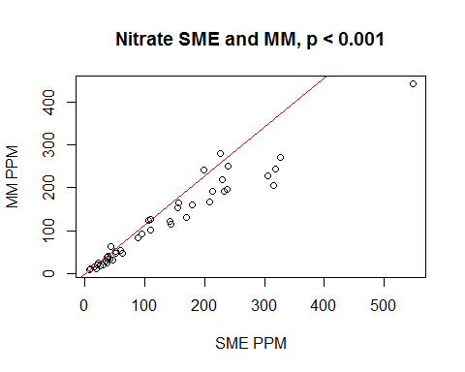 # Phosphorus ## Create dataframe w/variables of interest for P only, omit rows with NA

tomatofun_P <- subset(data, select = c("Phosphorus..ppm..SME", "Phosphorus..lb.Ac..MM", "P.....Leaf.Analysis"))  
tomatofun_P_NONA <- na.omit(tomatofun_P)

## Check distribution

shapiro.test(tomatofun_P_NONA$Phosphorus..ppm..SME)

##   
## Shapiro-Wilk normality test  
##   
## data: tomatofun_P_NONA$Phosphorus..ppm..SME  
## W = 0.68523, p-value = 5.792e-10

shapiro.test(tomatofun_P_NONA$Phosphorus..lb.Ac..MM)

##   
## Shapiro-Wilk normality test  
##   
## data: tomatofun_P_NONA$Phosphorus..lb.Ac..MM  
## W = 0.80092, p-value = 1.704e-07

shapiro.test(tomatofun_P_NONA$P.....Leaf.Analysis)

##   
## Shapiro-Wilk normality test  
##   
## data: tomatofun_P_NONA$P.....Leaf.Analysis  
## W = 0.95124, p-value = 0.01922

## Correlation tests

cor(tomatofun_P_NONA, method = "spearman")

## Phosphorus..ppm..SME Phosphorus..lb.Ac..MM  
## Phosphorus..ppm..SME 1.0000000 0.8404120  
## Phosphorus..lb.Ac..MM 0.8404120 1.0000000  
## P.....Leaf.Analysis 0.2051023 0.3496184  
## P.....Leaf.Analysis  
## Phosphorus..ppm..SME 0.2051023  
## Phosphorus..lb.Ac..MM 0.3496184  
## P.....Leaf.Analysis 1.0000000

cor.test(x = tomatofun_P_NONA$Phosphorus..ppm..SME, y = tomatofun_P_NONA$Phosphorus..lb.Ac..MM, alternative = "two.sided", method = "spearman", exact = NULL)

## Warning in cor.test.default(x = tomatofun_P_NONA$Phosphorus..ppm..SME, y =  
## tomatofun_P_NONA$Phosphorus..lb.Ac..MM, : Cannot compute exact p-value with  
## ties

##   
## Spearman's rank correlation rho  
##   
## data: tomatofun_P_NONA$Phosphorus..ppm..SME and tomatofun_P_NONA$Phosphorus..lb.Ac..MM  
## S = 5461.1, p-value < 2.2e-16  
## alternative hypothesis: true rho is not equal to 0  
## sample estimates:  
## rho   
## 0.840412

cor.test(x = tomatofun_P_NONA$Phosphorus..ppm..SME, y = tomatofun_P_NONA$P.....Leaf.Analysis, alternative = "two.sided", method = "spearman", exact = NULL)

## Warning in cor.test.default(x = tomatofun_P_NONA$Phosphorus..ppm..SME, y =  
## tomatofun_P_NONA$P.....Leaf.Analysis, : Cannot compute exact p-value with  
## ties

##   
## Spearman's rank correlation rho  
##   
## data: tomatofun_P_NONA$Phosphorus..ppm..SME and tomatofun_P_NONA$P.....Leaf.Analysis  
## S = 27201, p-value = 0.1192  
## alternative hypothesis: true rho is not equal to 0  
## sample estimates:  
## rho   
## 0.2051023

cor.test(x = tomatofun_P_NONA$Phosphorus..lb.Ac..MM, y = tomatofun_P_NONA$P.....Leaf.Analysis, alternative = "two.sided", method = "spearman", exact = NULL)

## Warning in cor.test.default(x = tomatofun_P_NONA$Phosphorus..lb.Ac..MM, :  
## Cannot compute exact p-value with ties

##   
## Spearman's rank correlation rho  
##   
## data: tomatofun_P_NONA$Phosphorus..lb.Ac..MM and tomatofun_P_NONA$P.....Leaf.Analysis  
## S = 22256, p-value = 0.006643  
## alternative hypothesis: true rho is not equal to 0  
## sample estimates:  
## rho   
## 0.3496184

## plot SME and MM correlations

plot(tomatofun_P_NONA$Phosphorus..lb.Ac..MM, tomatofun_P_NONA$Phosphorus..ppm..SME, type = "p", main = "Phosphorus SME and MM, p < 0.001", xlab = "MM PPM", ylab = "SME PPM")  
  
abline(lm(tomatofun_P_NONA$Phosphorus..ppm..SME~tomatofun_P_NONA$Phosphorus..lb.Ac..MM), col = "red") # regression line

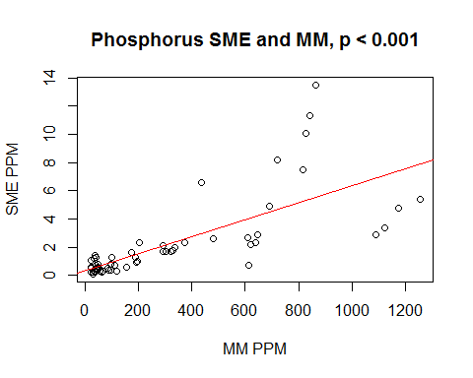

# Potassium

## Create dataframe w/variables of interest for P only, omit rows with NA

head(data)

tomatofun_K <- subset(data, select = c("Potassium..ppm..SME", "Potassium..lb.Ac..MM", "K.....Leaf.Analysis"))  
tomatofun_K_NONA <- na.omit(tomatofun_K)

## Check distribution

shapiro.test(tomatofun_K_NONA$Potassium..ppm..SME)

##   
## Shapiro-Wilk normality test  
##   
## data: tomatofun_K_NONA$Potassium..ppm..SME  
## W = 0.83161, p-value = 1.075e-06

shapiro.test(tomatofun_K_NONA$Potassium..lb.Ac..MM)

##   
## Shapiro-Wilk normality test  
##   
## data: tomatofun_K_NONA$Potassium..lb.Ac..MM  
## W = 0.93469, p-value = 0.003474

shapiro.test(tomatofun_K_NONA$K.....Leaf.Analysis)

##   
## Shapiro-Wilk normality test  
##   
## data: tomatofun_K_NONA$K.....Leaf.Analysis  
## W = 0.96719, p-value = 0.1118

cor(tomatofun_K_NONA, method = "spearman")

## Potassium..ppm..SME Potassium..lb.Ac..MM  
## Potassium..ppm..SME 1.00000000 0.8702502  
## Potassium..lb.Ac..MM 0.87025023 1.0000000  
## K.....Leaf.Analysis -0.08586213 -0.1142807  
## K.....Leaf.Analysis  
## Potassium..ppm..SME -0.08586213  
## Potassium..lb.Ac..MM -0.11428071  
## K.....Leaf.Analysis 1.00000000

cor.test(x = tomatofun_K_NONA$Potassium..ppm..SME, y = tomatofun_K_NONA$Potassium..lb.Ac..MM, alternative = "two.sided", method = "spearman", exact = NULL)

## Warning in cor.test.default(x = tomatofun_K_NONA$Potassium..ppm..SME, y =  
## tomatofun_K_NONA$Potassium..lb.Ac..MM, : Cannot compute exact p-value with  
## ties

##   
## Spearman's rank correlation rho  
##   
## data: tomatofun_K_NONA$Potassium..ppm..SME and tomatofun_K_NONA$Potassium..lb.Ac..MM  
## S = 4440, p-value < 2.2e-16  
## alternative hypothesis: true rho is not equal to 0  
## sample estimates:  
## rho   
## 0.8702502

cor.test(x = tomatofun_K_NONA$Potassium..ppm..SME, y = tomatofun_K_NONA$K.....Leaf.Analysis, alternative = "two.sided", method = "spearman", exact = NULL)

## Warning in cor.test.default(x = tomatofun_K_NONA$Potassium..ppm..SME, y =  
## tomatofun_K_NONA$K.....Leaf.Analysis, : Cannot compute exact p-value with  
## ties

##   
## Spearman's rank correlation rho  
##   
## data: tomatofun_K_NONA$Potassium..ppm..SME and tomatofun_K_NONA$K.....Leaf.Analysis  
## S = 37158, p-value = 0.5179  
## alternative hypothesis: true rho is not equal to 0  
## sample estimates:  
## rho   
## -0.08586213

cor.test(x = tomatofun_K_NONA$Potassium..lb.Ac..MM, y = tomatofun_K_NONA$K.....Leaf.Analysis, alternative = "two.sided", method = "spearman", exact = NULL)

## Warning in cor.test.default(x = tomatofun_K_NONA$Potassium..lb.Ac..MM, y =  
## tomatofun_K_NONA$K.....Leaf.Analysis, : Cannot compute exact p-value with  
## ties

##   
## Spearman's rank correlation rho  
##   
## data: tomatofun_K_NONA$Potassium..lb.Ac..MM and tomatofun_K_NONA$K.....Leaf.Analysis  
## S = 38131, p-value = 0.3888  
## alternative hypothesis: true rho is not equal to 0  
## sample estimates:  
## rho   
## -0.1142807

## plot SME and MM correlations

plot(tomatofun_K_NONA$Potassium..ppm..SME, tomatofun_K_NONA$Potassium..lb.Ac..MM, type = "p", main = "Potassium SME and MM, p < 0.001", xlab = "SME PPM", ylab = "MM PPM")  
abline(lm(tomatofun_K_NONA$Potassium..lb.Ac..MM~tomatofun_K_NONA$Potassium..ppm..SME), col = "red") # regression line

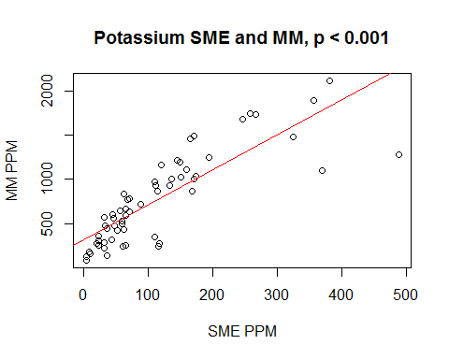

# P SME and pH MM

## Create dataframe w/variables of interest, omit rows with NA

head(data)

tomatofun_P_pH <- subset(data, select = c("Phosphorus..ppm..SME", "Soil.pH"))  
tomatofun_P_pH_NONA <- na.omit(tomatofun_P_pH)

cor(tomatofun_P_pH_NONA, method = "spearman")

## Phosphorus..ppm..SME Soil.pH  
## Phosphorus..ppm..SME 1.0000000 0.4851736  
## Soil.pH 0.4851736 1.0000000

cor.test(x = tomatofun_P_pH_NONA$Phosphorus..ppm..SME, y = tomatofun_P_pH_NONA$Soil.pH, alternative = "two.sided", method = "spearman", exact = NULL)

## Warning in cor.test.default(x = tomatofun_P_pH_NONA$Phosphorus..ppm..SME, :  
## Cannot compute exact p-value with ties

##   
## Spearman's rank correlation rho  
##   
## data: tomatofun_P_pH_NONA$Phosphorus..ppm..SME and tomatofun_P_pH_NONA$Soil.pH  
## S = 52687, p-value = 2.527e-06  
## alternative hypothesis: true rho is not equal to 0  
## sample estimates:  
## rho   
## 0.4851736

plot(tomatofun_P_pH_NONA$Phosphorus..ppm..SME, tomatofun_P_pH_NONA$Soil.pH, type = "p", main = "Phosphorus SME and pH, p < 0.001", xlab = "SME PPM", ylab = "pH")  
abline(lm(tomatofun_P_pH_NONA$Soil.pH~tomatofun_P_pH_NONA$Phosphorus..ppm..SME), col = "red") # regression line

