Dewlap color variation in Anolis sagrei is maintained among habitats within islands of the West Indies
Raphaël Scherrer, Colin M. Donihue,
R. Graham Reynolds, Jonathan B. Losos and Anthony J. Geneva
Department of Organismic and Evolutionary Biology and Museum of Comparative Zoology
Harvard University, Cambridge, MA, USA
Department of Biology, University of North Carolina Asheville, Asheville, NC, USA
Current address: Groningen Institute for Evolutionary Life Sciences,
University of Groningen, Groningen, The Netherlands
Current address: Department of Biology, Washington University, St. Louis, MO, USA
Current address: Department of Biology, Center for Computational and Integrative Biology,
Rutgers University–Camden, Camden, NJ, USA
Keywords — reflectance, adaptation, sexual signal, machine learning, polymorphism

Introduction
The staggering diversity of animal communication signals has long been of interest to evolutionary biologists. Animals use chemical, mechanical, electromagnetic, and visual signals to communicate in a wide variety of contexts, including, competition for mates, species recognition, aposematism, and cooperation (Bradbury & Vehrencamp, 2011). A primary evolutionary factor shaping communication signals is the sensory system and behavior of their recipients (the sensory drive hypothesis; Endler & McLellan (1988; Endler, 1992, 1998)). Over the past decades, scientists have established that signals evolve in an ecological context and are dependent on environmental conditions (Endler, 1992, 1993b; a). Just as different habitats may favor different combinations of eco-morphological traits to maximize performance and fitness (Arnold, 1983), they may also shape different forms of a signal, so as to maximize its transmission and detection (e.g. Seehausen (1997)), or reduce its detection by unintended recipients such as predators (Endler, 1984, 1990, 1991; Halfwerk et al., 2014). This selective pressure may drive the local adaptation of communication signals.
One potential barrier to the maintenance of localized signal divergence is the homogenizing effect of gene flow. Population genetics theory suggests that gene flow may counteract local adaptation between localities and prevent divergence altogether, especially at small spatial scales, because of the inflow of maladapted alleles or because of the breaking of linkage between coevolving loci (Felsenstein, 1976; García-Ramos & Kirkpatrick, 1997; Dieckmann & Doebeli, 1999; Lenormand, 2002; Hendry et al., 2007a). This genetic homogenization has been confirmed empirically in systems such as stick-insects (Nosil & Crespi, 2004) and sticklebacks (Hendry et al., 2007b). Yet, examples of microgeographic adaptation, i.e. adaptation at smaller scales than the range of dispersal, exist, highlighting the potential of some organisms to respond to selection in the face of gene flow (see Richardson et al. (2014) and references therein). Examples include small scale adaptation in fragmented areas in Australian fruit flies (Willi & Hoffmann, 2012), or local adaptation to predation pressure in North American salamanders (Richardson & Urban, 2013). Therefore, despite evidence that local adaptation may be particularly difficult at small spatial scales where gene flow tends to cause adjoining populations to remain genetically homogeneous, the potential adaptive response of species traits, in particular communication signals, to localized differences in habitats remains relatively unknown (Richardson et al., 2014).
Lizards of the neotropical genus Anolis are an excellent group for studying the eco-evolutionary dynamics of local adaptation and natural selection (Losos, 2009). A particularly conspicuous trait of anoles is their dewlap; an extensible flap of skin that is typically sexually dimorphic and used as a communication signal in courtship (Sigmund, 1983; Driessens et al., 2014, 2015) and territorial displays (Losos, 1985; Macedonia & Stamps, 1994; Macedonia et al., 2013) as well as in predator deterrence (Leal & Rodríguez-Robles, 1995, 1997; Leal & Rodriguez-Robles, 1997). Dewlap characteristics vary widely among the approximately species of the genus (Nicholson et al., 2007). Interspecific variation in dewlap coloration is implicated in species recognition (Williams, 1969; Rand & Williams, 1970; Williams & Rand, 1977; Losos, 1985; Macedonia & Stamps, 1994; Fleishman, 2000; Macedonia et al., 2013), and this function could have had a role in initiating and/or reinforcing reproductive isolation during speciation (Lambert et al., 2013; Geneva et al., 2015; Ng et al., 2017).
Within species, studies have shown a link between variation in dewlap coloration and differences in habitats or climatic conditions (Macedonia, 2001; Leal & Fleishman, 2002, 2004; Thorpe & Stenson, 2002; Thorpe, 2002; Vanhooydonck et al., 2009; Ng et al., 2012, 2013, 2016; Driessens et al., 2017). Some studies suggest that those differences may be adaptive, and that dewlaps may have evolved to maximize detectability given local light conditions (Fleishman & Persons, 2001; Leal & Fleishman, 2002, 2004). Although this claim is further supported by recent findings that dewlap colors are perceived differently under different levels of shading (Fleishman et al., 2020), other studies found conflicting patterns of between-habitat variation that did overall not support the sensory drive hypothesis (Fleishman et al., 2009; Ng et al., 2012; Macedonia et al., 2014).
Previous studies investigating variation in anole dewlaps compared populations at relatively large geographical scales, e.g. between islands (Vanhooydonck et al., 2009; Driessens et al., 2017) or within large islands such as Puerto Rico (Leal & Fleishman, 2002, 2004) or Hispaniola (Ng et al., 2012, 2016). These large scales and marine barriers should reduce gene flow (Ng & Glor, 2011; Lambert et al., 2013; Richardson et al., 2014; Ng et al., 2017). That said, examples do exist of divergence in dewlap coloration at smaller scales or between populations with high degrees of gene flow (Thorpe & Stenson, 2002; Thorpe, 2002; Stapley et al., 2011; Ng et al., 2016).
The species Anolis sagrei is widespread across islands of the West Indies (Reynolds et al., 2020). It has been the subject of study concerning local adaptation (Losos et al., 1994, 1997, 2001; Kolbe et al., 2012), biological invasion (Kolbe et al., 2008), sexual selection (Tokarz, 2002, 2006; Tokarz et al., 2005; Driessens et al., 2014, 2015; Steffen & Guyer, 2014) and many other topics. Between-island variation in the mainly orange-red color of its dewlap was shown to be better explained by climatic variables (Driessens et al., 2017) than by proxies for biotic factors such as sexual selection or predation pressure (Vanhooydonck et al., 2009; Baeckens et al., 2018). How intra-island differences in habitat may contribute to the diversity of dewlap coloration, however, remains unexplored, and may reveal new insights into the scale of local differentiation despite gene flow.
Here, we analyzed the color characteristics of A. sagrei dewlaps within nine islands in the Bahamas and Cayman Islands. These island systems presently, if not historically, comprise relatively small islands, with no major geographic barriers within islands limiting dispersal for this promiscuous species (Kamath & Losos, 2018). These islands all share three characteristic native West Indian habitat-types – beach scrub bush, closed-canopy primary coppice forest, and mangrove forest – that are often spatially intermingled. These habitats contrast in environmental parameters including vegetation community, light irradiance, humidity and temperature (Howard, 1950; Schoener, 1968). The Cayman Islands and the Bahamas have been colonized independently by A. sagrei from Cuba (Reynolds et al. (2020), van de Schoot et al. unpubl.), such that these archipelagos constitute an ideal suite of natural replicates to explore within-island dewlap diversity across multiple islands.
Our sampling design included sites in close proximity (the median distance between two sites within an island was km). Combining reflectance spectrometry and supervised machine learning, we tested for divergence in dewlap phenotype between habitats within islands and between islands across the range of A. sagrei. We predicted that if light conditions in the environment indeed drive color evolution, dewlaps should be most similar between beach scrub and mangrove forest, which both have high levels of light irradiance, compared to the darker, closed-canopy coppice forest. Similar, if detectability is maximized given the local conditions, we expected darker and more contrasting dewlaps in high irradiance habitats. Finally, if habitat characteristics are strong determinants of dewlap color variation, similar patterns should be observed across multiple islands (Losos, 2011).

Methods

Data collection
We sampled 466 male Anolis sagrei from seven islands in the Bahamas Archipelago – Abaco, North Andros, South Andros, South Bimini, Eleuthera, Long Island, Ragged Island – and two in the Cayman Islands – Cayman Brac and Little Cayman (Figure 1). These islands were chosen to span the breadth of the West Indian range of A. sagrei, because they have highly similar habitat types, and because the A. sagrei on each island group are derived from ancient and distinct colonization events from Cuba (i.e. relatively evolutionarily independent, Reynolds et al. (2020)). Three habitats were sampled on each island based on characterizations by Howard (1950) and Schoener (1968). Each habitat is clearly distinguishable by its dominant vegetation type — xeric coastal scrub (open, relatively dry habitat consisting of low vegetation or isolated trees), primary coppice forest (closed-canopy forest) and mangrove forest (wet coastal habitat with trees growing in brackish water and high light penetration). Sample sizes are given in Table 1. Our sampling design enabled us to test for differences between habitats at a coarse and fine geographical scale. The median distance between two localities within an island was km, with some islands being sampled at smaller or larger scales (Figure 4, Table 2). % of all pairwise distances within islands were less than km. Additionally, there are no major barriers to dispersal (such as mountains or grassland) on any of the islands that we sampled.

Reflectance measurements
We measured reflectance between 300 and 700nm wavelength, a range that encompasses the colors visible to most lizards and vertebrates in general (Lazareva et al., 2012). Measurements were taken with an Ocean Optics USB4000 spectrometer, a pulsed Xenon light source (PX-2, Ocean Optics, Largo, FL, USA) and a reflectance probe protected by a black anodized aluminum sheath. Measurements were taken with a 45-degree inclination to prevent specular reflection (Endler, 1990). The device was regularly standardized with a Spectralon white standard (Labsphere, North Sutton, NH, USA). Reflectance was measured at the center of the dewlap.

Analysis
All analyses in this study were performed in R 3.6.1 (R Core Team, 2019). We used our newly developed R package nmgc (Nested Multivariate Group Comparisons, https://github.com/rscherrer/nmgc), accompanying this manuscript, to perform all the analysis in this manuscript (the source code for the present manuscript can be found at https://github.com/rscherrer/dewlap, presently private). This package provides a simplified and powerful interface to perform group comparison analyses over multiple subsets of the data, such as islands or plots, by assembling both classical statistical tools (e.g. MANOVA, ANOVAs, Kruskal-Wallis) and machine learning tools (e.g. LDA, SVMs) into complete analysis pipelines. The procedures implemented include important steps such as PCA-transormation, assumption testing, automatic choice of suitable post-hoc tests, and for machine learning, full cross-validation procedures, binomial testing of accuracy scores and independent replicate trials.

Dimensionality reduction
Reflectance curves were smoothed using the R package pavo (Maia et al., 2013) as well as with custom R functions, down to one reflectance value at each nanometer in wavelength from 300 to 700nm. Because neighboring wavelengths are highly collinear in reflectance, we reduced the dimensionality of the data using principal component analysis (PCA), as per Cuthill et al. (1999) and Leal & Fleishman (2002). We performed PCA on each island separately and systematically retained the first four principal components (PC), which together always explained more than of the variance across islands (Table 3). PC1 explained between and % of the variance across islands; PC2 explained –%; PC3 –% and PC4 –%. The first four PCs explained similar proportions of variance when calculated for all islands together (Table 3). PCs need not represent the same wavelengths across islands because they are fitted on different datasets. Nevertheless, PC1 was very collinear with brightness for all islands (Figure 5, Table 4). PC2 correlated highly with the red and ultraviolet ends of the spectrum, which were inversely correlated with each other (Fig. 3A). Higher PCs corresponded to various combinations of wavelengths. Because PC1 correlated uniformly with all wavelengths across the spectrum we considered PC2 onwards to capture the chromatic dimensions of color space, i.e. the relative contributions of the wavelengths regardless of brightness.

Pooled analyses
In addition to within-island PCA, we performed a PCA on pooled data from all islands. The first four principal components explained 91.3% of the variance (Table 3). Again PC1 strongly correlated with brightness (Fig. 6, Table 4). PC2 was positively correlated to short wavelengths (ultraviolet to blue) and negatively correlated to long wavelengths (green to red, Fig. 7B). PC3 was strongly negatively correlated with UV reflectance and positively correlated with blue-green. PC4 was made of a mosaic of wavelengths, correlating positively with blue and red but negatively with ultraviolet and yellow.
We used this dataset to partition the variance in dewlap coloration among islands, habitats and habitats within islands, using a two-way multivariate analysis of variance (MANOVA) with an interaction term. However, because the assumptions of parametric MANOVA were violated for all islands but Ragged Island (multivariate normality, Henze-Zirkler’s test, Henze & Zirkler (1990), R package MVN, Korkmaz et al. (2014), Table 5; and homogeneity of covariance matrices, Box’s M-test, Box (1949; Morrison, 1988), R package heplots, Fox et al. (2018), Table 6), we used a semi-parametric MANOVA instead (R package MANOVA.RM, Friedrich et al. (2018)), with P-values calculated from a bootstrap procedure with 1,000 iterations. We calculated the proportion of variance explained by islands, habitats and the habitat-by-island interaction using partial effect sizes on a MANOVA-approximation of the analysis (R package heplots, Fox et al. (2018)).

Machine learning
Because of the aforementioned violations of MANOVA assumptions, and to reduce the chances of false discovery, we conducted multivariate group comparisons using support vector machines (SVMs), a model-free, powerful nonparametric supervised machine learning technique.
Machine learning for group comparison has become more common in ecology and evolution in recent years (e.g. Pigot et al. (2020)). In particular, SVMs are designed to find the best possible nonlinear boundaries between labelled groups of points in multidimensional spaces, without assumptions about the distribution of the data (Cortes & Vapnik, 1995; Cristianini & Shawe-Taylor, 2000; Kim & Oertzen, 2018). This makes them well suited to field biological data, which often violate the assumptions of classical linear modeling (Kim & Oertzen, 2018) and can be, as in the case of coloration, inherently highly multivariate (Cuthill et al., 1999). First, a machine is trained to recognize differences between groups within a subset of the data called the training set. Significance of differences is then assessed by testing the accuracy of that fitted machine in predicting the group-labels of data points that were not included in the training, called a testing set, based solely on their multivariate coordinates. This cross-validation procedure results in a proportion of correctly classified points, or generalization accuracy score, which can be compared to that expected under random guessing using a binomial test.
In this study, we performed SVM classifications on each island separately. We used a standard five-fold cross-validation procedure, where the data were randomly split into five bins of approximately equal sizes. Each bin was in turn taken as the testing set while the rest was used as a training set, thus resulting in five trained machines per cross-validation. We replicated this procedure 100 times for each island to account for stochastic outcomes. We performed binomial tests to evaluate the significance of deviations in observed mean generalization accuracy per island to null expectations under random guessing. Each training data set was downsampled to the size of its least represented habitat to ensure balanced training samples. We ensured that each habitat was represented by at least five data points in the training set.
All classification analyses were repeated using the more classical linear discriminant analysis (LDA), a supervised machine learning technique finding linear boundaries that maximize the differences between groups, albeit assuming multivariate normality and homogeneity of covariance matrices (Ripley, 1996). We used the R package rminer (Cortez, 2010, 2016) for SVMs, and MASS (Venables & Ripley, 2002) for LDAs. We used rminer’s default heuristic search option to automatically tune the Gaussian kernel parameter and the complexity parameter for the SVMs.
The same procedure was repeated on principal components from the whole archipelago (see Pooled analyses) to evaluate the significance of archipelago-wide differences in dewlap coloration across habitats.
All machine learning classifications performed on principal components were also repeated on the original reflectance datasets reduced to 50-nm spaced wavelengths from 300 to 700nm.
We conducted one-dimensional sensitivity analyses using rminer (Cortez & Embrechts, 2013) to determine the relative importance of the different input variables during classification where significant differences were detected, both on machines trained on principal components and machines trained on non-transformed reflectance at various wavelengths. In parallel, we conducted univariate analyses of variance to independently test the importance of different variables in between-habitat variation, on islands where the machines detected significant differences based on binomial tests (next section).

Univariate analyses
For each island where significant differences in multivariate dewlap coloration were detected between habitats, we used multiple univariate analyses of variance (ANOVA) to identify which variables were responsible for the observed differences. We constructed our ANOVA models in two steps, as per Zuur (2009). In a first step, we accounted for heterogeneity of variances across groups by systematically comparing the goodness-of-fit of an ANOVA model estimated with ordinary least squares (OLS) with that of a model estimated with generalized least squares (GLS), which allowed one estimate of residual variance per habitat (using the R package nlme, Pinheiro & Bates (2000; Pinheiro et al., 2020)). Both models were fitted with restricted maximum likelihood (REML). Goodness-of-fit was estimated using Akaike’s Information Criterion corrected for small sample sizes (AICc, R package MuMIn, Bartoń (2019)), and the estimation method yielding the lowest AICc was retained. In a second step, we re-fitted the retained model with maximum likelihood (ML) to test for the effect of habitat-type using likelihood ratio tests (LRT) between a model including a habitat-term and a null model lacking the habitat-term.
We tested the assumptions of the parametric ANOVA for each island included in the univariate analyses. For all islands where deviations from multivariate normality were detected in at least one habitat (Table 5), we assessed univariate normality for each principal component (Shapiro-Wilk’s test, Table 7). For skewed PCs that deviated significantly from normality, we repeated the analysis using a nonparametric Kruskal-Wallis test (Hollander et al., 2013). We found no multivariate outliers based on the Mahalanobis distance (package MVN, Korkmaz et al. (2014)). We used the cases of better fit of the GLS model relative to the OLS model as evidence for heterogeneity of variances, which were then accounted for by the GLS approach (Table [tab:anova]).
Significant post hoc contrasts were assessed using Tukey’s Honest Significant Difference (HSD) test whenever the assumptions of normality and homogeneity of variances was met (Tukey, 1949), Dunnett’s T3 method when only homogeneity of variances was violated but not normality (Dunnett, 1980), and Nemenyi’s test when normality was violated (Nemenyi, 1963). All post hoc tests were performed with the R package PMCMRplus (Pohlert, 2020).
We used the same procedure to investigate which variables, if any, were involved in archipelago-wide multivariate differences between habitats detected in our two-way MANOVA design (see Pooled analyses). However, in the first step or our model comparison procedure, we added mixed-effect equivalents of our OLS and GLS models, this time with island as a random effect. The resulting four models were compared and the best fitting variance structure was retained as explained above.

Spatial autocorrelation
We tested for within-island spatial autocorrelation between the geographical distances among sampling sites and their Euclidean distances in multivariate color space (mean PC1 to PC4 per site, Table 2), regardless of habitat-type. Because often only a few sites were sampled per island, we could not get meaningful results from tests that use sites as units of observation, such as Moran’s I test (Gittleman & Kot, 1990). Instead, we designed a permutation test where we randomly reshuffled individual lizards across sites within islands 1,000 times each, and systematically recalculated Pearson’s correlation coefficient between geographic distances (computed as geodesic distances in the R package geosphere; Hijmans (2019)) and phenotypic distances. We used the resulting null distributions of correlation coefficients to assess the significance of the observed spatial autocorrelation for each island.

Site differences
In this study, we were interested in the minimum spatial scale at which significant differences between habitats could be detected within islands. We performed multiple pairwise nonparametric Wilcoxon-Mann-Whitney tests (Hollander et al., 2013) to compare dewlap coloration between sites with different habitat-types, for each pair of habitats and each variable where significant differences were detected with our analyses of variances. The P-values were adjusted using a Benjamini-Hochberg correction for multiple testing (Benjamini & Hochberg, 1995).

Results
We tested for variation in A. sagrei dewlap coloration between populations living in three characteristic habitat types across nine islands that span the West Indian range of the brown anole (Fig 1, 4). We found that most of the variation in coloration is partitioned between islands (two-way semi-parametric MANOVA, modified ANOVA-type statistic (MATS) = 2009.6, P < 0.001, Fig. 8, explained variance %, MANOVA approximation). Nonetheless, we did find evidence for differences in dewlap coloration between habitat-types, and those were mostly island-specific (habitat-by-island interaction term, MATS = 384.4, P < 0.001, explained variance %), with a small but significant portion of the variation explained by an archipelago-wide habitat effect (MATS = 42.5, P = 0.001, %).
The small archipelago-wide effect of habitat-type was detected for PC1, PC2 and PC3 (mixed-effect ANOVA with island as a random effect, Table 8), but this effect was too small for post hoc tests to find which habitats differed. Archipelago-wide differences in dewlap coloration between habitats were also detected by SVMs trained on pooled data regardless of island identity, both for PCA data and reflectance scores (Fig. 9, 10). This seemed to be driven primarily by mangrove lizards being correctly reassigned more often than predicted by chance. Sensitivity analyses on these machines suggest that wavelengths from a large range, between 300 and 600nm, overall played a more important role in successful identification than wavelengths above 600nm (Fig. 12), and that PC3 and PC4 were more important than PC2 (Fig. 11). This suggests that archipelago-wide differences may involve fine deviations from the main axes of variation (such as PC2) in multiple wavelengths, and possibly nonlinear combinations of wavelengths, that only the SVMs, not the LDAs, could pick up (Fig. 13, 14). This pattern was weak, with machine accuracy scores narrowly distributed around about , which is suggestive of only small deviations and a large degree of overlap in color space (Fig. 7 and 15).
Within islands, SVM classifiers correctly assigned individuals to their habitat of origin based solely upon dewlap coloration on five islands: Abaco, Bimini, Cayman Brac, Little Cayman, and Long island (Fig. 2). An LDA approach yielded similar success rates (Fig. 16), suggesting robust differences between these populations. Of the five islands, Little Cayman was the best discriminated with a mean SVM generalization success of 73.4% (Table 9). The results of the classification analyses on PCA data were very similar to results from SVMs and LDAs trained on reflectance values at 50nm-spaced wavelengths from 300 to 700nm (Fig. 17 and 18).
Differentiation in dewlap coloration occurred in multiple dimensions of color space. Moreover, the differences in dewlaps between habitats generally were not consistent among islands, thus, we will discuss the habitat-specific variation in dewlap coloration for each island where significant differences were detected in turn (Fig. 3, Tables [tab:anova], 10). Figure 3A provides a key to map principal component scores to the underlying wavelengths.
On Abaco, dewlaps did not differ in PC1, which represents brightness. Mangrove lizards had significantly lower PC2 scores, corresponding to higher ultraviolet reflectance and lower red reflectance. Coastal beach scrub lizards had lower scores on PC3, corresponding to lower ultraviolet reflectance and higher blue reflectance.
On Bimini, coastal beach scrub lizards had significantly brighter dewlaps than lizards from mangroves (PC1), but mangrove lizards had higher PC2 scores than beach scrub lizards, indicating higher violet and blue reflectance, and lower red reflectance. Lizards from primary coppice had higher PC3 scores overall, which correlated very positively with ultraviolet reflectance.
On Cayman Brac, coppice-lizard dewlaps were significantly less bright than lizards from the other habitats. Coastal beach scrub lizards had dewlaps that scored low on PC2, corresponding to lower violet-blue and more red, while the mangrove lizards exhibited the opposite: relatively higher levels of violet-blue and less red. In PC3 space we found that dewlaps from lizards in the coastal habitat had high ultraviolet reflectance, coppice lizards had intermediate levels, and mangrove lizards had relatively low levels.
On Little Cayman, the dewlaps of coppice lizards were significantly darker (PC1) than coastal-lizards. Mangrove lizards had less ultraviolet and redder dewlaps (PC2). The dewlaps of the coastal beach scrub lizards had higher levels of red and ultraviolet reflectance and less blue reflectance than the dewlaps of the other habitat-populations (PC3).
On Long Island, lizards from the coppice habitat had darker dewlaps than lizards from the other habitats (PC1). Coastal lizards had relatively more ultraviolet and less blue-green reflectance in their dewlaps (PC3). These coastal-habitat lizards also scored lower on PC4, corresponding to slightly more violet and green-yellow dewlaps, and less blue dewlaps, than the mangrove lizards on the island.
Sensitivity analyses on classifiers suggested an overall higher relative importance for PC2 and PC3 in determining between-group differences on Abaco, both in SVM and LDA classifiers (Fig. 19, 20), consistent with our ANOVA results (Fig. 3B). There was no strong signal of differences in relative importance among principal components on the other islands. Sensitivity analyses of SVMs trained on reflectance scores rather than principal components revealed, however, a consistently higher importance of ultraviolet reflectance in between-group differences on all islands (Fig. 21). This pattern was not recovered for LDAs trained on reflectance scores (Fig. 22).
We did not find significant spatial autocorrelation between the sampling sites on the islands where we detected a significant habitat effect. We did, however, detect a significant positive signal of autocorrelation on Eleuthera (Table 11), suggesting possible color differentiation through isolation-by-distance on this island.
In contrast, differences in dewlap coloration between habitats were often detected in close geographical proximity. Such differences were detected on Bimini, Cayman Brac, and Little Cayman which were among the smallest islands in our study (Fig. 4). Indeed, most significant differences in dewlap coloration involved sites that were 5-10km apart. Our most extreme case of significant differences occurred for PC3 between a beach scrub site and a coppice site, separated from each other by a few hundreds of meters at most on Bimini (multiple pairwise Wilcoxon-Mann-Whitney tests, Fig. 23).
Patterns of differentiation were inconsistent across the five most significant islands. Contrasts in principal components between habitats, calculated on pooled data from the whole archipelago, were not similar, for any component, among islands (Fig. 24; MANOVA, Pillai’s trace = 0.354, , P = 0.36). No pattern of variation was shared by all five significant islands, along any dimension. Some patterns did seem more common however, such as darker dewlaps among coppice lizards (Cayman Brac, Little Cayman, and Long Island, Fig. 3) or the intermediate position of coppice lizards in chromatic color space (Cayman Brac and Long Island). In other cases, patterns of differentiation were reversed from one island to another, with more ultraviolet reflecting dewlaps in mangroves than in coastal habitat on Abaco and Cayman Brac, but the opposite on Little Cayman and Long Island. Overall, it seemed that patterns of heterogeneity of variance were often driven by higher variances in coloration within beach scrub lizards (Fig. 3, Table [tab:anova]). Yet other patterns were idiosyncratic, such as the combination of higher red and ultraviolet reflectance in coastal lizards on Little Cayman, where the rule seemed to be a negative correlation between ultraviolet and red reflectance across every other island.

Discussion

Dewlap coloration differs between habitat-types
We found that male dewlap coloration in A. sagrei significantly varied between fine-scale habitat-types (beach scrub bush, primary coppice forest and mangrove forest) on five islands of the West Indies: Abaco, Bimini, Cayman Brac, Little Cayman and Long Island. However, the habitat-specific variation in dewlaps was not consistent between these islands. Although those results are consistent with selection acting at a very local scale, other evolutionary drivers could be at work, such as phenotypic plasticity, random drift, or multiple colonization events. We reject this last explanation because all of the island populations in this study are strictly monophyletic, implying a single colonization event per island (van de Schoot, unpublished thesis; Driessens et al. (2017; Reynolds et al., 2020)).

A role of neutral drift is unlikely
Differences in organismal traits between environments are not necessarily proof of adaptation or selection, and genetic drift may result in patterns similar to local adaptation (Miles et al., 2019). We think this scenario is implausible, however, as we found significant differences in dewlap color over distances too small for genetic drift to have realistically produced such differentiation in the presence of homogenizing gene flow (Richardson et al., 2014). In particular we detected differences most of the time between sites 5-10km apart, sometimes a few hundred meters away, on Bimini for example. Besides, our study islands lack geographic barriers to the movement of A. sagrei, which have been shown to be highly mobile (Kamath & Losos, 2018), implying widespread gene flow across sites and habitats. Moreover, habitat-populations within each island were found to be non-monophyletic and often share identical haplotypes, based on phylogenetic analysis of mitochondrial DNA sequences (van de Schoot et al. unpublished thesis), suggesting gene flow between habitats may be common. We also found little evidence for phenotypic isolation-by-distance (low spatial autocorrelation), a pattern to be expected under a migration-drift balance where more distant subpopulations undergo neutral divergence in phenotype that is less overridden by gene flow. This does not preclude, however, more complex drift scenarios other than simple distance-mediated, diffusion-like processes to be at play (Miles et al., 2019). We did detect a significant signal of isolation-by-distance on Eleuthera, without differences in dewlap coloration between habitats, suggesting a possible role of drift on this island. Our results align with previous documented cases of persistent dewlap color divergence despite gene flow in multiple species of anoles, sometimes in relation to environmental conditions. Ng et al. (2012) and Ng et al. (2016) found divergent dewlap coloration in the face of gene flow between subspecies of A. distichus across Hispaniola, and proposed this as a mechanism of reproductive isolation in the early stages of speciation (Ng & Glor, 2011; Lambert et al., 2013; Ng et al., 2017). Stapley et al. (2011) found that dewlap color polymorphism was maintained in the absence of genetic structure between populations of A. apletophallus from Panama. Thorpe & Stenson (2002) found that divergence in dewlap coloration matched habitat-type better than mitochondrial lineage in A. roquet on Martinique, and a convergent pattern was found in A. trinitatis on the featureless island of St Vincent (Thorpe, 2002). Finally, regionally-distinct body coloration, but not dewlap coloration, is present in A. conspersus on another small island, Grand Cayman, where no physical barriers to gene flow exist (Macedonia, 2001).

A role of phenotypic plasticity is unlikely
Differences in coloration between habitat populations may not be genetically determined and instead may be influenced by environmental factors such as parasite load (Cook et al., 2013). The yellow, orange and red coloration in anoline dewlaps are produced by pterins and carotenoids (Ortiz, 1962; Ortiz et al., 1962; Ortiz & Williams-Ashman, 1963; Ortiz & Maldonado, 1966; Macedonia et al., 2000; Steffen & McGraw, 2007, 2009). Animals lack the ability to synthesize carotenoids, and those must therefore be found in the diet, while pterins are synthesized from nucleotides (Goodwin, 1984; Hill et al., 2002; Hill & McGraw, 2006). However, experimental manipulation of dietary carotenoid content showed no effect on dewlap coloration in A. sagrei (Steffen et al., 2010) nor in A. distichus (Ng et al., 2013), which also has an orange-based dewlap. This makes a plastic response to differences in diet across habitats unlikely. The differences we observed could therefore be genetically based. This hypothesis is further supported by Cox et al. (2017), who found a high degree of heritability of dewlap coloration in A. sagrei.

No conclusive evidence for adaptation of dewlap coloration to habitat type
One of the most informative tests for adaptation is the convergence of differentiation patterns across replicate islands or localities (Losos, 2009, 2011). Previous studies have described convergent patterns of dewlap color evolution in similar environments across islands and species (Thorpe & Stenson, 2002; Thorpe, 2002). However, the inconsistent and idiosyncratic patterns we observed reject the test of convergence across islands, suggesting that dewlap color variation between habitats cannot be predicted by habitat identity in A. sagrei its West Indian range.
One hypothesis that a relationship would exist between dewlap color and habitat stems from the idea that the communication signals evolve adaptively in response to light environment (the sensory drive hypothesis, Endler & McLellan (1988; Endler, 1992, 1998)). However, we find this explanation unlikely because the difference we observed were both inconsistent among islands and inconsistent with predictions of the sensory drive hypothesis. Previous studies have proposed that dewlap coloration may have evolved to be maximally detectable under local light conditions, primarily through UV contrast (i.e. UV-brighter dewlaps in UV-dark, mesic habitats and UV-darker dewlaps in UV-bright, xeric habitats), in A. cristatellus and A. cooki from Puerto Rico (Leal & Fleishman, 2002, 2004). On the contrary, we found no apparent habitat-dependent maximization of UV-contrast, or just any contrast in A. sagrei. Instead, we found for example the darkest dewlaps in the dark, mesic habitat – primary coppice forest – on three islands, and dewlaps often differed the most between beach scrub and mangrove forest, two xeric habitats with similar, high irradiance levels (Howard, 1950; Schoener, 1968). Studies of Jamaican and Hispaniolan anoles similarly found between-habitat differences in dewlap coloration but no evidence for higher dewlap detectability in different habitats (Fleishman et al., 2009; Ng et al., 2012). Our data are consistent with those previous results in suggesting that adaptation to local light conditions, or at least broad habitat types, is not a major driver of the within-island variation in dewlap coloration in A. sagrei.
Habitats on different islands may also differ in aspects other than light conditions, such as densities of predators or congeners, which have been shown to affect among-island dewlap diversity (Vanhooydonck et al., 2009; Baeckens et al., 2018). In particular, Baeckens et al. (2018) recently showed that dewlaps with spotted patterns occurred more often in A. sagrei on islands with more coexisting species of anoles. Therefore, if local adaptation occurs, it is more likely to involve components of the environment that do not encompass our broad habitat categories.
Selection, however, needs not necessarily be linked to habitat type, and may take the form of arbitrary, "Fisherian" sexual selection, where female preferences differ between localities for reasons unrelated to the environment, driving the divergent evolution of male ornaments (Lande, 1981; Andersson, 1994; Higashi et al., 1999). This process could account for the idiosyncratic patterns of within-island divergence we report, where initial differences in female preferences could have arisen for nonselective reasons (e.g. plasticity or random drift). Substantial levels of promiscuity in A. sagrei suggest ample opportunity for female mate choice (Kamath & Losos, 2018), and are in line with this scenario. However, Baeckens et al. (2018) found no link between A. sagrei dewlap coloration and size dimorphism (a proxy for sexual selection) in an among-island study of the same archipelagos.

Dewlaps differ more among islands than among habitats
In this study, we found that dewlap coloration differed much more between than within islands. Differences in A. sagrei dewlap color among these islands have been documented in Driessens et al. (2017), and were correlated to climatic variables. One last possibility to explain idiosyncratic patterns of between-habitat differences is that, if island populations are different in color on average, they may be experiencing different portions of a within-island fitness landscape whose shape changes depending on the starting phenotype. In other words, a population may not evolve in the same direction depending on its starting conditions, not only in terms of phenotype (average dewlap color differs among islands) but also its genetic composition (e.g. independent colonizations may have implied founder effects, Reynolds et al. (2020)), and so the selective pressures applying to populations with different starting phenotypes may be different. This could be applying in our system. For example, Fleishman et al. (2020) found that yellow stimuli are less detectable than red stimuli in high-light environments while both color are as detectable in low-light environments. Consequently, the environmental pressures applying to yellow dewlaps may differ than for red dewlaps, as red dewlaps should be always equally or more detectable than yellow dewlaps across light environments, whereas yellow dewlaps could experience more directional selection towards more red when in a high-light environments.

Conclusion
We identified patterns of dewlap color differentiation in populations of A.sagrei from different habitat-types on multiple islands of the West Indies. However, our main hypothesis to explain our findings – local adaptation and sensory drive – received little support from our multiple-island dataset. We also found other mechanisms such as drift or plasticity unlikely candidates to explain the observed patterns. This suggests that combinations of multiple factors interacting in more subtle ways than we expected, and that need not be the same across islands, may have contributed to present-day dewlap color diversity.

Acknowledgements
Collection permission was granted by the Bahamas Environment, Science and Technology Commission, the Bahamas National Trust, and the Cayman Islands Department of the Environment. The authors thank Sofia Prado-Irwin, Pavitra Muralidhar, Nicholas Herrmann, Richard E. Glor, Alberto R. Puente-Rolón, Kevin Aviles-Rodriguez, Kristin Winchell, Jason Fredette and Melissa Kemp for assistance in the field and Pratik Gupte, Max Lambert and James Stroud for helpful discussions. Funding for this work was provided by the Templeton Foundation (to JBL), NSF DEB #1927194 (to JBL and AJG), NSF DEB #1500761 (to AJG), NSF DBI #1609284 (to CMD), and a Harvard Museum of Comparative Zoology Putnam Expedition Grant (to RGR).

Figures

Figure 1: Map of the West Indies with sampled islands highlighted in black.
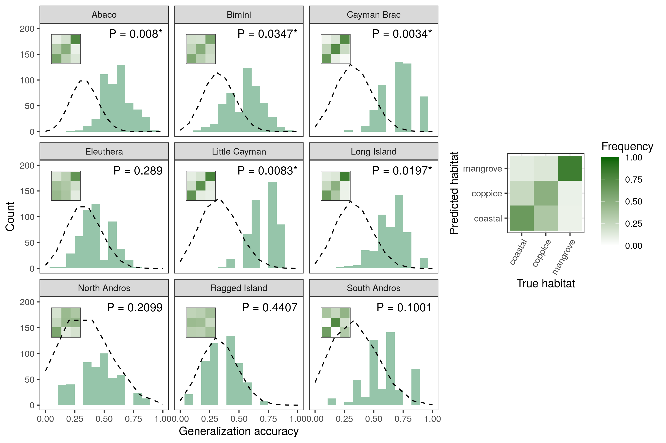
Figure 2: SVM classification accuracy across islands based on principal component data. Histograms show accuracy distributions over 100 replicates for each five cross-validation bins per island. The dashed line is the density of a corresponding null binomial distribution, which would be expected under random guessing (testing sets with 20% of the observations for each island and success probability of ). Inset plots show the corresponding average confusion matrices and represent the proportion of lizards from each habitat (columns) reassigned in each other habitat (rows), with an interpretation guide in the right panel. Binomial test P-values indicate deviations of the mean classification accuracy to the null distribution. *, P < 0.05.
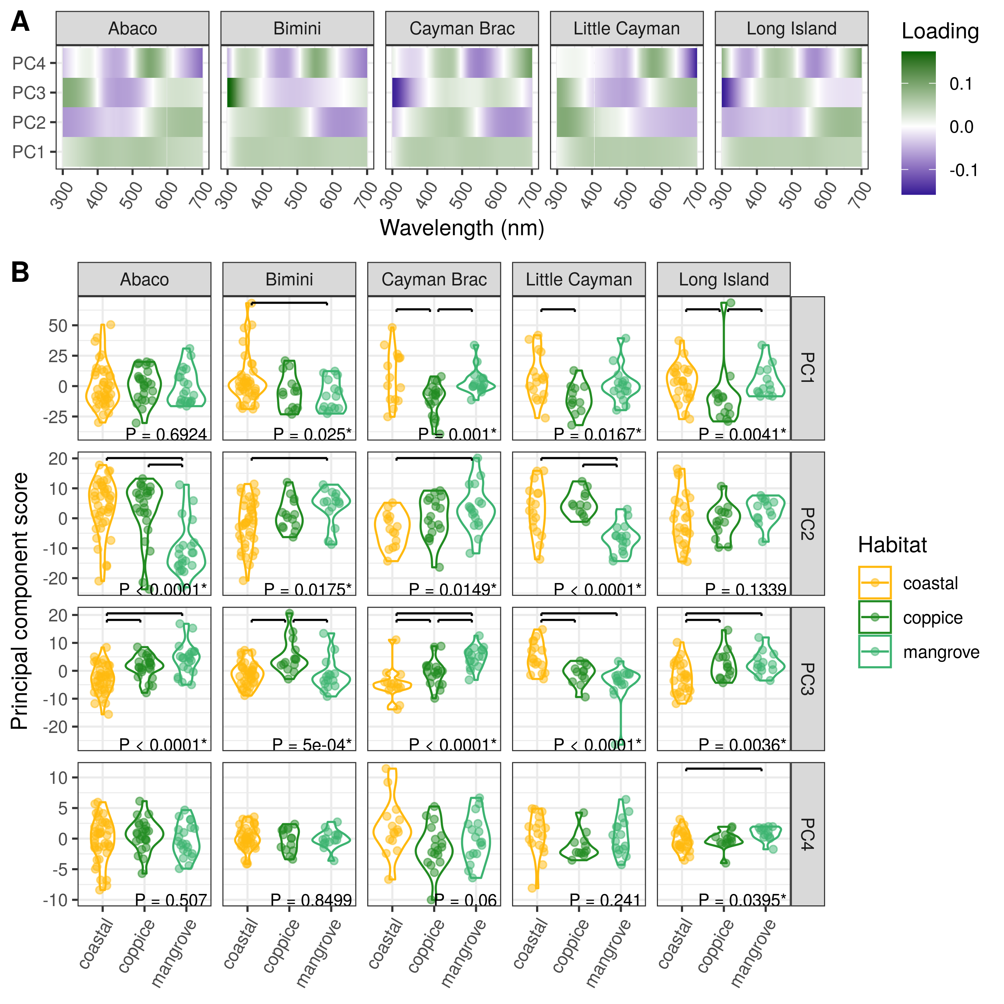
Figure 3: Dewlap color variation between habitat-types across the most significant islands. (A) Mapping of reflectance at various wavelengths onto the principal components (loadings from the PCA rotation matrix). (B) Distribution of PC scores between habitats along the first four PCs on each island where significant between-habitat differences were detected using SVMs. P-values are reported for univariate ANOVA (or Kruskal-Wallis tests when applicable, see Methods). Post hoc significant differences at a 0.05 error rate are indicated with horizontal bars. *, P < 0.05.

Tables
Island | Variable | Best fit | df | AICc | AICc | AICcw | df | Log-lik.
Abaco | PC1 | 1 | 4 | 710.4 | 0.0 | 0.746 | 2 | -357.0 | 0.14 | 0.9308
Abaco | PC2 | 1 | 4 | 620.1 | 0.0 | 0.882 | 2 | -310.2 | 31.74 | 0.0000 | ***
Abaco | PC3 | 1 | 4 | 517.8 | 0.0 | 0.732 | 2 | -257.2 | 27.37 | 0.0000 | ***
Abaco | PC4 | 1 | 4 | 440.6 | 0.0 | 0.596 | 2 | -217.2 | 1.36 | 0.5070
Bimini | PC1 | 1 | 4 | 561.3 | 0.0 | 0.595 | 2 | -283.1 | 7.40 | 0.0248 | *
Bimini | PC2 | 1 | 4 | 448.1 | 0.0 | 0.656 | 2 | -223.8 | 8.09 | 0.0175 | *
Bimini | PC3 | 2 | 6 | 405.3 | -0.2 | 0.529 | 2 | -199.2 | 10.39 | 0.0056 | **
Bimini | PC4 | 1 | 4 | 274.2 | 0.0 | 0.854 | 2 | -132.7 | 0.33 | 0.8499
Cayman Brac | PC1 | 2 | 6 | 402.8 | -4.1 | 0.884 | 2 | -200.9 | 13.81 | 0.0010 | **
Cayman Brac | PC2 | 1 | 4 | 332.1 | 0.0 | 0.853 | 2 | -165.9 | 8.41 | 0.0149 | *
Cayman Brac | PC3 | 1 | 4 | 295.8 | 0.0 | 0.800 | 2 | -146.6 | 27.16 | 0.0000 | ***
Cayman Brac | PC4 | 1 | 4 | 279.2 | 0.0 | 0.897 | 2 | -137.8 | 5.63 | 0.0600
Little Cayman | PC1 | 1 | 4 | 367.2 | 0.0 | 0.777 | 2 | -186.0 | 8.18 | 0.0167 | *
Little Cayman | PC2 | 2 | 6 | 287.6 | -3.6 | 0.859 | 2 | -140.5 | 29.76 | 0.0000 | ***
Little Cayman | PC3 | 1 | 4 | 277.7 | 0.0 | 0.669 | 2 | -138.1 | 21.34 | 0.0000 | ***
Little Cayman | PC4 | 1 | 4 | 226.7 | 0.0 | 0.780 | 2 | -110.7 | 2.85 | 0.2410
Long Island | PC1 | 2 | 6 | 442.3 | -2.1 | 0.740 | 2 | -221.2 | 2.91 | 0.2331
Long Island | PC2 | 2 | 6 | 351.4 | -3.1 | 0.823 | 2 | -172.6 | 4.52 | 0.1043
Long Island | PC3 | 1 | 4 | 322.1 | 0.0 | 0.862 | 2 | -160.0 | 11.24 | 0.0036 | **
Long Island | PC4 | 1 | 4 | 195.5 | 0.0 | 0.767 | 2 | -92.9 | 6.46 | 0.0395 | *
[tab:anova]

Supplementary Figures

Map of the sampling sites and corresponding habitats across nine islands of the West Indies.
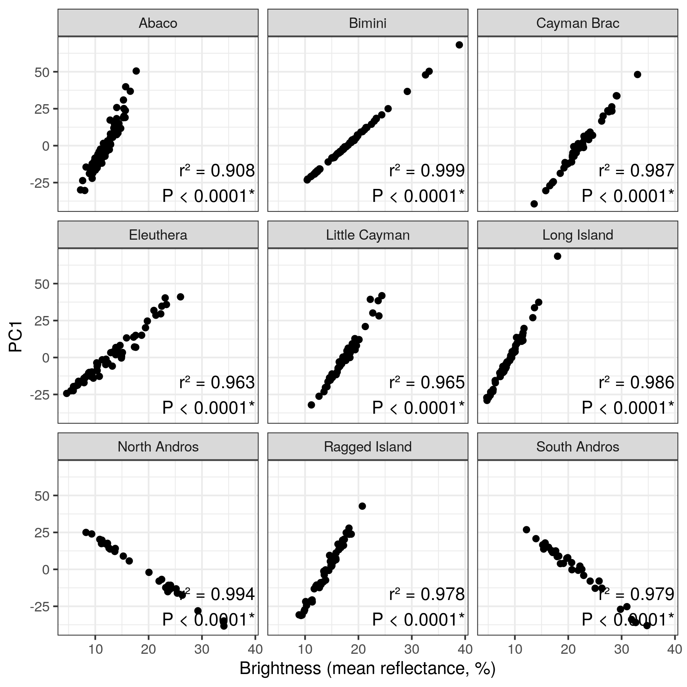
Correlation between dewlap brightness (as measured by the mean reflectance from 300 to 700nm in wavelength) and PC1 score for each island. Pearson’s squared correlation coefficients are reported. *, P < 0.05.
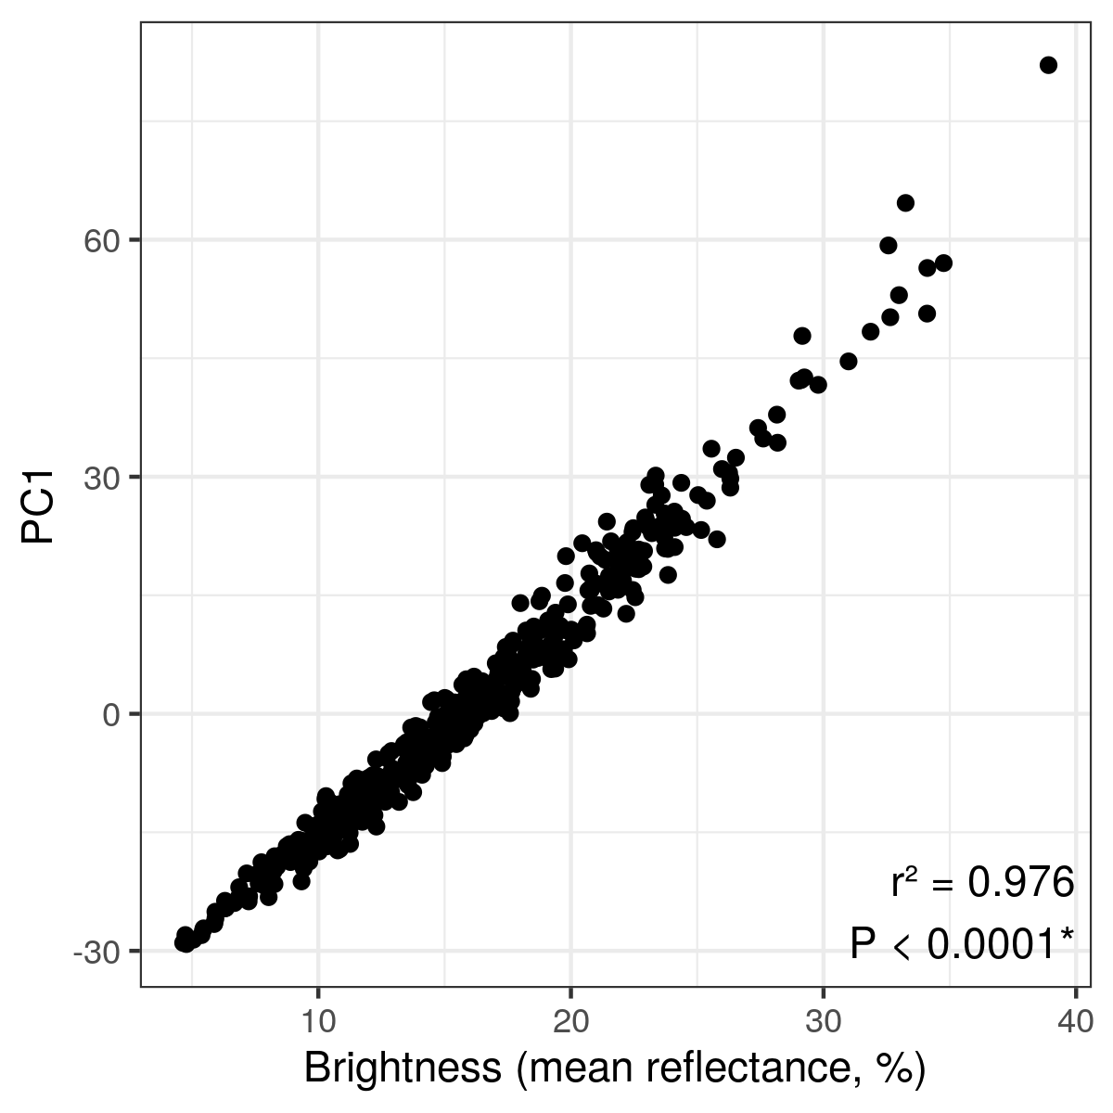
Correlation between dewlap brightness (as measured by the mean reflectance from 300 to 700nm in wavelength) and PC1 score across the whole archipelago. Pearson’s squared correlation coefficient is reported. *, P < 0.05.
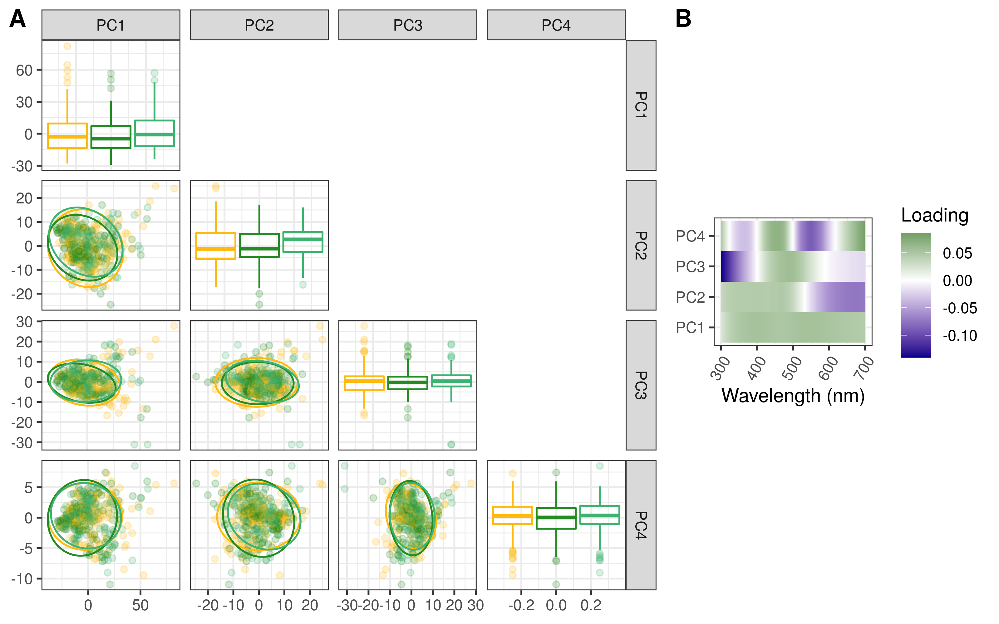
(A) Principal component scores and 5% confidence ellipses across habitats for the whole archipelago. The principal component analysis was performed on reflectance data from all islands pooled together. (B) PCA rotation matrix showing the loadings of each wavelength from 300 to 700nm onto the principal components.
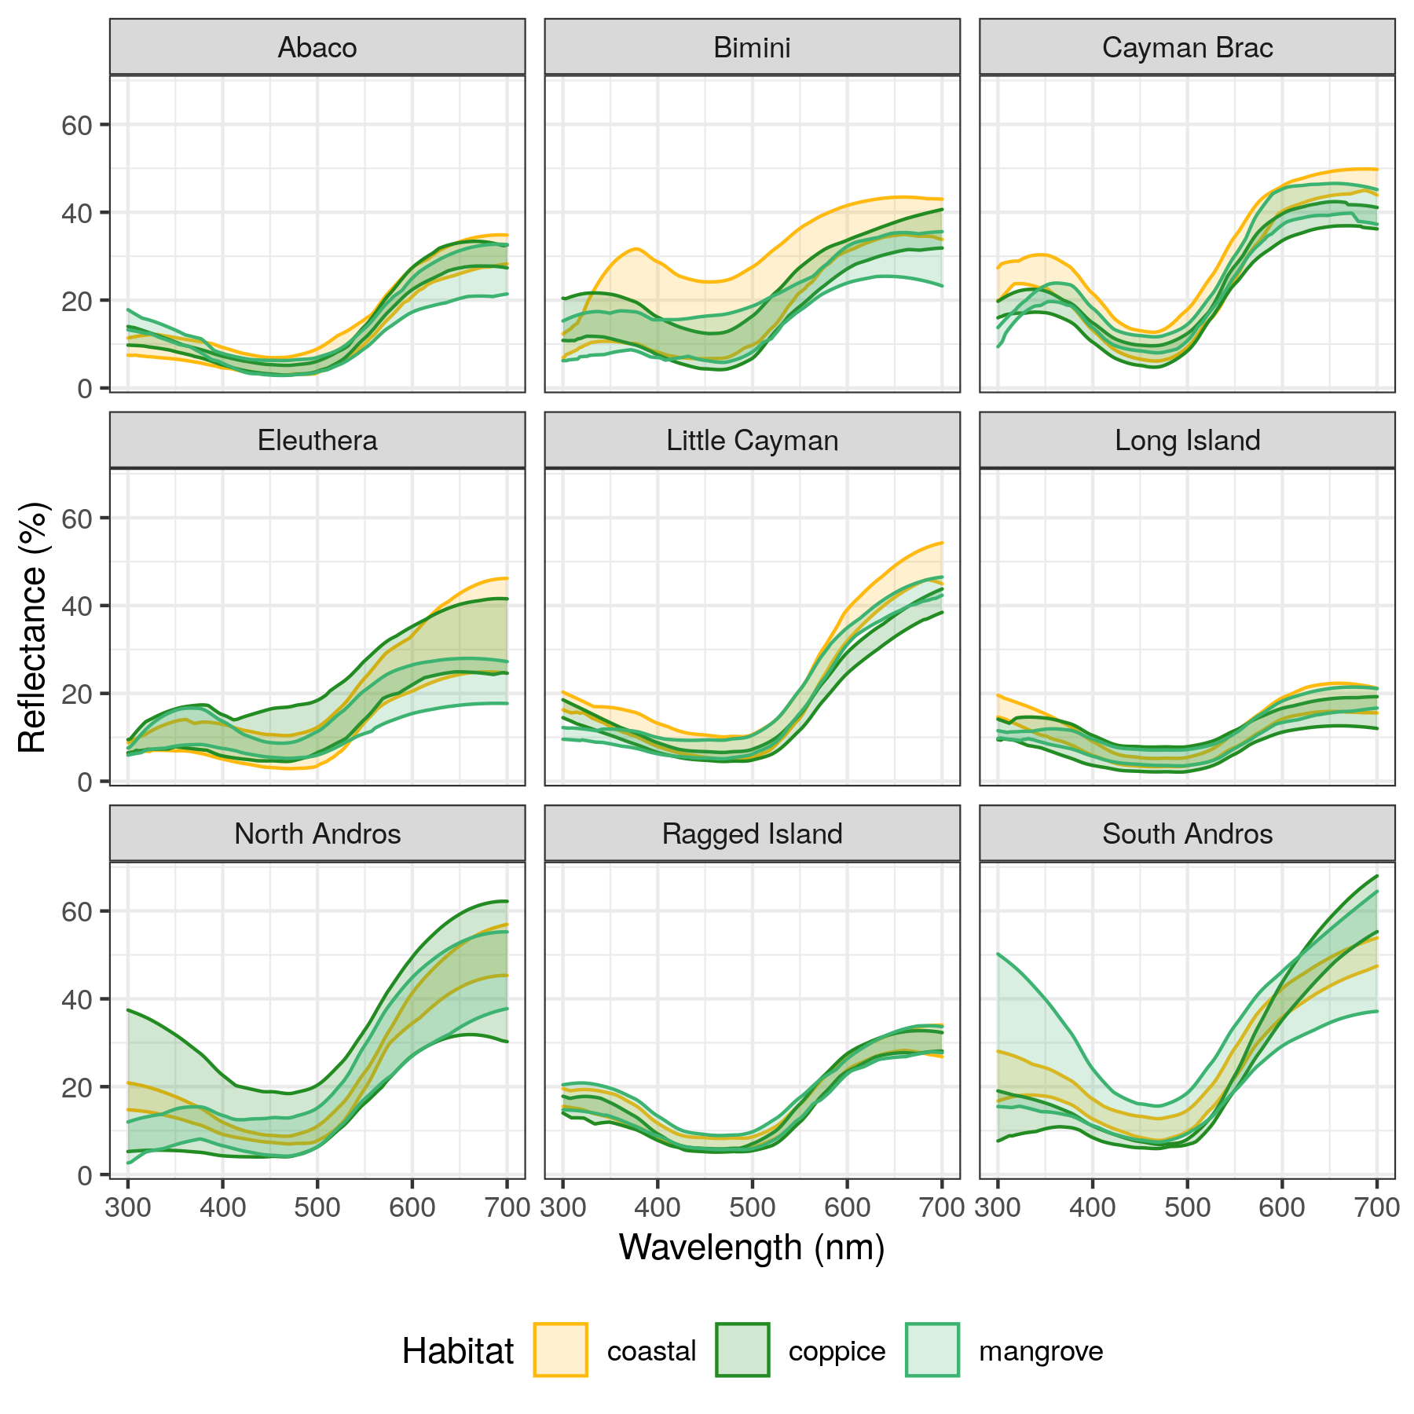
5-95th percentile range of lizard dewlap reflectance values (in % of incoming light) across wavelengths for each island and each habitat.
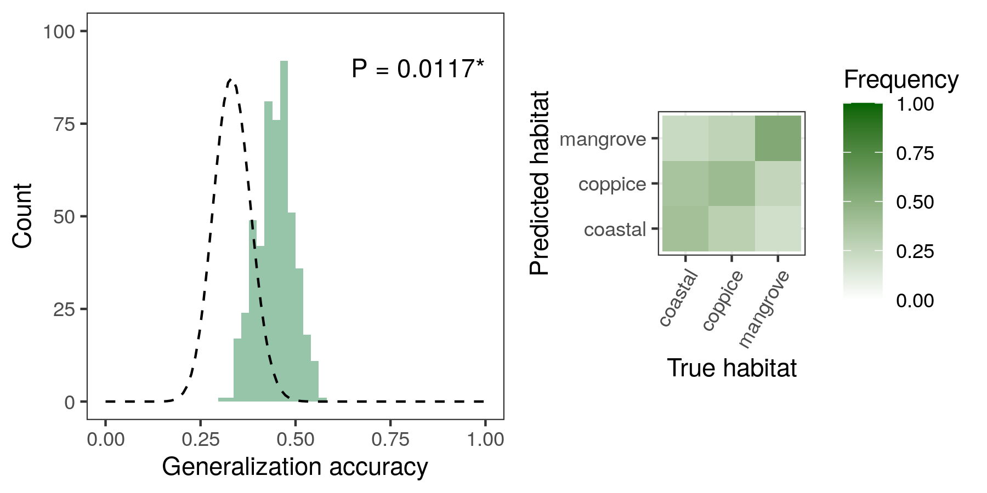
Archipelago-wide SVM classification accuracy based on principal component data. Machines were trained on individual dewlaps regardless of island identity. The histogram shows the accuracy distribution over 100 replicates for each five cross-validation bins. The legend is the same as in Figure 2.
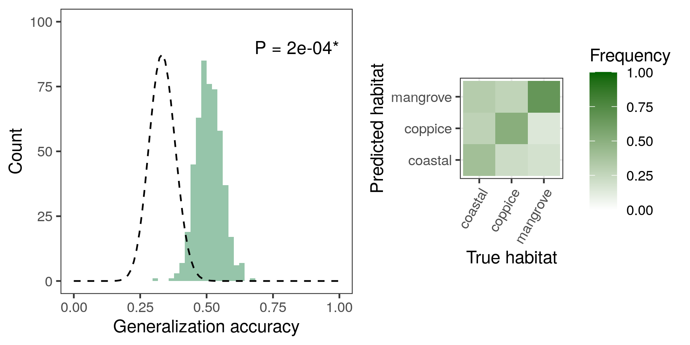
Archipelago-wide SVM classification accuracy based on reflectance data at 50nm-intervals in wavelength (see Methods). Machines were trained on individual dewlaps regardless of island identity. The histogram shows the accuracy distribution over 100 replicates for each five cross-validation bins. The legend is the same as in Figure 2.
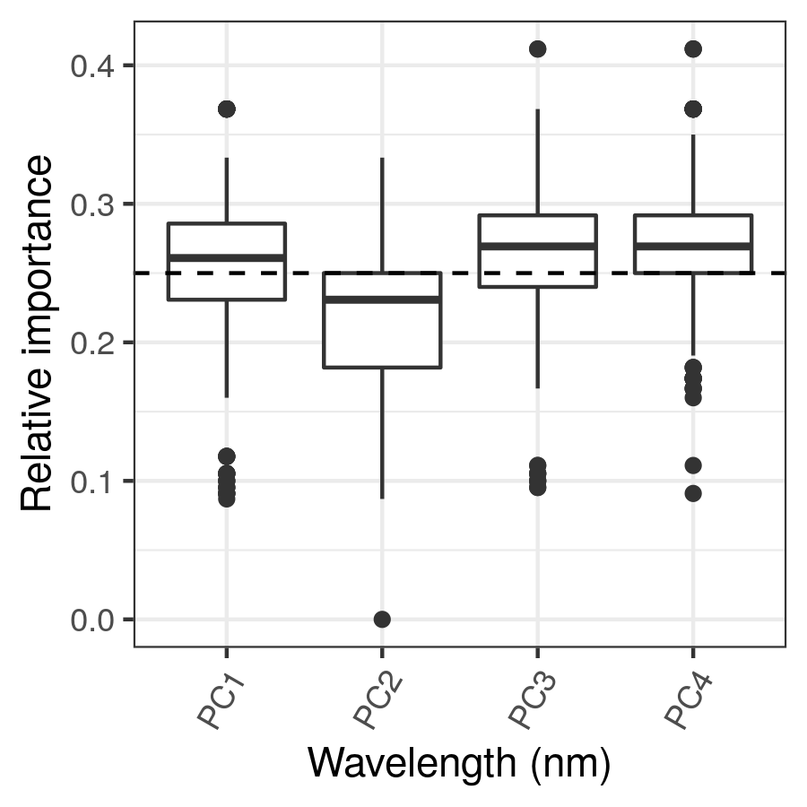
Sensitivity analyses of the different input variables in the archipelago-wide SVM classification on principal component data (Figure 9), with relative importance computed for every machine.
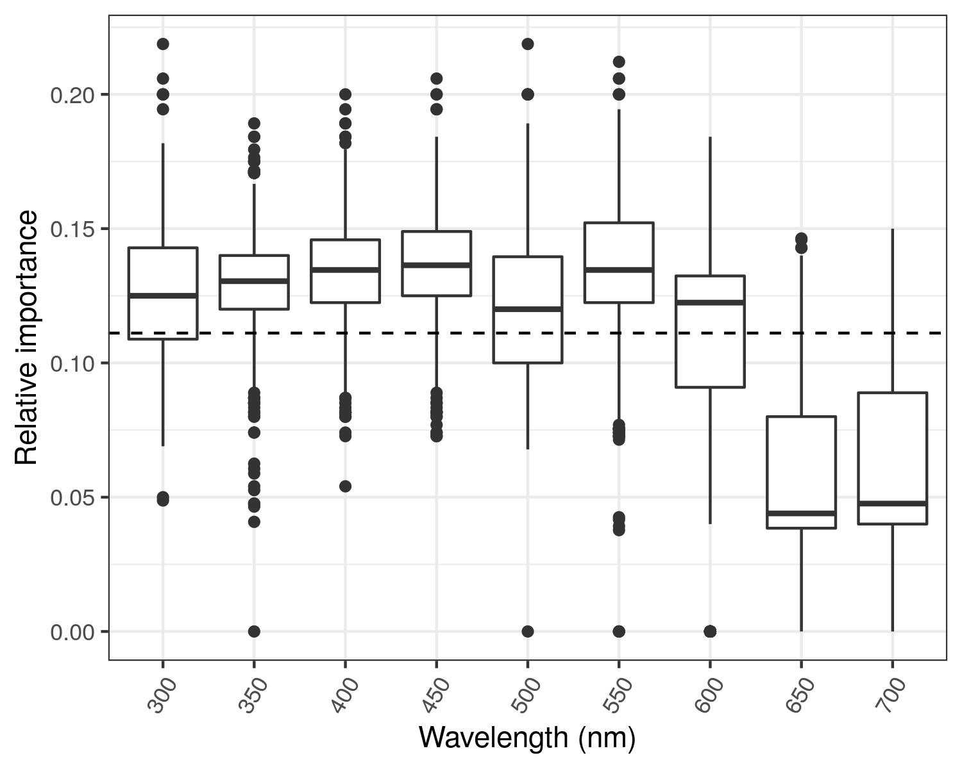
Sensitivity analyses of the different input variables in the archipelago-wide SVM classification on reflectance data at 50nm-intervals in wavelength (Figure 10), with relative importance computed for every machine.
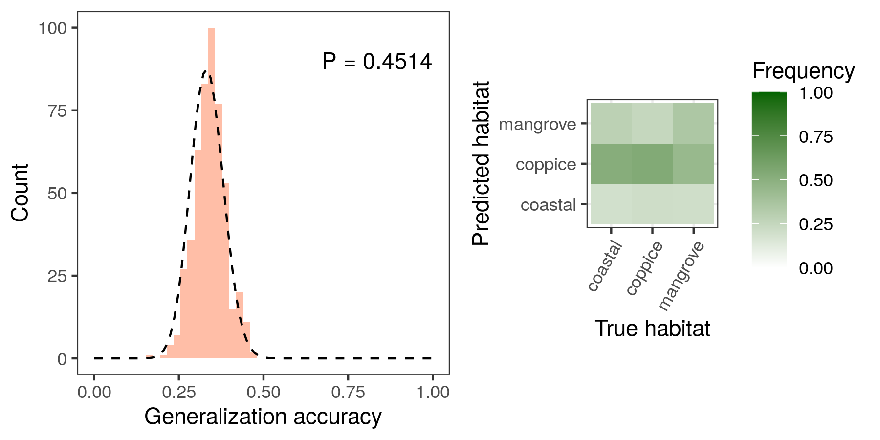
Archipelago-wide LDA classification accuracy based on principal component data. Machines were trained on individual dewlaps regardless of island identity. The histogram shows the accuracy distribution over 100 replicates for each five cross-validation bins. The legend is the same as in Figure 2.
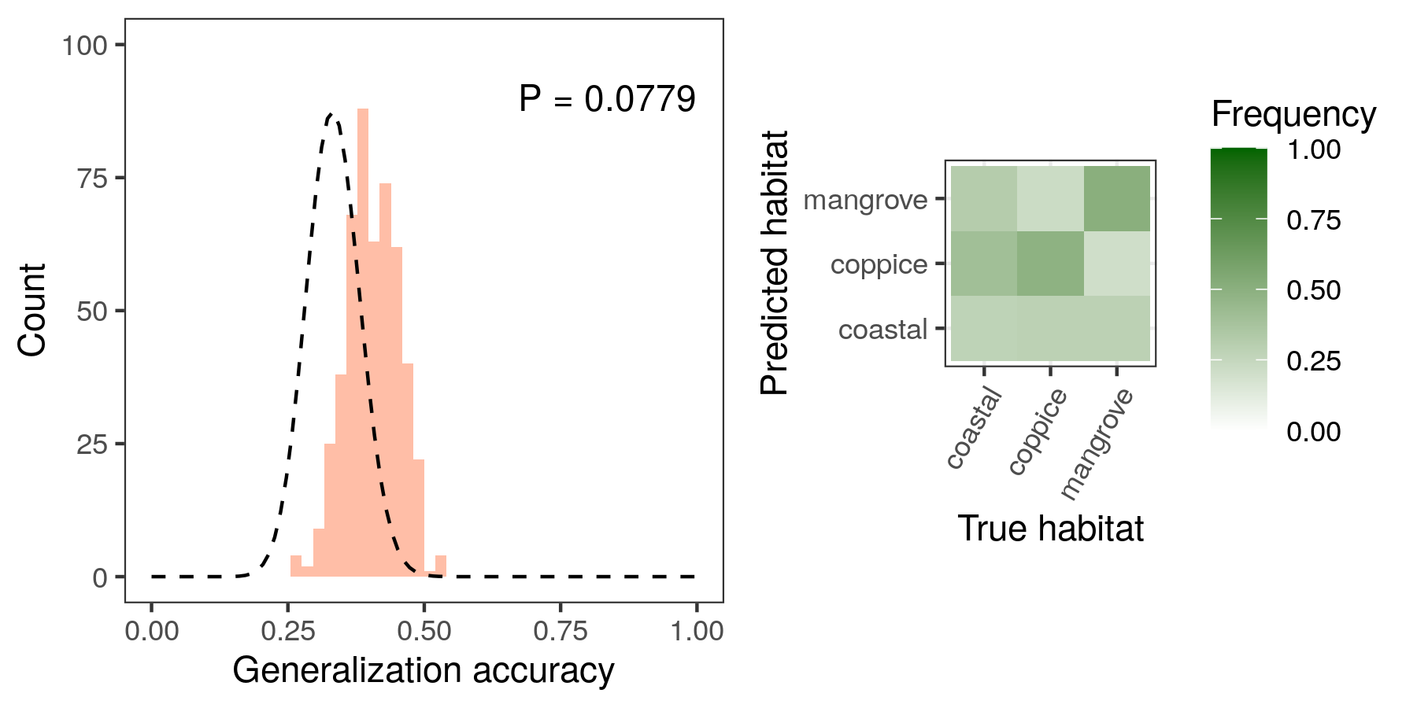
Archipelago-wide LDA classification accuracy based on reflectance data at 50nm-intervals in wavelength (see Methods). Machines were trained on individual dewlaps regardless of island identity. The histogram shows the accuracy distribution over 100 replicates for each five cross-validation bins. The legend is the same as in Figure 2.
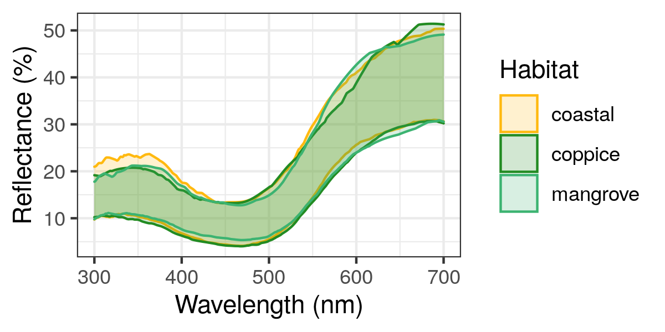
5-95th percentile range of lizard dewlap reflectance values (in % of incoming light) across wavelengths for each habitat throughout the whole archipelago.
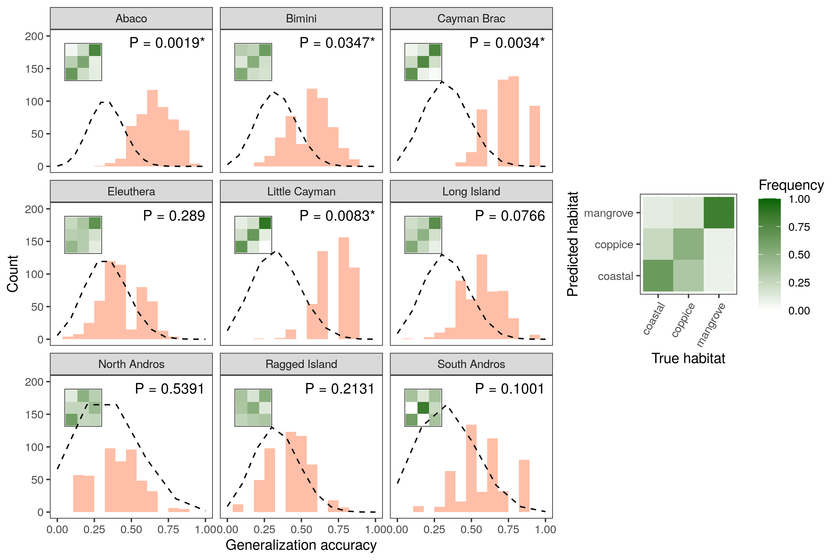
LDA classification accuracy across islands based on principal component data. Histograms show accuracy distributions over 100 replicates for each five cross-validation bins per island. The legend is the same as in Figure 2.
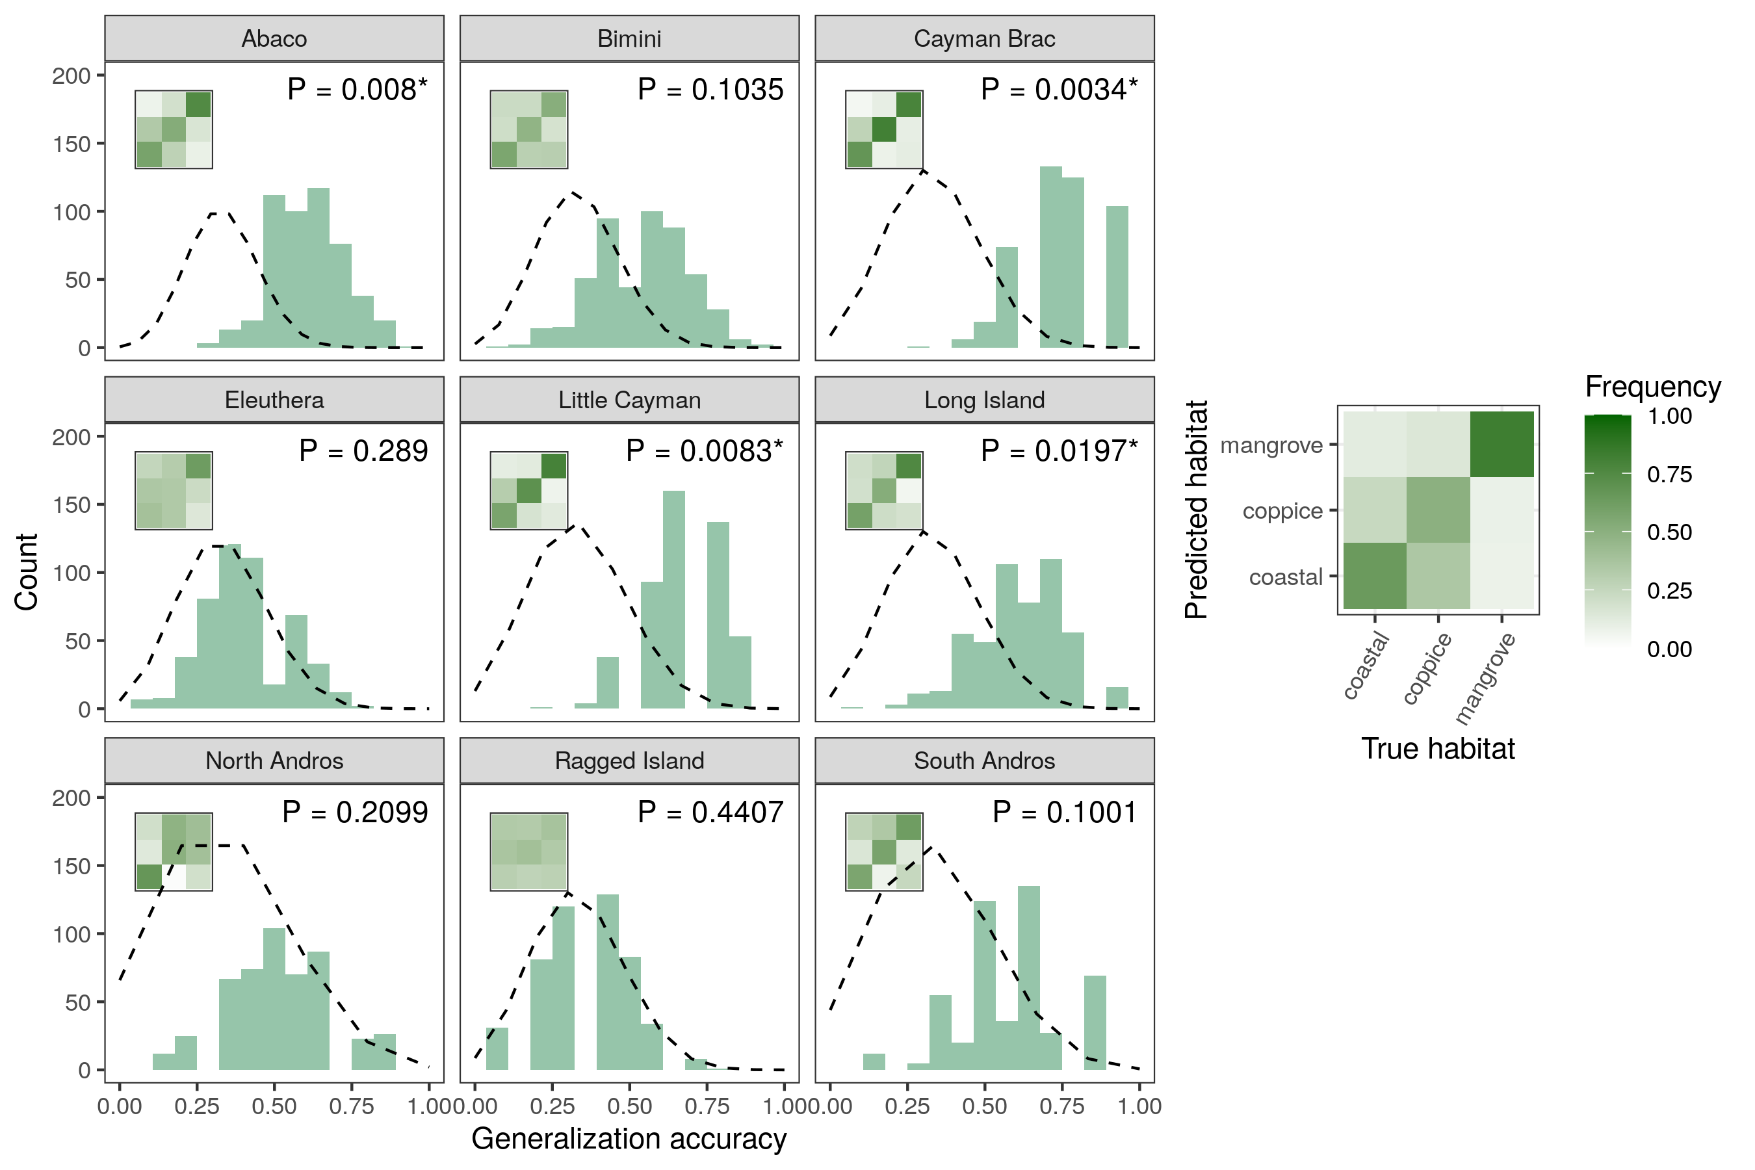
SVM classification accuracy across islands based on reflectance data at 50nm-intervals in wavelength (see Methods). Histograms show accuracy distributions over 100 replicates for each five cross-validation bins per island. The legend is the same as in Figure 2.
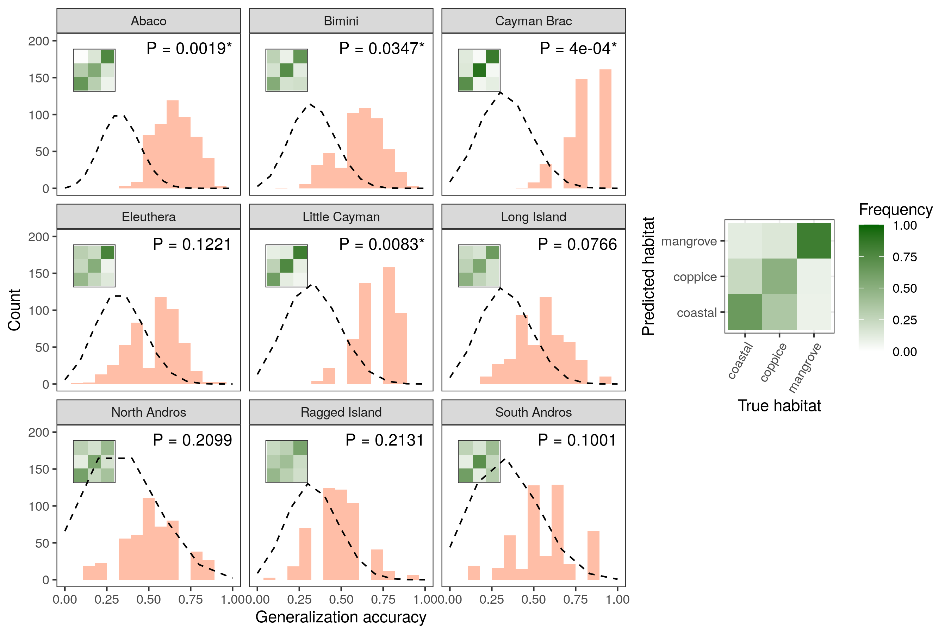
LDA classification accuracy across islands based on reflectance data at 50nm-intervals in wavelength (see Methods). Histograms show accuracy distributions over 100 replicates for each five cross-validation bins per island. The legend is the same as in Figure 2.
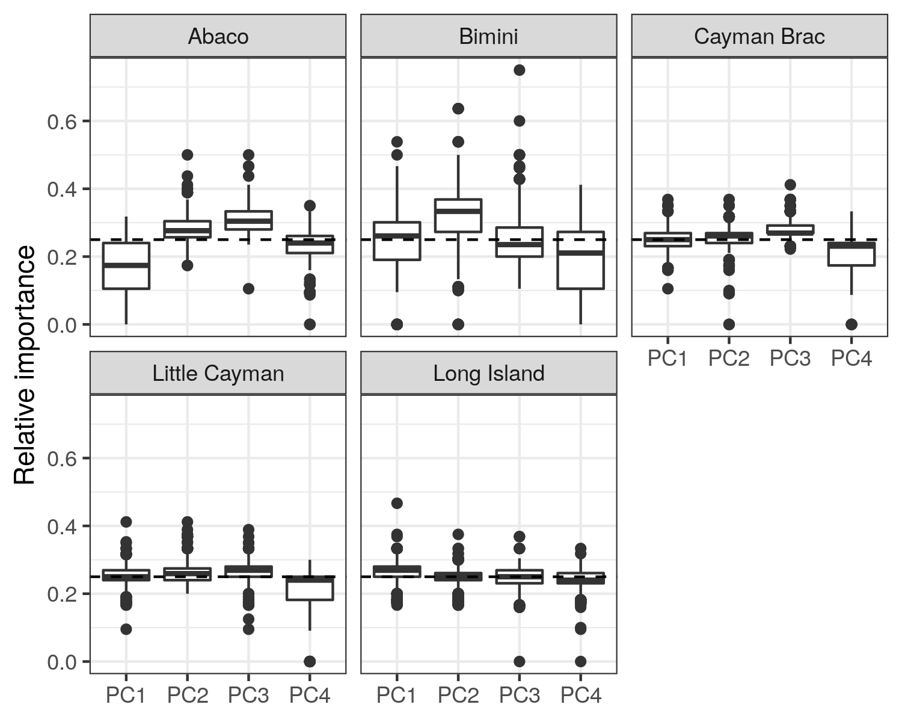
Sensitivity analyses of the different input variables in the within-island SVM classification on principal component data (Figure [supfig:classif-svm-pca]), with relative importance computed for every machine.
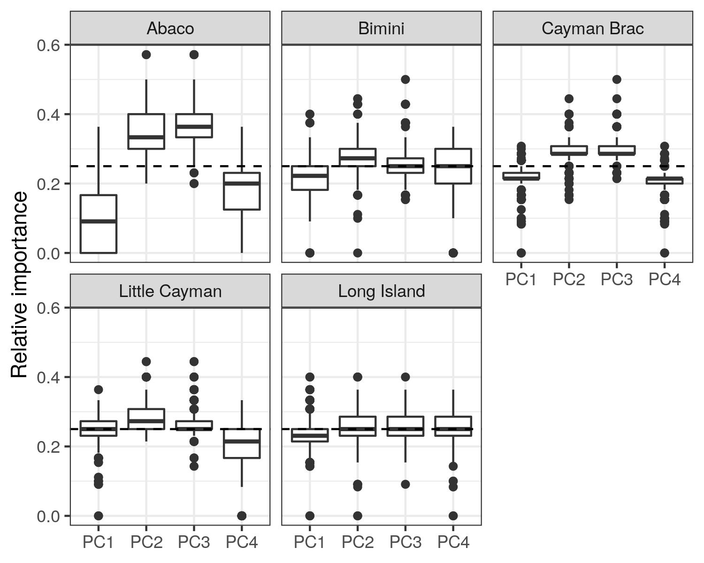
Sensitivity analyses of the different input variables in the within-island LDA classification on principal component data (Figure 16), with relative importance computed for every machine.
Sensitivity analyses of the different input variables in the archipelago-wide SVM classification on reflectance at 50nm-intervals in wavelength (Figure 17), with relative importance computed for every machine.
Sensitivity analyses of the different input variables in the archipelago-wide LDA classification on reflectance at 50nm-intervals in wavelength (Figure 18), with relative importance computed for every machine.
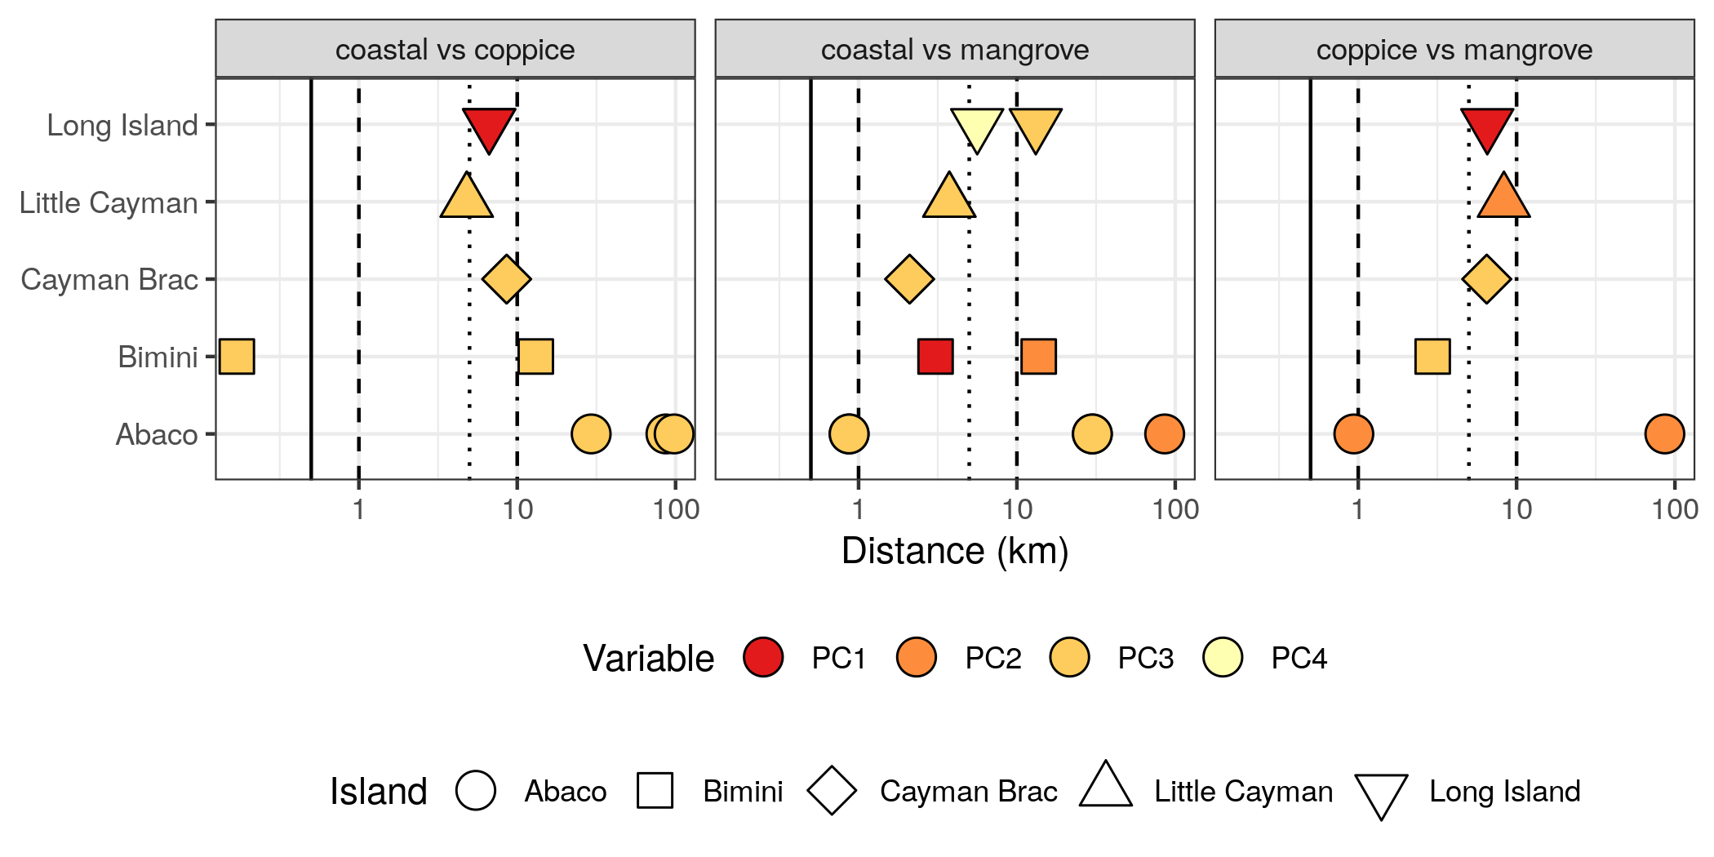
Spatial scale of between-habitat differences in dewlap coloration. For each variable and each pair of habitats where significant differences were detected (Figure 3), we performed multiple post hoc pairwise comparisons between the sites involved (Figure 4, Table 2), using nonparametric Wilcoxon-Mann-Whitney tests. Here we report, for each pair of habitats, the distances between sites that significantly differed in dewlap coloration at an error rate of 0.05 (P-values corrected with the Benjamini-Hochberg procedure for multiple testing).
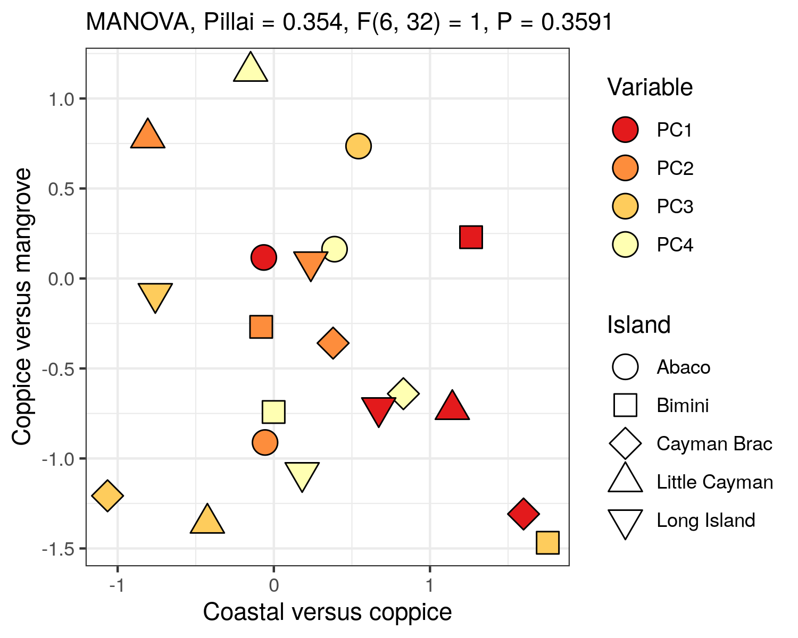
Test of parallel divergence between islands. Differences in habitat-means, or contrasts, are shown for two pairs of habitats for each principal component on each island, rescaled so the standard deviation of the means along each principal component is one. The contrasts represent the patterns of between-habtiat variation on each island, for a given principal component. The absence of clustering of islands by variable indicates that islands differ in their between-habitat divergence patterns. This is confirmed by a non-significant MANOVA test of the between versus within-variable variance in contrasts.

Supplementary Tables
Number of lizards sampled in each habitat on each island.
 | coastal | coppice | mangrove
Abaco | 41 | 24 | 21
Bimini | 38 | 14 | 15
Cayman Brac | 15 | 18 | 17
Eleuthera | 22 | 25 | 9
Little Cayman | 17 | 12 | 16
Long Island | 26 | 14 | 13
North Andros | 9 | 9 | 10
Ragged Island | 18 | 15 | 17
South Andros | 10 | 9 | 12
[suptab:counts]
Locations of the sampling sites across islands, with mean principal component scores per site.
Island | Longitude | Latitude | Habitat | PC1 | PC2 | PC3 | PC4
Abaco | -77.7256 | 26.9083 | mangrove | -5.4905 | 1.3541 | -0.4741 | 0.0083
Abaco | -77.5800 | 26.9020 | coastal | 1.8633 | 0.0365 | -0.4475 | 0.0033
Abaco | -77.5763 | 26.9128 | coppice | -1.6738 | -1.7793 | -0.0499 | 0.0012
Abaco | -77.1784 | 26.1045 | coastal | 1.1863 | 2.0408 | -0.3468 | 0.0022
Abaco | -77.0055 | 26.3254 | mangrove | -9.0319 | -2.7460 | 0.4687 | 0.0077
Abaco | -77.0039 | 26.3170 | coppice | 0.9967 | 0.5161 | -0.0267 | -0.0118
Abaco | -76.9968 | 26.3260 | coastal | 7.6077 | 0.3186 | 0.1771 | -0.0008
Bimini | -79.3022 | 25.5859 | coastal | 5.7537 | -0.1593 | -0.2505 | 0.0001
Bimini | -79.3014 | 25.7052 | coastal | -3.1822 | 1.6617 | -0.0460 | 0.0024
Bimini | -79.3002 | 25.7042 | coppice | -1.3514 | -3.8786 | 0.1027 | -0.0027
Bimini | -79.2709 | 25.7066 | mangrove | 3.3656 | 0.6244 | 0.1569 | -0.0021
Cayman Brac | -79.8627 | 19.6878 | coastal | 6.6606 | -2.5670 | 0.0166 | -0.0007
Cayman Brac | -79.8441 | 19.6949 | mangrove | -1.0914 | 4.3607 | 0.0855 | 0.0001
Cayman Brac | -79.7887 | 19.7209 | coppice | -4.5197 | -1.9793 | -0.0946 | 0.0004
Eleuthera | -76.3347 | 24.8146 | coppice | 3.2669 | -1.2404 | 0.1018 | -0.0085
Eleuthera | -76.3058 | 24.8127 | coastal | 0.4216 | -3.5133 | -0.0567 | 0.0009
Eleuthera | -76.2901 | 24.7981 | mangrove | 2.1881 | 0.7517 | 0.3957 | -0.0055
Eleuthera | -76.1616 | 24.9129 | coppice | -1.9136 | 1.0868 | -0.4978 | -0.0092
Eleuthera | -76.1492 | 24.9335 | coastal | -3.1863 | 2.4270 | 0.1881 | 0.0218
Little Cayman | -80.0660 | 19.6906 | coppice | 0.8021 | -1.9569 | -0.0760 | -0.0068
Little Cayman | -80.0205 | 19.6865 | coastal | -6.6917 | -1.2615 | 0.0659 | 0.0057
Little Cayman | -79.9871 | 19.6986 | mangrove | 6.5083 | 2.8079 | -0.0129 | -0.0010
Long Island | -75.2299 | 23.4740 | mangrove | -1.2873 | 1.9371 | -0.1880 | -0.0029
Long Island | -75.2063 | 23.4282 | coastal | 2.3686 | -0.9033 | 0.0215 | 0.0096
Long Island | -75.1884 | 23.4292 | coppice | -4.6266 | 0.5060 | 0.1049 | -0.0070
Long Island | -75.1408 | 23.3883 | coastal | 3.6139 | -1.4521 | 0.0475 | 0.0025
North Andros | -77.8908 | 24.8391 | coastal | -2.1881 | -1.1236 | 0.0397 | -0.0060
North Andros | -77.8428 | 24.7516 | coppice | -1.8115 | 0.0012 | -0.1678 | 0.0024
North Andros | -77.7540 | 24.6644 | mangrove | 3.5997 | 1.0101 | 0.1153 | 0.0033
Ragged Island | -75.7364 | 22.1768 | coppice | 3.2851 | -0.3274 | 0.1911 | -0.0013
Ragged Island | -75.7314 | 22.2097 | coastal | -0.6412 | -0.8878 | -0.1293 | -0.0033
Ragged Island | -75.7276 | 22.2045 | mangrove | -2.9188 | 1.5792 | -0.0034 | 0.0099
Ragged Island | -75.7270 | 22.1973 | mangrove | -1.2210 | 0.7285 | -0.0721 | -0.0028
South Andros | -77.6050 | 24.2027 | mangrove | -3.9253 | 0.4734 | 0.0477 | -0.0005
South Andros | -77.5936 | 24.1289 | coppice | 6.1152 | -0.4925 | 0.0349 | 0.0012
South Andros | -77.5453 | 24.0764 | coastal | -0.7933 | -0.1248 | -0.0887 | -0.0004
[suptab:sites]
Proportion of variance explained by the first four principal components on each island, as well as across the whole archipelago.
Island | PC1 | PC2 | PC3 | PC4 | Total
Abaco | 0.400 | 0.279 | 0.147 | 0.079 | 0.906
Bimini | 0.502 | 0.208 | 0.160 | 0.051 | 0.921
Cayman Brac | 0.438 | 0.190 | 0.155 | 0.105 | 0.888
Eleuthera | 0.490 | 0.233 | 0.138 | 0.066 | 0.926
Little Cayman | 0.441 | 0.212 | 0.176 | 0.078 | 0.907
Long Island | 0.515 | 0.205 | 0.161 | 0.043 | 0.925
North Andros | 0.560 | 0.170 | 0.152 | 0.054 | 0.937
Ragged Island | 0.483 | 0.226 | 0.127 | 0.072 | 0.907
South Andros | 0.488 | 0.247 | 0.146 | 0.067 | 0.948
Archipelago | 0.473 | 0.197 | 0.164 | 0.079 | 0.913
[suptab:pcavariances]
Pearson’s correlation test between dewlap brightness, as measured by the average reflectance between 300 and 700nm in wavelength, and PC1 scores, for all islands and across the whole archipelago. ***, P < 0.001.
Island
Abaco | 0.908 | < 0.0001 | ***
Bimini | 0.999 | < 0.0001 | ***
Cayman Brac | 0.987 | < 0.0001 | ***
Eleuthera | 0.963 | < 0.0001 | ***
Little Cayman | 0.965 | < 0.0001 | ***
Long Island | 0.986 | < 0.0001 | ***
North Andros | 0.994 | < 0.0001 | ***
Ragged Island | 0.978 | < 0.0001 | ***
South Andros | 0.979 | < 0.0001 | ***
Archipelago | 0.976 | < 0.0001 | ***
[suptab:brightness]
Henze-Zirkler’s test of multivariate normality, performed on principal components in each habitat and on each island. HZ, test statistic. *, P < 0.05; **, P < 0.01; ***, P < 0.001.
Island | Habitat
Abaco | coastal | 1.10 | 0.0027 | **
Abaco | coppice | 1.07 | 0.0022 | **
Abaco | mangrove | 1.06 | 0.0023 | **
Bimini | coastal | 1.28 | 0.0001 | ***
Bimini | coppice | 0.85 | 0.0482 | *
Bimini | mangrove | 1.19 | 0.0001 | ***
Cayman Brac | coastal | 0.65 | 0.5311
Cayman Brac | coppice | 0.70 | 0.3940
Cayman Brac | mangrove | 0.66 | 0.5357
Eleuthera | coastal | 1.61 | 0.0000 | ***
Eleuthera | coppice | 1.48 | 0.0000 | ***
Eleuthera | mangrove | 0.73 | 0.1423
Little Cayman | coastal | 0.62 | 0.6599
Little Cayman | coppice | 0.64 | 0.4867
Little Cayman | mangrove | 0.87 | 0.0413 | *
Long Island | coastal | 0.82 | 0.1468
Long Island | coppice | 0.92 | 0.0150 | *
Long Island | mangrove | 0.77 | 0.1289
North Andros | coastal | 0.66 | 0.3174
North Andros | coppice | 0.76 | 0.0900
North Andros | mangrove | 0.67 | 0.3185
Ragged Island | coastal | 0.76 | 0.2268
Ragged Island | coppice | 0.80 | 0.1115
Ragged Island | mangrove | 0.54 | 0.9022
South Andros | coastal | 0.66 | 0.3451
South Andros | coppice | 0.66 | 0.3154
South Andros | mangrove | 0.91 | 0.0144 | *
[suptab:multinorm]
Box’s M-test of homogeneity of covariance matrices across habitats on each island. , test statistic. *, P < 0.05; **, P < 0.01; ***, P < 0.001.
Island |  | df
Abaco | 47.1 | 20 | 0.0006 | ***
Bimini | 36.0 | 20 | 0.0152 | *
Cayman Brac | 36.9 | 20 | 0.0120 | *
Eleuthera | 44.6 | 20 | 0.0013 | **
Little Cayman | 32.8 | 20 | 0.0356 | *
Long Island | 56.2 | 20 | 0.0000 | ***
North Andros | 33.7 | 20 | 0.0283 | *
Ragged Island | 29.3 | 20 | 0.0824
South Andros | 46.5 | 20 | 0.0007 | ***
[suptab:covariance]
Shapiro-Wilk’s test of univariate normality performed on each island where significant differences were detected by SVM classification, in each habitat where deviations from multivariate normality were detected. , test statistic. *, P < 0.05; **, P < 0.01; ***, P < 0.001.
Island | Habitat | Variable
Abaco | coastal | PC1 | 0.954 | 0.0941
Abaco | coastal | PC2 | 0.927 | 0.0112 | *
Abaco | coastal | PC3 | 0.973 | 0.4228
Abaco | coastal | PC4 | 0.955 | 0.1027
Abaco | coppice | PC1 | 0.970 | 0.6776
Abaco | coppice | PC2 | 0.816 | 0.0005 | ***
Abaco | coppice | PC3 | 0.930 | 0.0976
Abaco | coppice | PC4 | 0.941 | 0.1711
Abaco | mangrove | PC1 | 0.881 | 0.0155 | *
Abaco | mangrove | PC2 | 0.869 | 0.0093 | **
Abaco | mangrove | PC3 | 0.986 | 0.9873
Abaco | mangrove | PC4 | 0.939 | 0.2044
Bimini | coastal | PC1 | 0.821 | 0.0000 | ***
Bimini | coastal | PC2 | 0.960 | 0.1854
Bimini | coastal | PC3 | 0.856 | 0.0002 | ***
Bimini | coastal | PC4 | 0.945 | 0.0611
Bimini | coppice | PC1 | 0.911 | 0.1648
Bimini | coppice | PC2 | 0.958 | 0.6927
Bimini | coppice | PC3 | 0.953 | 0.6146
Bimini | coppice | PC4 | 0.971 | 0.8953
Bimini | mangrove | PC1 | 0.884 | 0.0536
Bimini | mangrove | PC2 | 0.976 | 0.9363
Bimini | mangrove | PC3 | 0.982 | 0.9805
Bimini | mangrove | PC4 | 0.975 | 0.9232
Eleuthera | coastal | PC1 | 0.909 | 0.0461 | *
Eleuthera | coastal | PC2 | 0.886 | 0.0157 | *
Eleuthera | coastal | PC3 | 0.906 | 0.0390 | *
Eleuthera | coastal | PC4 | 0.962 | 0.5293
Eleuthera | coppice | PC1 | 0.922 | 0.0567
Eleuthera | coppice | PC2 | 0.954 | 0.3055
Eleuthera | coppice | PC3 | 0.781 | 0.0001 | ***
Eleuthera | coppice | PC4 | 0.901 | 0.0188 | *
Little Cayman | mangrove | PC1 | 0.907 | 0.1024
Little Cayman | mangrove | PC2 | 0.904 | 0.0924
Little Cayman | mangrove | PC3 | 0.739 | 0.0005 | ***
Little Cayman | mangrove | PC4 | 0.973 | 0.8802
Long Island | coppice | PC1 | 0.686 | 0.0003 | ***
Long Island | coppice | PC2 | 0.848 | 0.0210 | *
Long Island | coppice | PC3 | 0.931 | 0.3188
Long Island | coppice | PC4 | 0.904 | 0.1280
South Andros | mangrove | PC1 | 0.787 | 0.0067 | **
South Andros | mangrove | PC2 | 0.861 | 0.0500 | *
South Andros | mangrove | PC3 | 0.697 | 0.0008 | ***
South Andros | mangrove | PC4 | 0.950 | 0.6411
[suptab:normality]
Univariate ANOVAs performed on each principal component across the whole archipelago. Legend is the same as for Table [tab:anova], except that best fitting models 3 and 4 refer to the mixed effect equivalents to the OLS and GLS model, with island as a random effect (see Methods).
Variable | Best fit | df | AICc | AICc | AICcw | df | Log-lik.
PC1 | 3 | 5 | 3749.9 | -228.3 | 0.613 | 2 | -1874.7 | 8.69 | 0.0130 | *
PC2 | 4 | 7 | 3002.2 | -162.3 | 0.976 | 2 | -1496.2 | 17.76 | 0.0001 | ***
PC3 | 4 | 7 | 2826.3 | -175.4 | 0.968 | 2 | -1407.8 | 7.03 | 0.0298 | *
PC4 | 4 | 7 | 2015.7 | -305.8 | 0.519 | 2 | -1000.1 | 0.47 | 0.7914
[suptab:anova-pooled]
Mean SVM classification accuracy per island, over all replicates and cross-validation bins. , number of observations per island; , proportion of the data sampled to form the training set; , number of observations in the testing set. P-values indicate deviations from the expected null binomial distribution, with events per island and random guess success probability . *, P < 0.05, **, P < 0.01, ***, P < 0.001.
Island | Accuracy
Abaco | 0.612 | 86 | 0.2 | 17 | 0.0080 | **
Bimini | 0.547 | 67 | 0.2 | 13 | 0.0347 | *
Cayman Brac | 0.721 | 50 | 0.2 | 10 | 0.0034 | **
Eleuthera | 0.437 | 56 | 0.2 | 11 | 0.2890
Little Cayman | 0.734 | 45 | 0.2 | 9 | 0.0083 | **
Long Island | 0.651 | 53 | 0.2 | 10 | 0.0197 | *
North Andros | 0.453 | 28 | 0.2 | 5 | 0.2099
Ragged Island | 0.364 | 50 | 0.2 | 10 | 0.4407
South Andros | 0.600 | 31 | 0.2 | 6 | 0.1001
[suptab:classif-svm-pca]
Results of nonparametric Kruskal-Wallis tests performed on each variable on each island where deviations from normality were detected.
Island | Variable |  | df
Abaco | PC1 | 0.74 | 2 | 0.6924
Abaco | PC2 | 23.13 | 2 | 0.0000 | ***
Bimini | PC1 | 7.38 | 2 | 0.0250 | *
Bimini | PC3 | 15.17 | 2 | 0.0005 | ***
Little Cayman | PC3 | 19.95 | 2 | 0.0000 | ***
Long Island | PC1 | 10.98 | 2 | 0.0041 | **
Long Island | PC2 | 4.02 | 2 | 0.1339
[suptab:kruskal]
Individual-based permutation tests of spatial autocorrelation within islands. P-values were computed from 1,000 permutations of individual site-labels. Pearson’s coefficient measures the correlation between distances in color space and geodesic distances among the sites. , number of sites. *, P < 0.05.
Island
Abaco | -0.213 | 0.817 | 7
Bimini | 0.044 | 0.510 | 4
Cayman Brac | -0.010 | 0.465 | 3
Eleuthera | 0.816 | 0.015 | 5 | *
Little Cayman | -0.688 | 0.684 | 3
Long Island | -0.189 | 0.579 | 4
North Andros | 0.730 | 0.199 | 3
Ragged Island | 0.706 | 0.114 | 4
South Andros | -0.852 | 0.776 | 3
[suptab:autocor]
Andersson, M.B. 1994. Sexual selection. Princeton University Press, Princeton, N.J.
Arnold, S.J. 1983. Morphology, Performance and Fitness. American Zoologist 23: 347–361.
Baeckens, S., Driessens, T. & Van Damme, R. 2018. The brown anole dewlap revisited: Do predation pressure, sexual selection, and species recognition shape among-population signal diversity? PeerJ 6: e4722.
Bartoń, K. 2019. MuMIn: Multi-Model Inference.
Benjamini, Y. & Hochberg, Y. 1995. Controlling the false discovery rate: A practical and powerful approach to multiple testing. Journal of the Royal Statistical Society Series B 57: 289–300.
Box, G.E.P. 1949. A General Distribution Theory for a Class of Likelihood Criteria. Biometrika 36: 317.
Bradbury, J.W. & Vehrencamp, S.L. 2011. Principles of animal communication, 2nd ed. Sinauer Associates, Sunderland, Mass.
Cook, E.G., Murphy, T.G. & Johnson, M.A. 2013. Colorful displays signal male quality in a tropical anole lizard. Naturwissenschaften 100: 993–996.
Cortes, C. & Vapnik, V. 1995. Support-vector networks. Machine Learning 20: 273–297.
Cortez, P. 2010. Data Mining with Neural Networks and Support Vector Machines Using the R/rminer Tool. In: Advances in Data Mining - Applications and Theoretical Aspects 10th Industrial Conference on Data Mining (ICDM 2010), Lecture Notes in Artificial Intelligence 6171 (P. Perner, ed), pp. 572–583. Springer, Berlin.
Cortez, P. 2016. Rminer: Data Mining Classification and Regression Methods.
Cortez, P. & Embrechts, M.J. 2013. Using sensitivity analysis and visualization techniques to open black box data mining models. Information Sciences 225: 1–17.
Cox, R.M., Costello, R.A., Camber, B.E. & McGlothlin, J.W. 2017. Multivariate genetic architecture of the Anolis dewlap reveals both shared and sex-specific features of a sexually dimorphic ornament. Journal of Evolutionary Biology 30: 1262–1275.
Cristianini, N. & Shawe-Taylor, J. 2000. An Introduction to Support Vector Machines and Other Kernel-based Learning Methods, First. Cambridge University Press.
Cuthill, I.C., Bennett, A.T.D., Partridge, J.C. & Maier, E.J. 1999. Plumage Reflectance and the Objective Assessment of Avian Sexual Dichromatism. The American Naturalist 153: 183–200.
Dieckmann, U. & Doebeli, M. 1999. On the origin of species by sympatric speciation. Nature 400: 354–357.
Driessens, T., Baeckens, S., Balzarolo, M., Vanhooydonck, B., Huyghe, K. & Van Damme, R. 2017. Climate-related environmental variation in a visual signalling device: The male and female dewlap in Anolis Sagrei lizards. Journal of Evolutionary Biology 30: 1846–1861.
Driessens, T., Huyghe, K., Vanhooydonck, B. & Van Damme, R. 2015. Messages conveyed by assorted facets of the dewlap, in both sexes of Anolis Sagrei. Behavioral Ecology and Sociobiology 69: 1251–1264.
Driessens, T., Vanhooydonck, B. & Van Damme, R. 2014. Deterring predators, daunting opponents or drawing partners? Signaling rates across diverse contexts in the lizard Anolis Sagrei. Behavioral Ecology and Sociobiology 68: 173–184.
Dunnett, C.W. 1980. Pairwise Multiple Comparisons in the Unequal Variance Case. Journal of the American Statistical Association 75: 796–800.
Endler, J. 1998. Sensory ecology, receiver biases and sexual selection. Trends in Ecology & Evolution 13: 415–420.
Endler, J.A. 1984. Natural and sexual selection on color patterns in poeciliid fishes. In: Evolutionary ecology of neotropical freshwater fishes (E. K. Balon & T. M. Zaret, eds), pp. 95–111. Springer Netherlands, Dordrecht.
Endler, J.A. 1990. On the measurement and classification of colour in studies of animal colour patterns. Biological Journal of the Linnean Society 41: 315–352.
Endler, J.A. 1992. Signals, Signal Conditions, and the Direction of Evolution. The American Naturalist 139: S125–S153.
Endler, J.A. 1993a. Some general comments on the evolution and design of animal communication systems. Philosophical Transactions of the Royal Society of London. Series B: Biological Sciences 340: 215–225.
Endler, J.A. 1993b. The Color of Light in Forests and Its Implications. Ecological Monographs 63: 1–27.
Endler, J.A. 1991. Variation in the appearance of guppy color patterns to guppies and their predators under different visual conditions. Vision Research 31: 587–608.
Endler, J.A. & McLellan, T. 1988. The Processes of Evolution: Toward a Newer Synthesis. Annual Review of Ecology and Systematics 19: 395–421.
Felsenstein, J. 1976. The Theoretical Population Genetics of Variable Selection and Migration. Annual Review of Genetics 10: 253–280.
Fleishman, L.J. 2000. Signal function, signal efficiency and the evolution of anoline lizard dewlap color. In: Animal signals: Signalling and signal design in animal communication, pp. 209–236. Tapir Academic, Trondheim.
Fleishman, L.J., Leal, M. & Persons, M.H. 2009. Habitat light and dewlap color diversity in four species of Puerto Rican anoline lizards. Journal of Comparative Physiology A 195: 1043–1060.
Fleishman, L.J. & Persons, M. 2001. The influence of stimulus and background colour on signal visibility in the lizard Anolis Cristatellus. The Journal of Experimental Biology 204: 1559–1575.
Fleishman, L.J., Wadman, C.S. & Maximov, K.J. 2020. The interacting effects of total light intensity and chromatic contrast on visual signal visibility in an Anolis lizard. Animal Behaviour S0003347220302037.
Fox, J., Friendly, M. & Monette, G. 2018. Heplots: Visualizing Tests in Multivariate Linear Models.
Friedrich, S., Konietschke, F. & Pauly, M. 2018. Analysis of Multivariate Data and Repeated Measures Designs with the R Package MANOVA.RM. arXiv:1801.08002 [stat].
García-Ramos, G. & Kirkpatrick, M. 1997. Genetic Models of Adaptation and Gene Flow in Peripheral Populations. Evolution 51: 21–28.
Geneva, A.J., Hilton, J., Noll, S. & Glor, R.E. 2015. Multilocus phylogenetic analyses of Hispaniolan and Bahamian trunk anoles (Distichus species group). Molecular Phylogenetics and Evolution 87: 105–117.
Gittleman, J.L. & Kot, M. 1990. Adaptation: Statistics and a Null Model for Estimating Phylogenetic Effects. Systematic Zoology 39: 227.
Goodwin, T.W. 1984. The Biochemistry of the Carotenoids. Springer Netherlands, Dordrecht.
Halfwerk, W., Jones, P.L., Taylor, R.C., Ryan, M.J. & Page, R.A. 2014. Risky Ripples Allow Bats and Frogs to Eavesdrop on a Multisensory Sexual Display. Science 343: 413–416.
Hendry, A.P., Day, T. & Taylor, E.B. 2007a. Population Mixing and the Adaptive Divergence of Quantitative Traits in Discrete Populations: A Theoretical Framework for Empirical Tests. Evolution 55: 459–466.
Hendry, A.P., Taylor, E.B. & McPhail, J.D. 2007b. Adaptive Divergence and the Balance Between Selection and Gene Flow: Lake and Stream Stickleback in the Misty System. Evolution 56: 1199–1216.
Henze, N. & Zirkler, B. 1990. A class of invariant consistent tests for multivariate normality. Communications in Statistics - Theory and Methods 19: 3595–3617.
Higashi, M., Takimoto, G. & Yamamura, N. 1999. Sympatric speciation by sexual selection. Nature 402: 523–526.
Hijmans, R.J. 2019. Geosphere: Spherical Trigonometry.
Hill, G.E., Inouye, C.Y. & Montgomerie, R. 2002. Dietary carotenoids predict plumage coloration in wild house finches. Proceedings of the Royal Society of London. Series B: Biological Sciences 269: 1119–1124.
Hill, G.E. & McGraw, K.J. (eds). 2006. Bird coloration. Harvard University Press, Cambridge, Mass.
Hollander, M., Wolfe, D.A. & Chicken, E. 2013. Nonparametric statistical methods, Third edition. John Wiley & Sons, Inc, Hoboken, New Jersey.
Howard, R.A. 1950. Vegetation of the Bimini Island Group: Bahamas, B. W. I. Ecological Monographs 20: 317–349.
Kamath, A. & Losos, J.B. 2018. Estimating encounter rates as the first step of sexual selection in the lizard Anolis Sagrei. Proceedings of the Royal Society B: Biological Sciences 285: 20172244.
Kim, B. & Oertzen, T. von. 2018. Classifiers as a model-free group comparison test. Behavior Research Methods 50: 416–426.
Kolbe, J.J., Larson, A., Losos, J.B. & de Queiroz, K. 2008. Admixture determines genetic diversity and population differentiation in the biological invasion of a lizard species. Biology Letters 4: 434–437.
Kolbe, J.J., Leal, M., Schoener, T.W., Spiller, D.A. & Losos, J.B. 2012. Founder Effects Persist Despite Adaptive Differentiation: A Field Experiment with Lizards. Science 335: 1086–1089.
Korkmaz, S., Goksuluk, D. & Zararsiz, G. 2014. MVN: An R Package for Assessing Multivariate Normality. The R Journal 6: 151–162.
Lambert, S.M., Geneva, A.J., Luke Mahler, D. & Glor, R.E. 2013. Using genomic data to revisit an early example of reproductive character displacement in Haitian Anolis lizards. Molecular Ecology 22: 3981–3995.
Lande, R. 1981. Models of speciation by sexual selection on polygenic traits. Proceedings of the National Academy of Sciences 78: 3721–3725.
Lazareva, O.F., Shimizu, T. & Wasserman, E.A. 2012. How Animals See the WorldComparative Behavior, Biology, and Evolution of Vision. Oxford University Press.
Leal, M. & Fleishman, L.J. 2004. Differences in Visual Signal Design and Detectability between Allopatric Populations of Anolis Lizards. The American Naturalist 163: 26–39.
Leal, M. & Fleishman, L.J. 2002. Evidence for habitat partitioning based on adaptation to environmental light in a pair of sympatric lizard species. Proceedings of the Royal Society of London. Series B: Biological Sciences 269: 351–359.
Leal, M. & Rodriguez-Robles, J.A. 1997. Antipredator Responses of the Puerto Rican Giant Anole, Anolis Cuvieri (Squamata: Polychrotidae). Biotropica 29: 372–375.
Leal, M. & Rodríguez-Robles, J.A. 1995. Antipredator Responses of Anolis Cristatellus (Sauria: Polychrotidae). Copeia 1995: 155–161.
Leal, M. & Rodríguez-Robles, J.A. 1997. Signalling displays during predatorPrey interactions in a Puerto Rican anole, Anolis Cristatellus. Animal Behaviour 54: 1147–1154.
Lenormand, T. 2002. Gene flow and the limits to natural selection. Trends in Ecology & Evolution 17: 183–189.
Losos, J.B. 1985. An Experimental Demonstration of the Species-Recognition Role of Anolis Dewlap Color. Copeia 1985: 905–910.
Losos, J.B. 2011. Convergence, Adaptation, and Constraint. Evolution 65: 1827–1840.
Losos, J.B. 2009. Lizards in an Evolutionary Tree: Ecology and Adaptive Radiation of Anoles. University of California Press.
Losos, J.B., Irschick, D.J. & Schoener, T.W. 1994. Adaptation and Constraint in the Evolution of Specialization of Bahamian Anolis Lizards. Evolution 48: 1786–1798.
Losos, J.B., Schoener, T.W., Warheit, K.I. & Creer, D. 2001. Experimental studies of adaptive differentiation in Bahamian Anolis lizards. Genetica 112-113: 399–415.
Losos, J.B., Warheitt, K.I. & Schoener, T.W. 1997. Adaptive differentiation following experimental island colonization in Anolis lizards. Nature 387: 70–73.
Macedonia, J.M. 2001. Habitat light, colour variation, and ultraviolet reflectance in the Grand Cayman anole, Anolis Conspersus. Biological Journal of the Linnean Society 73: 299–320.
Macedonia, J.M., Clark, D.L., Riley, R.G. & Kemp, D.J. 2013. Species recognition of color and motion signals in Anolis Grahami: Evidence from responses to lizard robots. Behavioral Ecology 24: 846–852.
Macedonia, J.M., Clark, D.L. & Tamasi, A.L. 2014. Does Selection Favor Dewlap Colors that Maximize Detectability? A Test with Five Species of Jamaican Anolis Lizards. Herpetologica 70: 157–170.
Macedonia, J.M., James, S., Wittle, L.W. & Clark, D.L. 2000. Skin Pigments and Coloration in the Jamaican Radiation of Anolis Lizards. Journal of Herpetology 34: 99–109.
Macedonia, J.M. & Stamps, J.A. 1994. Species Recognition in Anolis Grahami (Sauria, Iguanidae): Evidence from Responses to Video Playbacks of Conspecific and Heterospecific Displays. Ethology 98: 246–264.
Maia, R., Eliason, C.M., Bitton, P.-P., Doucet, S.M. & Shawkey, M.D. 2013. Pavo: An R package for the analysis, visualization and organization of spectral data. Methods in Ecology and Evolution n/a–n/a.
Miles, L.S., Rivkin, L.R., Johnson, M.T.J., Munshi-South, J. & Verrelli, B.C. 2019. Gene flow and genetic drift in urban environments. Molecular Ecology 28: 4138–4151.
Morrison, D.F. 1988. Multivariate statistical methods. McGraw-Hill, Hamburg Auckland.
Nemenyi, P. 1963. Distribution-free multiple comparisons. Ph. D. dissertation, Princeton University, Princeton, NJ.
Ng, J., Geneva, A.J., Noll, S. & Glor, R.E. 2017. Signals and Speciation: Anolis Dewlap Color as a Reproductive Barrier. Journal of Herpetology 51: 437–447.
Ng, J. & Glor, R.E. 2011. Genetic differentiation among populations of a Hispaniolan trunk anole that exhibit geographical variation in dewlap colour. Molecular Ecology 20: 4302–4317.
Ng, J., Kelly, A.L., MacGuigan, D.J. & Glor, R.E. 2013. The Role of Heritable and Dietary Factors in the Sexual Signal of a Hispaniolan Anolis Lizard, Anolis distichus. Journal of Heredity 104: 862–873.
Ng, J., Landeen, E.L., Logsdon, R.M. & Glor, R.E. 2012. Correlation Between Anolis Lizard Dewlap Phenotype and Environmental Variation Indicates Adaptive Divergence of a Signal Important to Sexual Selection and Species Recognition. Evolution 67: 573–582.
Ng, J., Ossip-Klein, A.G. & Glor, R.E. 2016. Adaptive signal coloration maintained in the face of gene flow in a Hispaniolan Anolis Lizard. BMC Evolutionary Biology 16: 193.
Nicholson, K.E., Harmon, L.J. & Losos, J.B. 2007. Evolution of Anolis Lizard Dewlap Diversity. PLoS ONE 2: e274.
Nosil, P. & Crespi, B.J. 2004. Does Gene Flow Constrain Adaptive Divergence or Vice Versa? A Test Using Ecomorphology and Sexual Isolation in Timema Cristinae Walking-Sticks. Evolution 58: 102–112.
Ortiz, E. 1962. Drosopterins in the dewlap of some anoline lizards. American Zoologist 2: 545–546.
Ortiz, E. & Maldonado, A.A. 1966. Pteridine accumulation in lizards of the genus Anolis. Caribbean Journal of Science 6: 9–13.
Ortiz, E., Throckmorton, L.H. & Williams-Ashman, H.G. 1962. Drosopterins in the Throat-Fans of Some Puerto Rican Lizards. Nature 196: 595–596.
Ortiz, E. & Williams-Ashman, H.G. 1963. Identification of skin pteridines in the pasture lizard Anolis Pulchellus. Comparative Biochemistry and Physiology 10: 181–190.
Pigot, A.L., Sheard, C., Miller, E.T., Bregman, T.P., Freeman, B.G. & Roll, U. et al. 2020. Macroevolutionary convergence connects morphological form to ecological function in birds. Nature Ecology & Evolution 4: 230–239.
Pinheiro, J. & Bates, D. 2000. Mixed-Effects Models in S and S-PLUS. Springer-Verlag, New York.
Pinheiro, J., Bates, D., DebRoy, S., Sarkar, D. & Team, R.C. 2020. Nlme: Linear and Nonlinear Mixed Effects Models.
Pohlert, T. 2020. PMCMRplus: Calculate Pairwise Multiple Comparisons of Mean Rank Sums Extended. R package version 1.4.4.
Rand, A.S. & Williams, E.E. 1970. An Estimation of Redundancy and Information Content of Anole Dewlaps. The American Naturalist 104: 99–103.
R Core Team. 2019. R: A Language and Environment for Statistical Computing. R Foundation for Statistical Computing, Vienna, Austria.
Reynolds, R.G., Kolbe, J.J., Glor, R.E., López-Darias, M., Gómez Pourroy, C.V. & Harrison, A.S. et al. 2020. Phylogeographic and phenotypic outcomes of brown anole colonization across the Caribbean provide insight into the beginning stages of an adaptive radiation. Journal of Evolutionary Biology 33: 468–494.
Richardson, J.L. & Urban, M.C. 2013. Strong Selection Barriers Explain Microgeographic Adaptation in Wild Salamander Populations. Evolution 67: 1729–1740.
Richardson, J.L., Urban, M.C., Bolnick, D.I. & Skelly, D.K. 2014. Microgeographic adaptation and the spatial scale of evolution. Trends in Ecology & Evolution 29: 165–176.
Ripley, B.D. 1996. Pattern Recognition and Neural Networks, First. Cambridge University Press.
Schoener, T.W. 1968. The AnolisLizards of Bimini: Resource Partitioning in a Complex Fauna. Ecology 49: 704–726.
Seehausen, O. 1997. Cichlid Fish Diversity Threatened by Eutrophication That Curbs Sexual Selection. Science 277: 1808–1811.
Sigmund, W.R. 1983. Female Preference for Anolis Carolinensis Males as a Function of Dewlap Color and Background Coloration. Journal of Herpetology 17: 137–143.
Stapley, J., Wordley, C. & Slate, J. 2011. No Evidence of Genetic Differentiation Between Anoles With Different Dewlap Color Patterns. Journal of Heredity 102: 118–124.
Steffen, J.E. & Guyer, C.C. 2014. Display behaviour and dewlap colour as predictors of contest success in brown anoles: Dewlap Colour and Behaviour in Contests. Biological Journal of the Linnean Society 111: 646–655.
Steffen, J.E., Hill, G.E. & Guyer, C. 2010. Carotenoid Access, Nutritional Stress, and the Dewlap Color of Male Brown Anoles. Copeia 2010: 239–246.
Steffen, J.E. & McGraw, K.J. 2007. Contributions of pterin and carotenoid pigments to dewlap coloration in two anole species. Comparative Biochemistry and Physiology Part B: Biochemistry and Molecular Biology 146: 42–46.
Steffen, J.E. & McGraw, K.J. 2009. How dewlap color reflects its carotenoid and pterin content in male and female brown anoles (Norops Sagrei). Comparative Biochemistry and Physiology Part B: Biochemistry and Molecular Biology 154: 334–340.
Thorpe, R.S. 2002. Analysis of Color Spectra in Comparative Evolutionary Studies: Molecular Phylogeny and Habitat Adaptation in the St. Vincent Anole (Anolis Trinitatis). Systematic Biology 51: 554–569.
Thorpe, R.S. & Stenson, A.G. 2002. Phylogeny, Paraphyly and Ecological Adaptation of the Colour and Pattern in the Anolis Roquet Complex on Martinique: Interaction Between Phylogeny and Adaptation. Molecular Ecology 12: 117–132.
Tokarz, R.R. 2002. An Experimental Test of the Importance of the Dewlap in Male Mating Success in the Lizard Anolis Sagrei. Herpetologica 58: 87–94.
Tokarz, R.R. 2006. Importance of Prior Physical Contact with Familiar Females in the Development of a Male Courtship and Mating Preference for Unfamiliar Females in the Lizard Anolis Sagrei. Herpetologica 62: 115–124.
Tokarz, R.R., Paterson, A.V. & McMann, S. 2005. Importance of Dewlap Display in Male Mating Success in Free-Ranging Brown Anoles (Anolis Sagrei). Journal of Herpetology 39: 174–177.
Tukey, J.W. 1949. Comparing Individual Means in the Analysis of Variance. Biometrics 5: 99.
Vanhooydonck, B., Herrel, A., Meyers, J.J. & Irschick, D.J. 2009. What determines dewlap diversity in Anolis lizards? An among-island comparison. Journal of Evolutionary Biology 22: 293–305.
Venables, W.N. & Ripley, B.D. 2002. Modern Applied Statistics with S, 4th ed. Springer, New York.
Willi, Y. & Hoffmann, A.A. 2012. Microgeographic adaptation linked to forest fragmentation and habitat quality in the tropical fruit fly Drosophila Birchii. Oikos 121: 1627–1637.
Williams, E.E. 1969. The Ecology of Colonization as Seen in the Zoogeography of Anoline Lizards on Small Islands. The Quarterly Review of Biology 44: 345–389.
Williams, E.E. & Rand, A.S. 1977. Species Recognition, Dewlap Function and Faunal Size. American Zoologist 17: 261–270.
Zuur, A.F. (ed). 2009. Mixed effects models and extensions in ecology with R. Springer, New York, NY.

Corresponding author: r.scherrer@rug.nl

