Home Page (contains a link to a featured event)

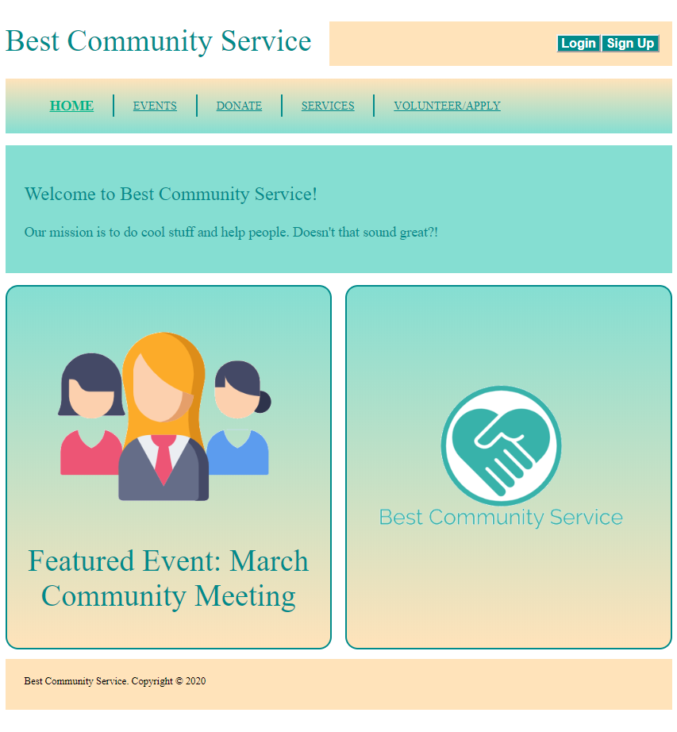

Events (contains a link to a description/signup page for each event)

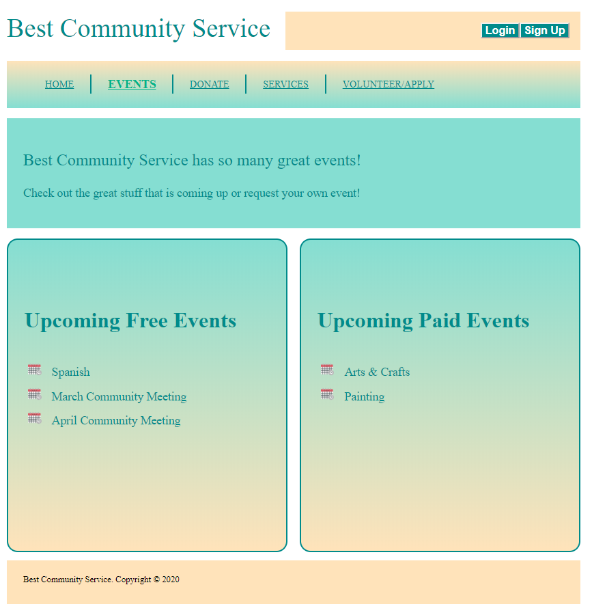

Donate (form accepting known/anonymous donations)

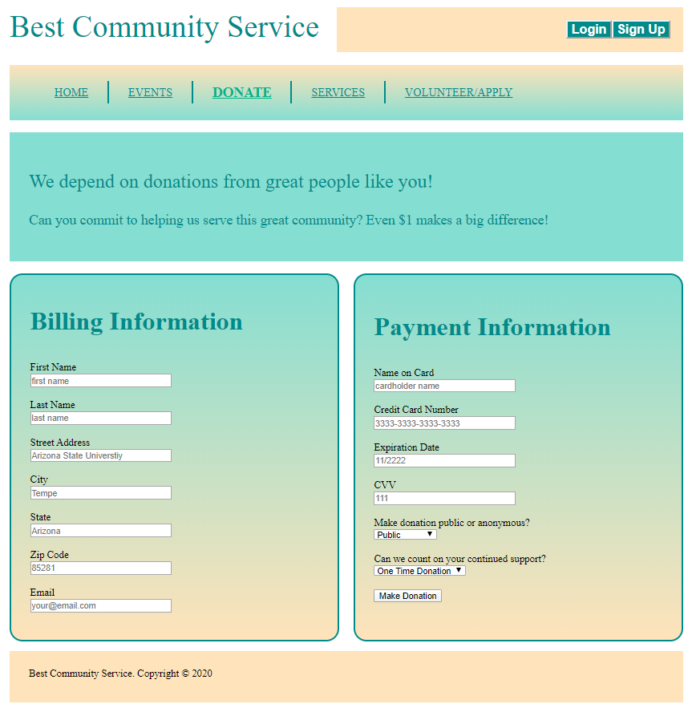

Services (contains a link to a description/request page for each event)

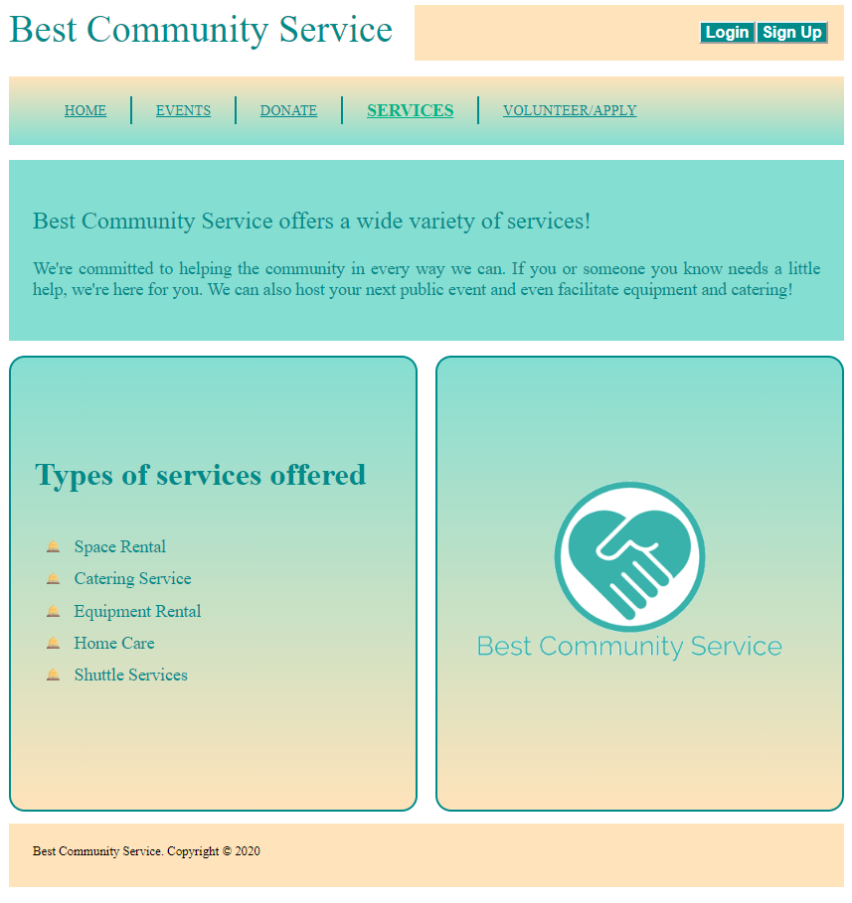

Volunteer/Apply (form containing volunteer interest / employment application options)

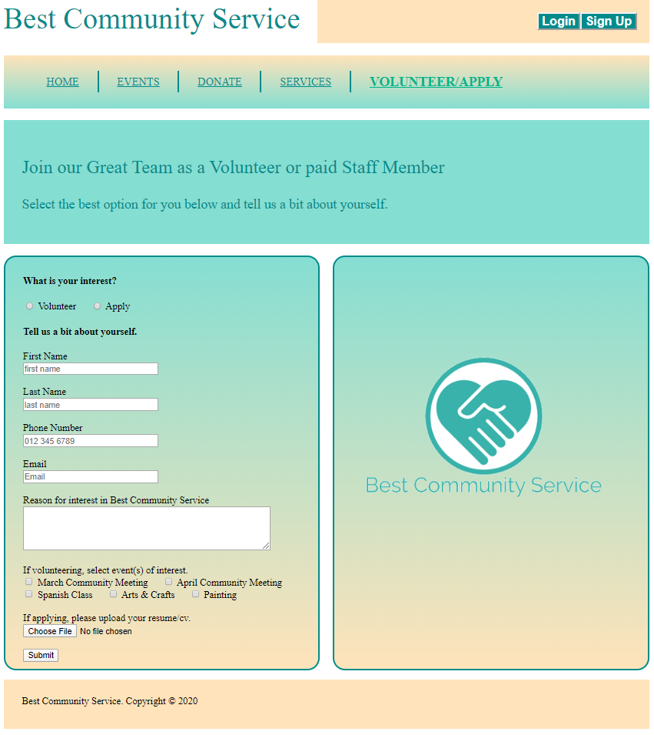

Login (sign in page for current users)

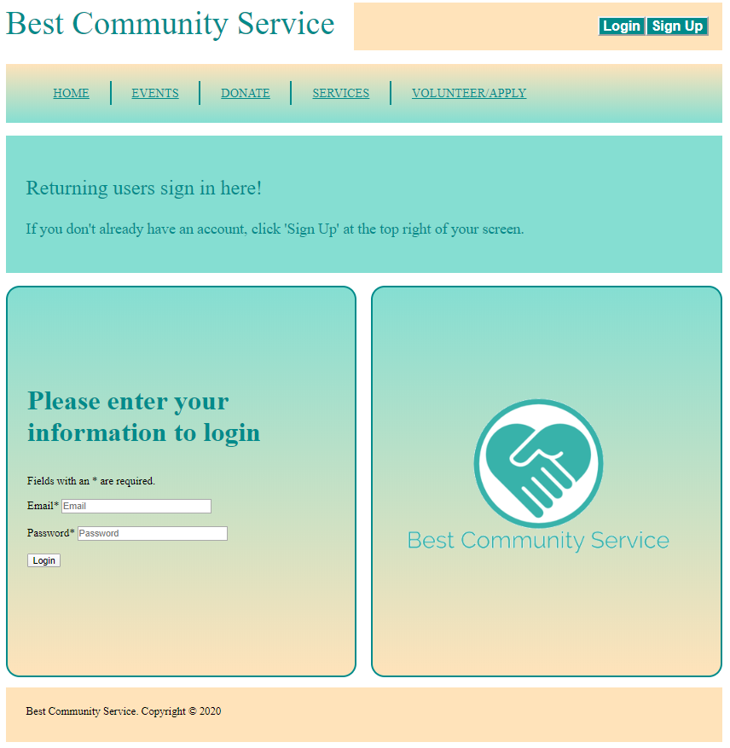

Signup (account creation page for new users)

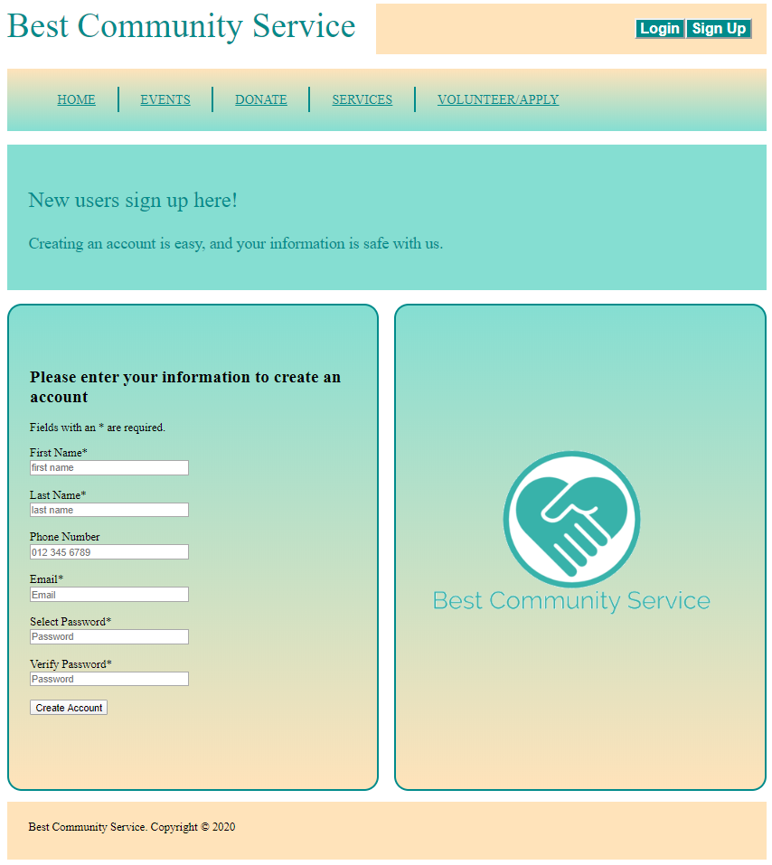

Events -> Spanish Class (form for registration for this event)

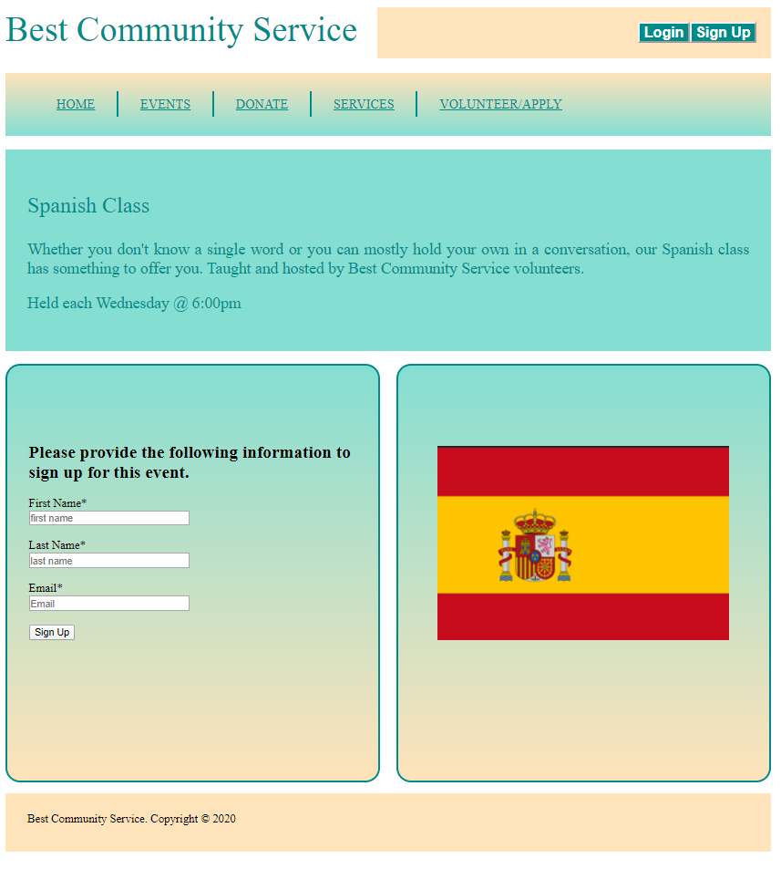

Events -> March Community Meeting (form for registration for this event)

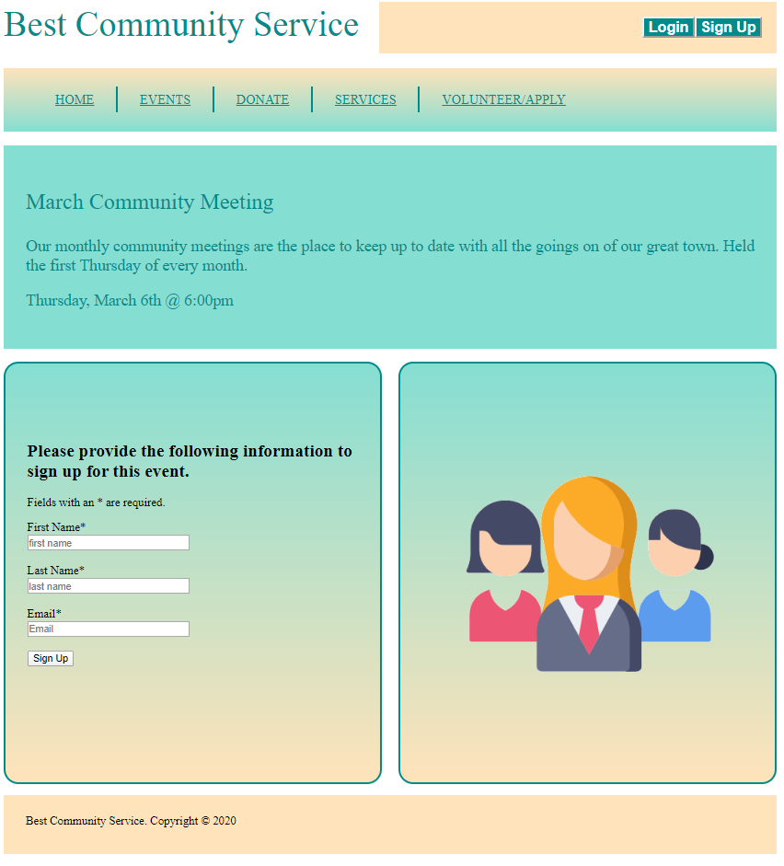

Events -> April Community Meeting (form for registration for this event)

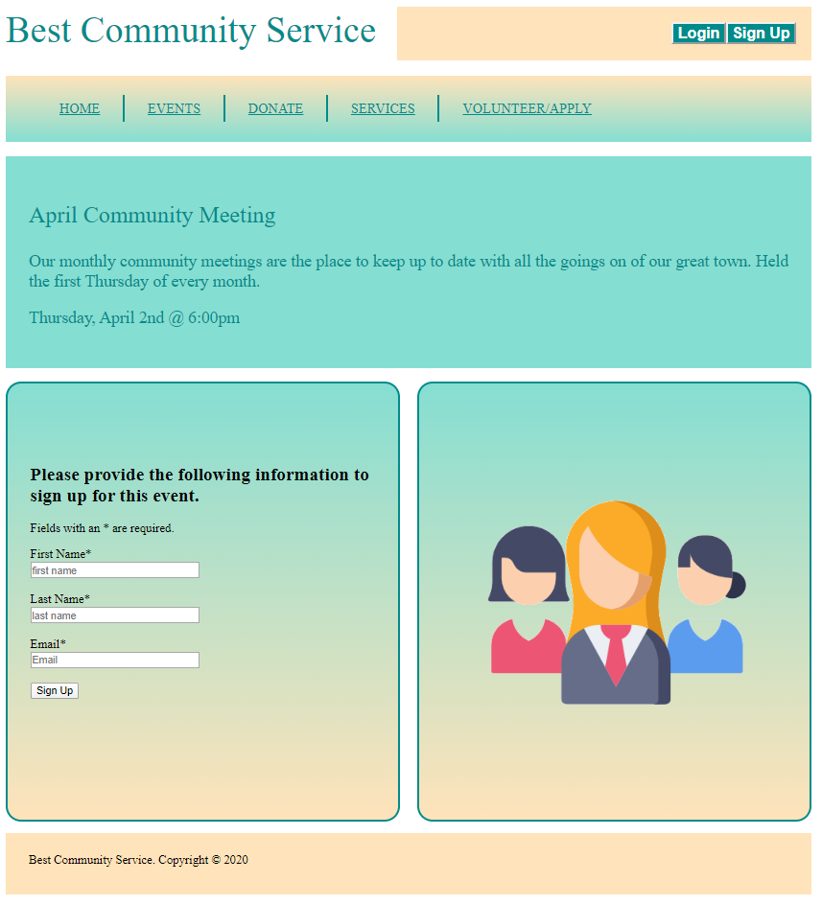

Events -> Arts & Crafts Class (form for registration for this event)

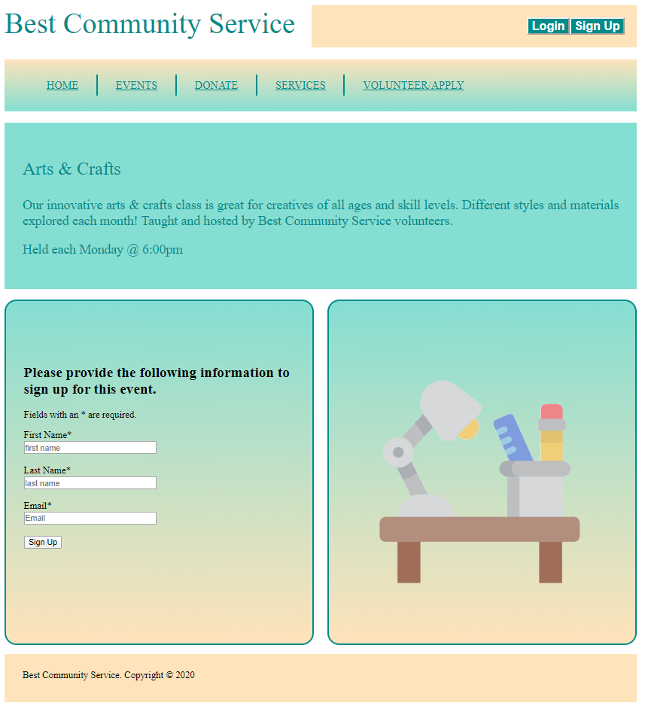

Events -> Painting Class (form for registration for this event)

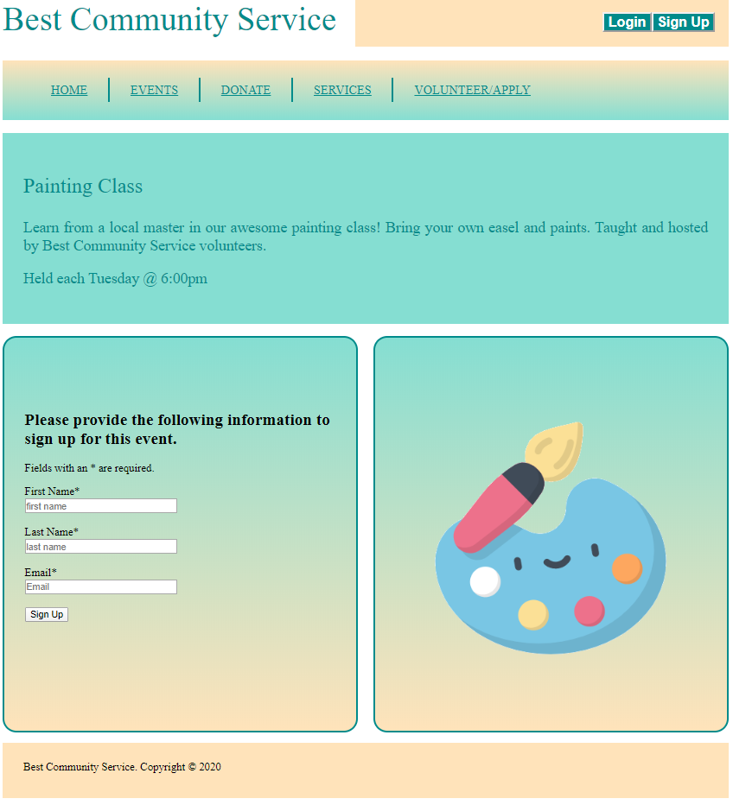

Services -> Space Rental (form to request this service)

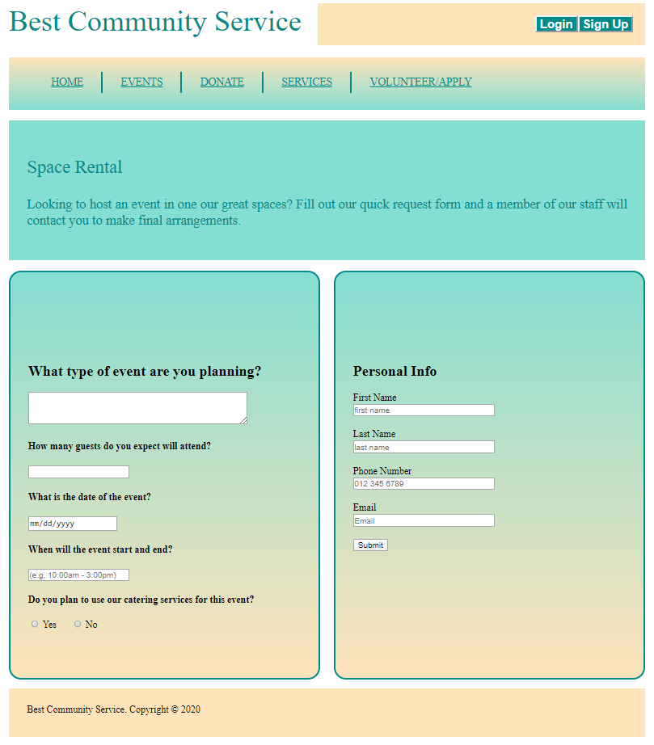

Services -> Catering Service (form to request this service)

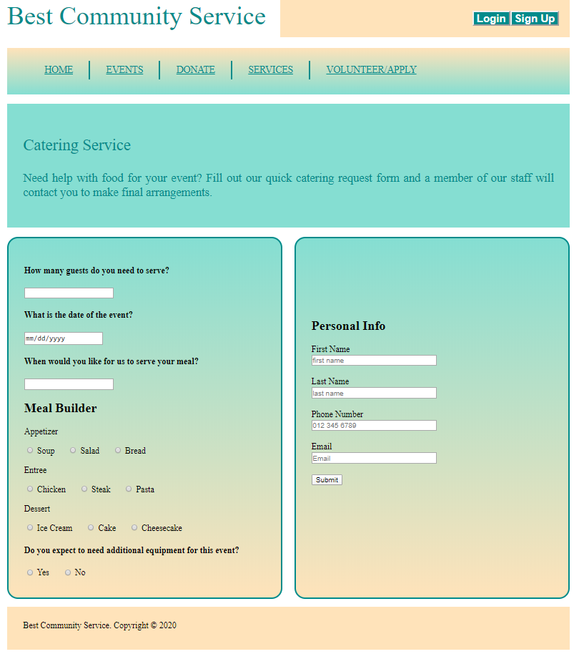

Services -> Equipment Rental (form to request this service)

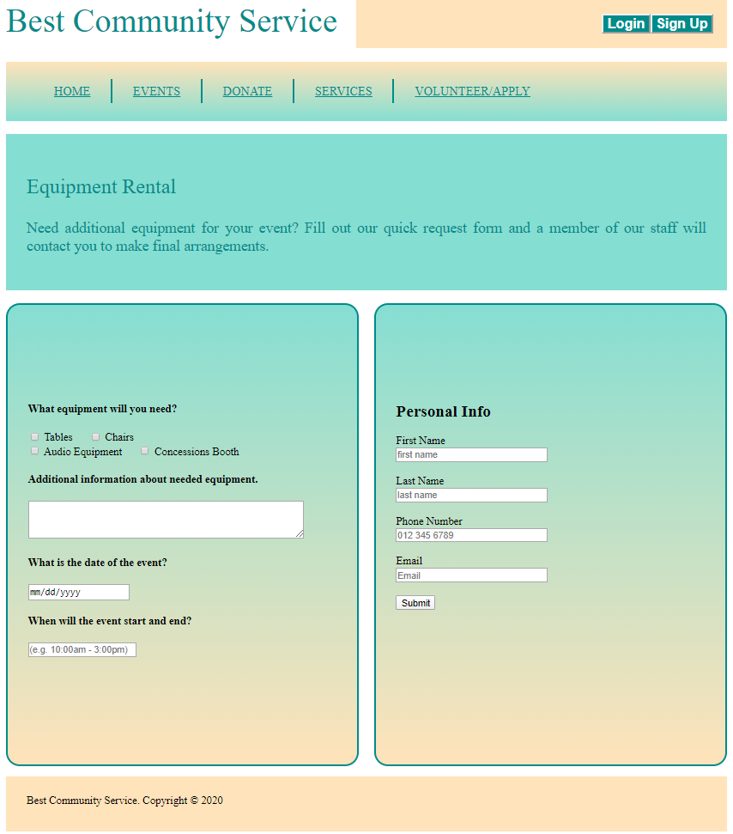

Services -> Home Care (form to request this service)

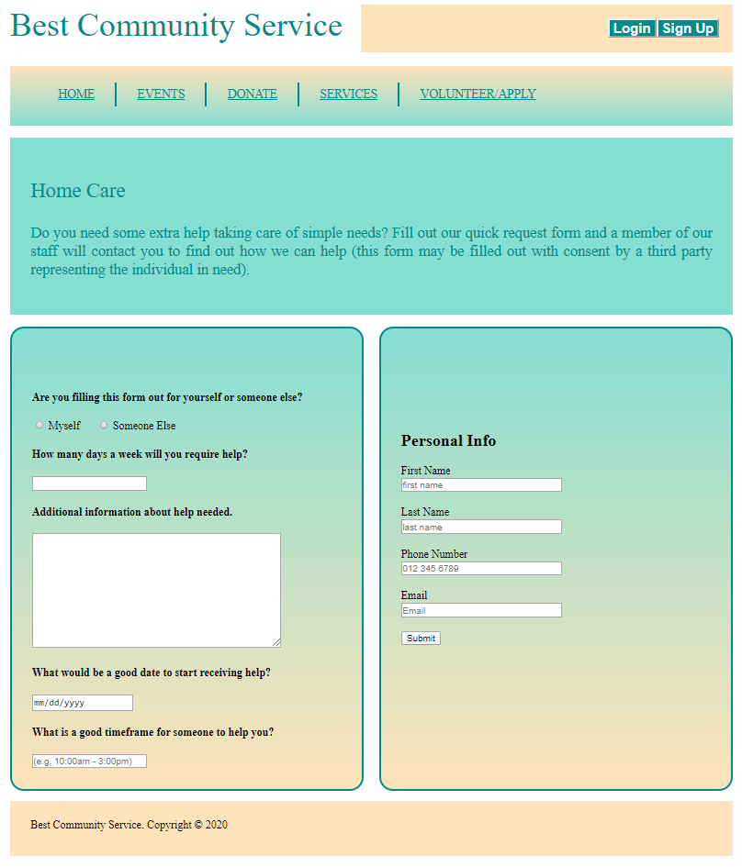

Services -> Shuttle Services (form to request this service)

