**A Cat, a Parrot, and a Bag of Seed**

1. A man needs to get all three (the cat, parrot, and the bag of seed) across the river safely. His boat can only carry one at a time, plus himself. Therefore he has to find a way to get all three across without leaving the cat alone with the parrot, or leaving the parrot alone with the bag of seed. However, the cat will not eat the bag of seed. He must take all three across, and he cannot leave any behind.
   1. The constraints:
      1. The cat will eat the parrot if left alone
      2. The parrot will eat the bag of seed if left alone
      3. Only one can come across in the boat at a time
   2. The sub-goals:
      1. Get the cat across safely
      2. Get the parrot across without it being eaten by the cat
      3. Get the seed across without it being eaten by the parrot
2. Solutions to constraints:
   1. Take the parrot or cat across so they are not left alone
   2. Take the parrot across first so the cat is left with the bag of seed
   3. Take only one across at a time, but bring one back with you if need be
3. Every solution does not work by itself, but combining solution b and c will work for the final solution and in all cases.
4. The solution will take 7 trips. For the first trip, the parrot will be taken across the river. This will leave the cat and the seed alone together, but the cat will not eat the seed. Then, he goes back across the river to the cat and the seed, leaving the bird alone on the opposite side. He takes a third trip, taking the cat with him. This leaves the seed by itself, and the cat and the bird on the opposite side. Since you cannot leave the cat and the bird alone, on the fourth trip over to get the seed, you must take the parrot with you. This time, you leave the parrot on the original side of the river, and take the seed over to the cat. Then, you go back to the side with the bird and come back across, carrying the bird on the final trip.

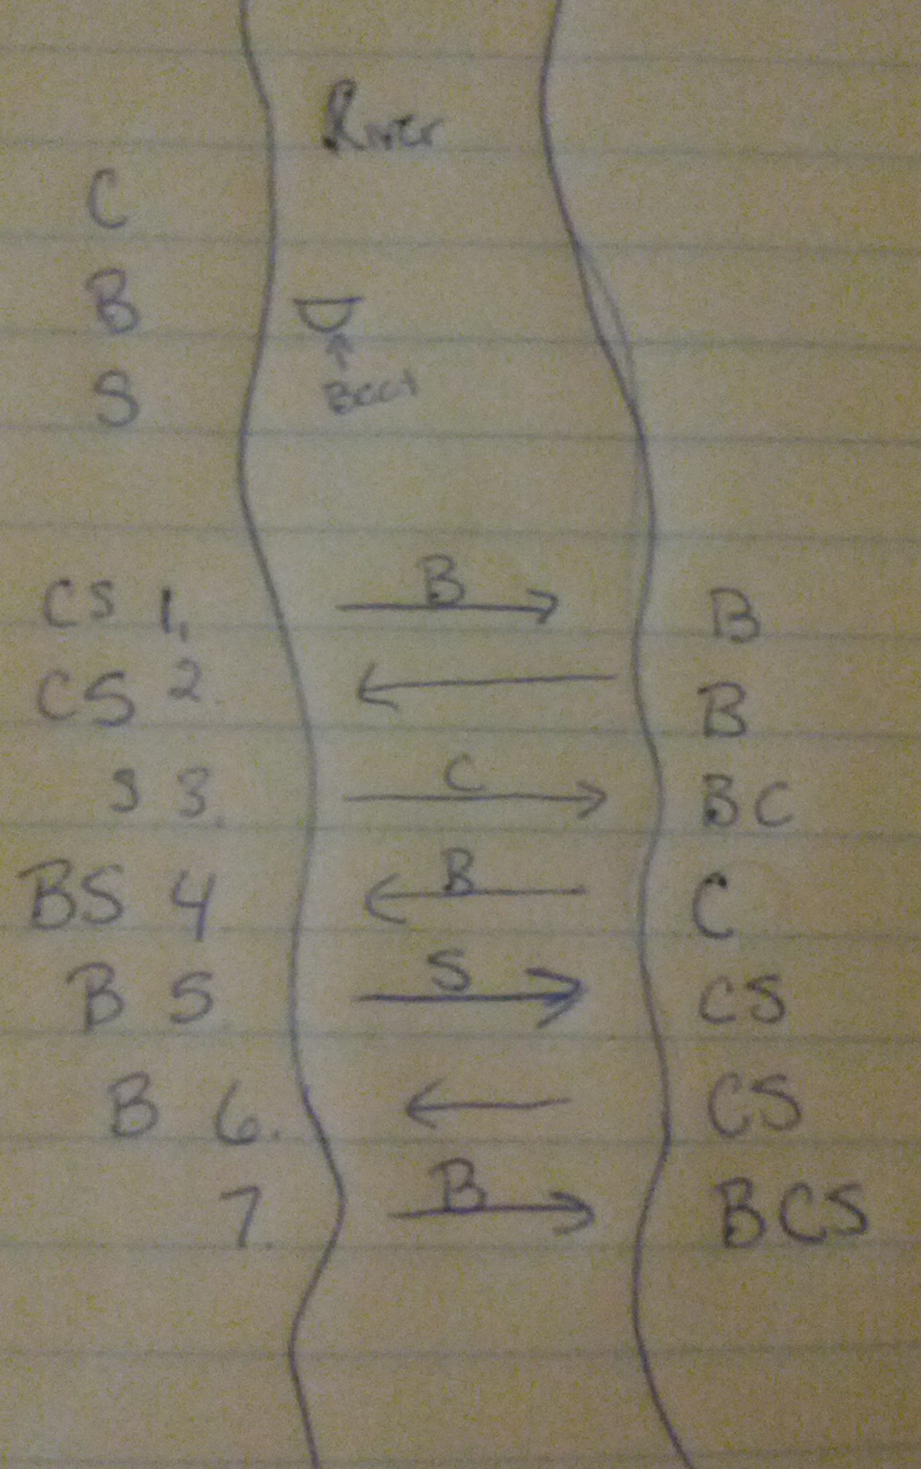

**Socks in the Dark**

1. There are socks in a drawer, and you can only select them in the dark. You cannot see what color you are grabbing until after you have already selected them. There are 5 pairs of black socks, 3 pairs of brown socks, and 2 pairs of white. How many do you need to grab to guarantee at least one matching pair, and how many to get one matching pair of each color?
   1. Constraints:
      1. There are 2 pairs of white socks
      2. There are 3 pairs of brown socks
      3. There are 5 pairs of black socks
   2. Sub-Goals
      1. Get at least one matching pair, no matter what color
      2. Get one matching pair of each color
      3. Do both of these in as few socks as possible.
2. You could, of course, grab every sock in the drawer and it would give you a matching pair of each color. However, you can grab fewer socks and still be good. You need to make sure you grab enough that you can get a matching pair of white, brown, and black socks. Unfortunately, the only way to do that is to ensure that you do not accidentally grab all brown or all white or all black. Grabbing 4 socks will allow one matching pair, and 12 socks will allow a matching pair of every color.
3. The final two sentences are a solution that will work every time.
4. To get one matching pair, you need to grab 4 socks – this will allow you to grab a black, a white, a brown, and a fourth sock that will match one of the previously obtained socks. The least amount of socks you would need to get a matching pair of every color is 12 socks. If you grab any less, you run the risk of not grabbing any but black, or getting all the brown and white socks. If you get 12 socks out, you can grab all 6 brown socks and all 4 white socks, and still have 2 black socks.

**Predicting Fingers**

1. The girl is counting using 8 fingers, starting with her thumb and calling it 1. She cycles through on one hand, but it is on a cycle of 8.
   1. Constraints: The pinkie and thumb are only counted once.
   2. Subgoals: Find what finger she will end with for counting from 1-10, then to 100, then to 1000.
2. Solution: See number 5
3. Evaluating the solution: Not sure
4. Counting to 10 ends on the pointer, and counting to 100 ends on the ring finger. Multiply 100 by 10 to get 1000, which means counting to 1000 will also end on the ring finger. Unfortunately, I cannot figure out how to explain my answer.