JAVA PROGRAMMING CLASS

Project Title:
“BankIt: Virtual Banking Application”
BankIt

TESDA PROJECT SUBMISSION

Student name | Jann Raniel P. Campos
Course / qualification | JAVA Programming NCIII
Batch / section | Batch 12 2026
Instructor / assessor | Marco Yimyaem
Institution / training center | Center for International Industries Competence Corp (CIICC)
Submission date | October 2026
GitHub repository | [Paste repository URL, if public or approved for submission]

Important: BankIt is a student learning project. It uses virtual money only and is not a real banking service.

PROJECT DESCRIPTION

BankIt is a student learning project that demonstrates common banking workflows with virtual money. Users can create an account, view a wallet, perform virtual cash-ins and transfers, review activity, and try roulette. HTML, CSS, JavaScript, and Tailwind CSS utilities build the interface. A Java HTTP server built with Maven serves the pages and API. Firebase Authentication handles email/password access, and Cloud Firestore stores profiles and activity records.

TOOLS USED
- HTML, CSS, JavaScript — Defines the pages, styling, form behavior, and dashboard interactions.
- Tailwind CSS utilities — Provides utility classes used alongside the project stylesheet.
- Java HTTP server — Serves the web files and handles the application API locally.
- Maven — Builds the Java application and manages its dependencies.
- Firebase Authentication — Handles email/password registration and sign-in.
- Cloud Firestore — Stores user profiles, transaction records, roulette game records, and admin audit logs.
- Git and GitHub — Git tracks source changes; GitHub hosts the repository after the owner publishes it.

The tools below are visible in the project files. Firebase service-account credentials are private and should never appear in portfolio screenshots or source-code evidence.

SYSTEM OVERVIEW
- Main Dashboard — Starting page where users can choose to register or sign in.
- Registration Form — Allows a new user to create an account using the supported registration fields.
- Login Form — Allows an existing user to sign in with email and password.
- Account Dashboard — Displays the user’s virtual wallet and available account actions.
- Account Dashboard Features — Includes virtual cash-in, transfers, transaction history, and roulette where implemented.
- Admin Dashboard — Provides administrative views for users and activity, plus account management features where implemented.

Basic User Flow
• Open the local BankIt home page and choose Log in or Create an account.
• After authentication, the Java API loads the user profile and virtual wallet.
• Try virtual cash-in or transfer, then review the updated transaction history.
• Open roulette to place a virtual bet; the Java server generates and stores the result.
• An authorized admin account can review users/activity and available account controls.
- t

Schema screenshot: In Firebase Console, open the BankIt Firebase project, choose Firestore Database, then open the Data tab. Expand users, open a demo user document, and show its transactions and games subcollections. The admin auditLogs collection is at the database root. Create fictional demo records first if the database is empty. Hide email/mobile values, document IDs, tokens, and all credentials. A simple diagram based on the table below is also suitable.

Main Home Page
The public home page introduces BankIt as a virtual-money student project. Its Log in and Create an account buttons open the existing authentication form. The Java server serves the home page and API locally.
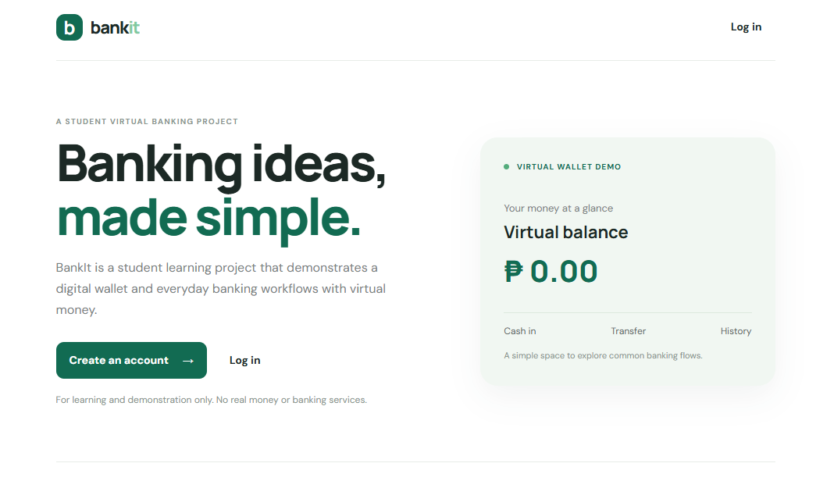
Code evidence: web/index.html, lines 16-65; navigation behavior: web/app.js, lines 29-57.
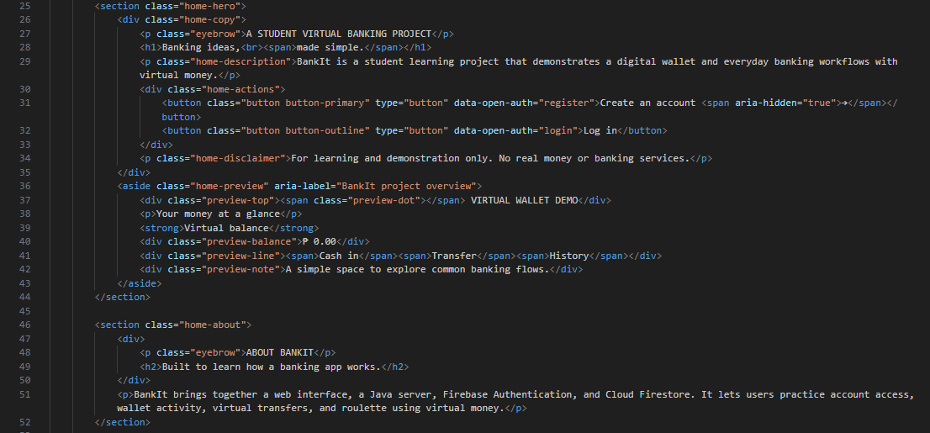

Login Form
The dashboard displays the signed-in user’s profile, virtual balance, recent activity, and account actions. The frontend loads profile and transaction data from the Java API.
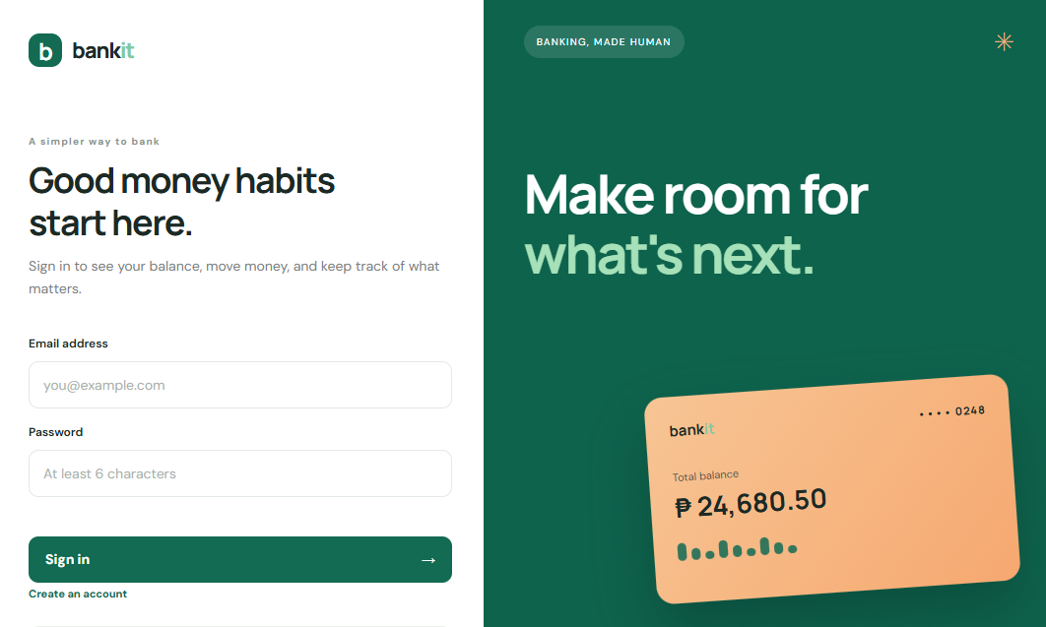
Login code: web/index.html, lines 90-103; web/app.js, lines 467-495 (Firebase sign-in: lines 493-495).
[ INSERT IMAGE HERE]
UI screenshot: In the running local website, open Log in and capture the email/password form with blank fields or fictional demo data. Add a separate VS Code screenshot for the code evidence. Never show a real password or private configuration.

Registration Form
The registration form collects full name, mobile number, email, and password. Firebase Authentication creates the email/password account; the browser then sends the name and mobile number to the Java API, which creates the Firestore profile.

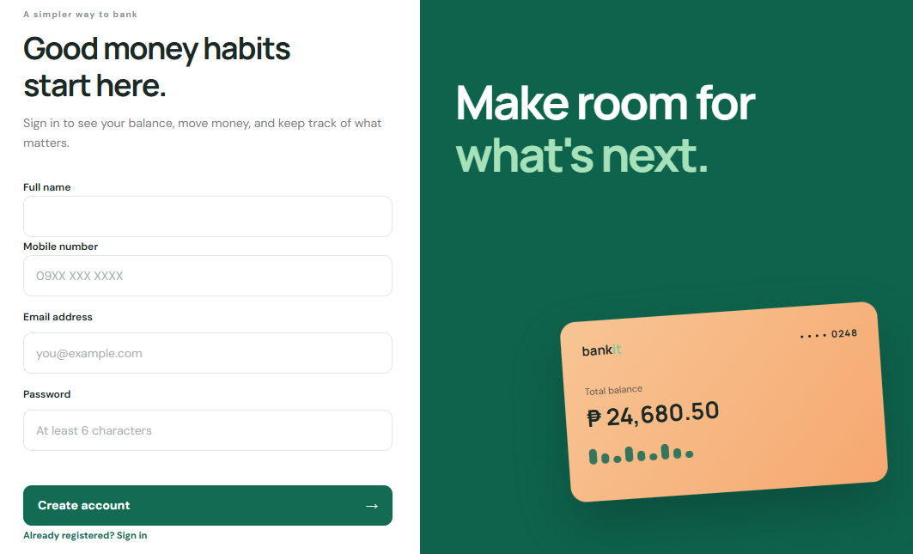
Registration code: web/index.html, lines 86-101; web/app.js, lines 476-492; src/Main.java, lines 320-349.
UI screenshot: Choose Create an account and capture the form with its name, mobile, email, and password fields visible; leave them blank or use fictional data. Add a separate VS Code screenshot for the code evidence. Never show a real password or private configuration.
[ INSERT IMAGE HERE]

Account Dashboard
The dashboard displays the signed-in user’s profile, virtual balance, recent activity, and account actions. The frontend loads profile and transaction data from the Java API.
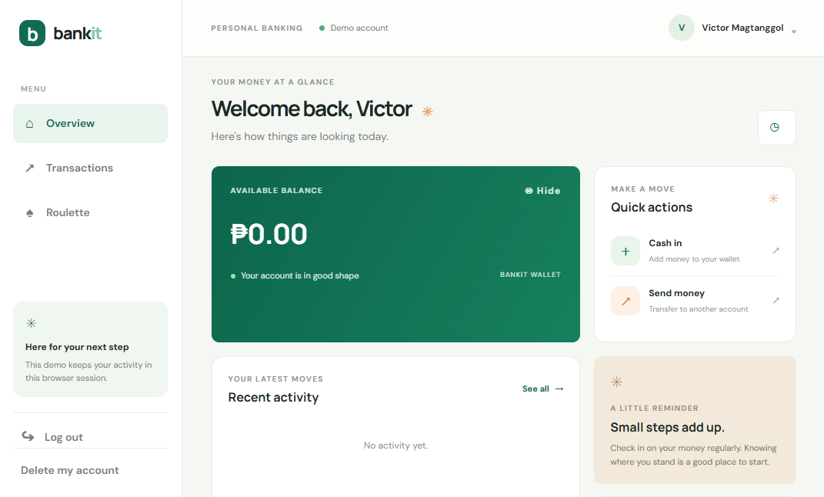
Code evidence: web/index.html, lines 203-260; web/app.js, lines 161-191.
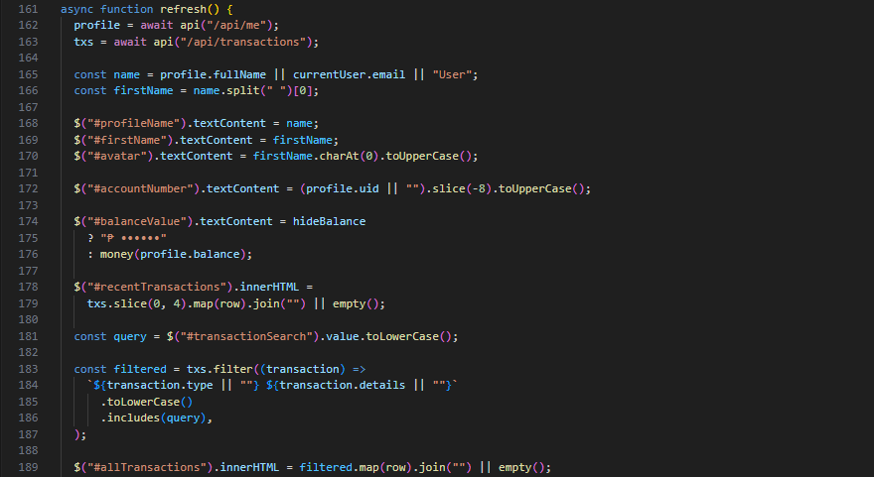
Account Dashboard Features
Feature | Description and code evidence
Virtual cash-in | The user enters an amount; the Java handler validates it, updates the virtual balance, and records CASH_IN. Frontend: web/app.js, lines 611-634. Backend: src/Main.java, lines 410-437.
Virtual transfer | The user supplies a recipient mobile number and amount. The server checks the recipient and balance, updates both accounts, and records both sides of the transfer. Frontend: web/app.js, lines 611-634. Backend: src/Main.java, lines 439-505.
Transaction history | The API retrieves the user’s recent transaction records; the frontend renders and filters them. Backend: src/Main.java, lines 366-386. Frontend: web/app.js, lines 161-191.

Cash-in
• Adds virtual funds to the signed-in demo wallet.
• The server validates the amount, updates the Firestore balance, and saves a transaction record.
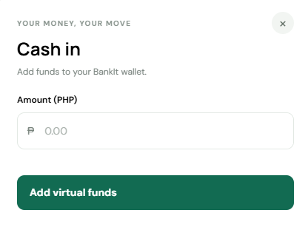

Code evidence: web/app.js, lines 611-634; src/Main.java, lines 410-437.
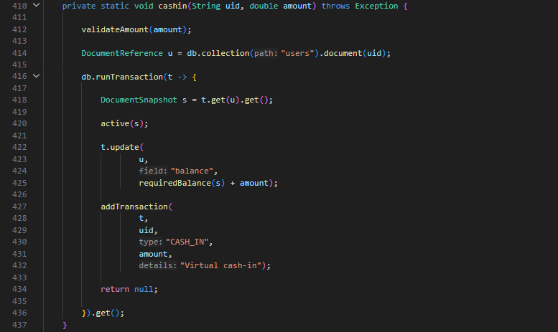

Transfer
• Sends virtual funds to another BankIt demo account using the recipient mobile number.
• The server checks the recipient and available balance, updates both wallets, and records sent/received entries.
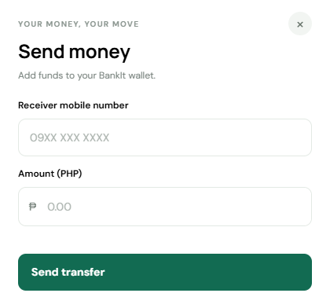
Code evidence: web/app.js, lines 611-634; src/Main.java, lines 439-505.
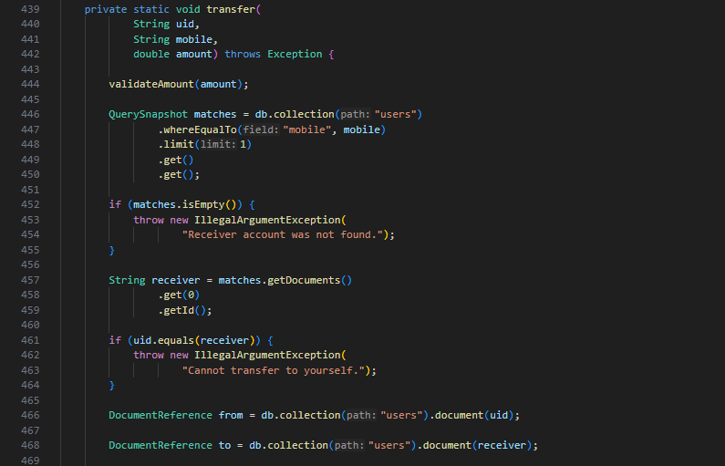

Transaction History
• Retrieves the signed-in user’s recent Firestore transaction records through the Java API.
• The dashboard displays the records with type, details, amount, and date; the user can search the activity list.
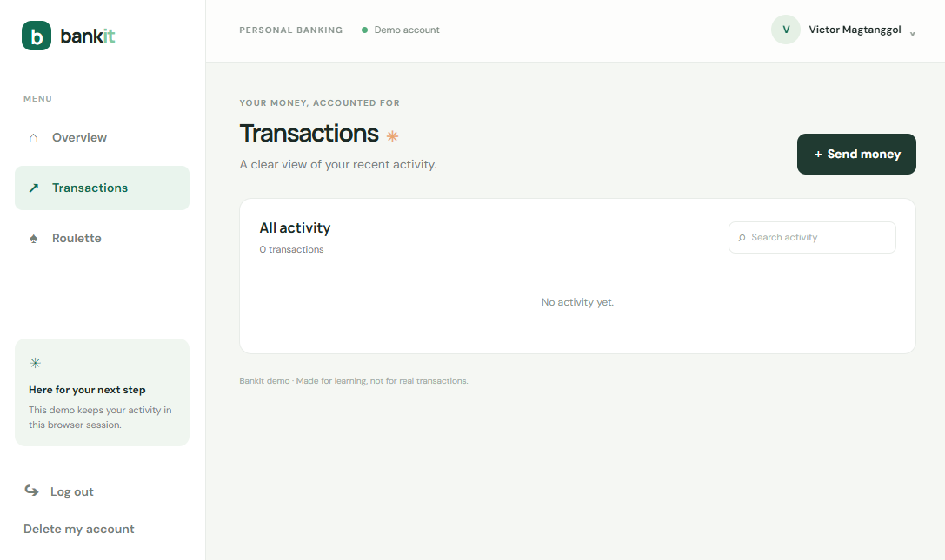

Code evidence: src/Main.java, lines 366-386; web/app.js, lines 161-191.
[ INSERT IMAGE HERE]

Roulette
• Lets the user place a virtual bet on red, black, odd, even, or a number from 0 to 36.
• The Java server generates the outcome, calculates the payout, updates the virtual balance, and stores the game record.
[ INSERT IMAGE HERE]

Code evidence: web/app.js, lines 644-707; src/Main.java, lines 507-615.
[ INSERT IMAGE HERE]

Admin Dashboard
• Loads admin totals, recent application activity, registered users, and audit records through protected API requests.
• Include a screenshot only after signing in with an authorized demo admin account.
[ INSERT IMAGE HERE]

Code evidence: web/app.js, lines 224-300; server admin summary: src/Main.java, lines 638-725.
[ INSERT IMAGE HERE]

Admin Controls and Authorization
• The server checks the admin claim before allowing protected admin operations.
• Account blocking and balance adjustment are supported; balance adjustment requires the balanceAdjuster claim and records an audit entry.
[ INSERT IMAGE HERE]

Code evidence: src/Main.java, lines 759-775, 827-892, and 949-955.
[ INSERT IMAGE HERE]

ADMIN FEATURES
- View registered users and application activity, where available.
- Block or unblock user accounts, if implemented.
- Adjust virtual balances, if implemented.
- Review administrative action records, if audit logging is implemented.
Use fictional demo accounts and verify each action in the local build before describing it as demonstrated. Do not include credentials, service-account keys, or real banking details.
Feature | Evidence / notes
User management | Admin dashboard retrieves and searches user profiles. Blocking/unblocking and profile editing are handled by protected Java API routes. Capture fictional demo users.
Activity / transaction review | Admin summary displays transaction and roulette totals plus recent activity. Use a demo database for screenshots.
Account controls / balance adjustment | Blocking/unblocking is implemented. Balance adjustment is implemented and requires the balanceAdjuster custom claim; verify it with an authorized demo admin before presenting.
Admin authorization / audit log | The server checks the admin claim. Balance adjustments and account controls write records to auditLogs. Evidence: src/Main.java, lines 759-775, 827-892, and 949-955.

ADDITIONAL PROJECT INFORMATION
Item | Details
Repository URL | [Paste the actual GitHub repository URL.]
Project status | Student learning project; virtual money only.
Testing / demonstration | Use fictional demo accounts and verify that each feature works before presenting.
Future improvements | Improve validation and error messages, add automated tests, document security rules, and refine responsive design.

CONCLUSION
BankIt demonstrates how a browser interface, Java server, Firebase Authentication, and Cloud Firestore can support common virtual banking workflows. This portfolio documents the current local learning project and provides evidence locations for its interface and implementation. BankIt uses virtual money only and is not a real banking service.

