COMPSYS 301 Report – Group 12

line 1: 1st Given Name Surname   
line 2: *dept. name of organization   
(of Affiliation)*  
line 3: *name of organization   
(of Affiliation)*line 4: City, Country

*Abstract*—This electronic document is a “live” template and already defines the components of your paper [title, text, heads, etc.] in its style sheet. *\*CRITICAL: Do Not Use Symbols, Special Characters, Footnotes, or Math in Paper Title or Abstract*. (*Abstract*)

# Introduction

This project's primary aim was to enhance a robot’s functionality using the Cypress Kit (CYKIT-059) to navigate a projected maze. The maze path was projected as a line from a ceiling-mounted projector, with the robot relying on a specially designed sensor PCB to position itself. The project encompassed both hardware and software designs to fulfil this task.

# Hardware Considerations

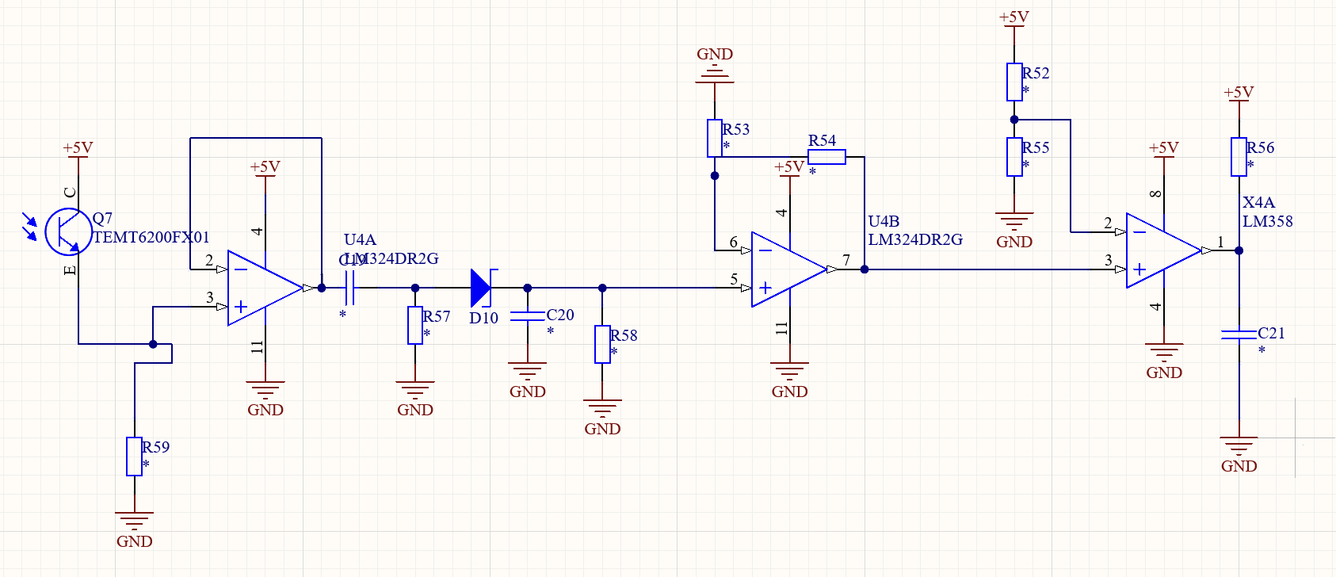

## **Rationale for using Phototransistor over Photodiode:**

## We chose a phototransistor over a photodiode for light detection. Phototransistors are more sensitive due to their inherent amplification, providing a larger current response to subtle light changes. Their ease of interfacing with digital circuits, straightforward biasing, and cost-effectiveness made them particularly appealing. While they have a marginally slower response time compared to photodiodes, the need for extra circuity compred to the decrease in rise time, didn’t warrant us using them. The phototransistor also has better durability and suitability over a photodiode.

## Sensing Circuitiry and Phototransistor Mechanism

A phototransistor, when exposed to light, allows a current to flow from the collector to its emitter, measured in microamperes (uA). To convert this current into a detectable voltage, we incorporated a load resistor. A 22k load resistor was chosen where the LM324 would take it from 0 to 3.5V

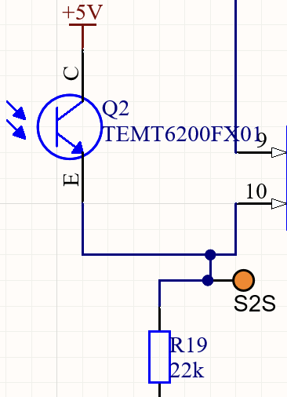

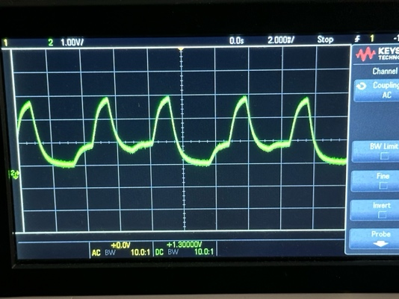

Insert photo from Oscilloscope/Graph/Schematic

## Voltage Follower

The primary reason we incorporated a voltage follower in this context is to serve as a buffer preventing the sensor circuit from experiencing loading effects, given that the OPAMP has a low output impedance. By doing so, it ensures that any subsequent components, including filters, do not influence or distort the raw voltage signal obtained directly from the transistor, thereby maintaining the integrity of the original measurement. This was a crucial component as part of our hardware design as the signal would otherwise lead to the signal being attenuated, giving us a less reliable signal to work with.

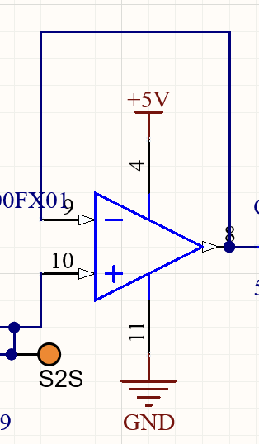

Insert photo from Oscilloscope/Graph/Schematic

## Signal Filtering Approach

The primary signal of interest from the projector operates at 120Hz. However, interference from ambient light presents an additional signal around 100Hz. To distinguish our target signal and ensure optimal fidelity, we've selected a cutoff frequency slightly above our desired 120Hz. Even though our primary signal undergoes some attenuation at this cutoff, it remains sufficiently strong for our requirements while ensuring that the 100Hz interference is significantly reduced. This allows us to maintain a clear distinction between the desired signal and the interference. The exact cutoff frequency was determined using the equation:

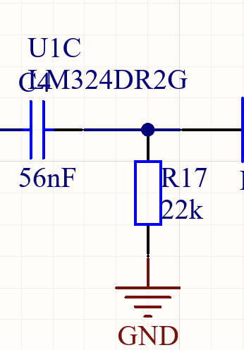

Insert photo from Oscilloscope/Graph/Schematic

## Necessity and Design of Rectifier

In our circuit, we've incorporated a rectifier to process only the positive segment of the signal, ensuring that we achieve a consistent DC-like value. This is crucial for maintaining the accuracy of our measurements against potential signal variations. The integration of a resistor sets the time constant of the capacitor to approximately 0.005 seconds. This duration has been optimised to produce a steady DC representation, yet it remains short enough to allow swift transitions when the signal shifts between black and white.

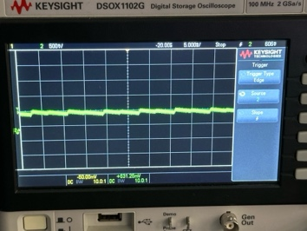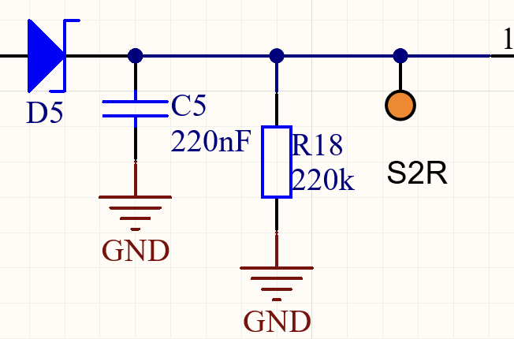

Insert photo from Oscilloscope/Graph/Schematic

## Amplification of Sensed Voltage

Before reaching the comparator stage, we amplified the detected voltage. The reason behind this is the minuscule voltage difference when light is present compared to its absence, which is nearly 0V. By employing amplification, we create a noticeable disparity between these two states. In our design, we achieved a gain factor of 4.4. We opted for a dedicated comparator for this application over alternatives such as op-amps because comparators are specifically tailored for discerning minute differences in voltage, offering faster response times and better precision. The chosen gain elevates the peak voltage to a level that facilitates easier differentiation of the signal.

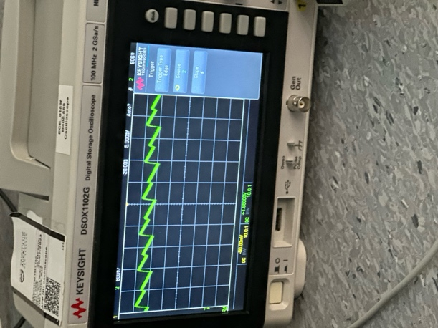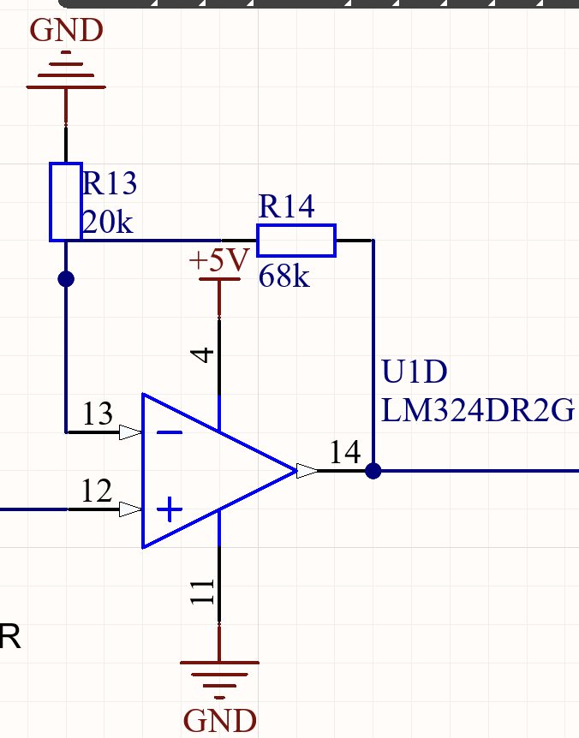

Configuration of the Comparator

## Comparator Functionality and Configuration

Our comparator is set to assess the input voltage, after amplification and rectification, comparing it to a set reference voltage of 1.2V. This particular threshold was chosen to reduce the likelihood of erroneous readings. When the comparator detects a voltage crossing, its transistor base enters an open circuit condition, putting it into a floating state. This necessitates the inclusion of a pull-up resistor, which raises the output voltage to 5V. We opted for a comparator over using an ADC because comparators provide a swift and direct digital output indicative of the voltage difference, whereas an ADC would necessitate additional processing and might introduce unnecessary delays to our system which is not ideal for a fast paced line following robot application.

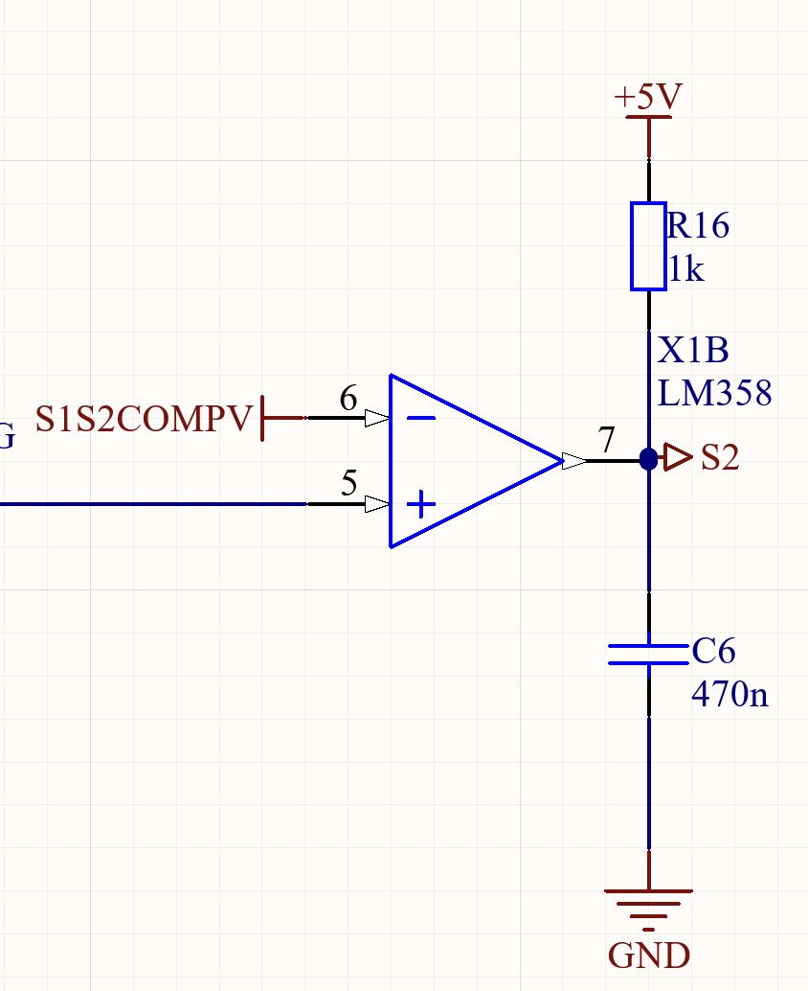

Insert photo from Oscilloscope/Graph/Schematic

## Deciding the Pull-Up Resistor Value

Track capacitances can inadvertently introduce delays, hindering the swift transition from logic '0' to '1'. By carefully selecting the resistor value, we can counteract this effect, facilitating a more immediate voltage shift. Our final design utilised a 1kΩ pullup resistor to achieve optimal performance.

1kΩ pullup resistor to achieve optimal performance.

# Verification And Testing

## Testing of Various Filter Designs

1. Low Pass Filter

Our initial assessments pointed towards the need to filter out high-frequency noise that could adversely affect our measurements. Implementing a low-pass filter seemed a logical choice, aiming to allow only the desired frequencies to pass through while attenuating those that were higher. However, we recognized that the low-pass filter was not optimally addressing some of the challenges we faced. Although the use of a low-pass filter eliminates high-frequency noise, we recognized that such a filter would not address the variations in the DC component. This inconsistency in the DC bias could introduce errors, particularly if this bias undergoes significant changes over time. It allows the DC bias (0 Hz) to pass through unaffected. Therefore, we had to evaluate alternative solutions or circuit designs that could stabilise or counteract this fluctuating DC bias, ensuring our readings remained reliable and accurate

1. High Pass Filter

By employing a high-pass filter, we could effectively eliminate the unwanted DC component, allowing only frequencies above a certain threshold to pass through. This was particularly relevant for our project as our primary signals of interest were not in the DC range, and the high pass filter ensured that the readings were free from DC induced distortions, therefore enhancing the accuracy and reliability of our sensor data.

1. Common Emmitter Configuration

Output is inverted

???

1. Common Collector

In phase

1. Photodiode

During the testing phases of out design, we initially explored the photodiode due to its rapid response to light changes.. After weighing our options, we transitioned to a phototransistor. It produced a more robust output signal and its ease of integration and enhanced sensitivity made the phototransistor a more pragmatic choice for our specific application, ensuring reliable light signal detection and processing. The photodiode doesn't have any internal amplification. The output is a raw signal that's directly proportional to the light it senses. It has a faster response time in contrast with a Phototransistor, but the fact that it need additional components for amplification was enough for us to go with a phototransistor instead.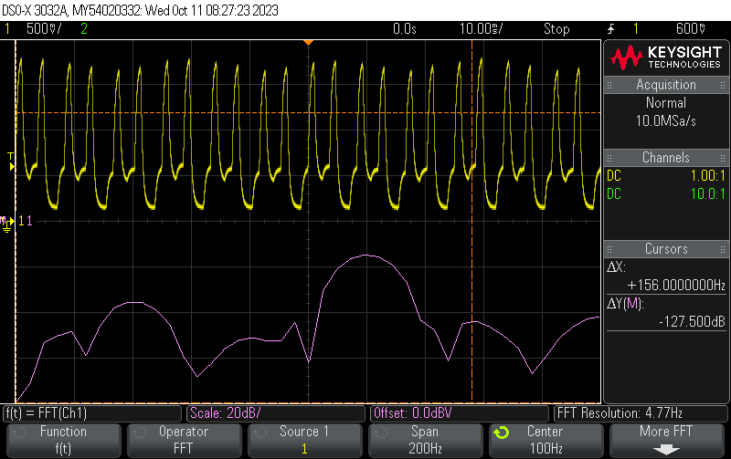

The photo transistor has inherent amplification due to the transistor's current gain. This results in a much stronger output signal, which can be advantageous for detecting low light levels or when a stronger signal is needed for interfacing with subsequent circuitry.

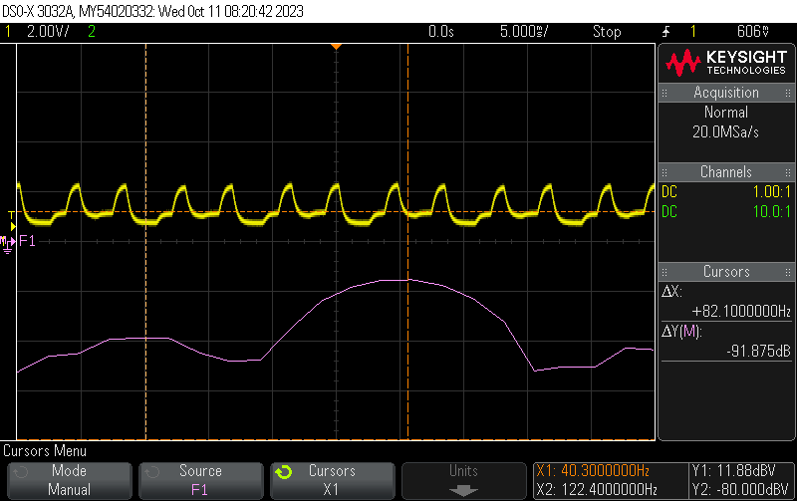

## Breadboarding and Verification of Design

By iteratively testing and modifying our circuit on the breadboard, we ensured that our design was both functional and optimised before moving on to a more permanent PCB layout. Additionally, breadboarding facilitated real-time feedback, enabling us to quickly adapt and refine our design based on the observed signals.   
For example, the selection of values and designs for our high-pass filter was a dynamic process, as we tweaked on the go.

LTSPICE MODEL + OUTPUT SIGNAL TO ATTACH

Get raw values of the input signals also take a fast fourier transform of the input signal and say what is our signal of interest and what is the otehr signal that we are removing

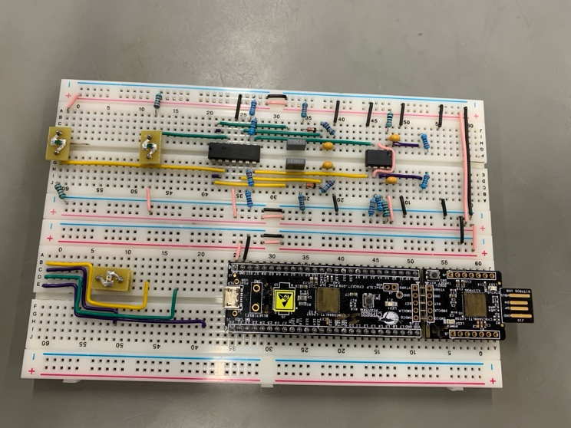

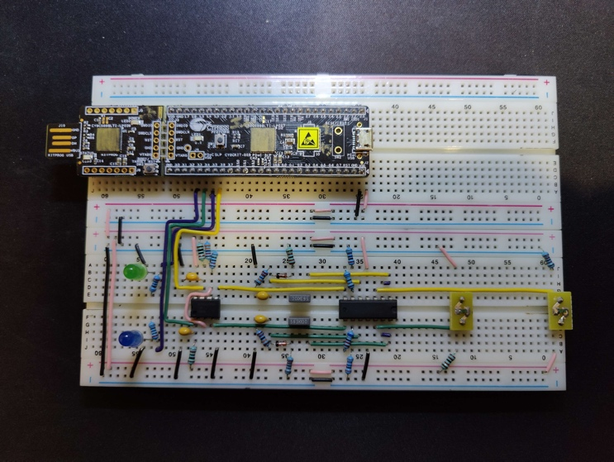

# PCB Design Choices

## Decouping Capacitors

We used 100n decoupling capacitors for each IC to stabilise the power supply, filter out voltage spikes and transients, and ensure consistent and noise-free operation across all integrated circuits.

## LED Matrix

## In our PCB design, we chose to integrate a matrix of LEDs. When illuminated by the projector light, these LEDs activate, but they deactivate upon encountering black lines. This visual feedback not only provides a clear indication of sensor triggering but also greatly aids in efficient debugging, saving us time.

## 5V and Ground Planes

### The inclusion of planes, specifically the 5V and GND planes, in our PCB design greatly enhanced its functionality and efficiency. These planes facilitate uniform distribution of power and ground throughout the board, ensuring stable operation of all components. Furthermore, having dedicated planes minimizes the impedance, reduces potential noise and interference, and offers a more streamlined path for return currents. This design choice not only aids in efficient power management but also optimizes the overall board layout, reducing the need for numerous trace routes and contributing to a more compact and reliable design.

## Sensor Placement

We incorporated three sensors at the front, three in the middle, and one at the back. This layout was meticulously measured and chosen to offer a balanced and comprehensive coverage of the sensing area. By positioning sensors at these specific locations, we were able to capture both immediate and more distant feedback, ensuring accurate detection of turns. This design choice not only provided a wide sensing range but also enhanced precision in detecting various conditions, enabling more responsive and accurate decision-making based on the sensor data.

# Software Considerations

*In our software design, selecting the appropriate graph traversal algorithm was crucial. Upon evaluation, we chose Breadth-First Search (BFS) over Depth-First Search (DFS). While algorithms like Dijkstra's and A* are powerful for weighted graphs, they carry significant computational costs that weren't suitable for our specific application.*

1. *Shortest Path Guarantee: Since the nature of our problem was to find the shortest path between two points, BFS inherently guarantees this by exploring all neighboring nodes at a given depth before progressing to nodes at the next depth level. This ensures that if a solution or path exists close to the source, BFS will identify it as the shortest path. Conversely, while DFS can potentially reach an endpoint more rapidly in certain scenarios, it doesn't provide assurance of the shortest path. We chose BFS over DFS because our primary objective was to reach an endpoint efficiently, without being constrained by the number of steps taken.*

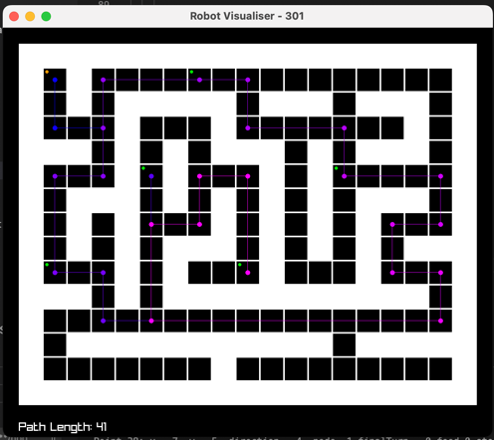

## Units

* Use either SI (MKS) or CGS as primary units. (SI units are encouraged.) English units may be used as secondary units (in parentheses). An exception would be the use of English units as identifiers in trade, such as “3.5-inch disk drive”.
* Avoid combining SI and CGS units, such as current in amperes and magnetic field in oersteds. This often leads to confusion because equations do not balance dimensionally. If you must use mixed units, clearly state the units for each quantity that you use in an equation.
* Do not mix complete spellings and abbreviations of units: “Wb/m2” or “webers per square meter”, not “webers/m2”. Spell out units when they appear in text: “. . . a few henries”, not “. . . a few H”.
* Use a zero before decimal points: “0.25”, not “.25”. Use “cm3”, not “cc”. (*bullet list*)

## Equations

The equations are an exception to the prescribed specifications of this template. You will need to determine whether or not your equation should be typed using either the Times New Roman or the Symbol font (please no other font). To create multileveled equations, it may be necessary to treat the equation as a graphic and insert it into the text after your paper is styled.

Number equations consecutively. Equation numbers, within parentheses, are to position flush right, as in (1), using a right tab stop. To make your equations more compact, you may use the solidus ( / ), the exp function, or appropriate exponents. Italicize Roman symbols for quantities and variables, but not Greek symbols. Use a long dash rather than a hyphen for a minus sign. Punctuate equations with commas or periods when they are part of a sentence, as in:

*a*  *b*    

Note that the equation is centered using a center tab stop. Be sure that the symbols in your equation have been defined before or immediately following the equation. Use “(1)”, not “Eq. (1)” or “equation (1)”, except at the beginning of a sentence: “Equation (1) is . . .”

## Some Common Mistakes

* The word “data” is plural, not singular.
* The subscript for the permeability of vacuum **0, and other common scientific constants, is zero with subscript formatting, not a lowercase letter “o”.
* In American English, commas, semicolons, periods, question and exclamation marks are located within quotation marks only when a complete thought or name is cited, such as a title or full quotation. When quotation marks are used, instead of a bold or italic typeface, to highlight a word or phrase, punctuation should appear outside of the quotation marks. A parenthetical phrase or statement at the end of a sentence is punctuated outside of the closing parenthesis (like this). (A parenthetical sentence is punctuated within the parentheses.)
* A graph within a graph is an “inset”, not an “insert”. The word alternatively is preferred to the word “alternately” (unless you really mean something that alternates).
* Do not use the word “essentially” to mean “approximately” or “effectively”.
* In your paper title, if the words “that uses” can accurately replace the word “using”, capitalize the “u”; if not, keep using lower-cased.
* Be aware of the different meanings of the homophones “affect” and “effect”, “complement” and “compliment”, “discreet” and “discrete”, “principal” and “principle”.
* Do not confuse “imply” and “infer”.
* The prefix “non” is not a word; it should be joined to the word it modifies, usually without a hyphen.
* There is no period after the “et” in the Latin abbreviation “et al.”.
* The abbreviation “i.e.” means “that is”, and the abbreviation “e.g.” means “for example”.

An excellent style manual for science writers is [7].

# Using the Template

After the text edit has been completed, the paper is ready for the template. Duplicate the template file by using the Save As command, and use the naming convention prescribed by your conference for the name of your paper. In this newly created file, highlight all of the contents and import your prepared text file. You are now ready to style your paper; use the scroll down window on the left of the MS Word Formatting toolbar.

## Authors and Affiliations

**The template is designed for, but not limited to, six authors.** A minimum of one author is required for all conference articles. Author names should be listed starting from left to right and then moving down to the next line. This is the author sequence that will be used in future citations and by indexing services. Names should not be listed in columns nor group by affiliation. Please keep your affiliations as succinct as possible (for example, do not differentiate among departments of the same organization).

### For papers with more than six authors: Add author names horizontally, moving to a third row if needed for more than 8 authors.

### For papers with less than six authors: To change the default, adjust the template as follows.

#### Selection: Highlight all author and affiliation lines.

#### Change number of columns: Select the Columns icon from the MS Word Standard toolbar and then select the correct number of columns from the selection palette.

#### Deletion: Delete the author and affiliation lines for the extra authors.

## Identify the Headings

Headings, or heads, are organizational devices that guide the reader through your paper. There are two types: component heads and text heads.

Component heads identify the different components of your paper and are not topically subordinate to each other. Examples include Acknowledgments and References and, for these, the correct style to use is “Heading 5”. Use “figure caption” for your Figure captions, and “table head” for your table title. Run-in heads, such as “Abstract”, will require you to apply a style (in this case, italic) in addition to the style provided by the drop down menu to differentiate the head from the text.

Text heads organize the topics on a relational, hierarchical basis. For example, the paper title is the primary text head because all subsequent material relates and elaborates on this one topic. If there are two or more sub-topics, the next level head (uppercase Roman numerals) should be used and, conversely, if there are not at least two sub-topics, then no subheads should be introduced. Styles named “Heading 1”, “Heading 2”, “Heading 3”, and “Heading 4” are prescribed.

## Figures and Tables

#### Positioning Figures and Tables: Place figures and tables at the top and bottom of columns. Avoid placing them in the middle of columns. Large figures and tables may span across both columns. Figure captions should be below the figures; table heads should appear above the tables. Insert figures and tables after they are cited in the text. Use the abbreviation “Fig. 1”, even at the beginning of a sentence.

1. Table Type Styles

| Table Head | Table Column Head | | |
| --- | --- | --- | --- |
| Table column subhead | Subhead | Subhead |
| copy | More table copya |  |  |

1. Sample of a Table footnote. (*Table footnote*)
2. Example of a figure caption. (*figure caption*)

Figure Labels: Use 8 point Times New Roman for Figure labels. Use words rather than symbols or abbreviations when writing Figure axis labels to avoid confusing the reader. As an example, write the quantity “Magnetization”, or “Magnetization, M”, not just “M”. If including units in the label, present them within parentheses. Do not label axes only with units. In the example, write “Magnetization (A/m)” or “Magnetization {A[m(1)]}”, not just “A/m”. Do not label axes with a ratio of quantities and units. For example, write “Temperature (K)”, not “Temperature/K”.

##### References

The template will number citations consecutively within brackets [1]. The sentence punctuation follows the bracket [2]. Refer simply to the reference number, as in [3]—do not use “Ref. [3]” or “reference [3]” except at the beginning of a sentence: “Reference [3] was the first ...”

Number footnotes separately in superscripts. Place the actual footnote at the bottom of the column in which it was cited. Do not put footnotes in the abstract or reference list. Use letters for table footnotes.

Unless there are six authors or more give all authors’ names; do not use “et al.”. Papers that have not been published, even if they have been submitted for publication, should be cited as “unpublished” [4]. Papers that have been accepted for publication should be cited as “in press” [5]. Capitalize only the first word in a paper title, except for proper nouns and element symbols.

For papers published in translation journals, please give the English citation first, followed by the original foreign-language citation [6].

1. G. Eason, B. Noble, and I. N. Sneddon, “On certain integrals of Lipschitz-Hankel type involving products of Bessel functions,” Phil. Trans. Roy. Soc. London, vol. A247, pp. 529–551, April 1955. *(references)*
2. J. Clerk Maxwell, A Treatise on Electricity and Magnetism, 3rd ed., vol. 2. Oxford: Clarendon, 1892, pp.68–73.
3. I. S. Jacobs and C. P. Bean, “Fine particles, thin films and exchange anisotropy,” in Magnetism, vol. III, G. T. Rado and H. Suhl, Eds. New York: Academic, 1963, pp. 271–350.
4. K. Elissa, “Title of paper if known,” unpublished.
5. R. Nicole, “Title of paper with only first word capitalized,” J. Name Stand. Abbrev., in press.
6. Y. Yorozu, M. Hirano, K. Oka, and Y. Tagawa, “Electron spectroscopy studies on magneto-optical media and plastic substrate interface,” IEEE Transl. J. Magn. Japan, vol. 2, pp. 740–741, August 1987 [Digests 9th Annual Conf. Magnetics Japan, p. 301, 1982].
7. M. Young, The Technical Writer’s Handbook. Mill Valley, CA: University Science, 1989.

**IEEE conference templates contain guidance text for composing and formatting conference papers. Please ensure that all template text is removed from your conference paper prior to submission to the conference. Failure to remove template text from your paper may result in your paper not being published.**