MS Word template and guidelines for the manuscript of the contributory papers in NASI-2023

1. Author1,2,* B. Author3, C. Author4, and D. Author5

# 1Nuclear Physics Division, Bhabha Atomic Research Centre, Mumbai - 400085, INDIA

# 2Homi Bhabha National Institute, Anushaktinagar, Mumbai - 400094, INDIA

# 3Department of Nuclear and Atomic Physics,

# Tata Institute of Fundamental Research, Mumbai - 400085, INDIA

# 4Inter University Accelerator Centre, Aruna Asaf Ali Marg, New Delhi - 110067, INDIA

# 5Physics Department, XYZ University

*. * email: aauthor@barc.gov.in*

**Introduction**

The 93rd Annual session of NASI will be held this year on the theme of “India secure @75” [1]. The event will consist of scientific sessions in Physical & Biological sciences, Popular scientific lectures, panel discussions, oral & poster presentations and a visit to Bhabha Atomic Research Centre, Mumbai for limited delegates

**This is the MS Word template** in which the guidelines **for preparing the manuscript of the contributory papers** are described. The guidelines and format are for the submission of contributions. In the format of this template, the details of the sizes and types of the fonts are described. Two-page write up of the work, strictly in the form of this template should be prepared. Only the pdf version of the paper should be uploaded in the website (http:///www.nasi2023.in) before the deadline. No hardcopy or email submission is acceptable.

**Format of the Template**

The various items and their font size and type are as shown in Table 1. Margins of the template are depicted in Fig.1 while the selection of the paper size of the template is shown in Fig.2. The margins from left, right, top and bottom are same and equal to 1.4 inches. The contribution has to be of two pages. One page contribution is not acceptable. The text should be in double columns and single spacing. The spacing between two columns is 0.2 inch. A new heading in the mist of texts should be preceded by a blank line having font size of 10 and followed by a blank line having font size of 4.

**Figures and Tables**

All necessary figures, plots, spectra, etc. have to be in very good quality (see Fig.1) with a good contrast. The size of the figures and tables should not exceed the column width else it can be in two columns width. The axes of the plots should be clearly visible and labeled properly with units, etc.

**Table 1:** Font type and size

|  |  |  |
| --- | --- | --- |
| For | Font type | Size |
| Title | Times New Roman – **Bold** | 14 |
| Author List | Times New Roman – Regular | 12 |
| Institute‘s Address | Times New Roman – *Italic(Preferably in not more than two lines)* | 9 |
| Text | Times New Roman – Regular (Indent size 0.3 inch) | 10 |
| Reference number | in square bracket | 10 |
| Section Headings | Times New Roman – **Bold** (in Title case, 1.5 spacing) | 12 |

**General Guidelines**

Once the paper is written as per the format either in MS Word or in Latex, it should be compiled and converted to a pdf file. To convert the Word file into a pdf file, one may i) open the file in MS Word, ii) save as PDF iii) and then give a file name ‘a_file.pdf’ when it asks. **Only the pdf files of the contributions should be uploaded in the website.**

In the authors’ list, in case of a large collaborative experiment it is advised to mention the name of the collaboration and the email address of the spokesperson, instead of the complete list of authors. For references also, the name of collaboration or only the “first author, *et al.”* style can be adopted.

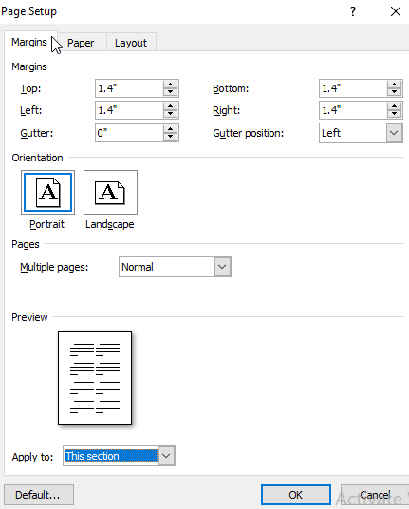

**Fig. 1** Margins of the template for page set up

The content should be sufficient and complete. Authors are also expected not to split their work to submit multiple contributions. Although the contributions are in soft copy form, the symposium organizer will not make any attempt to edit it to conform to the template format.

After screening of the contributions, the acceptance status of the papers shall be made available only on the website.

The accepted contributions have to be presented as poster during the symposium by any one of the authors. Selected contributory papers will be presented as Oral. For the poster presentation, the size of the posters will be about 90 cm width x 100 cm height. Poster presentations could be made impressive using color texts, figures, photographs and table. Three best posters will be chosen for the award on the basis of the work and presentation.

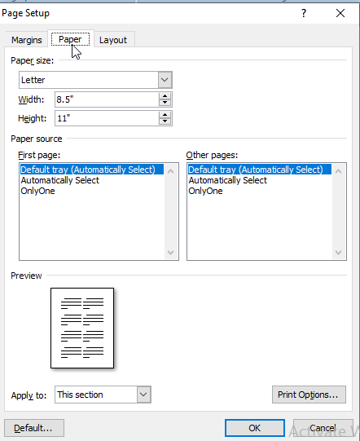

**Fig. 2** Paper size selection of the template

**References**

1. Announcement Poster and Website, 93rd Annual session of NASI.

.