Solar Positioning Algorithms and Viewshed Analysis for the Identification of Sun Glare Hazard
Selk, R., Gibb, M., Leonard, C., Poloway, L., Aktar, R.
Abstract
The sun, though an essential element to life on Earth has the potential to affect humanity in negative, even fatal ways, one of which is sun glare. The potential hazards of sun glare to road safety are known to most drivers, however there have been few studies to quantify and predict the nature, timing and severity of this hazard. Sun Glare is a significant problem for the project study area Whoop-Up Drive in Lethbridge, Alberta, Canada a large road artery connecting major portions of the city via a large river valley. The use of sun position algorithms, Digital Elevation Models (DEM), digital road networks, Global Positioning Systems (GPS), viewshed analysis and slope and direction comparisons are essential in producing sun glare hazard reports along Whoop Up Drive. Producing the Fiat Lux Model from a determined location and time of sun hazards is essential for potentially improved safety along roadways. From elevation points that were collected with the Trimble GPS unit, road slope was derived and used to enhance DEM and providing an input into the hazard rating being solar angle minus road slope. The hazard ratings are based on the angle between view direction and sun location, producing five hazard classes: not visible, low, moderate, high and extreme. Implementation of the Model provides the City of Lethbridge with accurate models that can be used to describe and potentially predict probable road hazards from sun glare.

- Introduction
Sun glare is a universal issue today as it has been in days past. Recorded history describes numerous accounts of using the sun’s position and sun glare as an advantage in medieval battles beginning in the early morning hours as the sun was rising with intentions of blinding the opponents in the west. This tactical advantage continues to be utilized today in modern day sports games where during the coin toss a team will choose a side avoiding the sun glare disadvantage.
Any motorist today depending on their time and direction of travel may be placed in a situation of hazard due to the glare of the sun. Numerous motor vehicle collisions are attributed to sun glare, blinding the vehicle’s driver and occupants and possibly creating a hazardous situation. This creates a challenge when attempting to determine who is at fault in a given situation. Until now, no reliable method has been identified to accurately verify the existence and severity of a sun glare hazard for the given time, as the position of the sun differs across the world and through time.
The focus of this paper is to provide a solution for determining sun position and sun glare hazard within a GIS for any given date and time. The creation of the model, called the Fiat Lux model, is outlined along with its possible applications and uses as an identifier of past and future hazardous locations. It can theoretically be applied to any location on Earth. Other applications also exist, such as addressing the next logical question of what can be done about hazards once they have been identified.
The primary objectives of the Fiat Lux project were to develop a user friendly model that would:
- Map the sun glare hazard along identified roadway sections for a given time or time period
- Streamline the tool to ensure universal applicability
- Provide user friendly options for input and output functions
- Demonstrate applications of the tool through case studies
The remainder of this paper is structured as follows. Section 2 provides the methodology used for the development of this tool and validation of its accuracy. Section 3 briefly outlines some example applications that have been identified and applied. Finally, Section 4 provides concluding remarks and future research areas.

- Global Methodology: The Fiat Lux Tool
The outcome of the Fiat Lux tool is dependent on the relationship between the sun and the road network (Figures 1 and 2). There are four fundamental variables that are derived and applied: solar elevation, solar azimuth, driving azimuth and local road slope. Several model components operate within this framework, each of which fulfills different requirements of the model. These components consist of a tool for calculating solar position, a DEM of the study area, a road network, a viewshed tool and a hazard classification system. All of these are integrated into the final, automated tool which is discussed in Section 2.6.
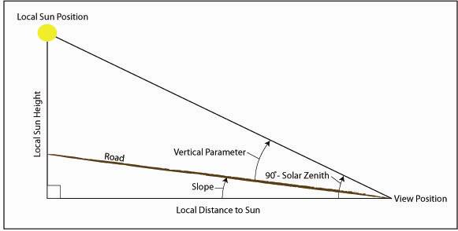
Figure 1 – Local Geometry – Side View
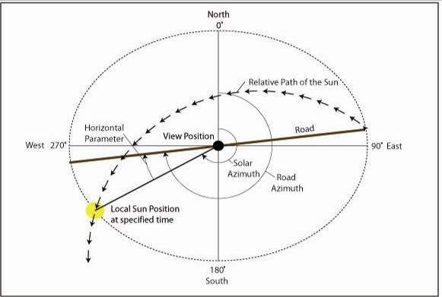
Figure 2 - Local Geometry - Top View
  - Solar Position Algorithms
The Fiat Lux model is dependent on the accuracy of the solar position calculation. A comparison of several different solar calculators was performed to evaluate the different solar positioning algorithms available. The three tools compared were SOLPOS 2.0 (Natural Renewable Energy Laboratory 2000), SPA (Natural Renewable Energy 2003) and NOAA’s Solar Position Calculator.
The NOAA tool calculates solar position for a location at a single date and time. It only provides two decimal precision on its calculations and is the least accurate. SOLPOS 2.0 calculates solar position and intensity for a given location, date and time and is valid from 1950 – 2050 CE. Time may be specified as a range in order to produce output for several time instances at once. It is based on the Michalsky algorithm, which has an uncertainty of ±0.01° (Michalsky 1988). The SPA tool focuses its output on properties of solar position and is valid for a much greater time period, 2000 – 6000 CE. As with the SOLPOS tool time may be specified as an interval. It was developed for more precise applications and has an uncertainty of ±0.0003° (Reda and Andreas 2003). The SPA and SOLPOS comparisons here show a solar zenith mean difference of 0.012740° and a solar azimuth mean difference of 0.003036° (Table 1).
Based on the results discussed above, the selected solar position algorithm is the SPA algorithm. It was selected due to (i) its documented high accuracy of ±0.0003° degrees (Reda and Andreas, 2003); (ii) validation, both in the peer-reviewed literature, and from our own independent tests and comparisons; (iii) freeware availability of the SPA.c algorithm as C-language source code. Access to the source code was important given our need to modify the software for integration into a larger software processing environment, and the requirement for rapid and numerous solar position determinations over space and time, unlike many available tools that provide sun position for one location and time using a static user interface. The actual solar position algorithm was unchanged; however, through access to the source code we could both customize the calling sequences for multiple sun position calculations and include those sequences in the larger software package whereby other modules must call SPA.c to update the current sun position due to change in driver position and/or time.

Table 1 - Solar Position Algorithm Comparison for 49.682°N 112.877°W
Date | Time | Solar Zenith Angle |  | Difference | Solar Azimuth Angle |  | Difference
Date | Time | MIDC-Solpos | SPA.c | Difference | MIDC-Solpos | SPA.c | Difference
Mar. 20 | 8am | 76.850067 | 76.850300 | -0.000233 | 105.648689 | 105.644481 | 0.004208
Mar. 20 | 1pm | 49.64151 | 49.639301 | 0.002209 | 186.969116 | 186.965617 | 0.003499
Mar. 20 | 5pm | 74.0354 | 74.031837 | 0.003563 | 250.878876 | 250.877822 | 0.001054
Jun. 20 | 8am | 58.452705 | 58.451384 | 0.001321 | 90.092079 | 90.090898 | 0.001181
Jun. 20 | 1pm | 26.756012 | 26.754627 | 0.001385 | 193.739548 | 193.742011 | -0.002463
Jun. 20 | 5pm | 57.412178 | 57.412066 | 0.000112 | 268.673157 | 268.675784 | -0.002627
Sept. 22 | 8am | 74.680428 | 74.677781 | 0.002647 | 108.736824 | 108.739667 | -0.002843
Sept. 22 | 1pm | 50.328583 | 50.330060 | -0.001477 | 191.736084 | 191.741213 | -0.005129
Sept. 22 | 5pm | 76.647522 | 76.649629 | -0.002107 | 253.620270 | 253.623767 | -0.003497
Dec. 21 | 8am | 94.269371 | 94.345902 | -0.076531 | 121.802254 | 121.806731 | -0.004477
Dec. 21 | 1pm | 73.371437 | 73.374259 | -0.002822 | 187.188019 | 187.191712 | -0.003693
Dec. 21 | 5pm | 94.283241 | 94.364193 | -0.080952 | 238.217529 | 238.219292 | -0.001763
 |  |  | Minimum | 0.000112 |  | Minimum | 0.001054
 |  |  | Maximum | -0.080952 |  | Maximum | -0.005129
 |  |  | Mean | -0.012740 |  | Mean | 0.003036

Table 3 shows all required inputs to the SPA program and the values that were used. Determination of these values was based on a sensitivity analysis.
  - Digital Elevation Model
A Digital Elevation Model (DEM) is an essential element to the functionality of the tool. The accuracy of the tool is directly reflected on the accuracy of the DEM utilized; therefore, a high accuracy DEM will yield optimal results. As the tool’s functionality is localized, minimal changes in terrain will alter the final output of the tool. The format of the DEM utilized is to be determined by the choice of GIS software, in this case ArcGIS. This software package requires an ArcGrid or raster DEM format to function. It should be noted that in the case of an urban area, a DEM which includes buildings, houses and other anthropogenic structures should be obtained to yield the most accurate results.

  - Road Network
In most instances a road network can be obtained from the local municipality; however, the network could be collected manually using a high quality GPS unit or by digitizing the network from a georeferenced aerial photo or satellite image. As the road is the primary concern, elevation points are required on the road surface itself to properly identify hazards along it. If the DEM does not already include accurate road elevations, field measurements with a high quality GPS unit would be required to accurately represent the road surface. These elevations should then be introduced into the DEM of the area of interest.
The direction of travel on the road is also required. This can be obtained from the road shapefile only if it has been digitized in the direction the road surface actually travels. This means that if there are two opposing lanes on the same road surface both lanes will have to be digitized in their proper direction. The accuracy of the road network will directly affect the final result.
  - Viewshed Algorithm
A viewshed identifies the cells in an input raster (DEM) that can be seen from an observation point (ESRI, 2006). The viewshed has a binary output, visible and not visible. In this case the viewshed tool in ArcGIS was applied with the observation point being the sun and using a digital elevation model (DEM) with road elevation information on the road network of interest. In order to account for driver eye level, 1.02m elevation (ATC, 1999) was added to the entire DEM for the purposes of the viewshed analysis. Areas identified by the viewshed as visible are considered to be illuminated by the sun and are therefore potential hazards.
The location of the viewshed visible/non-visible boundary was field validated using a Trimble Pro XRS system. The margin of error was reduced to less than 2 m using a time correction function.
  - Hazard Classification
A hazard rating system was determined in order to identify the areas of the road network where the position of the sun could be a hazard to drivers for a given date and time. As an automobile is in motion the driver views the roadway through the standard cone of vision. The cone of vision is based on both a horizontal domain and a vertical domain. In the Fiat Lux model, the primary vision cone in each domain is set to correspond to extreme hazard whereas the secondary cone corresponds to high hazard. In the primary horizontal cone dimension is 10º (or +/-5º) and the secondary horizontal cone dimension is 20º (or +/-10º) (Burnell, 2008a)..
The vertical cone dimensions were determined through field validation based on the average driver height of 1.02m (ATC, 1999) and averaged for a range of vehicle types. The primary cone dimension was determined to be -10º to +6º based on the field testing and the secondary cone dimension was determined to be +6º to +25º. In this case the primary dimension is representing the area that cannot be blocked by the sun visor, while the secondary dimension represents the area that can be blocked. The remaining hazard ratings are outlined in Table 2.
The hazard rating system is based on conditions of sun location relative to the horizontal and vertical parameters of the driver vision cones. If a section in the road does not fall within the viewshed, that section is not illuminated and the sun glare hazard can be considered to be non-existent. For a given date and time, if the road surface has a difference between solar elevation and road slope which falls within a vertical parameter range and the difference between the solar azimuth and driving direction falls within the corresponding horizontal parameter range, that section in the road is assigned the associated hazard rating at that date and time. Although the vertical and horizontal parameters have been field validated and tested, a custom rating system may be required for future studies.
Table 2 – General Sun Glare Hazard Classification System
  - System Integration Tool: The Fiat Lux Model
Horizontal Parameter  (Solar Azimuth – Driving Azimuth) | Vertical Parameter  (Solar Elevation – Road Slope) | Hazard Rating
+/-10º | -10º to 6º | Extreme
+/-10º | 6º to 25º | High
+/-10º to +/-30º | -10º to 25º | Moderate
+/-30º to +/-60º | -10º to 25º | Low
> 60º | > 25º | None

The complexity of the analysis required a number of programs and functions of various programming languages to be integrated. For this reason a C program (FiatLux.c) was developed which calls all of the programs and controls the order of operations and final outputs of the entire model. The integration of these programs and functions are illustrated in Figure 3. Utilizing the user inputs of location, date and time the FiatLux.c program calls SPA.c to perform the solar position calculation and stores the results. ArcGIS is then called and utilizes the SPA.c output to compute the viewshed, road surface slope and road azimuth which are then used as inputs into the hazard calculation. The final output is a shapefile showing hazard classes.
The FiatLux.c program has been developed in such a way that the tool can theoretically be used anywhere on Earth provided the necessary data are available. The reliability of the tool is highly dependent on the quality and resolution of DEM, the existence and quality of road network shapefile and the quality of elevation points along the road network itself, which may or may not exist within the DEM.
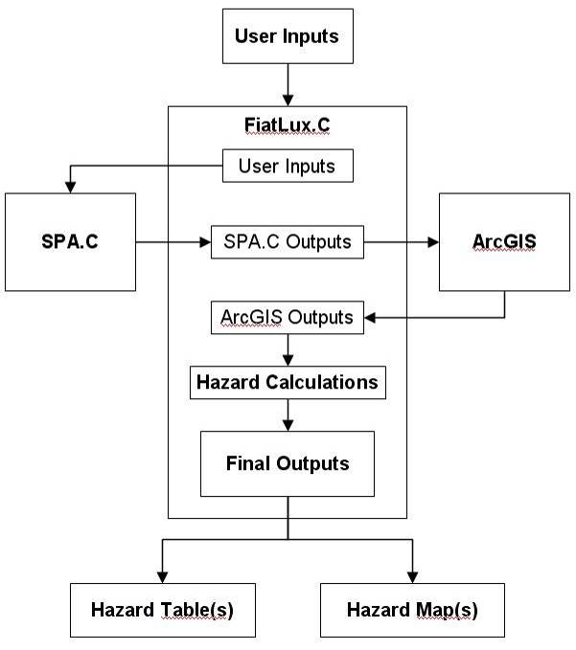
Figure 3 - Fiat Lux General Flow Chart
- Example Applications
Up to this point the focus has been on the development of the Fiat Lux tool. This section presents a few selected applications in order to demonstrate its flexibility in addressing various problems. The three applications are collision analysis, predictive hazard mapping and urban planning. In collision analysis the tool is used to verify sun hazard conditions at the time of two recorded collisions. The drivers in both situations cited sun glare as a significant cause of the incident and the validity of these claims are investigated.
The second application, predictive hazard mapping, demonstrates a more robust application of the tool. In this case the tool is run for an entire one year period and produces both hazard maps and a hazard table. Times and locations of extreme hazard situations are extracted and presented. These hazard maps and tables are then useful to planners and policy makers to determine the next course of action, which may be such things as public notification, reduced traffic flow or passive landscaping. This type of application could also be useful in roadway planning to minimize hazardous situations.
Urban Planning is the final example application explored here. It branches off of the previous two applications by providing aid to planners and/or technicians in installing some form of obstruction (i.e. passive landscaping, tinted screen, etc.) to reduce hazard levels in problem areas, which may have been recognized as a result of collision frequency or predictive hazard mapping. Based on a given hazard area and the location of the sun at that time, available locations for placing a passive sun block can be identified. The Fiat Lux tool can then be executed for situations where a block is included in the DEM and determine whether the hazards will be reduced.
All three applications are discussed in more detail below, along with their results within the study area. The input values used within the SPA tool to calculate the position of the sun for these are listed in Table 3.
Table 3 - SPA Tool Inputs Used for Applications
Input Variable | Value Used
Time Zone | -7
Elevation (m) | 1000
Pressure (mb) | 850
Temperature (C) | 10
Terrestrial Time - Universal Time | 64.7
Surface Azimuth Rotation | 180
Atmospheric Refraction | 0.5667

  - Study Area
The example applications were conducted in the study area of Lethbridge, Alberta (49°43’N 112°48’W) along Whoop-Up Drive (Figure 5). Whoop-Up Drive spans the Oldman River valley connecting West Lethbridge to the remainder of the City. The Oldman River Valley is approximately 95 meters from the top of the coulee to the river bottom. As the road climbs out of the valley to both the east and west the aspect of the road is such that the sun is in direct view of the driver at certain times in the morning and evening, resulting in hazardous travel times for commuters.
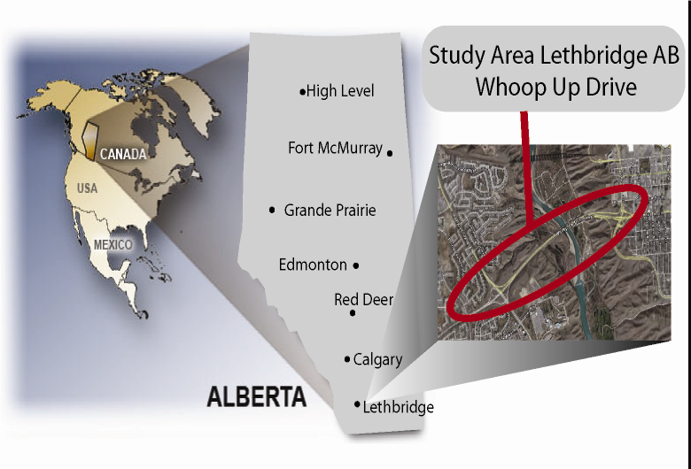
Figure 4 - Study Area in Lethbridge, AB Canada
  - Data
Model precision depends on the quality of the Digital Elevation Model (DEM) used. The DEM that was used for the example applications was created using an elevation mass point file, contour lines and breaklines which were provided by the City of Lethbridge. Due to the limited number of elevation points on the roadway in the mass points file, road elevation points where collected to more accurately represent the actual road surface. The road network was surveyed using the University of Lethbridge Trimble Pro XRS system, resulting in an improved accuracy of +/- 8 centimeters. The road network was further geo-referenced with Alberta Survey Control Monuments (ASCMs), known latitude, longitude and elevation monuments that are placed in the earth. The new road network and manipulation of the DEM increased the accuracy of the model and decreased the amount of potential error.
  - Collision Analysis
The first example application of the Fiat Lux model was to verify the presence of sun glare during known motor vehicle collisions. The City of Lethbridge traffic department reported that two separate collisions involving pedestrians occurred on the Whoop-Up drive westbound north ramp; one on August 31, 2004 at 19:25 and the other on September 25, 2007 at 18:50 (Burnell, 2008b). In both cases it was reported that the glare of the sun had played a factor in the visibility of the motorists involved.
The collision reports do not specify whether the times given represent collisions times, arrival of the police officer or the time of the assembly of the police report. The Fiat Lux model results for the recorded time indicated that on both occasions the sun in the local setting had already set, and was therefore of no hazard to the motorists in either situation. Based on these results and the uncertainty of the recorded time, the model was run for thirty minutes earlier. This time the results showed that an extreme hazard existed within the area approaching the crosswalk where a vehicle is able to begin evasive action in time to prevent a collision, which is beyond 75m for this section of the roadway (TAC, 1999). If the actual times of the above collisions were between a 30 minutes and one hour before the recorded times the results of the tool indicate an extreme hazard to the motorist and can confirm the reports of the sun as a potential factor in the collisions.
  - Predictive Hazard Mapping
This application was requested by the City of Lethbridge Transportation Department to aid in the development of sun glare hazard maps displaying peak times of sun glare which would pose potential risk to west bound commuter traffic along Whoop-Up Drive. The model was run for several situations, demonstrating the capabilities of the Fiat Lux model. Two such scenarios were a full calendar year, selecting 6:00pm on the 15th of each month (Figure 5), and a single day run August 31, 2008 (Figure 6).
Four of the twelve hazard maps for the year run do not display any data as the sun position is below the local horizon at the specified time. March and September show the presence of sun glare conditions in the extreme hazard range. For the single day run of the model, a day needed to be selected. The end of August is generally known by local commuters to have high sun glare hazards for their daily trips though the study area and could be considered as “collision prime time” (Alberta Transportation, 2004). Accordingly, August 31st was chosen for this example application and the model was run for every fifteen minutes during the evening commute between 5:00pm and 7:00pm. The results show moderate hazards for each time period, escalating to extreme during the 6:45pm and 7:00pm time periods.

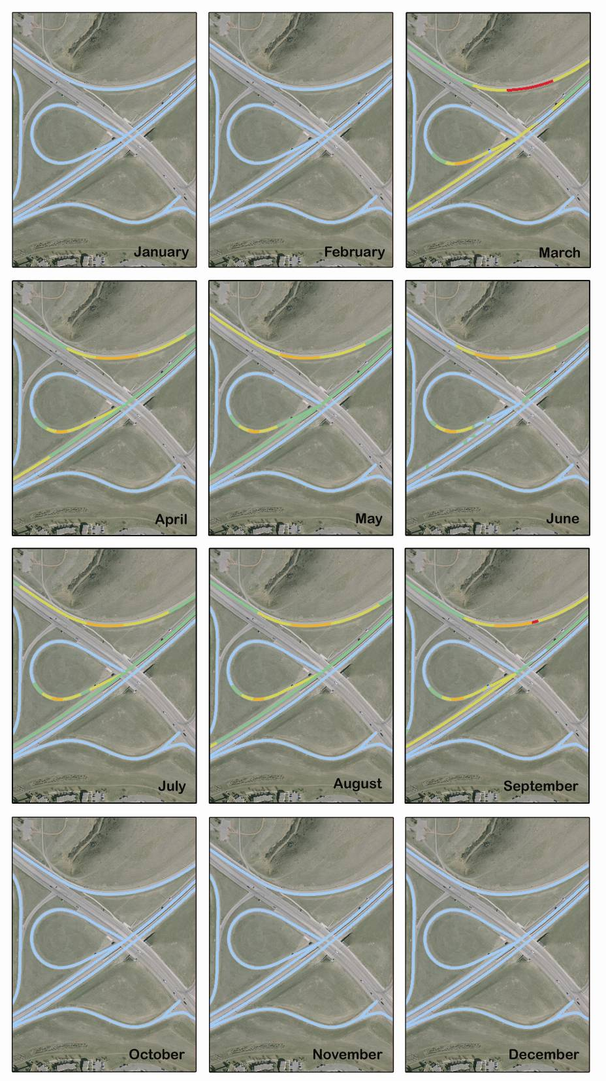
Figure 5 – Predictive Hazard Mapping for Full Calendar Year, 2008
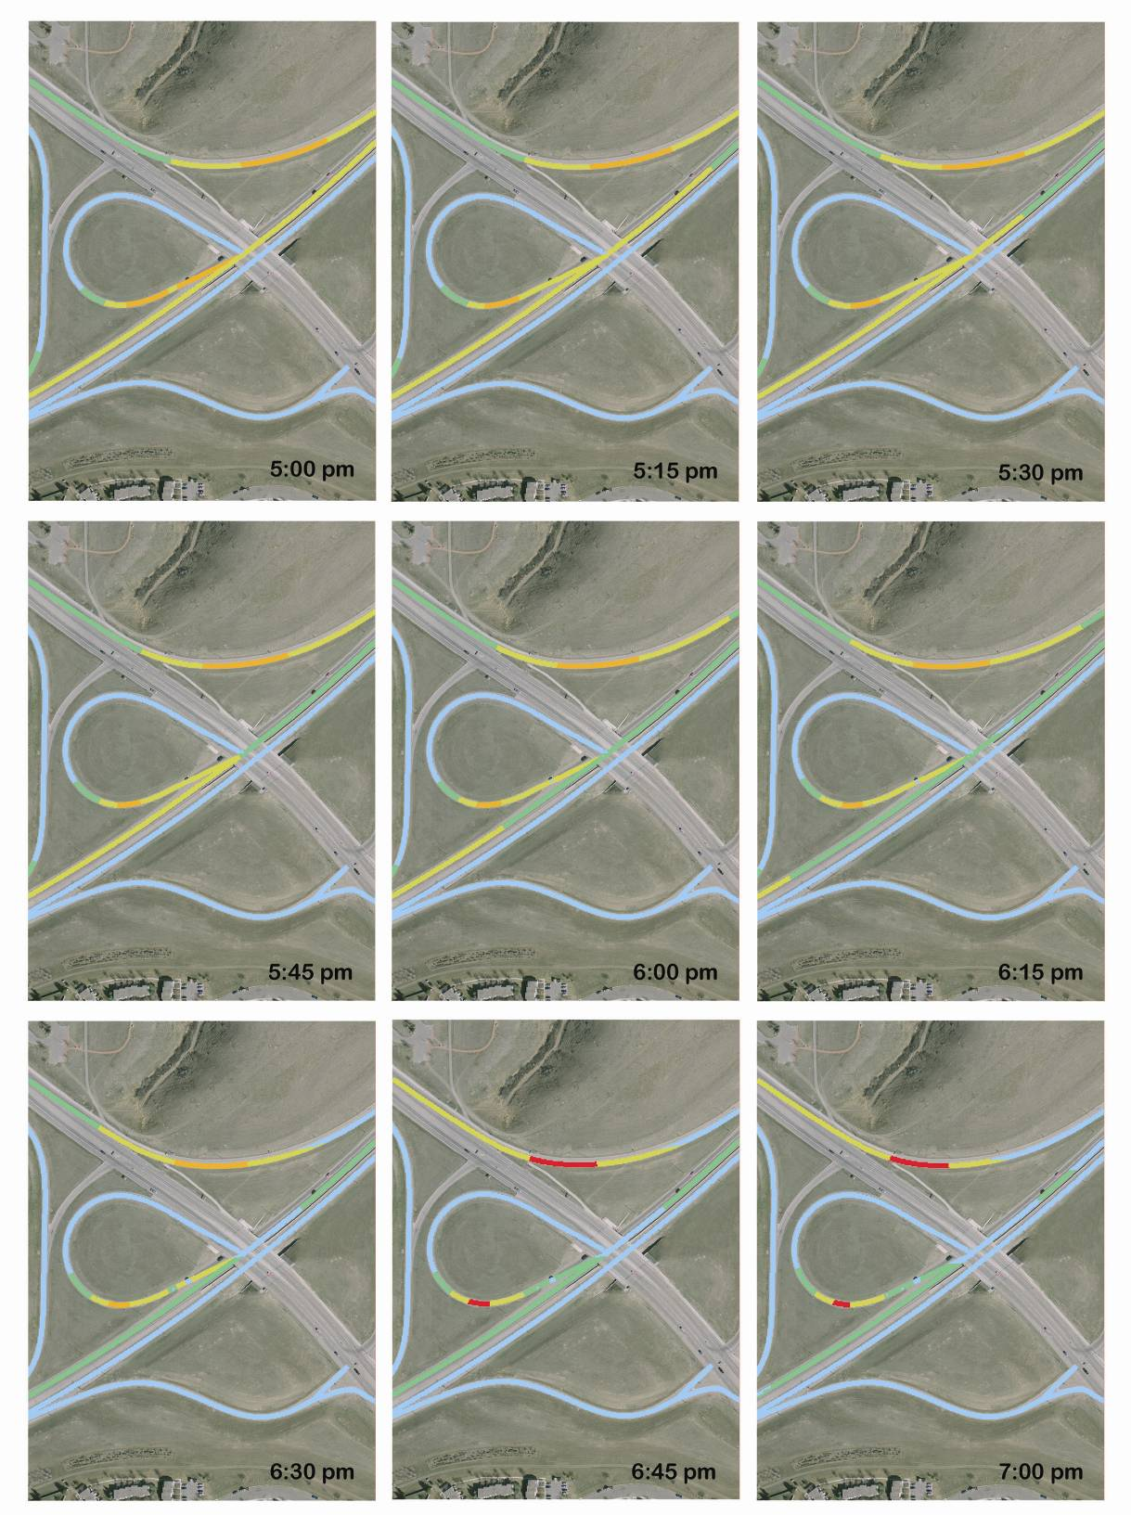

Figure 6 - Predictive Hazard Mapping for Single Day: August 31, 2008 5-7pm
  - Urban Planning: Passive Landscaping Location for Sun Glare Reduction
Identifying the impact of installing an obstruction to reduce sun glare hazard is the final example application explored here. The goal was to reduce the hazard ratings in an area within the safe stopping distance (REF) of the pedestrian crosswalk on the north ramp of Whoop-Up Drive. The date selected was August 31st, 2008 at 6:30pm. Based on the area of concern and the location of the sun at this time, two potential obstruction locations were identified. A viewshed was created for each block at various heights to examine its influence on the study area (Figure 7).
Results show that obstruction heights significantly greater than 10m are required in both locations to eliminate the hazard. A height of 30m is required for Block Location A, while 40m is required for Block Location B. While this is a major problem, there is also the issue that these obstruction locations are only valid within a given time period. Despite these challenges with the chosen study site, this application has shown that the Fiat Lux model can be used to analyze the suitability of obstruction placement for the minimization of sun glare hazard.

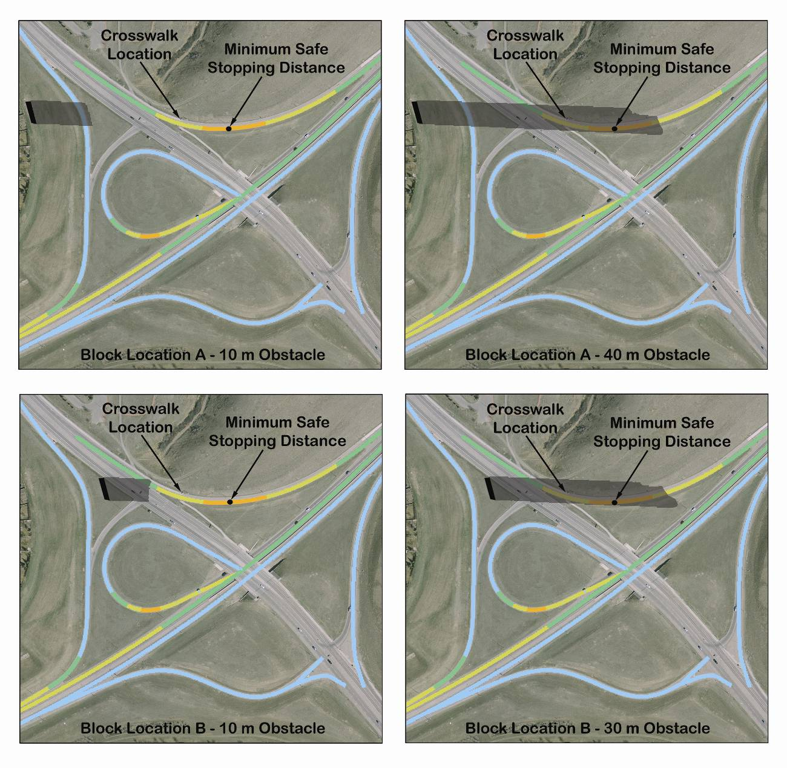
Figure 7 - Passive Landscaping Obstacle Locations and Regions of Impact

- Conclusion
The Fiat Lux model has been shown to address the universal problem of sun glare. It identifies the driving hazard in a given area for a given time period. The tool has been applied to verify the legitimacy of sun glare to a motor vehicle collision, to aid in determining the optimal location and size of passive landscaping required to minimize risk in a high sun glare hazard area, and to identify extreme hazard locations and times throughout the year. The above example applications expose the potential benefits the tool can create and provide the opportunity for the creation of several others.
There are numerous applications that can be developed based on the Fiat Lux model for potential clientele such as municipalities, architectural firms, urban planners and developers. Possible future applications to be explored are to determine the optimal location of solar collector positioning equipment and for urban agricultural applications. Construction and engineering project managers could use the Fiat Lux model when preparing to construct new roadways to minimize sun glare hazard, or buildings to allow the most available sunlight into a building, benefiting from natural illumination and reducing use of electricity. The universal applicability of the tool allows for it to be potentially applied in any region of the World in a variety of applications.
- References
Alberta Transportation (2004). Traffic Safety in Alberta, 20 Dec. 2004. Accessed 15 Apr. 2008 at http://www.saferoads.com/drivers/rules_donts.html.
Burnell, S. (2008a). Personal communication. City of Lethbridge Traffic Department. February 28, 2008.
Burnell, S. (2008b). Personal communication. City of Lethbridge Traffic Department. March 31, 2008.
Fiat Lux Technical Report (2008).
Michalsky, J. J. (1988). The Astronomical Almanac’s Algorithm for Approximate Solar Position (1950-2050). Solar Energy. Vol. 40, No. 3, pp. 227-235.
Reda, I.; Andreas, A. (2003). Solar Position Algorithm for Solar Radiation Applications. 55 pp.; NREL Report No. TP-560-34302, Revised January 2008.
Transportation Association of Canada (TAC). (1999). Geometric Design Guide for Canadian Roads. September 1999 Edition.

