Distributed battery optimization to minimize cumulative aging

Team members: Lin Xia, Raja Selvakumar, Yaser Marafee, Yu-Hsin Huang

# Abstract

*Lithium ion batteries currently dominate the battery market for energy storage applications. Cycle life is critically important, but prediction is mostly based on empirical trends, rather than mathematical models. In addition, modelling frameworks that apply to a single battery may not translate to combined battery circuits. The focus of this project is to characterize aging and fade in distributed battery networks. We will compare a physical model with a theoretical one by studying stochastic and analytic techniques. After this, we will design a control framework to more optimally distribute power during charge cycles. To ensure the rigidity of the model, we will conduct parameter sensitivity to assess model behavior in the presence of unpredictable boundary conditions.*

# Introduction

## Motivation & Background

With growing global concerns over CO2 emissions from energy sources, there is strong motivation for cleaner energy sources. In recent years, batteries have been seen as a promising future for vehicular transport, mainly due to their high energy density and power density values. As Figure 1 shows, while battery technology does not currently compare to gasoline, it feasibly holds the next best power to energy density ratio.

Fig. 6. Ragone plot for comparing the energy storage technologies and their power density versus energy density characteristics Tester (2005)  
                

**Figure 1**. Ragone Plot comparing various energy storage methods. Battery technologies are seen as a promising replacement to gasoline in the future (Tan and Panda 2010)

In battery technology, today lithium ion stands alone for the highest peak power and specific energy values. This statement can be corroborated in Figure 1. For larger grid energy storage applications, multiple batteries are combined in modules to aggregate power. These applications include home energy storage and car batteries for electric vehicles. And this trend is observed in other technologies as well: recent development has focused on improving the cathode material to reduce cost without compromising on performance.

These new technologies motivate theoretical modelling of battery behavior. Knowledge of system behavior over time is desired to better design batteries at the start. As Figure 2 demonstrates, there are a host of potential reasons for Li-ion aging. Determining ideal power distribution from a combination of new and aging batteries is important to prevent frequent replacement and overcharging of charged batteries. In the EV market, this information provides insight for range prediction and lifetime analysis. Current research has only been able to study capacity fade in smaller systems, and that too limited to physical mathematical models without experimental insight (Baek, Hong, and Cha 2014). We see a unique opportunity to characterize parameters that affect charge/discharge rates while enforcing a control mechanism to withdraw/provide targeted power to the right cells.

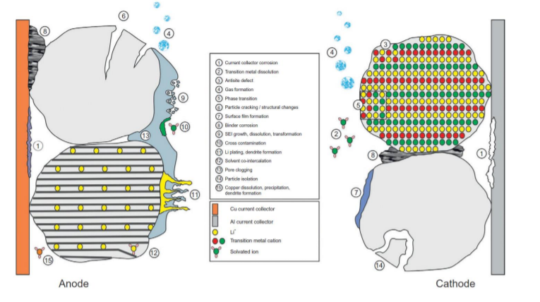

**Figure 2**. Lithium ion battery aging mechanisms in EV applications. Storage and operating conditions both combine for numerous effects on battery aging. (Vetter et. al 2005)

Our group consists of four chemical engineering masters students in the Product Development Program. We have all taken classes in electrochemical systems, ranging from mathematical fundamentals to first steps of solid-electrolyte interphase (SEI) modelling. These experiences provide us an advantage to test the differences between black-box and white-box modelling approaches. There are some ambitious challenges to address when attempting to model material degradation in these batteries from physical intuition, while also converting it to a control problem with fast response time. As a team, our goal is to learn advanced control and machine learning techniques, so we hope to show this in our project results. We recognize that better autonomous battery monitoring is a pressing challenge and would like to embark on the challenge.

## Focus of this Study

This study will focus on studying capacity fade in distributed rechargeable battery technologies. We break down our focus into **two parts**: a) understanding parameters that contribute to battery aging and material degradation and b) designing a control framework to optimally distribute power to/from the battery fleet. With this two-prong focus we aim to automate battery monitoring, hopefully even when faced with unpredictable thermal and catalytic degradation.

# Statement of Work

|  |  |  |
| --- | --- | --- |
| Workstream | Detailed responsibilities | Lead person |
| Review of existing battery models | * Study existing physical models, determine gaps in techniques * Determine key parameters that contribute to aging * Develop modelling equations * Identify problem target: EV or household market | *Yu-Hsin Huang* |
| Analysis of power distribution methods from battery fleets | * Understand existing configurations of batteries in cars * Obtain experimental data for battery monitoring * Identify feasible test cases to observe model feasibility | *Lin Xia* |
| Develop model | * Formulate linear programming model for a basis of comparison * Develop more advanced stochastic or analytical model * Compare results of two models with experimental values * Conduct parameter sensitivity analysis | *Yaser Marafee* |
| Implement control framework | * Formulate dynamic programming objective * Analyze time-dependent performance behavior * Tune control variables to match experimental data | *Raja Selvakumar* |

# Summary

Distributed battery lifetime analysis and control is a pressing problem in industry today. From EVs to households, the need for autonomous power distribution is growing. Thus far, most mathematical models have been empirically derived, while the physical models represent individual battery aging. The focus of this study is to a) create a robust mathematical model that can more accurately predict lifetime while withstanding haphazard parameter fluctuation and b) to construct a control framework to optimally distribute power during charging/discharging cycles.

# Relevant Literature

Yen Kheng Tan and Sanjib Kumar Panda (2010). Review of Energy Harvesting Technologies for Sustainable WSN, Sustainable Wireless Sensor Networks, InTech.

Baek, K.W., Hong, E.S. & Cha, S.W. Int. J Automot. Technol. (2015) 16: 309. <https://doi.org/10.1007/s12239-015-0033-2>

Abbas Fotouhi, Daniel J. Auger, Karsten Propp, Stefano Longo, Mark Wild. A review on electric vehicle battery modelling: From Lithium-ion toward Lithium–Sulphur. Renewable and Sustainable Energy Reviews. Volume 56, 2016. Pages 1008-1021. <https://doi.org/10.1016/j.rser.2015.12.009>.

Vetter, J., Novák, P., Wagner, M. R., Veit, C., Möller, K. C., Besenhard, J. O., ... & Hammouche, A. (2005). Ageing mechanisms in lithium-ion batteries. Journal of power sources, 147(1), 269-281.

Pinson, M. B., Bazant, M. Z (2013). Theory of SEI Formation in Rechargeable Batteries: Capacity Fade, Accelerated Aging and Lifetime Prediction. Journal of The Electrochemical Society. Volume 160. Pages A243-A250.

Grun, T. Stella, K. Wollersheim, O (2017). Impacts on load distribution and ageing in Lithium-ion home storage systems. Energy Procedia. Volume 135. pp 236-248. <https://doi.org/10.1016/j.egypro.2017.09.508>