Optimization Project - MiniBooNE Particle Identification

1. Presentation of the Dataset
1.1 General Overview
This dataset was obtained from the repository of the University of California UCI - Machine Learning Repository. The dataset is taken from the MiniBooNE experiment and is used to distinguish electron neutrinos (signal) from muon neutrinos (background). The characteristics are the following:

- 130,065 instances (samples).
- 50 attributes.
- 2 categories (electron and muon)

The MiniBooNE experiment at Fermilab is designed to observe neutrino oscillations, BooNE is an acronym for Booster Neutrino Experiment. When doing the experiment the neutrino beam consists mostly of muon neutrinos and that is why the data is unbalanced, but this is going to be shown later in the EDA section. The 50 attributes from the dataset are continuous variables that are measurements taken in the MiniBooNE detector.
The motivation for choosing this dataset is because I’m interested in applying Statistical Learning to Physics. Also, I wanted to try optimization algorithms like Gradient Descent with a ~big dataset to see how the theoretical concepts seen in class performed in practice. However, working with a matrix of dimension 50 * 130,065 resulted to be an unfeasible experiment with the computational resources that I have, that’s the reason I performed others methods to obtain good results in this problem.
1.2 Exploratory Data Analysis
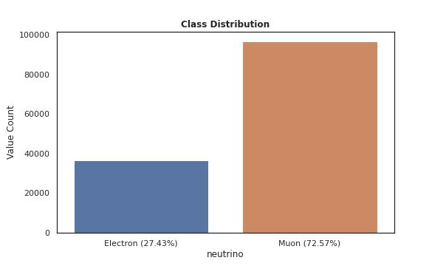

Figure 1 “Class Distribution”

The above figure shows that the data is Highly Imbalanced, because 72.57% of my data belongs to the class Muons, this is because in the BooNE experiment the neutrino beam consists of mostly Muons. There are many techniques I can use to overcome this obstacle like:
- Artificial Data Balancing: Down-sampling and Up-sampling techniques.
- Changing the loss function to take in to account the minority class.
The class distribution is important because with a very Unbalanced dataset I can’t really in metrics like accuracy to evaluate the optimal classifier.
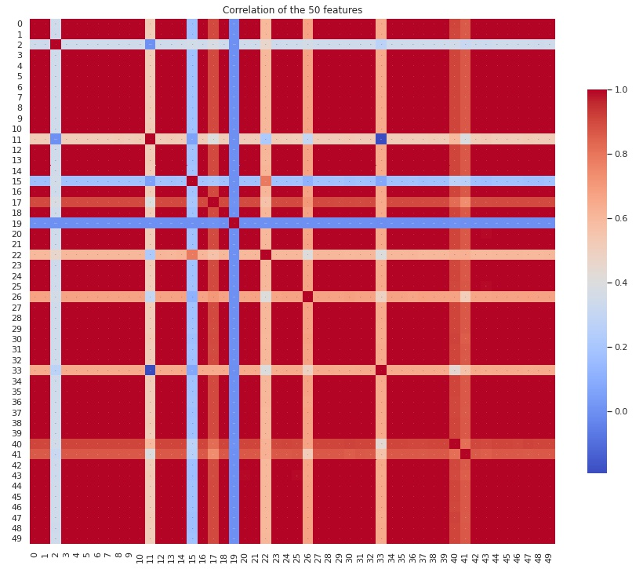

Figure 2 “Heat map of the correlations”
As we can see from Figure 2 the data is also highly correlated, which means there are some features that gives the same information, that’s why we are going to check different dimensional reductions so we can reduce the feature space. Additionally, it is important to mention that reducing the feature space dimensionality will help in the time of model computation and also will help in avoiding what some ml practitioners called “The curse of dimensionality”.
Before, we performed a dimensionality reduction technique we will scale our feature values with the MinMaxscaler of sklearn. This estimator scales and translates each feature individually such that it is in the given range on the training set, e.g. between zero and one.
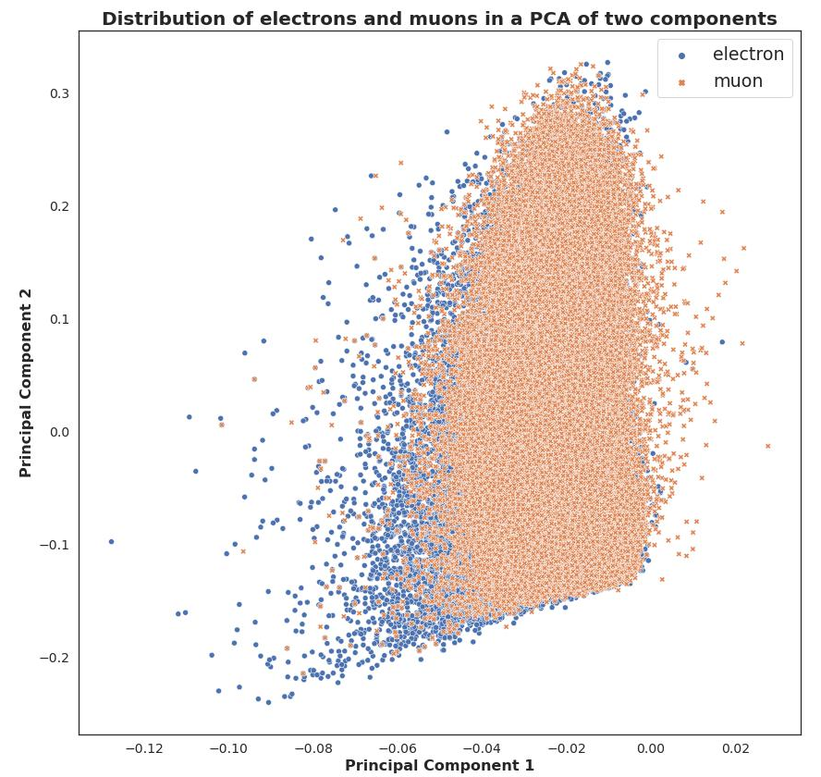
Figure 3 “Plotting the labels in a 2d space with PCA”
We can see in Figure 3 that as we expected the data is not linearly separable in 2d, that means that we will need more PCA components to perform logistic regression. However we can see that there are some electrons that are very far away from the cloud of muons, so they should be easy to classify.

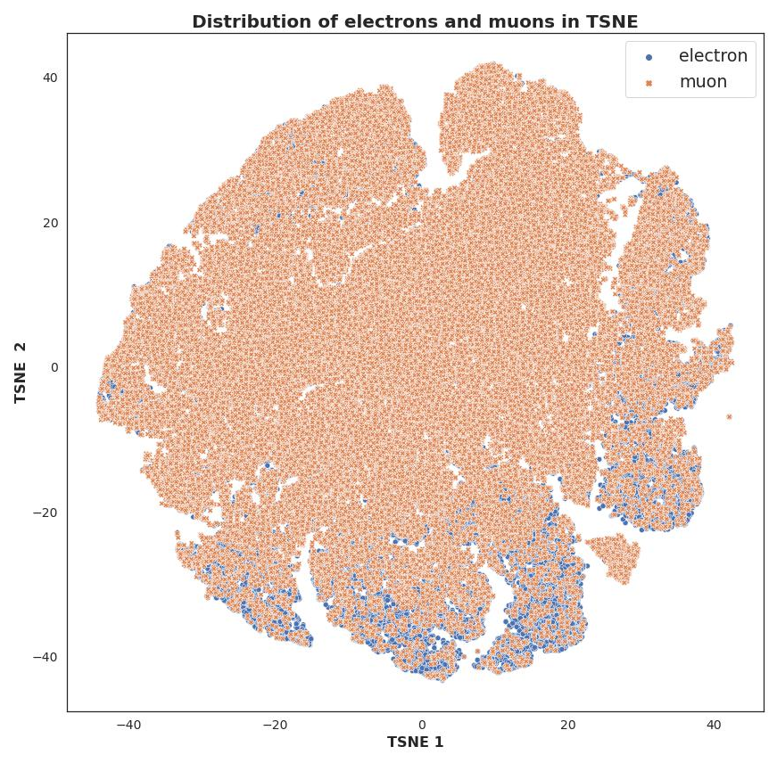
Figure 4 “Plotting the labels in a 2d space with TSNE”

We used another reduction algorithm named TSNE, one important thing here to mention is that the time to perform this algorithm was much greater than PCA. We can conclude from this plot the same statements as with PCA, the data is not linearly separable in 2d.

Which dimensionality reduction technique to choose? There are some theoretic intuitions on which dimensionality technique will be best. However, we are going to choose PCA because the computational time it takes to execute is much smaller than other techniques like: TSNE, ICA, etc. However, in a real world problem will be good to create an iteration planned to choose the best reduction technique.
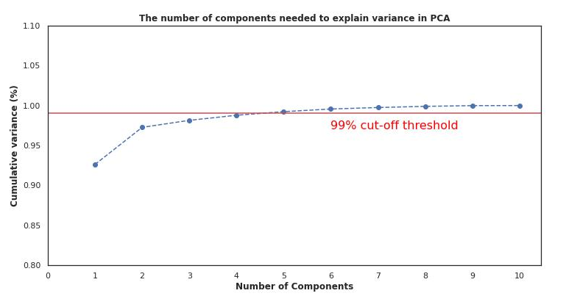
Figure 5 “Variance in PCA”

From figure 5 we can see that four or five components of PCA explained 99% of the variance of our problem that is why we are going to choose 5 PCA components.

Lastly, it is important to mention that we don’t find any Null values in the dataset and we did found 6 outliers, but they were removed from the dataset. Because we have almost 130k samples, removing the outliers will not affect our algorithm.
2. Presentation of the Problem

Our problem is a binary classification problem. That’s why we are going to use logistic regression, because it is a linear model, thus it is simpler and with a computational time that makes it feasible to train. However, due to it’s simplicity maybe we can’t obtain good results. The loss function better suited for Logistic Regression is:

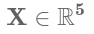

Equation 1 “Optimization Problem and Loss Function in Logistic Regression“
In our problem, the binary labels represent the following: -1 is the electrons and +1 the muons. It is important to mention that we are splitting our data into train and test set. X_train.shape = (93144, 5), X_test.shape = (39920, 5) and y_train = (93144,), y_test = (39920,)

3. Test of Stochastic Gradient Descent
In this section we will explained the experiments we performed with Stochastic Gradient Descent, as well as comparisons with Gradient Descent. The first thing that we learn at doing this project is that in some cases SGD is very slow and takes a lot of computational time.

The reason SGD is so slow is because with gradient descent, we calculate the gradient of all the dataset at once. With SGD, we calculate it on each sample, and then we do the same for other sample, until we have done 1 full pass through the data (1 epoch). In other words, in 1 epoch gradient descent makes only 1 gradient calculation and SGD makes n gradient calculations. Each calculation in SGD is faster than GD, but not n times faster. That’s why in this problem we couldn’t run the algorithms with the whole dataset ~93k samples in SGD, even though we tried. That’s why the following results with SGD are going to be of a sub sample of the previous dataset of 10k samples, in this sub sampling the data is going to be balanced, that means 5k samples of the category -1 and 5k samples of the category +1.

3.1 Different step sizes in Stochastic Gradient Descent

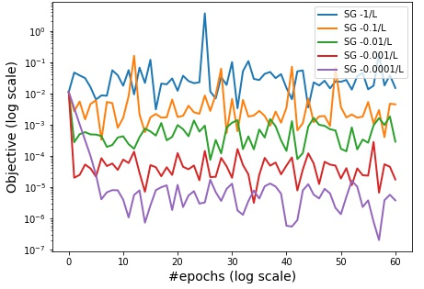
Figure 6 “Different Constant Step Sizes with Stochastic Gradient Descent”

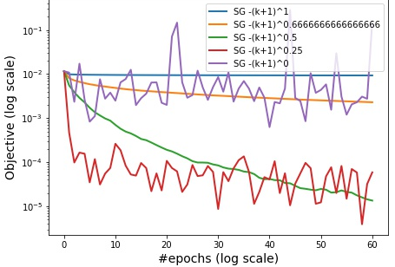
Figure 7“Different Decreasing Step Sizes with Stochastic Gradient Descent”
Observations of Figure 6 and 7:

- Both Figures: We observe the oscillating phase of SGD, because the method stalls and takes steps that improve or worse the objective value.
- Both Figures: We can see that the only step size that is actually converging is the decreasing step size of (k + 1) ^ 0.5. This is because there is no guarantee of converging with SGD, because it is not a descent method.
- Both Figures: We can observe that SGD rapid decreases in the first iterations but then stalls and begin to bounce up and forward.
- Figure 6 (Constant Step Size): It doesn’t matter the step size, because neither of them are converging. Theoretically, using a very small step size will lead to slow convergence and a very big step size would lead to an oscillatory behavior with no convergence. That’s the reason, that my guess is that all step sizes are too big and prevent SGD from converging. If I have to run this method again, I will choose even smaller step sizes.
- Figure 7 (Decreasing Step Size): The blue and orange trends are trapped in a sub linear convergence rate. We can see the oscillatory behavior of SGD, as well as it rapid decreasing in the first iterations.

3.2 Different batch sizes in Stochastic Gradient Descent
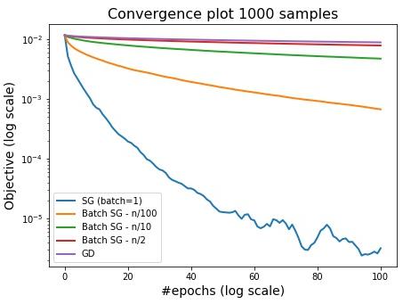

Figure 8 “Different Batch Sizes with Stochastic Gradient Descent”
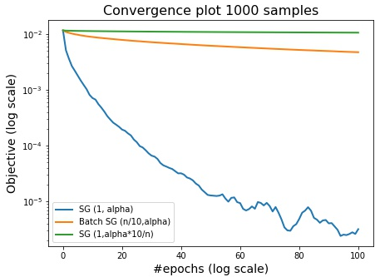

Figure 9 “Different Batch and Step Sizes with Stochastic Gradient Descent”

To obtain the figures 8 and 9 we had to sub sample the dataset of 10k samples to only 1k. The reason is that the computational time it took to compute the method SGD was too long.

Observations of Figures 8 and 9:
- In computational processing time the bigger the batch size, the faster it processes (When progressing the dataset of 10k).
- Both Figures: We weren’t expecting the behavior of SGD when the batch size is equal to 1, because it is decreasing in a good fashion and only at the end it presents and Oscillatory behavior. We taught that this behavior maybe was caused by a bug, but after the checking the code for many time we arrive at the following conclusion: The reason SGD batch size=1 is not presenting a very Oscillatory behavior is because in our 1k sample there is not a lot of variance in the data, so all the data is very similar and there is no outliers. However, a model trained with only 1k variable will obviously not generalize well the problem and perform poorly in test data.

- Mandatory things to put in the report:
- Presentation of the dataset. It should be medium scale (~10K points/features), and as original as possible. This part can include some useful visualization (1D display of features, histogramming, pca, t-sne, etc).
- Presentation of the problem. It can be either classification (2 or more classes) or regression.
- Test of batch gradient descent, with exploration of at least the descent step size and link with the course.
- Test of accelerated gradient descent (Nesterov),
- Test of stochastic gradient descent (impact of hyperparameters such as learning rate, (mini)-batch size, diagonal scaling, etc)
- Test of regularization (ridge/lasso using iterative soft thresholding)

