# Installation

1. Download the latest binary to match your platform from: ptsafe.wordpress.com/download
2. Run the executable installer (*.msi) and follow the prompts to install PT-SAFE.

# Getting Started

1. Launch PT-SAFE from C:\Program Files\PTSAFE\PTSAFE.exe
2. Adjust the sound card settings. If you are familiar with advanced settings, such as buffering size and sampling rate, you can click “Show advanced settings…” If you would like to test your sound card and audio setup, click the “Test” button, and you should hear a tone for a few seconds. 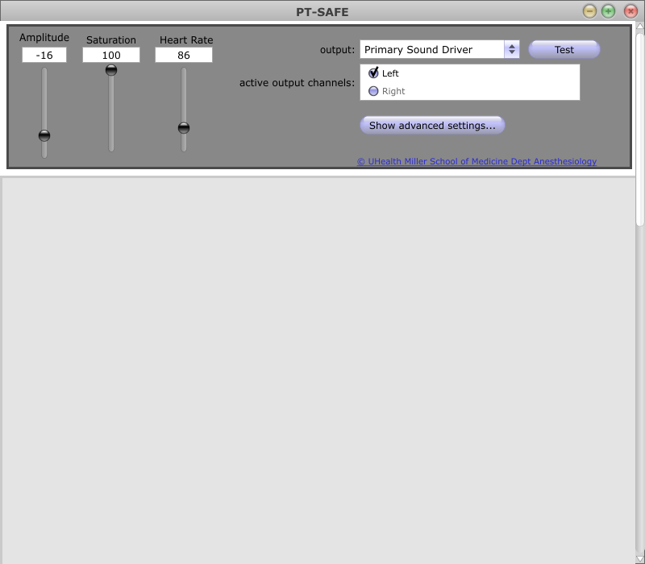
3. To create a new alarm, right click in the lower panel, and select “Add new monitor”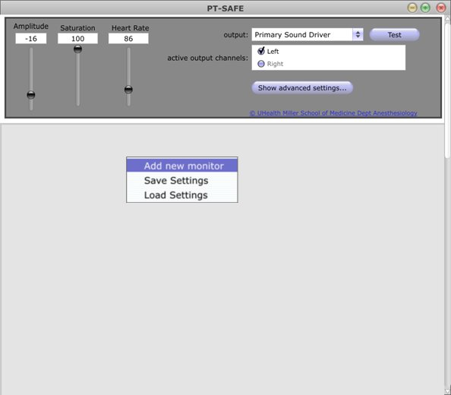
4. Select the Vital Sign to be monitored using the drop-down menu. The vital sign indicator will be displayed by a black dot that is in either a green, yellow, or red region. These indicate normal, cautionary, and emergency level values for that vital sign. These thresholds can be manually adjusted.  
   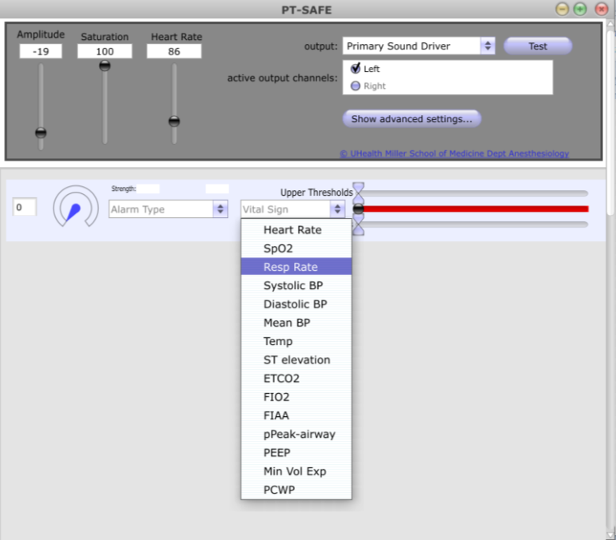
5. Select an alarm type to use using the drop-down menu. The alarm effect strength is governed by the Effect Strength circular knob.   
    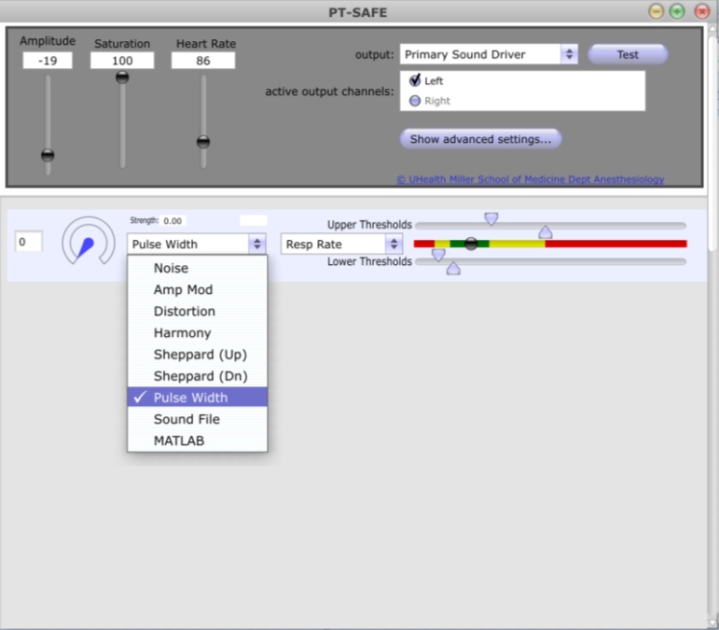
6. The alarm baseline, or effect strength when the vital sign is operating in the normal range, can be set by adjusting the effect strength knob to the desired setting, then by right clicking within the alarm module, and selecting “Set Baseline”  
   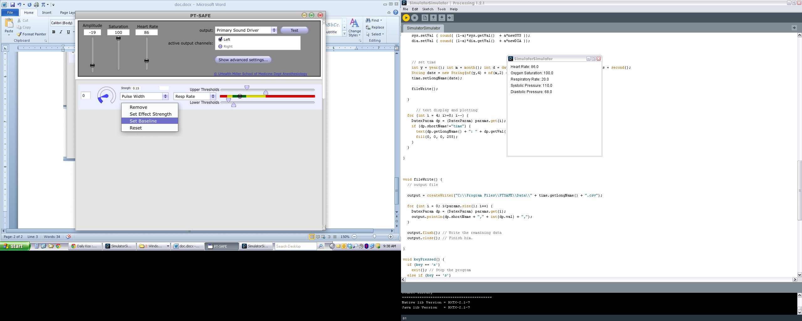
7. The Effect Strength for cautionary and emergency levels can also be set. First, adjust the threshold value to the proper value. Next adjust the Effect Strength to the desired setting. Finally, right-click in the alarm module, and select “Set Effect Strength”. When the vital sign value passes that threshold, the alarm Effect Strength will be applied accordingly.  
   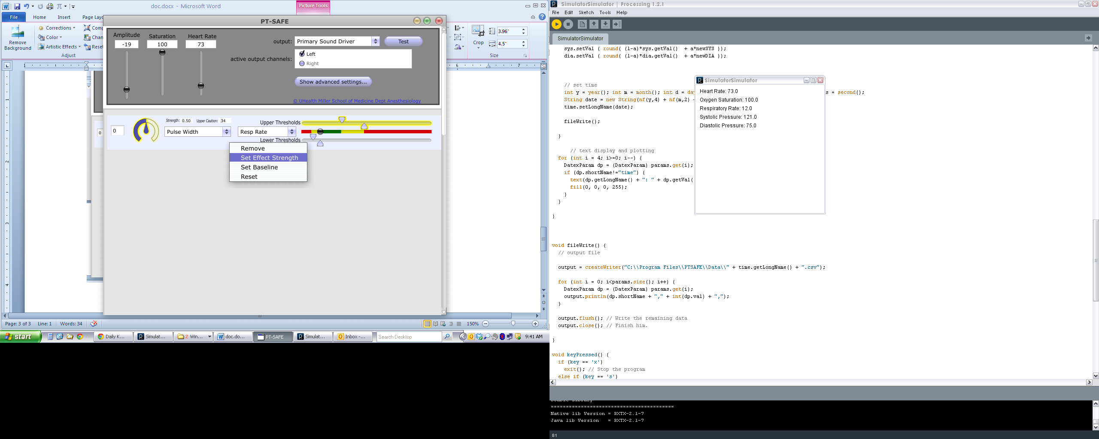
8. Additional alarms can be created. Once all of the desired alarms and settings have been created, you can save the alarm settings be right-clicking outside the alarm modules and selecting “Save Settings”.   
   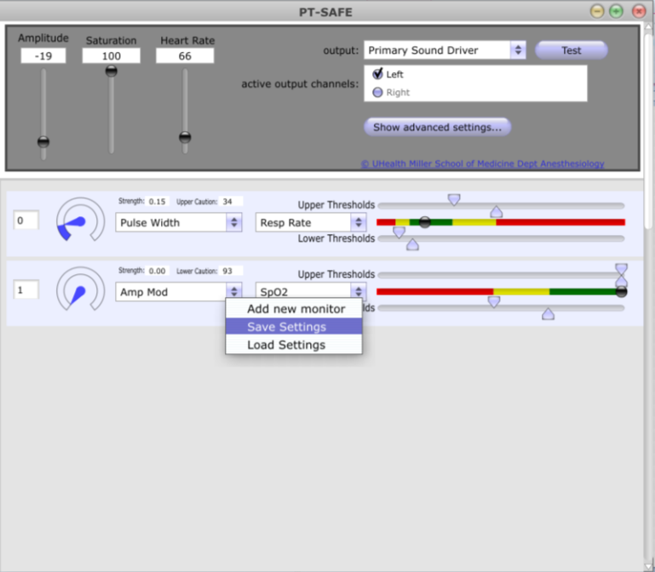

# Loading existing sound files

1. Select the alarm type as “Sound File”
2. From windows explorer, select 1 or 2 wave-format files from your hard disk, then drag-and-drop those files onto the alarm module. If the files have loaded correctly, one of the file names will appear just below the drop-down menu.
3. Setting the Effect Strength knob between 0 and 0.33 will result in no alarm, between 0.34 and 0.66 will result in the alarm with the label “lower”, “medium”, “cautionary”, or “warning” to play, and between 0.67 and 1.00 will result in the alarm with the label “upper”, “high”, “emergency”, or “danger”.

# Using Matlab to create a custom alarm

* Your custom Matlab algorithm must use the following interface:  
  function [y, state_ret] = foo(x, u, state, id)
* The vector ‘x’ is the input audio buffer. The size of this buffer corresponds to the size indicated in the “Advanced Settings…” under the audio interface setup.
* The output audio buffer (what will actually get played by PT-SAFE) is the vector ‘y’, that should be kept the same dimension and size as ‘x’.
* The scalar ‘u’ is a value from 0 to 1 that indicates the value of the Effect Strength knob.
* The vector ‘state’ is a protected block of memory (1024 double-precision floats) that can be used to store any kind of data. Changes to ‘state’ are made persistent by returning them as a vector in ‘state_ret’.
* Finally, the scalar ‘id’ indicates the vital sign being monitored, whereby HR=1; SPO2=2; RR=3; SYSBP=4; DIABP=5; MNBP=6; TEMP=7; ST=8; ETCO2=9; FIO2=10; FIAA=11; PPEAK=12; PEEP=13; MVE=14; PCWP=15.
* An example Matlab program is included in the main trunk at code.google.com/p/ptsafe
* The program is compiled using the Matlab compiler, and the command:  
  mcc –B csharedlib:foolib foo.m –C
* Finally, add the files foolib.dll and foolib.ctf to C:\Program Files\PTSAFE\bin. Note: you may want to backup any existing foolib.* files in this directory first before replacing them.