I have created two Test cases for verifying the user account id as well as the Profile name is correctly displaying on the My plan Page after editing it. All code is written in Selenium Webdriver and Python.

To run the test you have to use: pytest <file path>, In my case for example : pytest Tests/test_account.py. I can explain you the whole working of code in our call, no worries. 😊

Below are the Screenshot of Test Reports and successfully passed test ran under Pytest:

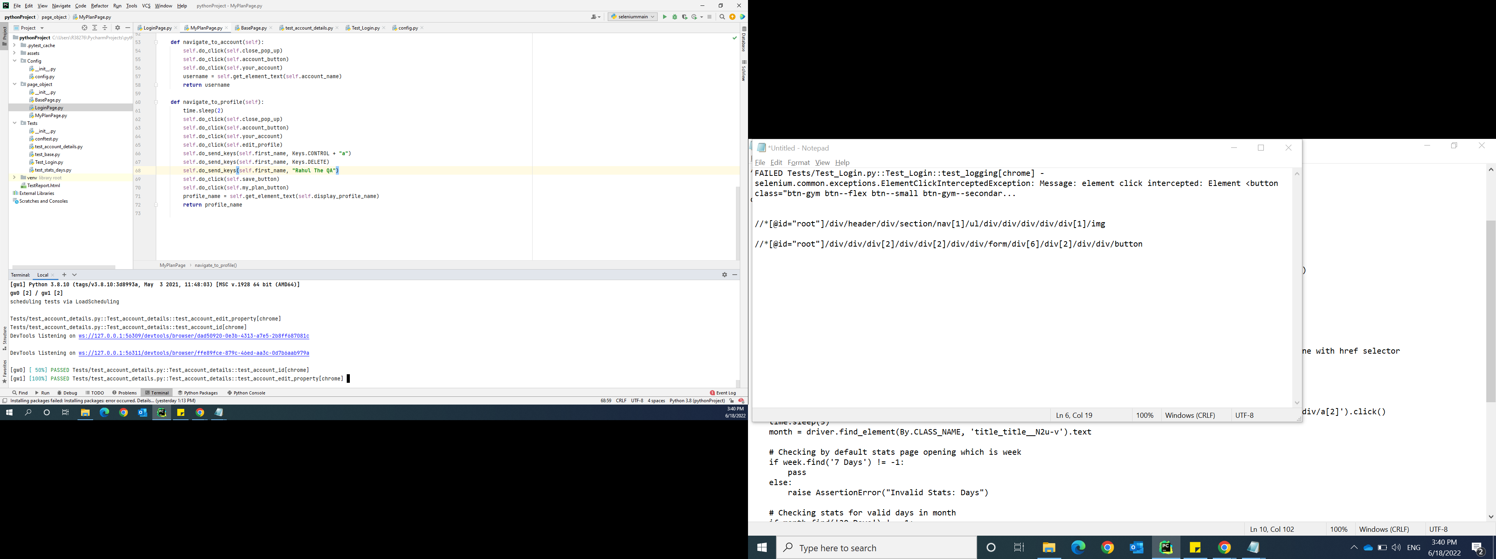

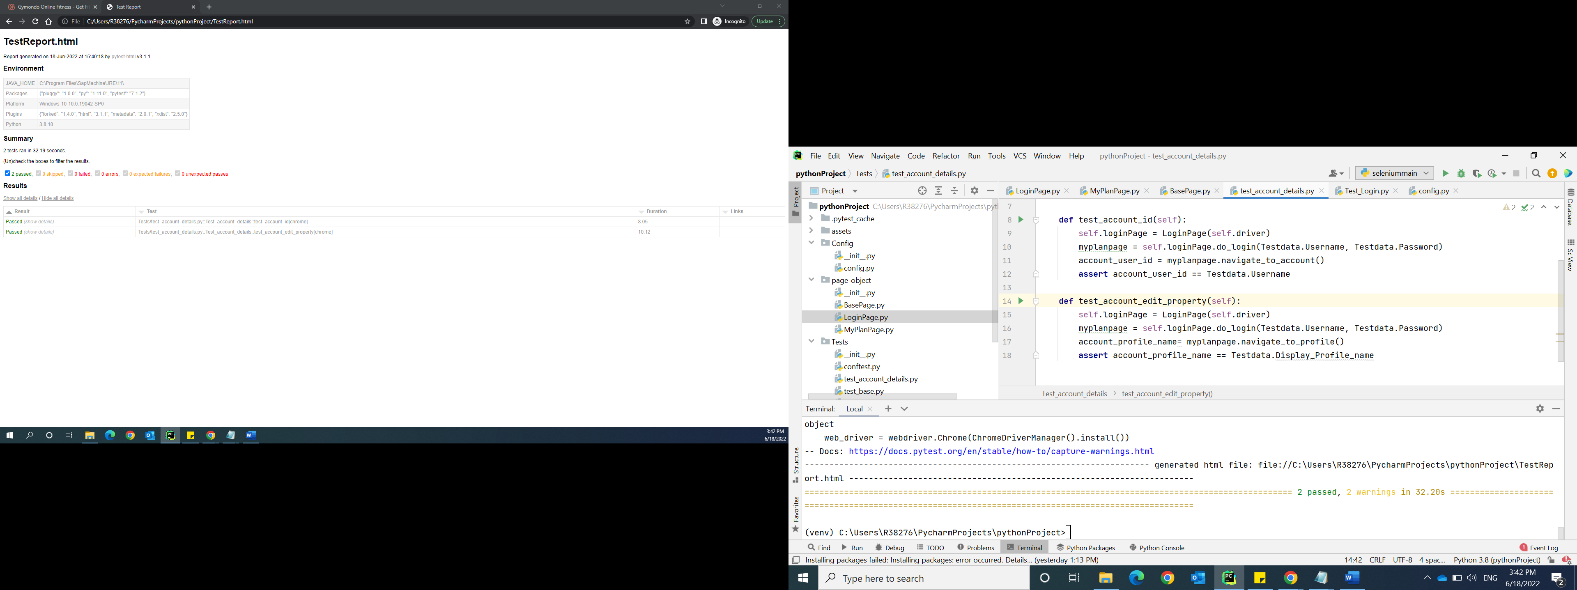

And I have created 3 test cases for Stats which do validate whether Days, Months and Year is correctly displaying and as you can all are successfully ran under Pytest and created a Test report for the same:

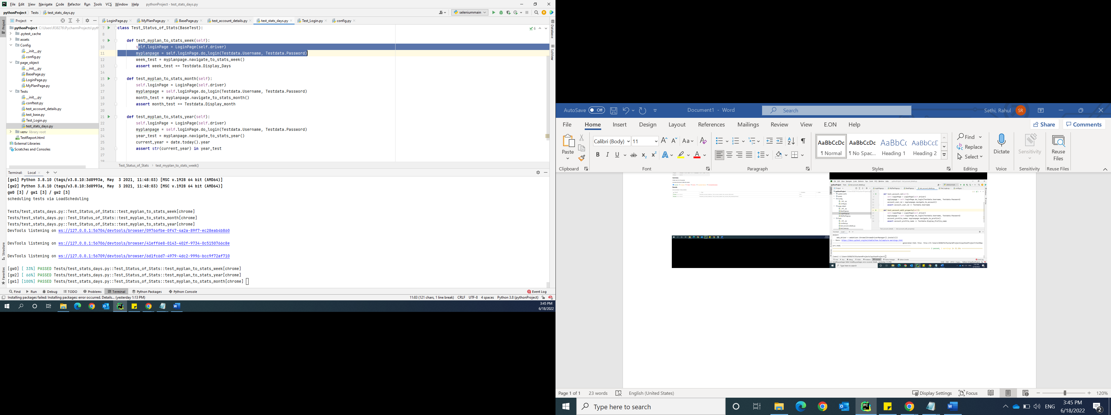

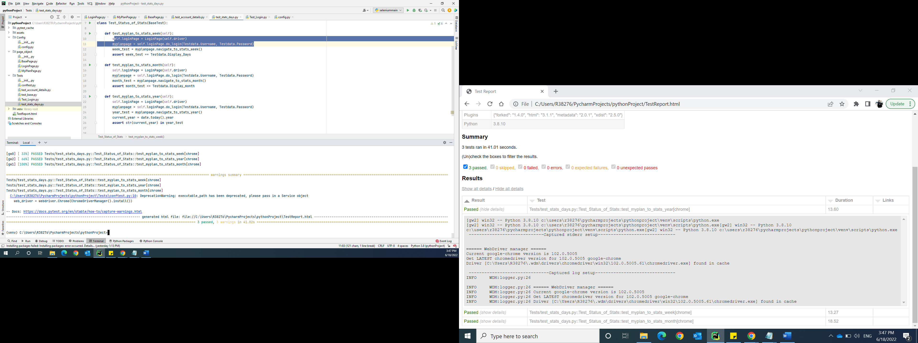

I would have created the n number of Test cases in xlsx and send you, but I already given a lot of time for this Test Cases to make it perfect with a Proper POM framework used and it took a lot of time, so I’ll not write the Test cases in Excel as I have my own things to do. Thank you.