# Forms loader/updater.

First off this is a use at your own risk tool.

The tool is hosted in the US here https://issuesimpexp.herokuapp.com/

## Usage suggestion

The best method is to export a template of your form definition rather than go it alone in excel. This will also export the form instances for that definition should you want to update them. You must have an instance of that definition in the project to export. If you do not have any instances of the form definition the tool cannot function for export. I suggest creating 1 dummy issue with all the fields filled in, to generate the export. Filling in all the fields will allow the exporter to generate all of the column headers. Currently the API does not expose the form definition, only the definition of an instance.

## Creating a excel definition file.

No matter whether you are exporting or uploading you need to login.

If “you need to login first” then click the user logo to login. If you have other tabs open with a Bentley IMS login already active then you most likely will not need to login.

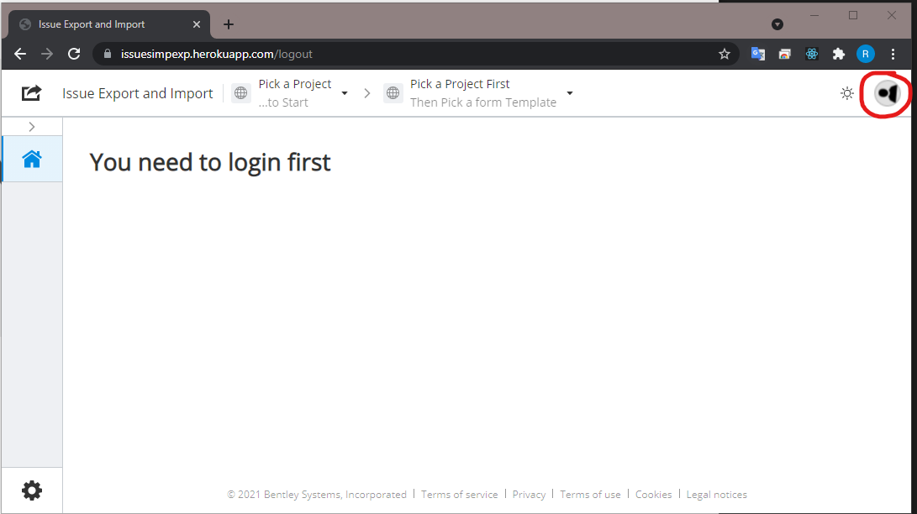

Once logged in the Pick a Project drop down will be populated with all the starred projects (aka Favourite) against your login.

Select the project you want to interact with from the drop down.

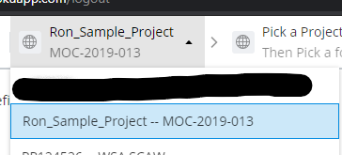

The change to the dropdown will force the Form Definition to load all of the definitions from that project.

Select the form definition you want to use as the bases for the definition file.

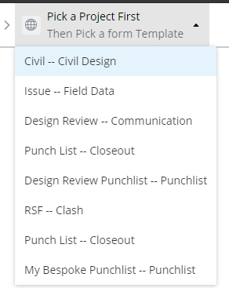

Click the Export Issues button. A running progress display will tell you what the tool is working on currently. Once the export process is complete the log will be displayed and the excel file will be downloaded.

If you wish to export the comments on the issues you can do so by ticking the “Export Comments” tickbox before clicking Export Issues. Note comments cannot be imported.

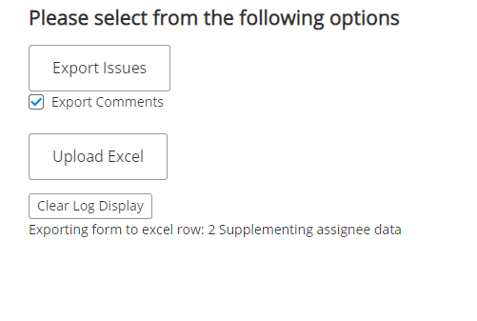

While running display

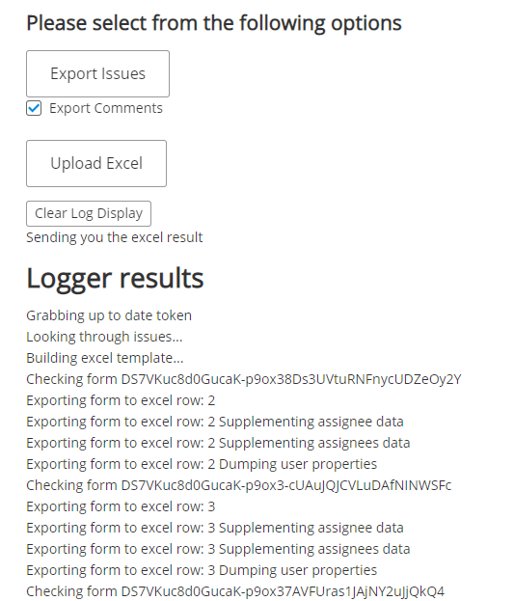

After completion of export

The excel file is of a fixed format until column Z.

Each column header has a comment attached.

Column headers have been color coded, red means the field will not be imported when uploading, yellow means that field may be used or is required as detailed in this document for upload.

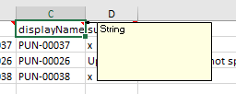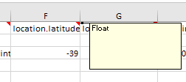

Related data is grouped in . format for example Location.latitude & Location.longitude to facilitate the nature of excel.

Anything mentioned as not required has the facility to leave blank during import. Any blank cells will not update the corresponding item on the form.

A brief description of the columns

Id = This is the instance ID of the existing form. If you want to update an existing form this value needs to be there. We’ll investigate this field being empty during the import process.

Number = This is the predetermined number of the form, it will not be loaded into the system and is basically readonly. Ignored on import but requires any value for new form creation.

displayName = The number field again. Readonly. Ignored on import.

Subject = subject field not required for update, required for form creation.

Description = description field not required.

Location.latitude = latitude for display in the Maps widget in forms. As a group (location.) not required

Location.longitude = longitude for display in the Maps widget in forms. As a group (location.) not required.

Container.id = imodel id. As a group (Container.) not required.

Container.url = imodel url. As a group (Container.) not required.

Container.displayName = iModel displayname. As a group (Container.) not required.

Item.id = ecinstance id(s) of elements in the model that the issue is linked to. As a group (item.) not required.

Item.url = formulated hyperlink to issue As a group (item.) not required.

elementId = source element in file as linked to issue. Not required.

modelPin.location.x/y/z These columns describe in model coordinates where the pushpin for the issue will be displayed. Not required.

createdBy Who the form instance was created by. Readonly. Ignored on import.

createdDate When the form instance was created in UTC time. Readonly. Ignored on import.

status The Status of the form instance. Readonly. Ignored on import.

assignee.displayName The user assigned to the assignee field. Readonly. Ignored on import.

assignee.email The email of the user assigned to the assignee field.

assignee.id The users GUID in our IMS system. Readonly. Ignored on import.

dueDate The inbuilt due date on the form (shows in the calendar widget in IRS)

state The state of the form. Readonly. Ignored on import.

assignees Shows the user(s)/role(s) bound to the assignees control. This is where you can attach multiple users as a notifier on the form instance. This is in the format of ‘user display name’|’user email’|’user guid’. If there are multiple users/roles each entry is separated by a || for example:

SEYDLER|0|91d7cf3f-8ba1-406b-b0de-9a49c1a86d05||Ron [Seydler|Ron.Seydler@bentley.com|fe0bd0e6-d9dc-4dec-b013-0bcfbc05a66c](mailto:Seydler|Ron.Seydler@bentley.com|fe0bd0e6-d9dc-4dec-b013-0bcfbc05a66c)

Displayname|0 if it is a role, otherwise users email|users/Roles Guid

For more information on importing users/roles against the assignee and assignees field refer to the “Assigning users” section

Properties.XXXXX = Anything prefix with properties are customer user defined controls on the form. Note that value checking is not performed, Test first 😊 Not required.

## Importing forms

Once you have the export template importing forms is simple.

The import works in both update and create mode so you can intermix updates and creates in the one load as required.

### Creating a new form instance.

Edit the excel and fill in the values in the columns you want to import. At a bare minimum you can create a new form by leaving the id column blank (column A) and putting anything in number (Column B) and then entering data in the fields you want to import, leaving fields you don’t want/use blank.

e.g.

|  |  |  |  |  |
| --- | --- | --- | --- | --- |
| id | number | displayName | subject | description |
|  | WHATEVER |  | This will make a new form |  |

Results in a new form with only the subject filled in, note that the number is auto generated, whatever value you use is ignored.

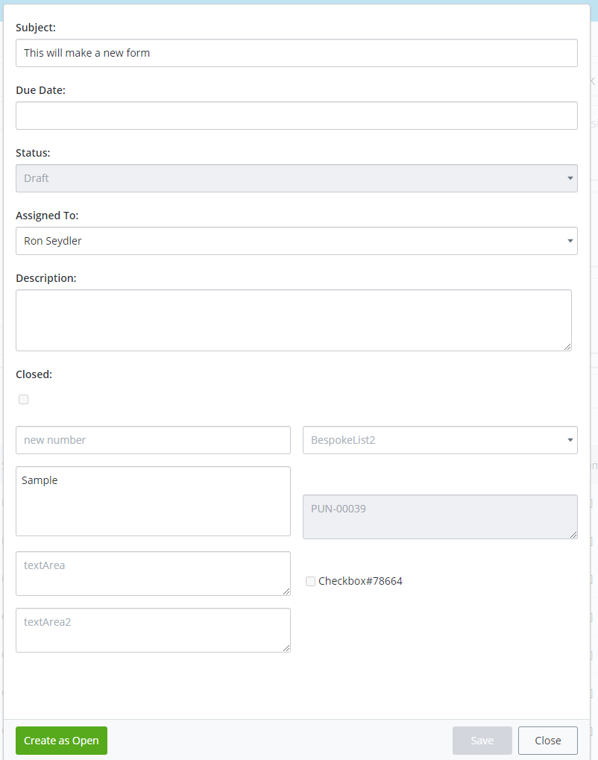

Make sure that the excel file is not open in Excel.

Open the website, login as required, select the project and the form definition.

The form definition is used to create new forms!

Click the Upload Excel button, select the excel file.

The progress of the upload will be shown on screen and at the end of the upload a full log of activity will be displayed.

### To update an existing form

The excel export would have loaded all of the existing form ids into the id column (ColumnA).

This column value is used to determine that the method is actually an update and not a new form instance. This is why that field is blank when you want to create a new form instance.

Set each row to be updated with the data you want to change/update. You can either blank fields that you don’t want to update or leave them with the values as exported (as long as the form has not been changed since export).

For example I want to update the subject and description of form PUN-0026. I can simply change the values for those columns and upload the excel.



Any columns that are blank are ignored for the update.

For example I need to alter the subject on PUN-0026. As a precaution I am not sure if the description has/will be changed by the time I upload the excel, I have blanked the field so the upload will ignore it and will only take the new subject (and any other filled in value).

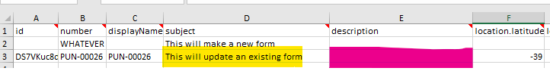

### Feedback on the upload:

This is via the full log dump at the end of the load.

### Assigning users

There are two types of assignments on a form. One type is a user assignment and the other type is a role.

#### Assignee

There is one field which is deemed “responsible person(s)” for the form. This can contain a user or role assignment. This field is detailed into the assignee.xxx columns in excel.

To import a new assignee at a minimum you must have the assignee.email column. If you are “trimming” the export template you do not need the assignee.displayName and assignee.id columns.

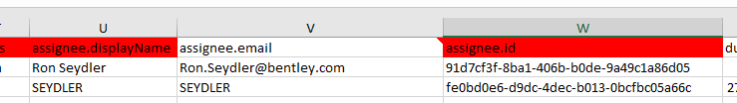

Enter the users email address or the role name into the assignee.email column. The system will determine the GUID and the correct display label. The role or use MUST be a member of the connect project. Should the resolution of the users email/role fail the entire row will be skipped.

The assignee.email field is case insensitive.

If the assignee.email field is blank no attempt is made to update the assignee and the row will be processed as normal.

If the assignee email fails to provide a user on the project the entire row is skipped and an error written into excel.

Once the assignee is updated the system WILL email the new assignee as is standard procedure if you had changed the assignee manually.

#### Assignees

The other field available on forms is the assignees field. This is where you can assign multiple users/roles against the form for notification purposes. This is exported/imported from the assignees column.

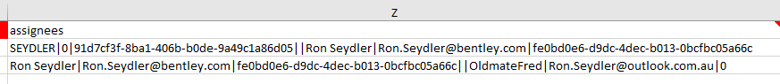

The value format is in the form of:

SEYDLER|0|91d7cf3f-8ba1-406b-b0de-9a49c1a86d05||Ron [Seydler|Ron.Seydler@bentley.com|fe0bd0e6-d9dc-4dec-b013-0bcfbc05a66c](mailto:Seydler|Ron.Seydler@bentley.com|fe0bd0e6-d9dc-4dec-b013-0bcfbc05a66c)

Displayname|0 if it is a role, otherwise users email|users/roles Guid

#### Assignees examples

To add users/roles to a form use the above format to input the data. Where the data is unknown you can use 0 as a placeholder.

E.g.

Joe Bloggs is the users name

[Joe.Bloggs@somecompany.com](mailto:Joe.Bloggs@somecompany.com) is the users email

I do not know the users guid.

In this case I would enter : Joe Bloggs|joe.bloggs@somecompany.com|0

If I wanted to add multiple users.. e.g.

Joe, Mary and Fred need to be added.

Joe|joe@somecompany.com|0||mary|mary@somewhere.com|0||fred|fred@gmail.com|0

Note that the delimiter between individual user/role entries is ||

Roles – Since roles have no email address use a 0

e.g

My role name is : All Disciplines

My role email is: This doesn’t exist for a role so we use a 0

My role GUID is: I do not know so we use a 0

The entry would be : All Disciplines|0|0

You can mix roles and users as required. To accumulate all the examples shown here would be

Joe|joe@somecompany.com|0||mary|mary@somewhere.com|0||fred|fred@gmail.com|0|| All Disciplines|0|0||Joe Bloggs|joe.bloggs@somecompany.com|0

The order of roles and users is not important.

The display name of the user is not important as it is updated by the system.

The role name is case insensitive.

The email is case insensitive.

If the assignees field is blank no attempt is made to update the assignees and the row will be processed as normal.

If the format is not followed or ANY of the user/role is not part of the project an error is written to excel and the entire row is skipped.

Once the assignees are updated the system WILL email the new assignees as is standard procedure if you had changed the assignees manually.

# Caveats

For dropdown lists the loader does not check for acceptable values. The backend service also does not check for acceptable values and will load whatever value you enter into the dropdown list. Make sure the data you are entering is correct as there is no validation performed.