**Grade 11 Computer Science ISP**

Overall expectations being assessed in this independent study project:

• A1. demonstrate the ability to use different data types, including one-dimensional arrays, in computer programs;

• A2. demonstrate the ability to use control structures and simple algorithms in computer programs;

• A3. demonstrate the ability to use subprograms within computer programs;

• A4. use proper code maintenance techniques when creating computer programs.

• B1. use a variety of problem-solving strategies to solve different types of problems independently…;

• B2. design software solutions to meet a variety of challenges;

• B4. apply a software development life-cycle model to a software development project;

In all phases of this ISP, you will be guided by an exemplar produced by Mr. Gordon.

The emphasis in this ISP is on understanding and applying the process of software development. The greatest success has historically come to students who plan their deliverables according to a manageable schedule and stick to their plan.

**Scope**

Aim to create a modest application that solves a problem you care about. If you solve the problem well, it is highly likely that others will find your application useful as well. Challenge yourself with something new, but avoid overreaching.

**Due Dates**

The proposal is due on Tuesday, February 28, 2017, at the start of class.

The first checkpoint (prototype) is due on Wednesday, March 8, 2017.

The second checkpoint (second prototype) is due on Tuesday, April 4, 2017.

The final submission (completed product) is due on Monday, April 10, 2017.

Note that you will be granted significant opportunities to work in class, but that there is, like any Grade 11 university preparation course, an expectation that work be completed outside of class time as well.

**Proposal**

I would like to recreate pinball

**What problem will your application solve?**

My application is the classic arcade game Pinball. The use of this application is for entertainment like most games. Like most games once again will be played when board and killing time is needed.

**What is your inspiration for this project?**

Pinball is an entertaining game that can be played over and over again so when I was thinking of a game to do as an ISP Pinball instantly came to mind. I hope that other people will find it entertaining other than me and use it to kill time if needed.

**What is your prior experience in this area?**

*Have you written an application like this before? Have you made use of any required APIs (for example, SpriteKit) before?*

I have not written an app exactly like this but I will be able to utilize Sprite Kit to add images and like in the game code before will be able to use the collisions to rack up points.

**What are skills do you hope to acquire by completing this project?**

I have not really written any other functional applications in swift in the past making this Pinball machine my fist one. I hope to be able to apply my skills and learn new skills to make my first app functional.

**Rate the personal difficulty level of this project.**

I Don’t think that this project will be extremely difficult because of my work in Sprite kit in the past. But I do thing that I will have to learn new things like the gravity and how to connect keys to do each movement needed. Also I will have to make a ui which might be difficult.

**Identify what you think your biggest challenge for successfully completing this ISP will be.**

Myself/time management. I will most likely hold myself back by procrastinating and try to rush something out at the end. If I can manage to manage my time correctly than the product will end up being significantly better.

**Make storyboards to indicate the user interface and/or functionality of your application.**

it will bring you to the game. Like to make the UI in illustrator or Photoshop

Settings in a corner.

If you hit settings it will bring up a screen with settings like sound and others.

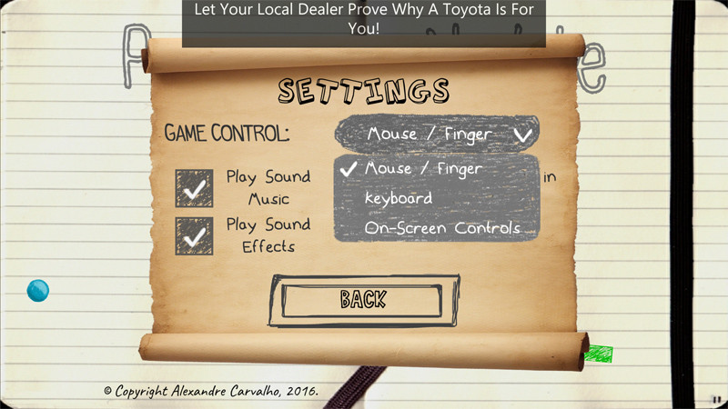

When brought into the game it will be top down (flat), left key will make the left paddle move, right key will make the right paddle move and down will launch the ball. There will be things the hit and go in for points.

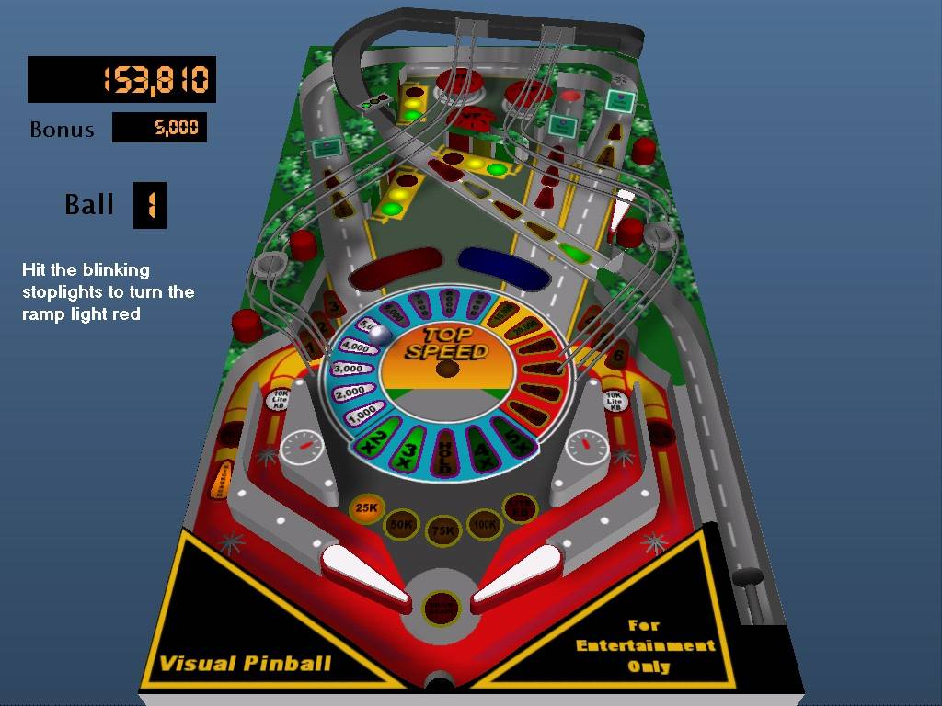

When you die the will either have another ball spawn and show lives or a game over screen and the score.

