**Grade 11 Computer Science ISP**

Overall expectations being assessed in this independent study project:

• A1. demonstrate the ability to use different data types, including one-dimensional arrays, in computer programs;

• A2. demonstrate the ability to use control structures and simple algorithms in computer programs;

• A3. demonstrate the ability to use subprograms within computer programs;

• A4. use proper code maintenance techniques when creating computer programs.

• B1. use a variety of problem-solving strategies to solve different types of problems independently…;

• B2. design software solutions to meet a variety of challenges;

• B4. apply a software development life-cycle model to a software development project;

In all phases of this ISP, you will be guided by an exemplar produced by Mr. Gordon.

The emphasis in this ISP is on understanding and applying the process of software development. The greatest success has historically come to students who plan their deliverables according to a manageable schedule and stick to their plan.

**Scope**

Aim to create a modest application that solves a problem you care about. If you solve the problem well, it is highly likely that others will find your application useful as well. Challenge yourself with something new, but avoid overreaching.

**Due dates**

The proposal is due on Tuesday, February 28, 2017, at the start of class.

The first checkpoint (prototype) is due on Wednesday, March 8, 2017.

The second checkpoint (second prototype) is due on Tuesday, April 4, 2017.

The final submission (completed product) is due on Monday, April 10, 2017.

Note that you will be granted significant opportunities to work in class, but that there is, like any Grade 11 university preparation course, an expectation that work be completed outside of class time as well.

**Proposal**

Modify this document and add your responses to the following prompts below.

Brainstorm

* Possibly some type of continuous platformer or sidescroller game where taps are used to jump and character is constantly moving
* Maybe a non continuous platformer as well similar to games like Mario where there are a various amount of levels possibly create 3-5

**What problem will your application solve?**

*Write a paragraph to describe the utility of your application. This applies equally for games. When would someone use your application? Why would they use your application?*

I am going to be creating an application that is intended to entertain people in form of an interactive game. At this point I am aiming for it to be a continuous sidescroller game possibly in a way so you are only jumping similar to the game Mario run. This game will include obstacles like moving circular items and some enemies as well. Someone would play my game when they are looking for a game that they can spend forever on like mine which is continuous. With a lot of games you have levels and once you beat those levels you have nothing left to due. The advantage with a continuous game is that you can continue to play and try and beat your old high score. It does not have a very specific path at this point just that I would like it to be something like a continuous platformer where you must dodge enemies and obstacles and the farther you get the higher your score gets.

**What is your inspiration for this project?**

*Have you seen another application that you wish to improve on? Has someone asked you to create this?*

I think it has always been a goal of mine to make some type of platformer. This is because of my childhood being filled with them like Mario, red beard and others as well. Platformer is the perfect type of game for everyone because it is so easy to play and is very easy to have fun. Something I may want to improve on from classic platformers is show top 3 scores instead of just the highest one. If I have time to implement this I will certainly try. No, no one has asked me to create this I purely thought it would be fun and I hope for it to be a success.

**What is your prior experience in this area?**

*Have you written an application like this before? Have you made use of any required APIs (for example, SpriteKit) before?*

Last year in processing I wrote a snake game which is not that much like my current ISP. The snake game I wrote last year was a game though but it was built in a different coding software which basically means I have to start from scratch in xcode. In class Mr.Gordon has recently taught us about how to use SpriteKit.

**What are skills do you hope to acquire by completing this project?**

*For example, you might be writing a networked application for the first time. Or, you may be writing an application that requires a particularly well designed user interface. Describe what you expect to learn by writing this application.*

I am hoping to acquire skills like becoming familiar with how to use gravity and movement in xcode. Also I think I will become more comfortable using collision as well as general formatting.

**Rate the personal difficulty level of this project.**

This will be a pretty hard project for me. I’m saying this because in my mind I think that the continuous part may become very hard. I don’t know if it will be easy or hard to implement but I’m assuming it could be very challenging.

**Identify what you think your biggest challenge for successfully completing this ISP will be.**

My biggest challenge I think will be getting the basics to work and once I have all of that I think it might flow pretty nicely.

**Make storyboards to indicate the user interface and/or functionality of your application.**

*In the section below, sketch out a plan for your application. This is where you will spend the majority of your time in completing the ISP proposal. Think through what you hope to create and as needed, adjust your responses to the questions above.*

When the application is first launched, a title screen will be shown. 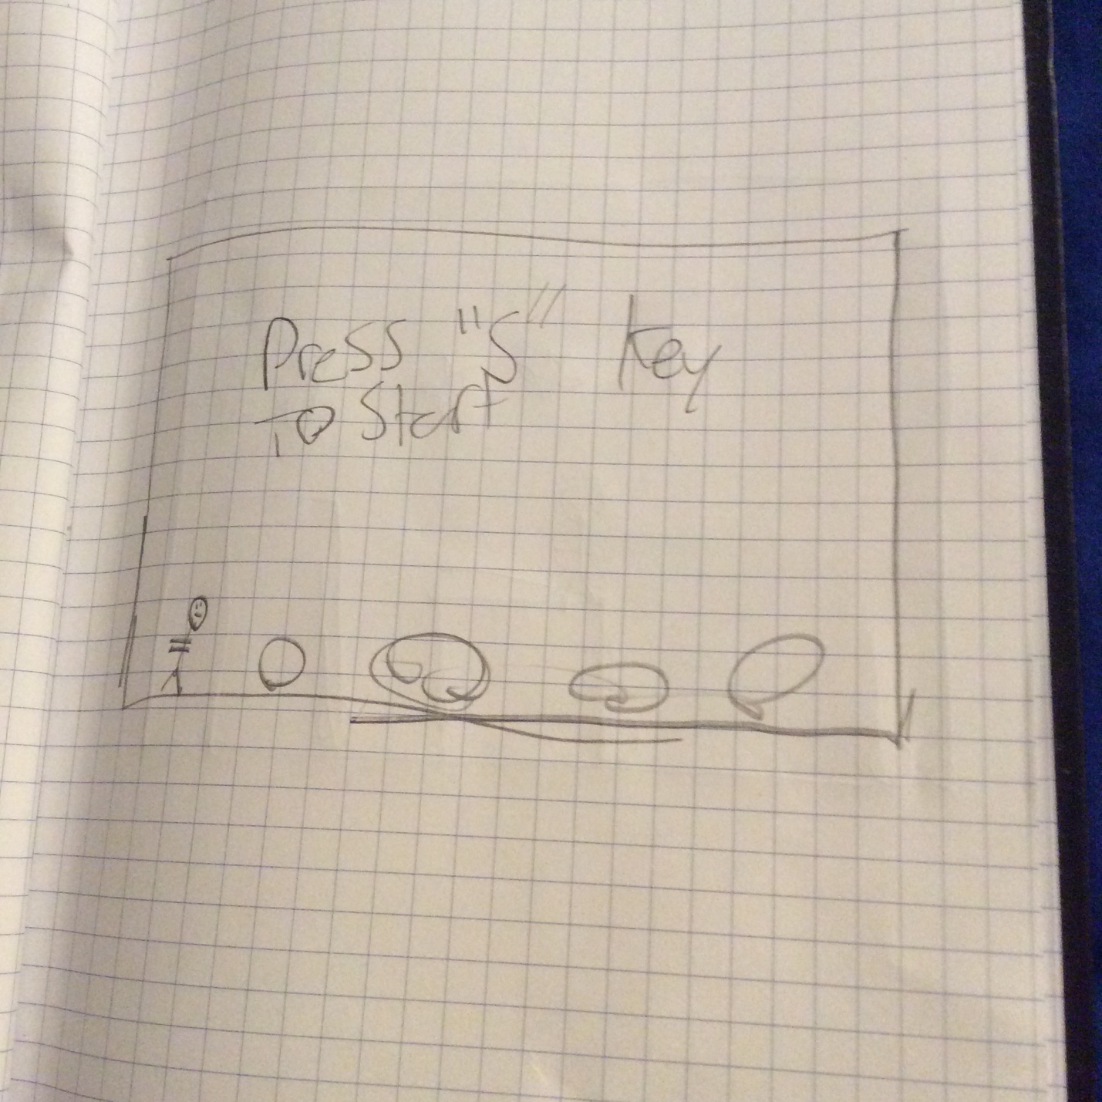

To start the game, you must press the s key

Once you press the s key there will be aerial enemies that appear as well as rolling objects.

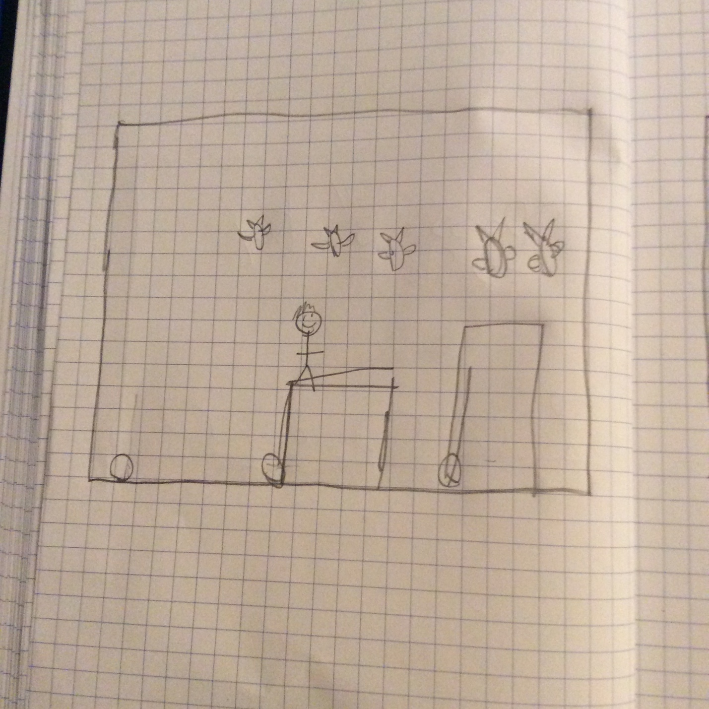

Once the character collides with a moving obstacle or an aerial enemy the game ends and you press the r key to restart the game.  
