**Grade 11 Computer Science ISP**

Overall expectations being assessed in this independent study project:

• A1. demonstrate the ability to use different data types, including one-dimensional arrays, in computer programs;

• A2. demonstrate the ability to use control structures and simple algorithms in computer programs;

• A3. demonstrate the ability to use subprograms within computer programs;

• A4. use proper code maintenance techniques when creating computer programs.

• B1. use a variety of problem-solving strategies to solve different types of problems independently…;

• B2. design software solutions to meet a variety of challenges;

• B4. apply a software development life-cycle model to a software development project;

In all phases of this ISP, you will be guided by an exemplar produced by Mr. Gordon.

The emphasis in this ISP is on understanding and applying the process of software development. The greatest success has historically come to students who plan their deliverables according to a manageable schedule and stick to their plan.

**Scope**

Aim to create a modest application that solves a problem you care about. If you solve the problem well, it is highly likely that others will find your application useful as well. Challenge yourself with something new, but avoid overreaching.

**Due dates**

The proposal is due on Tuesday, February 28, 2017, at the start of class.

The first checkpoint (prototype) is due on Wednesday, March 8, 2017.

The second checkpoint (second prototype) is due on Tuesday, April 4, 2017.

The final submission (completed product) is due on Monday, April 10, 2017.

Note that you will be granted significant opportunities to work in class, but that there is, like any Grade 11 university preparation course, an expectation that work be completed outside of class time as well.

**Proposal**

Modify this document and add your responses to the following prompts below.

**What problem will your application solve?**

My project – named *Match Predictor* – is an application to predict professional and college football matches. It will not only predict the outcome win or loss, but provide a likely score within a confidence interval. With this tool people can use it to make better bets, or make matchups just for fun, i.e. a highly ranked team versus a terrible team, just to see the carnage.

In each matchup the user will be given a detailed breakout of many different outcomes and their probabilities. They will be given graphs of teams scoring distributions and many other visual aids to see how the match was broken up statistically. A possible future addition is the user providing a score and the computer providing a probability for that score being achieved. This would be very interesting as users could try to guess a likely score, or just see the probability of a crazy score.

**What is your inspiration for this project?**

My inspiration for this project is my enjoyment in college football, and the knowledge I have gained from stats class. Additionally I drew inspiration from a football pool that I was in earlier in the year, this application would have helped me be more successful at football pools in the future.

**What is your prior experience in this area?**

I have some knowledge in statistical analysis methods from class. However, this is a whole new field and I have never applied my knowledge in this setting. I also have some knowledge in creating basic algorithms, but these had to do with display technology. I have never used JSON so that will be something that I have to learn.

**What are skills do you hope to acquire by completing this project?**

I have to acquire the skill of accessing JSON data from a database. With this data I then need to process it and run it through my algorithm. That will likely be the most difficult part, building the algorithm. Thirdly, I hope to learn how to make intuitive user interfaces, as this will be a crucial part of my project.

**Rate the personal difficulty level of this project.**

This project will be quite difficult for me. There are quite a few reasons for this, one of them is that I am in very unfamiliar territory. Many components of this project are skills that I am not very well versed in, such as user interface development, JSON, and algorithms. Another issue with this project will be the small sample size and high variability that football provides. Due to the few games that are played making accurate predictions will be difficult because there is not much data to pull from.

**Identify what you think your biggest challenge for successfully completing this ISP will be.**

Time management will be my biggest difficulty because I will have a lot of other things going on at the same time as this project. Many other courses will have work, so I need to make sure I make a schedule and stick to it.

**Make storyboards to indicate the user interface and/or functionality of your application.**

*In the section below, sketch out a plan for your application. This is where you will spend the majority of your time in completing the ISP proposal. Think through what you hope to create and as needed, adjust your responses to the questions above.*

The first screen displays what you see when you open the application. You need to select which league the matchup will be in, the NFL, or NCAA.

Next the second screen is displayed, as described on the page you select the conference, and then division of each team. This narrows down the results to make searching for teams easier. The team on the left is away, and the team on the right is home. You select the teams you want to match up and then click the Begin match button.

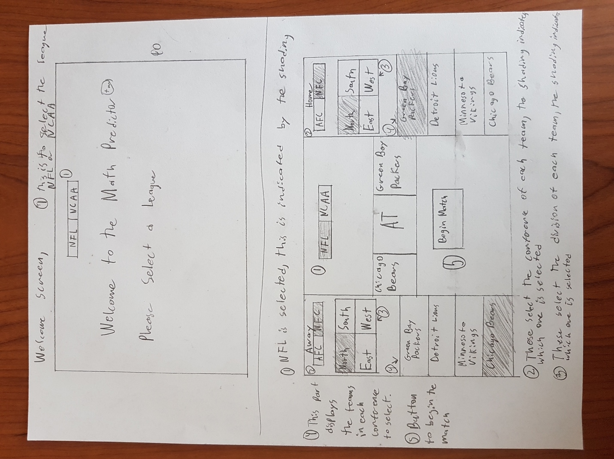

This is the screen that displays when you simulate the match. A winner is shown and below more information is given. The predicted score is shown with a confidence interval of how statiscally confident the program is with the answer. Other statistical information is shown. It will be normal distributions of the teams points scored and points against with the intersecting region being the likely interval. This will be a visual representation of the statistical analysis.