**Grade 11 Computer Science ISP**

Overall expectations being assessed in this independent study project:

• A1. demonstrate the ability to use different data types, including one-dimensional arrays, in computer programs;

• A2. demonstrate the ability to use control structures and simple algorithms in computer programs;

• A3. demonstrate the ability to use subprograms within computer programs;

• A4. use proper code maintenance techniques when creating computer programs.

• B1. use a variety of problem-solving strategies to solve different types of problems independently…;

• B2. design software solutions to meet a variety of challenges;

• B4. apply a software development life-cycle model to a software development project;

In all phases of this ISP, you will be guided by an exemplar produced by Mr. Gordon.

The emphasis in this ISP is on understanding and applying the process of software development. The greatest success has historically come to students who plan their deliverables according to a manageable schedule and stick to their plan.

**Scope**

Aim to create a modest application that solves a problem you care about. If you solve the problem well, it is highly likely that others will find your application useful as well. Challenge yourself with something new, but avoid overreaching.

**Due dates**

The proposal is due on Tuesday, February 28, 2017, at the start of class.

The first checkpoint (prototype) is due on Wednesday, March 8, 2017.

The second checkpoint (second prototype) is due on Tuesday, April 4, 2017.

The final submission (completed product) is due on Monday, April 10, 2017.

Note that you will be granted significant opportunities to work in class, but that there is, like any Grade 11 university preparation course, an expectation that work be completed outside of class time as well.

**Proposal**

Modify this document and add your responses to the following prompts below.

**What problem will your application solve?**

For my ISP, I am writing a 2D top down brawler where the purpose of the game is to fight through waves of enemies until you get to a boss, and then must defeat him. The enemies will be randomized each time. Enemies will be randomized in many aspects such as movement patterns, attack patterns and special abilities. The randomization is built to keep the game fresh, so each time they hop into the game they get a new experience.

As is the nature of a video game, it is built to entertain any regular player who wants a fast-paced, fresh gaming experience. Many gamers love extremely instinctual, brainless, highly mechanical games because it gives them a break from an extremely tiresome real world of constant thinking. This game will be made to appeal to those who want something energetic, fresh and stimulating.

A player might pick up this game when they want a distraction. For instance, when on the subway often times internet connection is either lacking or completely obsolete, the game could be played despite the lack of internet connection making it accessible on the subway or basically anywhere else as long as you have an energized phone and the app downloaded.

**What is your inspiration for this project?**

*Have you seen another application that you wish to improve on? Has someone asked you to create this?*

My inspiration for the game is often seeing phone games that are repetitive and lacking something that wants to bring the user back over and over again. An example of this is a game like flappy golf, while flappy golf can be extremely addicting and fun when you first get it, eventually you start to run out of steam for the simple reason that all the maps are preset, all the collectibles are in the same place and everything is static, the thing keeping the game fresh for its long time users is multiplayer. Sadly, this doesn’t help when you’re on the subway, or in a remote area with bad internet connection or simply have no friends available to play multiplayer with.

With my game, I hope to change that by using randomization for a lot of things in the game, including attack patterns, movement patterns, being melee or ranged, big or small, the possibilities could be endless each time you start up a game.

**What is your prior experience in this area?**

*Have you written an application like this before? Have you made use of any required APIs (for example, SpriteKit) before?*

In the past I have written small game applications in processing like a flappy bird knock-off and a game where you move a circle around and collect pellets that made the player bigger or smaller. These familiarized me with the concept of hitboxes as both games utilized them fairly often. Other than the most basic concepts used in processing like if statements or for loops, the knowledge doesn’t transfer over to well especially since hitboxes change quite a bit in SpriteKit.

I have practiced with SpriteKit a little bit in class using a physics playground to have objects such as circles and blocks interact with each other using bit masks. Obliviously, this was just an introduction to bit masks and hit boxes in swift, and I am not very well practiced with hitboxes due to my exposure to them in swift being limited to this physics playground.

Overall, I would say my prior experience in this area of programming is weak. I have some experience in the past and recently but only a small amount and a very basic understanding.

**What are skills do you hope to acquire by completing this project?**

*For example, you might be writing a networked application for the first time. Or, you may be writing an application that requires a particularly well designed user interface. Describe what you expect to learn by writing this application.*

The skills I am hoping to acquire by completing this project are mastering hitboxes, organizing classes for entities in the game and generally improving my SpriteKit expertise. I will learn hitboxes while writing this program by detecting when your character has been hit in various different ways, like colliding with a wall or colliding with enemies of different size. I will learn to organize entities into different classes because the game will have to keep track of different types of enemies that are all randomized, so in order to do this I will have to fully understand how to structure classes, without proper classes the game will be either nonfunctional or extremely messy code which is why it is so important to understand. Finally, my general SpriteKit expertise will be improved since this is the main API I will be using throughout my ISP and many aspects of the game will be based on it, like as mentioned before hit boxes (bit masks).

**Rate the personal difficulty level of this project.**

Organizing code into classes and creating structures is a completely new concept to me since all my ISP’s in the past have been completely messy code with no structure at all. SpriteKit is also a fairly new concept to me, even hitboxes and bit masks a topic that we have covered are still a struggle for me to understand. I think this will be a difficult project for me because many concepts in SpriteKit are still a struggle for me, structuring code into different entities is a new concept for me and the fact that it has been a while since I have last done an ISP.

**Identify what you think your biggest challenge for successfully completing this ISP will be.**

The biggest challenge for me is going to be learning new concepts while trying to keep with the creation of my project at the same time. In most subjects, you learn a concept and then do a project on the concept but in my ISP, I will be learning a lot of stuff while doing my project which will be hard to balance and keep up with.

**Make storyboards to indicate the user interface and/or functionality of your application.**

*In the section below, sketch out a plan for your application. This is where you will spend the majority of your time in completing the ISP proposal. Think through what you hope to create and as needed, adjust your responses to the questions above.*

**Legend:**

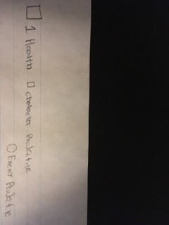

**Title Screen:**

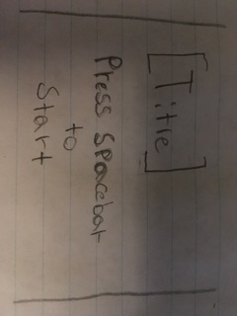

**Game Explanation:**

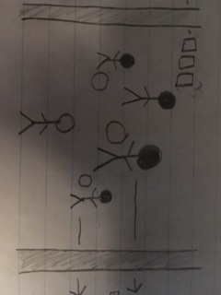

**Health Bar:**

Health bar for character, different enemies do different damage to health bar

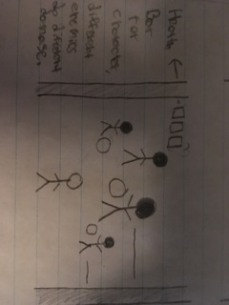

**Enemies:**

Each enemy has different stats, stats are randomized.

Ex: Enemy stats points = 20

Enemy : 10 Size, 2 damage, 3 speed, 5 projectile speed

Different enemies have different strengths, ex. Speed, damage, size projectile size, attack type.

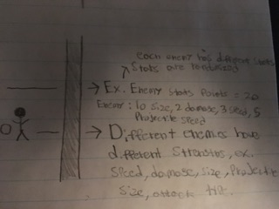

**Character’s Capabilities and Goal:**

Character has projectiles to shoot and enemies.

Your character can move around with the wasd keys.

The goal is to kill all enemies in the area.

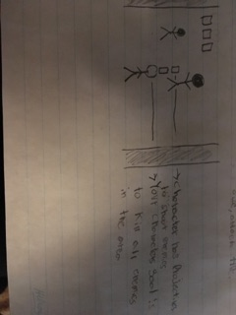

**Boss Fight:**

If all enemies are normal enemies are killed a boss will spawn.

A boss is a normal enemy with enhanced stats, therefore more of a challenge.

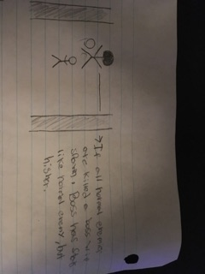

**End Game Screen:**

If all enemies and boss are killed. Game is won. End screen is shown for winning.

If health bar is depleted from being attacked by enemies. Game is over. End screen is shown for loss.

