Putting a Risk Score in Its Place: Geographic Context for a Machine-Learning Model of Diabetes
Rishil Shah
rshah10@usf.edu
Abstract
Most tutorials on diabetes prediction end the moment a classifier clears some accuracy threshold on the Pima Indians dataset. That is a strange place to stop, because the harder questions begin right after. Does the model hold up on people it was never trained on? Are its probabilities trustworthy enough to act on, or only to rank by? And what does a single number mean for a patient who lives somewhere the training data never described? This chapter works through one model end to end with those questions in mind. We build a calibrated tree-ensemble on the Pima data, but we spend most of our effort on what comes after the fit: an ablation that shows which design choices actually earned their keep, confidence intervals on every reported number, a significance test that quietly demolishes the case for a fancy ensemble, an external validation on a completely separate national survey, and SHAP attributions that we checked against clinical intuition rather than the other way round. The piece we think is genuinely new is geographic: we link each prediction to county-level prevalence from the CDC PLACES program and use a simple odds correction to re-express an individual score against the place that person lives. The internal model reaches a cross-validated ROC-AUC near 0.84; more interestingly, its discrimination survives almost intact when moved to NHANES, even as the base rate falls by more than half. We argue that this transportability is exactly what licenses the geographic adjustment, and we are candid about where the whole approach should not be trusted.
Keywords diabetes risk prediction · model calibration · external validation · SHAP · GeoAI · CDC PLACES · health geography · responsible machine learning

1 Introduction
The Pima Indians Diabetes dataset has been a teaching staple for more than thirty years. Eight measurements, one binary outcome, 768 rows: it is small enough to fit in memory a thousand times over and clean enough that a first-year student can get a respectable number out of it in an afternoon. That convenience is also its trap. The dataset is so well-behaved as a benchmark that it invites people to treat prediction as the finish line, when in any real screening setting it is barely the starting one.
We came at this project from the other direction. The model was never going to be the interesting contribution — the literature already contains dozens of papers reporting areas under the curve in the high 0.70s to mid-0.80s on this exact data, and we did not expect to beat them by much, nor did we. What we wanted to know was whether a model trained on a few hundred women from one community in Arizona could say anything defensible about a person somewhere else entirely, and whether we could attach an honest measure of place to its output. The second question is where the geographic component comes in, and it is the part of this chapter we would point a reviewer to first.
The structure follows the order in which we actually worked. Section 2 sketches the background and names the prior work we leaned on. Section 3 describes the three data sources — Pima for training, NHANES for external validation, and CDC PLACES for geography. Section 4 lays out the methods, including the prior-correction formula that underpins the geographic claim. Section 5 reports results, and we have tried to report the unflattering ones with the same prominence as the flattering ones. Section 6 describes the interactive system we built around the model. Section 7 deals with ethics and limitations, which on this particular dataset are not an afterthought. Section 8 closes.

2 Background and Related Work
The dataset originates with a 1988 study by Smith and colleagues, who used an early neural network they called ADAP to forecast the onset of diabetes in a population of adult women of Pima (Akimel O'odham) heritage. The features — number of pregnancies, plasma glucose, diastolic blood pressure, triceps skinfold thickness, serum insulin, body-mass index, a pedigree function summarising family history, and age — have been copied into teaching materials ever since. We say more about the ethics of this provenance in Section 7; for now it is enough to note that the data describe a specific community with a specific and painful relationship to diabetes research, and that this matters for how far any conclusion should travel.
On the modelling side we relied on well-worn tools rather than anything exotic. The ensemble of extremely randomised trees follows Geurts and colleagues; gradient boosting is represented by both the scikit-learn implementation and the XGBoost and LightGBM libraries. For turning raw scores into trustworthy probabilities we used Platt's sigmoid scaling. To compare two models without fooling ourselves we used the DeLong test for correlated ROC curves, and to explain individual predictions we used the SHAP framework of Lundberg and Lee. None of this is novel, and that is deliberate: the novelty we are claiming is in the geographic layer, not the estimator.
The geographic data come from PLACES, a collaboration between the CDC, the Robert Wood Johnson Foundation, and the CDC Foundation that publishes small-area estimates of chronic-disease measures for every county, place, and census tract in the United States. To our knowledge, coupling a personal Pima-trained risk model to PLACES prevalence through an explicit prior correction has not been done before, and it is the one thing in this chapter we would defend as genuinely new.

3 Data

3.1 Training cohort: Pima
The training data are the standard 768 records, of which 268 (34.9 percent) carry a positive diabetes label. A quirk that catches many newcomers is that several columns use zero as a stand-in for a missing measurement. A body-mass index of zero or a diastolic blood pressure of zero is not a low reading; it is no reading at all. We treat zeros in glucose, blood pressure, skinfold thickness, insulin, and BMI as missing and impute them with the training-fold median. As Section 5 shows, this single piece of data hygiene is worth more than any model swap we tried.

3.2 External cohort: NHANES 2017–2018
To test whether the model travels, we needed data it had never seen, collected by different people, with different instruments, in a different era. The National Health and Nutrition Examination Survey fits. From the 2017–2018 cycle we drew the demographics, fasting-glucose, body-measurement, blood-pressure, and diabetes-questionnaire files, joined them on the respondent identifier, and restricted to women aged twenty-one and over to match the Pima inclusion criteria. After dropping records without a usable diabetes answer or the core measurements, we were left with 1,181 respondents, of whom about sixteen percent report a diabetes diagnosis. Only four features line up cleanly between the two datasets — glucose, blood pressure, BMI, and age — so the external test uses that shared subset. The base-rate gap between the two cohorts, thirty-five percent against sixteen, turns out to be the whole point.

3.3 Geographic context: CDC PLACES 2024
The PLACES 2024 county release gives model-based estimates of adult prevalence for every United States county. We pulled five measures that bear on diabetes risk or care: diagnosed diabetes, obesity, physical inactivity, high blood pressure, and lack of health insurance. Across the 3,144 counties, the median county reports diabetes prevalence of 13.2 percent, obesity of 38.2 percent, and physical inactivity of 27.4 percent. These are population summaries, not individual records, and we use them as context rather than as features fed to the model — a distinction we return to in Section 4.5.

4 Methods

4.1 Preprocessing
Every preprocessing statistic is learned inside a scikit-learn pipeline so that no information leaks from test to train. The pipeline recodes the zero-as-missing columns, imputes with the median, optionally adds a handful of derived features — products and ratios such as glucose times BMI, BMI times age, and insulin over glucose, all of them chosen because they correspond to quantities a clinician would already think about — and standardises the result. Because the imputation medians are fit on training folds only, the same object can be handed a single new patient or a county's worth of them without special casing.

4.2 Models and selection
We compared seven estimators: logistic regression, random forest, extremely randomised trees, gradient boosting, XGBoost, LightGBM, and a stacked ensemble that feeds the first six into a logistic meta-learner. Selection was by repeated stratified five-fold cross-validation — three repeats, fifteen fits per model — scored on ROC-AUC. We chose ROC-AUC for selection because it does not depend on a threshold, which we tune separately and later.

4.3 Calibration and the decision threshold
A ranking is not a probability. Tree ensembles in particular tend to be overconfident in the middle of the range, so we wrapped the chosen model in Platt scaling fit by internal cross-validation, then chose an operating threshold by maximising the F1-score on out-of-fold predictions rather than defaulting to one-half. The threshold that fell out, near 0.28, is well below the textbook cut. That is not an accident: in a screening context, missing a case is usually costlier than a false alarm, and a low threshold trades precision for the recall that screening actually cares about.

4.4 Evaluation protocol
We report two kinds of evidence. For model selection we use the repeated cross-validation above. For honest performance numbers we hold out twenty percent of the Pima data, never touched during selection, and attach a 95 percent confidence interval to every metric by stratified bootstrap resampling with two thousand replicates. Where we compare two models head to head we use the DeLong test, which respects the fact that both models are scored on the same patients. We consider this the least glamorous and most important part of the whole exercise.

4.5 Geographic prior correction
Here is the idea that ties the chapter together. The model learns to separate cases from non-cases in a cohort where roughly a third of people have diabetes. Drop that same model into a population where only one in eight does, and its raw probabilities are miscalibrated for that setting even if its ranking is perfect. Bayes' rule tells us how to fix this if we are willing to assume the ranking transports: we shift the model's odds by the ratio of the local prevalence odds to the training prevalence odds.
odds_adjusted = odds_model × [ p_local / (1 − p_local) ] ÷ [ p_train / (1 − p_train) ]
Setting the local prevalence to a county's PLACES diabetes estimate re-expresses an individual's score against where they live. The correction is deliberately humble: it moves the base rate, not the biology, and as a sanity check, applying it at the training prevalence returns the input unchanged to within floating-point error (maximum deviation 1e-16). The assumption it leans on — that the model's discriminative signal carries across populations — is not free, and Section 5.6 is where we go looking for evidence that it holds.

5 Results

5.1 Which design choices mattered
We started with an ablation because we wanted to know what was doing the work. The answer was slightly humbling. Cleaning the zero-coded missing values lifted cross-validated ROC-AUC from 0.836 to 0.843; the derived clinical features nudged it to 0.844; and the stacked ensemble, for all its machinery, did not improve on a single well-configured tree model at all. If you take one practical lesson from this section, it is that an hour spent understanding how the data encode missingness beat every hour we spent on model complexity.
Configuration | CV ROC-AUC | Std
Raw features (no cleaning) | 0.8363 | 0.0277
+ zeros-as-missing imputation | 0.8434 | 0.0288
+ derived clinical features | 0.8437 | 0.0307
Stacked ensemble (full pipeline) | 0.8416 | 0.0319
Table 1. Ablation study. Repeated stratified five-fold cross-validated ROC-AUC as each pipeline component is added.

5.2 Model comparison, and a result we did not expect to like
Extremely randomised trees came out narrowly on top, but the DeLong test had something uncomfortable to say. The gap between the best tree model and plain logistic regression is not statistically significant — the p-value sits around 0.90, which is about as clear a null result as one ever sees. The stacked ensemble is likewise indistinguishable from the winner. On data this size, the honest summary is that the simple, interpretable baseline is every bit as good as the complicated thing, and we would have been wrong to dress up the ensemble as a contribution.
Model | CV ROC-AUC | Std | DeLong p vs best
Extra Trees | 0.8437 | 0.0307 | —
Logistic Regression | 0.8432 | 0.0301 | 0.8981
Stacked Ensemble | 0.8416 | 0.0319 | 0.5089
Random Forest | 0.8334 | 0.0319 | 0.0028
Gradient Boosting | 0.8230 | 0.0315 | 0.0044
XGBoost | 0.8183 | 0.0304 | 0.0004
LightGBM | 0.8130 | 0.0305 | 0.0000
Table 2. Model comparison. Cross-validated ROC-AUC and the DeLong test p-value for the difference from the best model. Large p-values indicate the simpler model is statistically indistinguishable from the best.

5.3 Held-out performance, with the uncertainty left in
On the untouched hold-out the calibrated model reaches a ROC-AUC of 0.82, recall of 0.83, and an F1 of 0.69 at the tuned threshold. The confidence intervals are wide — the ROC-AUC interval runs from roughly 0.75 to 0.88 — and they are wide for an unavoidable reason: a twenty-percent hold-out of 768 rows is about 154 patients, and you cannot wring tight intervals out of that. We would rather show the width than pretend a point estimate is more solid than it is.
metric | estimate | ci_low | ci_high
roc_auc | 0.823 | 0.754 | 0.882
pr_auc | 0.681 | 0.551 | 0.803
brier | 0.166 | 0.133 | 0.202
accuracy | 0.734 | 0.662 | 0.799
precision | 0.584 | 0.474 | 0.686
recall | 0.833 | 0.736 | 0.933
f1 | 0.687 | 0.593 | 0.770
Table 3. Held-out test metrics with 95% bootstrap confidence intervals (2,000 stratified resamples), calibrated, at the tuned decision threshold.

5.4 Are the probabilities trustworthy?
Calibration asks a different question from discrimination: not whether the model ranks patients correctly, but whether a stated probability of 0.3 really happens about thirty percent of the time. The reliability diagram in Figure 1 shows the raw tree-ensemble probabilities drifting away from the diagonal, and Platt scaling pulling them back toward it. The expected calibration error drops accordingly. This matters here because the geographic correction in Section 5.7 operates on probabilities, not ranks — feed it a miscalibrated score and the adjustment inherits the error.
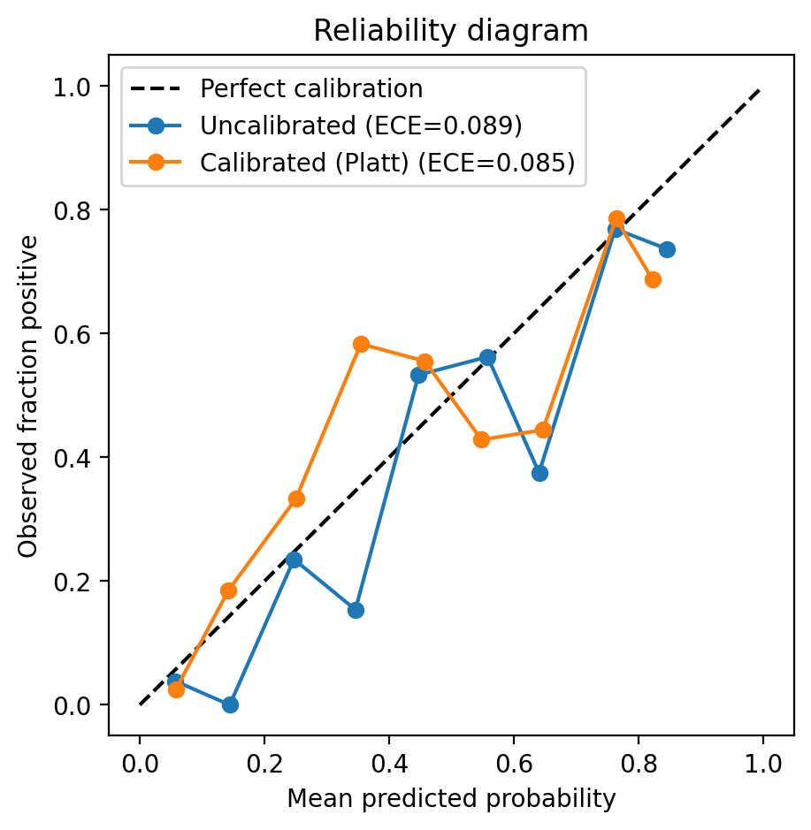
Figure 1. Reliability diagram before and after Platt scaling. Points on the dashed diagonal are perfectly calibrated; ECE is the expected calibration error.
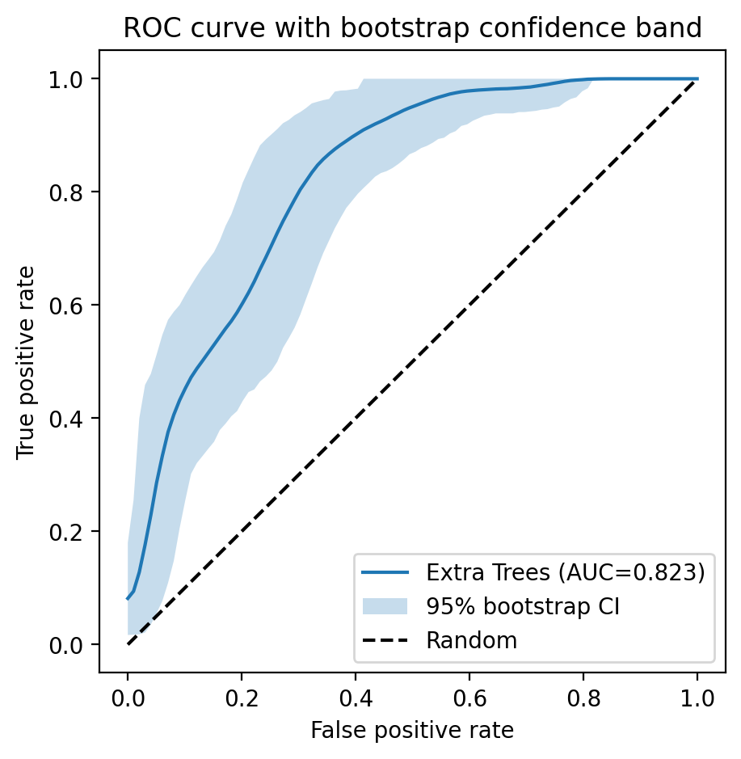
Figure 2. ROC curve for the held-out test set with a 95% bootstrap confidence band, conveying the same uncertainty as Table 3 in visual form.

5.5 What the model is actually looking at
We ran SHAP partly to explain the model and partly to check it had not learned something silly. It had not. Glucose dominates the attributions, followed by the glucose-times-BMI interaction, the BMI-times-age interaction, and age itself — an ordering that any clinician would have predicted before seeing a line of code. We treat that agreement as reassurance rather than discovery: when a model's reasons match established medical knowledge, a reader who does not trust machine learning has one less reason to dismiss it.
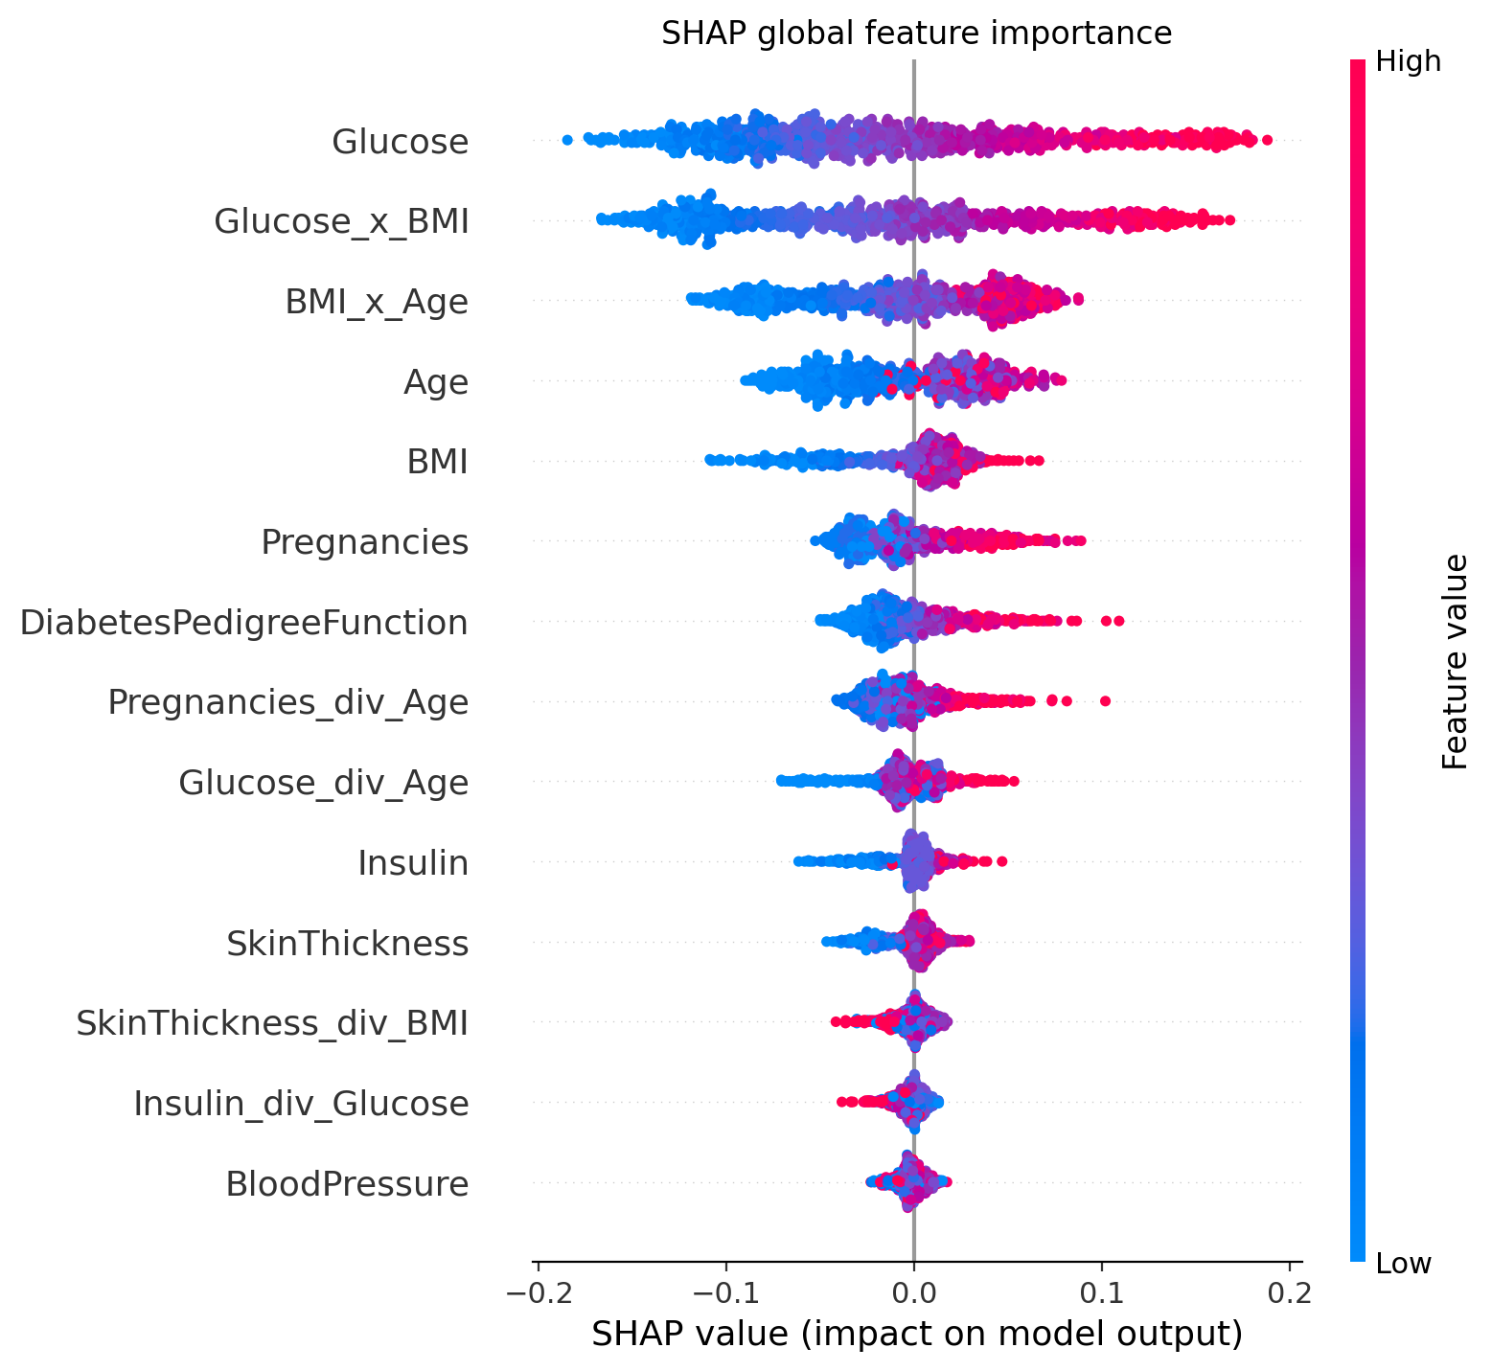
Figure 3. SHAP global feature importance. Each point is one patient; horizontal spread shows the feature's push toward or away from a diabetes prediction, coloured by feature value.

5.6 Does it travel? External validation on NHANES
This is the result that surprised us, in a good way. Trained on Pima and dropped onto NHANES without any refitting, the model's ROC-AUC barely moves: 0.82 on the Pima hold-out against 0.82 on NHANES, with a confidence interval of roughly 0.79 to 0.85. Discrimination, in other words, transports almost perfectly across two cohorts separated by decades, instruments, and geography. The precision-recall figures tell the complementary story: PR-AUC falls and raw accuracy actually rises on NHANES, both of which follow mechanically from the lower base rate rather than from any change in the model. We dwell on this because it is the empirical permission slip for the geographic adjustment: if the ranking holds across populations, then correcting only the base rate by place is a defensible move.
metric | internal_pima | external_nhanes | external_ci_low | external_ci_high
roc_auc | 0.821 | 0.822 | 0.789 | 0.854
pr_auc | 0.686 | 0.540 | 0.469 | 0.615
brier | 0.165 | 0.119 | 0.110 | 0.129
accuracy | 0.747 | 0.848 | 0.828 | 0.869
precision | 0.653 | 0.516 | 0.445 | 0.590
recall | 0.593 | 0.508 | 0.436 | 0.580
f1 | 0.621 | 0.512 | 0.446 | 0.572
Table 4. Internal (Pima hold-out) versus external (NHANES) performance on the four shared features. External metrics carry 95% bootstrap confidence intervals.

5.7 Risk in its place: the geographic layer
Figure 4 maps diagnosed-diabetes prevalence across every United States county, and the familiar geography of the condition is immediately visible — the band of high prevalence through the South stands out exactly as public-health data would lead you to expect. Figure 5 shows the correction at work. A raw model score of 0.6 does not mean the same thing for a patient in a county where one adult in twenty has diabetes as it does where one in five does, and the curves make that difference explicit. The dashed line is the training prevalence, where the correction does nothing by construction. We want to be precise about what this buys: it re-expresses population-level risk context, not place-based biology, and it is emphatically not a diagnosis keyed to a postcode.
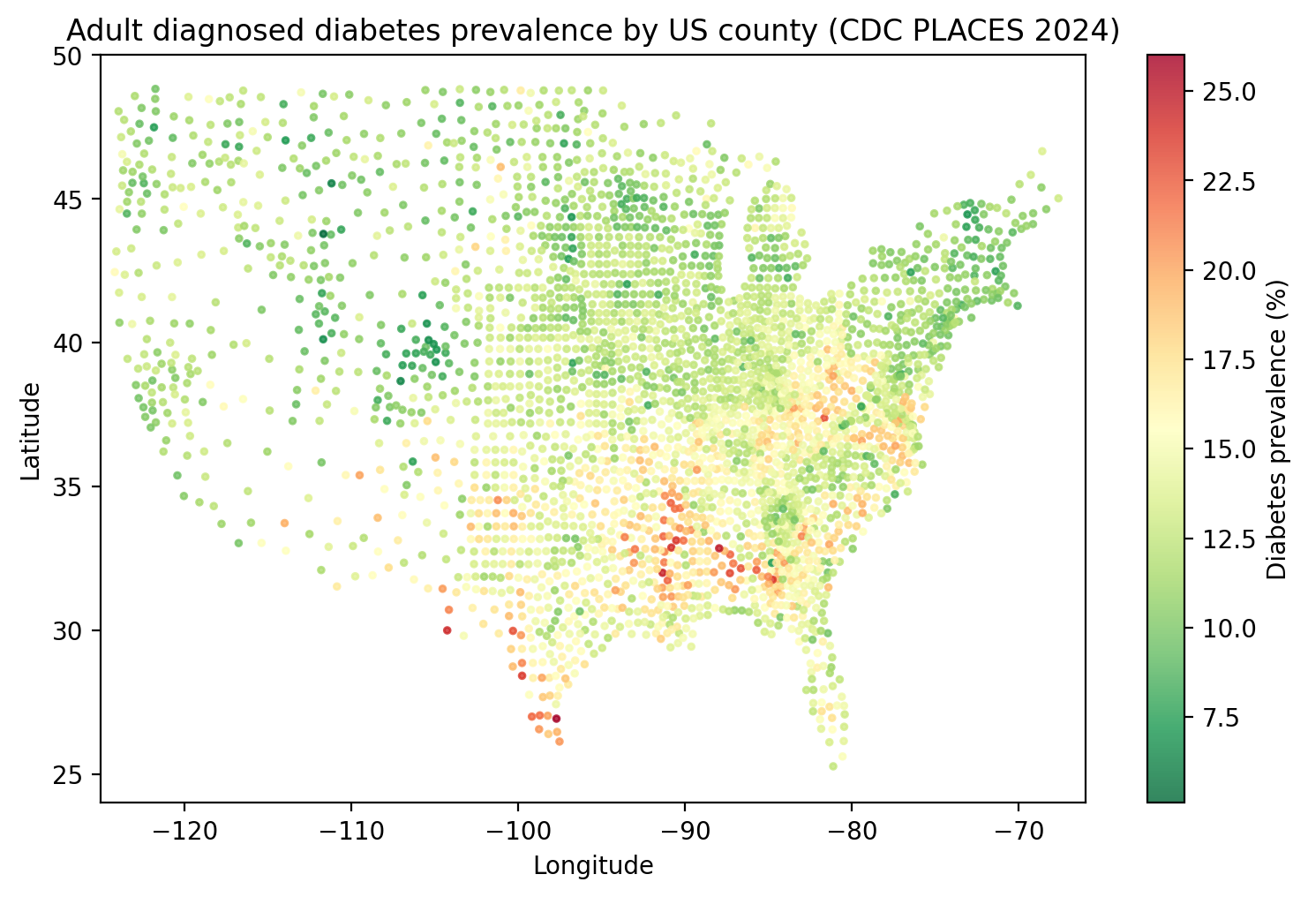
Figure 4. Adult diagnosed-diabetes prevalence by United States county (CDC PLACES 2024), across all 3,144 counties.
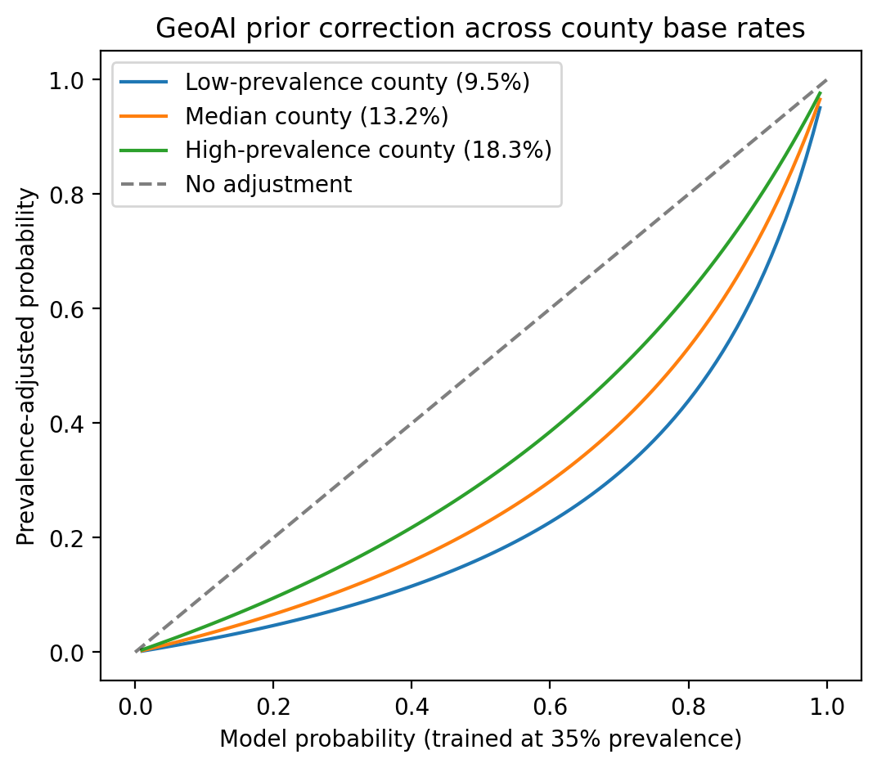
Figure 5. Prior correction across county base rates. The same model probability maps to different adjusted risks depending on local prevalence; the dashed line marks the training prevalence, where the correction is the identity.

6 The Interactive System
None of this would be much use locked in a notebook, so we wrapped it in an application built with Streamlit and a small FastAPI service for programmatic access. The dataset and a trained model ship with the app, so every page works on first launch without an upload. A user can explore the data, watch the seven models compete, drag a threshold and see the confusion matrix respond in real time, enter a single patient or upload a batch for scoring, and — the part we care about — drop that prediction onto a map of any United States county to read it against local prevalence. A separate results page exposes every table and figure in this chapter, regenerated from code, so a sceptical reader can audit the numbers rather than take them on faith. The whole analysis reproduces from a single command, with dependencies pinned and seeds fixed.

7 Ethics, Limitations, and Responsible Use
We cannot use this dataset without naming where it comes from. The Pima, or Akimel O'odham, people of Arizona have been studied intensively for diabetes since the mid-twentieth century, and that history is not a neutral one — it raises real questions about consent, benefit, and the extraction of knowledge from a community that has not always shared in the results. A model trained on a few hundred of their records should never be turned around and used to make claims about that community, and the transportability we demonstrate on NHANES is a statement about a statistical signal, not a licence to generalise about any group of people.
The technical limitations are equally worth stating plainly. The training set is small, single-cohort, and restricted to adult women, which bounds how far any conclusion can reach. The external labels in NHANES are self-reported, and clinical definitions of diabetes have shifted across the decades separating the two datasets. The shared-feature model leans on only four variables. And the geographic correction rests on an assumption — that discrimination transports — which we tested and found support for here, but which could fail for a different condition or a more distant population. Above all, this is a screening-style illustration and an educational artifact. It is not a medical device, it has not been validated for clinical use, and no individual should make a health decision on the strength of its output.

8 Conclusion and Future Work
The model in this chapter is ordinary on purpose. What we hope is less ordinary is the discipline around it: an ablation that tells you what mattered, intervals that admit what we do not know, a significance test that talked us out of a result we would have preferred, an external cohort that the model had to face cold, and a geographic layer that puts an individual score in the context of a place. The standout empirical finding is that discrimination held up across a decades-wide gap between cohorts even as the base rate halved, and that finding is precisely what makes the prevalence correction more than a cosmetic touch.
Several extensions suggest themselves. PLACES publishes estimates at the census-tract level, which would sharpen the geography from county to neighbourhood. Linking in the food-access and walkability data already collected by federal agencies would let the context speak to modifiable environment rather than prevalence alone. Conformal prediction would let the system say it does not know, instead of always answering. And a larger, more representative training cohort — BRFSS runs to hundreds of thousands of records — would narrow the intervals that Section 5 is so insistent about. The thread running through all of these is the same one running through the chapter: a prediction is more honest, and more useful, when it carries its uncertainty and its context along with it.

References
[1] Smith, J. W., Everhart, J. E., Dickson, W. C., Knowler, W. C., & Johannes, R. S. (1988). Using the ADAP learning algorithm to forecast the onset of diabetes mellitus. Proceedings of the Annual Symposium on Computer Application in Medical Care, 261–265.
[2] Geurts, P., Ernst, D., & Wehenkel, L. (2006). Extremely randomized trees. Machine Learning, 63(1), 3–42.
[3] Pedregosa, F., et al. (2011). Scikit-learn: Machine learning in Python. Journal of Machine Learning Research, 12, 2825–2830.
[4] Chen, T., & Guestrin, C. (2016). XGBoost: A scalable tree boosting system. Proceedings of the 22nd ACM SIGKDD International Conference on Knowledge Discovery and Data Mining, 785–794.
[5] Ke, G., et al. (2017). LightGBM: A highly efficient gradient boosting decision tree. Advances in Neural Information Processing Systems, 30.
[6] Platt, J. (1999). Probabilistic outputs for support vector machines and comparisons to regularized likelihood methods. Advances in Large Margin Classifiers, 10(3), 61–74.
[7] DeLong, E. R., DeLong, D. M., & Clarke-Pearson, D. L. (1988). Comparing the areas under two or more correlated receiver operating characteristic curves: a nonparametric approach. Biometrics, 44(3), 837–845.
[8] Lundberg, S. M., & Lee, S.-I. (2017). A unified approach to interpreting model predictions. Advances in Neural Information Processing Systems, 30, 4765–4774.
[9] Vickers, A. J., & Elkin, E. B. (2006). Decision curve analysis: a novel method for evaluating prediction models. Medical Decision Making, 26(6), 565–574.
[10] Centers for Disease Control and Prevention. (2024). PLACES: Local Data for Better Health, County Data. U.S. Department of Health and Human Services.
[11] Centers for Disease Control and Prevention, National Center for Health Statistics. (2020). National Health and Nutrition Examination Survey Data, 2017–2018 cycle.
[12] Efron, B., & Tibshirani, R. J. (1993). An Introduction to the Bootstrap. Chapman & Hall/CRC.

