# **STOCK TRACKER**

## Java 3 Project

## by Roman Shaiko, Dmitrii Kudrik

## Description

Application allows registered users to track their stock market investments made in different institutions (RBC, TD, Questrade etc.). User can switch easily between created by himself portfolios and track his trades within chosen portfolio, and move them between portfolios as well when needed. The portfolio can be of two types: **Real**, which allows user to track the real investments only and **Test** type (Virtual), which provides possibility for unlimited trading using real stock market prices. Thus, user can work in two modes: **Track mode** and **Test mode**. User can see the portfolio summary, create different reports (by types of trades, portfolios, periods), and export them into Excel. User can also open a chart of a selected symbol.

## Technologies

* IEX API (Intrinio API)
* Export to Excel
* Charts
* JSON
* JSwing

## UML Diagram

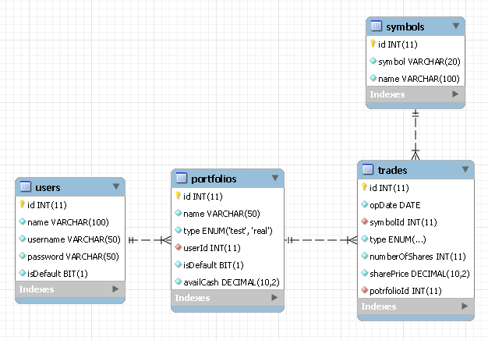

## User Interface

### Main window

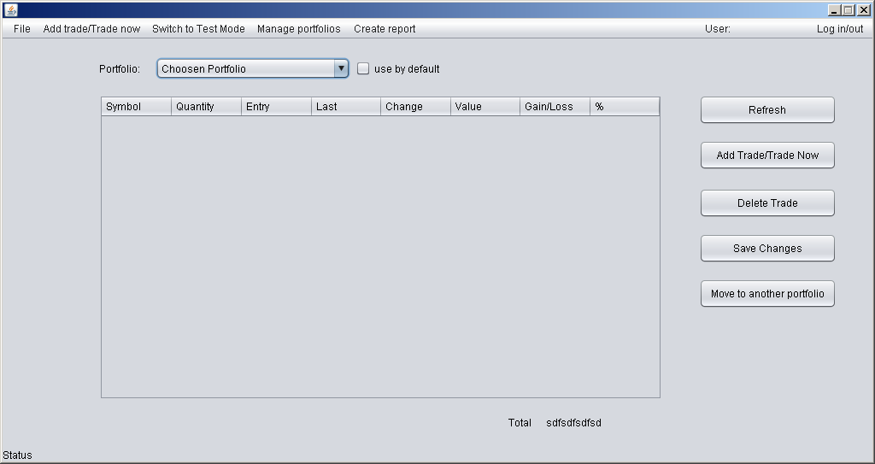

### Log In window

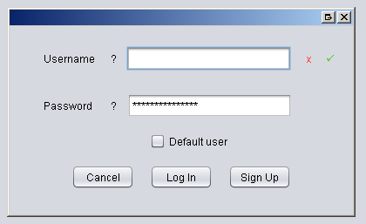

### Sign Up window

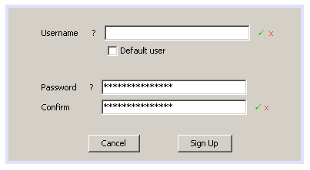

### Move to another portfolio window

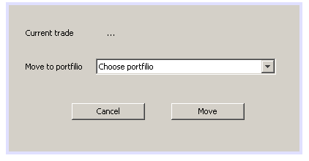

### Add Trade / Trade Now window

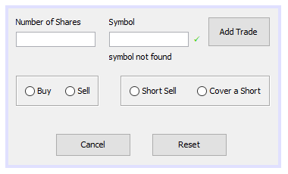

### Manage Portfolio window

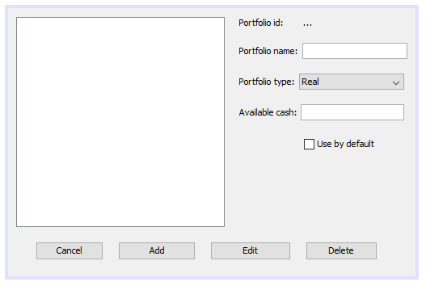

### Main_Table_Row PopUp window

### Manage_Portfolio PopUp window