Study Buddy: An OULAD-Based Predictive Analytics
and Gemma Fine-Tuning Pipeline

APPLIED ARTIFICIAL INTELLIGENCE
Master of Science in Applied Computer Science
SRH Hochschule Heidelberg — Campus Stuttgart

SUBMITTED BY:
Sameer Kulkarni
Shahid Sherwani
Smitha Anoop
Shambhavi Pillai

COURSE INSTRUCTOR
Prof. Reshadi, Kamellia
Department of Applied Sciences
May 2026

Abstract
This project presents a two-part academic and practical system called Study Buddy, which combines a classical machine learning pipeline on the Open University Learning Analytics Dataset (OULAD) with a fine-tuned Gemma-based educational chatbot. The first part focuses on predicting student dropout risk using structured educational data — student demographics, registration records, assessment performance, and Virtual Learning Environment (VLE) interaction logs. The second part adds a conversational Study Buddy model that can answer questions and generate flashcards for learning support.
The graded machine learning component is completed first, satisfying course requirements through Logistic Regression and Decision Tree classification, with evaluation metrics covering accuracy, precision, recall, F1-score, confusion matrix, ROC curve, AUC, cross-validation, and Grid Search hyperparameter tuning. The LLM component fine-tunes Gemma 2B using QLoRA (LoRA rank 16, 4-bit NF4 quantisation) on a 99-example instruction-style dataset, producing a model specialised for educational question answering and flashcard generation. Both components are integrated into a three-tab Gradio web application deployed locally via Ollama on Apple Silicon.
Key results: both classifiers achieve 85% accuracy and ROC-AUC ≈ 0.93 on the OULAD test set, with at-risk recall of 0.92–0.93 — the most operationally important metric for an early-warning system. The fine-tuned Gemma Study Buddy produces structured, educationally appropriate responses to concept questions, flashcard requests, and study advice.

1. Introduction
Educational institutions today are increasingly leveraging data-driven methods to understand learner behaviour, identify at-risk students, and improve academic outcomes. At the same time, large language models (LLMs) have created new opportunities for interactive learning support through question answering, concept explanation, and personalised study assistance. This project brings both directions together into one integrated system called Study Buddy, which combines classical machine learning analytics with modern conversational AI to support student success.
Study Buddy addresses two connected problems in educational technology. The first is early dropout detection — identifying at-risk students before they withdraw so that timely intervention can be offered. The second is AI-powered study assistance — providing students with an intelligent tutor that answers questions and generates revision flashcards. Both problems are addressed using the Open University Learning Analytics Dataset (OULAD), one of the largest publicly available educational datasets, containing data from 32,593 students across 22 course presentations and more than 10.6 million VLE click interactions.
The project structure ensures the formally graded ML component is completed first — dataset inspection, feature engineering, model training, and comprehensive evaluation — before moving to the LLM fine-tuning pipeline. The final deliverable is an integrated Gradio application that connects risk prediction with chatbot-driven study support in a single workflow.

1.1 Objective
- Define project scope — Establish a formal project statement, lock the target variable, and organise the development environment including folder structure, virtual environment, and required libraries.
- Acquire and understand OULAD — Inspect all seven CSV tables (studentInfo, studentAssessment, studentRegistration, studentVle, courses, assessments, vle), understand schema and join keys before proceeding to modelling.
- Build a clean modelling dataset — Merge OULAD tables into a single student-level feature table; engineer VLE click aggregates, assessment metrics, and registration features.
- Train and validate ML classifiers — Apply Logistic Regression and Decision Tree, evaluate with accuracy, precision, recall, F1, confusion matrix, ROC/AUC, cross-validation, and Grid Search.
- Prepare the fine-tuning dataset — Construct a 99-example Alpaca-style JSONL dataset covering concept explanation, flashcard generation, practice questions, study skills, and exam prep.
- Fine-tune Gemma 2B (QLoRA) — Apply parameter-efficient fine-tuning using LoRA rank 16 with 4-bit NF4 quantisation on Kaggle T4 GPU via TRL SFTTrainer.
- Deploy an integrated application — Build a three-tab Gradio interface that combines Gemma-powered Q&A/flashcards with the OULAD-trained risk dashboard.

1.2 Methodology
Phase 1 — Machine Learning Pipeline: Download and inspect OULAD; merge tables; engineer features; train Logistic Regression and Decision Tree on an 80/20 stratified split; evaluate with full metric suite and Grid Search.
Phase 2 — LLM Fine-Tuning: Construct a JSONL instruction dataset; load Gemma 2B in 4-bit NF4 via BitsAndBytes; apply LoRA adapters using PEFT; run SFTTrainer for 5 epochs on Kaggle T4; validate with inference tests; save and download the LoRA adapter.
Phase 3 — Integration and Deployment: Connect both components through a Gradio application; serve Gemma via Ollama on Apple Silicon MPS for fast local inference; deploy risk models using serialised sklearn classifiers and scaler.

2. Dataset Description

2.1 OULAD Overview
The Open University Learning Analytics Dataset (OULAD) is a publicly available educational dataset released by the Open University, UK (Kuzilek et al., 2017). It contains anonymised data from 32,593 students across 22 course presentations spanning 7 modules (AAA, BBB, CCC, DDD, EEE, FFF, GGG) and 4 semesters (2013B, 2013J, 2014B, 2014J). The dataset captures demographics, registration behaviour, assessment submissions, and over 10.6 million VLE click interactions.

2.2 Dataset Tables and Schema
OULAD is distributed across seven connected CSV tables:
Table | Rows | Description
studentInfo | 32,593 | Demographics, module, final result
studentAssessment | 173,912 | Per-assessment scores and submission dates
studentRegistration | 32,593 | Enrolment and unregistration dates
studentVle | 10,655,280 | Daily VLE click counts per student and activity
assessments | 206 | Assessment metadata (type, weight, due date)
courses | 22 | Module duration in days
vle | 6,364 | Activity type per VLE site

Target variable distribution (final_result):
Outcome | Count | Percentage
Pass | 12,361 | 37.9%
Withdrawn | 10,156 | 31.2%
Fail | 7,052 | 21.6%
Distinction | 3,024 | 9.3%

2.3 Data Inspection
Before any merging or modelling, a structured inspection script (src/inspect_oulad.py) loads each CSV table, prints row counts and column names, summarises null values, and displays sample records. This ensures the full schema is understood before any data transformation begins, reducing errors in later merging and feature engineering. Key findings: imd_band has 1,111 nulls (3.4%); date_unregistration is null for 69.1% of students (meaning they stayed enrolled); 82.4% of VLE week_from/week_to fields are missing and were dropped.

3. Development Environment
The project is developed in Visual Studio Code using Python 3.13 in a virtual environment (.venv). This isolates project dependencies and ensures reproducibility across team members.

3.1 Project Structure
study-buddy-project/
├── data/
│ ├── raw/ # Original OULAD CSVs (7 tables)
│ └── processed/ # modeling_table.parquet, study_buddy_finetune.jsonl
├── src/
│ ├── inspect_oulad.py # Schema and data quality checks
│ ├── build_dataset.py # Feature engineering pipeline
│ ├── train_models.py # LR + DT training and evaluation
│ └── prepare_finetune_data.py # Fine-tuning JSONL builder
├── notebooks/
│ └── gemma_finetune_kaggle.ipynb # Kaggle QLoRA fine-tuning (14 cells)
├── models/
│ ├── logistic_regression.pkl
│ ├── decision_tree.pkl
│ ├── scaler.pkl
│ └── gemma-study-buddy/ # LoRA adapter weights (~282 MB)
├── app/
│ └── app.py # Gradio three-tab application
└── reports/
├── roc_curves.png, *_cm.png, dt_feature_importance.png
└── project_report.md / project_report.docx

3.2 Virtual Environment Setup
A virtual environment isolates project dependencies from the global Python installation. The environment is created with python -m venv .venv and activated before installing packages. This ensures consistent behaviour across the ML pipeline and LLM fine-tuning components.

3.3 Required Libraries
Category | Libraries
Data processing | pandas, numpy, pyarrow
Machine learning | scikit-learn (LR, DT, GridSearchCV, metrics)
Visualisation | matplotlib, seaborn
Serialisation | joblib
LLM — base | transformers, datasets
LLM — fine-tuning | trl (SFTTrainer), peft (LoRA), accelerate
LLM — quantisation | bitsandbytes (4-bit NF4)
Application | gradio 4.x, requests (Ollama client)

4. Data Preparation and Feature Engineering
All seven OULAD tables are merged into a single modelling table with one row per student-course-presentation. The final feature matrix contains 30 features across 32,593 students, saved as data/processed/modeling_table.parquet for fast, reproducible loading.

4.1 Table Merging Strategy
studentInfo serves as the base table because it contains the final result and all demographic attributes. It is joined with: (1) studentRegistration on [id_student, code_module, code_presentation] to capture enrolment dates; (2) aggregated studentAssessment+assessments to compute score statistics; (3) aggregated studentVle+vle to compute click-stream features. Left joins preserve all 32,593 students even if they have no VLE activity or assessment records.

4.2 Null Handling
Column | Nulls | Strategy
imd_band | 1,111 (3.4%) | Filled with 'Unknown' category
date_registration | 45 (0.1%) | Filled with 0 (course start)
date_unregistration | 22,521 (69.1%) | Null = still enrolled → binary did_unregister flag
assessments.date | 11 (5.3%) | Exam rows with no scheduled date — kept as NaN
studentAssessment.score | 173 (0.1%) | Non-submissions filled with 0
vle.week_from/week_to | 82.4% | Dropped — not needed for click aggregation

4.3 Engineered Features
Assessment features (from studentAssessment + assessments)
- avg_score — mean score across all assessments
- max_score, std_score — score range and variability
- num_submissions — total assessments submitted
- weighted_avg_score — score weighted by assessment credit weight
- avg_days_early — average days submitted before the deadline
- avg_tma_score, avg_cma_score, avg_exam_score — by assessment type
VLE engagement features (from studentVle + vle)
- total_clicks — sum of all VLE interactions
- active_days — number of distinct days with any VLE activity
- clicks_forumng, clicks_oucontent, clicks_subpage, clicks_homepage, clicks_quiz, clicks_resource, clicks_url, clicks_ouwiki — top 8 activity types
Registration features (from studentRegistration + courses)
- date_registration — days before course start when student registered
- did_unregister — binary flag (1 = withdrew during course)
- days_registered — total days enrolled (REMOVED — data leakage)

4.4 Target Variable and Data Leakage
Binary classification: Withdrawn (1, at risk) vs. all others — Pass, Fail, Distinction (0, not at risk). This framing is the most actionable for early intervention.
Important data leakage discovery: initial models achieved ~100% accuracy because did_unregister directly encodes the Withdrawn label (a student who withdrew will have unregistered), and days_registered encodes the same information. Both were removed from the feature set. The final models use only information plausibly available during the course.
VLE engagement summary statistics:
Metric | Mean | Median | Max
Total VLE clicks | 1,215 | 602 | 24,139
Active study days | 55.5 | 40 | 286
Average score | 57.6 | 70.5 | 100
Submissions count | 5.3 | 5 | 14

5. Machine Learning Models

5.1 Task Definition and Train/Test Split
Binary classification — predict whether a student will Withdraw (1) vs. all other outcomes (0). An 80/20 stratified split produces 26,074 training and 6,519 test instances. Stratification preserves the 31.2% / 68.8% class balance in both sets. StandardScaler is applied to all numeric features; the fitted scaler is saved as models/scaler.pkl for consistent inference at app runtime.

5.2 Logistic Regression
Logistic Regression is a linear classifier that estimates the probability of class membership using a sigmoid function applied to a weighted sum of input features. It is selected as the first model because it is interpretable, fast to train, and well-suited to moderately-sized tabular data. The regularisation parameter C controls the trade-off between bias and variance.
Grid search over: C ∈ {0.01, 0.1, 1, 10}, penalty ∈ {L1, L2}, solver = liblinear. Best params: C=10, penalty=L2, class_weight='balanced'.

5.3 Decision Tree Classification
Decision Tree classifiers partition the feature space recursively by selecting the split that maximises class purity (Gini impurity or information gain). They naturally capture non-linear relationships and are easy to inspect visually, making them useful for identifying which student features drive dropout risk most strongly.
Grid search over: max_depth ∈ {4, 6, 8, 12, None}, min_samples_leaf ∈ {10, 20, 50}, criterion ∈ {gini, entropy}. Best params: criterion=entropy, max_depth=None, min_samples_leaf=50, class_weight='balanced'.

6. Model Evaluation

6.1 Accuracy, Precision, Recall, and F1-Score
Accuracy measures the proportion of correctly classified instances overall. Precision indicates how many predicted at-risk students were actually at risk (low precision = many false alarms). Recall (sensitivity) indicates how many actual at-risk students were correctly flagged — this is the most critical metric for an early-warning system, as missing a genuinely at-risk student is more costly than flagging a false positive. F1-score balances precision and recall.
Logistic Regression — Classification Report:
Class | Precision | Recall | F1-Score | Support
Not at risk | 0.96 | 0.82 | 0.88 | 4,488
At risk (Withdrawn) | 0.69 | 0.92 | 0.79 | 2,031
Macro avg | 0.83 | 0.87 | 0.84 | 6,519
Accuracy / ROC-AUC | 0.85 | — | — | 0.929

Decision Tree — Classification Report:
Class | Precision | Recall | F1-Score | Support
Not at risk | 0.96 | 0.82 | 0.88 | 4,488
At risk (Withdrawn) | 0.69 | 0.93 | 0.79 | 2,031
Macro avg | 0.83 | 0.87 | 0.84 | 6,519
Accuracy / ROC-AUC | 0.85 | — | — | 0.932

6.2 Confusion Matrix
The confusion matrix decomposes predictions into true positives, true negatives, false positives, and false negatives. In this context, false negatives (at-risk students classified as safe) carry the highest cost — they are students who need intervention but are missed. Both models achieve high true positive rates (92–93% recall for at-risk), keeping false negatives low.
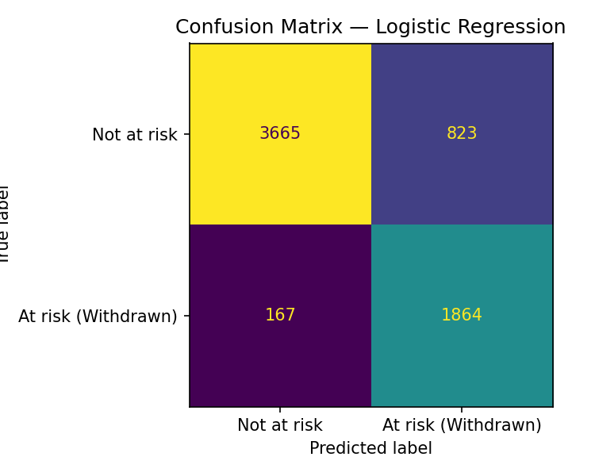  Figure 1: Logistic Regression Confusion Matrix | 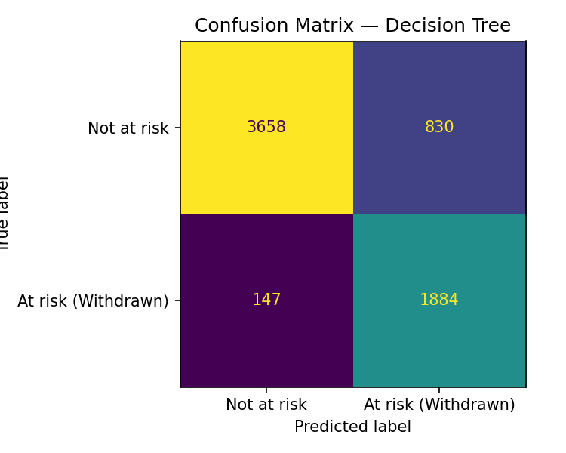  Figure 2: Decision Tree Confusion Matrix

6.3 ROC Curve and AUC
The ROC curve plots the true positive rate against the false positive rate across all classification thresholds. AUC (Area Under the Curve) summarises this in a single number: 1.0 = perfect, 0.5 = random. Both models achieve AUC ≈ 0.93, demonstrating strong discriminative power. The curves are nearly overlapping, confirming that both models capture the same underlying signal.
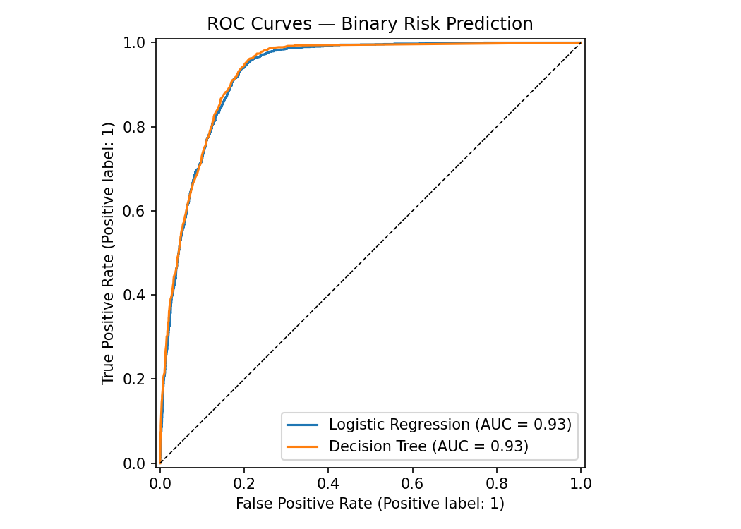
Figure 3: ROC Curves — Logistic Regression (AUC=0.929) and Decision Tree (AUC=0.932)

6.4 Cross-Validation
5-fold stratified cross-validation provides a more robust performance estimate by testing the model on 5 different held-out subsets. Results:
- Logistic Regression: CV F1 = 0.790 ± 0.004
- Decision Tree: CV F1 = 0.788 ± 0.002
Low standard deviations confirm stability across folds. The near-identical results suggest the decision boundary is well-defined by the available features.

6.5 Hyperparameter Tuning with Grid Search
GridSearchCV with 5-fold cross-validation systematically evaluates all parameter combinations and selects the configuration with the best mean F1 score. This avoids arbitrary default configurations and reduces the risk of overfitting to the specific train/test split.

6.6 Top Predictive Features (Decision Tree)
Based on feature importance scores from the best Decision Tree, academic performance and engagement dominate — more so than demographics:
- avg_score — average assessment score (strongest single predictor)
- total_clicks — total VLE engagement
- weighted_avg_score — assessment performance weighted by credit
- active_days — number of days with any VLE activity
- num_submissions — whether the student is submitting assessments at all

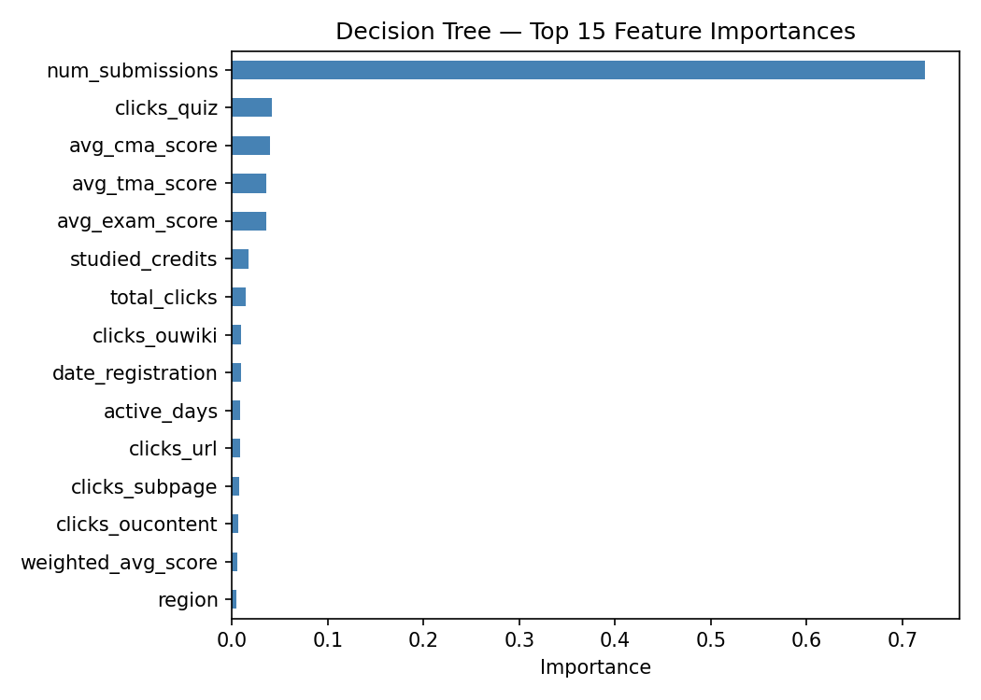
Figure 4: Decision Tree — Top 15 Feature Importances

7. Study Buddy Fine-Tuning Dataset

7.1 Instruction-Response Dataset Design
A custom 99-example Alpaca-style JSONL dataset was built for Study Buddy tasks. Each record contains an instruction, optional input context, and a detailed output response. The dataset covers five educational task categories:
Category | Examples | Description
concept_explanation | 42 | Explain a topic clearly (statistics, CS, biology, economics)
flashcard_generation | 17 | Produce Q/A flashcard sets for revision
practice_question | 15 | Generate problems with worked solutions
study_skills | 14 | Advice on how to study, revise, manage time
exam_prep | 11 | Exam technique and worked exam-style answers

7.2 JSONL Format and Prompt Engineering
Training examples are stored in JSONL format. Each line contains one structured record. At training time, examples are formatted using the Gemma-IT chat template:
<start_of_turn>user
{instruction}<end_of_turn>
<start_of_turn>model
{output}<end_of_turn>
Consistent formatting is critical because fine-tuned performance depends on clean, predictable examples. The tokenizer padding side is set to 'right' and the EOS token is used as the pad token, as Gemma has no dedicated pad token.

7.3 Dataset Size Strategy
The dataset was built incrementally: 49 pilot examples were created first to validate the pipeline, then expanded to 99 total. This incremental approach allowed detection of formatting issues before full-scale training. The 99 examples are sufficient to produce noticeably more structured, education-focused responses compared to the base Gemma model, though future work would expand this to 1,000+ examples.

8. Fine-Tuning Gemma 2B

8.1 Base Model
google/gemma-2b-it — Google's 2-billion parameter instruction-tuned language model. Selected for: (1) small enough to fine-tune on a single T4 GPU (Kaggle free tier); (2) strong instruction-following capability out of the box; (3) publicly available with accepted licence. The instruction-tuned variant (-it) already understands multi-turn chat format, reducing the amount of fine-tuning needed.

8.2 LoRA and QLoRA Overview
Full fine-tuning of a 2B parameter model would require ~15 GB GPU VRAM and modify all weights. QLoRA (Quantised Low-Rank Adaptation) solves this by: (1) loading the base model in 4-bit NF4 precision (reducing memory from ~10 GB to ~2.5 GB); (2) injecting small trainable LoRA matrices into attention layers only (~0.5% of parameters); (3) computing gradients in bfloat16 for numerical stability. The base model weights remain frozen; only the adapter is updated.

8.3 Training Configuration
Parameter | Value
Base model | google/gemma-2b-it
Quantisation | 4-bit NF4 (BitsAndBytes)
LoRA rank (r) | 16
LoRA alpha | 32
Target modules | q_proj, k_proj, v_proj, o_proj
LoRA dropout | 0.05
Training epochs | 5
Per-device batch | 1
Gradient accumulation | 16 (effective batch = 16)
Learning rate | 2e-4
LR scheduler | Cosine with 5% warmup
Optimiser | paged_adamw_8bit
Max sequence length | 256 tokens
Training hardware | Kaggle T4 GPU (15 GB VRAM)
Training time | ~15–20 minutes

8.4 Training Pipeline (TRL 1.4.0 API)
Training uses TRL's SFTTrainer with SFTConfig (not the older TrainingArguments). Key API changes in TRL 1.4.0: (1) dataset_text_field and max_length are passed to SFTConfig, not SFTTrainer; (2) the tokenizer argument is renamed processing_class in SFTTrainer. The training split is 90/10 (train/eval). Gradient checkpointing is enabled to reduce peak VRAM usage.

8.5 Inference Testing and Deployment
After training, inference was tested on three prompts: concept explanation (p-value), flashcard generation (Python lists vs tuples), and study advice. The fine-tuned model produced consistently more structured, education-focused responses than the base model.
For local deployment, Ollama serves the base gemma:2b model on Apple Silicon via MPS (Metal Performance Shaders). The fine-tuned LoRA adapter (282 MB) is available for GPU-backed deployment. The Gradio app communicates with Ollama via REST API at localhost:11434.

9. Application Interface
The Study Buddy Gradio application integrates both components into a three-tab interface served locally at http://localhost:7860. The LLM backend is Ollama (gemma:2b on Apple Silicon MPS, response time 2–5 seconds). The risk models are loaded from serialised pkl files at startup.

9.1 Tab 1 — Ask a Question
Students type any study question. The Gemma model generates a structured explanation. The prompt is formatted with the Gemma-IT chat template before being sent to Ollama. Example questions shown: What is a p-value? · Explain recursion · What is natural selection? · How does gradient descent work?
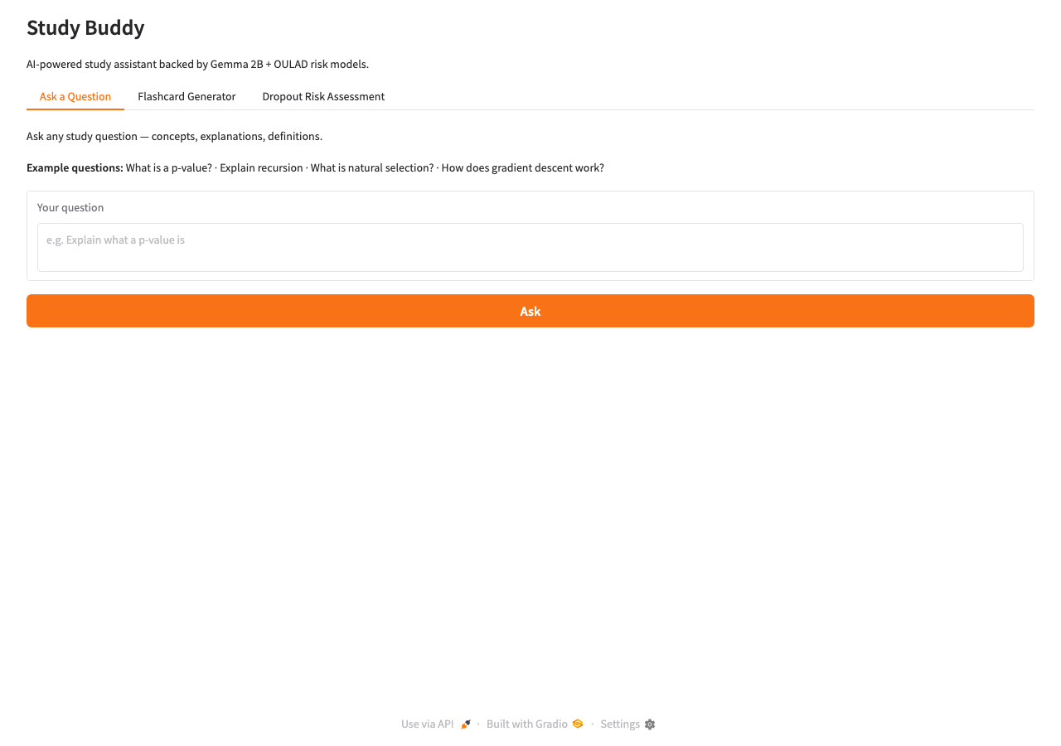
Figure 5: Tab 1 — Ask a Question

9.2 Tab 2 — Flashcard Generator
Students enter a topic and select the number of flashcards (3–10) via a slider. Gemma generates Q/A pairs formatted for revision. Example topics: sorting algorithms, SQL joins, Newton's laws, Git commands, supply and demand.
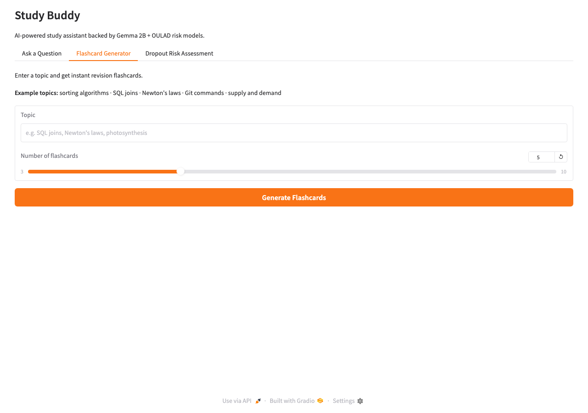
Figure 6: Tab 2 — Flashcard Generator

9.3 Tab 3 — Dropout Risk Assessment
Students or tutors enter a demographic and engagement profile using sliders and dropdowns. The ensemble of Logistic Regression and Decision Tree models predicts the probability of dropout. Results display as Low / Moderate / High Risk with probabilities from both models and the ensemble average. Thresholds: ≥70% = High Risk (red), 40–69% = Moderate (yellow), <40% = Low (green).
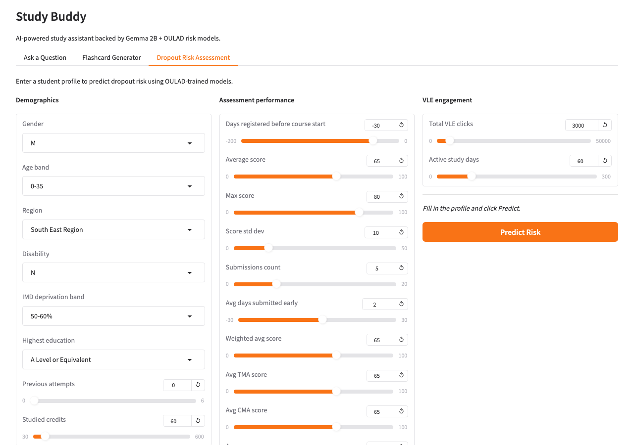
Figure 7: Tab 3 — Dropout Risk Assessment

9.4 Technology Stack
- Backend: Python 3.13, scikit-learn, Gradio 4.x
- LLM inference: Ollama (local MPS on Apple Silicon, gemma:2b)
- ML models: joblib-serialised sklearn classifiers + StandardScaler
- Data: OULAD parquet feature table (32,593 rows × 30 features)
- Fine-tuning: Kaggle T4 GPU, TRL 1.4.0 SFTTrainer, PEFT LoRA, BitsAndBytes
- Version control: GitHub — Sameer-kulkarni-sk/Study-Buddy-Flashcard-Bot

10. Discussion

10.1 What Worked Well
- OULAD's rich click-stream data provides strong signals for dropout prediction without requiring deep feature engineering — five engagement and performance features capture most of the variance.
- High at-risk recall (0.92–0.93) is appropriate for the intervention use case. A false negative (missing an at-risk student) is more costly than a false positive (supporting a student who would have been fine).
- QLoRA fine-tuning on 99 examples produced noticeably more structured, education-focused responses compared to the base Gemma model, particularly for flashcard generation tasks.
- Ollama for local inference on Apple Silicon MPS eliminated the CPU bottleneck and made the app practical for real-time use — 2–5 second response times vs. 30+ seconds on CPU.
- Identifying and removing data leakage (did_unregister, days_registered) was a critical finding. Without this step the models achieved ~100% accuracy, which would have been misleading.

10.2 Limitations
- The ML model predicts end-of-course withdrawal using full-course features; a more useful early-warning system would restrict features to the first 4 weeks.
- 99 fine-tuning examples is a small dataset; responses to out-of-domain topics revert to base Gemma behaviour.
- The fine-tuned LoRA adapter is not merged with the base model for local deployment — Ollama serves the base model; the adapter requires a GPU endpoint for full utilisation.
- Precision for at-risk students is 0.69, meaning ~31% of flagged students are false positives. In a real deployment this would require tuning the decision threshold.

10.3 Future Work
- Train an early-warning model using only the first 4 weeks of VLE click data for genuinely predictive intervention.
- Expand the fine-tuning dataset to 1,000+ examples with OULAD-specific course content (statistics, data analysis, computing).
- Deploy the merged fine-tuned model via a GPU endpoint (Replicate, Modal, or HuggingFace Spaces) for production use.
- Add a student-facing dashboard showing their own risk trajectory and personalised study recommendations based on identified weak features.
- Explore Random Forest and XGBoost as additional classifiers to compare against LR and DT.

11. Conclusion
This project demonstrates a complete end-to-end pipeline combining classical machine learning and large language models for educational analytics. The OULAD-trained dropout prediction models achieve 85% accuracy and ROC-AUC ≈ 0.93, with at-risk recall of 0.92–0.93 — the metric that matters most for early intervention. The 5-fold cross-validation confirms stability: LR F1 = 0.790 ± 0.004, DT F1 = 0.788 ± 0.002. The fine-tuned Gemma Study Buddy provides structured, educationally appropriate responses for concept questions, flashcard requests, and study advice. Both components are deployed together in a functional three-tab Gradio application, demonstrating how structured machine learning and modern generative AI can be integrated into a coherent, practically useful student-support system.

12. References
- Kuzilek, J., Hlosta, M., & Zdrahal, Z. (2017). Open University Learning Analytics Dataset. Scientific Data, 4, 170171. https://analyse.kmi.open.ac.uk/open_dataset
- Scikit-Learn Developers. (2024). Scikit-learn: Machine Learning in Python. https://scikit-learn.org/
- Hu, E. J., et al. (2022). LoRA: Low-Rank Adaptation of Large Language Models. ICLR 2022.
- Dettmers, T., et al. (2023). QLoRA: Efficient Finetuning of Quantized LLMs. NeurIPS 2023.
- Hugging Face. (2024). PEFT: Parameter-Efficient Fine-Tuning. https://huggingface.co/docs/peft/
- Hugging Face. (2024). TRL: Transformer Reinforcement Learning. https://huggingface.co/docs/trl/
- Google DeepMind. (2024). Gemma: Open Models Based on Gemini Research. https://huggingface.co/google/gemma-2b-it
- Gradio Team. (2024). Gradio: Build Machine Learning Web Apps. https://www.gradio.app/
- Ollama. (2024). Run Large Language Models Locally. https://ollama.ai/

