Assignment#1 - MapReduce

1. Config

Update the application.conf file accordingly

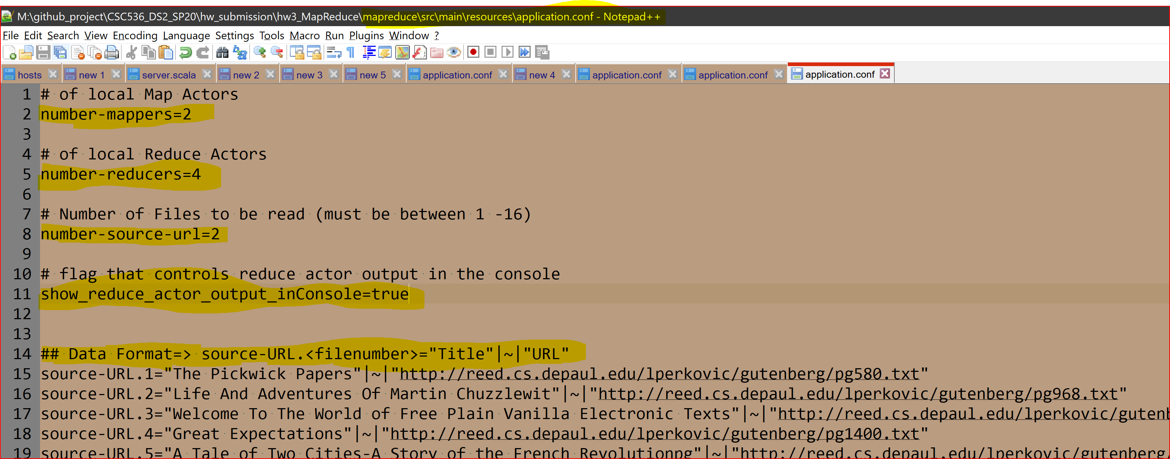  
  
*Set* ***show_reduce_actor_output_inConsole=false (by default its true)*** *to hide ReduceActor o/p in the console. The o/p is always printed to a txt file*

1. Run the MapReduce program

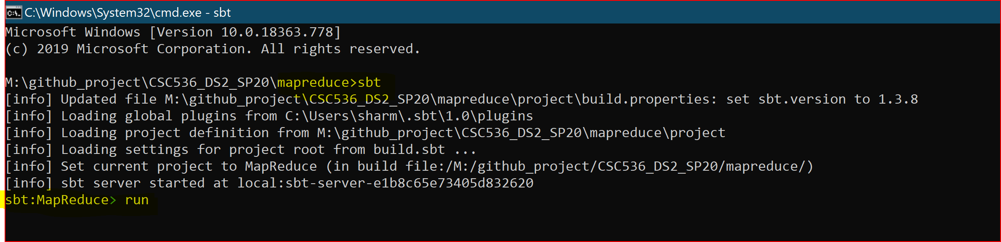

1. Final output console

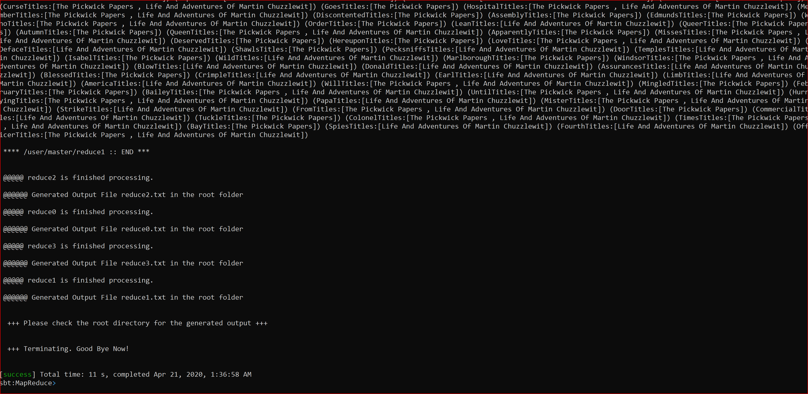

*Sample reduce actor map for 4 reduce actors*

**

Assignment#2 - Remote MapReduce

1. **Config**

**Go to application.conf and update the settings as needed  
  
 Application.conf for ServerMapReduce**

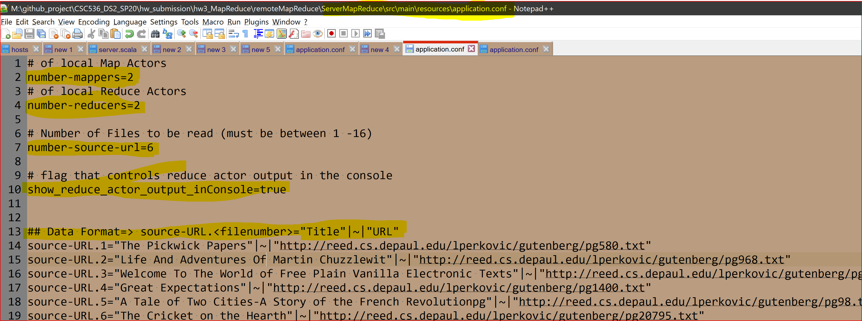

**Application.conf for ClientMapReduce** 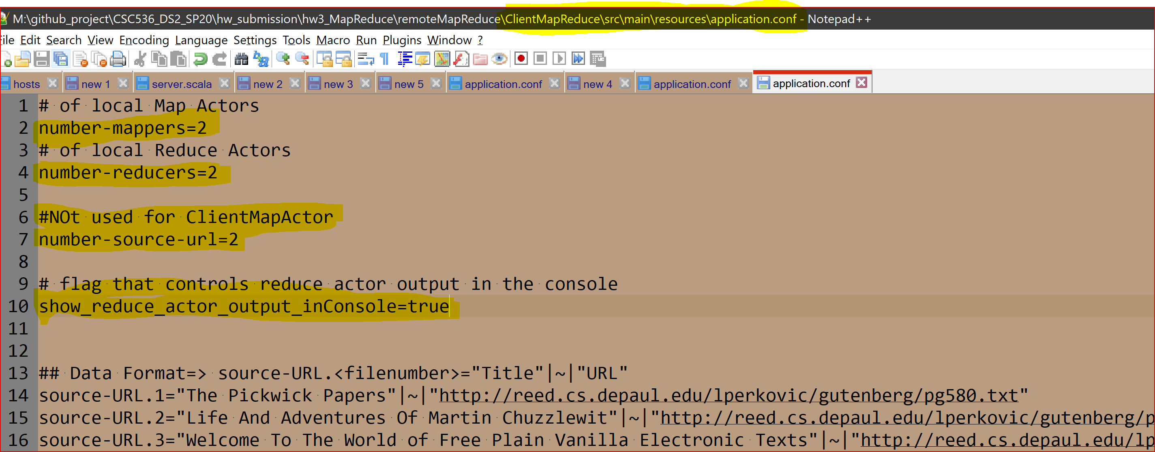

*Set* ***show_reduce_actor_output_inConsole=false (by default its true)*** *to hide ReduceActor o/p in the console. The o/p is always printed to a txt file*

1. **Start the Server MapReduceActor**

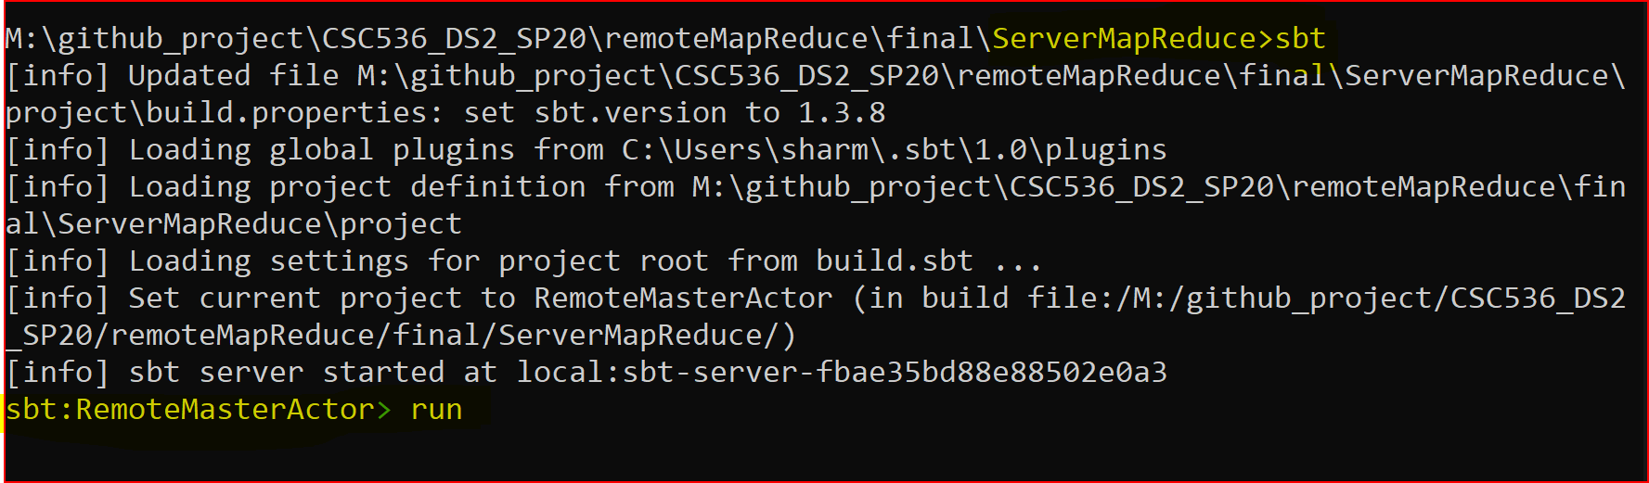

1. **Start the remote Client Map Reduce actor in a seaparte terminal/jvm**  
   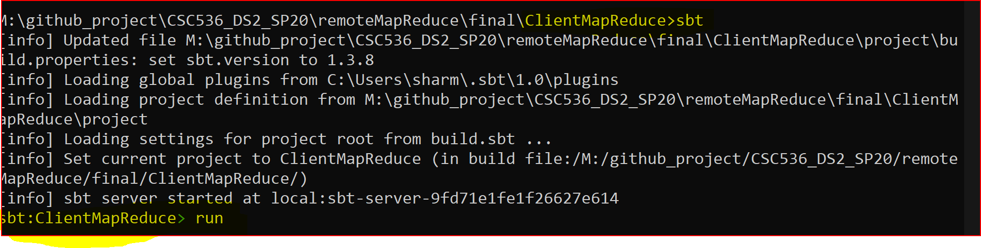

**Make sure both the Server and Client MapReduce actors are running**

1. As the execution begins, the reduce actors will print their output on the console and also save their outputs in a text file (at the root folder of the actor)
2. Once the execution is finished, both the client will print this message and terminate.   
   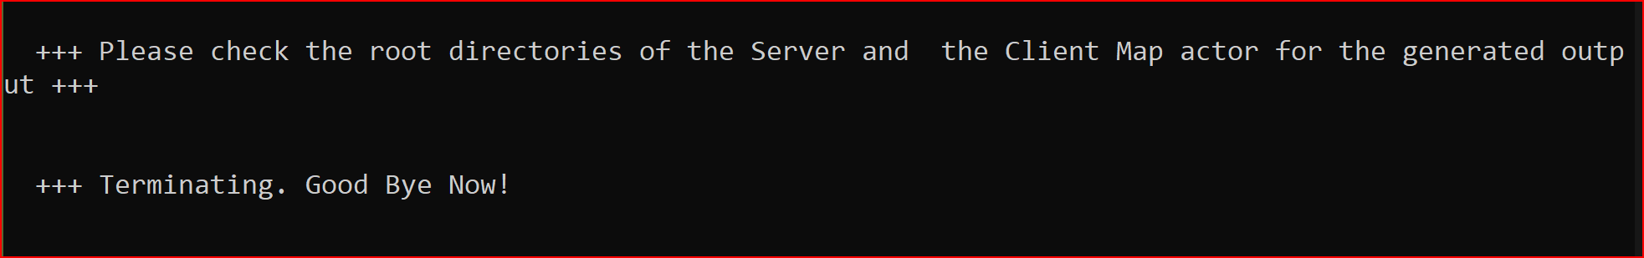
3. The reduce actor outputs will be generated in the text files of the root folder of both Server and Client Map actors.

|  |  |
| --- | --- |
|  |  |

Output Files

