Problem #2

**Few Notes**

1. First, run the ‘remote.FaultToleranceRemoteActor’
2. Next, run the ‘local.FaultToleranceLocalActor’ in a separate jvm  
     
   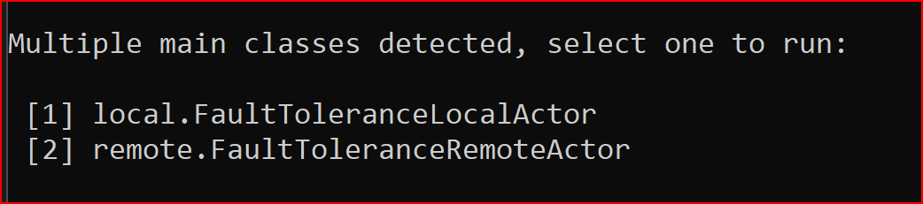
3. Close the JVM for ‘remote.FaultToleranceRemoteActor’.
4. Output

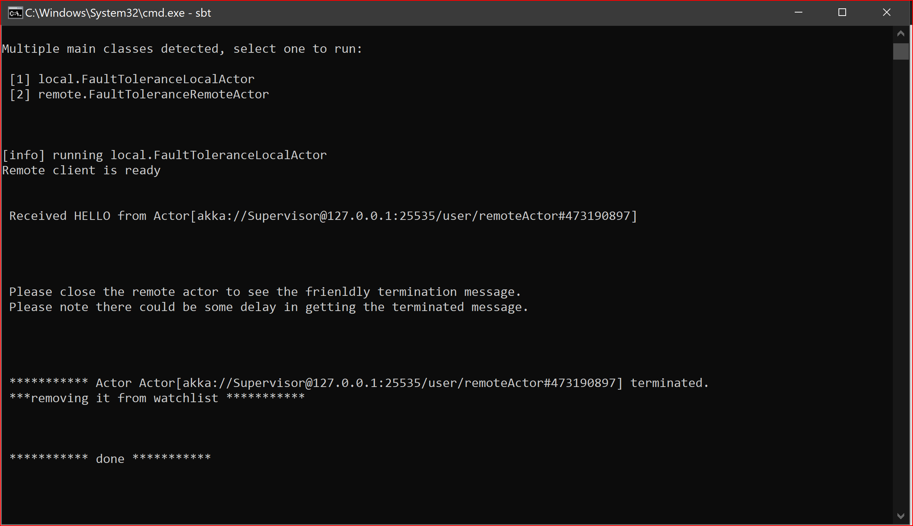

Problem #3

Few Notes

1. First, run the ‘server.MapReduceApplication’
2. Next, run the ‘client.MapReduceClient’ in a separate jvm  
   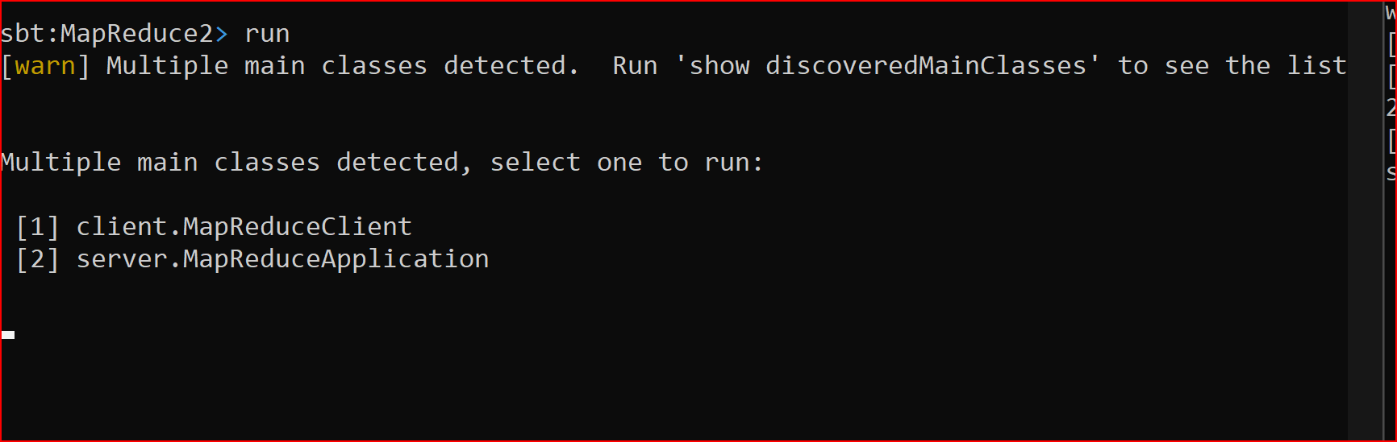
3. One of the map actor reads an invalid URL and throw exception, router catches it and resumes the actor. All outputs are written in text in the project folder

|  |
| --- |
| **Code Snippet** |
| **One of the Actor crashing due to malformed URL** |
| **Router Resumes the actor** |
| **Output** |