DOCKER

5 pts Your dockerfile. Please provide a link to this file rather than a screen capture.

**https://github.com/rsharm18/spring-petclinic/blob/master/Dockerfile**

5 pts Your running docker instance as shown by a ps command.



5 pts Your browser accessing the main page of the website from your local container.

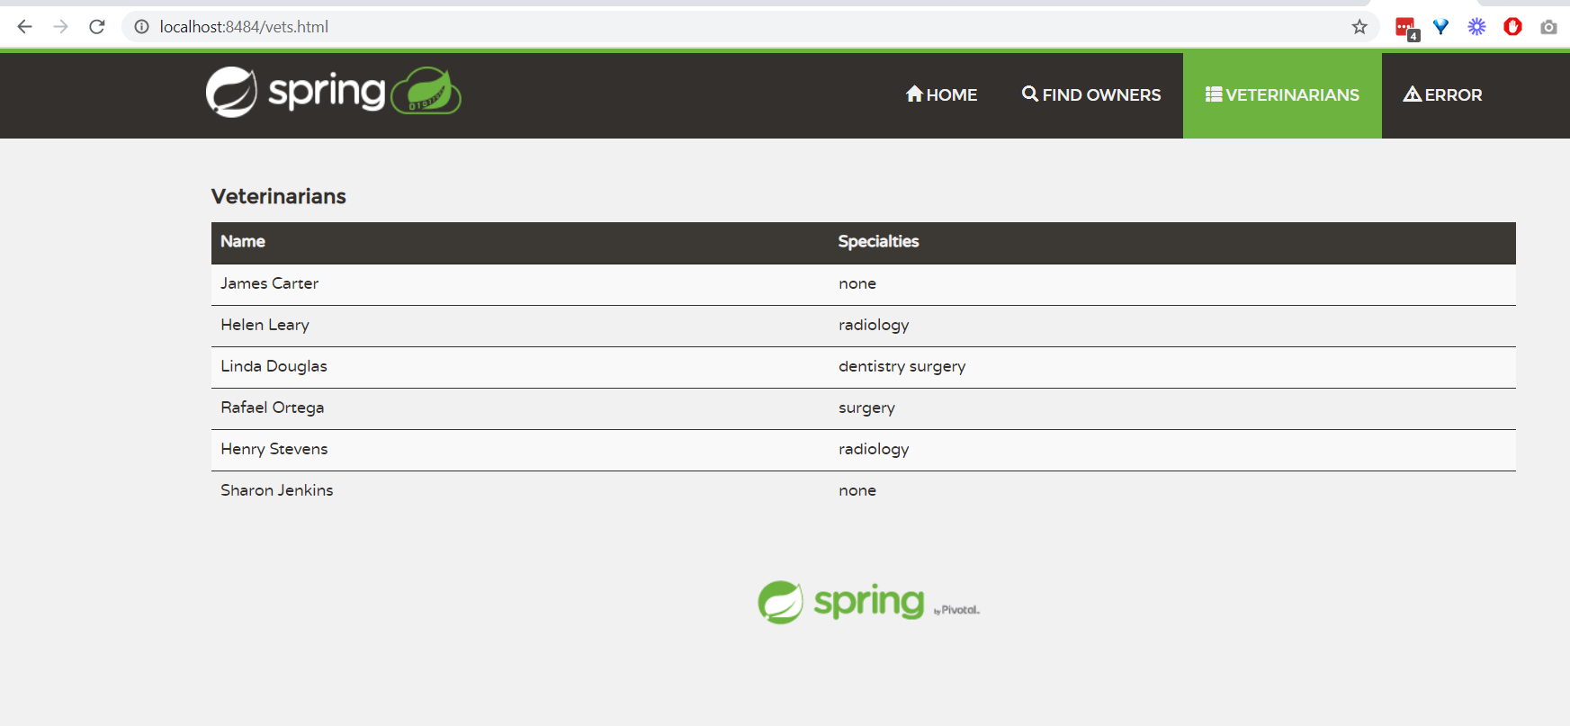

DOCKER COMPOSE - MYSQL ONLY

5 pts The output from the docker-compose up command.

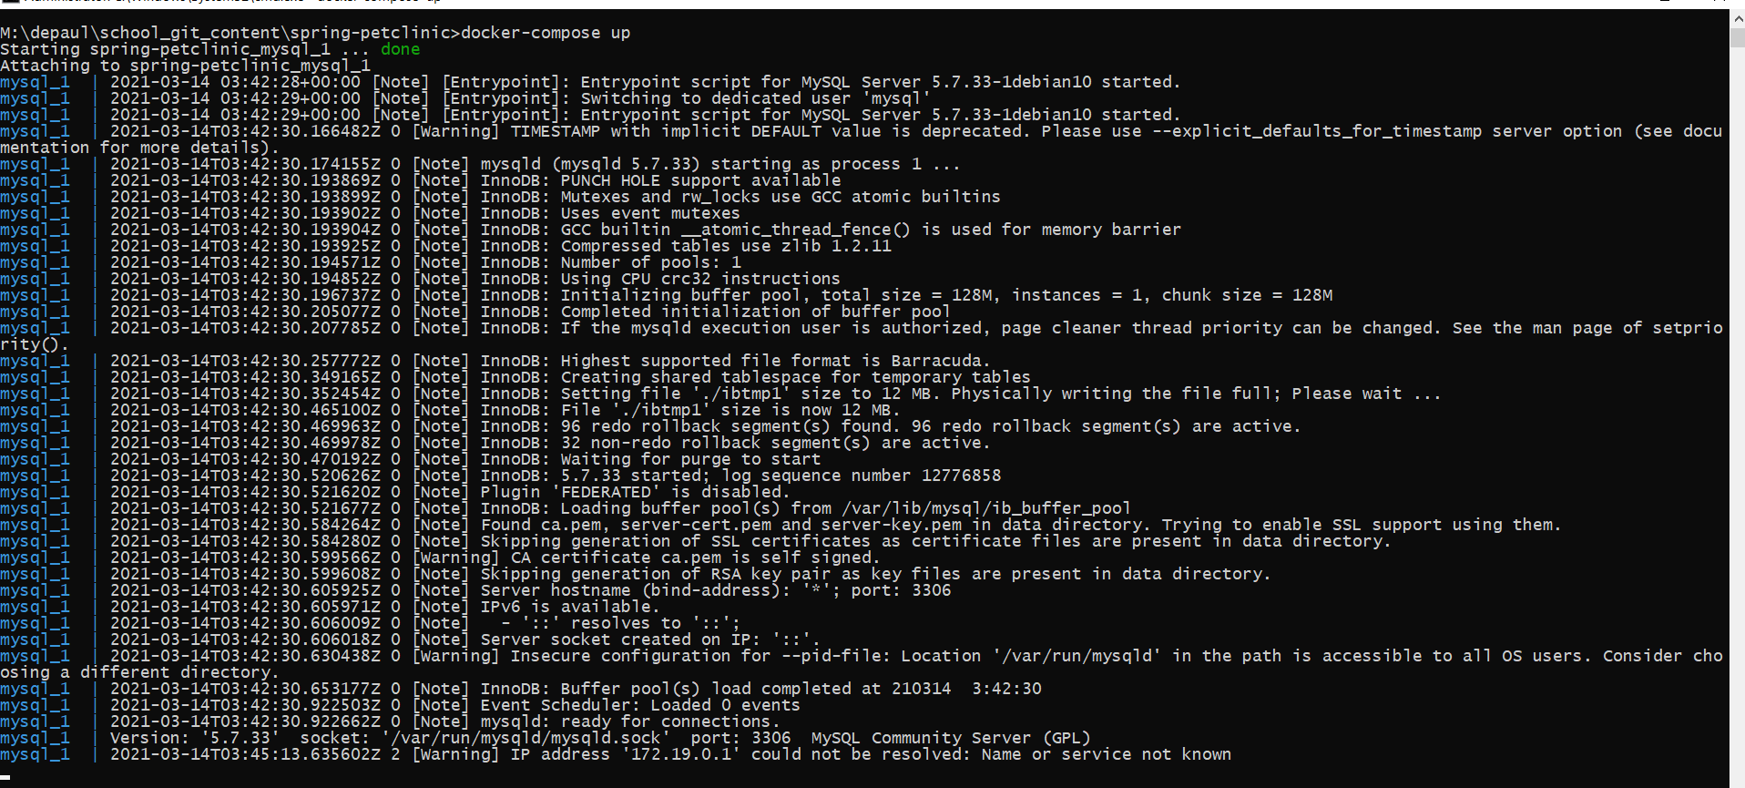

5 pts Your browser accessing the “Veterinarians” page of the website from your local container when you run the application from the host system.

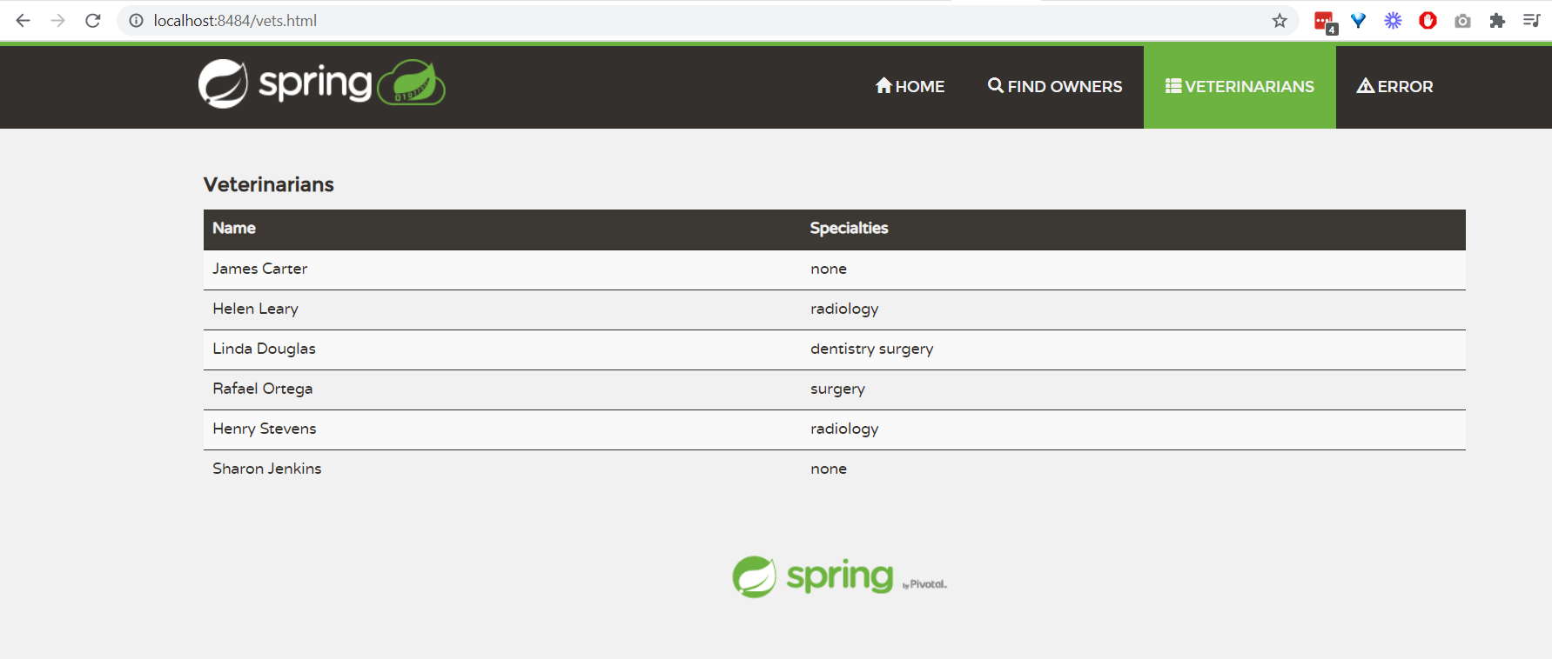

5 pts A section of the stack trace generated when you attempt to run the application container that has been updated to use MySQL.

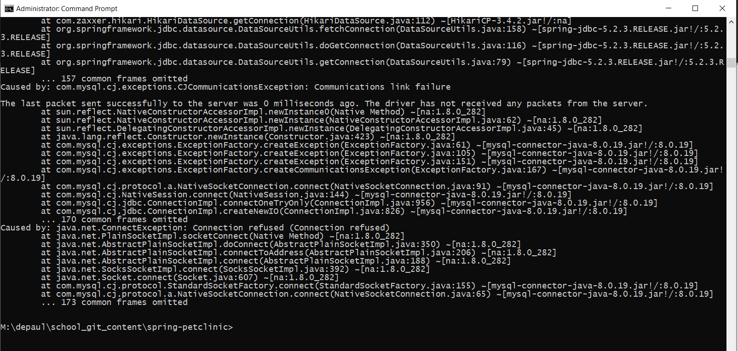

DOCKER COMPOSE - APP SERVER AND MYSQL

5 pts Your updated docker-compose.yml file containing the application server, built from your local Dockerfile, and the existing MySQL configuration. Please provide a link to this file rather than a screen capture.

**https://github.com/rsharm18/spring-petclinic/blob/master/docker-compose.yml**

5 pts Your updated application-mysql.properties file containing the URL change for the database server. Please provide a link to this file rather than a screen capture.

**https://github.com/rsharm18/spring-petclinic/blob/master/src/main/resources/application-mysql.properties**

5 pts The output from the docker-compose up command.

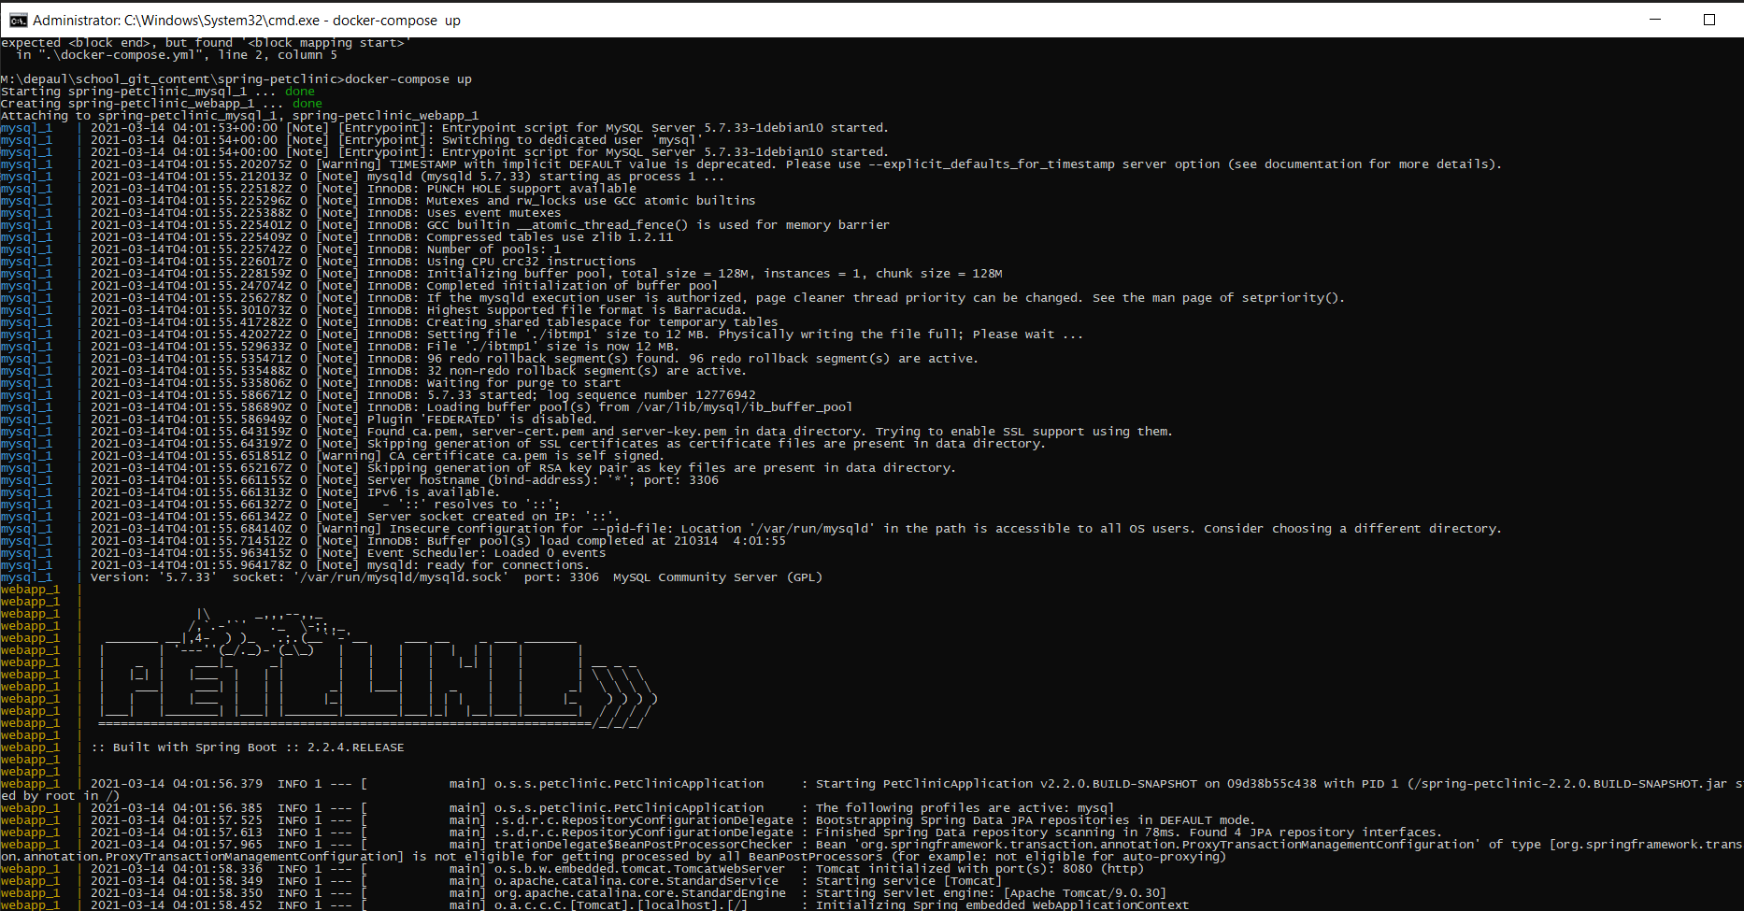

5 pts Your browser accessing the “Veterinarians” page of the website from your local container.

