- Productivity, DevOps & Shift Left (in a picture):

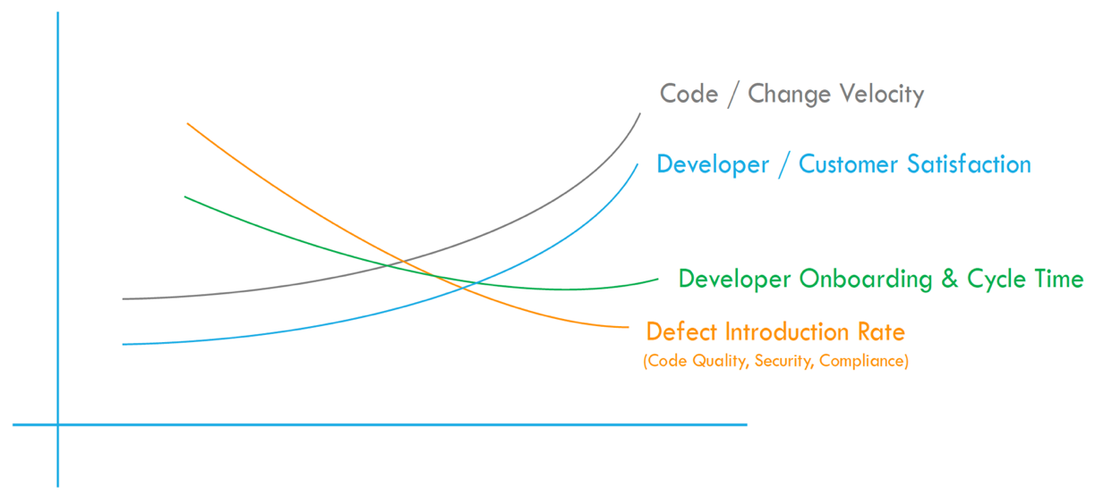
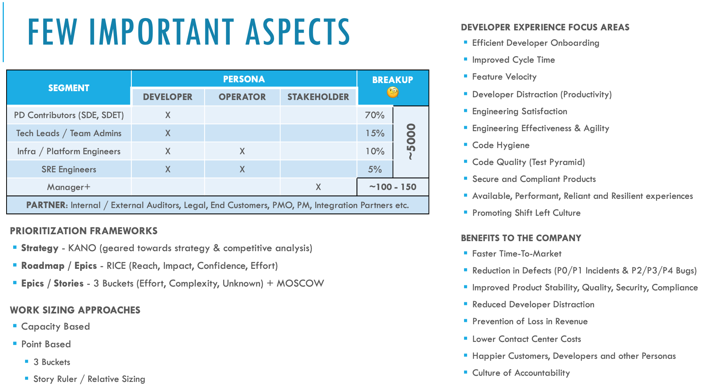

- SHIFT LEFT (in SDLC) for Engineering Effectiveness / Developer Productivity, lean DevOps transformation for the Enterprise and ~50,000 Engineers, across numerous Code Development use cases / flows, via a multi-year Roadmap, with a focus on Unified / Continuous Integration, Unified / Continuous Delivery, increased Accountability and Reduction in Defect Introduction Rate.

- DEVELOPER PLATFORMS / PRODUCTS Delivered (0 1):
                - Code Scanning as a Service - Abstraction based Automation Platform for Containerized Quality, Security & Compliance scans via CLI, CI, API, Listeners
                - Feature Readiness Platform - Code Hygiene Checklist to influence a Shift-Left mindset
                - Service Ownership Platform - GitHub attribution-based Service Ownership
                - Developer (Application Quality, Security & Compliance) Dashboards as a Platform
                - Software Artifact Metadata Repository (SAMR) Data Platform
                - Global Search Platform (with Conversational Search capabilities), to reduce Productivity loss due Information Discovery related Context Switching
- DEVELOPER TRANSFORMATIONS Driven (XF Relationship & Change Management):
- GitHub Release Org (GRO) model standardization
- 3-2-1 Branching model standardization
- Block Push model - Peer Review Enforcements on Stable Branches
- Webhook based Code Hygiene assessment via Opinionated Pipelines
- Deployment Compliance (for Builds from Production Repos and Stable Branches)
- Code Traceability (Change Ticket - Git Commits - JIRA Features)

---------------------------- Potential focus areas to influence culture of accountability and drive Signals (and hence change) ----------------------------
  - Focus Area #1: Code Hygiene and Traceability:
- GitHub Release Organization (GRO) - For all Web (C++, Java 7 / 8, Node / JavaScript, Scala, GO, Python etc.) and Native (Android, iOS) apps, cleanup and visualize a GitHub model called “GitHub Release Organization (GRO)”, to align Services / Apps to GitHub Repos via a 1:1 Source Code Management (SCM) model. Define GitHub Orgs based on Capabilities (and not Business Units).
- Protected Branches - Define a branching (develop, release, main - also known as protected branches) model for all production version artifacts hosted in GitHub. Teams can choose a 3,2 OR 1 Branch setup accordingly:
  - develop - for Development
  - release - N+1 Code (New Changes)
  - main - N Code (Production Version)
- Block Push Policies - Introduce GitHub Policies to prevent direct code pushes and self-approved pull-requests -> Build Reporting by BU to visualize State of Pre-Release Code Management metrics:
  - Code Merge Requests only via Pull Requests (PRs) and NOT Direct Pushes to Protected Branches (like develop, release and main).
  - Code Merged only via Peer Approved PRs and NOT Self-Approved PRs on Protected Branches (like develop, release and main).
  - # of Collaborators on all GRO Repos w/ merge access
  - InnerSource measurements
  - Feature IDs in Commits
- Change Traceability - Build logic to link different systems (GitHub, JIRA, Rally, ServiceNow), to production deployments, to commits and features.
- Code / Service Ownership - Build an ownership algorithm where “Owner” is identified as the Manager automatically based on largest number of common direct reports with Write / Admin access on a Service / Code Repository. Use LDAP traversal to build VP based ownership groupings of Artifacts.
- Reports & Visuals - Build a central view/reporting by BU (8+ VPs) to visualize Code Hygiene, Traceability (feature-commits-deployment relationship), Blocked Deployments and Exception Request, before releasing changes to production infrastructure.

  - Focus Area #2: SDLC Actions, Code Health Measures and Software Artifact Metadata Repository (SAMR):
    - Build Developer tooling to Standardize SDLC lifecycle actions (Build, Test, Integrate, Assemble, Deploy, Release) for 10+ different Programming Languages in containerized setups for all products.
- Build a central view / reporting by Business Unit (N+ VPs), with search for all deployable services (components/repositories/ apps) with following measurements:
  - Application Code Quality (Functional, Unit, Performance, Globalization, Accessibility, Active-Active, Monitoring etc.)
  - Code Level Test Coverage (Functional, Unit)
  - Application Security (Open Source, Static, Dynamic, Containerization, Interactive etc.)
  - Customer Flow Based Testing (in Production-Light Sandbox environments)
  - # of Collaborators/Service Ownership
  - Application Programming Language Type & Version
  - # of Deployments to Production systems
  - Average Daily Traffic
  - Critical P0s and P1s Incidents
  - Other P2, P3 and P4 Bugs
  - # of Failed Customer Interactions
  - Service/Component to Scrum Team relationship

  - Focus Areas #3: Release Readiness Validation (RRV) Checklist and Unified (Build / Release) Pipelines:
    - Introduce templates for Deployment, Testing and Building Code in a shared Release (N+1) isolated environment.
    - Build a Unified and Opinionated Build Integration System/Pipeline, for converting code commits/builds into manifests (Continuous Integration or CI) via a seamless way to run Code Health Checks at Pull-Request OR Build Phase.
    - Introduce Code Health Check gates using Phase 1 & 2 standards/tooling to Provide health and risk ratings to all Production Manifests for Release Readiness.
    - Ensure the system is Recommendation based, allows Engineers to make decisions (approve), but at the same time ensures code is stable and meets Enterprise Compliance requirements/standards.
    - Consolidate 5+ Code Release/Delivery Vehicles into 1 Unified Delivery System/Pipeline (Continuous Deployment or CD).
    - Build a central view by BU (8+ VPs), to report on Health, Risk ratings of all changes to Production and Developer decisions.

  - Focus Areas #4: Unified Release Pipeline, Defect Management and Engineering Accountability Report (EAR):
    - For all Code manifests validated as GREEN (or Approved) against Release (N+1) environments, prepare Unified and automated System/Pipeline to promote code changes (and new features) to Sandbox, Production (N) Nodes and a Master (N/Production Replica) environments.
    - Build a system to run E2E Flow tests on Sandbox environments and smoke/performance tests on Production (N) Nodes.
    - Refine bug management system(s) and SLAs for all incident / defect categories (P0, P1, P2, P3, P4) to improve Open on Live (OOL) times.
    - Accommodate Leading (Pre-Release) and Lagging (Post-Release) indicators in the Ops Accountability OR Engineering Accountability Report (EAR) by tying Phase 1, Phase 2, Phase 3 and Phase 4 together, and automating notifications to Engineers, their Leaders and VPs.

----------------------------------------------------- Different aspects of Effectiveness, Agility, Quality etc. ------------------------------------------------------

- Productivity Areas of Opportunity: Ways to assess effective change management via Engineering Productivity (Excellence, Effectiveness):
    - Developer Onboarding:
- Are Engineers equipped from the start to quickly begin coding? Have all their tech stack need been met?
- A fascinating article by Emil Sit on this aspect - https://www.donut.com/blog/onboarding-engineers-at-toast/
- Some related strategies can be: Making courses like "Push to Production" part of Onboarding, Baking Dev Persona into the laptop images with the tools for them to get running quickly, making other library of Dev Tools available on an internal App Store (at a prior company our app store was called Self Service).
- Success here can be measured by looking at Survey based options sent to all new Devs after 45 days of having them start OR looking at TTFHW (Time to First Hello World) from starting to do 1st commit to 1st build metrics.

    - Developer Distraction:
      - Distraction can be many things: Are there too many meetings? Is the environment too noisy? Is the tooling broken for basic things like search, build, test? Are compile times high? Is the CDLC system too complex to use? Are PMs not providing the right specs?
      - Some strategies here can be doing a bi-yearly "Ways of Working" survey, that captures Developer sentiments around everything by Dev Persona (IC, Tech Leads, EMs, Architects, Directors can be sub-segments).
      - Simple things like a "No Meeting Days" and empowering Developers (by leadership sending an announcement) to decline meetings on the set day, drive a lot of positive sentiments in this aspect. I have also seen all Platform teams become more accountable for basic hygiene, search, availability, observability, latency and resiliency related aspects on all platforms that affect a Developer's Cycle Time journey.

    - Developer Satisfaction:
      - We can co-relate this to a MAP (Mastery, Autonomy, Purpose) based qualitative approach.
        - Mastery: How valued or specialized do I feel in my work. Have I developed some kind of mastery in my craft? Do my team and I feel proud about my accomplishments?
        - Autonomy: Standards are great and I love them. But am I provided some amount of autonomy to make decisions and direct my work, without feeling micro-managed? Have I built trust with my team and my leadership?
        - Purpose: Am I working on something that is bigger than me and important to the company?
      - We can also measure satisfaction via quantitative approaches, by adding Feedback Loops / Buttons (at a prior company we used Qualtrics for Developer Engagement Scores) in CLI tool documentation, API documentation OR a product GUI itself.
      - We can also measure these by observing trends in Support Tickets and Bugs (or sometimes Slack Help).
      - Some strategies here can be doing a bi-yearly "Ways of Working" survey, that captures Developer sentiments around everything by Dev Persona (IC, Tech Leads, EMs, Architects, Directors can be sub-segments).

    - Engineering Effectiveness:
      - There are few ways of measuring Effectiveness. Many organizations think # of Commits is a good measure, but I have learned over years that that is a metric that can easily be increased by doing 100 single line commits.
      - Some of the Metrics that communicate right signals at Enterprise level:
        - YoY Reduction in Defect Introduction Rate (DIR): This can directly co-relate to instability and be translated to potential loss in Revenue due to the instability caused by Incidents. Via a Release Readiness validation system, we can build a model like “Unhealthy Release > Incident > TPV > Revenue Impact”.
        - Failed Customer Interactions (FCI): Has the same effect as DIR but at flow levels (instrumenting smaller flows).
        - YoY Reduction in Customer Contact due to Bugs: This kind of metric can help track reduction in Customer Support (Calls) cost due to reduction in Bugs. NOTE - Defects = Incidents (PX, P0, P1) + Bugs (P2, P3, P4).
        - YoY Reduction in Developer Cycle Time (DCT): This is a sum of all Dev Activities in Code Dev lifecycle, and by instrumenting all platforms that touch the Dev journey from coding to prod, we can assess if we are making their feature shipping journey better:
          - From Commit to PR
          - From PR generation to PR Review
          - From PR Review to PR Merge
          - From PR Merge to Build
          - From Build to Release Validation
          - From Release Validation to 1st Deploy (this can be Canary or 1st Node)
          - From 1st Deploy to full 100% Ramp
        - Lines of Code & Test Coverage: All N+1 changes should ideally have 100% Test Coverage.
        - AppSec Scores: All releases should be free of Open Source (Critical) Vulns and no PII Class Data should be logged. Some teams expand these to Image (Container) Level Vulns, Security Static Analysis & Dynamic Analysis.
        - Code Velocity: Do we see YoY improvement in Code Velocity. Do bugs count as velocity vs GA releases. I feel it depends on each team's team agreement. Here is some reference material:
    - https://www.infoq.com/news/2011/09/bug-fixes-velocity/
    - https://www.nagarro.com/en/blog/bug-fixing-scrum-team-velocity#:~:text=Estimating%20bugs,of%20the%20last%203%20sprints.
    - https://docs.microsoft.com/en-us/azure/devops/report/dashboards/velocity-guidance?view=azure-devops&tabs=in-context
- Something worth listening to: https://www.thoughtworks.com/insights/podcasts/technology-podcasts/developer-effectiveness
            - Ease of Information Discovery:
              - If we were do sit down and do some analysis, we will find that 10-15% of efficiency per employee each month is lost “looking for information” such as Product documentation, Team issues home page, historical occurrences of issues etc.
              - As leaders, we can make looking for information lean, well managed / governed and a bit streamlined. This will cause some investment in building a program that solves some of these challenges, but over a period of time the return would be less productivity loss and more efficiency from every member in our organizations.
              - For e.g.: indexing these kinds of things via a robust search model in an Organizations Home Central page / app and parsing for details across assets can alleviate some of these issues.
              - As organizations grow this becomes a more challenging issue to solve; if it was not seeded as part of growth and monitored, governed and evolved over a period of time.

- Importance of (and automating) Feedback Loops:
    - All Engineering Experiences or Effectiveness efforts are usually designed to improve Onboarding & Cycle Time as a key goal for Engineers (at the same time embedding aspects to make the same Engineers accountable).
    - As we break down these aspects into tools and buckets for an engineer’s journey to release software i.e.: Onboarding -> First Commit / PR -> PR Merge -> Build -> Release -> Deploy; we should embed Feedback Loops in these stages.
    - Some feedback loops can be as simple as obtaining Feedback from your Users via Feedback Forms, 1:1, Engineering CABs, Support Ticket patterns etc.
    - Some feedback loops can be automated event-based triggers, signaling when a system (serving one of the buckets above) degrades beyond a usual threshold.
    - <In Progress>

    - Developer Tooling Standards:
      - We often confuse DevOps, Developer Experience and Shift Left change management with which is the best Cloud, which is the best Container, which is the best Build System. Though, these “tools” are certainly “enablers” of Developer Velocity, they by themselves are not a silver bullet that will drive your DevOps transformation and better Developer Experience.
      - We have to understand how different pieces of an ecosystem connect with each other to drive change / transformation (as with any other transformation). People, Process, Culture, Behaviors, setting up good SDLC standards and making Data Visible to everyone influence effective Software Development (with Shift Quality Left signals in entire SDLC). More on this in Focus Areas 1-4 above.
      - Refer a great talk: https://resources.github.com/videos/Automating-CI-CD-pipeline-n/
      - You may have heard of a great OpenSource project: https://backstage.io/ and some similar products (for e.g.: https://www.atlassian.com/software/compass) in the market. Here is a list of many companies that (I believe) use Backstage as a single pane of glass for all Developer Interactions - https://github.com/backstage/backstage/blob/master/ADOPTERS.md
      - Additional Resources:
  - https://github.com/workos-inc/awesome-developer-experience
  - ETSY’s: https://codeascraft.com

            - Team Agility:
      - Some Metrics that communicate this at Team Level (NOTE - These may be used for team to measure its own success and should not be used by leadership to measure and compare team outcomes:
        - Backlog Health: Does the team consistently have 2 sprints worth of groomed stories in their backlogs?
        - Plan / Do Ratio: How many committed story points are actually PO accepted end of each sprint (some teams also like expanding this to how many points are actually shipped).
        - Iteration Churn: How many stories are split / moved. How many bugs get found as part of Development OR are filed by support and taken up by the team in the same sprint.
        - Qualitative Aspects like Retrospectives: How many teams do these and find value. How many teams stop doing these and why?

- Effective SRE is in most cases “post-live Ops” part of DevOps (aka SRE != DevOps):
  - SRE is often confused by companies as everything DevOps (you can find hundreds of jobs posted with this confusion).
  - Leaders are not to blame here; as the industry is still trying to understand DevOps as a practice and that it truly involves People, Process, Culture, Behaviors that influence effective Software Development (with Shift Quality Left signals in entire SDLC)
  - SRE has some role to play before code actually hits production, but towards the tail end of an entire SDLC flow. Sure, SRE can create governance around what is certified as an approved release OR how are release tickets documented OR how incidents / defects are managed (the SLAs around them, the importance of Root Cause Analysis and Corrective Actions on bugs).
  - DevOps is both “Dev” and “Ops” and often (internal) Developer Experience (DevEx) teams are charged with making a Developers’ journey effective, from the time they onboard at a company, to the time they check-in (and assess Quality, Security, Compliance of) their changes and prepare a build for deployment.
  - There is a natural hand-shake that happens at the release readiness / deployment point between DevEx (Dev) & SRE (Ops); though DevEx teams also work on building / bringing in the tools and experiences that may allow Dev Teams to effectively operate / monitor their applications.
  - DevEx and SRE teams in most cases end up working very closely with each other. At many companies Internal DevEx (Developer Infrastructure & Productivity), SRE (or Environment / Tech Ops) and External DevEx (API / SDK Developer Platforms) are often under a single Developer Ecosystem Organization.

- Following the Test Pyramid:

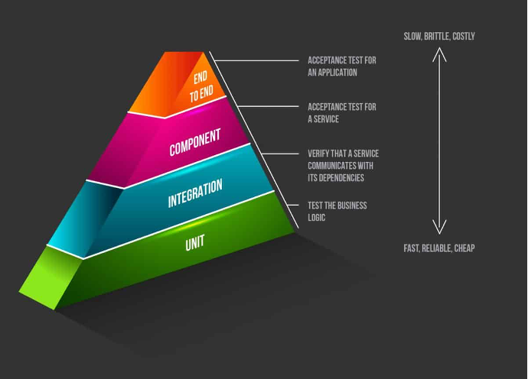
Ref: https://phoenixnap.com/blog/microservices-continuous-testing

