**PRACTICAL-8**

**Alter Command**

**Commands:-**

create table Doctor_Listn(Sno Integer,Doctor_Name varchar(20) PRIMARY KEY,Speciality varchar(20),Salary Integer)

create table Patient_Listnew(Sno Integer, Patient_Name varchar(20),Assigned_Doctor varchar(20),FOREIGN KEY(Assigned_Doctor) references Doctor_Listn(Doctor_Name))

Alter table Doctor_Listn add Timing Integer

select *from Doctor_Listn

Alter table Doctor_Listn drop col(salary,timing)

select *from Doctor_Listn

**OUTPUT:-**

**Doctor Table:**

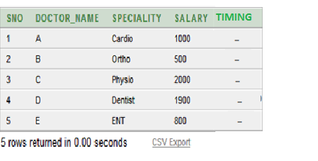

**Alter table Doctor_Listn**

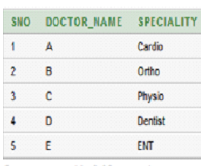

**PRACTICAL-5**

**Using Where Clause**

**Commands:-**

create table Doctor_Listn(Sno Integer,Doctor_Name varchar(20) PRIMARY KEY,Speciality varchar(20),Salary Integer)

create table Patient_Listnew(Sno Integer, Patient_Name varchar(20),Assigned_Doctor varchar(20),FOREIGN KEY(Assigned_Doctor) references Doctor_Listn(Doctor_Name))

insert all into Doctor_Listn values(1,'A','Cardio',1000) into Doctor_Listn values(2,'B','Ortho',500) into Doctor_Listn values(3,'C','Physio',2000) into Doctor_Listn values(4,'D','Dentist',1900) into Doctor_Listn values(5,'E','ENT',800) select *from dual

insert all into Patient_Listnew values(1,'Dhruv','A') into Patient_Listnew values(2,'Chris','D') into Patient_Listnew values(3,'Sam','E') into Patient_Listnew values(4,'Fred','A') into Patient_Listnew values(5,'Rohit','B') into Patient_Listnew values(6,'Fin','B') into Patient_Listnew values(7,'Henry','C') into Patient_Listnew values(8,'Ron','C') select *from dual

select *from Patient_Listnew

select * from Patient_Listnew where Assigned_Doctor='C'

**OUTPUT:-**

**Where Assigned Doctor!=C**

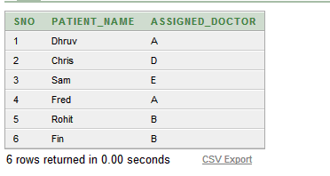

**PRACTICAL-3**

**Insert Into**

**Commands:-**

create table Doctor_Listn(Sno Integer,Doctor_Name varchar(20) PRIMARY KEY,Speciality varchar(20),Salary Integer)

create table Patient_Listnew(Sno Integer, Patient_Name varchar(20),Assigned_Doctor varchar(20),FOREIGN KEY(Assigned_Doctor) references Doctor_Listn(Doctor_Name))

insert all into Doctor_Listn values(1,'A','Cardio',1000) into Doctor_Listn values(2,'B','Ortho',500) into Doctor_Listn values(3,'C','Physio',2000) into Doctor_Listn values(4,'D','Dentist',1900) into Doctor_Listn values(5,'E','ENT',800) select *from dual

insert into Patient_Listnew values(1,'Dhruv','A')

insert into Patient_Listnew values(2,'Chris','D')

insert into Patient_Listnew values(3,'Sam','E')

insert into Patient_Listnew values(4,'Fred','A')

insert into Patient_Listnew values(5,'Rohit','B')

insert into Patient_Listnew values(6,'Fin','B')

insert into Patient_Listnew values(7,'Henry','C')

insert into Patient_Listnew values(8,'Ron','C')

select *from dual

select *from Patient_Listnew

select *from Doctor_Listn

**OUTPUT:-**

**Doctor Table:**

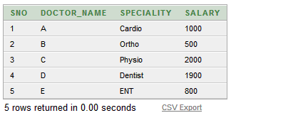

**Patient Table:**

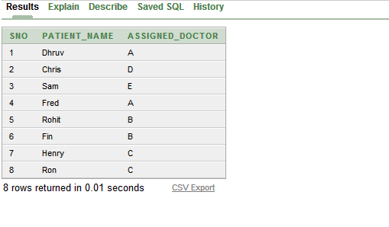

**PRACTICAL-6**

**Delete Command**

**Commands:-**

create table Doctor_Listn(Sno Integer,Doctor_Name varchar(20) PRIMARY KEY,Speciality varchar(20),Salary Integer)

create table Patient_Listnew(Sno Integer, Patient_Name varchar(20),Assigned_Doctor varchar(20),FOREIGN KEY(Assigned_Doctor) references Doctor_Listn(Doctor_Name))

insert all into Doctor_Listn values(1,'A','Cardio',1000) into Doctor_Listn values(2,'B','Ortho',500) into Doctor_Listn values(3,'C','Physio',2000) into Doctor_Listn values(4,'D','Dentist',1900) into Doctor_Listn values(5,'E','ENT',800) select *from dual

insert all into Patient_Listnew values(1,'Dhruv','A')

into Patient_Listnew values(2,'Chris','D')

into Patient_Listnew values(3,'Sam','E')

into Patient_Listnew values(4,'Fred','A')

into Patient_Listnew values(5,'Rohit','B')

into Patient_Listnew values(6,'Fin','B')

into Patient_Listnew values(7,'Henry','C')

into Patient_Listnew values(8,'Ron','C')

select *from dual

delete from Patient_Listnew where Assigned_Doctor=C

delete from Doctor_Listn where Speciality=ENT

select *from Patient_Listnew

select *from Doctor_Listn

**OUTPUT:-**

**Doctor Table:-**

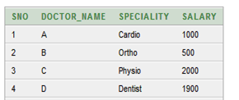

**Patient Table:-**



**PRACTICAL-7**

**Update Command**

**Commands:-**

create table Doctor_Listn(Sno Integer,Doctor_Name varchar(20) PRIMARY KEY,Speciality varchar(20),Salary Integer)

create table Patient_Listnew(Sno Integer, Patient_Name varchar(20),Assigned_Doctor varchar(20),FOREIGN KEY(Assigned_Doctor) references Doctor_Listn(Doctor_Name))

insert all into Doctor_Listn values(1,'A','Cardio',1000)

into Doctor_Listn values(2,'B','Ortho',500)

into Doctor_Listn values(3,'C','Physio',2000)

into Doctor_Listn values(4,'D','Dentist',1900)

into Doctor_Listn values(5,'E','ENT',800)

select *from dual

insert all into Patient_Listnew values(1,'Dhruv','A')

into Patient_Listnew values(2,'Chris','D')

into Patient_Listnew values(3,'Sam','E')

into Patient_Listnew values(4,'Fred','A')

into Patient_Listnew values(5,'Rohit','B')

into Patient_Listnew values(6,'Fin','B')

into Patient_Listnew values(7,'Henry','C')

into Patient_Listnew values(8,'Ron','C')

select *from dual

update Doctor_Listn set Salary=800 where Sno=2

select *from Doctor_Listn

**OUTPUT:-**

**Updated Doctor Table:-**

