1. Create a Table Empl to store employee

* Created the table in the mysql.

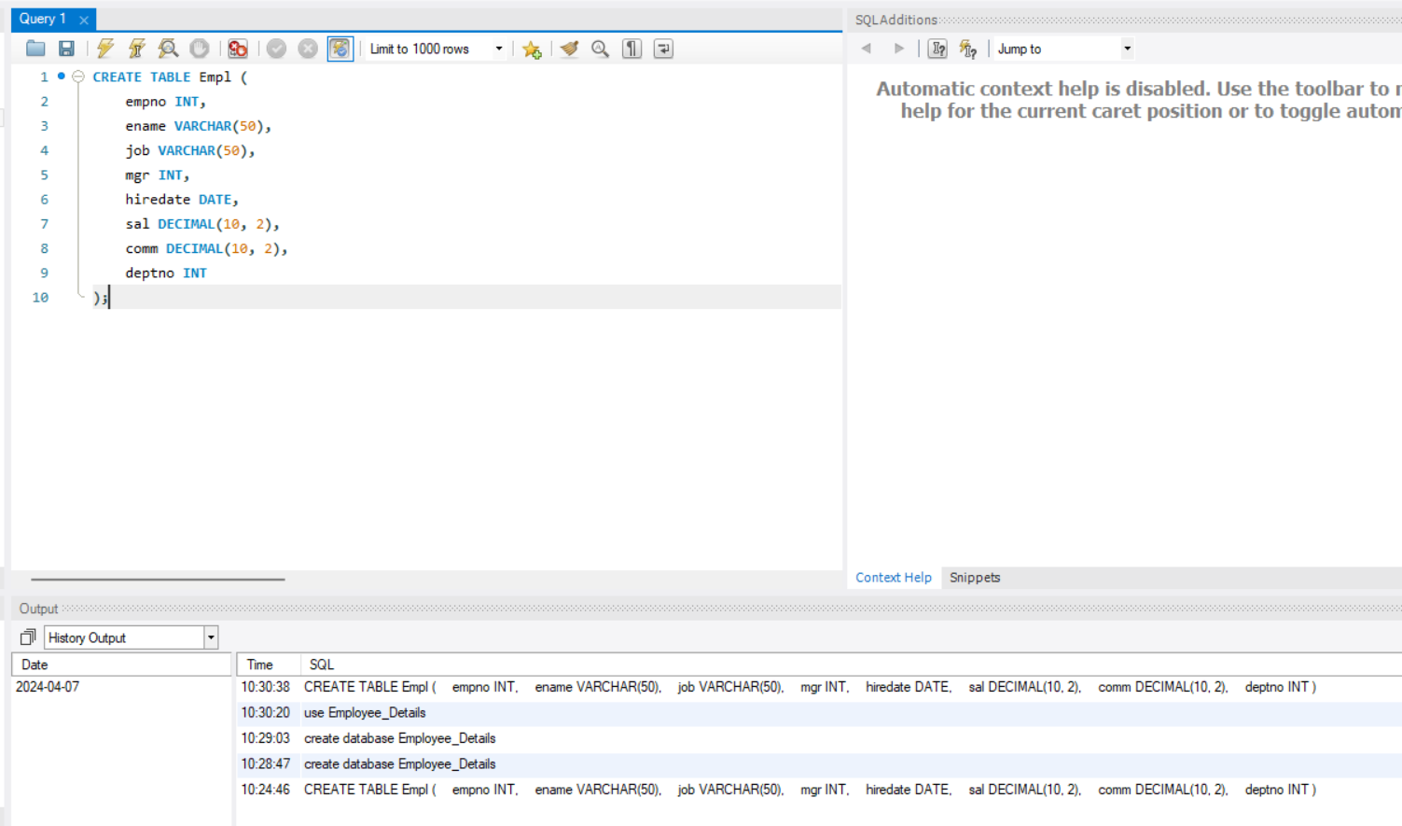

* Inserted the details into the table using this code

INSERT INTO Empl (empno, ename, job, mgr, hiredate, sal, comm, deptno) VALUES

(8369, 'SMITH', 'CLERK', NULL, '1990-12-18', 800.00, NULL, 20),

(8499, 'ANYA', 'SALESMAN', 8698, '1991-02-20', 1600.00, NULL, 30),

(8521, 'SETH', 'SALESMAN', 8698, '1991-02-22', 1250.00, 500.00, 30),

(8566, 'MAHADEVAN', 'MANAGER', 8839, '1991-04-02', 2985.00, NULL, 20),

(8654, 'MOMIN', 'SALESMAN', 8698, '1991-05-01', 2850.00, NULL, 30),

(8882, 'SHIVANSH', 'MANAGER', 8839, '1991-06-09', 2450.00, NULL, 20),

(8844, 'KULDEEP', 'SALESMAN', 8698, '1991-09-08', 1500.00, 0.00, 30),

(8698, 'BINA', 'MANAGER', 8839, '1991-05-01', 2850.00, 0.00, 30),

(8888, 'SCOTT', 'ANALYST', 8566, '1992-12-09', 3000.00, NULL, 20),

(8888, 'AMIR', 'PRESIDENT', NULL, '1992-12-09', 3000.00, NULL, 10);

* All data created as per the table

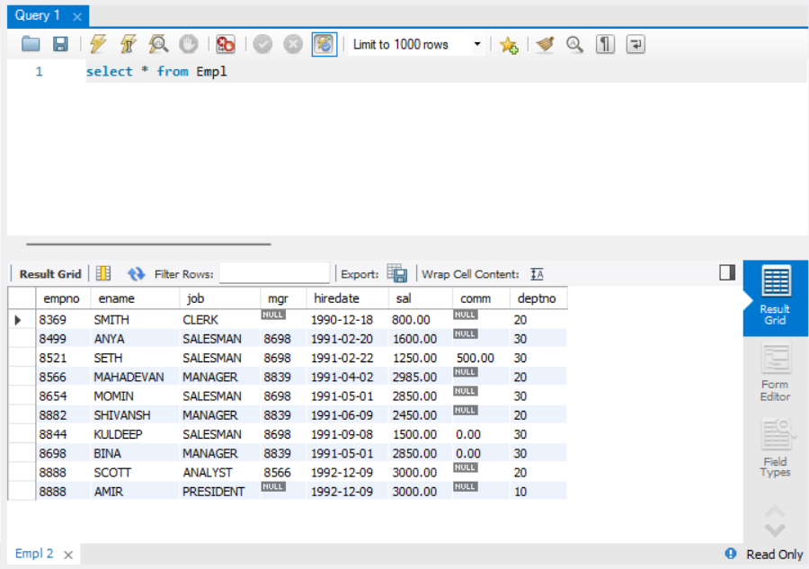

1. Query to display EName and Sal of employees whose salary are greater than or equal to 2200.

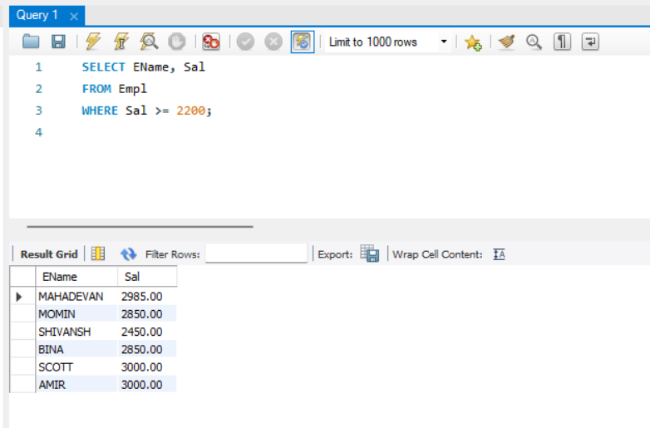

1. Query to display details of employees who are not getting commission

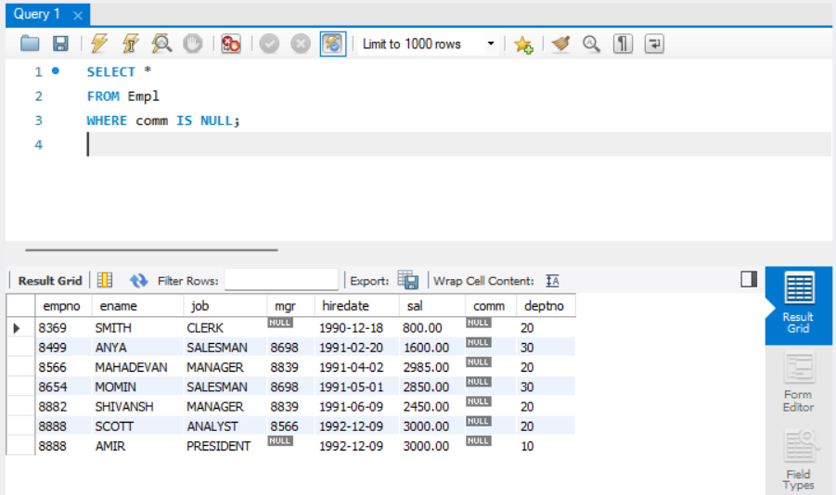

1. Query to display employee name and salary of those employees who don’t have their salary in the range of 2500 to 4000

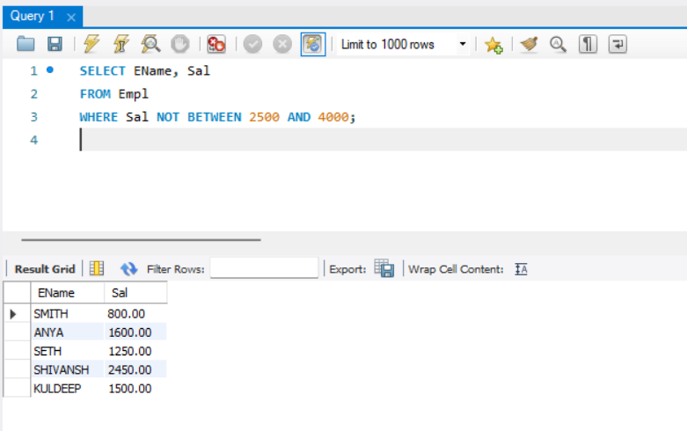

1. Query to display the name, job title and salary of employees who don’t have a manager

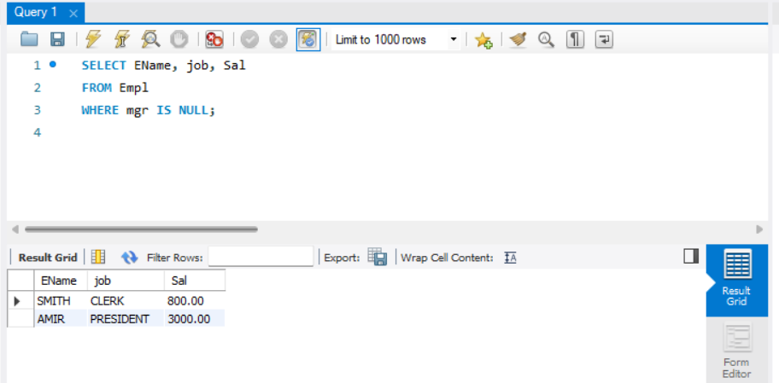

1. Query to display the name of an employee whose name contains “A” as third alphabet

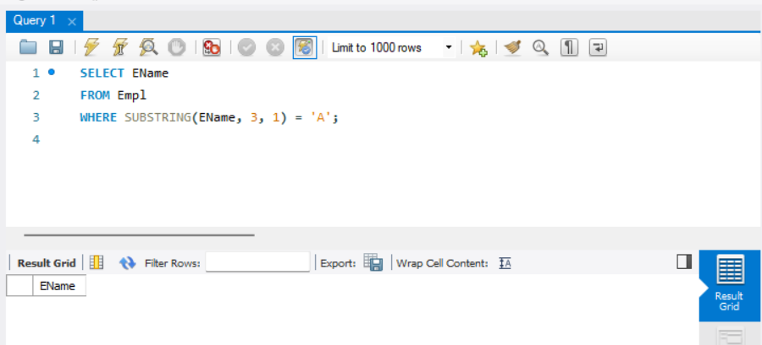

1. Query to display the name of an employee whose name contains “I” as the last alphabet

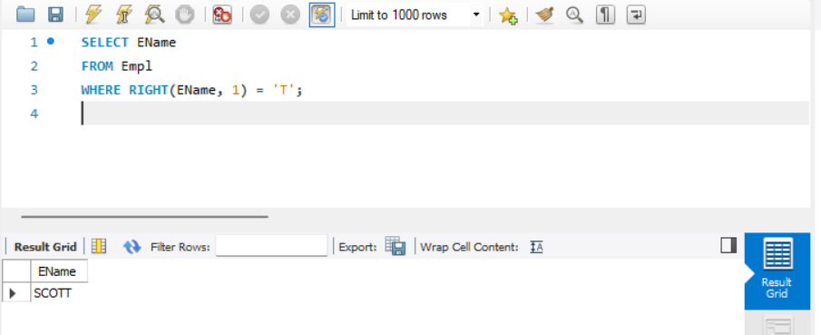

1. JDBC connectivity:

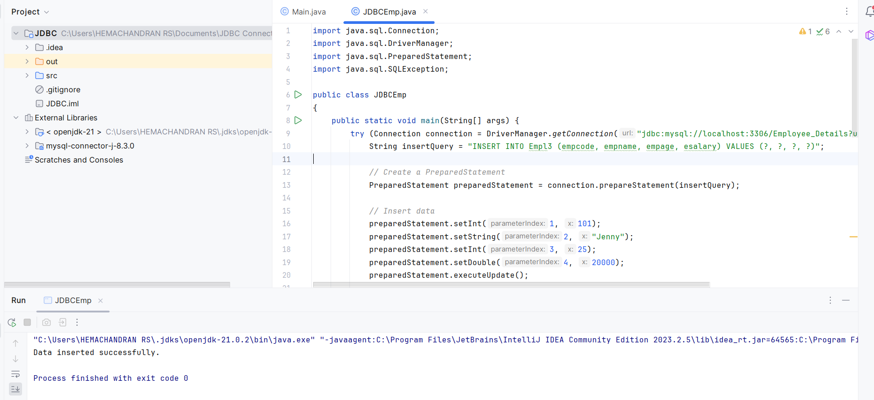

In MySQL

