Problem statement:
For this project, I set out to identify which predictors might affect the trajectory of a child’s academic performance as they navigate their early academic life.
As I explored various datasets and concepts, I became particularly interested in those that examine the effectiveness of various educational systems. Given every educational system is much closer to the “prototype” stage than the “finished concept” stage of development, I think it’s not only interesting, but of vital importance to analyze its function. I expect interested parties in the result of this investigation will include early-learning institutions, parents of younger children, and academic boards hoping to provide the greatest chance for success among students.
For this investigation, a “gifted learner” is defined as any child whose math scores or reading scores were in the top 15% of all scores and the dataset is limited to only kindergarten and elementary school (K-5th grade). This better captures the influence a of a child’s environment, as even as early as 6th grade it is expected that students have developed self-regulatory skills to better mitigate external factors (1).
Dataset Description
For the project, I selected a dataset from the National Center for Education Statistics (NCES) resulting from a longitudinal study from 2011–2016. The study tracked more than 8000 variables across ~18,000 students or participating parents, designed to capture the students’ academic performance to better understand how children develop academically, socially and behaviorally over time.
Due to the size of the study, the datais stored as a fixed-width format. The benefit of this format is efficient storage of large volumes of data, allowing for more information in a smaller file size. Although the raw data file stores each case across multiple lines, the dataset is structured such that each row represents a single student once properly parsed using the provided schema (synthesized from the .sps file and the codebook).
All participants in the study did so knowledgeably and voluntarily, and the data is purely observational, not causal. Of the ~8000 variables, I selected 13 indicators from 4 axes: personal factors (including child’s gender, race and disability status), domestic factors (parents’ education levels, primary language spoken at home, poverty status), institutional factors (school type, public vs. private) and performance factors (kindergarten math/reading scores, 3rd grade math/reading scores).
While 13 indicators out of more than 8,000 is a significant departure from the dataset, these were chosen to reflect the factors identified as testable for project 1. These variables were then used to train a model to predict whether a student will achieve gifted status in their 5th grade year.

Data Cleaning & Pre-processing:
The data cleaning and pre-processing phase of the project was extensive: between handling sentinel values, identifying, quantifying and resolving missing and pseudo-missing variables, one-hot encoding categorical values, as well as wholly converting from the .dat format to a format useable in Visual Studio Code (VSCode), this phase constituted a significant portion of the project.
Through rigorous troubleshooting and consultation of external documents, the .dat file was read into VSCode. Once the file was loaded, the data needed to be made readable by VSCode.
To isolate specific data in a .dat file, a codebook and .sps file associated with the .dat file are used to interpret what different characters in a string represent. The character ranges are then extracted into VSCode, validated against the raw .dat file, and the result is data of the corresponding variable (for example, for each student, characters within the index range 1484-1491 represent a given child’s kindergarten reading scores). This process was repeated and implemented for every applicable student.
The original .dat file had various categories that would treat “not applicable” values, typically denoted as -1, and null values, denoted as -9 (but sometimes as -7), as different despite an identical function. Any of these error codes (or sentinel values) were treated as missing. One of the earliest steps performed was replacing all sentinel values with “NaN”. This allowed for simpler data cleaning steps later on.
Once the data was cleaned, it needed to be processed: the values for child’s race, gender and disability, parent’s education status, family’s poverty level, the type of school and whether it’s private or public were one-hot encoded.
Once all variables were made useable for modeling, the dataset was separated into feature variables (X) and the target variable (y). An 80/20 train-test split was then applied, allowing the models to be trained on one portion of the data and evaluated on another.

Modeling
After the data had been cleaned and processed, it was ready to be used in a predictive model. By the end of the project, I’d created a logistical regression model (LRM), decision tree (DT), and random forest model (RFM).
The LRM was done first primarily due to ease of interpretability, but also because of the importance that was placed on it in class. The creation of the model was fluid and resulted in very telling data with ~85% accuracy:
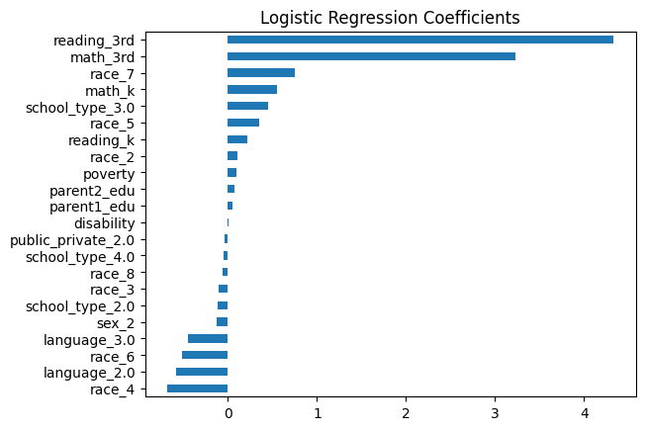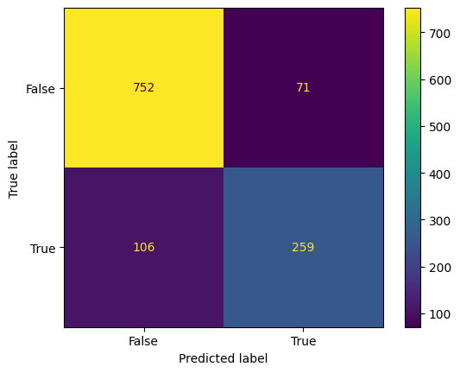
The coefficient chart corresponded well not only within expectation (that is, the most telling factor would be a student’s performance in earlier grades followed by parents’ education level) but the factors identified in this model were identified as significant factors in the study on which support systems help at-risk students. However, the presence of race_7 (American Indian/Alaskan Native, non-white) was surprising; all race variables would have SOME impact, but it being seen as so prominent was concerning. However, following investigation, it was found not only that race_7 was among the most under-represented groups, but the 4 groups with the lowest population comprised less than 7% of the dataset combined. This will naturally lead to greater skew in this model. The confusion matrix for this model was less stellar: while a 91% accuracy in correctly identifying non-gifted students accurately is a strong performance matrix, a 71% accuracy in correctly identifying gifted students is undesirable, and suggests a model bias towards rejecting gifted students as opposed to accepting them.
The DT model performed worse than the LRM in terms of accuracy, F1 scores and recall accuracy, and initially suffered in production of a comprehensive visual due to the number of variables (particularly after one-hot encoding variables such as race). Without a constraint on depth, the model produced a chart with a depth of 25, with illegible nodes. When forcing a depth of 5, however, the structure chart becomes much more coherent and identifies some more concrete data: 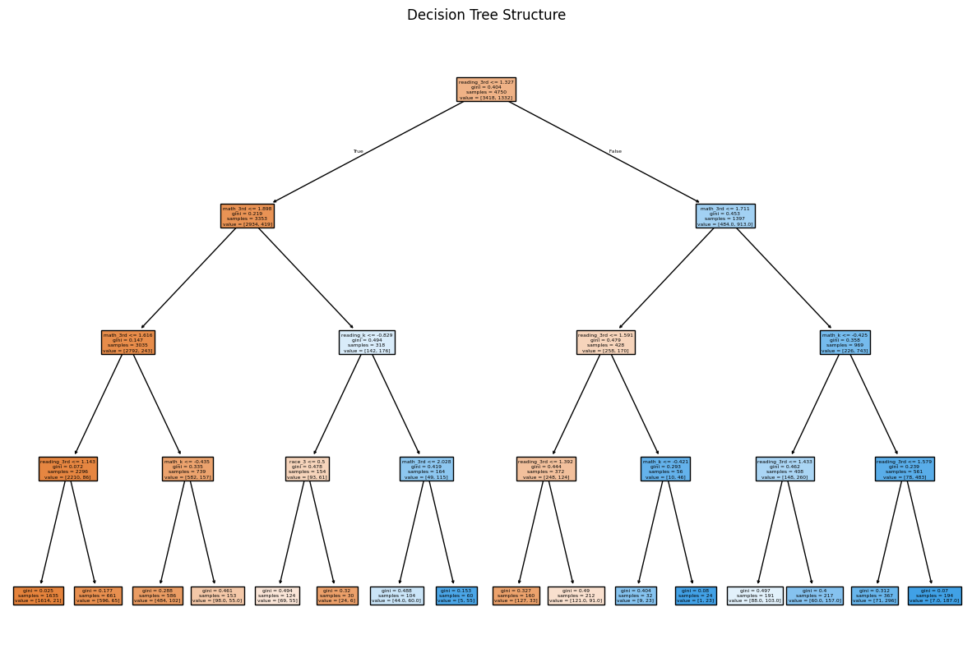
While it is still difficult to make out, the very first node makes a decision split along the metric of a reading score of 1.327. This aligns well with the LRM, but shows more concrete decisions and impacts of multiple variables.
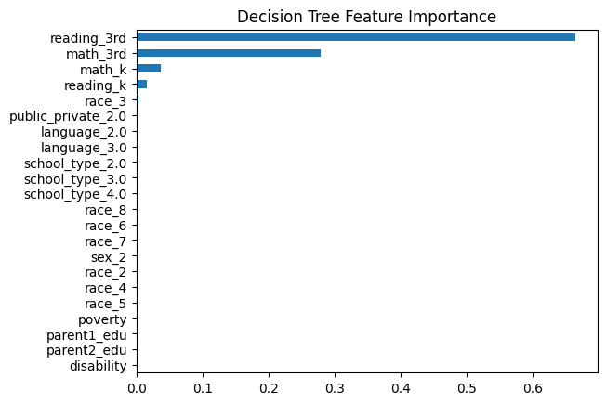
The DT Model also identified academic performance, specifically 3rd grade performance, as the strongest indicators of a child’s ability to achieve gifted learner status by 5th grade. Though as the chart progresses, we see the lowest relative importance of a the parents’ education level of any model, and a sharp decline of every other variable from there. This, combined with lower performance scores overall, suggests that a decision tree with an artificially constrained depth may struggle to meaningfully incorporate a data set with more variables, making it less effective for a study like this.
The RF Model performed approximately as well as the LRM, but with scores a few points lower across the board. Interestingly, the confusion matrices between the two charts were very similar, but with marginal differences: Overall, the RF Model is less capable of predicting gifted students, but has a slightly improved recall score compared to the LRM.
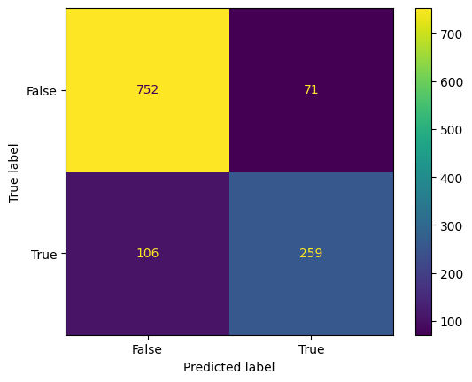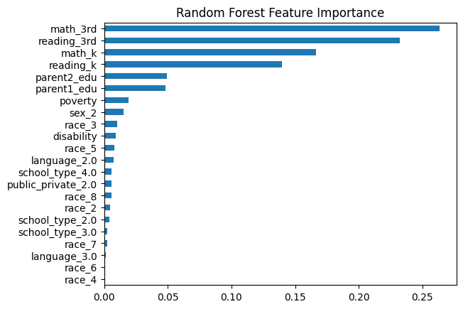
Much like the LRM, the RF Model feature importance table cleanly identifies the variables that more strongly predicted a child’s likelihood of being a gifted learner in the 5th grade: 3rd grade and kindergarten academic performance and parents’ levels of education. And while it places more significance on poverty than the LRM, it is still relatively minor. Of note, however, the RF Model placed significantly lower importance on most metrics pertaining to the student’s profile, including sex and race, whereas the LRM, even if it was based on skewed data, valued a child’s race being American Indian/Alaskan Native, non-white as being very indicative.
The overall performance of the models was close, and each model clearly places the most weight on the academic performance of a given child in their 3rd year, followed by their academic performance in kindergarten. though the differences are not insubstantial. Overall, the Logistic Regression model was the most effective model in this project due to its higher performance metrics across the board, interpretable results, and ability to account for a wide range of variables while avoiding both overfitting and underfitting.

Key insights and implications
The three models provide a consistent view of factors and their relationship to a student’s academic success, as defined in the paper. Across all models, third grade performance, usually in reading, followed by kindergarten performance emerged as the strongest predictors. The clear importance of parental education was also consistently highlighted. These findings suggest a narrative placing more emphasis on the child’s early performance and the presence of support networks outside of school, and less importance (but not none) on factors that are outside of a child’s control, such as disability, poverty status, race or gender.

Limitations and Ethical Constraints
When working with a large-scale data set, it is important to protect the privacy of participants. Though the dataset was anonymized, the capability of developing a profile of a given participant increases as the dataset expands. This highlights one of the primary concerns when establishing any dataset, particularly when working with sensitive information.
The model itself displays clear consistent bias towards a negative output, true or otherwise. This is seen most clearly in the Logistic Regression model, but exists in the accuracy scores of every model. There is also the presence of significant racial disparity, as half of the racial groups make up 93% of the dataset.
These factors combine to create multiple risks: The positive classification of the negative group, or the negative classification of the positive group can result in stunted academic growth of an individual. There is also the risk for re-identification, exacerbated by the longitudinal nature of the study spanning ~6 years. These risks highlight the importance of properly creating, handling, and utilizing a database like this.

References & AI Use Transparency
I used various websites and google searches to check for syntax on writing code (especially for importing a .dat file) and used ChatGPT for spell-checking, organization and grammar corrections
Sources (which I really thought I’d use more of)
https://www.sciencedirect.com/science/article/pii/S0885200606000627

