**Soil Moisture Sensor Specifications**

For more info check: Hrisko (2020) Capacitive Soil Moisture Sensor Theory, Calibration, and Testing. DOI: 10.13140/RG.2.2.36214.83522

1. **Material used:**
2. Probe#1: Capacitive soil moisture sensor v2.0; HW-390; 3,3..5 V; length 10cm; width 2.2cm;

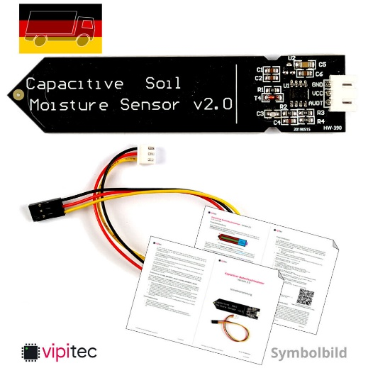

1. Arduino UNO Microcontroller ATmega328 R3 Board CH340; Boardversion R3; USB-Chip: CH340; Microcontroller Atmel ATmega328-PU (SMD-Version); 14 digital GPIOs (6 with PWM-Funktion); 6 analogue inputs; Output Voltage 3.3V, 5V; Recommended Input Voltage 7-12V; (max) input voltage 6-20V; 1KB EEPROM; 32KB Flash, 0.5KB Bootloader

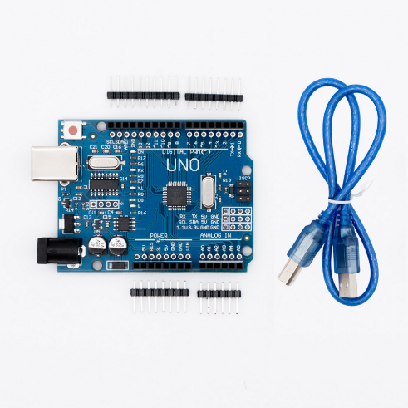

1. Arduino Compatible Micro SD Storage Board; 5V or 3.3V; power supply is 4.5V ~ 5.5V, 3.3V voltage regulator circuit board; SPI interface; six pins (GND, VCC, MISO, MOSI, SCK, CS)

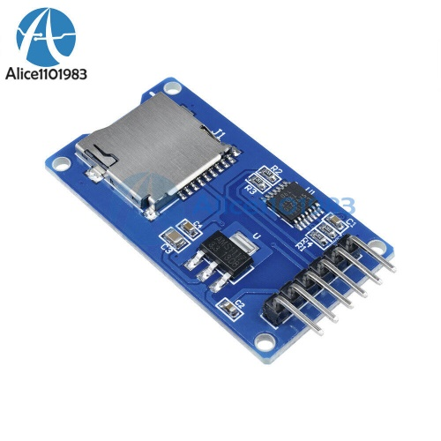

1. Cables
2. **Connections:**

Probe#1 to control board:

* Module GND -- Arduino GND pin
* Module VCC -- Arduino VCC pin
* Module AUOT -- Arduino A0 pin

SD Card to control board:

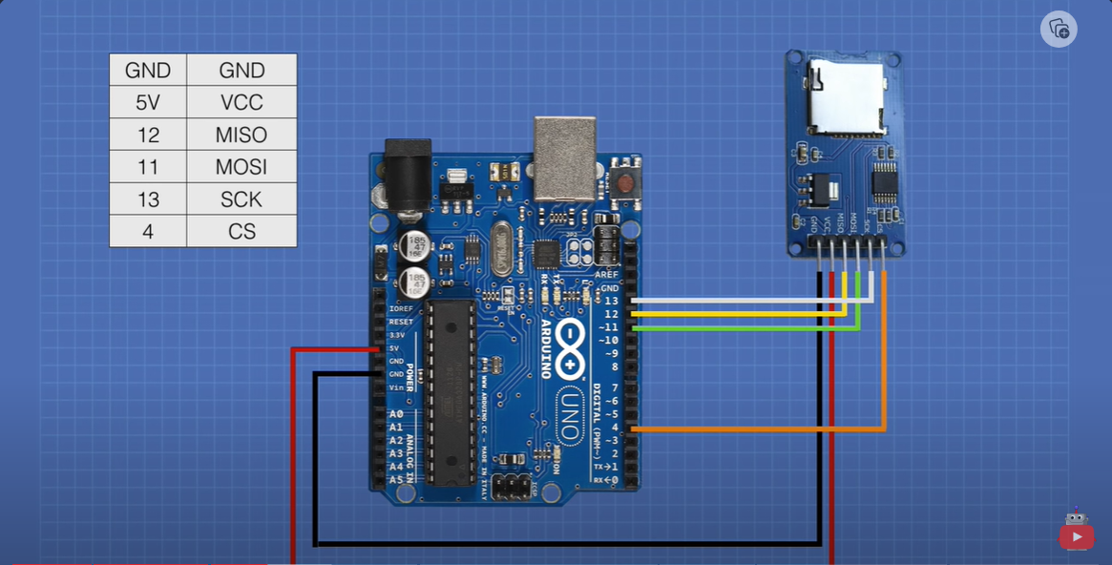

1. **Calibrating and Testing:**

Calibration Readings:

In full dry conditions (air): 510 units

In full dry conditions (dry soil) = 9% 🡪 18.86 (humidity) 🡪 482 (dryness) (USED)

In full wet conditions (glass of water): 192 units

In full wet conditions (Saturated soil) = 98% 🡪 66.92 (humidity) 🡪 196 (dryness) (USED)

1. **On-Site-Procedure:**
2. Recording geolocation of measurement point.
3. Starting SM sensor in dry air for control.
4. Removing topsoil layer with dense organic matter.
5. Inserting SM sensor at 10 cm depth.
6. Keeping SM sensor stable for at least 1 min.
7. Removing sensor from soil.
8. Waiting 30 seconds in dry air for control.
9. Turning off sensor.

The average of readings was calculated at each point after sensor stabilized. The readings of soil moisture (humidity) was converted to Plant Available Water (PAW).

* PAW (%) is calculated: PAW = 100x (SM – WP)/(FC –WP)
* For loam soil: FC=33% and WP=13%