Biorails UI overview
This is a quick document show the current UI of bioraols with some idea on use and flow.

General Elements

Main menu
This focuses the system down on a domain in the application.
- Catalogue
- Inventory
- Setup
- Organization/Study
- Execution/Experiment

Data Len
This provides a number of views of the down
- Overview
- Timeline
- Setup
- Data
- Report
- Notes

Panels
- Finder
- Central
- Context

Study
This is the organizational domain of the application
- Name study
- Setup/Import parameters
- Creates/Import protocols for data management
- Create experiments

List (Entry Point)
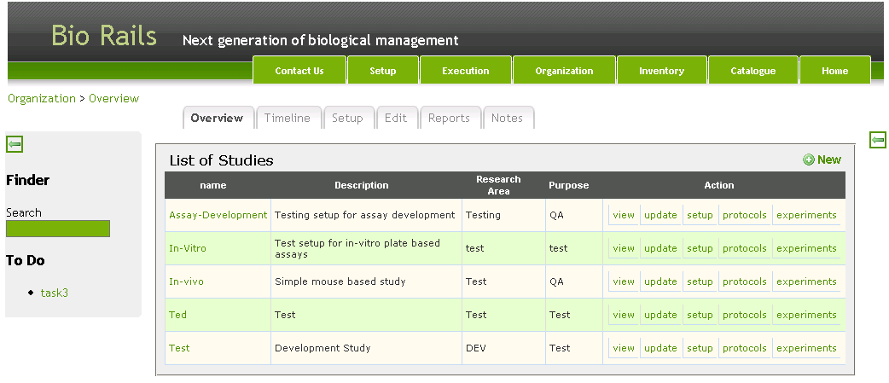

Study Overview
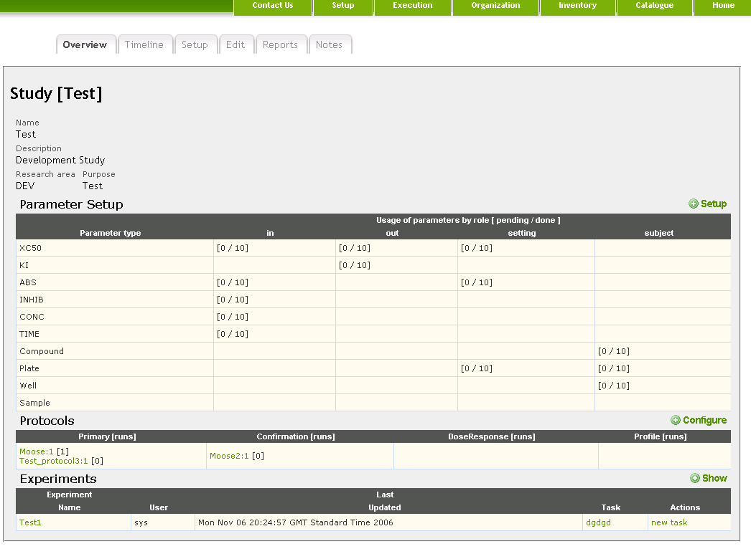

Study Setup
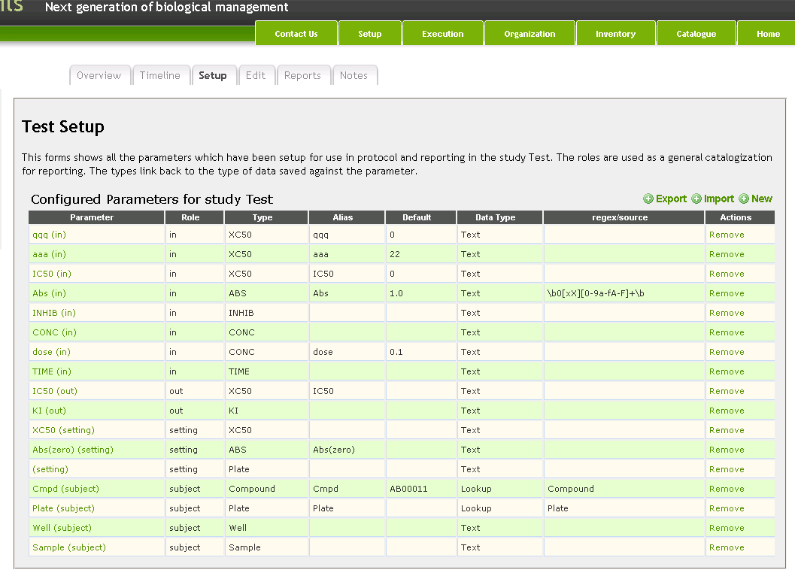

Study Parameter Dialogs

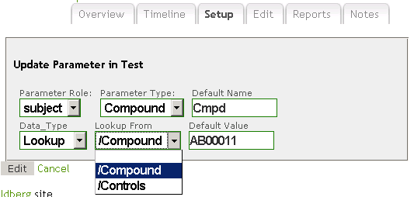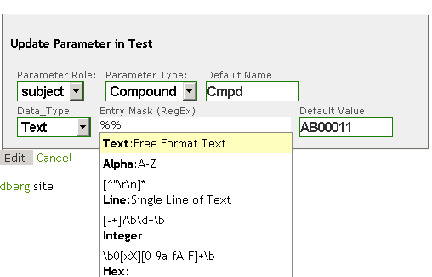

Study Protocols
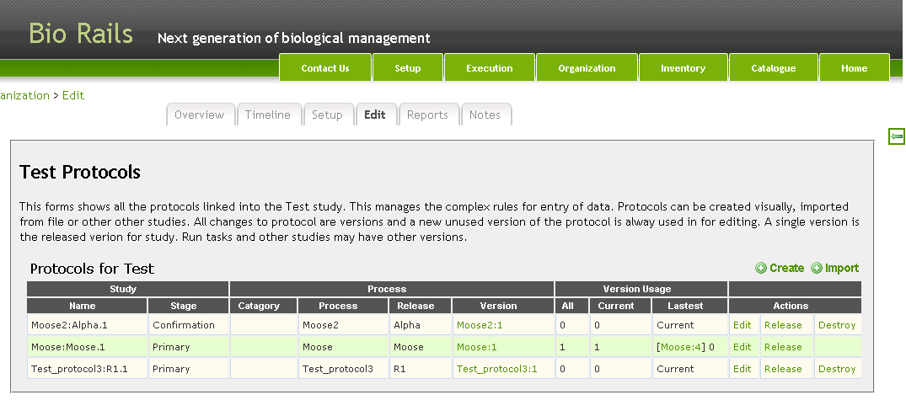
The system has a number of protocol (how-to for data entry) associated with it. These linked to a stage for reporting and versions to all changes are tracked.

Protocol History
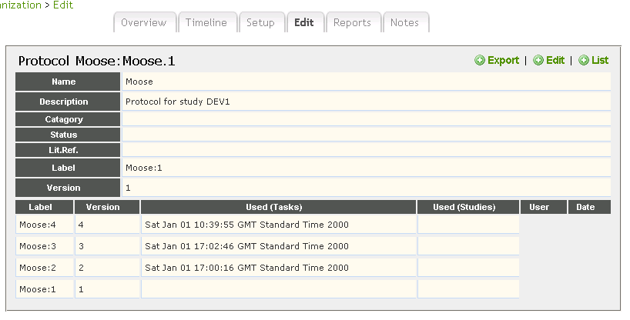
Each time a protocol is edited a number “save point” or version is created this is needs so editing do effect running tasks. A version may be release as the current version for the study or be linked multiple experiments and tasks.

Protocol Editor
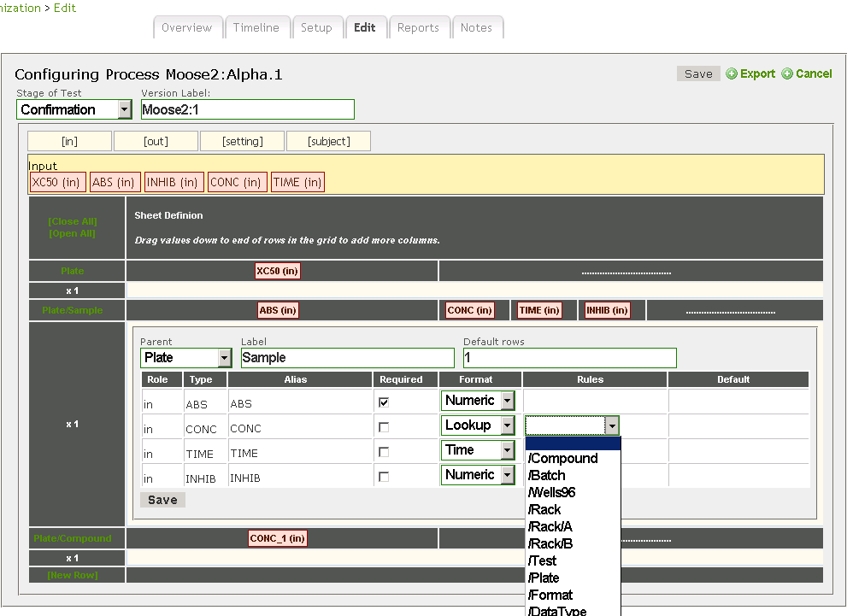

This is an oddity as a web page and drag and drop has been used at the standard method of configuring the data entry sheet. Here parameters, defined as the study level can be selected and dragged down onto “contexts|” (rows) to create dat entry sections. The “contexts” can be linked in tree’s to multiple up the rows. For example a Plate may have a number of samples each which appear in a number of wells.

Experiments
This is all about doing stuff. A experiment is seen a collection of schedule tasks which have to be performed. This allow for complex flows and multiday work. Each task is assigned to a user. This causes it to automatically appear on there todo list.

Experiment List
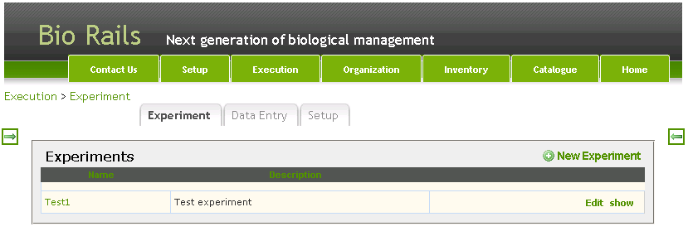

Single Experiment
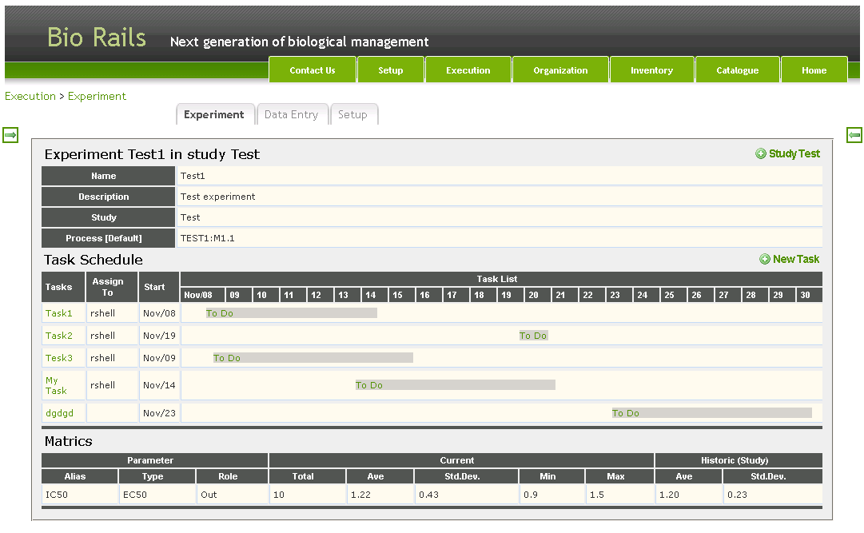

This shows a schedule of the tasks with status visually shown. Then a simple statistical summary of the all parameter compared to the averages for the study.

Study statistics are updated when an experiment is marked a completed. Experiment statistics are updated when an task is marked as completed. So see in-progress data is only shown when the task is opened.

Creating a new Task
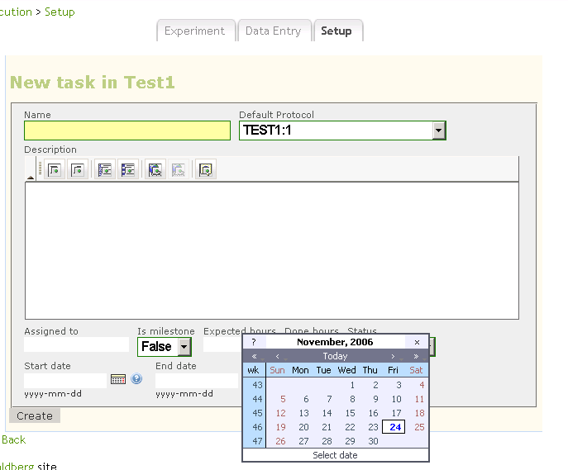

Currently a task is created via a simple form like calendering systems. Where they are named and scheduled. A simple rich text (html) editer with cut and paste to words is provided for descriptions.

Task show/Entry
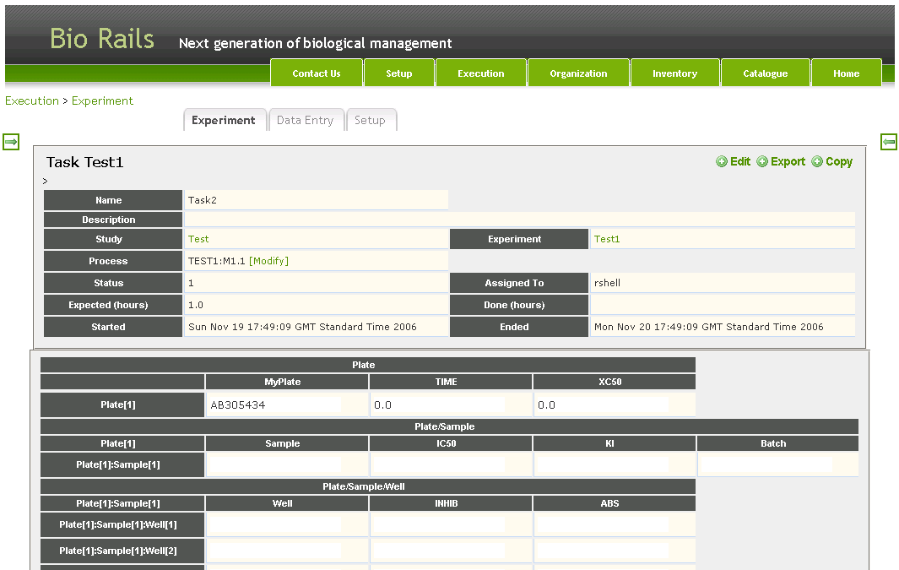

This same format is used for display and data entrty. In data entry the cell display the correct style of entry field for the data type

- URL, Numeric & Text: Text_field with check against regex expression
- Date: DataBock_field
- Quantity: Text_field with extra to allow a post fix unit (otherize default for study/protocol used )
- Time: Text_field with regex + extras for oddities like 5 min 10 sec etc
- Lookup: This will have a drop down of matching from records id more >20 items other wize a selector
- Attachment: File selector with upload

Catalogue
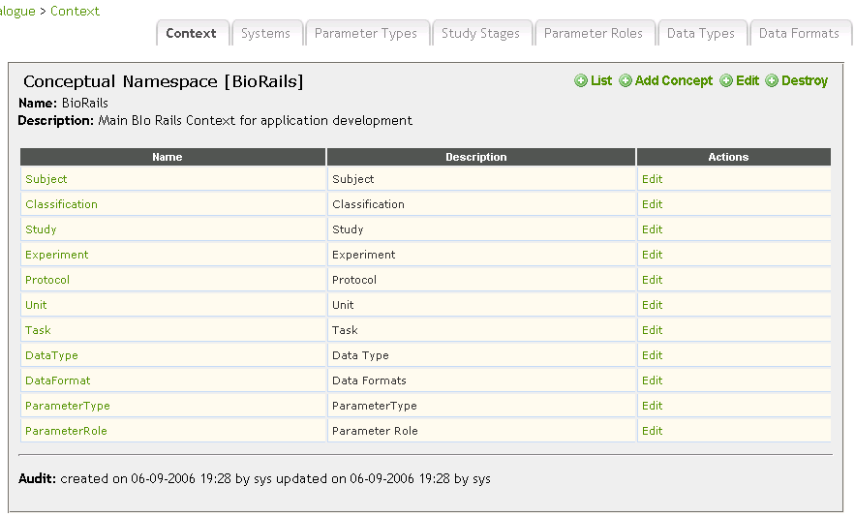

The namespace govens the list of things which can be linked to a parameter type as a selector for use in the application.

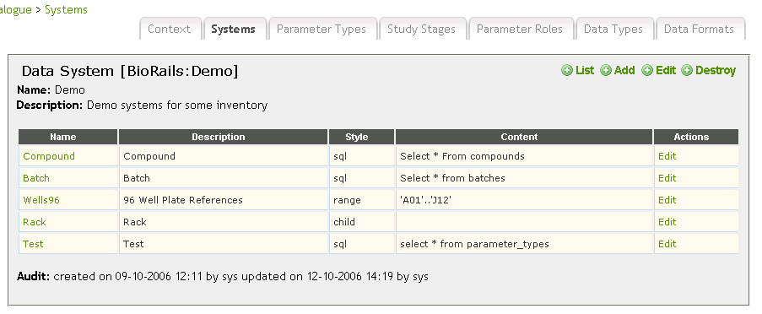

For each concept there be a number of implementations (each linked to a dat systems). So same for the concept of a compound there could be multple sources ( Internal registration systems, Standard and controls, library x etc)

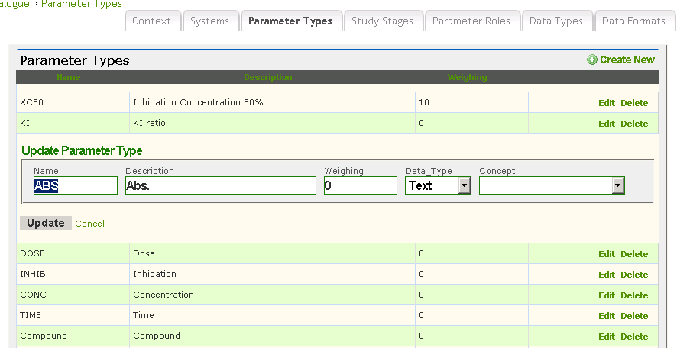

When a parameter is defined it can be liked to a concept. Then is use in a study this can be converted to a set system.

