Feature Detection

The Gaussian window size is 7 by 7. K is 0.7 and nonmax radius is 5.

Feature Matching

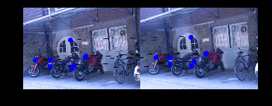

Bike1 bike2

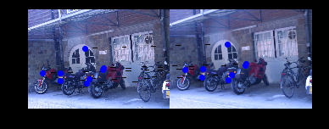

Bike1 bike3

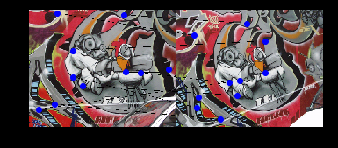

Graf1 graf2

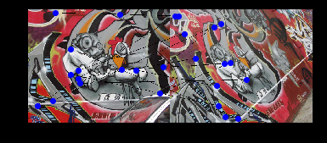

Graf1 graf3

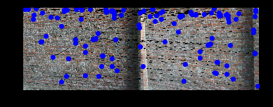

Wall1 wall2

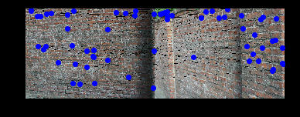

Wall1 wall3

Stitching with Affine transformation

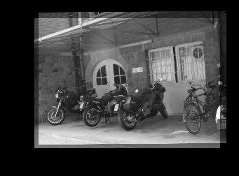

Bike1 bike2

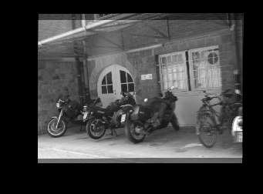

Bike1 bike3

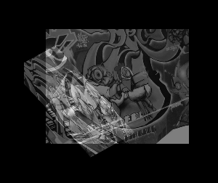

Graf1 graf2

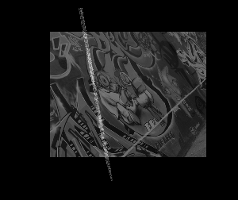

Graf1 graf3

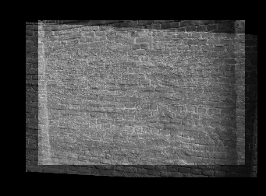

Wall1 wall2

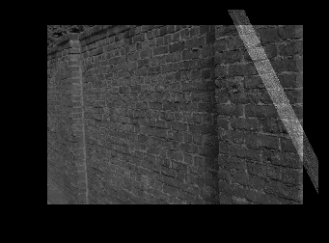

Wall1 wall3

Stitching with fully-projective (8 degrees of freedom) alignment model.

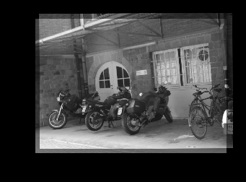

Bike1 bike2

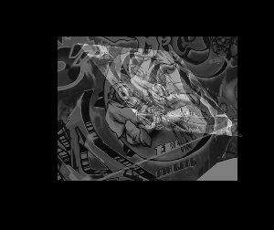

Graf1 graf2

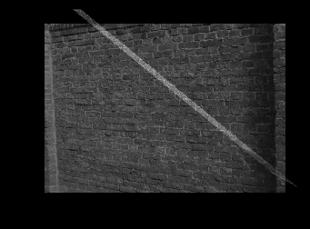

Wall1 wall2

Feature Description (simple SIFT)

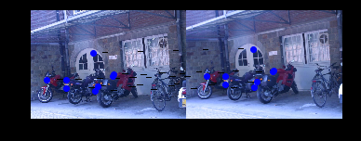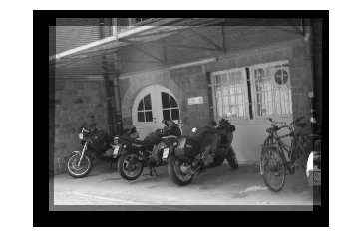

Bike1 bike2

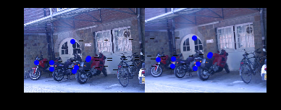

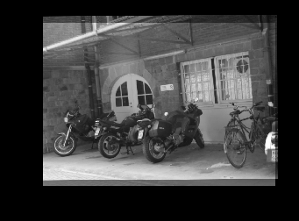

Bike1 bike3

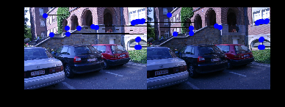

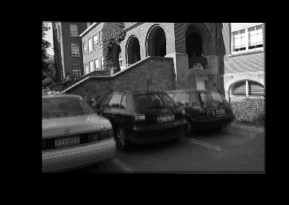

leuven1 leuven2

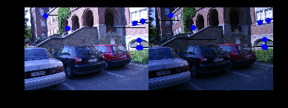

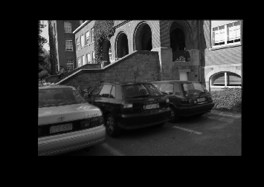

leuven1 leuven3

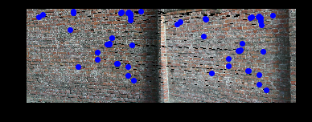

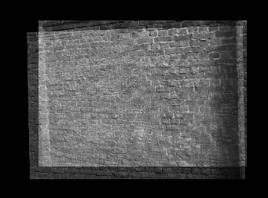

wall1 wall2

An additional file called match_ssifts.py is added to the folder. Most alignments were decently performed. However, I wasn’t able to find matches between wall1 and wall3, graf1 and graf2, graf1 and graf3 with simple sift method. As a result, using simple SIFT method provides better matching feature but makes it harder to align.