Assignment 3

PPHA 38520

**Buffering!**

*Goal of Lab: To learn more about spatial queries and what can be added through buffering and clipping  
Note: Before starting be sure to download the assignment files and unzip to a local folder*

* All the processes in this lab build on what we’ve done in the demos, assignment so far
* While you may consult with your classmates on individual steps or processes if you are stuck, you need to do your own work and submit via Canvas

**Background**

You need to conduct a study of households that are within three miles of the development around the Obama Presidential Library and Museum.

Due to the impacts of the development on the neighborhood and sensitive nature of the survey, the research organization wants to target households within low-income tracts (defined, for these purposes, as tracts with a median household income below $30,000). We will identify the households that meet these criteria, make a map, and answer some key questions.

**Data**

* Mappable file of IL tracts with ACS data
* Geocoded .csv file of all residential addresses within nearby ZIP codes

**New skills**

* Turning a ‘flat’ (.csv) file with latitude/longitude info into a ‘mappable’ file of point data
* Registering data to use a specific coordinate system
* Creating a new feature class
* Editing a layer
* Creating a buffer
* Clipping data

**Overview**

1. Plot geocoded .csv file using latitude/longitude data from the attribute table; register it with the same coordinate system as the IL tract file
2. Query tract file to show only those tracts with medhhinc < 30,000; add selection to layout
3. Create a new feature class ; edit new point file; add point at location of the Obama Library; export as a shapefile
4. Create 5-mile buffer around Obama Library point layer
5. Clip the tract select layer using the 5-mile buffer
6. Clip the household point data using the file from step 5
7. Make a map and answer questions

**Coordinate systems**

To start, unzip the data for assignment 3 into a new folder, and then open assignment3.aprx.

The goal of this assignment is to build a three-mile buffer around the proposed location of the Obama Presidential Library development to query a list of addresses. To do this, we need to make sure that all our files contain information projected in the same coordinate system as the data frame. When ArcGIS is started with a new, blank map, there is no default coordinate system. Instead, it will take coordinate system of the first layer added. In our case, this is the Illinois tract file. Right-click on il_tract and go to properties.

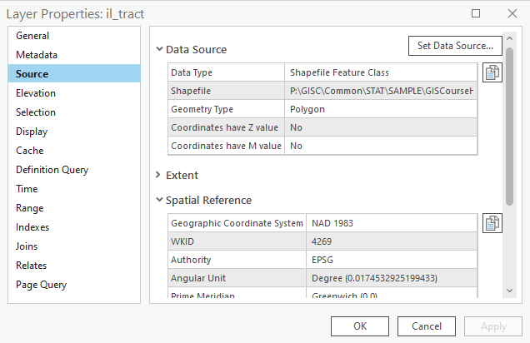

Then, right click on the Layers (above the il_tract in the drawing order) in the contents and go to properties.

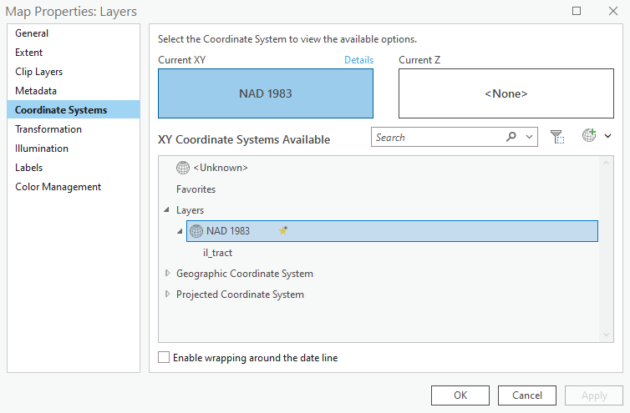

They are the same. With the Data Frame coordinate system established, even if you add a new file with a different projection, it will automatically be displayed using the coordinate system of the data frame. For our purposes, as we create new mappable data, we need to be diligent about giving our data a projection.

**Plotting csv file**

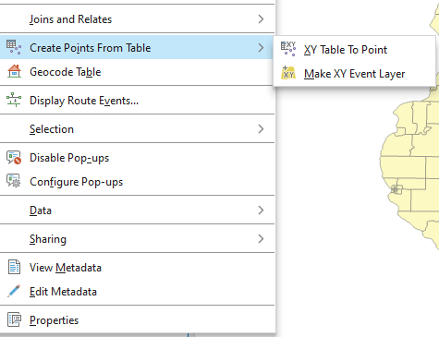

The .csv file in the workspace named *obama_fulladvo_mappable_t.csv* contains the geocoded addresses of over 200,000 housing units in the ZIP codes surrounding the Obama Library. Geographic information is currently being stored in the file’s attribute table in longitude and latitude fields. In order to plot these addresses on our map, navigate to the ‘Contents’ panel, then right-click on the file in the table of contents and select ‘Create Points From Table’ > ‘XY Table To Point.’ ArcGIS automatically fills in the X and Y fields, but ensure that they are set to longitude and latitude respectively. *ignore warnings you may get*.

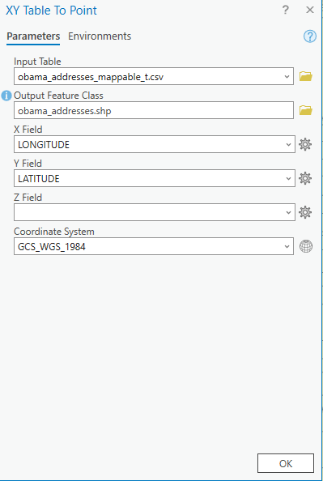

**Query tract file**

Right-click on your ‘il_tract’ layer in Contents -> Attribute Table -> Using the ‘Select by Attributes’ menu, make a selection of tracts in IL that have "med_hh_inc"<30000. Create a new layer from selected features.

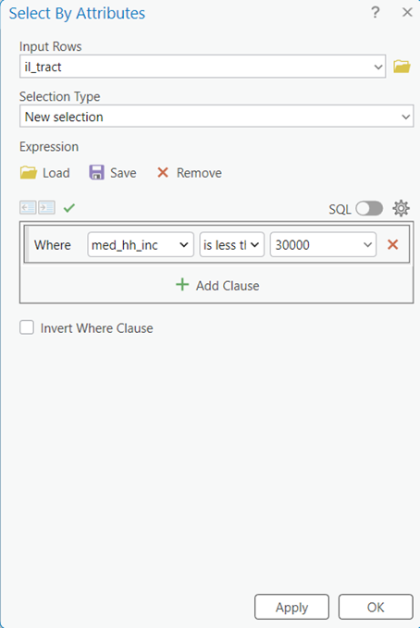

Create a new layer from the selected features. Right-click on ‘il_tract’ > selection > make layer from selected features.

**Create a new feature class**

There are several ways we could go about creating a buffer around the Obama Library. Perhaps the most intuitive would be to select the tract containing the Obama Library, create it as a new layer, and draw a buffer. But here, we decided to include a demo on how to create new mappable data in ArcGIS as it is a useful skill.

We know the precise center or location of the Obama Library within its census tract. Google Maps plots the Obama Library development at (41.784304, -87.585469). To create three-mile buffer around this point, we need to first create a layer that is this point. To do so, click the “Tools”  button and go to (Data Management) Toolboxes tab >> Feature Class >> Create Feature Class OR search for “Create Feature Class” using the text search tool.

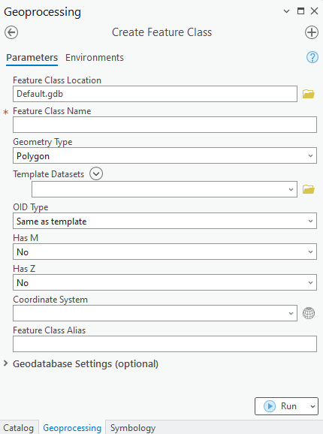

In Feature Class Location, put the directory where you are saving your files which may be the default geodatabase; **you may need to enter the directory into the text field directly** i.e “c:\lab3\”. In Feature Class Name call it ‘temp_point’. In Geometry Type, select POINT. And finally, we need to make sure our new layer has the proper coordinate system or at least a non-missing coordinate system. Under the ‘Coordinate System’ dropdown menu select ‘il_tract’.

**Edit new feature class**

The file temp_point will now appear in the Table of Contents, but it currently holds no data. To edit this new layer, select it in the table of contents, go to the ‘Edit’ tab and click ‘Create’. In the Create Features, window on the right, select temp_point.

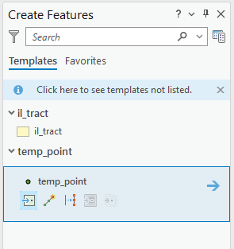

With temp_point selected, the cursor now becomes a plotting tool. To plot a point exactly the coordinates listed above. Right click with the cursor and select ‘Absolute X, Y, Z’.

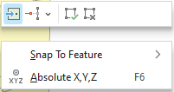

In the X,Y box put the coordinates (41.784304, -87.585469) and press ‘enter’. In the Edit ribbon click `Save` and save your edits, then click the `Finish` button at the bottom of the screen to stop editing. 

**Creating a buffer**

We now want to create a buffer extending 3 miles from our new point. To do this go to the Geoprocessing Tools >> Analysis Tools >> Proximity >> Buffer. As the Input Features select ‘temp_point’ and save the output as obama_buffer3. As the linear unit, select ‘US Survey Miles’ from the drop down and put ‘3’.

**Clipping**

Clipping is an intersection tool that changes the mappable features of an input layer by “cutting out” parts that do not align with another layer. . We will now clip il_tract selection layer using the buffer. In the toolbox, navigate to: Geoprocessing Tools >> Analysis Tools >> Extract >> Clip. In Input Features put il_tract selection and in Clip Features put obama_buffer3. Save the new file as il_tract_clip.

Finally, use the results from the tract clip, to clip the set of addresses.

**Questions**

1. Make a map to show the potentially-impacted households based on the distance criterion in the last step. Make your map professional-looking with appropriate scale, titles, and design elements as we discussed in class and illustrated during the last demo. (40 points).
2. Experiment with buffers of different sizes, e.g. 1 or 2 (or more) miles; how does that change the number of households who would be eligible for the survey? Would it include different places, neighborhoods? (10 points)
3. What other socioeconomic factors do you thinkthe developer should consider for the analysis, if any? How might those parameters influence analysis and results? (10 points)
4. Admittedly, the work done in this assignment is functional and not analytical. The end result is a list of addresses that could be used in a survey to understand the concerns of specific residents and not necessarily an idea to be communicated using a map. Nevertheless, imagine a situation in which you need to convey to someone what our process looks like. Create a map and show the results from one or more queries. If there are other variables and data that you consider important (parks, streets, ACS data, etc.), include it in your map. Make your map professional-looking with appropriate scale, titles, and design elements. (40 points)