Task-Oriented Language Grounding

To perform tasks specified by natural language instructions, autonomous agents need to extract semantically meaningful representations of language and map it to visual elements and actions in the environment. This problem is called task-oriented language grounding. Recent works have used end-to- end trainable neural architecture for task-oriented language grounding in 3D environments which assumes no prior linguistic or perceptual knowledge and requires only raw pixels from the environment and the natural language instruction as input. The proposed model combines the image and text representations using a Gated-Attention mechanism and learns a policy to execute the natural language instruction using standard reinforcement and imitation learning methods. The work has showed the effectiveness of the proposed model on unseen instructions as well as unseen maps, both quantitatively and qualitatively. The work has also introduced a novel environment based on a 3D game engine to simulate the challenges of task-oriented language grounding over a rich set of
instructions and environment states.

Problem setting is as follows:

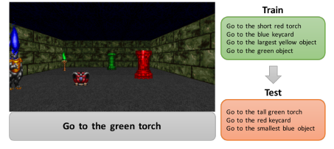

This work is extension of the work on Task-oriented language visual grounding using Deep Reinforcement Learning. The original work has a simple attention mechanism and still achieves a very high accuracy in comparison when compared to normal concatention of the image level pixels and the natural language instruction.

The architecture of the network used is as follows:

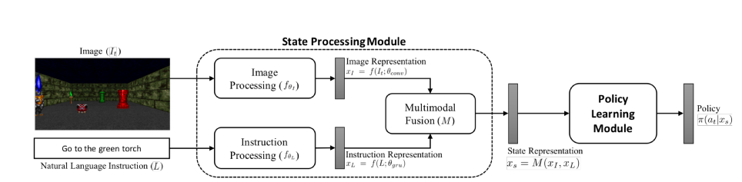

In order to see the performance of the attention mechanism of the above work I have spent some time in visualizing it . Few snapshots of the visualization video are as follows:

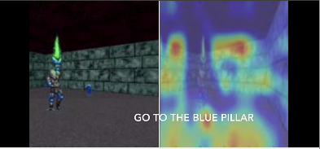
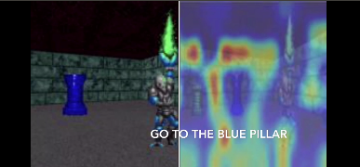
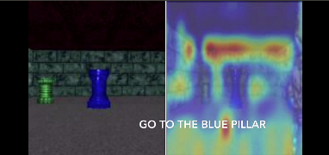

Hence our first attempt was made in replacing the attention mechanism . We did so by placing stacked attention ( inspired from stacked attention networks ) instead of the simple gated attention mechanism.
We are now trying to add curiosity along with standard RL learning for the agent. Since in many real-world scenarios, rewards extrinsic to the agent are extremely sparse, or absent altogether, curiosity can serve as an intrinsic reward signal to enable the agent to explore its environment and learn skills that might be useful later in its life.

