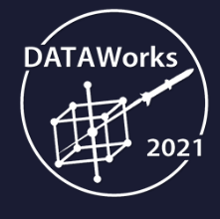 

Mini-Tutorial: Introduction to Neural Networks for Deep Learning with TensorFlow

2021 04 14 1300-1430

Roshan Patel, [roshan.r.patel2.civ@mail.mil](mailto:roshan.r.patel2.civ@mail.mil)

Prerequisite Overview

# Purpose

This document will guide you through some of the software prerequisites for this mini-tutorial. The material will be lightly covered during the session.

# Python

Python is an open-source, high-level programming language that can be used for various applications. It has gained popularity in the field of statistics and scientific computing for its ease-of-use and matrix algebra optimizations. Python applications typically run a bit slower than those written in C, C++, or Java, but they also usually take much less time to develop. The same utilities are available to produce large-scale, object-oriented applications. There is compilation step for running Python code, thus the edit-test-debug cycle is quick.

We will use Python throughout the mini-tutorial to implement simple neural networks.

See [here](https://www.python.org/doc/essays/blurb/) for more information.

# Anaconda Installation

Getting started with Python may be a bit complicated for newcomers due to the need to manage third-party packages and dependencies between those packages. The Anaconda distribution of Python provides a bundle of the most popular packages for applications in engineering, statistics, and machine learning along with some package management utilities. It is one of the easiest ways to get started with Python programming.

In this mini-tutorial, we will be creating a new Python environment that includes packages for TensorFlow. A Python environment is a collection of Python packages of particular versions that are compatible with one another. Management of package versions is necessary because we will be using many open-source packages that have complex dependency chains. Anaconda will help us manage these.

Please follow the steps at [this link](https://docs.anaconda.com/anaconda/install/) to install the latest version of Anaconda Individual Edition for Python 3. Most operating systems are supported.

# Anaconda Navigator

The Anaconda Navigator is a GUI that you can use to interface with your Python environments. Search for “Anaconda Navigator” in Windows Search after installing Anaconda. It will take a few minutes to launch the first time.

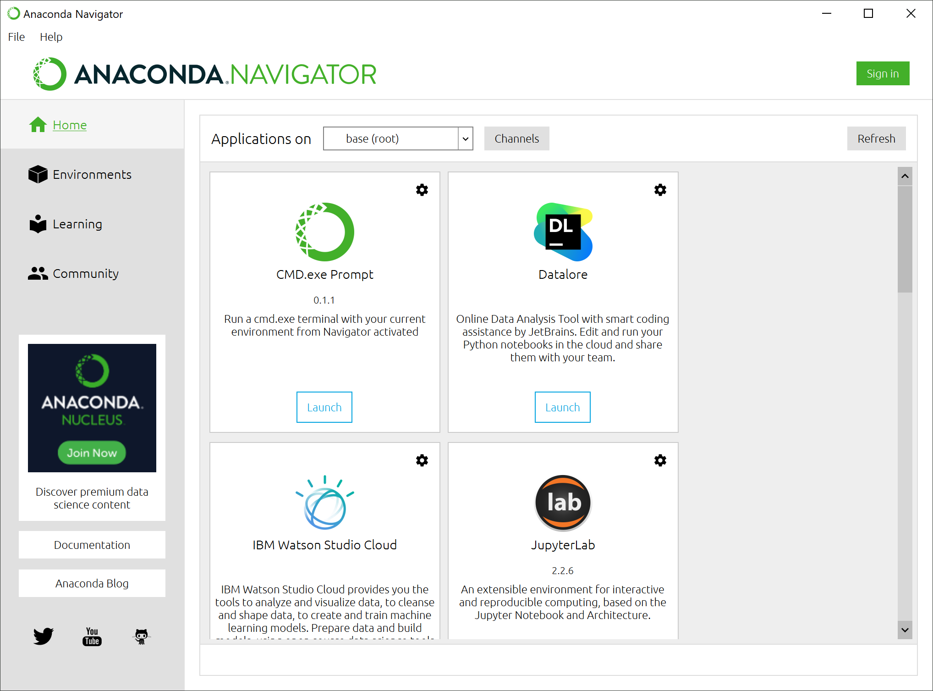

Go to the Environments tab on the left menu. This is a view of all your currently controlled environments. In the screenshot below, we can see that this instance is managing four environments. On a fresh install, you may only see one.

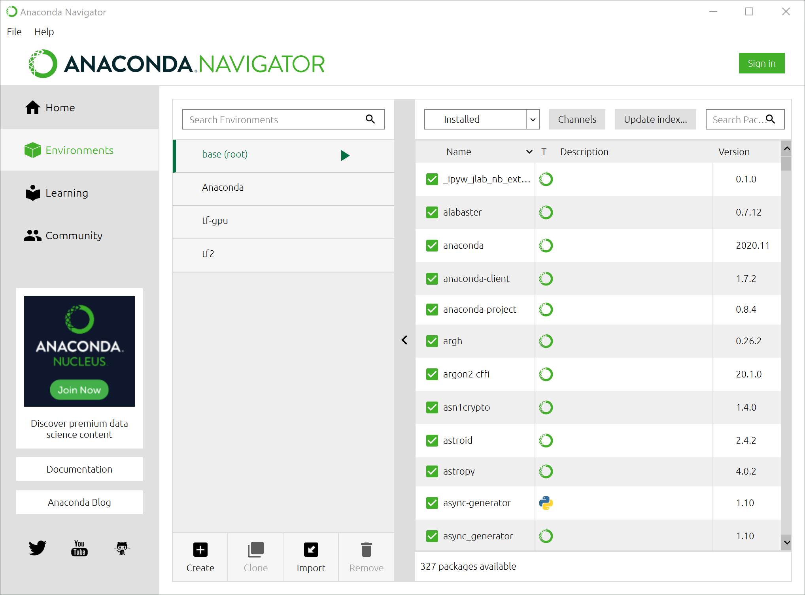

We will create a new environment for this mini-tutorial. In this environment, we will install based on an environment specification that will be provided to you. The specification file details which packages and which versions of those packages should be installed. It will be named ‘dataworks-2021.yml’.

Select “Import”. Name the environment “dataworks-2021” and select the provided yml file as the specification file. If created successfully, you should see another environment populate the list.

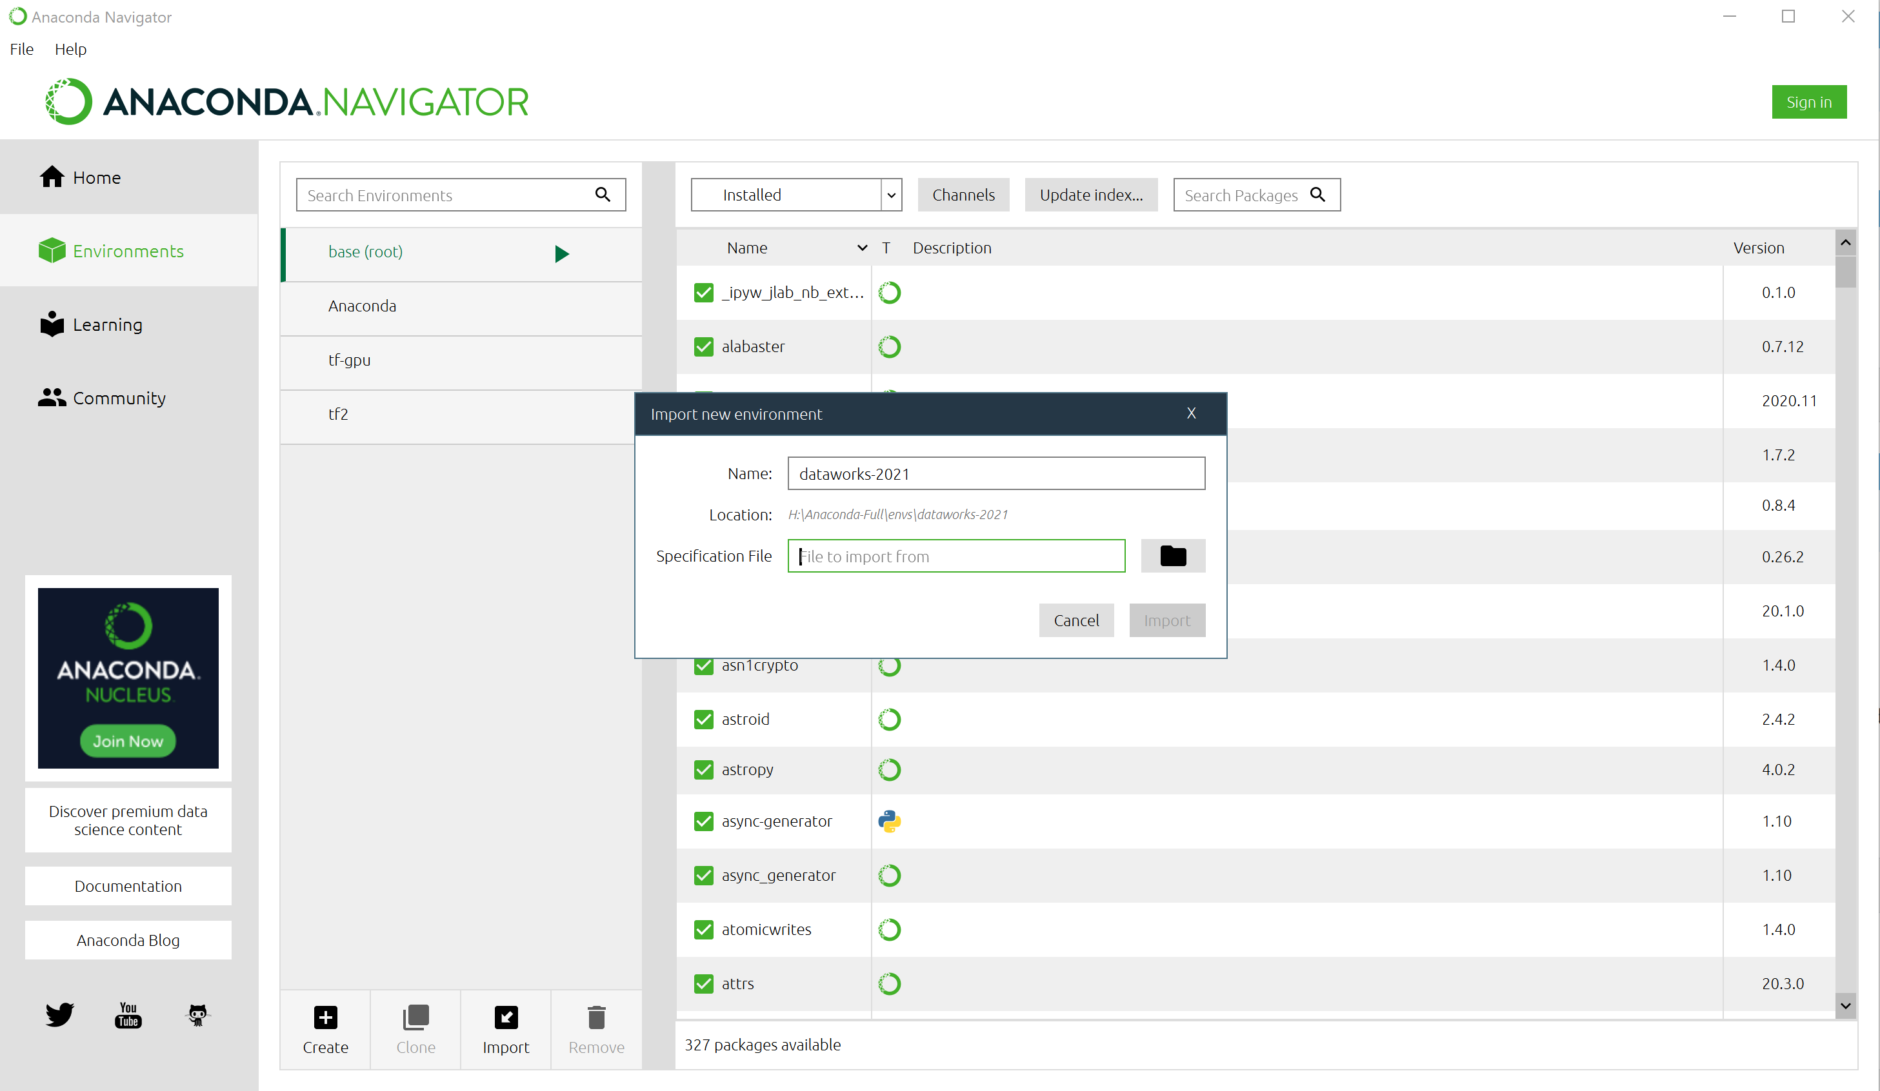

Navigate back to the Home tab and select “dataworks-2021” from the dropdown to select the newly created environment. Applications launched in this panel will launch using the dataworks-2021 env.

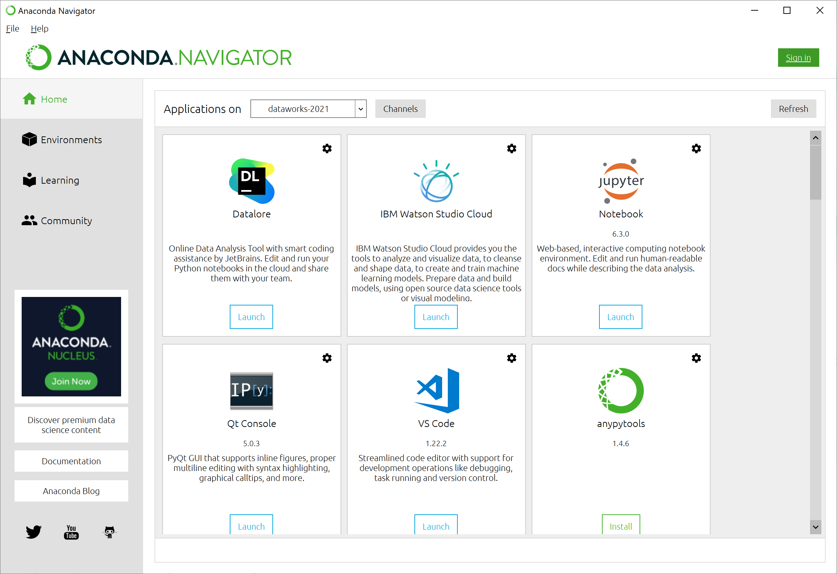

# Jupyter Notebook

A Jupyter Notebook is an integrated development environment that supports Python, R, and some other programming languages. It is a server application that can run locally on your machine. You will interface with it through a web browser (e.g. Chrome, Firefox, MS Edge, Safari) by visiting the server’s URL endpoint. If run locally, that will be localhost:port.

Jupyter Notebooks are popular amongst the scientific community because it offers a means to produce web-based reports with in-line code, code outputs, interactive JavaScript components, and HTML comments. See an example of this below.

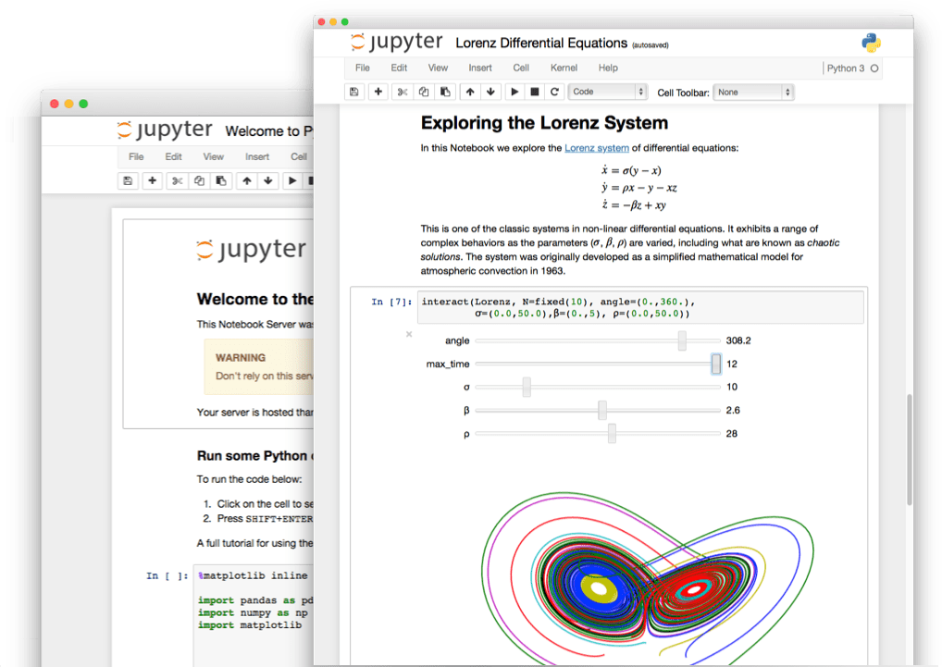

In this mini-tutorial, all code demonstrations will be conducted through the Jupyter Notebooks. The course materials will include a set of Jupyter Notebooks.

You can launch a Jupyter Notebook server using Anaconda Navigator. Navigate to the environment you would like to run a Jupyter Notebook on (dataworks-2021) and select “Launch” under the Jupyter Notebook panel.

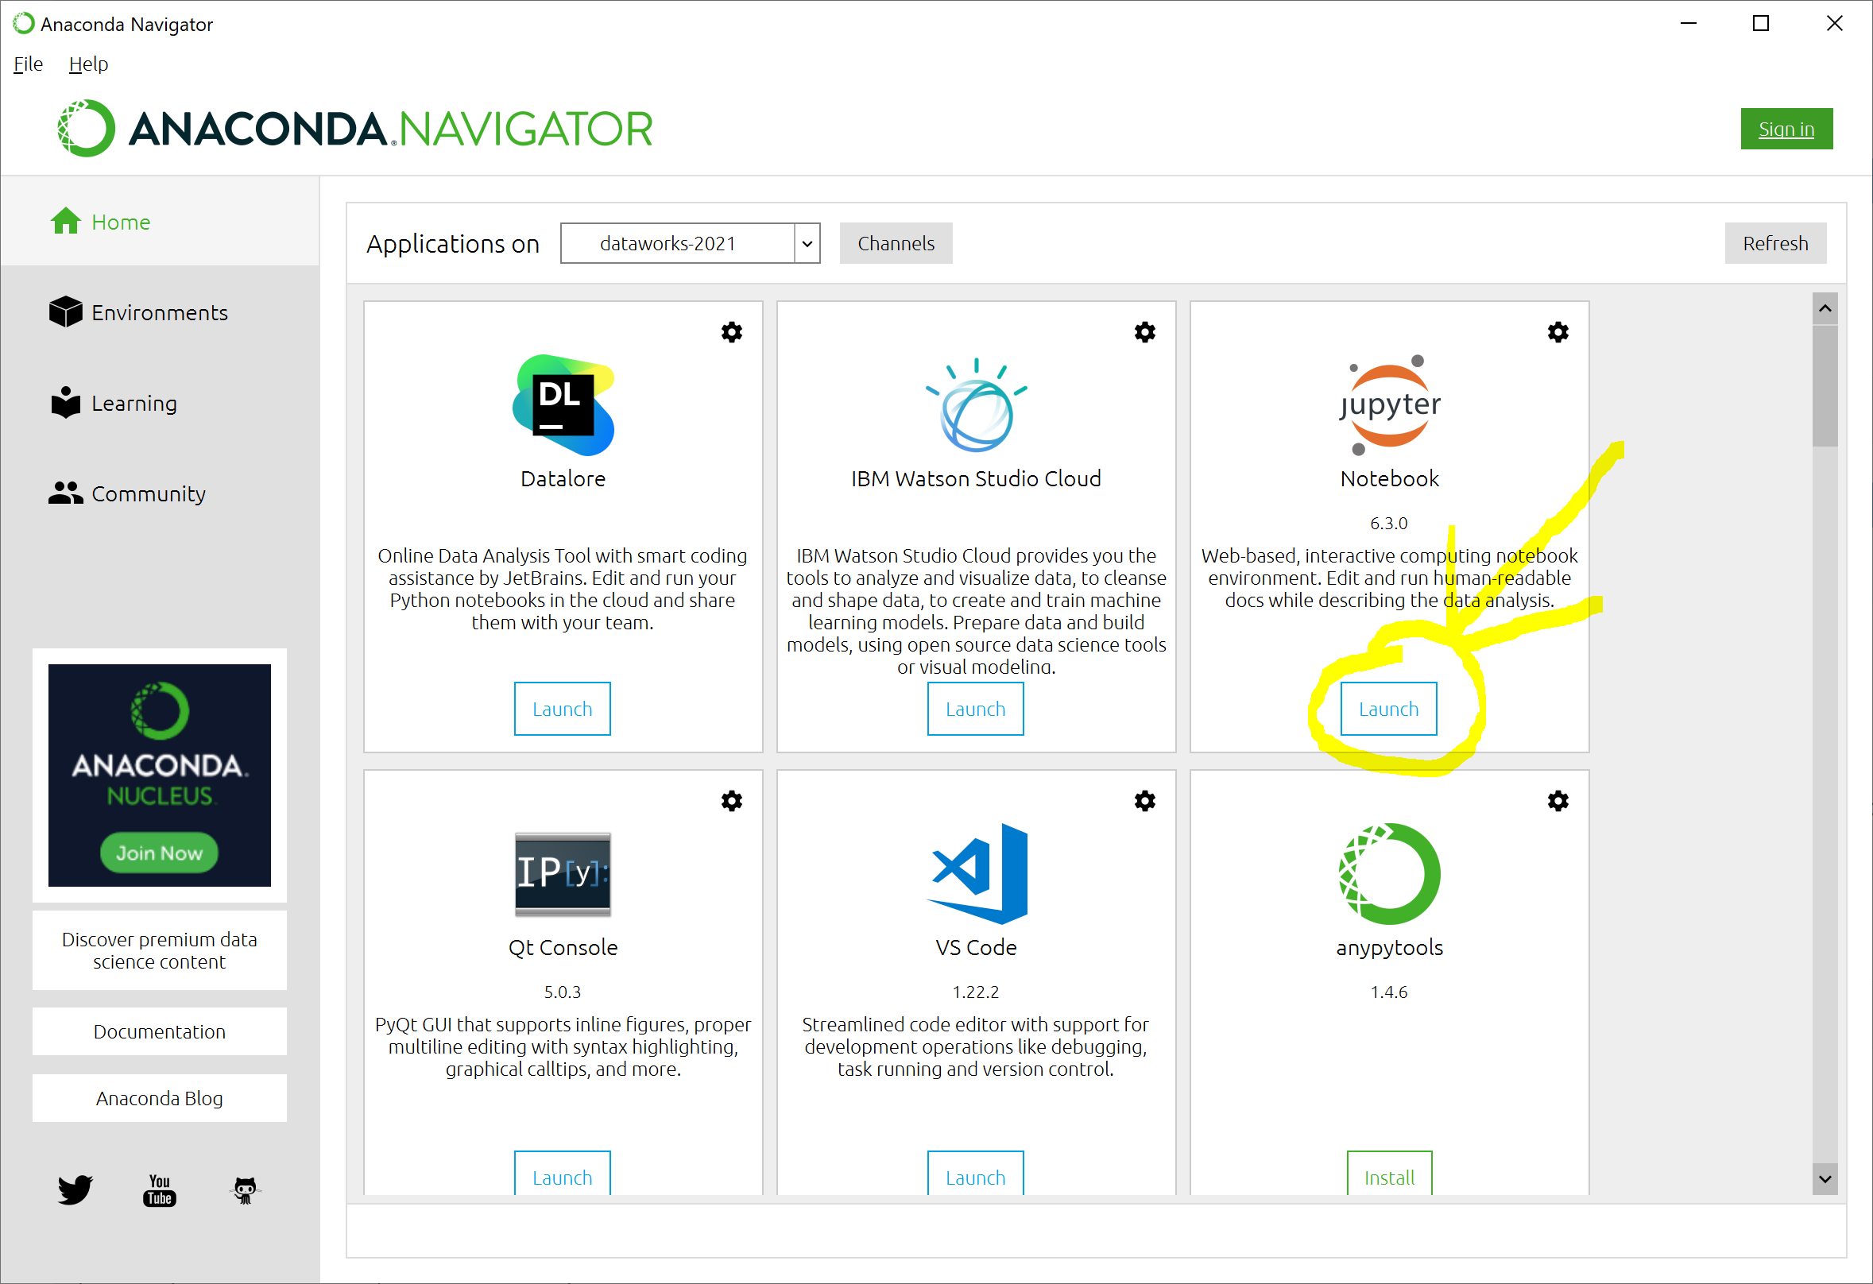

Your default web browser should open a local host URL showing the directory of your user home folder.

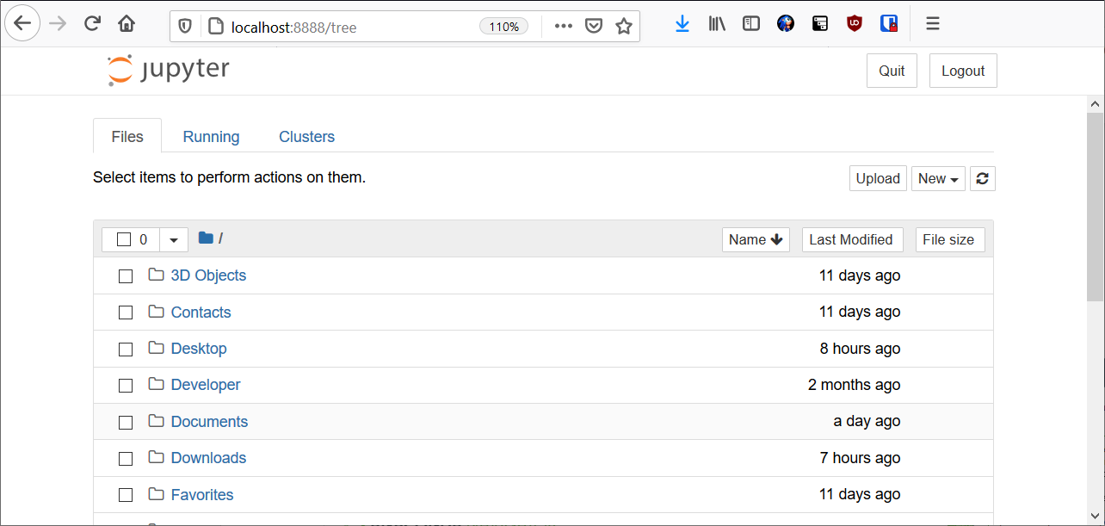

Navigate to the provided folder of Jupyter Notebooks and select one to open.

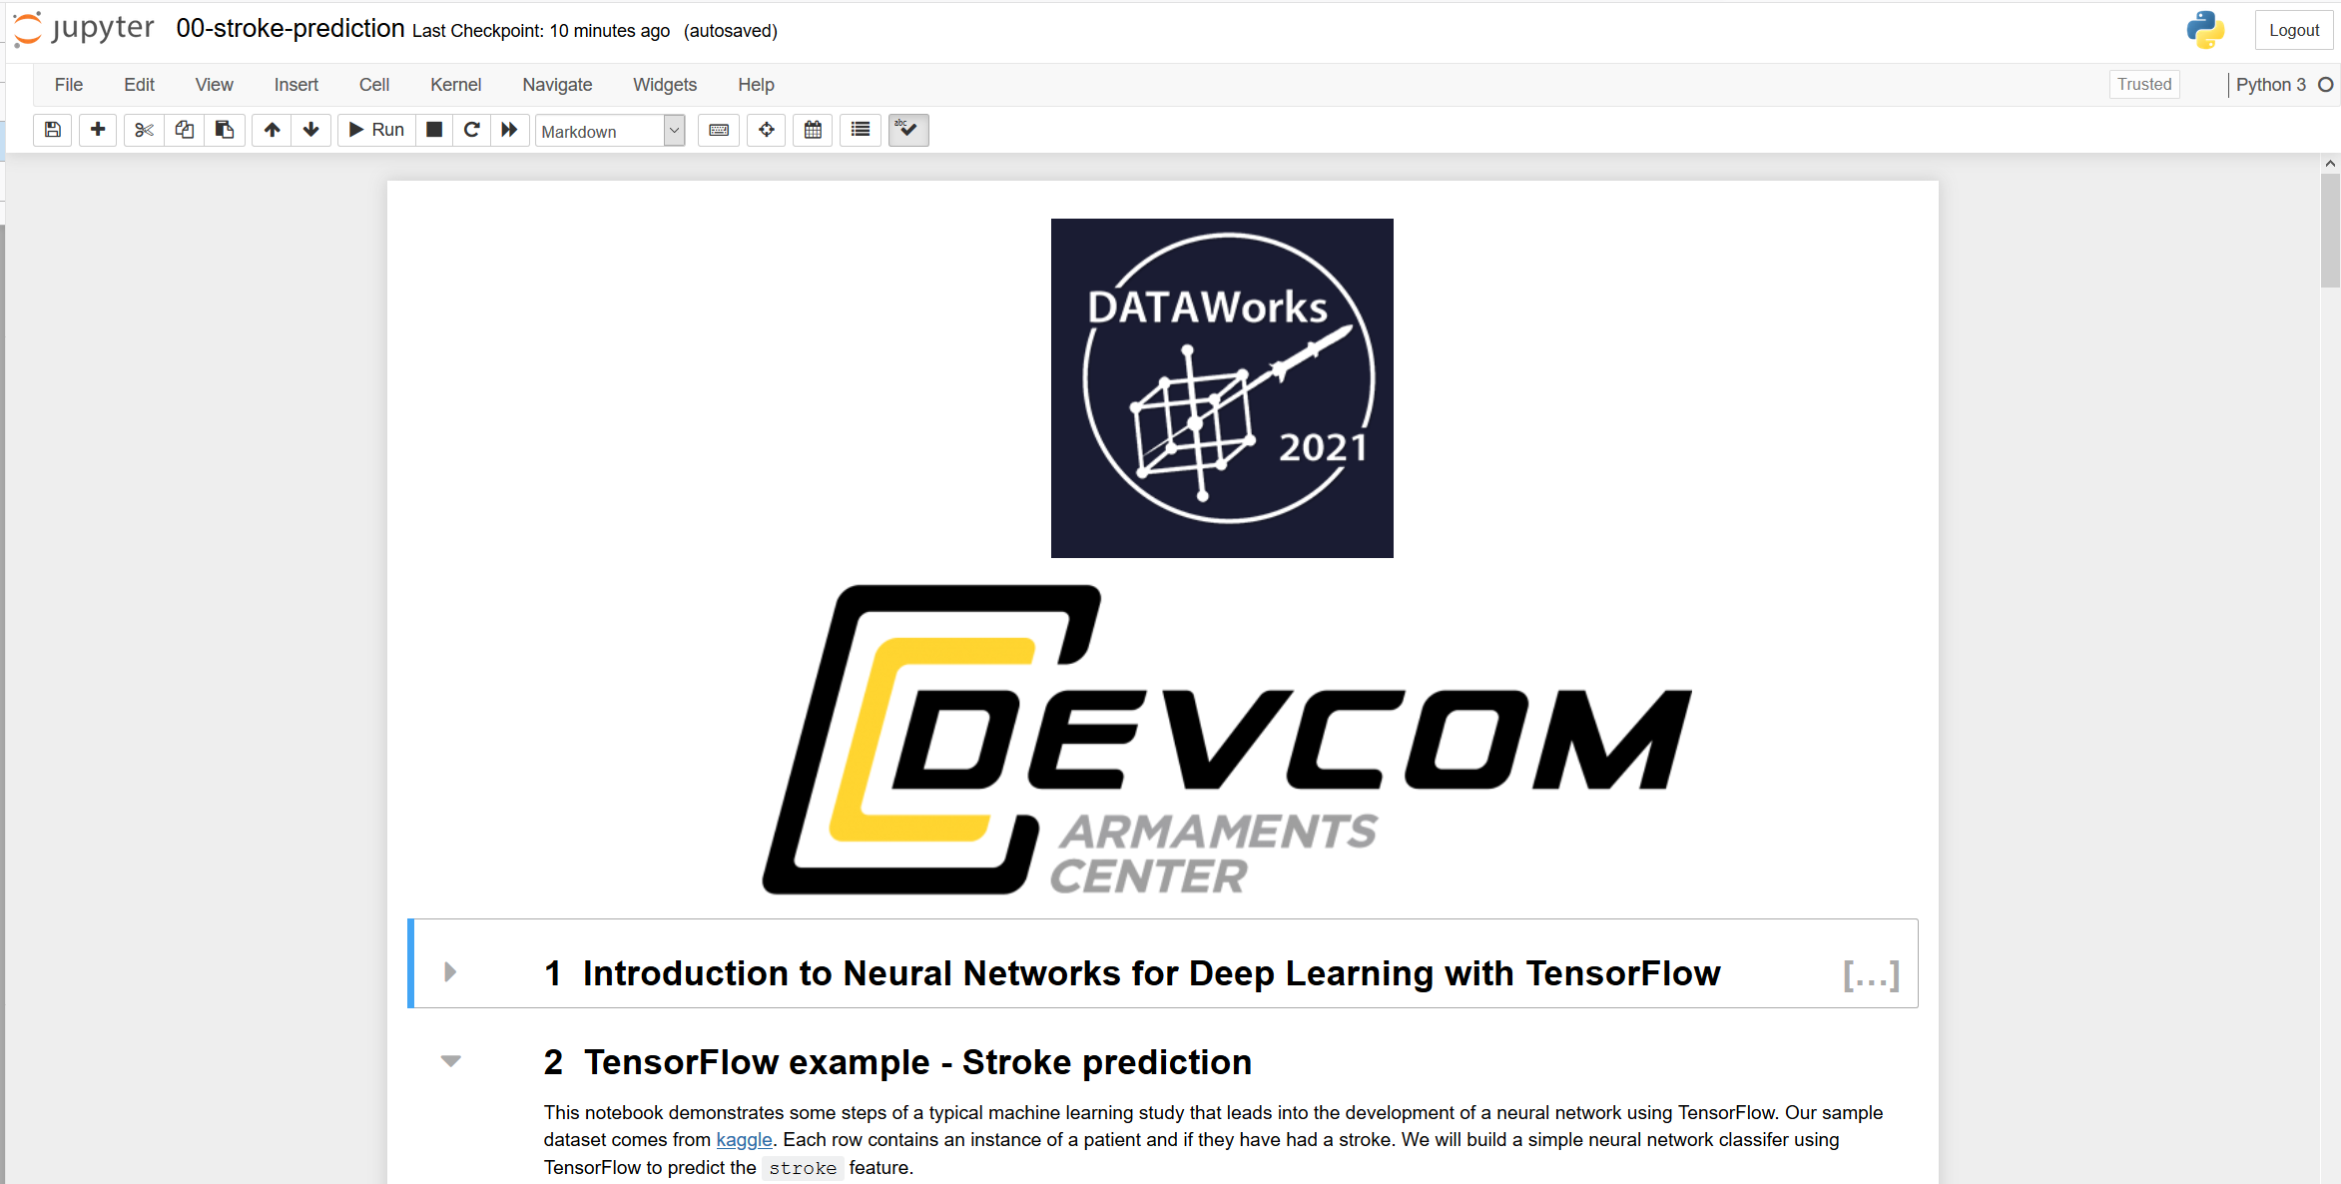

# TensorFlow

TensorFlow is an open-source platform for machine learning—in particular deep learning. It is developed and maintained by Google, and is a very popular framework for building neural network models. It is designed to manage computation graphs that are optimized for computing gradients of computation chains. Other frameworks for building neural network models using Python include: PyTorch, MS CNTK, MXNet, scikit-learn.

In this mini-tutorial session, we will demonstrate neural network concepts using Tensorflow. The “dataworks-2021” environment using the provided environment specification file will contain TensorFlow version 2.1.