**POST request**

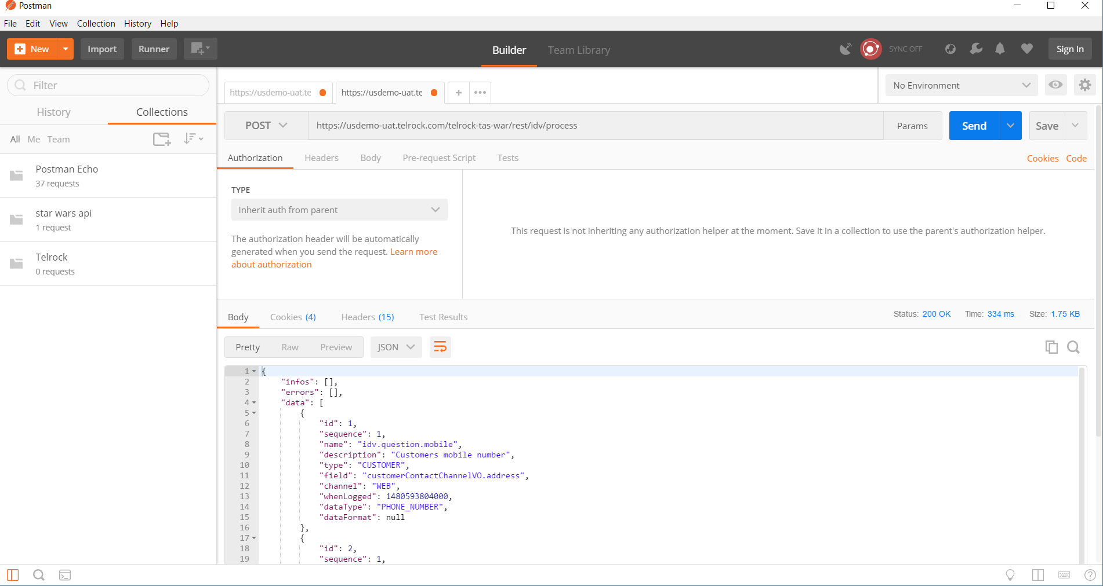

**PUT Request with correct login details**

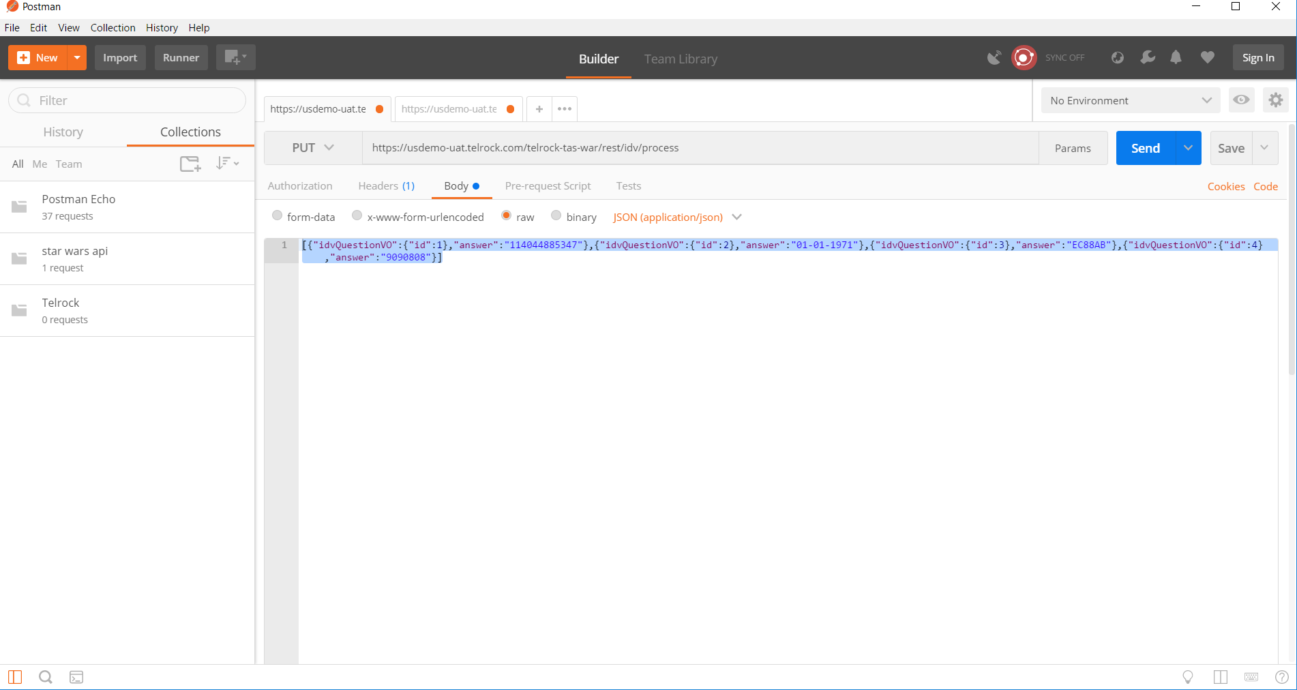

**Response- Status code 200 OK**

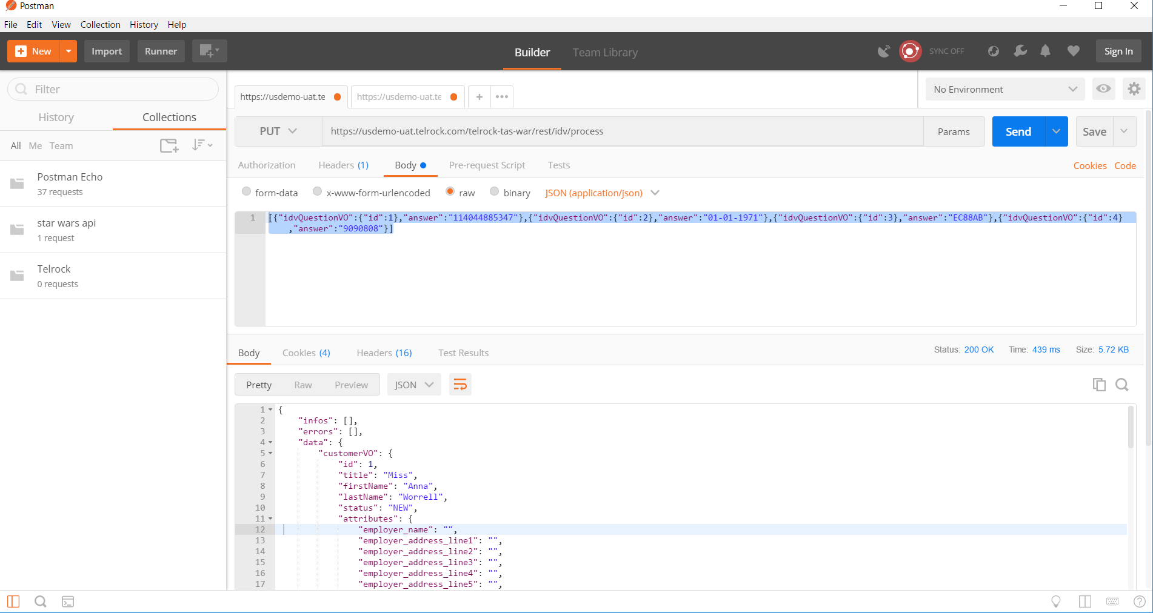

**PUT request with incorrect Parameters (login details incorrect)**

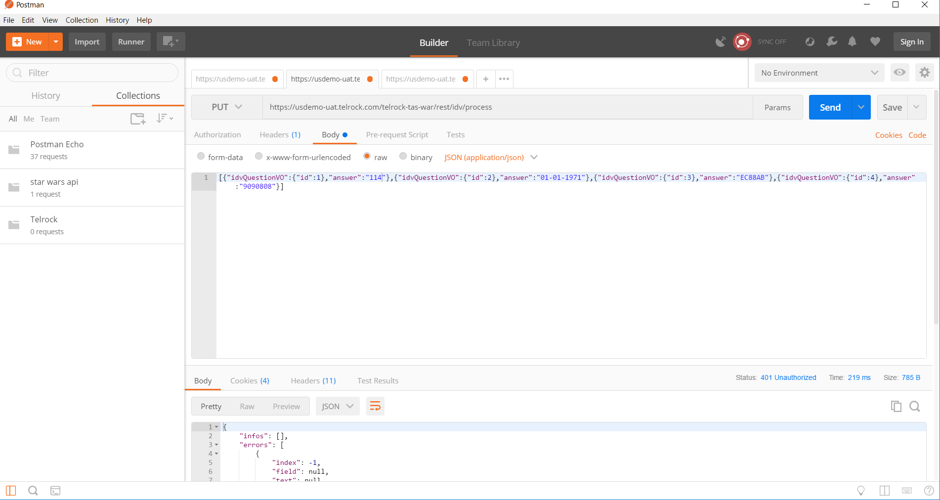

**Response- Status Code 401**

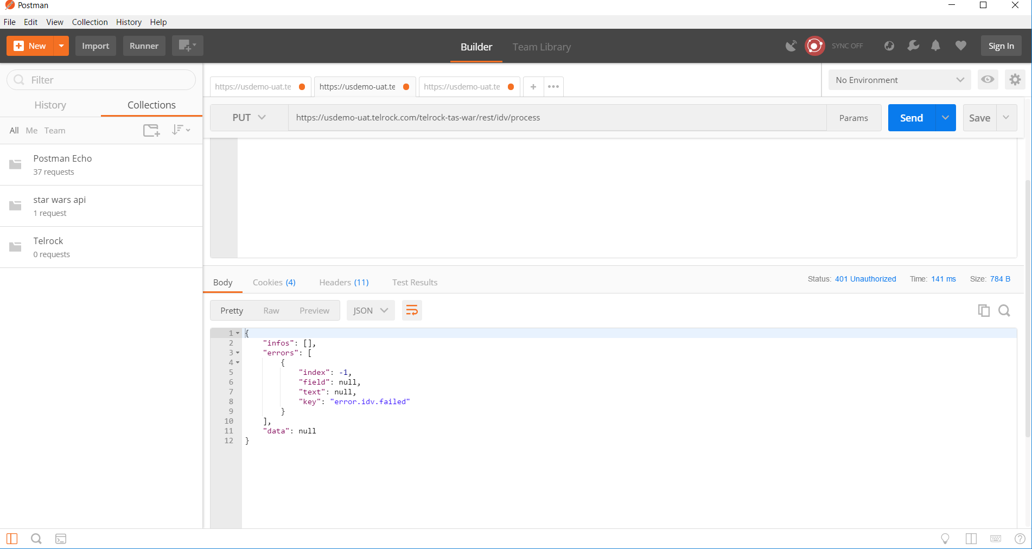

**PUT request with answer of id:2 removed from login details- Status code 401**

